**Partnering in healthcar****e - for better care and outcomes**

**Safer Care Victoria is our state’s new healthcare quality and safety improvement agency. We are committed to partnering with consumers in healthcare, and we believe care in hospital should be inclusive and respectful and respond to the needs of all people.**

**We know not all Victorians are able to participate in their healthcare in an equal way, or have their needs equally well met. That’s why we’re developing the Partnering in healthcare framework. And we need your input to help guide better, safer care for all Victorians.**

For more information on the project, or to provide feedback, visit [engage.vic.gov.au/](https://engage.vic.gov.au/)partneringinhealthcare

**Why is a new approach needed?**

We know better health outcomes happen when consumers, the people that support them and communities work together with health workers. We also know that healthcare organisations have different levels of success when it comes to partnering with consumers for better care and outcomes.

The new framework responds to these challenges, to support and improve consumer participation in Victorian hospitals and health services.

**How is Partnering in healthcare being developed?**

Safer Care Victoria is collaborating with health service staff, consumers and peak bodies to develop the framework.

An innovative co-design methodology is being used, and includes an online survey, workshops and a large-scale focus group. Importantly, the draft framework is based on thorough evidence, including a KPMG review, Cochrane systematic reviews and extensive patient engagement and health literacy literature.

**Where will Partnering in healthcare be used?**

The Partnering in healthcare framework will be implemented in Victorian public hospitals.

**Partnering in healthcare framework**

*Partnering in healthcare* *- for better care and outcomes* outlines a co-design approach to develop a healthcare framework for consumer participation. The aim of this framework is to strengthen person- and family-centred healthcare and improve the healthcare experience and outcomes for all Victorians.

The framework describes five connected domains that work together to make significant improvements.

1. **Person- and family-centred services, care and outcomes**

*Healthcare should involve people and their supports in all aspects of their care.*

Person-centred services and care is a Victorian Government priority. We aim to put people and their families at the centre of all care decisions. We see consumers as experts, working with health professionals to have control over their life and the healthcare they receive.

1. **Teams, partnerships, knowledge and shared learnings**

*Quality healthcare is provided by teams who work together with the patient.*

Person- and family-centred care can only be provided when teams work together and with patients. This involves the sharing of knowledge, skills and expertise between staff, patients and the people that support them, to best manage health conditions and improve health outcomes.

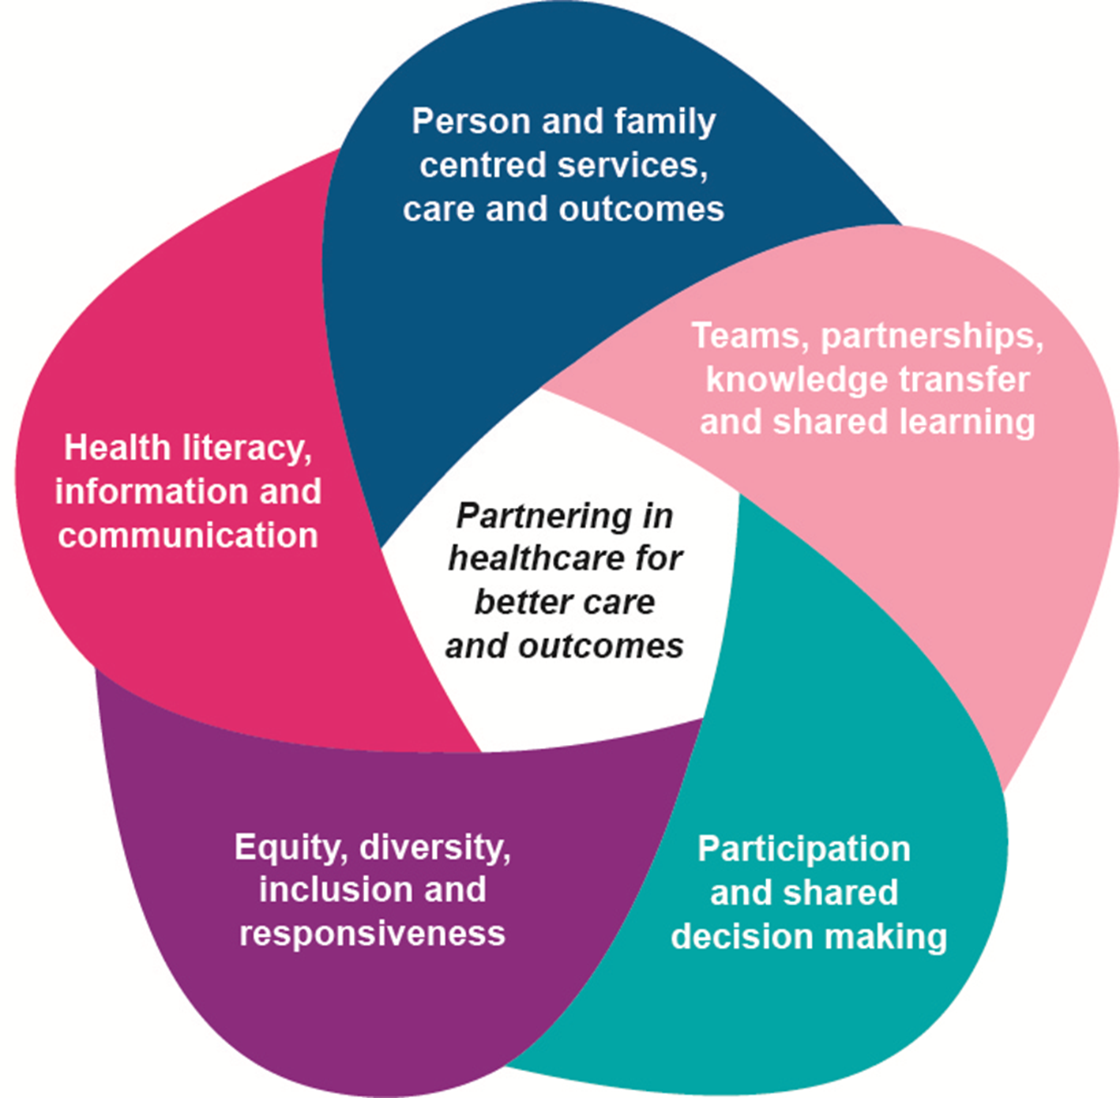

1. **Participation and shared decision making**

*Healthcare works best when people participate and are involved in decisions that affect them and the people they support.*

Supporting people to be involved in decisions about their healthcare improves their experience of hospital care and their outcomes. This involves including patient preferences when making decisions about their care, as well as patient engagement in how hospital care is delivered and improved.

1. **Equity, diversity, inclusion and responsiveness**

*Healthcare is care of equal quality - safe, effective, and person-centred. People have their healthcare needs equally well met.*

High-quality, safe care responds to people’s individual needs and preferences. It means understanding people have different experiences and that they can affect a person’s health and wellbeing; understanding people may have many important needs at the same time; and respecting people’s identity and experiences.

1. **Health literacy, information and communication**

*Healthcare information and communication should be easy to understand and act on.*

People can obtain, understand and use the health information and services they need to make appropriate health decisions. Healthcare providers and the health system should provide information and improve interaction with individuals, communities and each other to respond to and improve health literacy.

To receive this publication in an accessible format phone 9096 9008, using the National Relay Service 13 36 77 if required, or [email Safer Care Victoria](mailto:safercarevictoria@dhhs.vic.gov.au) safercarevictoria@dhhs.vic.gov.au

Authorised and published by the Victorian Government, 1 Treasury Place, Melbourne.

© State of Victoria, Australia, Safer Care Victoria, November 2017.

Available at [Safer Care Victoria](http://www.safercare.vic.gov.au) www.safercare.vic.gov.au