
Safer Care Victoria strategic plan
2017-2020
How we will lead quality and safety improvement in healthcare,
for the benefit of all Victorians, for the next three years

Department of Health
Safer Care Victoria strategic plan
2017-2020

To receive this publication in an accessible format phone 03 9096 1384, using the National Relay Service 13 36 77 if required, or email Safer Care Victoria <safercarevictoria@dhhs.vic.gov.au>
Authorised and published by the Victorian Government, 1 Treasury Place, Melbourne
© State of Victoria, Safer Care Victoria, October, 2017
ISBN 978-1-76069-060-1 (print)
ISBN 978-1-76069-061-8 (online)
Available at Safer Care Victoria <www.safercare.vic.gov.au>
(1709046)
Contents
CEO’s foreword 7
Our story 12
Our values 14
Our strategic priorities 15
Partnering with consumers 17
Partnering with clinicians 18
Our chief clinicians 18
Leadership 19
Review and response 20
System improvement and innovation 21
References 22

CEO’s foreword
Safer Care Victoria ‘opened its doors’ as our state’s new healthcare quality and safety improvement agency on 1 January 2017. We were born out of a review of Victoria’s hospital quality and safety assurance – Targeting Zero: supporting the Victorian hospital system to eliminate avoidable harm and strengthen quality of care. The review itself was undertaken in response to a major health service governance failure. A failure that none of us ever wish to witness again.
It has been an honour to have been a practising clinician, an obstetrician, for the past three decades or more. To have been invited into people’s lives and families, to have shared in their joys, hopes and expectations, and to have contributed to their health and recovery, even in the smallest of ways, has been truly wonderful. Even in darker moments, to have been allowed to share in and witness some of the most profound grief, at times of an almost unbearable weight, has been a humbling privilege. Aching, but an intense privilege.
At the centre of my professional life for these past 30 years has been an endless, and at times frenetic, series of patient encounters. Thousands upon thousands of encounters. Each so different and yet often so similar. Encounters that, sadly, at times have not been without shame or error. My shame. My error. But encounters that have shaped and informed me, as patient encounters have shaped and informed many other clinicians before me. In particular, they have informed me, very clearly, of the task ahead of us.
That task is not an easy one. But it is an essential one. It will require change, much change, perseverance and focus. It will also require transparency, shared learning and an investment in each other. Above all, at Safer Care Victoria we are committed to elevating the consumer to be a genuine partner in her/his own healthcare. Easy to write. Much more difficult to deliver. To paraphrase Don Berwick, the days of medical heroism are (thankfully) gone. Ahead of us lies a journey of professionalising our industry in a manner never really witnessed before. We would love you to join us on that journey. We certainly can’t do it without you.
In this plan, we lay out our strategy, approaches and priorities for that improvement journey. Our hopes are there too. You will read about culture and leadership. About clinician and consumer engagement. And about innovation – targeted innovation. You will also read that we are committed to measuring. Not because we believe that the measurements themselves are an outcome but because we want to know what works and what doesn’t. And we want you to know too.
Our work plans are a result of a myriad of conversations, debates and arguments that we have had with you and your colleagues, with interstate and international friends, and of course with consumers. Not quite enough of the latter but we are working on it. Our plans are not quite perfect but that’s okay. We are not yet a year old. We would welcome all and any feedback. Please tell us when we are doing well – we like that – but also tell us when we have missed the mark.

I look forward to working with you to deliver on the challenges handed to us by Targeting Zero and, more importantly, on the expectations of all Victorians. All of us at Safer Care Victoria do. Join us.
Professor Euan Wallace AM
Chief Executive Officer

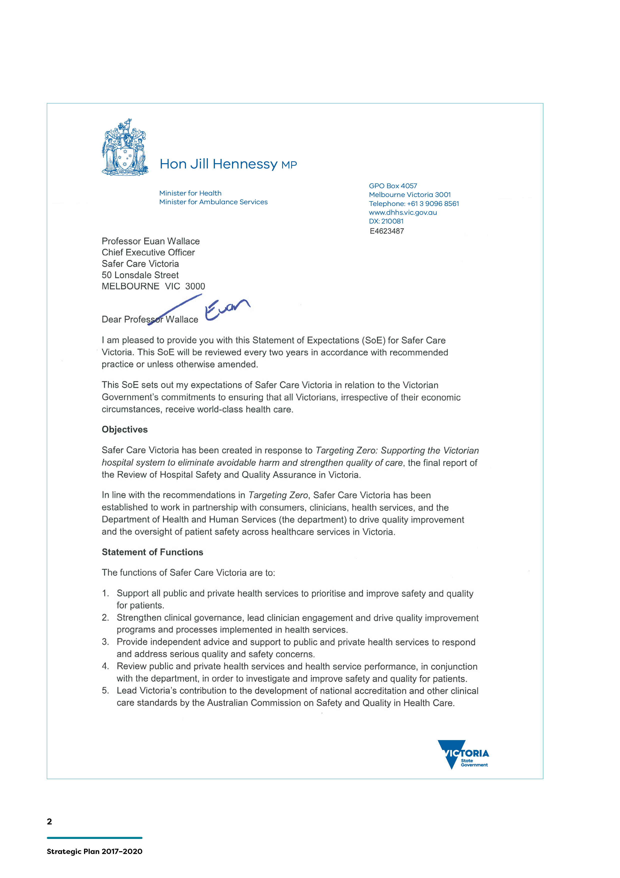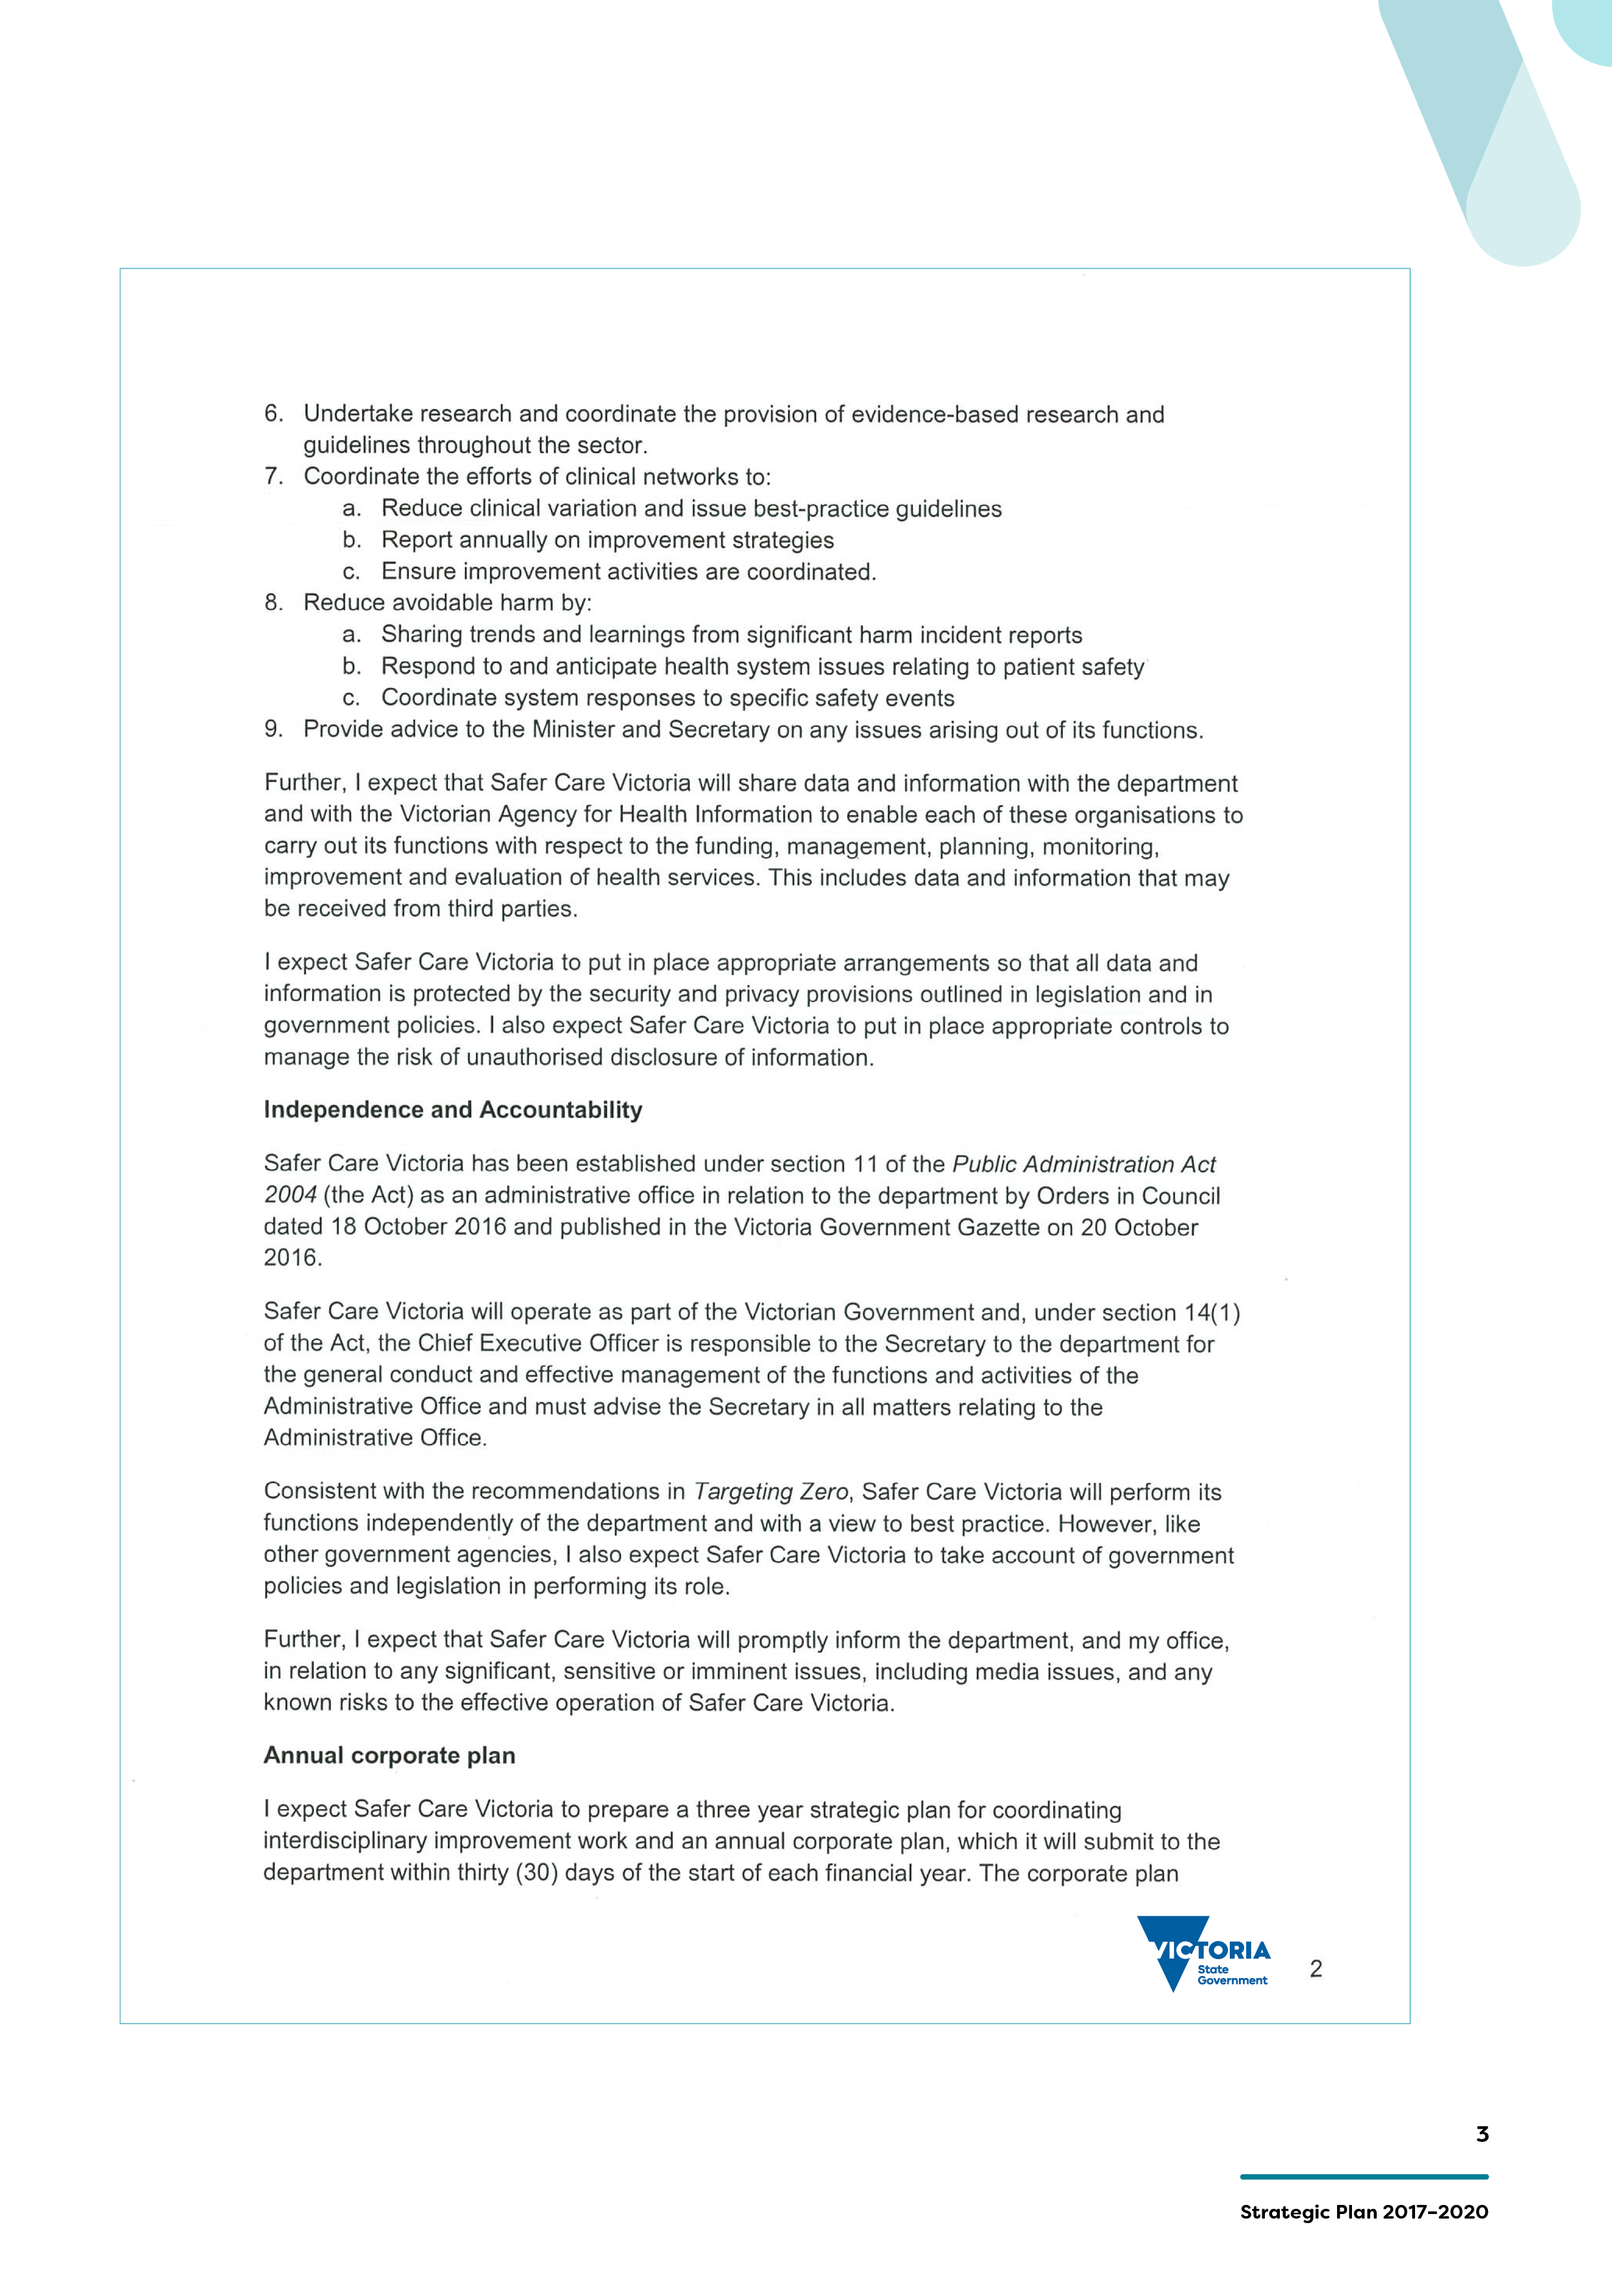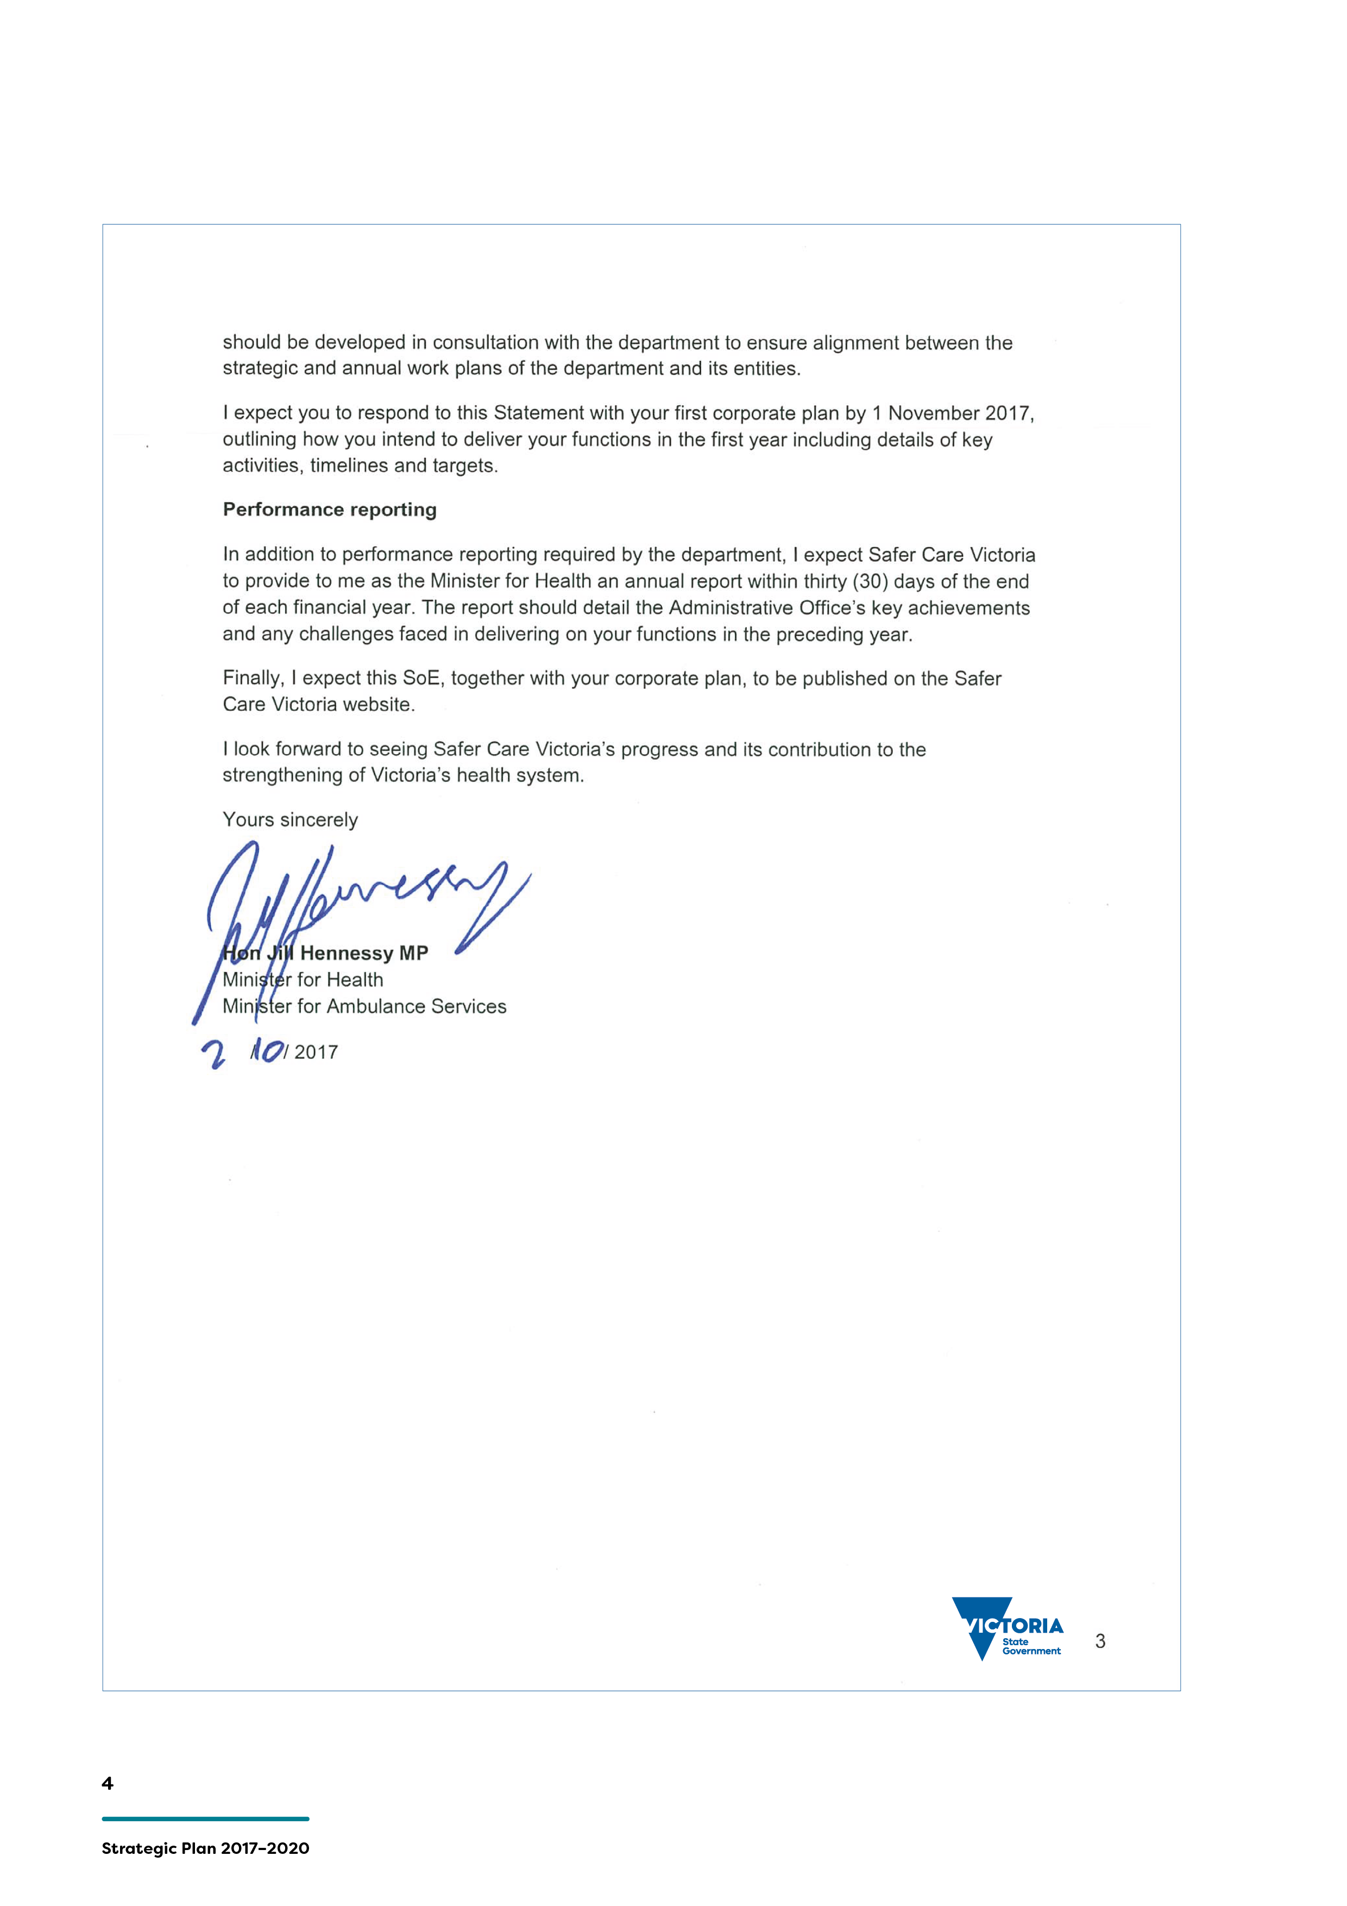

Our story
Safer Care Victoria (SCV) was established in January 2017 in response to the discovery of a cluster of preventable stillbirths at a Victorian health service that had occurred in 2013 and 2014.
The establishment of SCV was one of the key structural reforms recommended by Targeting Zero¹, the final report of the review that investigated what needed to be done to prevent such tragedies from occurring again in our state.
Our purpose at SCV is both simple and complex: simple, in that we exist to support health services to provide outstanding healthcare to Victorians. Always.
Complex, in that achieving this goal will require us to work closely with consumers, their families and carers, clinicians, health service executives and management, our universities and research institutes, professional colleges and other regulatory authorities. Alongside these stakeholders, we will also be working with our colleagues in the Department of Health and Human Services (the department) and other government departments and agencies – such as the Victorian Agency for Healthcare Information (VAHI) and the Australian Commission on Safety and Quality in Health Care.
We know that Victoria has a world class healthcare system, with many examples of best practice and innovation. Our task is to shine the light on these many pockets of excellence and share them across the system.
We also know that avoidable harms continue to occur in our health services, as they do within all sophisticated healthcare systems². Our role is to lead the state in driving down such harm – with the goal of zero avoidable harm. Targeting zero.
As an Administrative Office of the department we are accountable for contributing to the delivery of several of the department’s strategic directions and priority actions³. However, the deliberate separation of quality and safety from other departmental functions, which was achieved with our establishment, requires us to be independent-minded and forthright in our approach to leading change and improving the quality and safety of our health system.
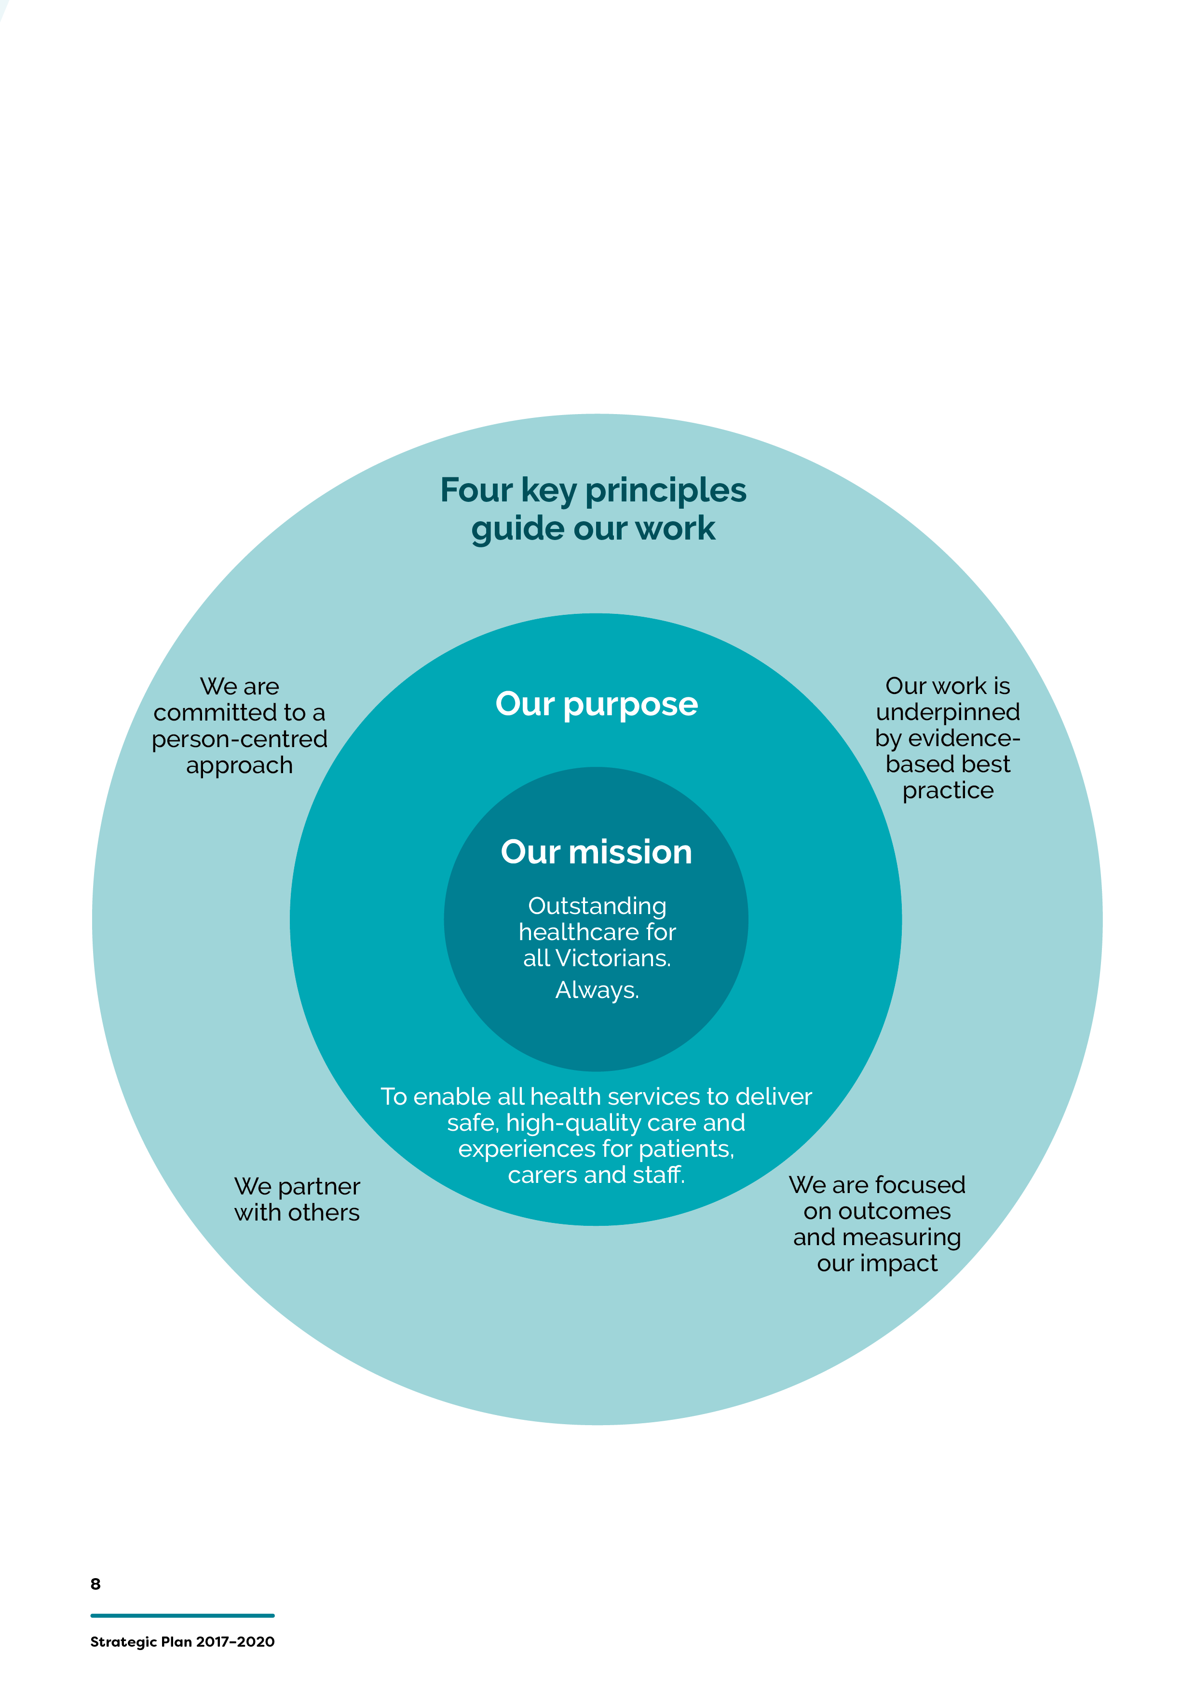

Our values
Our staff set our values. They describe how we do business.
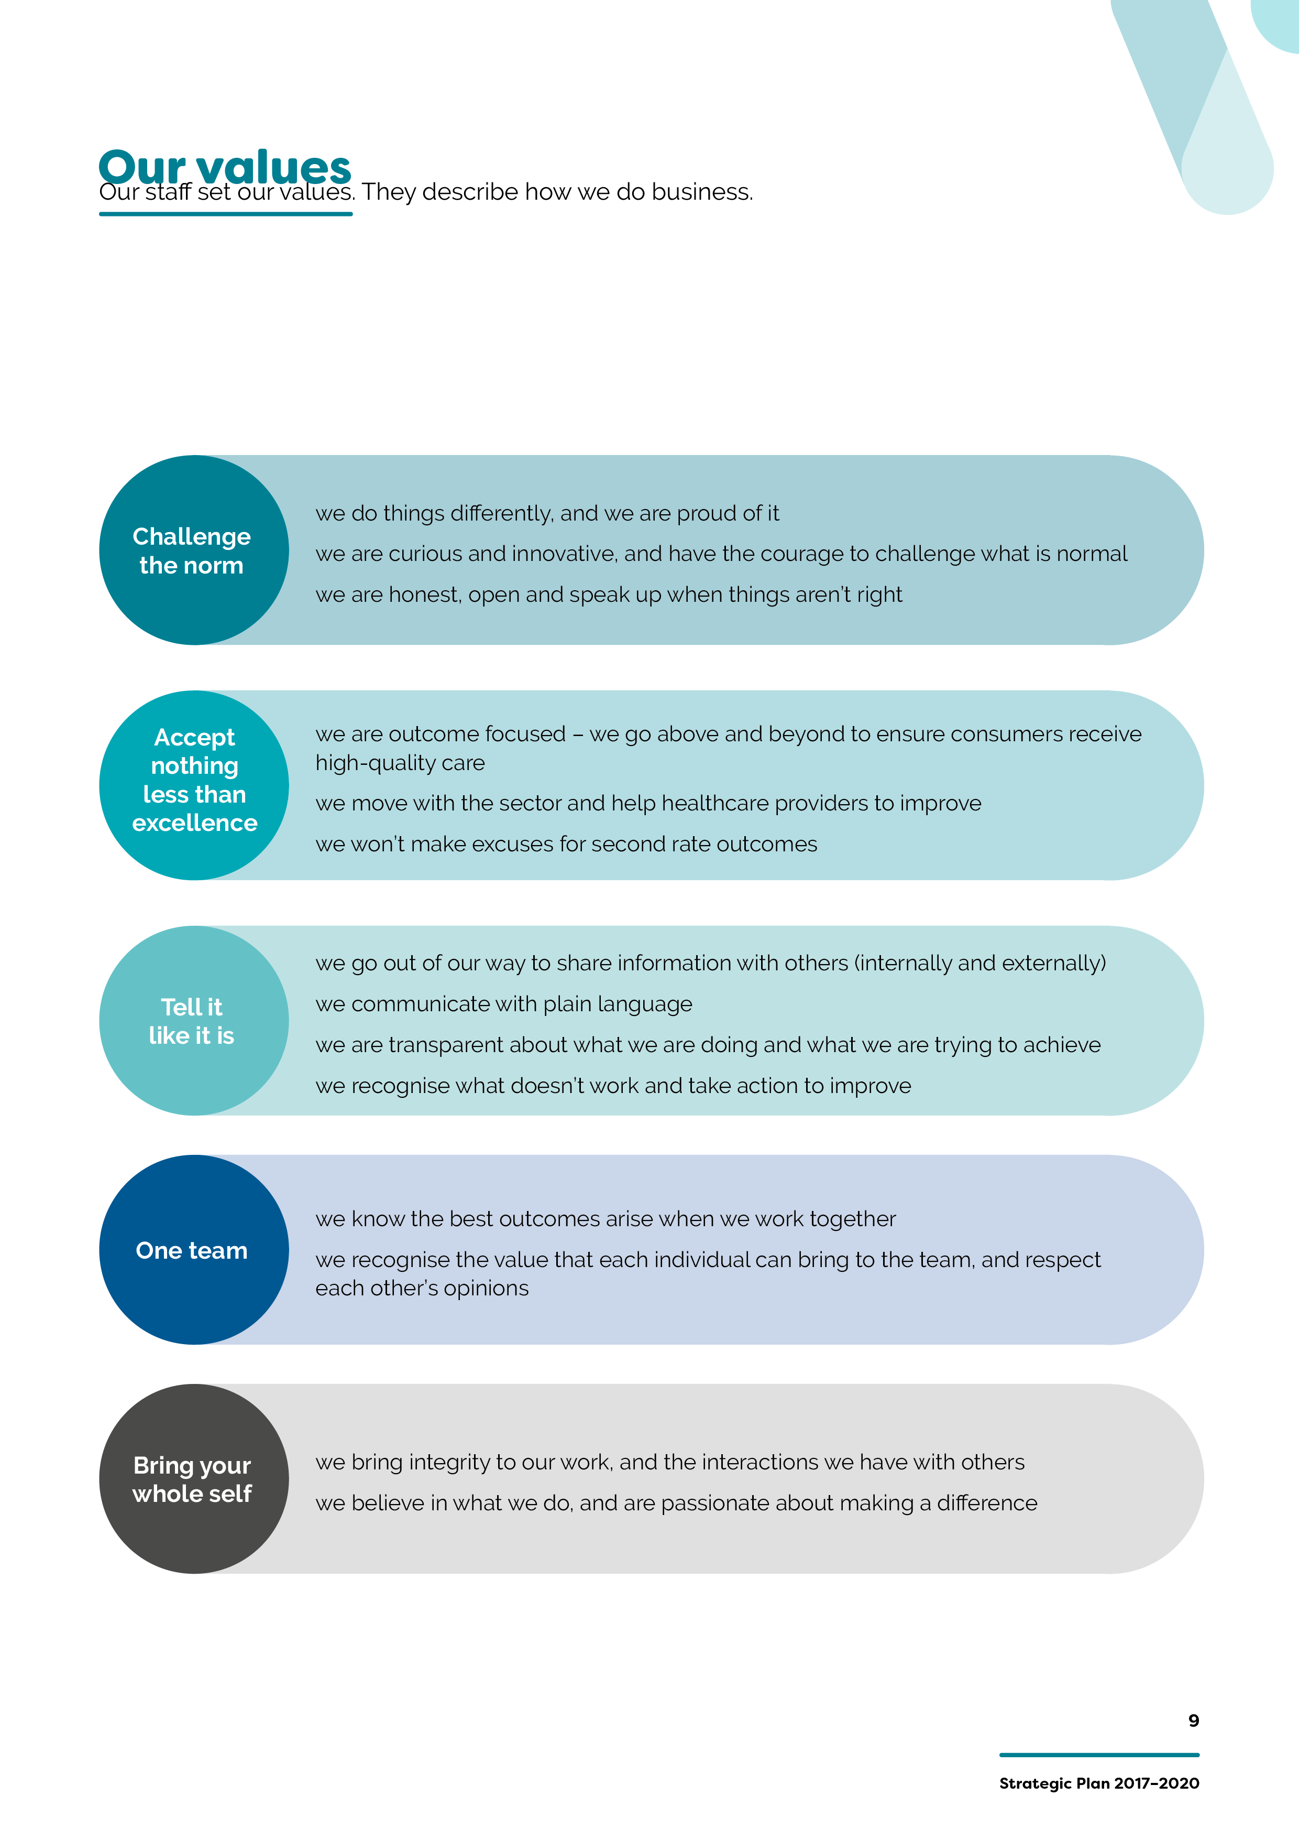

Our strategic priorities
Our five strategic priorities were primarily determined by the people who matter most to us: consumers and clinicians.
We also took into account the learnings from Targeting Zero and the findings of similar reviews⁴ of health system failings, as well as other reports⁵. These reviews provide a consistent evidence base for strong patient safety cultures in healthcare. Get these components right and our system will be in a good place.
The reviews are very clear that the health services and systems that have failed: did not work with and listen to consumers and their families; did not work with and listen to clinicians; had poor workforce culture, inadequate leadership and governance; lacked outcome monitoring; and paid inadequate attention to improvement and innovation.
Our strategic priorities are:
- Partnering with consumers
- Partnering with clinicians
- Leadership
- Review and response
- System improvement and innovation

Strategic priority | Strategic objectives | What success looks like in three years
Partnering with consumers | Consumer voices and choices are central to own care | Consumer-defined outcome measures and improvement goals being delivered at a health service level and within SCV
Partnering with consumers | Consumer voices and experiences improve health services and the health system | Demonstrable improvement in patient experience
Partnering with clinicians | Reductions in unwarranted variation in practice and outcome | Reduction in variation in specific clinical conditions – to be identified with clinicians and consumers
Partnering with clinicians | Clinicians’ voices and experiences improve health services and the health system | SCV chief clinicians, the Victorian Clinical Council and clinical networks are utilised to inform policy and planning
Leadership | Healthy culture driven by strong leaders | System-wide approach to developing and sustaining current and future leaders
Leadership | Quality and safety governance embedded throughout health services | Evidence that accountability of health services’ governing bodies and executives is strengthened
Review and response | Robust response and review of serious incidents | A just culture: demonstrable improvements in the number of serious events reported to SCV
Review and response | Dissemination of learnings from serious incidents, and local best practice | Measurable reductions in avoidable harm
Review and response | Quality and safety data analysis drives system oversight and response | New quality and safety measures in clinician-driven reports for sector and public
System improvement and innovation | Lead improvements in priority areas | Demonstrable reductions in avoidable harm in priority areas
System improvement and innovation | Enable innovation in priority areas | Evidence of local innovation scaled across the system
System improvement and innovation | SCV is a national and international leader in quality and safety | Publications and presentations evidencing SCV impact

Partnering with consumers
Commitment to the involvement of consumers and community stakeholders – and ensuring they have an equal voice – in quality and safety improvement activities is critical. A key aspect of our work is supporting a person-centred approach to quality and safety improvement initiatives, including to health service incident responses and patient complaints, and to develop the capacity for people to participate fully in their care.
To achieve our first objective, Consumer voices and choices are central to own care, SCV will deliver:
- practical ways to improve person-centred care
- advice and support to promote the uptake of shared decision-making approaches
- opportunities to develop and promote the use of tools to improve health literacy
- support to ensure there is open disclosure between consumers and health services when things go wrong
- alternative pathways supporting patients, families and carers to escalate their concerns when they are worried
- different ways for patients, families and carers to provide feedback about their experiences in healthcare.
To achieve our second objective, Consumer voices and experiences improve health services and the health system, SCV will:
- implement a statewide consumer participation strategy (Partnering in healthcare framework)
- establish a SCV patient and family council
- support health services to recruit, develop and support patient leaders
- support and train consumers to participate in serious event investigations
- enhance the utility of existing patient reported experience measures and ensure they are publicly reported
- work with consumers, clinicians and VAHI to establish an agreed set of patient reported outcome measures and revised patient reported experience measures
- support health services to involve consumers in improvement and innovation activities
- promote and support the use of person-centred co-design as a method for improvement
- triangulate positive feedback and complaints to the Minister for Health, Health Complaints Commissioner, Mental Health Complaints Commissioner and the department to inform system-level responses.

Partnering with clinicians
Support, engagement and coordination with clinicians to enable authentic partnership and leadership on quality and safety improvement is essential for system-wide improvement.
The clinical networks and the Victorian Clinical Council play crucial roles in bringing clinician and consumer voices to the forefront of SCV’s work.
We have a range of clinical networks covering specialty areas of healthcare that work collaboratively to unite practitioners across the state.
Our clinical networks will drive reductions in unwarranted variation, establish clinical practice guidelines and lead specific improvement programs and projects.

Our chief clinicians
Our chief clinicians provide frontline experiences and knowledge within SCV as we deliver our reform agenda, ensuring we are relevant to current-day practice concerns. Our chiefs are connected to their colleagues across the nation and, via regular events and bulletins, link clinicians from across the Victorian public and private sectors.
To achieve our first objective, Reductions in unwarranted variation in practice and outcome SCV will:
- amplify the work of the clinical networks
- utilise our clinical networks to drive reductions in unnecessary clinical practice variation in specific areas
- actively facilitate the spread of best practice across the state
- develop and support the implementation of clinical practice guidelines.
To achieve our second objective, Clinicians’ voices and experiences improve health services and the health system, SCV will:
- deliver and implement a clinical engagement framework
- provide relevant clinical outcome measures to clinicians
- utilise the Victorian Clinical Council and clinical networks for advice on health policy and system planning
- build alumni networks of leadership program participants and secondments to establish a workforce of quality and safety leaders
- connect clinicians – across the system and the nation – to share knowledge and provide support.

Leadership
Healthy cultures are driven by strong leaders. Leadership for quality and safety across all organisational levels enables more effective governance to be embedded throughout
health services.
We are partnering with the sector to develop a strategy and series of programs to enhance, support and connect senior and frontline leaders within and across health services and the
health system.
To achieve our first objective, Healthy culture driven by strong leaders, SCV will:
- co-design a suite of leadership development programs tailored to the different types of existing and emerging consumer, clinician and manager leaders in our system, and their varied career pathways
- provide tools and training to develop skills in continuous improvement quality and safety and management, across the sector
- identify and work to reduce the barriers for people to take up pivotal quality and safety leadership roles, such as Director of Medical Services
- work with rural health leaders to understand and help address their unique leadership challenges.
To achieve our second objective, Quality and safety governance embedded throughout health services, SCV will:
- co-design a clinical governance curriculum and range of targeted education programs to enhance skills, below board level
- introduce a standard suite of measures for health service boards to monitor the effectiveness of clinical governance
- establish a program for regular review of implementation of the clinical governance framework.

Review and response
We are responsible for the oversight of quality and safety in Victorian health services and, in partnership with VAHI, monitoring and reviewing data and providing advice to health services and the department.
We support the sector to respond to system issues including Therapeutic Goods Administration (TGA) alerts. We also engage with national committees and agencies to drive the quality and safety reform agenda. Our legislated consultative councils conduct case reviews, identify trends and themes, and provide recommendations and advice on how to prevent avoidable harm.
To achieve our first objective, Robust response and review of serious incidents, SCV will:
- build a team to provide immediate response, support and follow through after serious incidents
- establish an academy of expert reviewers to lead service-level clinical reviews
- establish a network of trained clinicians to offer independent advice as part of root cause analysis investigations
- develop best practice tools to support root cause analysis, in-depth case review and other contemporary investigation methods
- work with the department to establish new regional mortality and morbidity committees.
To achieve our second objective, Dissemination of learnings from serious incidents, and local best practice, SCV will:
- share learnings from best practice and serious incidents via our website, formal reports, bulletins and forums
- establish a rapid notification system to alert health services to emerging issues or risks
- support the publication of expert case reviews by our consultative councils, together with support to implement their system-level recommendations.
To achieve our third objective, Quality and safety data analysis drives system oversight
and response, SCV will:
- work with consumers, clinicians and VAHI to establish new quality and safety clinician-driven reports for the sector and the public using existing data sets
- work with consumers, clinicians and VAHI to identify new measures for inclusion in quality and safety reports
- work with VAHI to provide timely, transparent and accessible data for clinicians and organisations to drive improvement and innovation.

System improvement and innovation
We support the development, implementation and scaling of improvement and innovation programs and projects.
Time-limited quality and safety programs and projects, including those funded by the Better Care Victoria Innovation Fund, help us deliver on this strategic priority.
To achieve our first objective, Lead improvements in priority areas, SCV will:
- work with the sector to select and develop targeted improvement programs and objectives
- support the implementation of improvement projects, for example collaborations and partnerships
- establish a team of improvement specialists to support health services.
To achieve our second objective, Enable innovation in priority areas, SCV will:
- test new innovations that improve access to high-quality care by funding sector-led projects
- scale up innovation projects that demonstrate system-wide benefits.
To achieve our third objective, Safer Care Victoria is a national and international leader in quality
and safety, SCV will ensure that:
- best practice is identified – where needed, designed – disseminated and implemented across the system
- our staff are customer focused
- we contribute to the national quality and safety agenda
- we support the development of robust quality and safety initiatives across the delivery of human services to benefit all Victorians
- we are a preferred employer and strive to continuously improve our workforce with learning and support.

References
- Duckett S., Cuddihy M., Newnham H. Targeting Zero: supporting the Victorian hospital system to eliminate avoidable harm and strengthen quality of care. Report of the review of hospital safety and quality assurance in Victoria. Victorian Government; October 2016
- Baker, G. R., Norton, P. G., Flintoft, V., Blais, R., Brown, A., Cox, J., Etchells, E., Ghali, W. A., Hebert, P. and Majumdar, S. R. (2004) ‘The Canadian Adverse Events Study: the incidence of adverse events among hospital patients in Canada’, Canadian medical association journal, 170(11), p 1678-1686
Davis, P., Lay-Yee, R., Briant, R., Ali, W., Scott, A. and Schug, S. (2002) ‘Adverse events in New Zealand public hospitals I: occurrence and impact’, New Zealand Medical Journal, 115(1167)
Vincent, C., Neale, G. and Woloshynowych, M. (2001) ‘Adverse events in British hospitals: preliminary retrospective record review’, BMJ, 322(7285), p 517-519
Institute of Medicine (2000) To err is human: Building a safer health system, National Academy Press Washington, DC
- Department of Health and Human Services strategic plan. Victorian Government (2017)
- Victorian Auditor-General’s Office (2016) Patient Safety in Victorian Public Hospitals, webpage <https://www.audit.vic.gov.au/report/patient-safety-victorian-public-hospitals>
Victorian Auditor-General’s Office (2008) Patient safety in public hospitals, webpage <https://www.audit.vic.gov.au/report/patient-safety-public-hospitals>
Victorian Auditor-General’s Office (2005) Managing patient safety in public hospitals, webpage <https://www.audit.vic.gov.au/report/managing-patient-safety-public-hospitals>
- Keogh, B. (2013) Review into the quality of care and treatment provided by 14 hospital trusts in England: overview report, NHS
Francis, R. (2013) Report of the Mid Staffordshire NHS Foundation Trust Public Inquiry: Executive summary, The Mid Staffordshire NHS Foundation Trust Public Inquiry.

