Update: Partnering in healthcare framework consultation

Safer Care Victoria is our state’s new healthcare quality and safety improvement agency. We are committed to partnering with consumers in healthcare, and we believe care in hospital should be inclusive and respectful and respond to the needs of all people.

We know not all Victorians participate in their healthcare in an equal way, or have their needs equally well met. That’s why we’ve been working with you on a Partnering in healthcare framework, using your input to help guide better, safer care for all Victorians.

## Thank you

More than 700 Victorians contributed to Partnering in healthcare framework consultations, providing more than 3,000 comments and suggestions. We’ve heard from people with deep knowledge and wisdom based on personal experiences, and from those who work in our healthcare services.

We appreciate the time you took to share your experiences and expertise, and we’re confident we can use these consumer and health service voices and experiences to improve health services and our health system. This document provides a brief overview of what we heard, and what we’re doing next.

## Where we began and what you’ve told us

In 2017 we developed a draft framework that responds to the challenges of participating in healthcare. This framework aims to give practical direction to improve consumer participation in Victorian hospitals and health services.

The framework outlined five connected domains (areas). Evidence shows that these domains can work together to make positive differences to healthcare experiences and outcomes.Figure 1: The original Partnering in healthcare domains

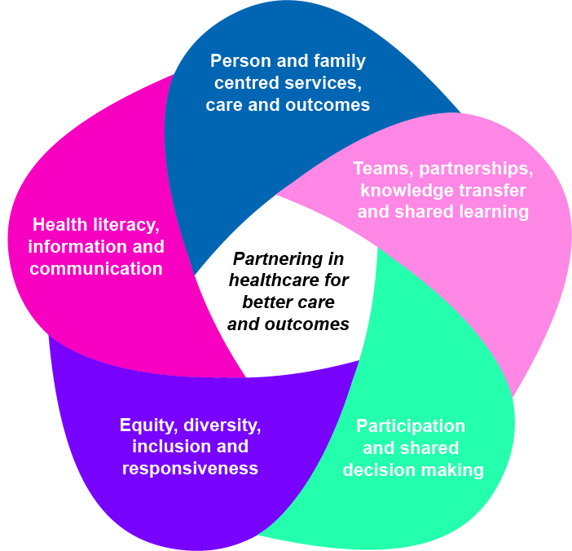

“Hospital patients should be seen as human rather than just a cluster of symptoms.”

## How we heard from you

### Online survey

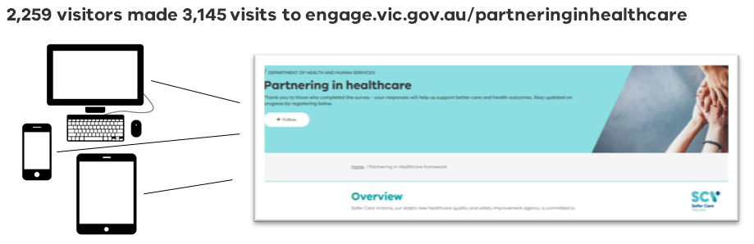In the first half of 2018 we delivered on our promise to collaborate with health service staff, consumers and peak bodies to check in on the draft Partnering in healthcare framework. We used the Engage.vic online consultation platform to reach as many Victorians as possible in an eight-week timeframe.

Figure 2: Using online platforms helped us reach more Victorians

Online consultation – who did we hear from?

* 28% have never worked in healthcare
* 71% work/have worked in healthcare
* 26% are frequent hospital users
* 45% identify as having an ongoing health condition
* 32% support someone with a long-term health condition, disability, or who is elderly
* 10% speak a language other than English
* 9% identify as LGBTI
* 11% identify as a person with a disability
* 3% are Aboriginal and Torres Strait Islander people
* 74% female, 24% male
* 2% preferred not to identify gender
* 58% under 54 years old, 43% older
* 63% live in Melbourne
* 24% live outside Melbourne
* 74% educated with a Bachelor’s degree or higher
* 76% employed
* 39% have children at home
* 34% are couples without children

## reaching out

Using social media and other online networks, we were able to share the message about the Partnering in healthcare framework with close to 180,000 Victorians.

This resulted in 2,259 visitors making 3,145 visits to our consultation web page.

### Priorities summit

In March 2018 we hosted a priorities summit workshop with 31 attendees. We used this face-to-face workshop as an opportunity to hear more ideas from consumers with different kinds of life experience.

To achieve this, we aimed for a ratio of at least two health consumers (who hadn’t ever worked in healthcare) for each health professional in the room. We also paid attention to making sure those in the room represented a good cross-section of our communities.

“Patients need to know when doctors/allied health will visit them. They get very anxious when they don't know. Perhaps a chart on the wall where the person concerned commits to what they are going to do so patients know. (E.g. Physio-daily, Dr-daily, pharmacist – as required.) This takes away guesswork.”

The workshop itself used a mixture of online voting and small group discussion to help us prioritise a big list of ideas (close to 100) into a smaller list. Key priority areas identified on the day included:

* Improving communication
* Addressing continuity of care and care planning
* Supporting care that is compassionate and respectful
* Supporting shared decision making
* Ensuring care responds to people’s individual and diverse needs

Figure 4: Priorities Summit – who was in the room?

## SURVEY AND SUMMIT RESULTS

The answers and ideas you shared with us gave us two key things. Firstly, endorsement that the five areas we identified are important ones to focus on, and secondly, insight into specific areas that need to be prioritised for framework implementation. The table on the next page shows the five areas we wanted to know about, the questions we asked, and some of the ideas shared with us.Table 1: An overview of what we asked, and what we heard

|  |  |  |
| --- | --- | --- |
| We wanted to know more about: | So we asked: | Suggestions included: |
| Person- and family-centred services, care and outcomes | “What could be done differently in hospitals to ensure that patients are treated as a whole person?” | * More holistic treatment of patient in hospitals, looking at the whole person not just the illness * More time is needed to be with patients and consider what is important to the individual (identified by consumers and those working in health services) * More attention on finding out what’s important to the patient and the people caring for them |
| Teams, partnerships, knowledge and shared learnings | “How could hospitals support patients and staff to work together for better care?” | * Clinicians and hospital staff to understand the patient’s story and share that information with others caring for patient be that other clinicians, services and families * Enhance opportunities for clinical team meetings with patients and families * Involve consumers in quality and safety improvements plus innovations in health services |
| Participation and shared decision making | “What needs to change for patients and the people who support them to be more involved in healthcare decisions in hospitals?” | * Recording, communicating and implementing patients’ preferences * Patients should be equal partners in decisions about care, given information and have autonomy, plus treated as unique individuals that all have different needs and requirements * Encourage two-way communication in doctor’s rounds |
| Equity, diversity, inclusion and responsiveness | “What could be done differently to respond to people’s individual needs in hospitals?” | * Consider cultural diversity/competence training for staff * Ensure greater access to interpreters for patients with limited English proficiency, including information in their preferred language * Ensure that the diversity of consumer representatives matches the diversity of people using a health service |
| Health literacy, information and communication | “How can hospital staff help patients better understand health information?“ | * Include patients and families when developing health information * Better use of available technology when it matches consumer needs * Help hospital staff build their skills in effective verbal and written communication |

**“Consumers should always be part of the process in developing health information, so that they are presenting information in a way that is understandable/relevant.”**

“Communications training for doctors and nurses would be great. My main experience has been that sometimes it's difficult to understand the entire picture or what is going on at any one moment in time. Having a single person whose job it is to manage the patient's case would also be wonderful so that you're not left having to try to deal with a bunch of different specialists all saying something different.“

## Where to from here

Now that we’ve heard what’s important to you, we’re developing a final framework that will act as a guide for consumers and health services.

The second half of 2018 will see us conduct further online and face-to-face events to share our framework and implementation recommendations.

To hear more about what happens next, you can register at **engage.vic.gov.au/partneringinhealthcare**.

|  |  |  |
| --- | --- | --- |
| To receive this publication in  an accessible format phone  9096 5484, using the National Relay Service 13 36 77 if required, or email [**info@safercare.vic.gov.au**](mailto:info@safercare.vic.gov.au) | Authorised and published by the Victorian Government, 1 Treasury Place, Melbourne.  © State of Victoria, Australia, Safer Care Victoria, February 2018  ISBN 978-1-76069-527-9 (pdf/online/MS word)  Available at [www.safercare.vic](http://www.safercare.vic).gov.au |  |