Atrial fibrillation

## What is atrial fibrillation?

Atrial fibrillation (AF) is a common and important disturbance of the heart’s electrical system.

In normal heart rhythm (known as sinus rhythm) the upper chambers of the heart (the atria) control the heartbeat. In AF, the electrical activity of the atria is disorganised, causing the atria to ‘flutter’, or in medical terms, ‘fibrillate’ (see Figure 1). The atrial rhythm becomes rapid and irregular, and this irregularity is passed on to the main pumping chambers. When AF occurs, the pulse becomes irregular and the heart is less efficient.

Figure 1: A normal heart and one with atrial fibrillation

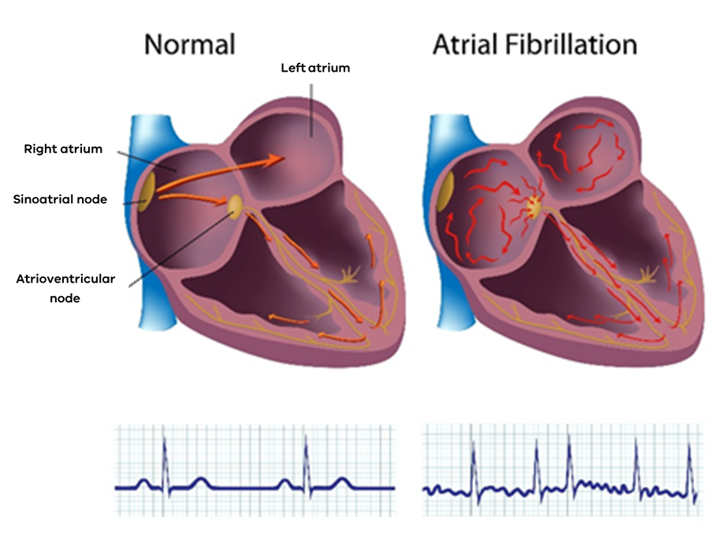

AF is common, affecting two per cent of the general population and five per cent of people over the age of 65. People with AF often experience palpitations, which is the feeling or sensation that your heart is racing, thumping or skipping beats. This often feels rapid and irregular and it may be uncomfortable. Shortness of breath, fatigue or even collapse may occur due to reduced heart efficiency. For some people with AF, there may be no symptoms or mild symptoms. However, it is still important that AF is treated because it can be associated with other problems.

Some episodes of AF are brief, with spontaneous return of normal rhythm after a short period of time. This is called ‘paroxysmal’ AF and it can occur with or without symptoms.

The most common causes of AF are long-term high blood pressure, diseases of the heart muscle or valves, excess alcohol intake and sleep disorders. Other conditions such as chronic bronchitis, pneumonia and an overactive thyroid gland often ‘trigger’ AF episodes, but in some cases no underlying cause is found.

## Risk of stroke

Having AF may increase the risk of stroke. In Australia more than one-third of strokes are associated with AF. The irregular heart rhythm causes abnormal blood flow and blood ‘pools’ or collects in the heart. This can cause blood clots. Clots can then travel to the brain, leading to a stroke brought on by blocked blood vessels. Strokes occur in patients with AF whether symptoms are present or not. There are treatments available to help prevent a stroke if you have AF.

## emergency care

### Tests

While in an emergency department or urgent care centre, you will usually have an electrocardiogram (commonly known as an ECG), which is a tracing of your heart. You might also get an x-ray of your chest and blood tests to check the levels of different substances in the blood and to check for thyroid problems. An echocardiogram (commonly known as an ‘echo’) is an ultrasound examination of the heart and is usually ordered as an outpatient.

### Treatment

There are various ways to treat AF. Your doctor will discuss the options and recommend the most appropriate treatment for you.

**1.** Some patients are treated with rate-controlling therapy. This involves using medications to slow down the pulse, which reduces symptoms and improves heart function. Your doctor may prescribe a beta-blocker (such as metoprolol), a calcium channel blocker (such as diltiazem) or digoxin.

**2.** In some patients, treatment aims to restore normal heart rhythm. Medications are usually given through a drip and may include amiodarone or flecainide. In some cases, electrical cardioversion may be attempted, using an electrical current administered under general anaesthetic.

**3.** Anticoagulant medications (blood thinners) such as apixaban, rivaroxaban and warfarin are used to prevent stroke. This treatment depends on your risk factors for stroke and for bleeding. In straightforward cases, treatment may start in an emergency department or urgent care centre. If not, this type of treatment may be considered at a follow-up medical appointment.

## follow-up

If this is your first episode of AF you may be referred to a heart specialist (cardiologist), who will assess your case and discuss ongoing treatment or tests with you. For some patients with ongoing symptoms, other treatments such as catheter ablation (a procedure that uses energy to remove small areas of heart tissue causing AF) may be required. Your cardiologist will talk to you about this.

Seeking help

In a medical emergency call an ambulance – dial triple zero (000).

You should see your doctor, return to the emergency department or urgent care centre if:

• you experience chest pains

• you experience palpitations that last more than a few hours

• you feel faint

• you experience adverse effects from your AF medication.

For health advice from a registered nurse you can call NURSE-ON-CALL 24 hours a day on 1300 60 60 24 for the cost of a local call from anywhere in Victoria.*

NURSE-ON-CALL provides access to interpreting services for callers not confident with English.

* Calls from mobiles may be charged at a higher rate.

## Want to know more?

* Ask your local doctor or healthcare professional.
* Visit the Better Health Channel at [www.betterhealth.vic.gov.au](http://www.betterhealth.vic.gov.au).

|  |  |  |
| --- | --- | --- |
| To receive this publication in an accessible format phone 9096 7770, using the National Relay Service 13 36 77 if required, or email emergencycare.clinicalnetwork@safercare.vic.gov.au  Disclaimer: This health information is for general education purposes only. Please consult with your doctor or other health professional to make sure this information is right for you. | Authorised and published by the Victorian Government, 1 Treasury Place, Melbourne.  © State of Victoria, Australia, Safer Care Victoria, May 2019  ISBN 978-1-76069-811-9 (pdf/online/MS word) | Also available online at [www.safercare.vic.gov.au](http://www.safercare.vic.gov.au) |

Modified from *Atrial fibrillation and stroke*, UK Stroke Foundation; *Atrial fibrillation – patient information*, AF Foundation, UK, *Heart Foundation consumer information*.