|  |
| --- |
|  |
| Maternity dashboard  User handbook |

|  |  |  |
| --- | --- | --- |
| This handbook was made available for use by Safer Care Victoria but is to be attributed to the State of Victoria through the Victorian Managed Insurance Authority (VMIA).  The Handbook has been updated by Safer Care Victoria and is current as at August 2019. It is based on the system as it was configured on 9 April 2018. The VMIA takes no responsibility for any information which is out of date after this point | | |
| To receive this publication  in an accessible format phone  03 9096 1384, using the National Relay Service 13 36 77 if required, or email info@safercare.vic.gov.au | Authorised and published by the Victorian Government, 1 Treasury Place, Melbourne.  © State of Victoria, Australia, Safer Care Victoria, August 2019.  ISBN 978-1-76069-723-5 (online)  Available at [www.safercare.vic](http://www.safercare.vic).gov.au |  |

Contents

Abbreviations 1

Introduction 2

Section 1: Running a report 5

Running the report 5

Reading the report 6

Printing the report 9

Saving the report 10

Section 2: Analysing your data 11

Data integrity 11

Drill down and auditing 12

Changing position and or minimum access levelof the report 13

Section 3: Indicator definitions 15

Appendix A Summary report template 41

Appendix B Indicator mapping 42

Acknowledgements 43

Contact us 44

# Abbreviations

ACHI Australian Classification of Health Interventions

ACHS The Australian Council of Healthcare Standards

BOS Birthing Outcomes System

DOM domiciliary

FGR fetal growth restriction

GSPMR Gestation standardised perinatal mortality ratio

HITH hospital in the home

MCATS Management Consultants and Technology Services

PSPI Perinatal Services Performance Indicators

SCN/NICU Special care nursery/ Neonatal Intensive care unit

SCV Safer Care Victoria

VBAC vaginal birth after caesarean

VICNISS Hospital-Acquired Infection Surveillance Program

VIHSP Infant Hearing Screening Program

VMIA Victorian Managed Insurance Authority

VPDC Victorian Perinatal Data Collection

WHA Women's and Children's Healthcare Australasia

# Introduction

The maternity indicators dashboard report is an easy-to-use, easy-to-read, real-time report tool – enabling access to local data through an integrated platform. As a tool for clinicians, managers and health service executives, the dashboard report can help identify and share evolving clinical issues with staff. It can also inform better outcomes for Victoria’s mothers and babies.

While most health services collect and analyse their own data through self-built mechanisms, the new dashboard report provides centralised, real-time performance benchmarking and measurement.

This implementation handbook will help health services understand the importance of monitoring maternity data. It will also assist in the running and interpretation of a local maternity dashboard report in the Birthing Outcomes System (BOS).

This handbook has three sections:

Section 1

A practical ‘how to’ guide, with steps on how to run, understand, print and save the dashboard report.

Section 2

Where to start when analysing data, cleaning it and reviewing individual cases.

Section 3

Details the definitions and clinical significance of each maternity dashboard indicator.

### Report features

Simple to generate, the report transforms raw maternity data into a suite of 35 key performance indicators. Hospitals may use this report to regularly monitor their own performance, enabling robust evaluation of their internal activity relative to best practice and previous performance measures.

Leveraging data already captured in BOS, the maternity dashboard report:

* provides a centralised summary page with a high-level snapshot of each performance indicator, with trend lines and coded traffic light statuses to help interpret the data
* allows for drilling down into each of the 35 performance indicators
* displays each indicator in a useful way, including as a graph with trendlines, targets, definitions and transparently documented numerator and denominator explanations
* allows for further interrogation and review of individual episodes of care, through a list of all birth records.

The dashboard report can be exported with Microsoft Excel functionality.

About BOS

BOS is an integrated pregnancy, birthing and neonatal record used by the majority of Victorian maternity hospitals and supported by the Management Consultants and Technology Services (MCATS) group. BOS is the primary data source for the Victorian Perinatal Data Collection and supports the Hospital-Acquired Infection Surveillance Program (VICNISS), Infant Hearing Screening Program (VIHSP) and Women's and Children's Healthcare Australasia (WHA) data collections.

For additional help with BOS, please refer to the relevant BOSv6 online help section, or contact MCATS BOS support on (03) 9527 3997 or support@mcats.com.au.

### Background

Victorian maternity services collect a wealth of data to fulfil legislative and regulatory requirements. However, some health services may lack the necessary resources and tools to effectively analyse their own information to adequately fulfil their governance obligations and drive clinical improvement activities. Additionally, maternity services receive the Perinatal Services Performance Indicators (PSPI) annual data report. However, there is a time lag in receiving this.

This presents an opportunity for a new reporting tool that fills these requirements.

In response to these challenges, VMIA, the Department of Health and Human Services and Safer Care Victoria (SCV) worked together on a new report to minimise time lag between data submission by health services and performance reporting. VMIA developed a tool that:

* can be generated automatically to present routinely collected data
* is reflective of the quality and safety of an individual service, irrespective of size or complexity
* can be generated in a timeframe dictated by individual services
* will provide visibility of ‘raw’ data to create awareness of data integrity issues
* can be used to generate dashboards to identify specific performance issues
* will ultimately lead to better outcomes for Victorian women and their babies.

Table 1: The maternity dashboard report indicators

|  |  |
| --- | --- |
| Indicator | Name of Indicator |
| MDX00 | Number of babies born |
| MDX05 | Number of women who gave birth |
| MDA10 | First visit before 12 weeks |
| MDA20 | Severe fetal growth restriction |
| MDA30 | Smoking cessation |
| MDA40 | Pertussis vaccination |
| MDA41 | Influenza vaccination |
| MDB00 | All births - inductions |
| MDB01 | All births – caesarean section |
| MBD02 | All births – 3rd and 4th degree tears |
| MBD03 | All births - episiotomy |
| MDB10 | Standard primiparae – induction rate |
| MDB20 | Planned vaginal birth after caesarean (VBAC) |
| MDB21 | Successful VBAC after planned VBAC |
| MDB30 | Caesarean section – Robson group 1 |
| MDB31 | Caesarean section – modified Robson group 2 |
| MDB33 | Caesarean section – Robson group 1 & modified 2 |
| MDB40 | Caesarean section – under general anaesthesia |
| MDB50 | Third or Fourth degree perineal tear – (first birth) |
| MDB51 | Third or Fourth degree perineal tear – (subsequent birth) |
| MDB60 | Primiparae – third or fourth degree tears – (unassisted birth) |
| MDB61 | Primiparae – third or fourth degree tears – (assisted birth) |
| MDB70 | Primiparae – episiotomy (unassisted birth) |
| MDB71 | Primiparae – episiotomy (assisted birth) |
| MDM10 | Blood transfusion during birth admission with a blood loss >499mls |
| MDM11 | Blood loss >499ml (vaginal) and >749 (caesarean) |
| MDM20 | Peripartum hysterectomy |
| MDF10 | Five minute Apgar score <7 |
| MDF20 | Transfer to Special care nursery (SCN)/Neonatal Intensive care unit (NICU) |
| MDF30/MDF31 | Perinatal deaths & gestation standardised perinatal mortality ratio (GSPMR) at >32 weeks |
| MDP10 | Term babies – breastfeeding initiation |
| MDP11 | Term breastfed babies – given formula |
| MDP12 | Term breastfed babies – last feed from the breast |
| MDP20 | Referral to domiciliary (DOM) or hospital in the home (HITH) |

# Section 1: Running a report

This section will help health services with basic operations, such as running, reading, printing and saving the dashboard report. More advice is available through the webinar from SCV’s Maternity and Newborn Clinical Network and regional midwives. For more information, go to [bettersafercare.vic.gov.au/maternityandnewbornclinicalnetwork](https://bettersafercare.vic.gov.au/about-us/about-scv/our-clinical-networks/maternity-and-newborn-clinical-network).

Running the report

Most Victorian health services use BOS to document pregnancy, intrapartum, postpartum, SCN/NICU care and domiciliary outcomes for their patients. A range of built-in reports and reporting features currently enable BOS users to manage and analyse data relating to outcomes across all these areas. The changes released in BOS 6.4.3 extend the reporting capability of the BOS platform, while allowing the dashboard report to be run in a way familiar to BOS users.

The dashboard report is accessible through the ‘periodic reports’ menu:

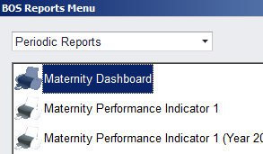

**Note:** the report may take a few minutes to run – this is normal as it is processing large amounts of data.

Only an ‘end date’ is required in the ‘reports input’ screen. The report by default will generate a report for the 12 months prior to the given date. A future date can be used:



Selecting the required campus and clicking ‘OK’ will generate the report. The report is generated through Microsoft Excel and can be saved to the desktop if required.

Reading the report

The aim of this report is to help support health services track performance and implement timely actions. The dashboard report is not intended to supersede existing reporting or quality improvement methods. However, while many health services may already have similar tools and undertake activities to fulfil this function, the value of this report may be found in its simplicity and consistency.

After running the report, there are 11 tabs in the workbook (found at the very bottom of the page). These tabs are explained in the following section.

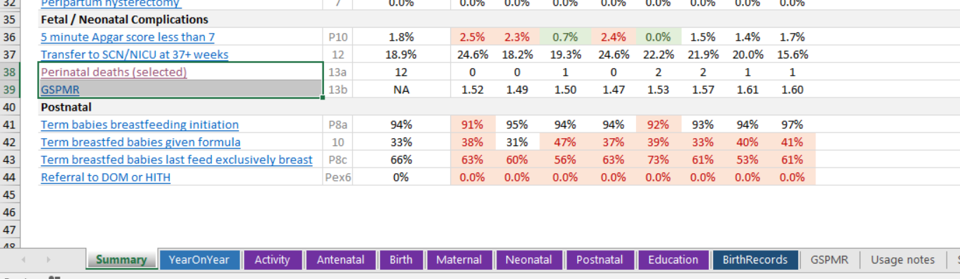

### Tab 1: The summary

The report summary page allows for the export of a high-level snapshot of the health services data across all 25 maternity indicators.

Grouped in the order of the patient journey, the summary tab provides a month by month data snapshot of the health services outcomes, trendlines for the current year and a traffic light system to flag results in relation to least and most favourable parameters.

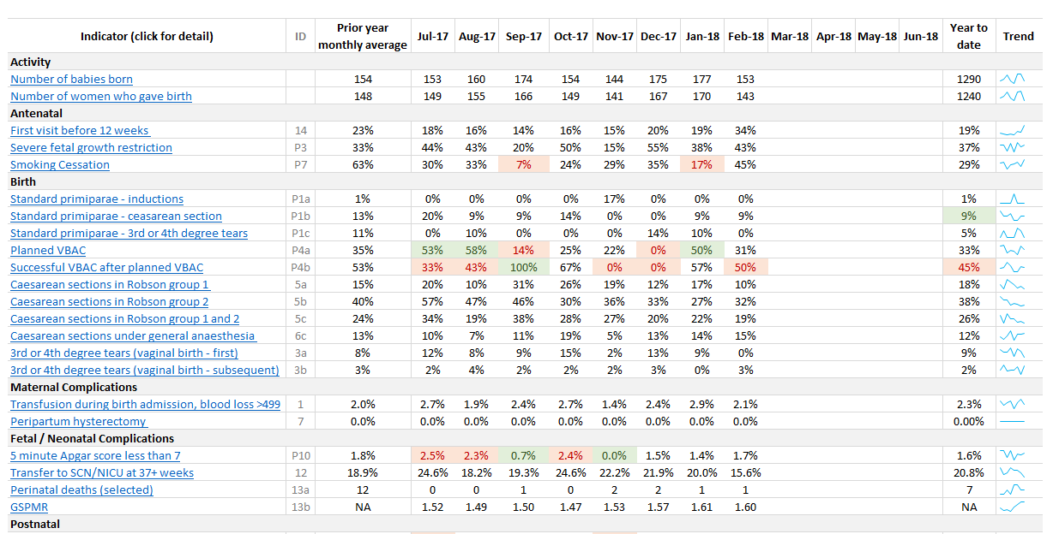

### Tab 2: Year on year

Year on year data provides a snapshot of the health services performance as a year on year comparison. Trend lines indicate how they have been going over the previous three years.

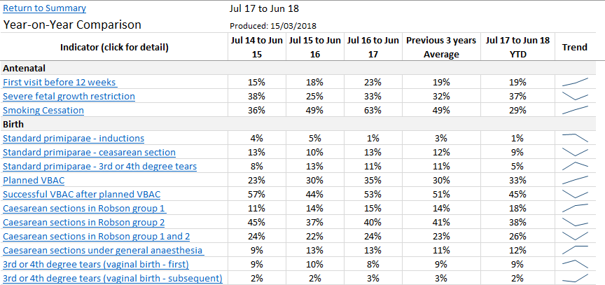

Tab 3: Activity

The health services birthing activity (number of babies born and number of women giving birth) is captured here. This information is important as it helps the health service understand the context in which their maternity Indicators have been derived.

For example, increasing birthing activity might help explain why the standard primiparae indicator results in caesarean section and/or induction are increasing or decreasing, supporting the health service to develop targeted action plans to improve.

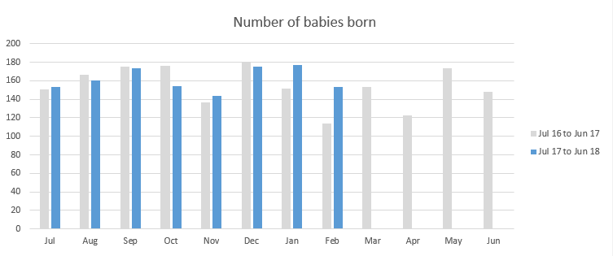

Tabs 4 to 9: Antenatal, birth, maternal, neonatal, postnatal and education

These sheets graphically compare the health services performance for current period with their previous year. Some indicators have target limits, mostly based on the lower and upper quartiles published in the current PSPI report. When these limits are breached – either favourably or unfavourably – the colour will change to green or red as an alert.

**Note:** For some indicators, namely where the monthly population size (denominator) is expected to be small, only the year to date will alert the health service to this.

Green = Above (or below) the favourable limit.

Red = Above (or below) the unfavourable limit.

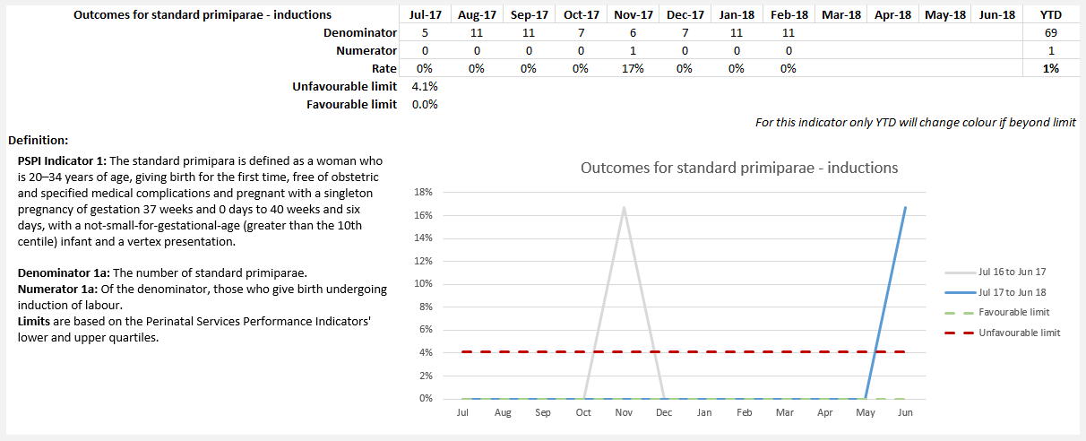

Tab 10: Birth records

Individual records are displayed on the birth records tab for drill down and auditing.

These are not deidentified, so please be mindful of who the report is shared with.

Tab 11: Gestation standardised perinatal mortality ratio (GSPMR)

The health services raw perinatal data and five-year GSPMR data is captured here for further drill down, audit and reference.

Printing the report

The report may be printed through Microsoft Excel. To print the currently active sheet:

1. Click **File**.



1. In the left bar, click **Print.**



Saving the report

The instructions for saving to PDF are the same as printing, except instead of selecting printing, click **Save as**.

1. Select PDF from the **Save as type** dropdown.

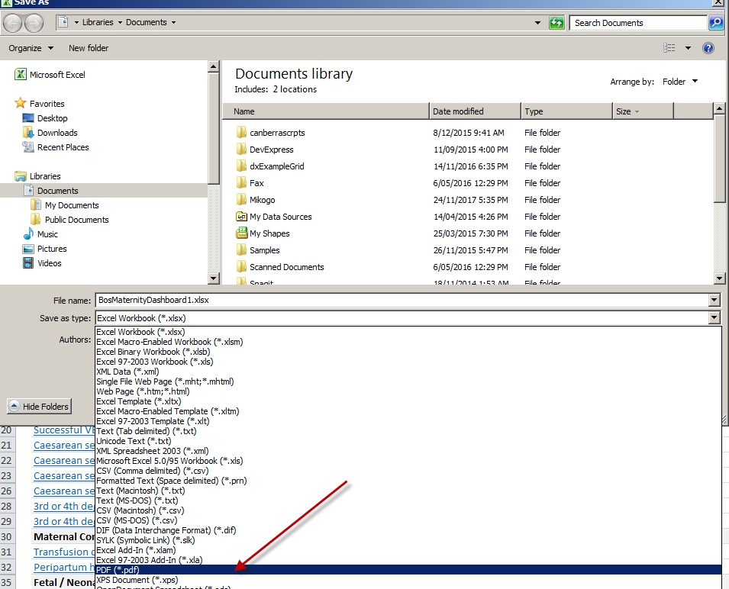

1. Type in file name and click **Save.**

This will save the current page, suitable for printing or emailing. Please be mindful of sending identified data.

# Section 2: Analysing the data

## Data integrity

When interpreting the data in this report, it is important to note the following:

* The indicators are only as good as the quality of the data comprising them.
* We recommend using the ‘birth records’ sheet as a tool to help identify data issues.
* Common issues, including missing data elements, may be quickly identified by observing the value in the ‘check’ column in the birth records sheet.
* Please give special attention to the following BOS reference files before relying on the indicators:
  + **Congenital anomalies**
  + Ensure the Victorian Perinatal Data Collection (VPDC) code is specified for all items, including non-reportable minor anomalies and ‘Nil’.
  + Use code 9999 (Not reportable) for minor anomalies and ‘Nil’. Please refer to **Appendix B** in the [Victorian Congenital Anomalies Register report](https://www2.health.vic.gov.au/hospitals-and-health-services/quality-safety-service/consultative-councils/council-obstetric-paediatric-mortality/congenital-anomalies-register).
  + **Procedures**

Indicator MDM20 – Peripartum hysterectomy relies on the existence and use of an item mapped to Australian Classification of Health Interventions (ACHI) Code 3565301 – Peripartum hysterectomy.

* + **Discharge destination**

Indicator MDF20 – Transfer to SCN/NICU at 37+ weeks relies on the setting of the ‘NICU or SCN’ flag.

* + **Maternal medical conditions**

The standard primiparae definition excludes women who have conditions mapped to the following codes: O2432, O2433, O2434, O2439, O994, O100, F200, F201, F203, F204, F205, F206, F208, F209, F310, F311, F312, F313, F314, F315, F314, F318, F319, F500, F501, F502, F503, F504, F505, F508, F509, F6031

* + **Induction indication**

The standard primiparae definition excludes records with induction indications mapped to any code starting with O1, O2 or O3

* + **Perineum status**

The tear-related indicators refer to the VPDC Code, not The Australian Council of Healthcare Standards (ACHS) report code.

* All sheets are protected, including the birth records sheet. To drill down using the filter, please un-protect sheets using the link in the top right of the summary sheet.
* Calculations are disabled on each sheet. Changing data directly on the sheet will have no effect. To recalculate indicators after data is changed on BOS, please re-run the Maternity dashboard.
* Please read definitions carefully. Some conditions, inclusions or exclusions may be changed from the original indicator definitions.
* Targets that are taken from published sources such as PSPI may vary from year to year. As such, caution is advised when using these as the targets may not match the reporting period in question.

## Drill down and auditing

In order to interrogate the data, first unprotect the sheet from the top of the summary page



Once unprotected message below will appear



Now move to the birth record tab and interrogate the data.

It is important to run the report and check the birth records (first column ‘check’). Filter on that column by unticking the blank data element leaving records that require investigation or correction for missing data. Filtering on birth date can assist in focusing on specific months/years.



Making these corrections will allow for data completeness and a more robust report. All corrections need to be made within the BOS record in order to be reflected in the report once re-run.

**Note:** Changes made to the birth record spreadsheet will not impact the summary spreadsheet or any other spreadsheets.



Once the data has been cleaned and the report re-run, it is time to look at individual indicators from the summary sheet by clicking on the indicator name which will go to the indicator definition and graph.

To further drill down into the data, click on the numerator or the denominator then click to see records.



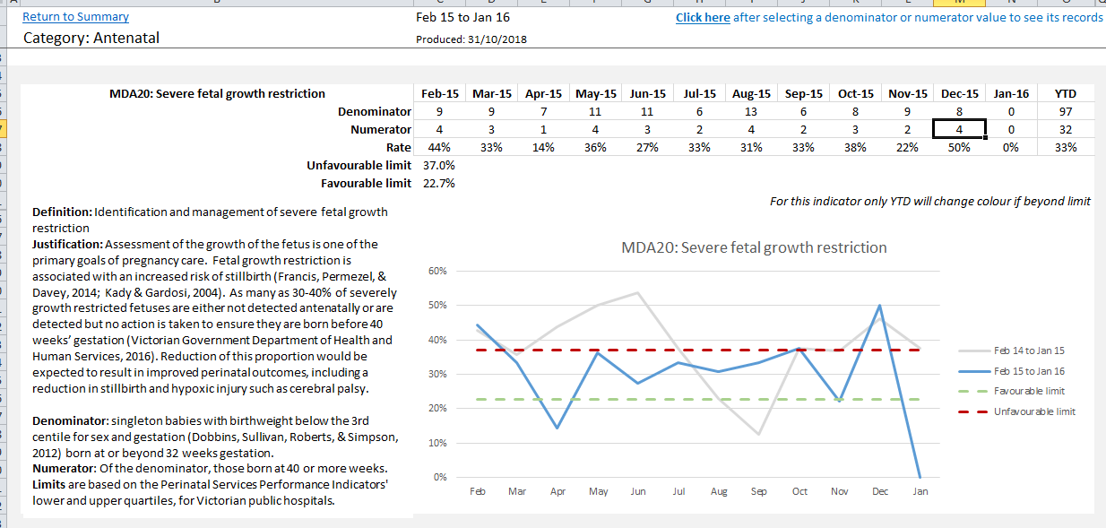

To return to the summary sheet from birth records click on return to last indicator in header

Return to Last Indicator

## Changing position and or minimum access levelof the report

System administrators need to go to ‘system maintenance’ in the header.



Report parameters under the system control files.

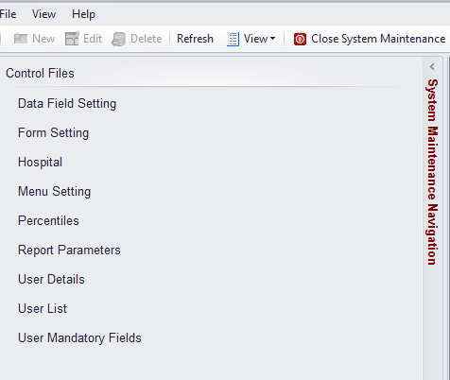

Search for the Maternity dashboard by starting to type the name in the search box.



Double click on the Maternity dashboard name, this opens the settings details.

The minimum access level and position of the report can be changed here in consultation with program leads.

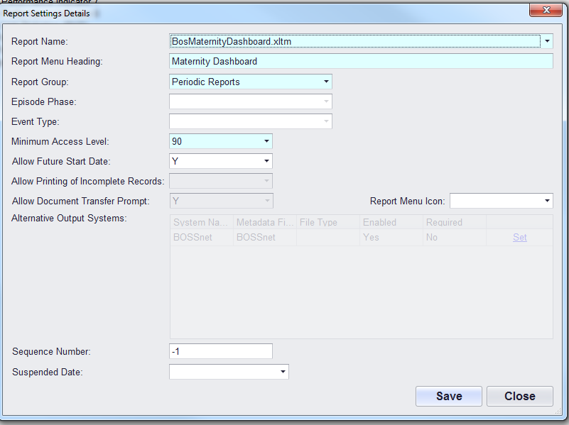

Once changes have been made, remember to **Save.**

# Section 3: Indicator definitions

The below definitions are intended to provide consistency across all hospitals. While we acknowledge there will be debate on the definitions, the below aligns to the PSPI report where possible. We anticipate these definitions will be reviewed regularly to reflect any agreed changes in thinking in the sector. Please contact us to provide feedback.

Table 2: BOS indicators, grouped by primary category

| Indicator | Name of indicator |
| --- | --- |
| Activity |  |
| MDX00 | Number of babies born |
| MDX05 | Number of women who gave birth |
| Antenatal |  |
| MDA10 | First visit before 12 weeks |
| MDA20 | Severe fetal growth restriction |
| MDA30 | Smoking cessation |
| MDA40 | Pertussis Vaccination |
| MDA41 | Influenza Vaccination |
| Birth |  |
| MDB00 | All births – inductions |
| MDB01 | All births – caesarean section |
| MDB02 | All births – 3rd or 4th degree tears |
| MDB03 | All births - episiotomy |
| MDB10 | Standard primiparae – inductions |
| MDB20 | Planned VBAC |
| MDB21 | Successful VBAC |
| MDB30 | Caesarean section – Robson group 1 |
| MDB31 | Caesarean section – modified Robson group 2 |
| MDB33 | Caesarean section – Robson group 1 and modified 2 |
| MDB40 | Caesarean section under general anaesthesia |
| MDB50 | Third or fourth degree perineal tear – first birth |
| MDB51 | Third or fourth degree perineal tear – subsequent birth |
| MDB60 | Primiparae – 3rd or 4th degree tears (unassisted birth) |
| MDB61 | Primiparae -3rd or 4th degree tears (assisted birth) |
| MDB70 | Primiparae – Episiotomy (unassisted birth) |
| MDB71 | Primiparae – Episiotomy (assisted birth) |
| Maternal complications | |
| MDM10 | Blood transfusion during birth admission, blood loss >499mls |
| MDM11 | PPH – Blood loss.499ml (vaginal birth) and >749ml (caesarean section) |
| MDM20 | Peripartum hysterectomy |
| Fetal and neonatal complications | |
| MDF10 | Five-minute Apgar score <7 |
| MDF20 | Transfer to SCN/NICU |
| MDF30/MDF31 | Perinatal deaths and gestation standardised perinatal mortality ratio (GSPMR) at >32 weeks |
| Postnatal |  |
| MDP10 | Term babies – breastfeeding initiation |
| MDP11 | Term breastfed babies – given formula |
| MDP12 | Term breastfed babies – last feed exclusively breast |
| MDP20 | Referral to domiciliary (DOM) or hospital in the home (HITH) |

### Indicator MDX00: Number of babies born

All babies born ≥ 20 weeks gestation. Includes births prior to arrival to the health service.

### Indicator MDX05: Number of women who gave birth

Total number of pregnancies resulting in at least one livebirth or stillbirth ≥ 20 weeks gestation. Includes births prior to arrival to the health service.

### Indicator MDA10: First visit before 12 weeks

Rate of women attending their first antenatal visit prior to 12 weeks’ gestation.

|  |  |
| --- | --- |
| Current definition | The first antenatal visit is the first visit to a midwife or doctor arranged at which advice or management is provided related to the pregnancy, but not one that is limited to confirmation of pregnancy. The visit may be provided by any care provider in the community or in hospital.  A maternity or antenatal care provider is defined as the clinician who provides care to pregnant women and includes midwives, general practitioners and obstetricians. |
| Clinical significance | Early engagement with antenatal care enables caregivers to provide information, support and screening for potential problems. Provision of care only after 12 weeks of pregnancy misses important opportunities for preventative healthcare and is considered to be suboptimal. |
| Numerator | Of the denominator, those whose first antenatal care visit with any provider occurs before 12 weeks’ gestation. |
| Denominator | The number of women who gave birth. |
| Limits | Based on PSPI’s lower and upper quartiles, for Victorian public hospitals. |

### Indicator MDA20: Severe fetal growth restriction

Rate of severe fetal growth restriction (FGR) in a singleton pregnancy undelivered by 40 weeks.

|  |  |
| --- | --- |
| Current definition | Severe FGR is defined as a birthweight less than the 3rd centile for gestation and sex whether live born or stillborn.  Exclusions are:   * babies without severe FGR * multiple births * births at earlier gestations (less than 32 weeks). |
| Clinical significance | Assessment of the growth of the fetus is one of the primary goals of pregnancy care.  Fetal growth restriction is associated with an increased risk of stillbirth (Francis, Permezel & Davey, 2014; Kady & Gardosi, 2004) As many as 30-40% of severely growth restricted fetuses are either not detected antenatally or are detected but no action is taken to ensure they are born before 40 weeks’ gestation. (Victorian Government Department of Health and Human Services, 2016).  Reduction of this proportion would be expected to result in improved perinatal outcomes, including a reduction in stillbirth and hypoxic injury such as cerebral palsy. |
| Numerator | Of the denominator, babies born at 40 or more weeks’ gestation. |
| Denominator | Singleton babies (live and stillborn) with a birthweight below the 3rd centile for gestation and sex (Dobbins, Sullivan, Roberts, & Simpson, 2012) born at, or beyond 32 weeks’ gestation. |
| Limits | Based on PSPI’s lower and upper quartiles, for Victorian public hospitals. |

### Indicator MDA30: Smoking cessation

Smoking cessation rate for pregnant women.

|  |  |
| --- | --- |
| Current definition | Rate of women who stopped smoking after 20 weeks’ gestation among those who smoked before 20 weeks. |
| Clinical significance | This measure indirectlyassesses the performance of Victorian health services in providing smoking cessation advice, assistance and follow-up during the antenatal period to reduce both the rate of smoking among pregnant women and the risk of smoking-associated adverse health outcomes for babies.  Women who smoke while pregnant have an increased risk of ectopic pregnancy, miscarriage, placenta praevia and pre-term labour, and are more likely to give birth to a low-birthweight baby compared with non-smokers.  The damaging effects of maternal cigarette smoking on an unborn baby include reduction of oxygen supply, restricted growth and development, increased risk of cleft lip and cleft palate, and increased heart rate and disruption of the baby’s breathing movements in utero.  Smoking in pregnancy is a preventable cause of significant obstetric and perinatal complications, and adverse outcomes. Pregnancy is therefore an important time for health professionals to implement strategies and interventions to help women quit smoking, particularly given that women are motivated to protect their baby’s health. |
| Numerator: | Number of women who stopped smoking after 20 weeks gestation among those who smoked before 20 weeks. |
| Denominator: | Number of women who smoked before 20 weeks’ gestation. |
| Limits | Based on PSPI’s lower and upper quartiles, for Victorian public hospitals. |

### Indicator MDA40: The rate of women vaccinated for pertussis

Rate of women vaccinated for pertussis

|  |  |
| --- | --- |
| Current definition | The rate of women vaccinated for pertussis during pregnancy |
| Numerator | The number of women who received a pertussis vaccine at any point during pregnancy (excludes postnatally) |
| Denominator | The number of women who gave birth. |
| Limits | Based on PSPI’s lower and upper quartiles, for Victorian public hospitals. |

### Indicator MDA41: The rate of women vaccinated for influenza

Rate of women vaccinated for influenza

|  |  |
| --- | --- |
| Current definition | The rate of women vaccinated for influenza during pregnancy |
| Numerator | The number of women who received influenza vaccine at any point during pregnancy |
| Denominator | The number of women who gave birth. |
| Limits | Based on PSPI’s lower and upper quartiles, for Victorian public hospitals. |

### Indicator MDB00: Outcome for all births – induction of labour

Rate of inductions of labour for all births.

|  |  |
| --- | --- |
| Current definition | Total number of women who gave birth following an induction of labour |
| Clinical significance | Induction of labour can increase the need for instrumental vaginal birth or caesarean section, therefore safely reducing the number of women who have an induced labour may reduce the numbers who require birthing interventions overall |
| Numerator | Of the denominator, those who give birth undergoing induction of labour |
| Denominator | Total number of pregnancies resulting in at least one livebirth or stillbirth. Includes births prior to arrival at the health service |

### Indicator MDB01: Outcome for all births – caesarean section

Rate of caesarean sections for all births.

|  |  |
| --- | --- |
| Current definition | Total number of women who gave birth via caesarean section |
| Clinical significance | Caesarean section can increase the risk of complications, lead to longer recovery times for women and adversely affect future pregnancies. Therefore, hospitals with higher levels of medical intervention are encouraged to review their practices and processes. |
| Numerator | Of the denominator, those who give birth via a caesarean section |
| Denominator | Total number of pregnancies resulting in at least one livebirth or stillbirth. Includes births prior to arrival to the health service. |

### Indicator MDB02: Outcomes for all births – 3rd and 4th degree tears

Rate of women who sustain a 3rd or 4th degree tear.

|  |  |
| --- | --- |
| Current definition | Total number of women who birthed and sustained a 3rd or 4th degree perineal tear |
| Clinical significance | Severe perineal trauma is an important cause of both short and long-term morbidity and an increasing cause of medical litigation. Skilled care at birth can reduce the severity or occurrence of perineal trauma.  While a low rate for this indicator is preferable, optimal care involves identification of 3rd and 4th degree tears and referral for appropriate management.  A higher than expected rate could therefore indicate careful assessment and thereby better identification, or conversely, a low rate could indicate quality care or poor assessment and failure to identify a severe tear. |
| Numerator | Of the denominator, those who sustained a 3rd or 4th degree tear |
| Denominator | Total number of pregnancies resulting in at least one livebirth or stillbirth. Includes births prior to arrival to the health service. |

### Indicator MDB03: Outcomes for all births - episiotomy

Rate of women who have an episiotomy.

|  |  |
| --- | --- |
| Current definition | Total number of women who birthed and had an episiotomy performed |
| Numerator | Of the denominator, those women who have an episiotomy performed |
| Denominator | Total number of pregnancies resulting in at least once livebirth or stillbirth. Includes births prior to arrival to the health service |

### 

### Indicator MDB10: Standard primiparae – Induction rate

Rate of inductions of labour in standard primiparae.

|  |  |
| --- | --- |
| Current definition | The standard primiparae is defined as a woman aged between 20 to 39years, with no obstetric and specified medical complications (pre-existing hypertension, diabetes, heart disease or serious psychiatric conditions), giving birth for the first time, with a singleton pregnancy, not growth restricted (greater than tenth centile) and presenting head first at 37 weeks and 0 days to 40 completed weeks gestation. |
| Clinical significance | This indicator focuses on low-risk and uncomplicated pregnancies. Therefore, medical intervention and the rate of complications during labour and birth for this group of women are expected to be low.  Induced labour can increase the risk of complications, lead to longer recovery times for women and adversely affect future pregnancies. Therefore, hospitals with higher levels of medical intervention are encouraged to review their practices and processes. |
| Numerator | Number of standard primiparae who give birth undergoing induction of labour |
| Denominator | Number of standard primiparae women who gave birth. |
| Limits | Based on PSPI’s lower and upper quartiles, for Victorian public hospitals. |

### Indicator MDB20: Vaginal births after primary caesarean section Planned VBAC

Rate of women who planned for vaginal birth following a primary caesarean section.

|  |  |
| --- | --- |
| Current Definition | Rate of women who planned for vaginal birth following a primary caesarean section.  May differ from other vaginal birth after caesarean (VBAC) indicators.  Primary caesarean is often defined as the first ever caesarean regardless of parity, whereas this indicator selects only prior caesareans in primiparae.  The VPDC collects outcomes for women at term whose only previous birth was a caesarean section; any of these women who entered labour and did not have a subsequent planned caesarean is assumed to have planned a VBAC. |
| Clinical Significance | Approximately one-third of all babies in Victoria are born by caesarean section. While many of these procedures are necessary and improve outcomes for women and babies, having a caesarean section can prolong recovery from the birth, increase the small risk of serious morbidity after the birth and increase the risk of major complications in subsequent pregnancies (particularly problems with implantation of the placenta). For health services, caesarean section procedures require additional resources and costs.  Reducing the number of avoidable caesarean sections minimises these problems. |
| Numerator | Of the denominator, those who enter labour with a plan for a vaginal birth. |
| Denominator | The number of women (para 1 and at term with a singleton pregnancy) whose previous birth was a caesarean section. |
| Limits | Based on PSPI’s lower and upper quartiles, for Victorian public hospitals. |

### Indicator MDB21: Vaginal births after primary caesarean section -Successful VBAC

Rate of women who had a planned vaginal birth following a primary caesarean section.

|  |  |
| --- | --- |
| Current definition | Of those women who attempted a VBAC, the rate of women who achieved a vaginal birth following a primary caesarean section.  May differ from other vaginal birth after caesarean (VBAC) indicators. Primary caesarean is often defined as the first ever caesarean regardless of parity, whereas this indicator selects only prior caesareans in primiparae.  The VPDC collects outcomes for women at term whose only previous birth was a caesarean section; any of these women who entered labour and did not have a subsequent planned caesarean is assumed to have planned a VBAC. |
| Clinical significance | Reducing the number of avoidable caesarean sections minimises problems associated with this major surgical procedure. Two strategies to do this are:   * + 1. Preventing a woman’s first caesarean section (having a caesarean section for the first birth greatly increases the risk of needing a caesarean in subsequent births)     2. Encouraging women who have had a prior caesarean section to safely attempt a subsequent VBAC and supporting them to achieve this.   The safety of women and babies is paramount. Sound clinical judgement is required to differentiate the avoidable from the unavoidable first caesarean section and to assess women with a prior caesarean section for whom a plan for a VBAC is appropriate. |
| Numerator | Of the denominator, those who had a vaginal birth. |
| Denominator | The number of women (para 1, at term with a singleton pregnancy) whose previous birth was a caesarean and who enter labour with a plan for a vaginal birth. |
| Limits | Based on PSPI’s lower and upper quartiles, for Victorian public hospitals. |

### Indicator MDB30: Caesarean Section Rate in Robson Group 1

Rate of caesarean sections in women classified as a Robson Group 1.

|  |  |
| --- | --- |
| Current definition | Rate of caesarean sections in women classified as a Robson Group 1.  Robson Group 1 describes the nulliparous women with a single cephalic pregnancy, at 37 weeks or more gestation with a spontaneous labour onset. |
| Clinical significance | The caesarean section (CS) rate in Victoria is currently 33%. This is widely regarded as too high. While caesarean birth is necessary and desirable, in some cases it is accompanied by a number of adverse consequences: a slower recovery from the birth for the mother, increased rates of maternal morbidity, lower rates of breastfeeding, increased risk in subsequent pregnancies including abnormal placentation (placenta praevia, placenta accreta) and a high elective repeat CS rate, and an increased burden on the maternity care system.  While it is often possible for a woman who has had a caesarean to achieve a vaginal birth in subsequent pregnancies this in fact occurs for only a minority of these women. Preventing the first caesarean is likely to be a more effective way of reducing the overall caesarean rate.  The Robson 10 group classification system is a method of categorising women according to readily available characteristics using parity, gestation, onset of labour, plurality, presentation and history of caesarean section. It does not account for other complications of pregnancy or pre-existing maternal medical conditions.  The proportion of women in this category who give birth by caesarean section provides a useful measure of the quality of intrapartum care. |
| Numerator | Of the denominator, the number of women in Robson Group 1 who have a caesarean section. |
| Denominator | Number of women in Robson Group 1. |

### Indicator MDB31: Caesarean section rate in modified Robson Group 2

Rate of caesarean sections in women classified as modified Robson Group 2

|  |  |
| --- | --- |
| Current definition | Rate of caesarean sections in women classified as modified Robson Group 2.  Modified Robson Group 2 describes the nulliparous woman with a single cephalic pregnancy at 37 weeks or more gestation who was induced. Excludes women having a planned caesarean section. |
| Clinical significance | As per MDB30:  The proportion of women in this group who give birth by caesarean section provides a useful measure of the quality of intrapartum care. |
| Numerator | Of the denominator, those who have a caesarean section. |
| Denominator | Number of women in modified Robson Group 2. |

### Indicator MDB33: Caesarean section rate in Robson Groups 1 and modified2

Rate of caesarean sections in women classified as a Robson Group 1 and modified Robson Group 2 combined.

|  |  |
| --- | --- |
| Current definition | Rate of caesarean sections in women classified as a Robson Group 1 and modified 2 combined.  Groups 1 and 2 include the women giving birth for the first time with a singleton, term, cephalic-presenting baby. Group1 are those in spontaneous labour and modified Group 2 are those whose labour was induced. Excludes those women having a planned caesarean section. |
| Clinical significance | As per MDB30:  Collectively, the proportion of women in each Groups 1 and modified 2 combined who give birth by caesarean section provides a useful measure of the quality of intrapartum care. |
| Numerator | Of the denominator, those who have a caesarean section. |
| Denominator | Number of women in Robson Groups 1 and modified 2. |

### Indicator MDB40: Caesarean section – General anaesthesia

Rate of caesarean sections performed under general anaesthesia.

|  |  |
| --- | --- |
| Current definition | Rate of women having a caesarean either planned or as an emergency who receive a general anaesthetic. |
| Clinical significance | In the vast majority of cases, caesarean sections are performed under regional anaesthesia. In some cases, the urgency with which the caesarean is required does not allow for the placement of regional anaesthesia, or regional anaesthesia is unable to be attained, or there is a clinical reason for preferring general anaesthesia.  General anaesthesia is associated with higher levels of maternal morbidity than regional and typically requires more advanced neonatal resuscitation.  This indicator includes women who had multiple births |
| Numerator | Of the denominator, the number of women who have had a general anaesthetic for their caesarean section. |
| Denominator | The number of women who give birth by caesarean section. |

### Indicator MDB50: OASI 3rd or 4th degree perineal tear – First birth

Rate of women having their first baby vaginally who experience a 3rd or 4th degree perineal tear.

|  |  |
| --- | --- |
| Current Definition | Rate of women having their first baby vaginally, who experience Obstetric anal sphincter injury (OASI)- 3rd or 4th degree perineal tear, regardless of type of vaginal birth. |
| Clinical Significance | Severe perineal trauma is an important cause of both short and long-term morbidity (Pollack et al., 2004; Priddis et al., 2013) and an increasing cause of medical litigation. Skilled care at birth can reduce the severity or occurrence of perineal trauma.  While a low rate for this indicator is preferable, optimal care involves identification of 3rd and 4th degree tears and referral for appropriate management.  A higher than expected rate could therefore indicate careful assessment and thereby better identification, or conversely, a low rate could indicate quality care or poor assessment and failure to identify a severe tear. |
| Numerator | Of the denominator, those who experience a 3rd or 4th degree perineal tear |
| Denominator | Women who birthed their first baby vaginally. |

### Indicator MDB51: OASI 3rd or 4th degree perineal tear – Subsequent birth

Rate of women having a subsequent (not first) baby vaginally, regardless of the type of birth who experience a 3rd or 4th degree perineal tear.

|  |  |
| --- | --- |
| Current definition | Rate of multigravida women having a subsequent (not first) baby vaginally, experiencing a 3rd or 4th degree perineal tear regardless of type of vaginal birth. |
| Clinical significance | Severe perineal trauma is an important cause of both short and long-term morbidity and an increasing cause of medical litigation. Skilled care at birth can reduce the severity or occurrence of perineal trauma.  While a low rate for this indicator is preferable, optimal care involves identification of 3rd and 4th degree tears and referral for appropriate management.  A higher than expected rate could therefore indicate careful assessment and thereby better identification, or conversely, a low rate could indicate quality care or poor assessment and failure to identify a severe laceration. |
| Numerator | Of the denominator, those who experience a 3rd of 4th degree perineal tear. |
| Denominator | Women having a subsequent (not first) baby vaginally. |

### Indicator MDB60: Primiparae – 3rd or 4th degree perineal tear (unassisted birth)

Rate of women who sustain a 3rd or 4th degree perineal tear during an unassisted vaginal birth

|  |  |
| --- | --- |
| Current definition | For all primiparae, the proportion who have a third- or fourth-degree perineal tear during an unassisted vaginal birth. Included are those women who gave birth for the first time and had a vaginal birth, without instruments. Women who had a multiple birth are included if this was the first time, they had given birth.  Excluded are those women who did not give birth for the first time or gave birth by caesarean section.  The rates for third- and fourth-degree tears includes episiotomies extended by a laceration of a third and fourth-degree. |
| Clinical significance | Complications such as third or fourth degree perineal tears after vaginal birth can cause long term problems for women. Therefore, a low rate of third and fourth degree perineal tears after unassisted vaginal birth is desirable |
| Numerator | Of the denominator, the number of primiparae who had a 3rd or 4th degree perineal laceration during an unassisted vaginal birth. |
| Denominator | The number of primiparae who had an unassisted vaginal birth |
| Limits | Based on PSPI’s lower and upper quartiles, for Victorian public hospitals. |

### Indicator MDB61: Primiparae – 3rd or 4th degree perineal tear (assisted birth)

Rate of women who sustain a 3rd or 4th degree perineal tear during an instrumental vaginal birth

|  |  |
| --- | --- |
| Current definition | For all primiparae, the proportion who have a third- or fourth-degree perineal tear during an assisted vaginal birth. Assisted (or operative/instrumental) vaginal birth refers to a forceps or vacuum assisted birth). Included are those women who gave birth for the first time and had a vaginal birth, with instruments. Women who had a multiple birth are included if this was the first time, they had given birth.  Excluded are those women who did not give birth for the first time or gave birth by caesarean section.  The rates for third- and fourth-degree tears includes episiotomies extended by a laceration of a third and fourth-degree. |
| Clinical significance | Complications such as third or fourth degree perineal tears after vaginal birth can cause long term problems for women. Therefore, a low rate of third and fourth degree perineal tears after vaginal birth is desirable |
| Numerator | Of the denominator, the number of primiparae who had a 3rd or 4th degree perineal laceration during an assisted (instrumental) vaginal birth. |
| Denominator | The number of primiparae who had an assisted vaginal birth |
| Limits | Based on PSPI’s lower and upper quartiles, for Victorian public hospitals. |

### 

### Indicator MDB70: Primiparae – episiotomy (unassisted birth)

Rate of women who have an episiotomy performed during an unassisted vaginal birth

|  |  |
| --- | --- |
| Current definition | For all primiparae, the proportion who received an episiotomy during an unassisted vaginal birth.  Episiotomy is defined as an incision of the perineum and vagina made during vaginal birth.  Included are those women who gave birth for the first time and had a vaginal birth, without instruments. Women who had a multiple birth are included if this was the first time, they had given birth.  Excluded are those women who did not give birth for the first time or gave birth by caesarean section. |
| Numerator | Of the denominator, the number of primiparae who had an episiotomy performed during an unassisted vaginal birth. |
| Denominator | The number of primiparae who had an unassisted vaginal birth |

### Indicator MDB71: Primiparae – episiotomy (assisted birth)

Rate of women who have an episiotomy performed during an assisted vaginal birth

|  |  |
| --- | --- |
| Current definition | For all primiparae, the proportion who received an episiotomy during an assisted vaginal birth.  Episiotomy is defined as an incision of the perineum and vagina made during vaginal birth.  Included are those women who gave birth for the first time and had a vaginal birth, with instruments. Women who had a multiple birth are included if this was the first time, they had given birth.  Excluded are those women who did not give birth for the first time or gave birth by caesarean section.  Assisted (or operative/instrumental) vaginal birth refers to a forceps or vacuum assisted birth. |
| Numerator | Of the denominator, the number of primiparae who had an episiotomy performed during an assisted (instrumental) vaginal birth. |
| Denominator | The number of primiparae who had an assisted vaginal birth |

### Indicator MDM10: Blood transfusion of any blood product during the birth admission (blood loss >499ML)

Rate of women who receive any blood products during the birth admission with a primary blood loss of >499mls.

|  |  |
| --- | --- |
| Current definition | All women with a primary blood loss of >499mls who receive a blood product in the form of an intravenous transfusion. |
| Clinical significance | Postpartum haemorrhage remains an important cause of maternal mortality and severe maternal morbidity (Consultative Council on Obstetric and Paediatric Mortality and Morbidity, 2016; Knight et al., 2009; World Health Organisation, 2007). As such, some measure of blood loss is an important indicator of the quality of maternity care.  Estimated blood loss in the 24 hours after each birth is reported routinely to the Victorian Perinatal Data Collection (VPDC), however estimation of blood loss is notoriously inaccurate and inevitably influenced by threshold definitions. A more pragmatic and clinically relevant measure of significant blood loss, and inadequate care of the anaemic pregnant woman during pregnancy, is the use of blood following birth. VPDC are moving towards collecting measured blood loss.  The use of blood products for transfusion is also reported to the VPDC. |
| Numerator | Of the denominator, those who receive a blood transfusion (red cells, whole blood or other) during the birth admission. |
| Denominator | Number of women who gave birth. |

### 

### Indicator MDM11: PPH – Blood loss >499ml (vaginal birth) and >749ml (caesarean section)

The number of women who have a post-partum haemorrhage (PPH) with a blood loss of >499mls (vaginal birth) and >749ml (caesarean section

|  |  |
| --- | --- |
| Current definition | The number of women with a primary blood loss of >499mls (vaginal birth) and >749ml (caesarean section). |
| Clinical significance | Postpartum haemorrhage remains an important cause of maternal mortality and severe maternal morbidity (Consultative Council on Obstetric and Paediatric Mortality and Morbidity, 2016; Knight et al., 2009; World Health Organisation, 2007).. As such, some measure of blood loss is an important indicator of the quality of maternity care. |
| Numerator | Of the denominator, those women who have a primary PPH with a blood loss of >499mls (vaginal birth) and >749ml (caesarean section) during the birth admission. |
| Denominator | Number of women who gave birth. |

### Indicator MDM20: Peripartum hysterectomy

Rate of women who have a hysterectomy at the time of birthing or within 24 hours of giving birth.

|  |  |
| --- | --- |
| Current definition | Peripartum hysterectomy can be defined as a hysterectomy performed at the time, or within 24 hours, of birthing. |
| Clinical significance | Peripartum hysterectomy is a rare adverse event. It is associated with major maternal morbidity. Peripartum hysterectomy most commonly carried out in response to uncontrollable postpartum haemorrhage and may reflect inadequate care in the immediate postpartum period.  Note: peripartum hysterectomy must be present in Procedures reference table, available for selection in the birth episode record and coded appropriately |
| Numerator | Of the denominator, the number of women who have a peripartum hysterectomy. |
| Denominator | The number of women who give birth. |

### Indicator MDF10: Five minute Apgar score less than 7

Rate of term babies without significant congenital anomalies with an Apgar score less than 7 at five minutes.

|  |  |
| --- | --- |
| Current definition | Rate of term babies without congenital anomalies with an Apgar score of less than 7 at five minutes  The Apgar Score is an assessment of a newborn’s wellbeing at birth based on five physiological attributes at both one (1) and five (5) minutes from the time of birth (and longer if applicable). The APGAR Score assesses:   * colour * breathing * heart rate * muscle tone * reflex irritability.   A score of 0 (unfavourable), 1, or 2 (optimal) is assigned for each domain, producing a score with a maximum of 10.  An inborn term baby is an infant born at the reporting hospital at gestational age of 37 weeks or more.  This indicator excludes: stillbirths, babies born with significant congenital anomalies, babies born at less than 37 weeks’ gestation, and babies born before arrival at hospital. |
| Clinical significance | An Apgar score below 7 at five minutes after birth has been shown to be associated with a suboptimal intrapartum care (Berglund, Pettersson, Cnattingius & Grunewald, 2010), neonatal death, cerebral palsy (Moster, Lie, Irgens, Bjerkedal, and Markestaf, 2001) and birth asphyxia (Hogan, Ingemarsson, Thorngren-Jerneck, & Herbst, 2007). .  It is widely used as a proxy for the quality of intrapartum care as well as the response to resuscitation. |
| Numerator | Of the denominator, those babies born with a five-minute Apgar score  below 7. |
| Denominator | The number of liveborn, inborn babies without significant congenital anomalies born at 37 or more weeks’ gestation.  An inborn baby is an infant born at the reporting hospital |
| Limits | Based on PSPI’s lower and upper quartiles, for Victorian public hospitals. |

### Indicator MDF20: Transfer to SCN/NICU at term

Rate of term babies without significant congenital anomalies who require additional care.

|  |  |
| --- | --- |
| Current definition | Rate of inborn babies without significant congenital anomalies born at the reporting hospital at gestational age of 37 weeks or more. Term babies without congenital anomalies who require additional care are defined as newborns that:   * Are not less than 37 weeks and 0 days’ gestation * Weigh not less than 2,500 grams * Are without significant congenital anomalies. |
| Clinical significance | Babies included in this indicator are at least 37 weeks 0 days’ gestation, have a birthweight of 2,500 grams or more, and are born without significant congenital anomalies.  Therefore, their need for additional medical care and treatment should be low. Higher rates may indicate quality-of-care issues during labour, birth and/or the immediate neonatal period. |
| Numerator | Number of babies without significant congenital anomalies born at 37 or more weeks’ gestation who are admitted to Special Care Nursery or Neonatal Intensive Care in the birth hospital or via transfer to another hospital |
| Denominator | Number of babies born without significant congenital anomaly at 37 or more weeks’ gestation. |

### Indicator MDF30 and MDF31: Perinatal deaths and gestation standardised perinatal mortality ratio (GSPMR)

GSPMR for babies born at 32 weeks or more using five years’ pooled data from Victorian public hospitals.

|  |  |
| --- | --- |
| Current definition | The GSPMR is standardised according to the gestational age-specific perinatal mortality rates of the total population in Victorian public hospitals. The standardisation does not adjust for inter-hospital transfers, and deaths are ascribed to the birth hospital regardless of the timing of the death in relation to the transfer.  Exclusions:   * Births earlier than 32 weeks and 0 days * Birthweights less than 150 grams regardless of gestation * Terminations of pregnancy for suspected congenital anomaly or maternal psychosocial indications ("Planned TOP") * Babies *assumed* to have died from significant congenital anomaly * Neonatal deaths occurring after 28 days. |
| Clinical significance | This indicator measures perinatal mortality including fetal deaths (stillbirths) and deaths of liveborn babies within the first 28 days after birth (neonatal deaths).  While the cause of a persistently high GSPMR is likely to be multifactorial, it is expected that hospitals will closely analyse their relative performance and investigate possible causes to optimise the outcomes for women and babies. |
| Numerator | Number of observed perinatal deaths (see exclusions).  GSPMR 32+ weeks (see exclusions). |
| Denominator | N/A |

Please note:

The GSPMR shown for each month within Maternity indicator MDF30 is based on five years of pooled data prior to the end date of each month and the latest set of expected mortality rates known to BOS at the time of running the report.

The figure may vary widely from GSPMR published by SCV for any, or all, of the following reasons:

* Deaths due to congenital anomalies are assumed, whereas SCV use Consultative Council on Obstetric and Paediatric Mortality and Morbidity (CCOPMM) data to confirm and exclude these from their GSPMR.
* The expected mortality rates (at each gestation) used in the calculation may not correspond to the rates used by SCV. The rates are determined by SCV at the end of the reporting year and are not available until possibly midway of the following year (or when the PSPI is published).
* Deaths occurring post initial separation from birth hospital, but within the 28 days of birth are NOT included as a death, whereas SCV may include based on CCOPPM data. These are still counted amongst the eligible births.
* The ‘Planned TOP’ (termination of pregnancy) field (added to BOS 2017/2018) is not backfilled in the histories.
* Lack of BOS history for the complete five-year period.
* Other data not specified, especially Birth weight for stillbirths.

Running the report retrospectively for a period far back in history may yield no result at all, as appropriate mortality rates may not be available.

Please note that the the expected mortality rate denominator used in the GSMPR calculation may not be disclosed.

### Indicator MDP10: Term babies - Breastfeeding initiation

Rate of breastfeeding initiation for babies born at 37+ weeks’ gestation.

|  |  |
| --- | --- |
| Current definition | Rate of breastfeeding initiation for term babies (≥37/40) during the birthing episode. |
| Clinical significance | Breastfeeding provides optimal nourishment for a growing baby’s physical, cognitive and immunological development and is best for both mother and baby. Babies who are breastfed have a reduced risk of respiratory illnesses and infections of the ear and gastrointestinal tract. Breastfeeding has also been shown to protect babies from sudden infant death syndrome, diabetes and heart disease later in life. Women who have breastfed have lower rates of cancer of the breast and ovaries, type 2 diabetes and obesity.  Clinicians should encourage women to recognise when their babies need feeding and offer help if required. In addition, providing women with accurate information about the importance of breastfeeding to their health and the health of their baby can result in changes in infant feeding decisions. The Baby Friendly Hospital Initiative (World Health Organization 2009) provides information and support to hospitals and community healthcare facilities to encourage exclusive breastfeeding and improve infant health. |
| Numerator | Of the denominator, the number of attempting to breastfeed at least once (regardless of the success of the attempt) |
| Denominator | The number of women giving birth at 37 or more weeks’ gestation. |
| Limits | Based on PSPI’s lower and upper quartiles, for Victorian public and private hospitals combined |

### Indicator MDP11: Term breastfed babies – Given formula

Rate of use of infant formula by breastfed babies born at 37+ weeks’ gestation.

|  |  |
| --- | --- |
| Current definition | Rate of use of infant formula in term breastfed babies (≥37/40) whose mother initiated breastfeeding during the birthing episode. |
| Clinical significance | Breastfeeding is the optimal feeding method for babies and their mothers. The vast majority of women initiate breastfeeding. Giving infant formula prior to the establishment of breastfeeding is known to interfere with the establishment of breastfeeding and to be associated with earlier than planned weaning. |
| Numerator | Of the denominator, the number of babies born at 37 or more weeks’ gestation whose mother initiated breastfeeding and was given infant formula during their birth admission. |
| Denominator | The number of babies born at 37 or more weeks’ gestation whose mother initiated breastfeeding. |
| Limits | Based on PSPI’s lower and upper quartiles, for Victorian public and private hospitals combined |

### Indicator MDP12: Term breastfed babies – Last feed exclusively from the breast

Rate of final feed being taken exclusively and directly from the breast by breastfed babies born at 37+ weeks’ gestation.

|  |  |
| --- | --- |
| Current definition | Rate of final feed taken exclusively and directly from the breast in term babies (≥37/40) whose mother initiated breastfeeding during the birthing episode. |
| Clinical significance | Breastfeeding is the optimal feeding method for babies and their mothers. |
| Numerator | Of the denominator, the number of babies born at 37 or more weeks’ gestation whose mother initiated breastfeeding and who fed directly and entirely from the breast at the last feed before discharge. |
| Denominator | The number of babies born at 37 or more weeks’ gestation whose mother initiated breastfeeding |
| Limits | Based on PSPI’s lower and upper quartiles, for Victorian public and private hospitals combined. |

### Indicator MDP20: referral to domiciliary (DOM) or hospital in the home (HITH)

Rate of referrals to postnatal domiciliary care or Hospital in the home.

|  |  |
| --- | --- |
| Current definition | The proportion of women referred to home-based domiciliary postnatal care or hospital in the home (HITH) following discharge from hospital for the birthing episode. |
| Clinical significance | Postnatal care may be provided in the acute and community healthcare sectors or in the woman’s home. Domiciliary home care provides Victorian mothers and babies with support around:   * recuperation from the birthing process * breastfeeding education * parenting education * clinical care to promote physical and psychological health and wellbeing of the woman and her baby.   The department had set a target percentage of women with prearranged, home-based domiciliary postnatal care or Hospital in the Home following discharge at 100 per cent. |
| Numerator | Of the denominator, those referred to postnatal domiciliary care or HITH, including women who declined. |
| Denominator | The number of women giving birth excluding women transferred to another hospital. |
| Limits | * The target for all Victorian public hospitals is 100% * The favourable limit is set at 99.6% * The unfavourable limit is set at 96.1%   These limits are based on PSPI’s lower and upper quartiles (2014–15), for Victorian public hospitals. This indicator was retired in 2014 for Victorian public hospitals. |

# Appendix A Summary report template

### Instructions for use

To move around the form, use the Tab key to go to the drop-down boxes, and your mouse to complete the grey boxes.

You can use the report to present as many indicators as you wish; simply highlight the first box and ‘copy’, then ‘paste’ onto the bottom of the report.

The page is locked, but if you wish to make any changes, contact your IT department. There is **not** a password to prevent changes.

## Maternity Indicator Dashboard Report Results Summary

Date range

|  |
| --- |
| Definition:  Indicator Choose an item.  **Numerator/denominator explanation:**  Indicator Choose an item.  **Outcomes:**  Result (%):       Numerator:       Denominator:  **Comments:**  **Quality improvement actions:** |
| Definition:  Indicator Choose an item.  **Numerator/denominator explanation:**  Indicator Choose an item.  **Outcomes:**  Result %:       Numerator:       Denominator:  **Comments**:  **Quality improvement actions:** |

# Appendix B Indicator mapping

|  |  |  |  |
| --- | --- | --- | --- |
| BOS maternity dashboard ID | 2017-18 PSPI area | PSPI data source | Notes |
| MDB10 | Indicators 1a, Outcomes for standard primiparae | VPDC (BOS) | The exact exclusion relating to “indication for induction’ are unknown, the results may vary from the PSPI report. |
| MDA20 | Indicator 3:  Severe fetal growth restriction (FGR) | VPDC (BOS) |  |
| MDB20  MDB21 | Indicators 4a and 4b:  Vaginal births after primary caesarean section | VPDC (BOS) |  |
| MDB30  MBB31 | Indicators 1bi and 1bii:  Robson group 1 and modified Robson group 2 | VPDC (BOS) |  |
| MDB60  MDB61 | Indicators 1ci and 1cii:  3rd and 4th degree tears for unassisted and assisted vaginal births in all primiparae | VPDC (BOS) | 1ci, 1cii, 1di and 1dii inclusive of all primiparae, not restricted to standard primiparae |
| MDF30  MDF31 | Indicators 5a and 5b:  Five-year (2011–2015) gestation standardised perinatal mortality ratio (GSPMR) | VPDC (BOS+) | PSPI GSPMR may use additional or more up-to-date data sources than the dashboard. |
| MDA30 | Indicator 7:  Smoking cessation | VPDC (BOS) |  |
| MDP10  MDP11  MDP12 | Indicators 8a, 8b and 8c:  Breastfeeding in hospital | VPDC (BOS) |  |
| MDA10 | Indicator 9:  First Antenatal visit | VPDC (BOS) |  |
| MDF10 | Indicator 10:  Apgar score less than 7 at five minutes | VPDC (BOS) |  |
| MDA40  MDA41 | Indicators 12A and 12B:  Maternal Immunisations | VPDC (BOS) |  |
| MDP20 | 2013/14 Indicator 6 (since retired):  Referral to postnatal domiciliary care or Hospital in the Home | VAED | The dashboard uses expected home care in BOS to determine this. |

# Acknowledgements

This implementation handbook was originally developed by VMIA with expert advice from SCV, the Perinatal Safety and Quality Committee and an expert advisory group.

### Collaborative partners and reference group participants

|  |  |
| --- | --- |
| Linda Barber  Dr Mary-Ann Davey  Dr Lauren De Luca  Franki McMahon  Angela Scully  Di Hoskin  Claire Geldard  Arlie Lydom  Lisa Smith  Kirrily Gilchrist  Karen Gates  Michelle Knight  Pauline Hamilton  Genie Pedagogos  Jennifer Francis  Liz Cox  Ursula Harrisson  Shevaun O’Loghlen  Euan Wallace  Robyn Hudson  Lisa Oro | Barwon Health/Safer Care Victoria  Monash University  Western Health  Western Health  Latrobe Regional Health  Latrobe Regional Health  Barwon Health  Barwon Health  Western Health  The Kilmore and District Hospital  The Kilmore and District Hospital  Monash Health  Eastern Health  Epworth Freemasons Hospital  Epworth Freemasons Hospital  VMIA  VMIA  VMIA  SCV  SCV  SCV |

Our thanks also to MCATS for their technical support on BOS, which provides the operating platform for this report.

# Contact us

To provide feedback on this handbook, or on the indicator definitions, please contact us on:

Phone (03) 9096 6141

Email maternityclinicalnetwork@safercare.vic.gov.au

For technical support with BOS, please contact MCATS on:

(03) 9527 3997

support@mcats.com.au.

