|  |
| --- |
| August 2019 |
| Renal key performance indicators review |

|  |  |  |
| --- | --- | --- |
| To receive this publication in an accessible format phone  03 9096 1384, using the National Relay Service 13 36 77 if required, or email  [renal.clinicalnetwork@safercare.vic.gov.au](mailto:renal.clinicalnetwork@safercare.vic.gov.au) | Authorised and published by the Victorian Government,  1 Treasury Place, Melbourne.  © State of Victoria, Australia,  Safer Care Victoria, July 2019.  ISBN 978-1-76069-950-5 (pdf/online/MS word)  Available at [safercare.vic](http://www.safercare.vic).gov.au |  |



Contents

About this report 5

Summary of recommended changes 6

Key performance indicator 1 7

Key performance indicator 1a (SURE test) pilot 9

Key performance indicator 2 11

Key performance indicator 3 14

Key performance indicator 4 18

Key performance indicator 5 20

Key performance indicator 6 23

Patient-reported outcomes and experiences 26

ANZDATA registry 28

Potential new quality indicators 30

Next steps 32

Appendices 33

References 59

## Abbreviations

AKX Australian Paired Kidney Exchange Program

ANZDATA Australian and New Zealand Dialysis and Transplant Registry

AVF arteriovenous fistula

AVG arteriovenous graft

CALD culturally and linguistically diverse

CKD chronic kidney disease

CVC central venous catheter

ESKD end-stage kidney disease

ICHOM International Consortium for Health Outcomes Measurement

ISPD International Society of Peritoneal Dialysis

KPI key performance indicator

PREM patient-reported experience measure

PROM patient-reported outcome measure

RRT renal replacement therapy

SCV Safer Care Victoria

SMR standardised mortality ratio

SURE test Sure of myself; Understand information; Risk-benefit ratio; and Encouragement test

# About this report

Renal key performance indicators (KPIs) were established in 2012 to drive service improvement. Safer Care Victoria (SCV) produces quarterly KPI reports that compare how the state’s renal services are performing against these measures. To make sure the measures are appropriate and useful, we have reviewed the renal KPIs. This report shares our findings, recommended changes and opportunities to improve performance reporting.

## How to read this report

This report is structured around the six KPIs. In each section you will find the definition and targets, reasons for variation, assessment of evidence and performance, and recommendations.

This report also discusses possible new KPIs, the role of the Australian and New Zealand Dialysis and Transplant Registry (ANZDATA) and patient-reported outcome and experience measures.

## Why a review?

Effective healthcare quality indicators should drive improvements in health outcomes. The renal KPIs were established in 2012 and have not been thoroughly reviewed since that time. This review seeks to determine if the measures are still appropriate. There is some concern about the variation in performance of some KPIs, particularly those which have not shown an overall performance improvement for several years. The quarterly reports are available on the [SCV website](https://www.bettersafercare.vic.gov.au/reports-and-publications/victorian-renal-key-performance-indicators).

### Process

In June 2018 the Renal Clinical Network surveyed key stakeholders on the current performance of the KPIs. The survey was sent to heads of nephrology services in Victoria and members of the Renal Clinical Network committees. The results of the survey are summarised in **Appendix 1**. We then held a forum to discuss the results of the survey, involving a larger group of key stakeholders.

We assessed the choice of measures and the target thresholds. Our assessment was supported by the following principles:

* Quality indicators should be based on patient safety (quality assurance) or a specific improvement goal (quality improvement).
* Quality assurance (safety) targets should be evidence-based and linked to a specified performance target that all participating health services are expected to achieve.
* Quality improvement measures involve setting specific measurable improvement goals that can be reached in a specified timeframe. They are more future-directed than quality assurance targets but should still be achievable and evidence-based.
* The International Consortium for Health Care Outcomes Measurement’s (ICHOM) standard set of outcomes for chronic kidney disease (CKD), which sets out essential (tier-1) and important (tier-2) outcomes (**Appendix 6**).1

We developed an assessment matrix for the KPIs (see **Appendices 3 and 4**), using the following criteria: (1) quality of evidence, (2) quality assurance, (3) quality improvement, (4) ICHOM CKD standard set status, (5) reliability of measure, (6) validity of target, (7) impact on practice,(8) benefit for consumers, and (9) risk of adverse unintended consequences. This matrix was developed to summarise the key characteristics of the KPIs and help the authors in the review process.

We also considered the role of ANZDATA and patient-reported outcome and experience measures in the review.

# Summary of recommended changes

|  |  |  |
| --- | --- | --- |
| KPI | | Recommendation |
| 1 | Proportion of new, planned patients who have received chronic kidney disease (CKD) education before starting dialysis | **Change** Develop a better measure of the quality of CKD education to replace the existing measure. |
| 1a | Proportion of planned patients who have received timely and effective CKD education before starting dialysis | **Remove** |
| 2 | Proportion of new, planned renal replacement therapy patients (excluding pre-emptive live donor transplants within two weeks of transplant) who successfully use an arteriovenous fistula or graft access at first haemodialysis treatment | **Change**   * Systematically collect data on the specific reasons why planned haemodialysis patients start dialysis without arteriovenous access (that is, with a central venous catheter). * Patients with a failed transplant or transferring from peritoneal dialysis will no longer be excluded from this KPI. |
| 3 | Proportion of dialysis patients who are dialysing at home | **Change** Replace current targets with a benchmarking approach. |
| 4 | Peritonitis rates of each hub service | **Unchanged** Continue current quality improvement target of a peritonitis rate less than 0.33 episodes per year at risk. |
| 5 | Proportion of new live donor transplants that are pre-emptive | **Change** Update and combine these KPIsto monitor renal transplant status at six and 12 months after beginning renal replacement therapy (without targets). The age of the target group will be increased to 70 years or younger. |
| 6 | Proportion of new end-stage kidney disease patients under 65 years old who have received a transplant or are on the active list |
| New | Establish new KPIs for dialysis and transplantation:  Dialysis:  i. Standardised mortality ratio (SMR) for dialysis patients starting dialysis at the health service in the preceding five years.  ii. Vascular access bloodstream infection rates in haemodialysis patients.  Transplantation:  i. SMR at one year for kidney transplants performed in the preceding five years.  ii. Risk-adjusted graft failure ratio at one year for transplants performed in the preceding five years. | |

Key performance indicator 1

### Proportion of new, planned patients who have received CKD education before starting dialysis

Patients, their families and carers should receive quality information and education about the nature of end-stage kidney disease (ESKD) and the treatment options to allow them to make an informed decision about managing their condition.

Kidney Health Australia’s *Caring for Australasians with renal impairment guidelines for acceptance onto dialysis*2 supports a multidisciplinary approach to pre-dialysis education.

#### Timely and appropriate CKD education

* Supports informed decision making.
* Facilitates a planned approach to starting dialysis.
* Improves pre-dialysis care and self-management.
* Increases rates of permanent access.
* Reduces the need for urgent-start dialysis.
* Increases the uptake of home therapies.
* Improves quality of life and reduces mortality in the first 90 days after dialysis starts.3–7

## Definition and targets

**Target**: 80 per cent of new, planned patients who start dialysis have attended a CKD education session.

Planned: Patients referred to a nephrologist within three years but prior to three months before requiring renal replacement therapy (RRT).

CKD education:

* Either attending a CKD session or a one-on-one session with a member of the CKD team (not a nephrologist consultation only).
* Education session documented in the patient’s medical record.

Exclusions: Late referrals (patients starting dialysis within three months of their first renal consultation) and patients returning to dialysis with a failed transplant.

## Assessment

### Assessment of KPI evidence

Good quality CKD education is an important aspect of care for CKD patients, especially those in a pre-ESKD phase of their CKD trajectory (**Appendix 3**).

Ensuring that renal services provide quality CKD education is important for good patient outcomes.

### Potential reasons for variation

* Patient access to education programs, including resources, culturally and linguistically diverse (CALD) and transport.
* Patient uptake of education programs, including psychosocial, support, collaborative care.
* Documentation of education provided due to processes, definitions, measures.

### Assessment of KPI performance

In recent quarterly reports (KPI Q) variation between services has been minimal, with all services consistently achieving the target.

All hub providers of renal care services have consistently achieved the 80 per cent target for KPI 1 since shortly after it began.

In the first one to two years of the KPI program there was significant improvement in the performance of some hubs for this KPI. However, there has been no demonstrable improvement in the performance of health services in KPI 1 in recent years.

There is no convincing evidence that KPI 1 in its current form is an effective quality improvement indicator to actively improve the quality of CKD education.

A major limitation of this KPI is that it provides no information about the quality or usefulness of the CKD education provided from the perspective of either the patient or the provider.

Recommendations and next steps

To improve the performance of this KPI, the Renal Clinical Network will develop a better measure of the quality of CKD education. This measure will replace the current KPI 1 and will be developed by SCV’s improving patient–provider communication working group.

The Renal Clinical Network should standardise and document achievements in CKD education, RRT consent and shared decision making, and develop and implement useful quality improvement indicators for these processes through the working group.

# Key performance indicator 1a (SURE test) pilot

### Proportion of planned patients who have received timely and effective CKD education before starting dialysis

Direct patient involvement is important when evaluating the quality of CKD education.

The SURE test offers one approach to assess decisional conflict in patients.8 The SURE test is a four-part screening test:

* Sure of myself
* Understand information
* Risk-benefit ratio
* Encouragement.

The test was initially developed to assist women considering prenatal screening for Down syndrome. It was found to correlate with the Decisional Conflict Scale.

The SURE test has been applied to other situations where there is uncertainty in decisions and is used to measure the quality of shared decision making.

## Assessment

### Assessment of KPI evidence

There is a strong rationale for direct patient involvement in developing CKD education quality measures through patient-reported measurement.

The SURE test has not been specifically evaluated for use as a tool to assess the quality of CKD education (**Appendix 3**).

### Potential reasons for variation

* Patient access to education programs, including resources, CALD and transport.
* Patient uptake of education programs, including psychosocial, support and collaborative care.
* Documentation of education provided due to processes, definitions and measures.

There is limited data at this stage about the level of variation in KPI 1a.

### Assessment of performance

There is insufficient data to determine whether KPI 1a is an effective quality improvement indicator to actively improve the quality of CKD education (**Appendix 3**).

Feedback from CKD educators about the practical implementation of the SURE test varied, with concerns raised by some that administering the tool is difficult.

Preliminary data from the SURE test indicates that decisional conflict is not uncommon in patients with advanced CKD who are required to make a choice from the available management options for ESKD.

It is unclear to what extent decisional conflict measured by the SURE test in patients with advanced CKD reflects the quality of the CKD education because there are other factors that may contribute to decisional conflict in this context.

Recommendations and next steps

Following feedback from Renal Clinical Network members and the KPI review survey (**Appendix 1**) we recommend that KPI 1a should be discontinued as a measure of the quality of education.

There is a level of uncertainty about the effectiveness of the SURE test in the CKD context and difficulties with practical implementation.

The Renal Clinical Network will assess other options for patient-reported measures as quality improvement indicators of CKD education through the improving patient–provider communication working group.

# Key performance indicator 2

### Proportion of new, planned RRT patients who successfully use an arteriovenous fistula (AVF) or graft access at first haemodialysis treatment

Current guidelines suggest that arteriovenous access is the preferred choice of vascular access (over central venous catheters) for patients starting haemodialysis.9–12

When compared with central venous catheters (CVCs), arteriovenous access use (AVF and arteriovenous graft (AVG)) is associated with a significantly reduced risk of sepsis and mortality.13 However, consideration should be given to the most appropriate type of vascular access for each patient.

## definition and targets

Target: 70 per cent of new planned dialysis patients use an arteriovenous access at first treatment.

New haemodialysis patients: Patients who have chronic maintenance haemodialysis as the first RRT.

Planned: Patients referred to a nephrologist prior to three months before requiring RRT, and seen within the preceding three years.

Arteriovenous access: Either an AVF or an AVG.

Successful use of an arteriovenous access: Those patients not requiring a CVC at first haemodialysis treatment.

Exclusions: Late referrals (patients starting dialysis within three months of their first renal consultation) and patients with a failed transplant or transferring from peritoneal dialysis.

## Assessment

### Assessment of KPI evidence

Observational data shows better outcomes for dialysis patients with AVFs compared with CVCs.13 However, it is uncertain to what extent the data reflects direct causality or other factors such as bias by indication.

Risks of haemodialysis CVCs include:

* catheter-related bloodstream infection
* catheter dysfunction (up to 87 per cent during their use and 30 per cent develop dysfunction monthly)
* central venous stenosis (up to 40 per cent in the haemodialysis population)
* high risk of requiring repeat interventions
* less than 10 per cent of CVC survive for one year without the need for intervention.14–17

There is a lack of data to support or refute suggestions that CVC safety has improved in recent years, in particular lower infection rates, and whether this should be taken into account.

Patients using catheters in Australia tend to be younger, female, with more comorbidity, diabetic, and often referred late (2017 ANZDATA annual report).

The achieved rates for AVF use at first haemodialysis reported in national registries (for example, ANZDATA) and international datasets (for example, the Dialysis Outcomes and Practice Patterns Study) are highly variable. A majority of national and international data shows achieved rates at less than the Victorian KPI target of 70 per cent.

There is a lack of data showing a relationship between achieved rates of AVF use at first haemodialysis and patient-centred outcomes such as mortality or quality of life.

It is unknown whether there are unintended consequences of a service achieving a higher or lower rate of AVF use at first haemodialysis.

There is no clear data to support any specific target for AVF use at first haemodialysis (**Appendix 3**).

KPI 2 does not give any information about other potential measures of vascular access quality such as rates of prevalent AVF and rates of blood stream infection.

Overall, the quality of the evidence supporting KPI 2 is moderate (**Appendix 3**).

### Potential reasons for variation between services

* Timing of referral for vascular access creation by the nephrologist or renal team.
* Patient reluctance to address impending dialysis necessity or reliance on a pre-emptive transplant.
* Public health service waiting list times for vascular surgery.
* Differences in clinical follow-up of AVF development postoperatively.
* Number of public and private patients.

Other reasons for variations between services may include patient preferences and uncertainty about the optimal timing of AVF creation.

Further research is needed to better understand the reasons for variation in vascular access patterns between services.

### Assessment of performance

Since we first began measuring KPI 2 in 2012:

* the 70 per cent target has never been achieved statewide
* the rate of AVF use at first haemodialysis has fallen approximately 5 per cent (from 65 per cent to 60 per cent).

There is substantial variation in performance between Victorian renal healthcare services. These reasons are not well understood and it is not known whether they are associated with differences in clinically meaningful outcomes. Although many hubs are not reaching the 70 per cent target, the results of the KPI survey (**Appendix 2**) indicated a high level of confidence in the evidence underpinning this KPI.

There is currently little evidence that KPI 2 is driving effective quality improvement.

Recommendations and next steps

Although the effectiveness of the current target is uncertain, there is currently no evidence to support its change

We recommend that the current 70 per cent target for KPI 2 continue until there is sufficient evidence to support a change in target or methodology. The Renal Clinical Network insight subcommittee will review and monitor KPI 2 results and revise the KPI in the future, as indicated by performance and emerging evidence.

**Changes to exclusions**

Patients with a failed transplant or those who are transferring from peritoneal dialysis should no longer be excluded. This will ensure the KPI is more inclusive of patient groups.

**Collection of data**

The Renal Clinical Network should collect data on the specific reasons why planned haemodialysis patients start haemodialysis without arteriovenous access (that is, with a CVC). Collecting this data will:

* stimulate local service efforts at quality and performance improvement
* improve SCV’s understanding of the reasons for the variation in practice and performance in KPI 2
* help direct ongoing quality improvement initiatives.

**Establishing new measures**

We recommend that a new KPI is established to drive quality improvement in vascular access by measuring bloodstream infection rates in haemodialysis patients (**Appendix 4**).

# Key performance indicator 3

### Proportion of dialysis patients who are dialysing at home

Home dialysis maximises independence and helps address current access issues, including transportation for rural patients.

Other advantages include quality of life and social and economic benefits.

Increasing home dialysis uptake encourages improved outcomes and lower costs. Identifying barriers to home therapies will help improve home dialysis rates across the state.

## Current definition and targets

Incident patients: The percentage of patients who are dialysing at home within six months of starting dialysis (out of total patients who started dialysis in the six months prior).

Prevalent patients: The overall percentage of patients who are dialysing at home.

Targets:

* Incident patients: 35 per cent of dialysis patients are on home dialysis within six months of starting dialysis.
* Prevalent patients: 35 per cent of dialysis patients are on home dialysis.

Dialysing at home: Refers to nocturnal and conventional haemodialysis, and automated and continuous ambulatory peritoneal dialysis.

Inclusions: Patients who have successfully been on home dialysis during any of the six months.

Exclusions: Patients who are in home training units.

## Assessment

### Assessment of KPI evidence

Observational data for home haemodialysis consistently show better outcomes than facility haemodialysis, but this should be interpreted with caution due to the potential for confounding.18

Observational outcome data comparing peritoneal dialysis with facility haemodialysis are highly variable and are regarded as non-definitive. Weinhandl et al.19 favours peritoneal dialysis; Mehrotra et al.20 suggests haemodialysis and peritoneal dialysis have similar outcomes; McDonald et al.21 (Australian study) suggests peritoneal dialysis did worse than haemodialysis.

Advantages of home dialysis may include:22

* enhanced independence
* greater flexibility, personalisation and optimisation of the dialysis regimen
* reduced healthcare costs
* enhanced capacity for employment
* avoiding the need for transportation to dialysis.

Limitations of home dialysis may include:22

* risk of social isolation
* shifting of financial and care burdens for the health service to the patient and their carers
* increased healthcare costs if increased establishment costs are not offset by reduced running costs
* ‘home-first’ approaches might compromise patient autonomy and risk inappropriate patient modality selection.

### Current incidence and prevalence targets

National and international comparisons show wide variability in home dialysis incidence and prevalence rates. There is insufficient data to clearly define optimal incidence and prevalence rates for home dialysis.

Transitions from home dialysis to other therapies such as transplantation or facility haemodialysis are common. This means the prevalent home dialysis rate is usually lower than the incident home dialysis rate.

### Patient-centred care and shared decision making

Complex decision-making scenarios such as choice of treatment modality for ESKD should be made based on patient-centred care and shared decision making.23

Patients with ESKD should receive adequate information about home dialysis modalities, as well as other management options. Renal services should aim to improve the quality of all options for EKSD management and assist patients to select the best option for their circumstances.

Factors that influence the preferred therapeutic modality for individual patients may be complex, including medical factors, psychosocial factors and local service factors. While patient choice may be limited by local service availability, arbitrary restrictions to patient choice should be avoided.

Feedback from the Renal Clinical Network members and the results of the survey showed significant variation in opinion about the quality of evidence for KPI 3 (**Appendix 1**). Overall, the evidence supporting this measure was generally assessed as moderate or less (**Appendix 3**).

KPI 3 is not a core quality assurance (safety) measure (**Appendix 3**). The impact of KPI 3 on quality improvement is uncertain (**Appendix 3**).

KPI 3 is not included in the ICHOM CKD standard set (**Appendix 3**).

## Potential reasons for variation between services

* Lack of infrastructure for training, support and education.
* Travel distances for rural patients, educators and technicians.
* Lack of local support for patients requiring time-dependent assistance.
* Lack of adequate water supply or consistent electrical means for rural patients.
* Prevalence of rental accommodation or transient living arrangements in a region.

Data shows an association between home dialysis and patient education levels and a patient’s location (metropolitan compared with rural/remote). However, the effect-size of these relationships is small.

Socioeconomic disadvantage is associated with technique failure and lower prevalence of home dialysis. At an individual level this can be associated with unstable accommodation, reduced access to community or carer support, high set-up costs and reduced health literacy.24,25

There may be centre effects or variations.26

Individual unit practices that influence dialysis prevalence include systems for timely peritoneal catheter insertion and infection management.

## Assessment of performance

Since KPI 3 was introduced in 2012 there has been a significant increase in home dialysis, from approximately 25 per cent to 40 per cent in the first two to three years. At the same time other state-based initiatives also drove an increase in home dialysis.

The incidence rate for home dialysis has been relatively stable over the past three to five years, fluctuating between 35 and 40 per cent, generally achieving the specified target of greater than 35 per cent.

Following the introduction of KPI 3, prevalence rates of home dialysis gradually rose from approximately 23 per cent to 29 per cent, followed by a gradual decline over the past two years to around 27 per cent. The target home dialysis prevalence rate of 35 per cent for KPI 3 has never been achieved statewide. The prevalence level is consistently less than the incidence level by a margin of eight to 13 per cent.

Performance between Victorian renal health services for KPI 3 varies, although the extent of this variation appears less than before the introduction of this measure. It is unknown how significant this variation is or whether it has any impact on clinical outcomes.

KPI 3 has shown a substantial impact on patterns of clinical practice in the several years following its introduction. It is unclear whether it continues to impact clinical practice.

The gains in the incidence and prevalence rates in home dialysis rates may have been maximised. It is unlikely that we will see further substantial increases in the absence of measures that restrict patient choice.

Recommendations and next steps

KPI 3 functions as a quality indicator that patients are receiving sufficient education and access to the option of home dialysis.

We recommend continuing KPI-3, to encourage improved access to and uptake of home dialysis.

We recommend removing the current targets for KPI 3 and replacing them with a benchmarking approach to drive improvement by comparison between services (without targets).

# Key performance indicator 4

### Peritonitis rates of each hub service

Peritonitis remains the primary reason for peritoneal dialysis failure. Peritonitis also contributes to increased hospitalisation and increased mortality.28 For a peritoneal dialysis program to be successful, close attention must be paid to preventing peritoneal dialysis -related infections including peritonitis29 and evaluating the causes when they do occur.

## Current definition and targets

Target: A maximum of 0.33 peritonitis episodes for every patient year.

Peritonitis rate: Number of peritonitis episodes in all patients during the month divided by the number of patient months on peritoneal dialysis and then multiplied by 12 to be expressed as a yearly rate (0.33 episodes per patient year).

**Relapsing peritonitis** should be counted as a single episode.

**Recurrent and repeat episodes** should be counted.

Exclusions: Patients who have a catheter in situ but are still pre-dialysis.

The International Society of Peritoneal Dialysis (ISPD) 2016 guidelines recommended the peritonitis rate be reported as the number of episodes per patient year.27

The ISPD has also recommended 0.5 episodes per year at risk as the minimum guideline for peritonitis incidence.27

However, as part of a continuous quality improvement program we lowered the target to 0.33 episodes per year at risk. Note that lower results reported for this KPI represent better performance.

## Assessment

### Assessment of KPI evidence

Consultation with our stakeholders showed a view that KPI 4 has a strong foundation in evidence, including an international consensus guideline (ISPD) (**Appendix 3**).

The survey showed that 85 per cent of respondents agree that the current target is appropriate, and 76 per cent agree to continue this KPI without change (**Appendix 1**).

Peritonitis rates are relevant to patient safety, so KPI 4 is a useful marker of quality assurance (patient safety).

Although there is variation in peritonitis rates, this could be addressed by improvement initiatives, indicating that KPI 4 is a useful quality improvement indicator.

Renal Clinical Network data is consistent with 0.33 episodes per year at risk as an achievable target peritonitis rate.

### Potential reasons for variation between services

* Patient training techniques and the patient’s ability to perform the procedure and manage the treatment.
* Staff-to-patient ratios in peritoneal dialysis training units and clinics.
* Treatment regimens for peritonitis.
* Patient demographics, support and time already spent on peritoneal dialysis.
* Catheter care.

Smaller peritoneal dialysis programs may observe greater fluctuation in their quarterly KPI 4 results.

Variation in performance most likely reflects local variations in protocols and practices.

### Assessment of performance

Lower results, or below target results, represent better performance for this KPI. Lower peritonitis rates have a significant benefit to consumers.

Statewide peritonitis rates have fluctuated between 0.26 and 0.35 episodes per year throughout the KPI program. During the past two to three years we have seen a trend to lower peritonitis rates.

Some individual centres have shown significant improvement (KPI Q2 2018 report).

There is also a significant variation in performance between service centres. In the KPI Q2 2018 report five hub services performed below target (achieving low peritonitis rates), two hub services were within target range, and three hub services were above target (recording higher peritonitis rates than desirable).

The overall state average remains below the target range and in line with the performance goal.

Recommendations and next steps

We recommend the Renal Clinical Network continue to monitor peritonitis rates of hub services as an important measure of patient safety (quality assurance) and service improvement (quality improvement).

Renal services should continue to aim for the current quality improvement target of less than 0.33 peritonitis episodes per year at risk. Services with peritonitis rates of less than the target will be discussed as examples, and the lessons shared, with the aim of supporting other services to reach this level.

The Renal Clinical Network insight subcommittee should continue to regularly review the achievable quality improvement target peritonitis rate, with the long-term goal of achieving the lowest possible statewide peritonitis level.

The Renal Clinical Network should help improve and standardise peritoneal dialysis protocols and procedures across all hub service providers.

Peritonitis rates are the principal quality indicator for peritoneal dialysis programs; however, other measures such as technique and patient survival could also be considered.

# Key performance indicator 5

### Proportion of new live donor transplants that are pre-emptive

Kidney transplantation is the optimal form of RRT for ESKD. Live donor (related or unrelated) transplantation currently represents about 40 per cent of all transplants and offers excellent patient and transplant outcomes.

Timeliness of live donor transplantation potentially avoids prolonged periods of dialysis, which carries increased risk of morbidity and significant cost. In many instances, the timing of live donor transplantation can be such that dialysis can be completely avoided (pre-emptive transplantation).

Pre-emptive transplantation is associated with better post-transplant kidney function, rejection rates, graft survival and reduced costs of treatment of ESKD, and earlier return to work for the patient.

The quality and efficiency of a live donor program can be measured in part by the proportion of live donor transplants that are pre-emptive.

## Current definition and targets

Target: 40 per cent of new live donor transplants are pre-emptive.

New patients: Patients new to ESKD (not previously had a transplant).

Pre-emptive transplant: patients who are transplanted requiring no or under two weeks of dialysis

Exclusions:

* patients with a failed transplant recommencing RRT.
* patients having a combined organ transplant.

## Assessment

### Assessment of KPI evidence

Access to kidney transplantation is an important quality goal for ESKD treatment programs.

Live donor kidney transplantation has better rates of patient and graft survival compared with deceased donor kidney transplantation.30

International rates of pre-emptive live donor kidney transplantation range from 22 to 42 per cent.30–34 The Renal Clinical Network initially targeted 20 per cent for KPI 5, with a subsequent increase to 40 per cent based on performance.

Internationally, the proportion of RRT patients whose first treatment modality is a pre-emptive kidney transplant ranges from 2.5 to 4.3 per cent.30,31,33,34 Studies showing the benefits of pre-emptive kidney transplantation may be limited by observational and selection bias.35,36

Live donor kidney transplants performed within the first six to 12 months of haemodialysis also achieve excellent patient and graft survival, which is only slightly inferior to pre-emptive kidney transplantation.31,37,38

Improved performance in KPI 5 could potentially be indirectly achieved by reducing the number of live donor transplants, rather than an increase in the number of pre-emptive live donor transplants.

KPI 5 performance might be inadvertently negatively affected by increased use of the Australian Paired Kidney Exchange Program (AKX), if transplant services prioritise benefits of improved immunological compatibility achieved by AKX over earlier direct live donor transplantation.

KPI 5 is not included in the CKD ICHOM standard set as a tier-1 (essential) or important (tier-2) outcome measure. KPI 5 does not directly function as a safety (quality assurance) indicator.

Overall, the quality of the evidence underpinning KPI 5 was assessed as moderate (**Appendix 3**).

### Potential reasons for variation between services

* Timely access to relevant services.
* Appropriate education of patients and potential donors.
* Physician attitudes.
* Substantial variation in rates of live donor transplants.

A significant reason for variation in KPI 5 performance is the small numbers of applicable patients in many services. For example, the KPI Q1 2018 report range is between two and 26 applicable patients in the service, with eight of 10 hubs reporting fewer than 10 applicable patients. These low numbers contribute to wide variability between services, and within services, from year to year. This variability and low numbers have a negative impact on the reliability of the indicator as a measure of actual performance. This large data variability negatively affects the capacity of the data measurement to accurately reflect actual performance (**Appendix 3**).

Social disadvantage reduces living donor transplantation and pre-emptive (living) transplantation in Australia.39 Services with a higher burden of social disadvantage may have more difficulty in achieving KPI 5.

### Assessment of performance

Statewide results have varied with a trend to improvement in the state average between 2012 and 2018. The state target has been consistently met over the past two years.

A collaborative including Austin, Barwon, St Vincent’s, Eastern and Bendigo Health services has shown the greatest improvement in percentage of live donor transplants that are pre-emptive across this time period.

There is a high degree of variation between services and within services from year to year. This variation could be largely explained by the small number of cases contributing to the denominator in many of the services.

It is unclear to what extent KPI 5 is currently functioning as a quality improvement indicator, or impacting significantly on current practice (**Appendix 3**).

Recommendations and next steps

Responses to the KPI survey indicated there was enough evidence to support pre-emptive living donation and that it improves quality of life for recipients (**Appendix 1**). Although the majority supported continuation of KPI 5, many were unsure about an appropriate target.

We recommend that the Renal Clinical Network retains access to living donor kidney transplantation as a quality improvement goal (see also recommendations for KPI 6).

KPI 5 in its current form is significantly limited by its variability given the low number of live donor transplants performed by many hub services.

We recommend replacing KPI 5 with a new measure of access to live donor kidney transplantation, as detailed in the recommendations for KPI 6.

# Key performance indicator 6

### Proportion of new end-stage kidney disease patients under 65 years old who have received a transplant or are on the active list

For patients with ESKD who are medically, surgically and psychologically suitable, early transplantation is the best life-extending treatment option. Increasing time on dialysis is associated with reduced survival and early transplantation is associated with increased survival.

Early live donor transplantation or timely listing for deceased donor transplantation provides the best chance of reducing time on dialysis. Significant planning before starting dialysis is required.

KPI 6 is a measure of the efficiency of the work-up process and may identify barriers.

The target dialysis group for transplantation is those aged 65 years or older. It is assumed that the percentage of unsuitable patients is similar across all health services (for example, due to obesity, smoking, cardiovascular disease, mental health, non-adherence and malignancy).

## Current definition and targets

**Targets:**

* 30 per cent of new ESKD patients within three months of requiring RRT.
* 40 per cent of new ESKD patients within six months of requiring RRT.

**New patients:** Patients new to ESKD (no previous transplant).

**Requiring RRT:** Either transplantation or dialysis is required to sustain life.

**Inclusions:**

* any patient who has been ‘active’ within the three or six months.
* all pre-emptive transplants.

**Exclusions:**

* patients with a failed transplant recommencing RRT
* patients having a combined organ transplant.

### 

## Assessment

### Assessment of KPI evidence

Quality indicators for access to the kidney transplant waiting list should provide information about efficiency (timeliness of listing) and equity (transparency and fairness around criteria for transplant waitlist suitability).

Time to listing has not been established as a reliable surrogate for time to transplantation for suitable patients. Time to actual kidney transplantation may be a more meaningful measure than time to wait-listing.

The rationale for the 65 years age cut off is unclear. National guidelines do not have an age cut off for kidney transplantation. ANZDATA also shows that kidney transplants are being performed beyond the age of 65 years. Consideration for cut offs could be given to more global indices of post kidney transplant prognosis such as Estimated Post Transplant Survival Score and the Charlson Comorbidity Index.

There is no direct data to support the validity of the current targets (30 per cent at three months and 40 per cent at six months). These targets were lowered from the original measures, which were 35 per cent at three months and 50 per cent at six months, as those targets were not achievable. This may explain some ambivalence among hubs about striving for these targets (**Appendix 3**).

KPI 6 is not included in the CKD ICHOM standard set as a tier-1 (essential) or important (tier-2) outcome measure (**Appendix 3**). KPI 6 does not directly function as a safety indicator (**Appendix 3**).

Responses to the survey indicate that KPI 6 should continue with minor or major changes (**Appendix 1**).

### Potential reasons for variation between services

* Referral patterns to nephrology and transplant services.
* Decision-making processes regarding suitability.
* Access to investigations, appointments and referrals to other services (for example, imaging, cardiology, psychiatry).
* Physician attitudes regarding suitability factors (for example, surgical, medical, smoking status and weight).
* Patient demographics and comorbidities (cardiovascular disease, obesity, adherence, mental health, treatment refusal), geographic factors and educational factors.

Performance is highly variable both between and within hubs over time. In addition to the possible clinical factors outlined above, variability is likely to be a result of low patient numbers. For example, in a recent KPI quarterly report (KPI Q2 2018), across the whole state at three months, 79 patients had achieved the KPI (mean 7.9 patients per hub, range 0–20 per hub), and at six months 111 patients had achieved the KPI (mean 11.1 patients per hub, range 0–24 per hub). This variability and low numbers have a negative impact on the reliability of the indicator as a measure of actual performance (**Appendix 3**).

It is possible that three months is too soon after starting RRT to assess the efficiency of the transplant work up process. Data at six and 12 months may be more reliable and meaningful.

### Assessment of performance

The statewide performance for these KPIs has been five to seven per cent below current benchmarks in most quarters, despite the reduction of the targets.

Many hubs are regularly failing to meet the current KPI benchmarks. For example, in the KPI Q2 2018 report, seven of the nine reporting hubs did not achieve the KPI benchmark for three months, and six of the nine hubs did not achieve the KPI benchmark at six months.

Longer term results (KPI Q 2012-18 reports) show a trend to gradual improvement for the number of new ESKD patients aged under 65 years who are transplanted or are on an active list within three months (average annual increase 0.6 per cent) or six months (average annual increase 1.1 per cent). However, at this rate of improvement, these KPI targets will not be achieved statewide for several years (**Appendix 2**).

It is unclear to what extent KPI 6 is functioning as a quality improvement measure that actively influences the performance of the hubs.

Recommendations and next steps

We recommend that the Renal Clinical Network continues to monitor access to kidney transplantation as a quality improvement measure (see also recommendations for KPI 5).

KPI 6 should be modified to address the high variation and low number of applicable patients for many hub services.

We recommend KPI 6 instead capture renal transplant status, recording a patient’s transplant status at six and 12 months after beginning RRT, documenting whether they are:

* transplanted from a living kidney donor (including pre-emptive)
* transplanted from a deceased kidney donor
* active on the deceased donor kidney transplant waiting list
* under assessment for kidney transplantation
* not proceeding to kidney transplantation.

We recommend that the target group for the above kidney transplant status KPI be:

* new patients requiring RRT at 70 years of age or younger when RRT commenced
* late-presenters not excluded.

We recommend that the performance for this KPI be monitored with a benchmarking approach (that is, data comparison between services, with no targets).

We recommend that access to kidney transplantation results be interpreted in the context of kidney transplantation outcomes data at that service, measured by:

* ANZDATA outcomes of the standardised mortality ratio at one year for transplant recipients
* ANZDATA outcomes of the risk-adjusted graft failure ratio at one year for transplant recipients.

Patient-reported outcomes and experiences

## Definitions and background

Patient-reported outcomes (PROs): PROs provide direct reports from patients about their own health, quality of life, symptoms or functional status associated with healthcare or treatment received (for example, rating of pain).

Patient-reported outcome measures (PROMs):40–42 PROMs are tools or instruments used to report PROs (for example, self-completed questionnaires).

Patient-reported experience measures (PREMs): PREMs provide insight into patients’ experiences with care or a health service such as satisfaction scales and more general aspects (for example, customer service).

These measures are patient-focused. PREMS reflect an ongoing health service commitment to involve patients and the public in developing and evaluating healthcare service delivery and quality improvement.

There is increasing international attention regarding use of PROMs and PREMs as quality indicators of patient care and safety. The United Kingdom (National Health Service) has mandatory reporting of PROMs for some of its health services, as well as a comprehensive PREMs program for renal services by the United Kingdom Renal Registry. Large-scale use of these measures requires significant resources and infrastructure to collect and analyse data.

## Assessment

PROMs and PREMs provide data on how well a health service is performing from a patient-centred perspective. Results from the KPI survey support the systematic collection and monitoring of PROMs and PREMs data by the Renal Clinical Network (**Appendix 1**).

Between 2014 and 2015 the Renal Clinical Network introduced the POS-renal questionnaire and the Karnofsky performance scale every six months in stage 5 CKD patients over the age of 65 years. This process remains across many Victorian renal services. There is no organised process for collecting this PROMs data or analysing its impact on patient outcomes or care.

There is an existing ANZDATA working group looking at PROMs and PREMs.

Existing tools include:

* generic tools such as SF-36, EQ-5D, EuroQol
* renal-specific tools such as KDQOL (adapted from SF-36), POS-renal.

Sufficient infrastructure would be needed to collect this data. Including patient-reported outcomes as well as clinical outcomes in research and clinical practice provides a more patient-centred understanding of the impact of an intervention, therapy or service.

Validity, sensitivity, reliability, generalisability and feasibility should influence selection. In addition, the benefits of PROMs and PREMs need to be assessed in the context of the costs and resources required to collect and analyse the data.

PROMS are recommended as a tier-1 (essential) outcome measure in the CKD ICHOM standard set (**Appendix 6**). Suggested PROMs in the CKD ICHOM standard set include health-related quality of life, pain, fatigue, physical function, daily activity and depression. PREMs do not form part of the CKD ICHOM standard set. Clinical trials assessing the role of PROMs in CKD care are in development (for example, the SWIFT trial).43

Recommendations and next steps

There are currently insufficient resources for the Renal Clinical Network to collect and report on PROMs or PREMs data in a comprehensive way. The systematic collection of PROMs and PREMs data for Victorian renal patients may require collaboration with VAHI.

The Renal Clinical Network should explore options with VAHI to systematically collect consumer outcome and experience data on Victorian renal patients. We also recommend that the Renal Clinical Network monitor national plans (ANZDATA) for the introduction of PROMs and PREMs in CKD patients, as well as emerging evidence in this area.

ANZDATA registry

## About

The ANZDATA registry monitors epidemiological trends and patient outcomes for ESKD patients in Australia and New Zealand. All Victorian renal hub service providers submit annual data on each dialysis and transplant patient to ANZDATA. Other activities of ANZDATA include quality indicators, research projects, annual reports and clinical trials.

ANZDATA publishes annual hospital reports for both dialysis and transplants, including outcomes from each service over a five-year period. The Individual hospitals reports data includes patient survival, dialysis technique survival and transplant survival. The details of the Individual hospitals reports are not publicly available or available to state-based health authorities. An abridged version of the report including hospital-specific data is made publicly available on the ANZDATA website. The abridged reports include:

* standard mortality ratio (SMR) for each health service for dialysis and transplant
* risk-adjusted graft failure ratio for transplant

## Assessment

ANZDATA also collects and reports quarterly data on incident vascular access (similar to KPI 2) and peritonitis (similar to KPI 4), although there are methodological differences to the Victorian KPIs.

ANZDATA is investigating options for collecting additional data on a variety of other quality indicators including PROMs and PREMs.

There is currently no formal relationship between ANZDATA and state-based agencies such as SCV. Both ANZDATA and SCV collect quality indicator data with the objective of improving the quality of care for dialysis and transplant patients. ANZDATA data entry for Victorian renal patients is routinely performed by Victorian government employees working for renal hub providers.

Responses to the KPI survey indicated that if ANZSN and ANZDATA introduced a national set of standardised KPIs, this would be likely to be supported by Victorian renal hub service providers (**Appendix 1**).

There was no consensus on whether a national system of renal KPIs would make the system of Victorian renal KPIs redundant (**Appendix 1**).

### Potential disadvantages of replacing current KPIs with a national ANZDATA set

* Not yet known what renal KPIs ANZDATA will develop
* We would need to work with ANZDATA to set agreed timelines
* Data completeness and timeliness would be outside our control
* Replacing Renal Clinical Network KPIs might lead to a loss of Victorian identity.

### Potential advantages of replacing current KPIs with a national ANZDATA set

* There is an existing reporting system in place that is being refined
* There is potential to include all but KPI 1
* There is potential to include new KPIs
* SMRs could be reported
* ANZDATA captures demographics and could adjust for ‘case mix’ differences
* Victorian data could be compared with other states.

Recommendations and next steps

We recommend that the Renal Clinical Network reviews the outcomes from Victorian renal hub providers published in the annual ANZDATA hospital reports. In particular, the dialysis and transplant SMR and the risk-adjusted graft failure ratio should be reviewed. This will help us to work constructively with hub providers who fall outside of the 95 per cent confidence intervals to improve these outcomes.

The Renal Clinical Network should continue to engage with and monitor the quality initiatives of ANZDATA and ANZSN, with the longer-term objective of maximising synergies and minimising redundancies in the quality assurance and quality improvement efforts of these organisations.

# Potential new quality indicators

## Dialysis

### Standardised mortality ratio (SMR) for patients starting dialysis at the health service in the preceding five years (as per ANZDATA reporting)

Rationale

* Tier-1 (essential) ICHOM treatment-specific outcome (**Appendix 6**).
* Valid quality assurance (safety) measure.

Data source: ANZDATA annual hospital reports (publicly available).

Targets and response:If a service experiences an increased SMR outside of the 95 per cent confidence interval the Renal Clinical Network should work constructively with the hub provider on a strategy to improve this outcome.

### Vascular access bloodstream infection rates in haemodialysis patients

Rationale

* Tier-2 (important) ICHOM treatment-specific outcome (**Appendix 6**).
* A valid quality improvement measure.
* A possible quality assurance (safety) measure.
* Monitoring of bloodstream infection rates in haemodialysis patients was the most commonly suggested new KPI in the survey.

Results:We recommend resultsshould be reported as:

* bloodstream infection rate per 1,000 patient days or per 100 patient-months
  + overall rate for all haemodialysis patients
  + rate for haemodialysis patients with an arteriovenous access
  + rate for haemodialysis patients with a haemodialysis CVC.

Data source: explore synergies with existing data collection systems, for example: VICNISS, REDUCCTION.

Proposed targets and response:44

* overall rate for haemodialysis patients
  + target < 1.0 bloodstream infection/100 patient months
* rate for haemodialysis patients with an arteriovenous access
  + target < 0.5 bloodstream infections/100 patient months
* rate for haemodialysis patients with a haemodialysis CVC
  + target < 3.0 bloodstream infections/100 patient months.

## Kidney transplantation

### SMR at one year for kidney transplants performed in the preceding five years

**Rationale:**

* Tier-1 (essential) ICHOM treatment-specific outcome (**Appendix 6**).
* Valid quality assurance (safety) measure.

Data source: ANZDATA annual hospital reports (publicly available).

Targets and response: If a service experiences an increased SMR outside of the 95 per cent confidence interval, the Renal Clinical Network should work constructively with the hub provider on a strategy to improve this outcome.

### Risk-adjusted graft failure ratio at one year for transplant recipients

Rationale

* tier-1 (essential) ICHOM treatment-specific outcome.
* valid quality assurance (safety) measure.

Data source: ANZDATA annual hospital reports (publicly available).

Targets and response: If a service experiences an increased risk-adjusted graft failure ratio outside of the 95 per cent confidence interval, the Renal Clinical Network should work constructively with the hub provider on a strategy to improve this outcome.

Potential new quality indicators are summarised in **Appendix 4.**

## Other considerations

The KPI survey generated a wide range of suggestions for quality indicators, including measures of renal supportive care, acute kidney injury, outpatient access, and CKD. These suggestions will be considered by the Renal Clinical Network committees.

# Next steps

### Implement recommended KPI changes

#### Phase 1: June 2019 to December 2019:

* Merge KPI 5 and 6.
* Remove KPI 3 targets.
* Introduce new KPIs:
  + SMR for dialysis patients starting dialysis at the health service in the preceding five years.
  + SMR for kidney transplants performed in the preceding five years.
  + Risk-adjusted graft failure ratio for transplant recipients.

#### Phase 2: June 2019 to June 2020:

* Vascular access bloodstream infection rates in haemodialysis patients.
* KPI 1: Develop a better measure of the quality of CKD education to replace this KPI.
* KPI 2: Systematic data collection on the reasons why planned haemodialysis patients start haemodialysis without arteriovenous access.

### Ongoing review of KPI performance

Existing KPIs should be assessed annually by the clinical lead and chair of the insight subcommittee using the assessment matrix (**Appendices 3 and 4**). These results should be reviewed annually by Renal Clinical Network committees to ensure all KPIs are useful and relevant. KPIs that are not functioning effectively should be modified or removed.

### Consider future KPIs

The assessment matrix (**Appendices 3 and 4**) should be used as a guide for future KPIs to be assessed by the Renal Clinical Network committees.

We recommend a process to audit the data entry of KPIs within the services is established.

# Appendices

## Appendix 1: Results of survey

KPI 1 and 1A

Contact Safer Care Victoria on 03 9096 1384 or email <safercarevictoria@dhhs.vic.gov.au> for an accessible version of this PowerPoint presentation.


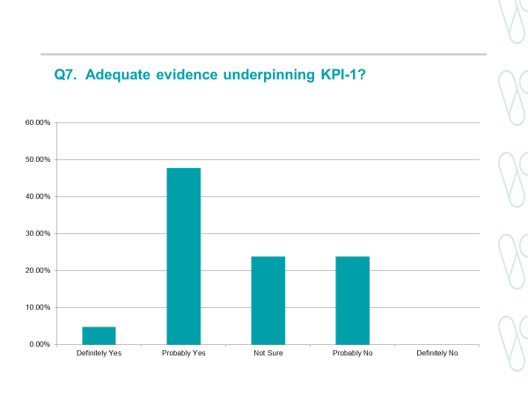

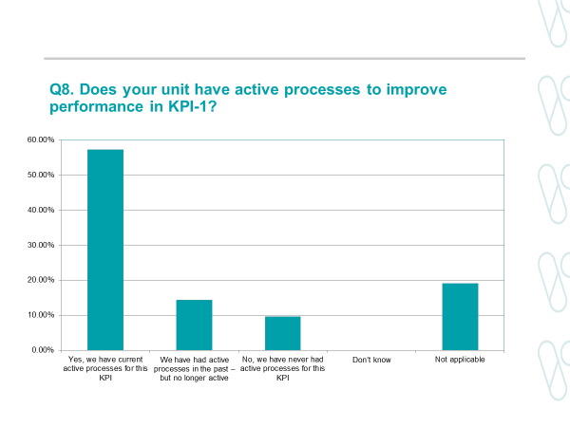

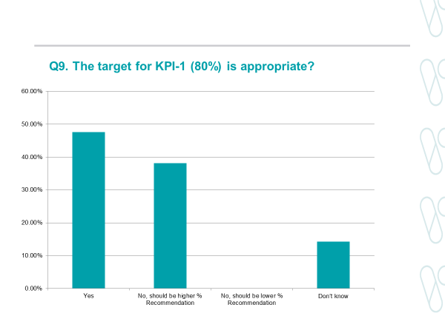

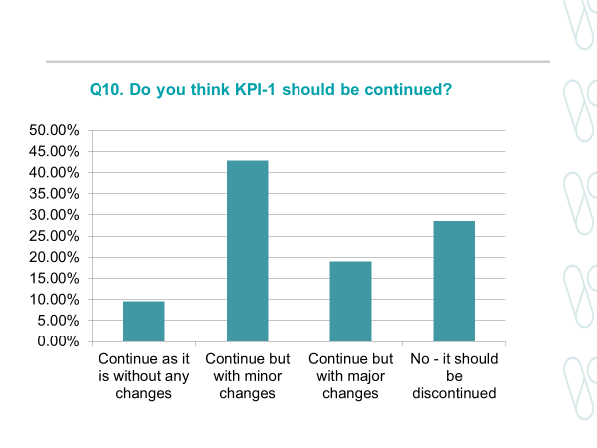

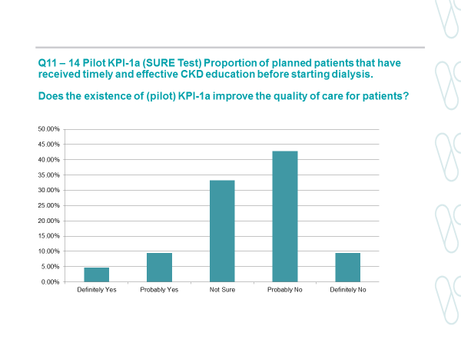

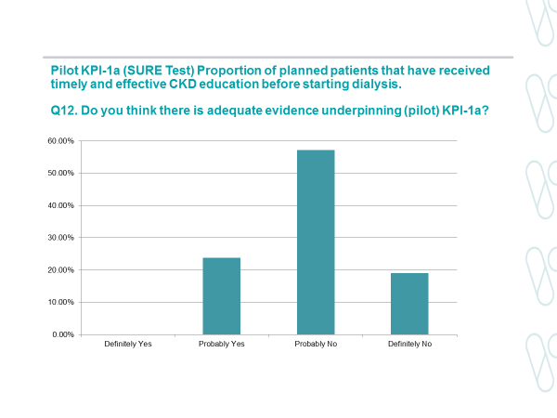

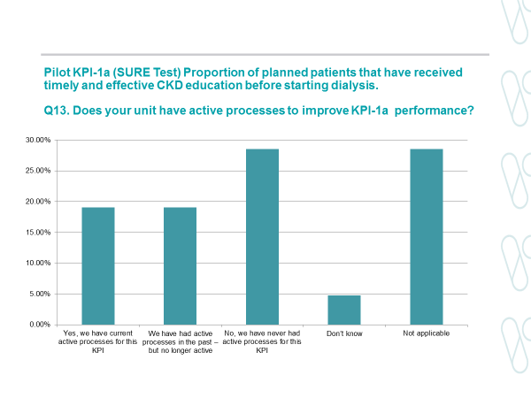

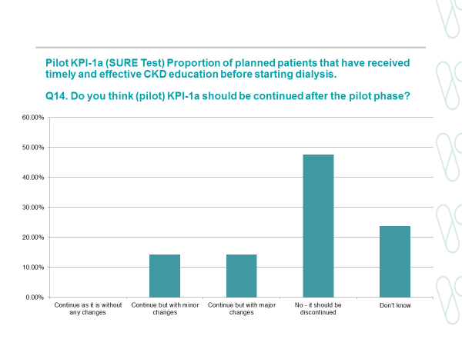

### KPI 2 (vascular access)

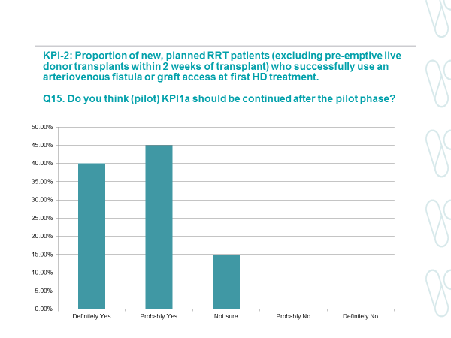

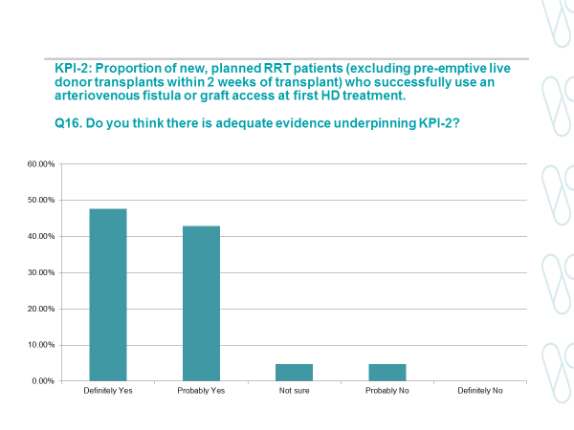

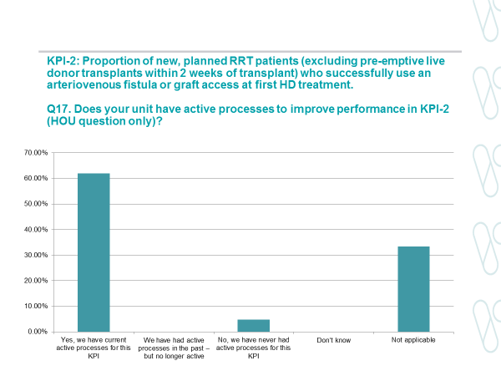

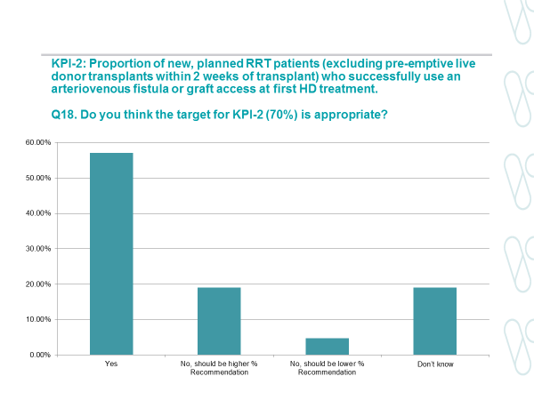

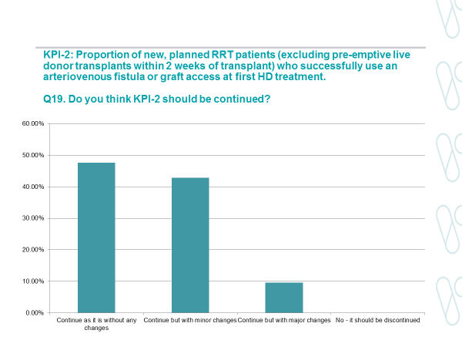

### KPI 3 (home therapies)

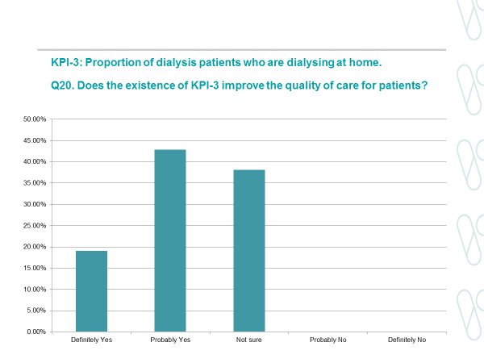

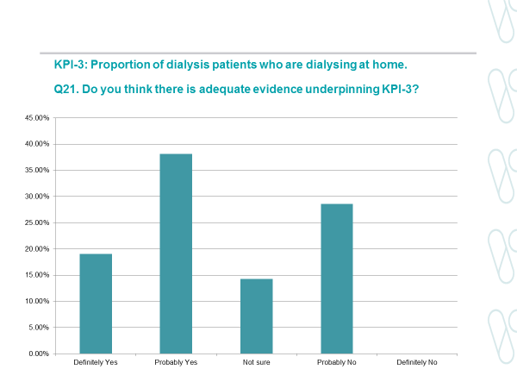

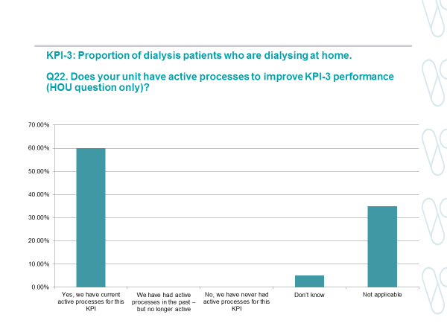

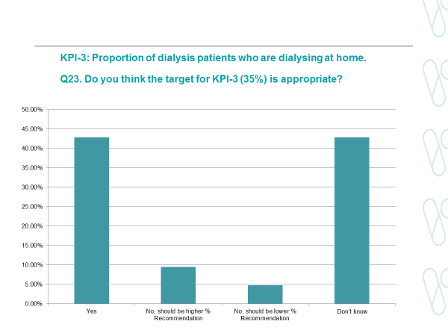

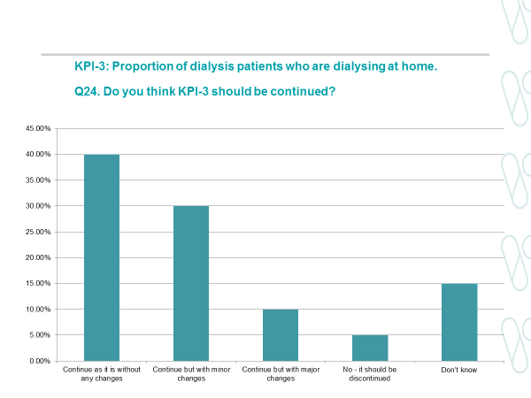

### KPI4 (peritonitis)

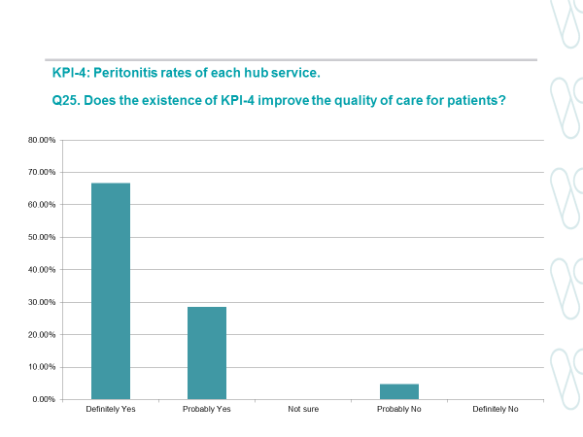

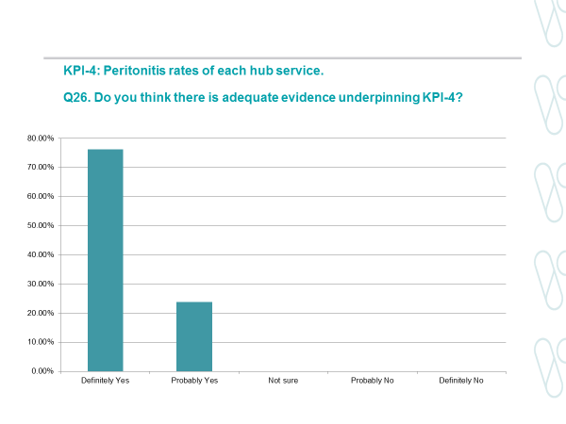

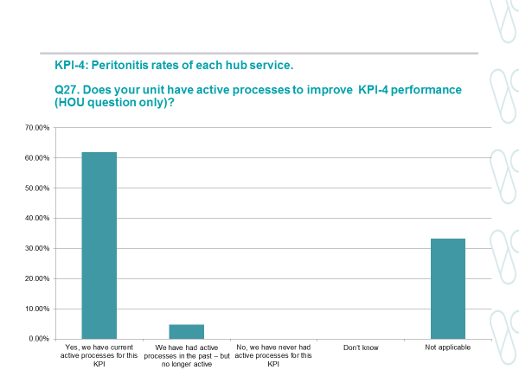

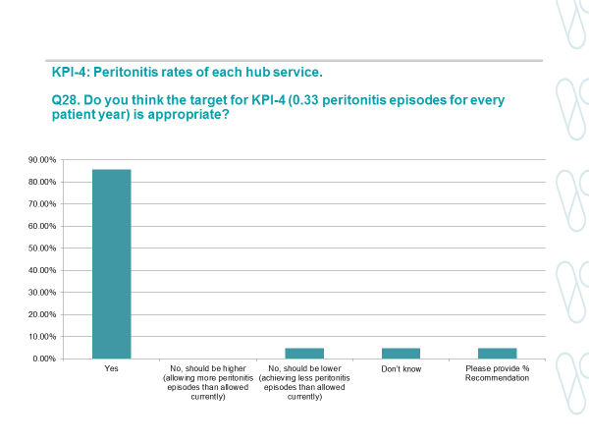

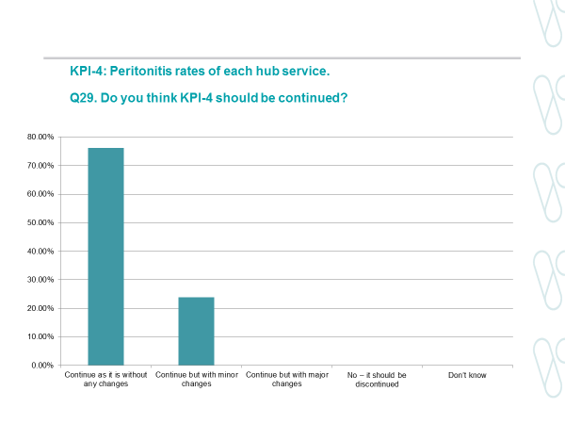

### KPI 5 (live donor transplantation)

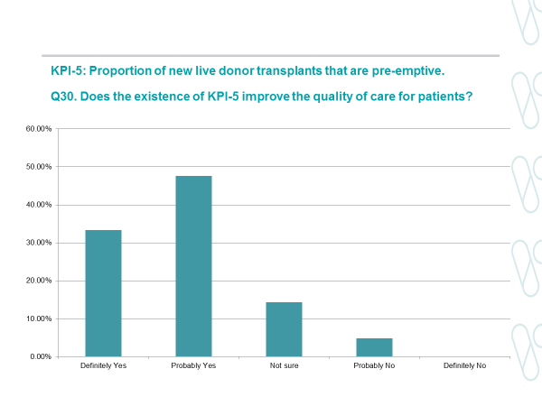

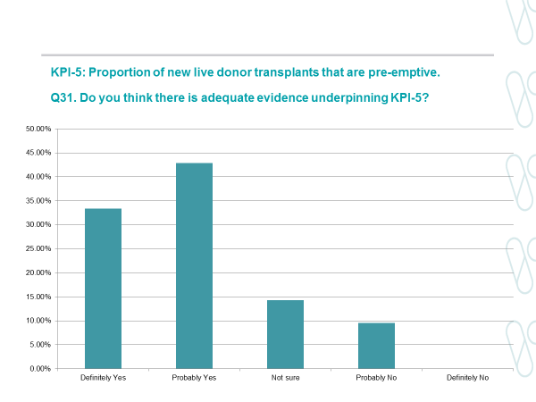

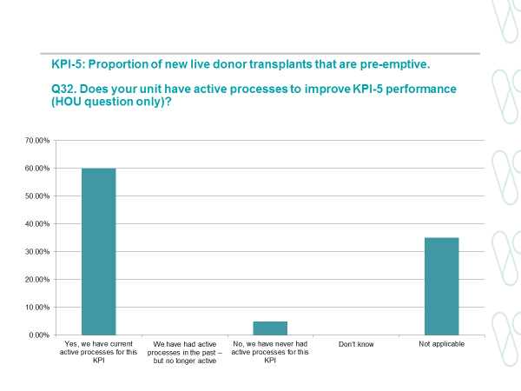

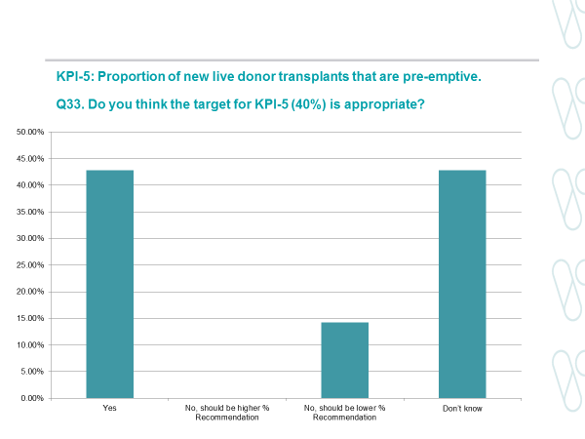

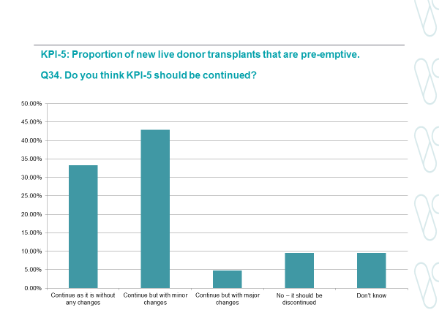

### KPI 6 (transplant work-up)

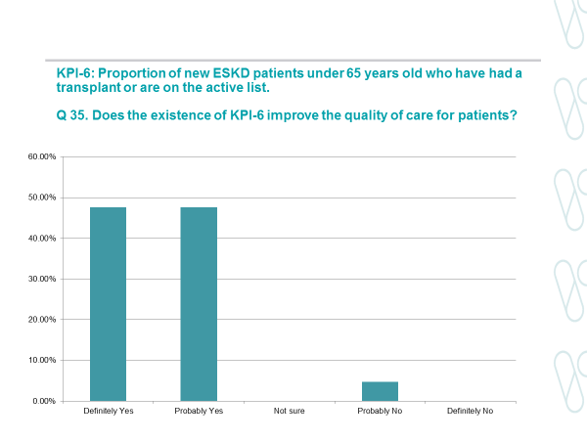

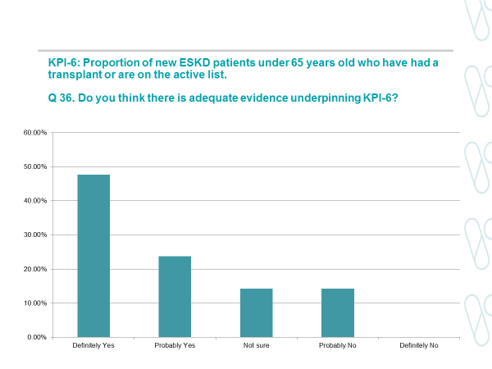

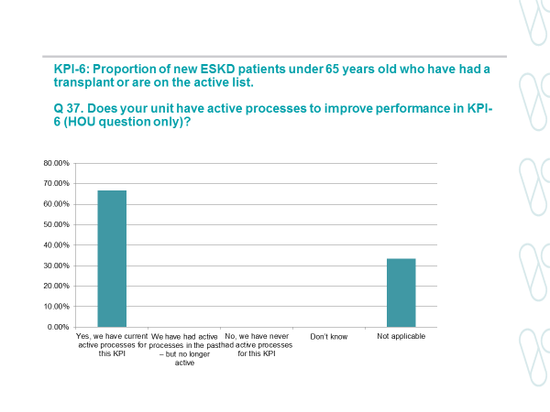

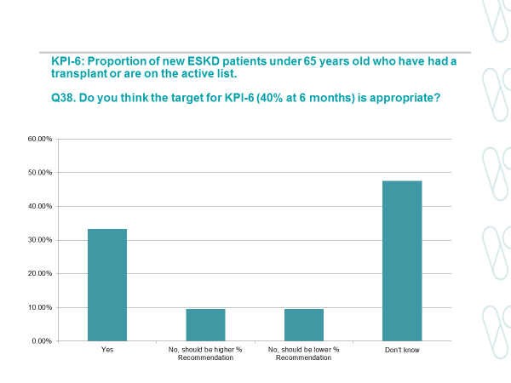

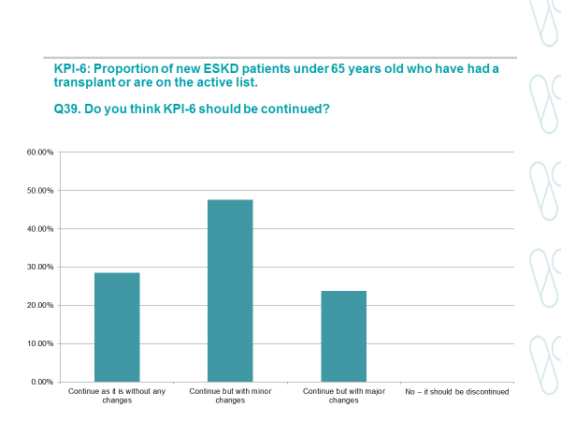

### PROMS and PREMS

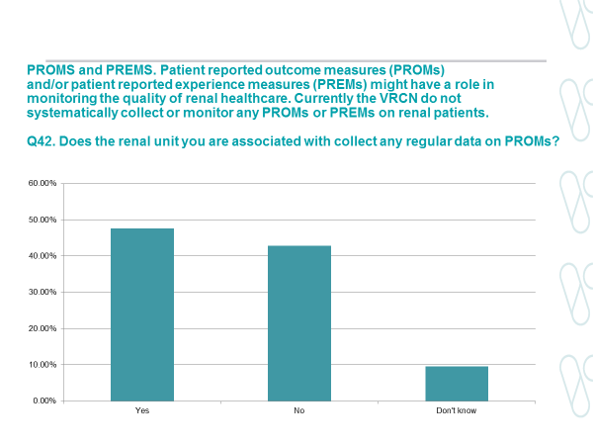

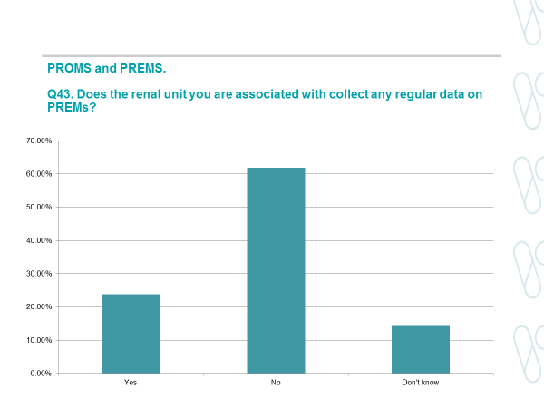

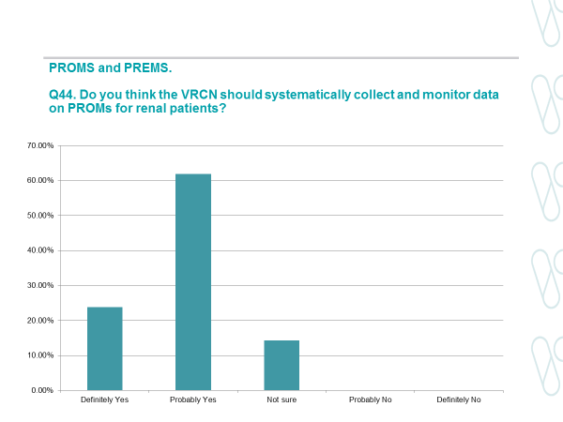

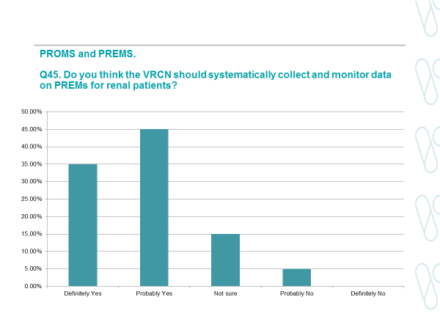

### ANZDATA

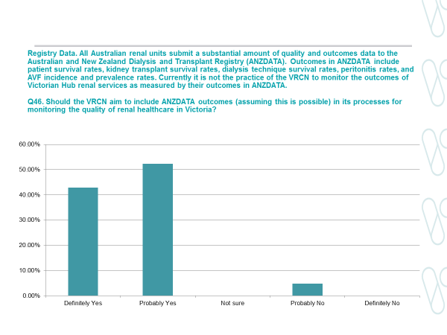

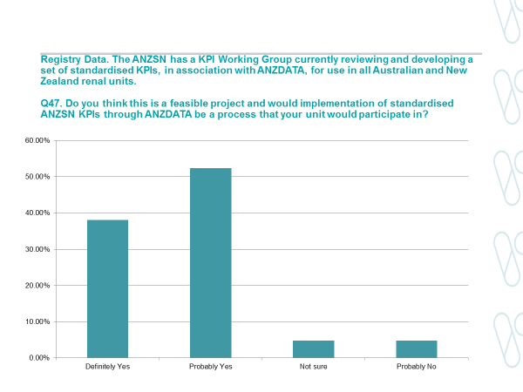

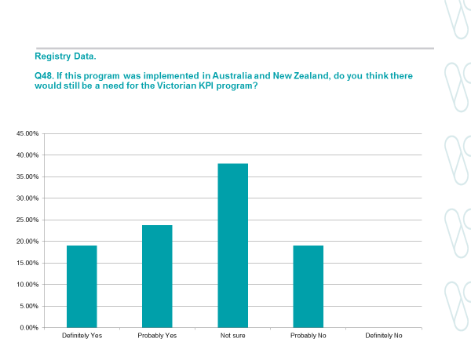

### General

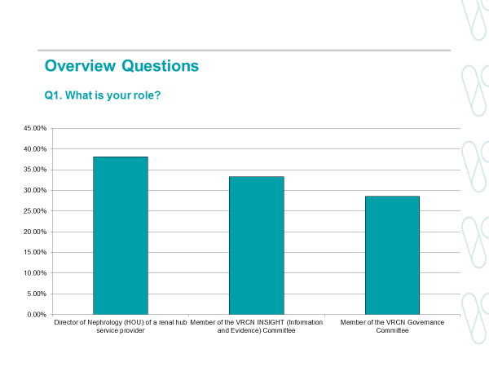

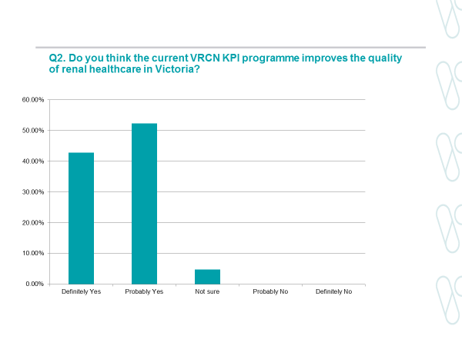

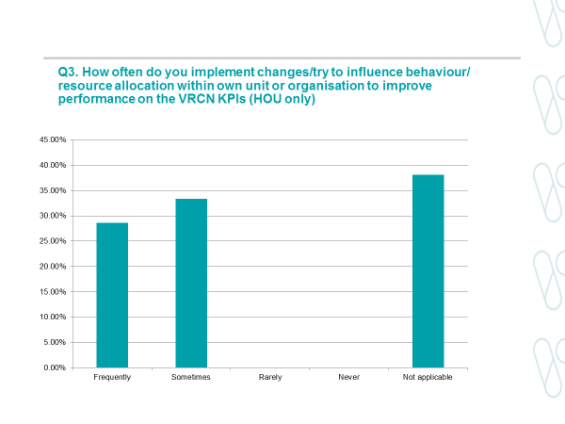

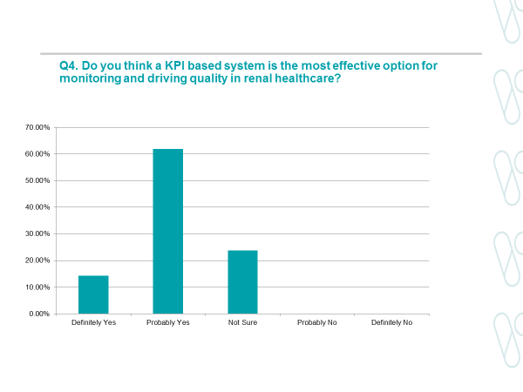

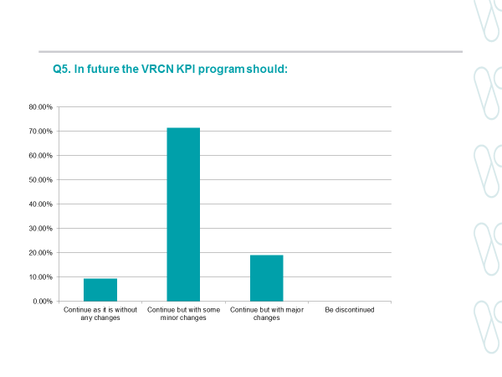

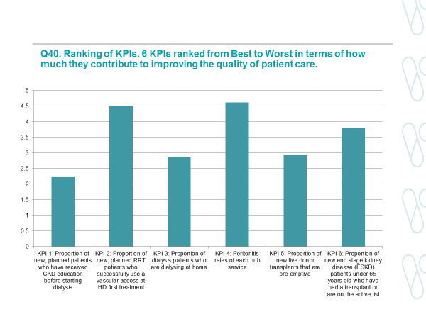

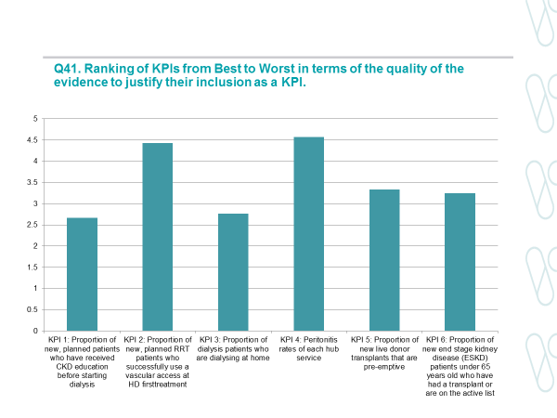

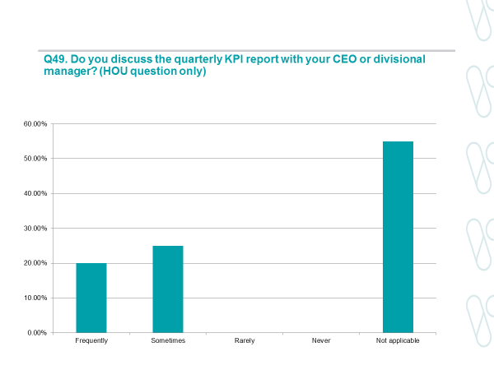

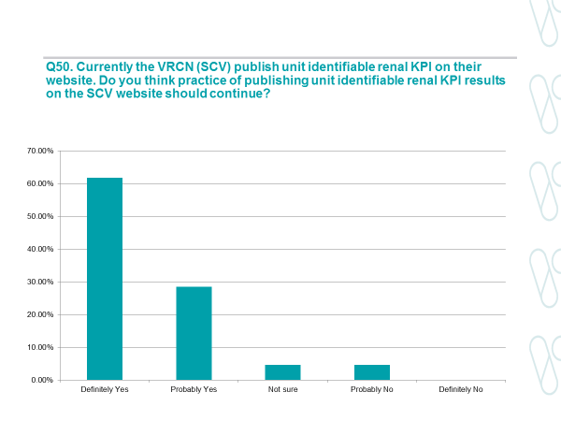

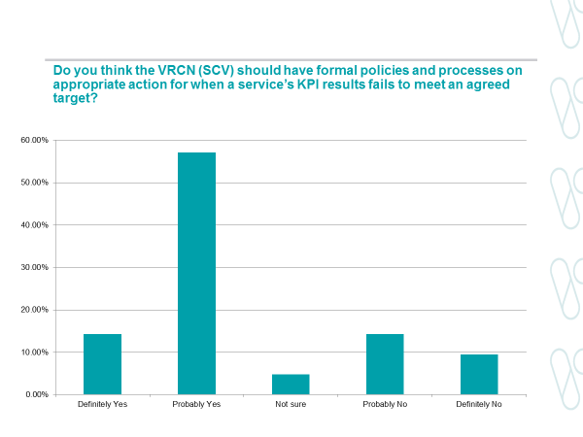

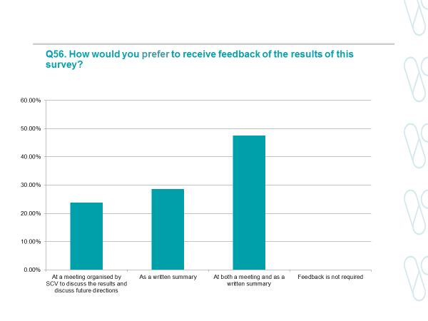

## Appendix 2: Longer term KPI performance

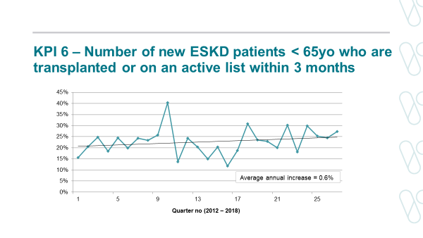

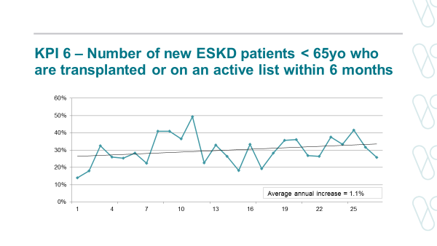

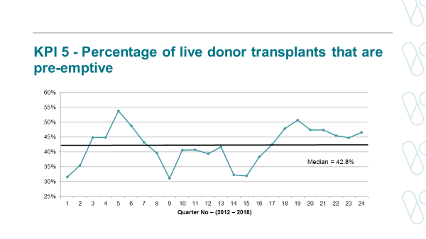

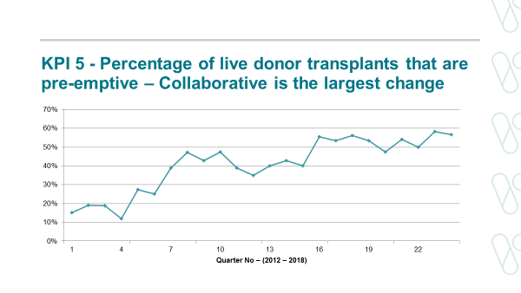

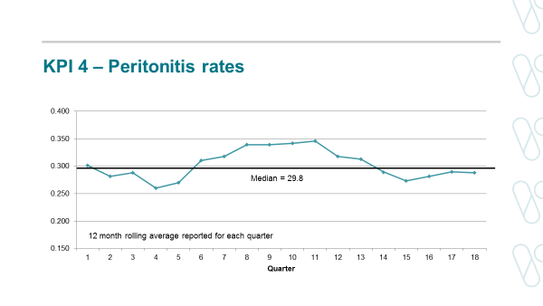

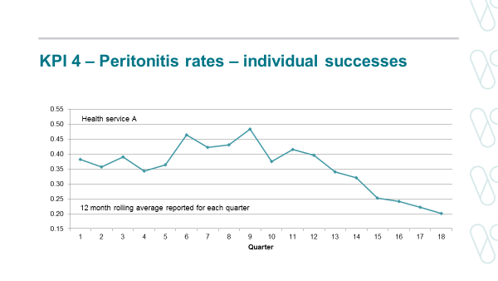

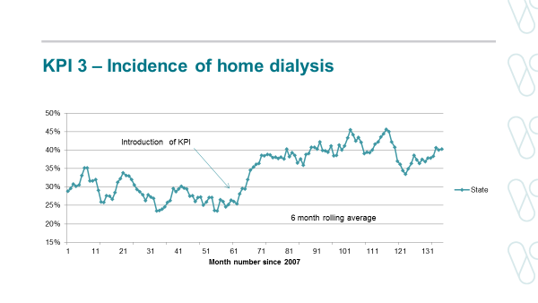

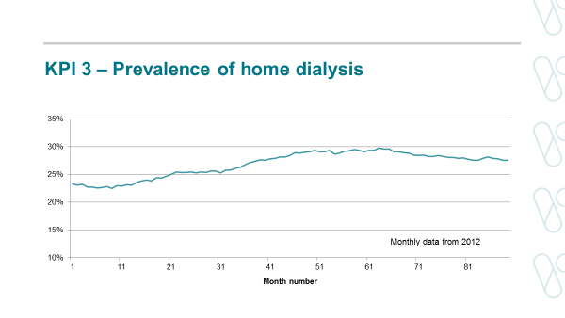

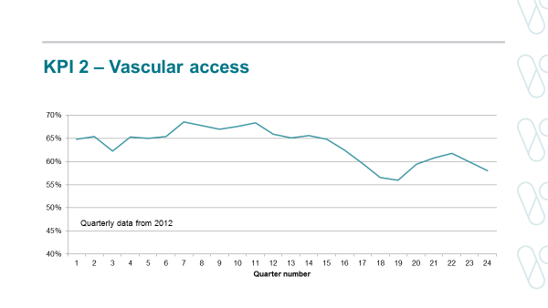

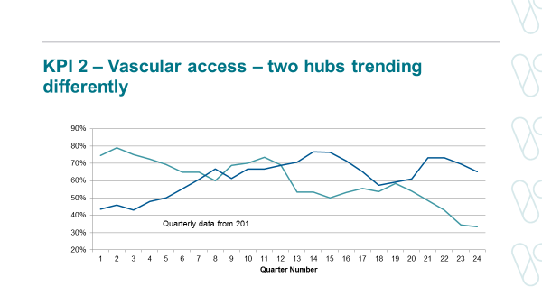

## Appendix 3: Assessment matrix for reviewingcurrent KPIs

This matrix was developed to summarise the key characteristics of the KPIs and help the authors in the review process.

|  |  |  |  |  |  |  |  |  |  |  |
| --- | --- | --- | --- | --- | --- | --- | --- | --- | --- | --- |
| KPI | Quality of evidence for indicator  3 = good  2 = moderate  1 = unsure  0 = poor | QA measure  2 = yes  1 = unsure  0 = no | QI measure  2 = yes  1 = unsure  0 = no | ICHOM status  2 = tier-1  1 = tier-2  0 = not included | Reliability of measurement*  3 = good  2 = moderate  1 = unsure  0 = poor | Validity of target  3 = good  2 = moderate  1 = unsure  0 = poor | Impact on practice  3 = high  2 = moderate  1 = unsure  0 = low | Benefits for consumers  3 = high  2 = moderate  1 = unsure  0 = low | Adverse unintended consequences  3 = unlikely  2 = unsure  1 = possible  0 = probable | Total score  (range: 0–24) |
| 1 | 2 | 0 | 0 | 0 | 3 | 1 | 0 | 2 | 3 | 11 |
| 1a | 1 | 0 | 1 | 0 | 1 | 1 | 1 | 1 | 2 | 7 |
| 2 | 2 | 0 | 2 | 0 | 3 | 2 | 2 | 2 | 2 | 15 |
| 3 incidence | 2 | 0 | 1 | 0 | 3 | 2 | 2 | 1 | 1 | 12 |
| 3 prevalence | 2 | 0 | 1 | 0 | 3 | 1 | 2 | 1 | 1 | 11 |
| 4 | 3 | 2 | 2 | 1 | 3 | 3 | 2 | 3 | 3 | 22 |
| 5 | 2 | 0 | 2 | 0 | 1 | 2 | 2 | 2 | 2 | 13 |
| 6 | 2 | 0 | 2 | 0 | 1 | 2 | 2 | 2 | 2 | 13 |

Notes and definitions

* A quality assurance measure defines a safety standard that all services are expected to achieve. Where quality assurance standards are not met, SCV should work cooperatively with service providers to understand the reasons for this and facilitate corrective measures.
* A quality improvement measure defines an agreed improvement objective of a service or a network, which ideally should be linked to a plan to achieve that target. Quality improvement measures are more aspirational than quality assurance measures but should still be evidence-based and achievable.
* The ICHOM CKD standard set (October 2017) defines a list of essential (tier-1) and important (tier-2) outcome measures for CKD patients.
* Values included in the table were decided on by chairs of the Renal Clinical Network committees.

* Reliability of measurement refers to the extent to which the data generated is a reliable measure of the parameter of interest. Factors that may impact adversely on this include small sample sizes, causing large random variations, and varying interpretations of definitions.

## Appendix 4: Assessment matrix for reviewing future quality indicators

|  |  |  |  |  |  |  |  |  |  |  |
| --- | --- | --- | --- | --- | --- | --- | --- | --- | --- | --- |
| Quality indicator | Quality of evidence for indicator  3 = good  2 = moderate  1 = unsure  0 = poor | QA measure  2 = yes  1 = unsure  0 = no | QI measure  2 = yes  1 = unsure  0 = no | ICHOM status  2 = tier-1  1 = tier-2  0 = not included | Reliability of measurement*  3 = good  2 = moderate  1 = unsure  0 = poor | Validity of target  3 = good  2 = moderate  1 = unsure  0 = poor | Impact on practice  3 = high  2 = moderate  1 = unsure  0 = low | Benefits for consumers  3 = high  2 = moderate  1 = unsure  0 = low | Adverse unintended consequences  3 = unlikely  2 = unsure  1 = possible  0 = probable | Total score  (range: 0–24) |
| Dialysis  mortality (SMR) | 3 | 2 | 1 | 2 | 3 | 2 | 1 | 3 | 3 | 20 |
| Haemodialysis  bloodstream infection | 3 | 1 | 2 | 1 | 2 | 2 | 2 | 3 | 3 | 19 |
| Kidney transplant mortality (SMR) | 3 | 2 | 1 | 2 | 3 | 2 | 2 | 3 | 1 | 19 |
| Kidney transplant  (risk-adjusted graft failure ratio) | 2 | 2 | 2 | 2 | 3 | 2 | 2 | 3 | 1 | 19 |

## Appendix 5: Acknowledgements

Thank you to Associate Professor Peter Mount (Clinical Lead) and the Renal Clinical Network Governance and Insight committee members for their contribution to this report.

We would also like to acknowledge all those who completed the KPI review survey (including the heads of Victorian renal units and our committees) and those who contributed to writing the review report. Thanks also to those who presented at the 2019 leadership forum including:

* Mr Daniel Ussher (KPI 1 and 1a)
* Professor Kevan Polkinghorne (KPI 2)
* Dr Timothy Pianta (KPI 3)
* Ms Nuala Barker (KPI 4)
* Dr David Langsford (KPI 5)
* Associate Professor Bill Mulley (KPI 6)
* Associate Professor Matthew Roberts (ANZDATA)
* Associate Professor Nigel Toussaint (PROMs and PREMs)

## Appendix 6: The International Consortium for Health Outcomes Measurement (ICHOM) for chronic kidney disease

The ICHOM for chronic kidney disease defines a set of essential (tier-1) and important (tier-2) outcomes.1

Tier 1: Essential

| Burden of care | PROMs | Treatment-specific |
| --- | --- | --- |
| * Survival * Hospitalisation * Cardiovascular events | * Health-related quality of life * Pain * Fatigue * Physical function * Daily activity * Depression | * Malignancy * Renal function (estimated glomerular filtration rate) * Vascular access survival * Peritoneal dialysis modality survival * Kidney allograft function * Kidney allograft survival |

Tier 2: Important

| Treatment-specific |
| --- |
| * Bacteraemia * Albuminuria * Peritonitis * Acute rejection |

# References

1. International Consortium for Health Outcomes Measurement (ICHOM). ICHOM chronic kidney disease data collection reference guide (Revised: October 25th, 2017). Available at: https://ichom.org/files/medical-conditions/chronic-kidney-disease/chronic-kidney-disease-reference-guide.pdf.
2. Kelly J, Stanley M, Harris D. The CARI guidelines. Acceptance onto dialysis guidelines. Pre-dialysis education. Nephrology. 2005;10 Suppl 4:S46-S60.
3. Thomas M. Pre-dialysis education for patients with chronic kidney disease. Nephrology. 2007;12:S46-S48.
4. Lacson Jnr L, Wang W, DeVries C, et al. Effects of nationwide predialysis education program on modality choice, vascular access and patient outcomes. Am J Kidney Dis. 2011;58(2):235-242.
5. Saggi SJ, Allon M, Bernardinin J, et al. Considerations in the Optimal Preparation of Patients for Dialysis. Nephrology. 2012; 8:381-389.
6. Wu W, Wang S, Hsu K, et al. Multidisciplinary predialysis education decreases the incidence of dialysis and reduces mortality – a controlled cohort study based on the NKF/DOQI guidelines. Nephrol Dial Transplant. 2009; 24:3426-3433.
7. Van Biesen W, Verbeke F, Vanholder R. We don’t need no education…. (Pink Floyd, The Wall) Multidisciplinary predialysis education programmes: pass or fail? Nephrol Dial Transplant. 2009; 24:3277-3279.
8. Légaré F, Kearing S, Clay K, et al. Are you SURE? Assessing patient decisional conflict with a 4-item screening test. Canadian Family Physician. 2010; 56(8): e308-e314.
9. Polkinghorne KR, Chin GK, MacGinley RJ, et al. KHA-CARI Guideline: Vascular access – central venous catheters, arteriovenous fistulae and arteriovenous grafts. Nephrology. 2013;18(11):701-705.
10. Jindal K, Chan CT, Deziel C, et al. Hemodialysis clinical practice guidelines for the Canadian Society of Nephrology. J Am Soc Nephrol. 2006; 17(3 Suppl 1):S1-S27.
11. Vascular Access Work Group. Clinical practice guidelines for vascular access. Am J Kidney Dis. 2006;48 Suppl 1:S248-S273.
12. Tordoir JH, Canaud BJ, Haage P, et al. EBPG on vascular access. Nephrol Dial Transplant. 2007;22 Suppl 2:ii88-ii117.
13. Ravani P, Palmer SC, Oliver MJ, et al. Associations between hemodialysis access type and clinical outcomes: a systematic review. J Am Soc Nephrol. 2013; 24(3):465-473.
14. Shingarev R, Barker-Finkel J, Allon M. Natural history of tunneled dialysis catheters placed for hemodialysis initiation. J Vasc Interv Radiol. 2013;24(9):1289-1294.
15. Griffiths RI, Newsome BB, Block GA, et al. Patterns of hemodialysis catheter dysfunction defined according to National Kidney Foundation guidelines as blood flow <300 mL/min. Int J Nephrol. 2011;2011:891259.
16. Suhocki PV, Conlon PJ, Knelson MH, et al. Silastic cuffed catheters for hemodialysis vascular access: thrombolytic and mechanical correction of malfunction. Am J Kidney Dis. 1996;28(3):379-386.
17. Poinen K, Quinn RR, Clarke A, et al. Complications from tunneled hemodialysis catheters: a Canadian observational cohort study. Am J Kidney Dis. 2019;73(4):467–475.
18. Marshall MR, Polkinghorne KR, Kerr PG, et al. Intensive Hemodialysis and mortality risk in Australian and New Zealand populations. Am J Kidney Dis. 2016; 67(4):617-628.
19. Weinhandl ED, Foley RN, Gilbertson DT, et al. Propensity-matched mortality comparison of incident hemodialysis and peritoneal dialysis patients. JASN. 2010; 21(3):499-506.
20. Mehrotra R, Chiu YW, Kalantar-Zadeh K, et al. Similar outcomes with hemodialysis and peritoneal dialysis in patients with end-stage renal disease. Arch Intern Med. 2011; 171(2):110-118.
21. McDonald SP, Marshall MR, Johnson DW, et al. Relationship between dialysis modality and mortality. JASN 2009; 20(1):155-163.
22. Walker RC, Hanson CS, Palmer SC, et al. Patient and caregiver perspectives on home hemodialysis: a systematic review. Am J Kidney Dis. 2015;65(3):451-463.
23. Fortnum D, Smolonogov T, Walker R, et al. My kidneys, my choice, decision aid: supporting shared decision making. J Ren Care. 2015; 41(2):81-87.
24. Shen JI, Mitani AA, Saxena AB, et al. Determinants of peritoneal dialysis technique failure in incident US patients. Perit Dial Int. 2013;33(2):155-166.
25. Chidambaram M, Bargman JM, Quinn RR, et al. Patient and physician predictors of peritoneal dialysis technique failure: a population based, retrospective cohort study. Perit Dial Int. 2011; 31(5):565-573.
26. Htay H, Cho Y, Pascoe EM, et al. Center effects and peritoneal dialysis peritonitis outcomes: analysis of a national registry. Am J Kidney Dis. 2018;71(6):814-821 (ANZDATA 2004–2014).
27. Li PK, Szeto CC, Piraino B, et al. The International Society of Peritoneal Dialysis (ISPD) peritonitis recommendations: 2016 update on prevention and treatment. Perit Dial Int. 2016;36(5):481-508; Erratum: Perit Dial Int. 2018 38(4):313.
28. Strippoli GF, Tong A, Johnson D, et al. Catheter-related interventions to prevent peritonitis in peritoneal dialysis: A systematic review of randomized, controlled trials. J Am Soc Nephrol. 2004;15: 2735-2746.
29. Piraino B, Bernadini J, Brown E, et al. ISPD position statement on reducing the risks of peritoneal dialysis-related infections. Perit Dial Int. 2011; 31:614-630.
30. ANZDATA Registry. 40th Report, Chapter 7: Transplantation. Australia and New Zealand Dialysis and Transplant Registry, Adelaide, Australia. 2018. Available at: http://www.anzdata.org.au.
31. Gill JS, Rose C, Joffres Y, et al. Variation in dialysis exposure prior to non-preemptive living donor kidney transplantation in the United States and its association with allograft outcomes. Am J Kid Dis. 2018; 71(5):636-647.
32. Foucher Y, Le Borgne F, Legendre C, et al. Lack of impact of pre-emptive deceased-donor kidney transplantation on graft outcomes: a propensity score-based study. Nephrol Dial Transplant. 2018. Oct 15. doi: 10.1093/ndt/gfy317.
33. Canadian Institute of Health Information. Organ replacement in Canada: Canadian Organ Replacement Register (CORR) annual statistics, 2018. Available at: https://www.cihi.ca/en/organ-replacement-in-canada-corr-annual-statistics-2018.
34. National Health Service (NHS). Annual report on kidney transplantation for 2017/2018. Available at: https://nhsbtdbe.blob.core.windows.net/umbraco-assets-corp/12256/nhsbt-kidney-transplantation-annual-report-2017-2018.pdf.
35. Abramowicz D,Hazzan M, Maggiore U, et al. Does pre-emptive transplantation versus post start of dialysis transplantation with a kidney from a living donor improve outcomes after transplantation? A systematic literature review and position statement by the Descartes Working Group and ERBP. Nephrol Dial Transplant 2016; 31(5): 691-697.
36. Haller MC, Kammer M, Oberbauer R. Dialysis vintage and outcomes in renal transplantation. Nephrol Dial Transplant 2018 Apr 20. doi: 10.1093/ndt/gfy099. [Epub ahead of print].
37. Jay CL, Dean PG, Helmick RA, et al. Reassessing preemptive kidney transplantation in the United States: Are we making progress? Transplantation 2016; 100(5):1120-1127.
38. Haller MC, Kainz A, Baer H, et al. Dialysis vintage and outcomes after kidney transplantation: a retrospective cohort study. CJASN 2017; 12(1):122-130.
39. Grace BS, Clayton PA, Cass A, et al. Transplantation rates for living- but not deceased-donor kidneys vary with socioeconomic status in Australia. Kidney Int. 2013; 83(1):138-145.
40. Anderson NE, Calvert M, Cockwell P, et al. Using patient-reported outcome measures (PROMs) to promote quality of care in the management of patients with established kidney disease requiring treatment with haemodialysis in the UK (PROM-HD): a qualitative study protocol. BMJ Open 2018; 8:e021532. doi: 10.1136/bmjopen-2018-021532.
41. Aiyegbusi OL, Kyte D, Cockwell P, et al. Using Patient-Reported Outcome Measures (PROMs) to promote quality of care and safety in the management of patients with advanced chronic kidney disease (PRO-trACK project): a mixed-methods project protocol. BMJ Open. 2017; 30;7(6):e016687. doi: 10.1136/bmjopen-2017-016687.
42. Aiyegbusi OL, Kyte D, Cockwell P, et al. Measurement properties of patient-reported outcome measures (PROMs) used in adult patients with chronic kidney disease: A systematic review. PLoS One. 2017; 21;12(6):e0179733.
43. Morton R. Symptom Monitoring with Feedback Trial (SWIFT) Pilot: A feasibility and acceptability study of ANZDATA E-PROMs data capture and feedback. University of Sydney. Kidney Health Australia Medical and Scientific Research Grant 2018. Available at: https://kidney.org.au/researchgrants.
44. Worth LJ, Spelman T, Holt SG, et al. Epidemiology of infections and antimicrobial use in Australian haemodialysis outpatients: findings from a Victorian surveillance network, 2008-2015. Journal of Hospital Infection. 2017; 97:93-98.