|  |
| --- |
|  |
| Care of the dying person  Survey report |

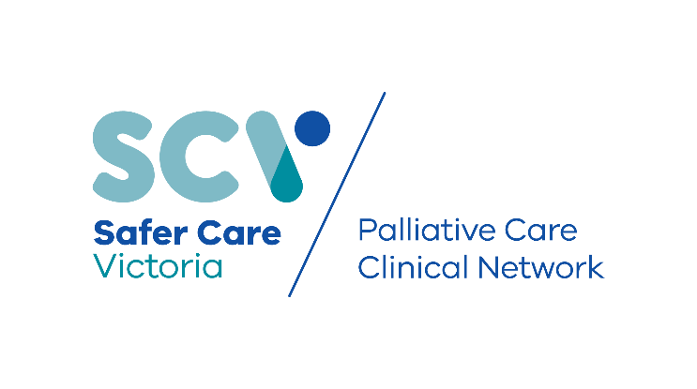

|  |  |  |
| --- | --- | --- |
| To receive this publication in an accessible format phone  03 9096 1384, using the National Relay Service 13 36 77 if required, or email [info@safercare.vic](mailto:info@safercare.vic).gov.au | Authorised and published by the Victorian Government, 1 Treasury Place, Melbourne.  © State of Victoria, Australia, Safer Care Victoria, September 2019  ISBN 978-1-76069-038-0 (pdf/online/MS word)  Available at [www.safercare.vic](http://www.safercare.vic).gov.au |  |



# Introduction

This report summarises the first phase of our project to improve consistency in the use of best practice principles for end of life care in acute settings. It analyses results from a survey of health services that provide acute care, and an audit of more than 600 cases.

### About the project

The Victorian palliative care sector told us that the care provided to those in the last days of life likely varies from service to service. Determining current best practice principles for care delivery was identified by the sector as a priority project for Safer Care Victoria’s Palliative Care Clinical Network.

There are two phases to this project:

#### Phase 1: Scoping

* Convening a working group so we can understand the issues relating to care in the last days of life in Victoria.
* Developing a survey and audit that is reported here.
* Disseminating the survey and audit to health services in Victoria.
* Collecting and analysing data from the survey and audit, as reported here.

#### Phase 2: Testing for improvement

* Recruiting a small number of health services to test improvement innovations in the acute care setting.
* Introducing a collaborative process with these services including learning around improvement science.
* Collecting data to understand (by aggregating data) if the changes made have led to improvement.

### Background

Nationally, delivery of palliative and end of life care is guided by the National Palliative Care Strategy (2010)1, End of Life Care in Acute Hospitals2 and National Palliative Care Standards3. In Victoria, we are also guided by the *Victorian End of Life and Palliative Care Framework*4.

Additionally, the Care Plan for the Dying Person – Victoria (CPDP-Vic) provides an evidence-based approach to providing consistent care in the last days of life in the acute care setting. This was funded by the Department of Health and Human Services and led by the Victorian End-of-Life Care Coordinating Program. The CPDP-Vic is aligned with the International Collaborative for Best Care of the Dying Person. Safer Care Victoria became responsible for the CPDP-Vic in 2018.

The CPDP-Vic was made available to the Victorian acute healthcare sector in 2017. However, the sector told us that practice still varies, and further implementation and support was required to understand the impact of the CPDP-Vic. We also understand that the CPDP-Vic is not the only viable option to support care in the last days of life in acute settings.

### Progress so far

In August 2018 we convened a working group, including consumers and representatives from palliative care in both public and private health services. (For membership, see Appendix 2.)

Supporting phase 1 of this project, the group met three times and:

* **agreed to best care principles for care** in the last days of life using existing national consensus statements and guidelines1, 2, 3, 4 and learnings from international work5,6 (see box below)
* **developed an organisational survey** and patient record audit to help health services understand how care was being delivered, including whether CPDP-Vic was being used
* **determined the scope for phase two** of the project.

Principles of care for the dying person5

1. Dying is **recognised** and clearly communicated. Decisions are made in accordance with regularly reviewed needs and wishes. Strategies are used to ensure understanding.

2. Sensitive **communication** with the dying person and those important to them.

3. The dying person (and those important to them) are as **involved** as they want to be.

4. Those important to the dying person are **supported**, both before death and through bereavement.

5. Individualised, holistic, **compassionate care** is agreed, co-ordinated and provided.

# Summary of findings

#### Level of care provided

Most of the organisations we surveyed provided acute care, including care in the last days of life, with almost all reporting some form of access to specialist palliative care support. Results suggest that regional and rural centres rely more on visiting and telehealth specialist palliative care support, usually available Monday to Friday during business hours.

#### Governance and training

While less than half of the health services reported having an end of life care committee or governance team, most had some form of end of life care staff training program in place. However, the type of training, and who received it, varied across organisations.

Support to increase staff education is warranted to reduce variability in end of life care and improve care in line with the agreed principles. We hypothesise that this may result in an increased uptake of CPDP-Vic, or other care plans for care in the last days of life in acute healthcare settings.

#### Use of CPDP-Vic

While a small proportion of health services had implemented the CPDP-Vic, most reported using another form of care plan. Variability of organisation settings in this survey may support employing different care plans that are better suited to the local setting. Further investigation is required to ensure best practice and standardised quality care is delivered regardless of which end of life care plan is used.

#### Record keeping

Organisations generally reported high levels of patient file documentation surrounding recognition of dying and end of life care principles.

#### Use of medical emergency teams (MET)

Most MET calls occurred within 24 hours of a patient’s death. While this finding could be construed as, or indicative of, a failure to recognise deterioration and dying, careful consideration must be made to cases where a MET call may have been appropriate at the point of care.

The organisational, clinical and social context surrounding the time of MET calls needs to be investigated further before conclusions can be made about MET activity reported in this survey.

### Next steps

Informed by the survey and audit results of phase 1, the Palliative Care Clinical Network is now working with a small number of health services to test our suggested principles of care for the dying person (see page 2).

Using the Institute for Healthcare Improvement’s model for improvement, this project aims to increase the number of acute care patients cared for using agreed principles of end of life care by 20 per cent. Key measures will help us understand what change constitutes a meaningful improvement as we work towards reducing variation in care at the end of life.

We will also develop supportive resources for health services to improve end of life care in the acute setting.

Survey methodology

We sent the online survey to 517 contacts, including quality and safety representatives from public, private, metropolitan, rural and regional health services, and prior registrants who had accessed the CPDP-Vic suite of resources.

The survey was open from 17 December 2018 to 1 February 2019. It was designed with branching logic so we could collect more detailed information depending on a user’s responses.

Audits were to be performed for consecutive patient deaths between 1 May and 31 October 2018.

Health services were capped to one survey response and 20 patient file audits. Smaller services were asked to audit all deaths if the total was below 20 for the defined period.

### Survey response

We received 72 survey responses and 650 file audits from across the state and sector.

The average time to complete the survey was eight minutes with a 96 per cent completion rate. Each audit took an average four minutes, with a 100 per cent completion rate.

We encouraged health services to contact us if they needed any support to complete the survey. This resulted in a number of telephone and face-to-face conversations about the project and the work of the Palliative Care Clinical Network.

### Data management

We cleansed the data to remove duplicates and non-admitting services (e.g. GP practice) from the organisational survey and blank responses from the audit responses. Multiple sites submitted more than one survey, potentially highlighting the need for shared conversation around care at the end of life within the organisation.

In total, we analysed 52 organisational surveys and 640 audits.

### Limitations

Very few private and not-for-profit health services participated. Therefore, results may not accurately represent all Victorian health services and further effort would be required in any future investigations and initiatives.

Due to our data collection method, we were not able to link survey responses with clinical audit results. Exploring this possibility in future investigations will provide opportunities to report on causal and precipitating factors associated with the organisation and their patient clinical practices.

Clinical audits were performed only for patients admitted to hospitals. However, due to the known co-location of acute and residential aged care services in some rural/regional services, we cannot exclude residents from aged care services in this survey. Anecdotal reports during the survey period told us some organisations reviewed all deaths in one pool, across acute and aged care, and, in some cases use the same care plan (Residential Aged Care End of Life Care Pathway) across both acute and residential aged care settings. In order to thoroughly investigate variability in end of life care across health services, similar clinical audits need to be conducted in residential aged care facilities and other community services that take care of dying patients.

# Organisational survey results

The working group developed the survey to understand the governance, education and quality improvement functions organisations had in place to support care in the last days of life. Survey questions were focused under four main headings:

* the organisation and the care provided
* organisational governance associated with end of life care
* care planning
* staff training in end of life care

Questions were intended to provide information and answers around key questions, including:

1. Does the organisation have governance support for end of life care?
2. Are staff supported to provide end of life care?
3. Do staff have the skills to communicate information about end of life care?
4. How are patients and their families/carers involved in the care provided?

### The organisation and the care provided

Of the 52 respondents, 26 (50%) services identified that they had a palliative care unit and/or designated palliative care beds. Thirty-two (61%) stated they provided residential aged care services, and 11 (21%) provided care across all settings including acute, subacute, and community based (Figure 1).

Figure 1 Organisation setting

Percentages will not sum to 100 per cent as more than one response was permitted

Nineteen (37%) organisations were based in metropolitan locations. Regional and rural centres comprised the remaining 13 (25%) and 20 (39%) services, respectively. Forty-one (79%) were public organisations, eight (15%) were private and three (6%) were not for profit.

All but one organisation had access to specialist palliative care, with 25 (48%) reporting onsite face-to-face access and 37 (64%) with face-to-face but visiting access. Twenty (39%) services reported having 24/7 palliative care support available, even if they did not have face-to-face specialist palliative care. Fifteen (29%) stated they had business hours and after hours support, and 17 (33%) reported business hours only support. Comments provided by respondents indicated that support after hours was dependent on relationships between clinicians and on the geographical location of service/clinical support.

### Organisational governance and end of life care

Twenty-three (44%) organisations reported having an End of Life Care Committee, with only six having a consumer representative present.

Figure 2 illustrates more than 80 per cent of the services surveyed reported having specific guidelines/policies/protocols for:

* goals of care/treatment escalation plans
* recognition of dying and end of life care
* not for resuscitation (NFR).

Specific policies for bereavement care were only present in 40 per cent of services but 45 (89%) organisations reported having written information available to patients and families.

Figure 2 Organisational policies and guidelines

Percentages will not sum to 100 per cent as more than one response was permitted

In the last days of life, all services provided unrestricted visiting hours and visitor numbers. More than 85 per cent provided culturally and linguistically diverse support, acknowledgement of religious considerations, and facilities for family to stay overnight.

All but five services sought feedback about patients and/or family, with several services highlighting use of the palliative care Victorian Healthcare Experience Survey.

### Staff training

In response to staff training in end of life care, more than half of the services reported providing education on care for the dying patient (56%). Fewer reported providing education on recognition of dying (46%) and communication around dying (40%), with only 27 per cent of organisations providing education in bereavement care. Some organisations reported receiving local palliative care consortia education and/or internal training from specialist palliative care teams.

Training was routinely provided to nurses in 18 (37%) of the services surveyed. Routine education was provided for doctors in 16 (33%) organisations, and allied health (nine services). Three (6%) organisations reported providing no training to staff in end of life care (Figure 3).

Figure 3 Prevalence of routine staff training

Percentages will not sum to 100 per cent as more than one response was permitted

### Care planning

Thirty-eight (73%) organisations reported using an individualised care plan for the dying. Services reported using one or more care plans out of a total of 17 different plans that were documented. One organisation reported using the Liverpool Care Pathway (LCP), despite the LCP documentation and brand being withdrawn and no longer supported for use locally and internationally in 2015.

The CPDP-Vic was reported to have been formally implemented in 12 (23%) services. Five services reported implementing the CPDP-Vic across the whole of the health service, with this usually preceded by staff education and training sessions. The remaining seven organisations reported gradually rolling out the resource. In these services, the CPDP-Vic was usually commenced in medical (and palliative care bed) units where most deaths occurred.

Eight of the 12 services reported using a peer mentoring approach to provide training around the CPDP-Vic. Ten organisations provided training to nurses and one to pharmacy. None of the organisations reported training/education for doctors or allied health staff.

When asked if organisations intended to implement the CPDP-Vic resources in the future, 17 (33%) indicated that they would, two (4%) said they would not, and 15 (29%) were unsure (Figure 4).

Figure 4 Intention to implement CPDP-Vic

### Rurality and variability

Exploratory analyses were undertaken to investigate associations between service location and responses. Results are presented for questions which exhibited variability due to organisation rurality.

When investigating specialist palliative care support by rurality, it was found that regional and rural sites relied mostly on offsite support (telephone support and visiting services) (Figure 5). Furthermore, while some regional and rural centres reported having 24/7 support, the overwhelming majority reported business hours only support. All metropolitan services reported some form of weekend support   
(Figure 6).

Figure 5 Specialist palliative care support by rurality

Figure 6 Specialist palliative care support type by rurality

Finally, while end of life care committees were in place across a variety of metropolitan and regional/rural centres (Figure 7), the majority of organisations with a formally implemented CPDP-Vic were from regional and rural services.

Figure 7 End of life care committee by rurality

Figure 8 CPDP-Vic implemented by rurality

# Clinical audit results

The working group developed clinical audit questions to understand end of life care delivery for patients in acute settings.

The clinical audit comprised nine questions relating to clinical care. These questions were important to understand how organisational support translated to the point of care and how services were tracking against end of life care principles. This included documentation of:

* recognition that the patient was dying
* conversations around dying were held with the patient and those important to them
* MET calls
* if a care plan was used
* bereavement support for the family.

A total of 640 audits were appropriate for analysis.

### Care of the dying in practice

Of the 640 deaths audited, 71 per cent took place in acute wards, 13 per cent in subacute wards, and nine per cent in a specialist palliative care unit. Deaths in intensive care units and emergency departments accounted for seven per cent of the sample. While clinical audits were requested only for patients admitted to hospitals, the inclusion of residents from aged care services in this survey could not be excluded due to the co-location of acute and residential aged care services in some rural/regional services.

Eighty-six per cent of deaths were reported to have documented recognition that the patient was dying, with conversations around dying held with patients in 39 per cent of cases and with families in 82 per cent of cases. Evidence of documentation was also present for the following:

* NFR (85% of cases)
* Anticipatory prescribing/medications in place (67% of cases)
* Goals of care discussions (47% of cases)
* Preferred place of death discussed (22% of cases)

Sixty-two per cent of cases were reported to have had an individualised care plan for the dying, eight per cent of which was the CPDP-Vic. Bereavement support was documented in 53 per cent of cases audited.

Twenty-two per cent of cases had one or more MET calls documented during their final admission with most taking place within 24 hours of death. Figure 9 illustrates the frequency of MET calls at the end of life grouped by setting. While most MET calls within 24 hours occurred in the acute ward, almost half comprised cases from all other settings.

Figure 9 Frequency of MET calls at end of life by setting

## APPENDIX 1: Survey and audit questions

### Organisational survey

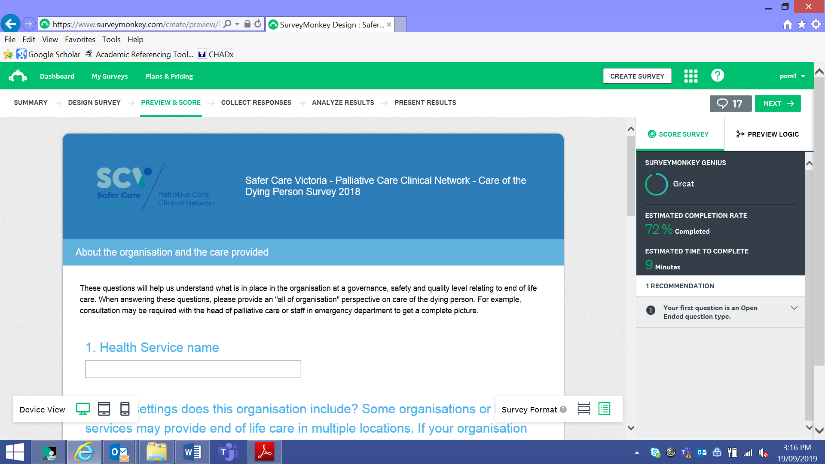

### Clinical audit

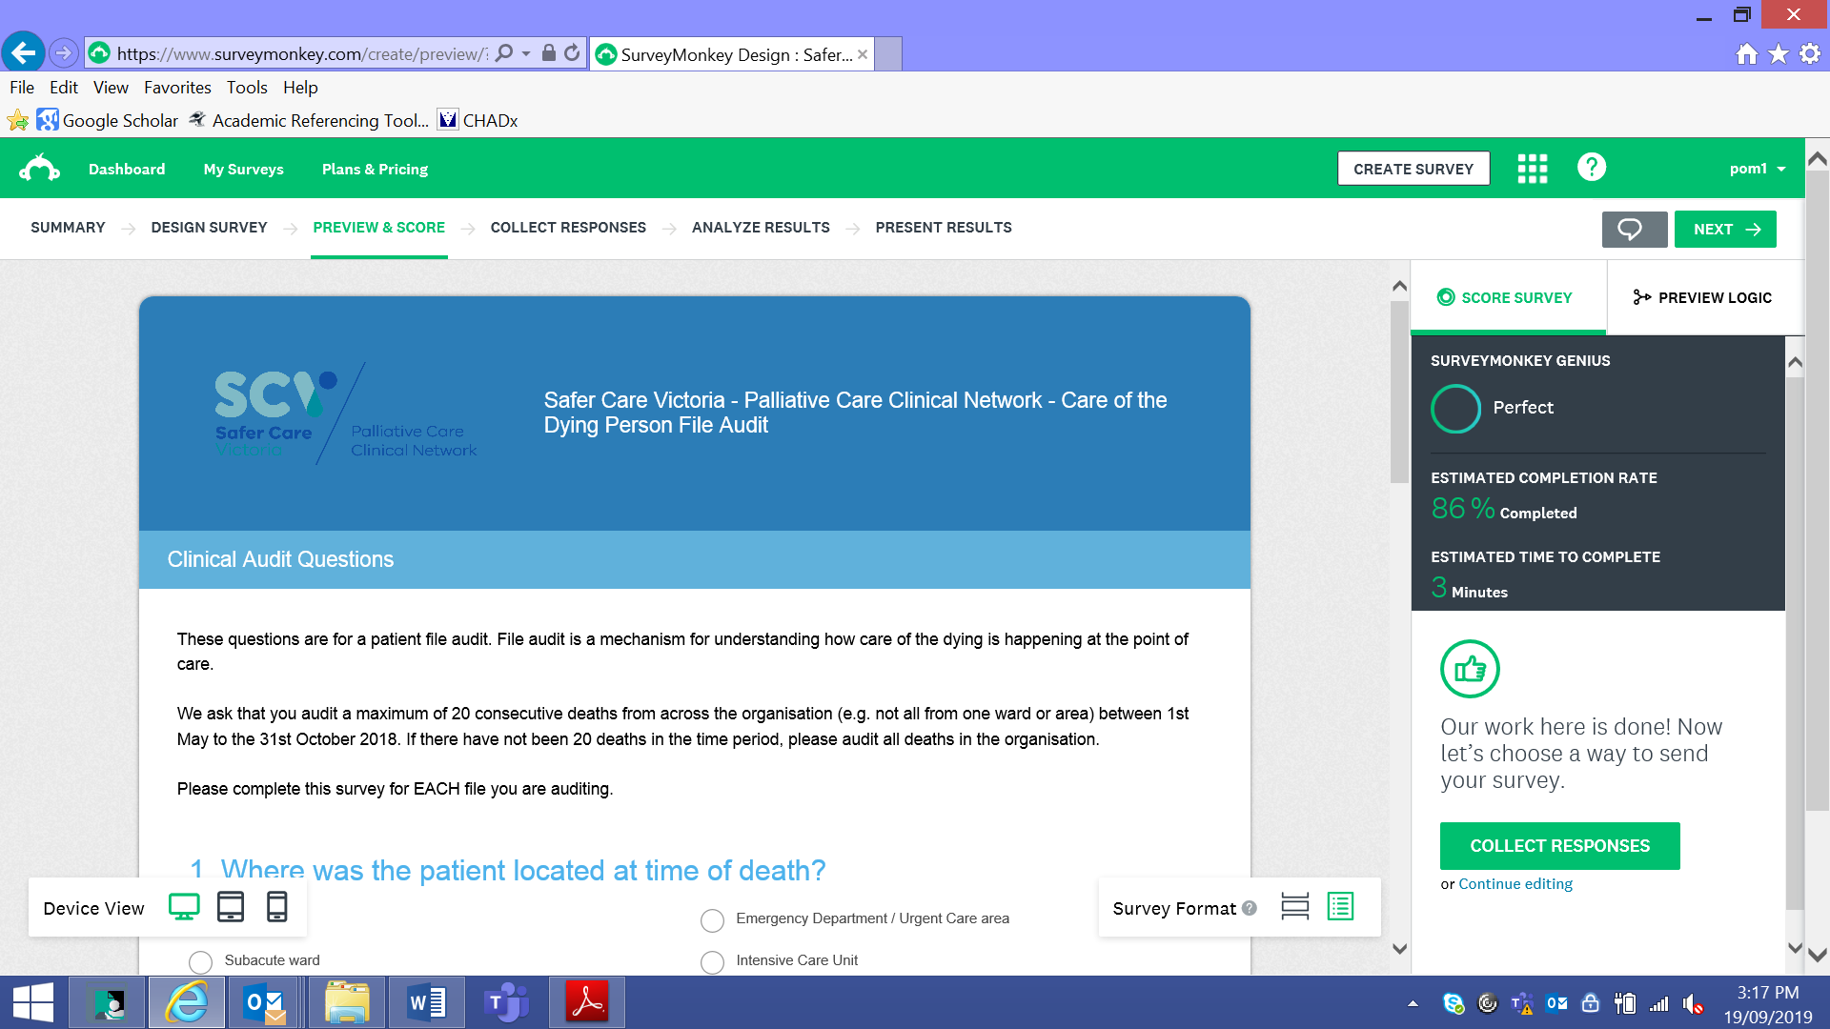

## APPENDIX 2: Work group members

|  |  |
| --- | --- |
| Name | Role |
| Rowan Hearn (Co-chair) | Consultant in palliative medicine |
| Fiona Israel (Co-chair) | Nurse, researcher |
| Nicola Atkin | Palliative care physician |
| Angela Baird | Nurse unit manager palliative care |
| Melanie Benson | Palliative care physician |
| Sandeep Bhagat | Palliative care physician |
| Melissa Bloomer | Academic – nursing and end of life care |
| Mark Boughey | Clinical Lead Palliative Care Clinical Network |
| Liam Brady | Palliative care nurse consultant |
| Roberto Chiletti | Consultant paediatric intensivist |
| John Clements | Consumer |
| Jodie Cotte | Pharmacist aged care |
| Monica Dowling | Nurse organ donation specialist |
| Paul Felicetti | Paramedic/previous nurse |
| Erika Fisher | Clinical nurse consultant |
| Sue Gorman | Social worker |
| Lawrence Habegger | Palliative care nurse practitioner |
| Michelle Ielasi | Palliative care nurse consultant |
| Natalie Ladner | Campus manager, nurse |
| Helen Nickson | Social worker – chronic illness |
| Steve Philpot | Intensivist |
| Nora Refahi | Consumer advocate |
| Marianne Wadsley | Geriatrician/physician |
| Dr Janice Wan-Yoke Yeung | Intensivist |

## References

1. Department of Health 2010, *Supporting Australian’s to live well at the end of life: National Palliative Care Strategy 2010*, Australian Government, Canberra.
2. Palliative Care Australia 2018, *National Palliative Care Standards,* Canberra.
3. Australian Commission on Safety and Quality in Health Care 2015, *National Consensus Statement: essential elements for safe and high-quality end-of-life care*, Sydney.
4. Department of Health and Human Services 2016, *Victoria's end of life and palliative care framework*, Victorian Government, Melbourne.
5. Principles adapted from: Leadership Alliance for the Care of Dying People 2014, *One chance to get it right* (Publications Gateway Reference 01509) in response to the independent review of the Liverpool Care Pathway for the Dying Patient.
6. International Collaborative for Best Care for the Dying Person 2019, *About the International Collaborative for Best Care for the Dying Person*. Retrieved from: https://bestcareforthedying.org/

