Summary report: Reducing readmissions after paediatric tonsillectomy and adenoidectomy

**In 2019 the Victorian Paediatric Clinical Network (VPCN) at Safer Care Victoria partnered with five hospitals to test and adapt a change package to reduce rates of readmission following paediatric tonsillectomy. Resources were developed to improve families’ understanding of what to expect before tonsil surgery and how to care for their child when returning home, with the goal of minimising the need for readmission.**

## background Tonsillectomy and adenoidectomy (T & A) are the most common surgical procedures in childhood, with over 12,000 procedures in Victoria per year. Tonsillectomy is mainly performed for sleep disordered breathing (SDB) or recurrent tonsillitis. As SDB affects 10% of children, it represents a major health burden and high-volume reason for seeking medical care.

Results at a glance

**Health services**Five paediatric wards from paediatric tertiary, metropolitan, regional, public and private health services participated.

**Duration**July 2019 – March 2020

**Project Measures**One outcome, four process and two balancing measures were used.

**Results**By March 2020, the combined results of the participating health services showed > 15% reduction in readmissions following paediatric tonsillectomy.

**Other outcomes**

* High level of family satisfaction with support received.
* Increased clinician awareness of how to best support families of children having tonsillectomy.
* Increased capability of clinicians to lead quality improvement projects.

Readmission to hospital after T & A is the most common reason for readmission after a surgical procedure in a child1. Data provided by the Victorian Agency for Health Information (VAHI) shows that many Victorian hospitals have readmission rates well above the state-wide average.

The Victorian Government recognises this as a high priority area for improvement, including it as a Budget Paper 32 measure which health services use to monitor their performance. The VPCN also recognised the importance of conducting improvement work in this area and commenced the Reducing clinical variation in paediatric adenotonsillectomy project in 2018.

## aim



The aim of the project was to reduce the rate of readmission following paediatric tonsillectomy by 15% in the participating health services by May 2020.

## Improvement approach

An Expert Working Group, including multi-disciplinary clinicians and consumer representatives was established to co-design the project. Health service visits and a literature review were also undertaken to inform the development of a change package.

The change package focuses on pre and post-operative information, pain management guidance and follow up support.

Following an expression of interest process, five health services were chosen to work together in a collaborative.

The participating health services formed teams of nurses, surgeons, quality mangers and clinical directors. The VPCN provided a series of learning sessions to teach the participants about improvement science, change management, data collection and interpretation.

Participants used the Model for Improvement3, including the Plan-Do-Study-Act cycle of quality improvement to design, test and adapt the change package. The VPCN provided ongoing support with regular communication and visits to each health service.

**Key Improvements**

Change ideas

The health services developed ideas to successfully implement the change package in their local setting. **Consumer resources** were developed to enhance communication and help families understand what to expect when a child has tonsil surgery and how to care for them at home:

* Before your child has tonsil surgery fact sheet
* Caring for your child after tonsil surgery fact sheet
* Pain management plan after tonsil surgery.

A **standardised phone script** was developed for clinicians to use for follow-up calls with the family after surgery:

* Following up families after a tonsillectomy.

1. Zhou H, Della P, Roberts P, Porter P, Dhaliwal S. A 5-year retrospective cohort study of unplanned readmissions in an Australian tertiary paediatric hospital. Australian Health Review: a publication of the Australian Hospital Association. 2019; 43(6): 662-671.
2. Victorian Government, Delivering for all Victorians. Victorian Budget 19/20 Service Delivery. Available from: <https://s3-ap-southeast-2.amazonaws.com/budgetfiles201920.budget.vic.gov.au/2019-20+State+Budget+-+Service+Delivery.pdf>. Last accessed 11 June 2020.
3. Langley GJ, Moen RD, Nolan KM, Nolan TW, Norman CL, Provost LP. The Improvement Guide: A Practical Approach to Enhancing Organizational Performance. 2nd edition. San Francisco: Jossey-Bass Publishers; 2009.

[**View the resources**](https://www.bettersafercare.vic.gov.au/resources/tools/reducing-readmissions-after-paediatric-tonsil-surgery) – Health services can use these as part of a targeted improvement initiative to minimise the risk of children needing to return to hospital after tonsil surgery.

By the end of December 2019, three out of five sites were testing 100% of the change package and the other two sites were testing 75% by February 2020.

## Statistics Results

By March 2020 the aim of the project was achieved:

* From January 2020, the combined weekly readmission data for the five health services demonstrated a change in median from 4.2% to 0%. This exceeded the aim to achieve a 15% reduction (median 3.6% - the line where half of the data points are expected to be above and below that line).
* Further time is needed to assess if these results can be sustained.

**Figure 1. Run chart of readmission after tonsillectomy for five sites combined**

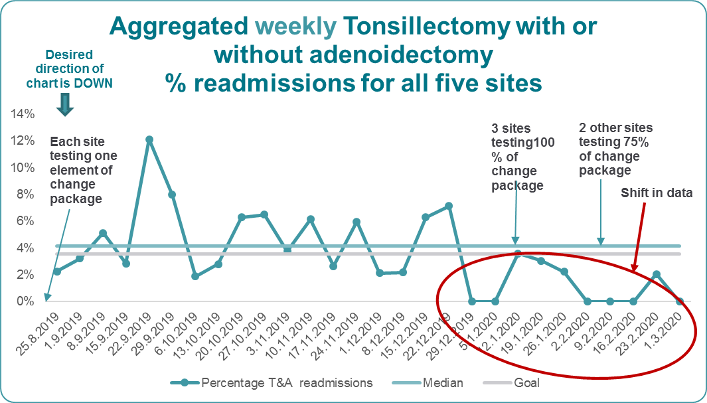

## next steps for the VPCN

Over the next six months we will:

* monitor state-wide readmission rates following paediatric tonsillectomy to determine sustainability of the changes in the participating health services
* promote the change package for use in additional health services.