|  |
| --- |
| Daily Operating System (DOS) administration guide |
| Better Care Victoria, Victoria State Government |

|  |
| --- |
|  |
| To receive this publication in an accessible format phone 03 9096 2761,  using the National Relay Service 13 36 77 if required, or [email Safer Care Victoria](mailto:bcv@safercare.vic.gov.au) <bcv@safercare.vic.gov.au>.  Authorised and published by the Victorian Government, 1 Treasury Place, Melbourne.  © State of Victoria (Safer Care Victoria) 2018    This work, Daily Operating System (DOS) administration guide, is licensed under a Creative Commons Attribution 4.0 licence [link to http://creativecommons.org/licenses/by/4.0/]. You are free to re-use the work under that licence, on the condition that you credit the State of Victoria (Safer Care Victoria) as author, indicate if changes were made and comply with the other licence terms. The licence does not apply to any branding, including the Victorian Government logo and the Safer Care Victoria logo.  ISBN 978-1-76069-239-1 (pdf/online/MS word)  Available at Better Care Victoria <https://www.bettercare.vic.gov.au>  Suggested citation: Nicholson, A 2018, *Daily Operating System (DOS) administration guide*, Safer Care Victoria, State Government of Victoria, Melbourne. |
|  |

Contents

Daily Operating System (DOS) administration guide 1

1. Purpose 4

1.1. How does a DOS fit within your health service? 4

2. Introduction to DOS 5

2.1. What is a Daily Operating System? 5

2.2. What is the value of using a Daily Operating System? 6

2.3. Who participates in a Daily Operating System? 7

2.4. How does a Daily Operating System link with strategic plans and priorities? 7

3. Key components of a Daily Operating System 8

3.1. Supporting elements 9

3.2. Daily readiness assessment 10

4. Implementing a Daily Operating System 11

4.1. Implementation considerations 11

4.2. Key high-level phases to implementation 13

4.3. Implementation structure options 14

4.4. Implementation challenges 16

# Purpose

The purpose of the *Daily Operating System administration guide* is to present health services with the four key elements needed for the successful implementation of a Daily Operating System (DOS):

* Leadership
* Tiered huddle structure
* Visual practice management
* Daily readiness assessment.

The guide will not tell health services *how* to implement a Daily Operating System, as each health service needs to adopt a DOS process, which is relevant for their own organisation.

## How does a DOS fit within your health service?

A DOS can fit within any organisation in a number of different ways. The primary objective of a DOS is to ensure the alignment of daily operational activities and strategic activities with the organisation’s objectives. Figure 1 illustrates this connection.

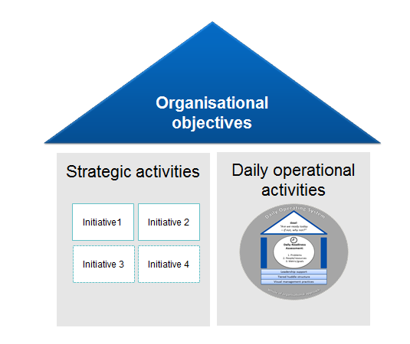

Figure 1: How a Daily Operating System fits within an organisation

# Introduction to DOS

## What is a Daily Operating System?

A Daily Operating System is a way of working to help a health service answer the fundamental question, ‘Are we ready today – if not, why not?’. In the healthcare context, this is a critical question to help improve patient care, access and flow. This does not mean that this question cannot be answered in another way, however health services with a DOS in place are able to speed up their answer to this question in a structured, whole-of-organisation oversight way.

A DOS provides the visibility of today’s operations and allows problems to be identified quickly. Frontline staff are empowered to solve these problems daily, and the problems they cannot fix are escalated, allowing countermeasures to be created quickly.

A DOS is known as a Daily Management System (DMS) in other industries. However, there are usually more elements included in a DMS, which are not as relevant for health services.

For a DOS to work effectively in the healthcare context, it is recommended that the following elements be present.

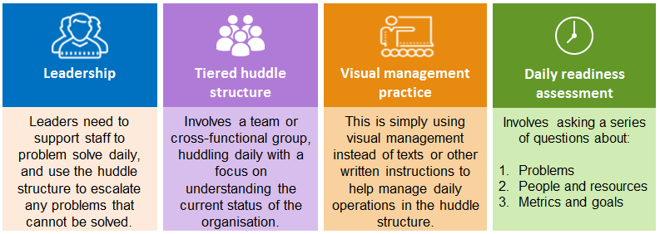

Figure 2: Elements of a Daily Operating System

## What is the value of using a Daily Operating System?

Having a Daily Operating System in place can help health services to:

* Answer the question, ‘Are we ready today – if not, why not?’ quicker, increasing the pace at which problems are raised and solved.
* Have greater whole-of-organisation oversight, increasing everyone’s awareness of the whole system, and improving teamwork and coordination of effort.
* Have regular, structured communication about daily operations and performance.
* Improve staff morale and accountability. Anecdotal reports indicate that staff feel like their problems are being heard and addressed.
* Break down organisational silos and improve teamwork and coordination of effort.
* Better work planning and resource allocation.
* Build capability in staff to ask better questions.
* Promote openness and transparency in raising issues.
* Promote a proactive approach to problem solving, rather than simply reacting to issues.
* Have better quality monitoring, as senior leaders are aware of the current state of performance.
* Gain access to the right people for troubleshooting, resulting in timely problem solving.

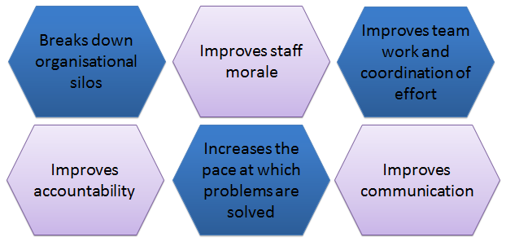

Figure 3: The value of a Daily Operating System

## Who participates in a Daily Operating System?

Figure 4 describes the role of Victoria’s health services in relation to a Daily Operating System. It is recommended that senior executives play a key role in supporting and driving this new way of working. The system will not be effective without whole-of-organisation buy-in and participation.

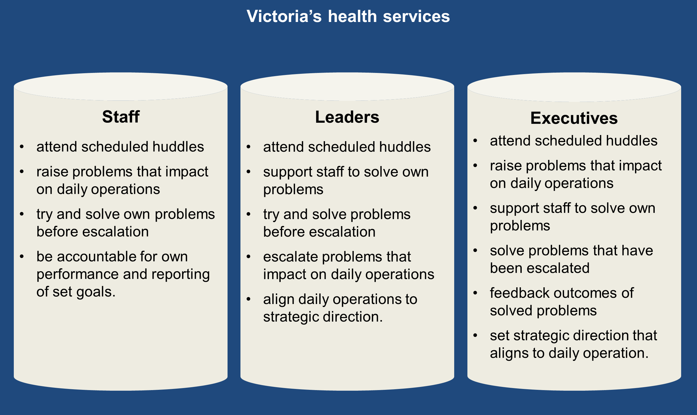

Figure 4: Daily Operating System participants

## How does a Daily Operating System link with strategic plans and priorities?

Implementing a Daily Operating System can help a health service align daily operations to long-term strategic objectives. Health services need to consider the focus of their daily readiness assessment to achieve the organisation’s strategic objectives.

A common question asked as part of the daily readiness assessment is around metrics and goals. The metrics and goals should align to the organisation’s long-term strategic priorities. For example, if a health service has a strategic objective to reduce harm to patients, what are they doing on a daily basis to achieve this? The DOS should ensure oversight of this objective on a daily basis.

# Key components of a Daily Operating System

A Daily Operating System has two key components – supporting elements and a daily readiness assessment. It is recommended that these two components be present for a DOS to work effectively.

The primary goal of a DOS is to determine if – as a whole organisation – we are ready to deliver care today. This goal can be achieved when the two components are working together.

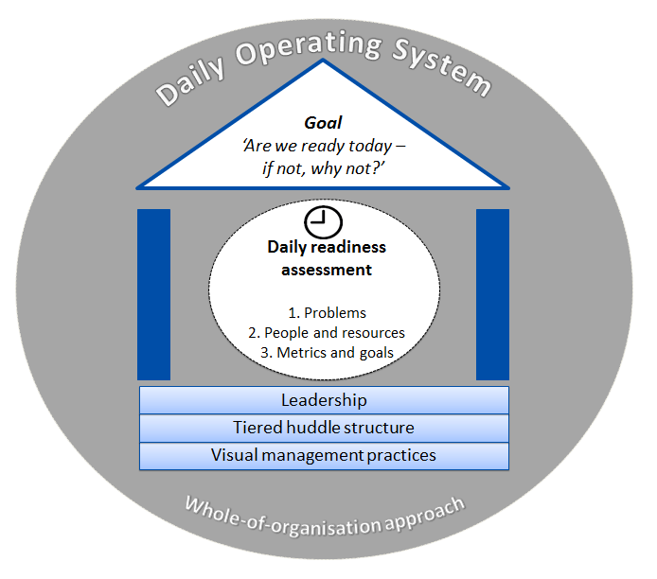

Figure 5: Daily Operating System

## Supporting elements

The supporting elements are fundamental to making a Daily Operating System work. Figure 6 outlines the supporting elements.

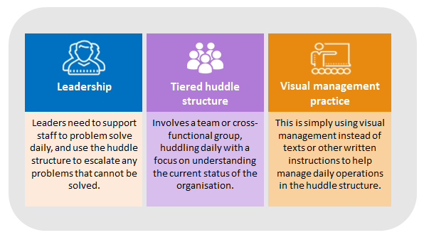

Figure 6: Daily Operating System supporting elements

The supporting elements are described as follows:

* **Leadership** – leaders need to change their way of working for a Daily Operating System to work effectively. They need to support their staff to problem solve on a daily basis. If these problems cannot be solved, leaders then need to escalate the problems through the tiered huddle structure.
* **Tiered huddle structure** – usually involves a team or cross-functional group, coming together every day for a short, targeted discussion, with a focus on understanding the current status of the organisation. For huddles to be most effective, there should be a tiered structure to enable escalation, with a standard format and clearly defined components (for example, duration, venue, roles, responsibilities). Problems are identified at these huddles. If the staff in the huddle cannot solve them, it is the leader’s responsibility to escalate to the next huddle level. The huddle process can contribute significantly to team formation, coordination of effort and accountability of problems.
* **Visual management practice** – the purpose of this supporting element is to help drive conversations and promote problem solving. It involves using visual signals, instead of texts or other written instructions, and should enable quick recognition of the information, in order to increase efficiency and clarity. The focus of visual management practice should be about the discussion that supports it, rather than the activity of updating the visual management.

## Daily readiness assessment

The daily readiness assessment is conducted every day in the tiered huddle structure, to help the health service answer the question, ‘Are we ready today – if not, why not?’. The assessment involves asking a series of questions that help operational management. The questions asked should align to the organisation’s strategic objectives. Figure 7 summarises the most common questions asked in a daily readiness assessment.

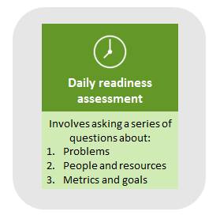

Figure 7: Daily Operating System daily readiness assessment

The most common daily readiness assessment questions are described below:

* **Problems** – the primary objective of a Daily Operating System is to solve the problems that prevent the health service from being ‘care ready’ on a daily basis. Staff are expected to solve any problems that impede their ability to deliver care that day. If a problem cannot be solved at a huddle, it is the leader’s responsibility to escalate the problem to the next huddle level. The tiered huddle structure provides a way for problems to be escalated and feedback from outcomes of the problems returned.
* **People and resources** – for a health service to know if they are ready to deliver care that day, there needs to be a discussion about whether or not the right people and resources are available to deliver this care. The question, ‘Do we have enough staff and resources today?’, is asked in the tiered huddle every day. It is the responsibility of the staff attending each huddle to raise any issues or concerns they have about people or resources.
* **Metrics and goals** – the final readiness assessment is about the organisation’s performance and should be linked to the organisation’s strategic objectives. Performance is determined by asking the questions, ‘How did we go yesterday?’ and ‘What is our goal today?’.

# Implementing a Daily Operating System

This section provides recommendations for health services considering the implementation of a Daily Operating System. It covers considerations, key high-level phases, implementation options and implementation challenges. This section will not explain *how* to do this, as each health service needs to make the system relevant for their own organisation.

A key finding from the health services that have already implemented a Daily Operating System is: don’t let perfection get in your way of doing something, just start somewhere and build a structure to regularly review and improve this system. Currently, Eastern Health is the only health service that has evaluated their DOS. The final evaluation (conducted by Monash University) findings have not yet been released. Preliminary insights however, align to these recommendations.

## Implementation considerations

There are a number of considerations that health services should think about prior to implementing a Daily Operating System. Figure 8 presents the considerations as questions, structured around each of the key elements. Health services should consider the answers to these questions and reflect on how they relate to their organisation.

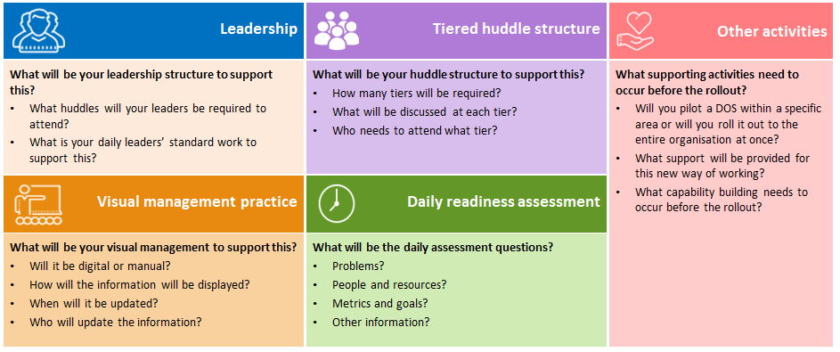

Figure 8: Implementation considerations

### Leadership

Health services need to consider what the leadership support and structure will look like when implementing a Daily Operating System. Without leadership to support this way of working, the system will not be successful.

Questions to consider include:

* What huddles will your leaders be required to attend?
* What is your daily leader’s standard work to support this? For example, what agreed way of working must your leaders follow?

### Tiered huddle structure

The huddles need to be structured in a way that enables staff to raise problems and also to facilitate the daily readiness assessment. This is best done via a tiered huddle structure. The number of tiered huddles, frequency and focus for each huddle will be different for each health service. It should be implemented based on organisational needs.

Questions to consider include:

* How many tiers will be required?
* What will be discussed at each tier?
* Who needs to attend what tier?

### Visual management practice

Visual management should be used to support huddle conversations and make the outcomes visible. It should be simple and placed somewhere that can be seen by all who needs to see it. Health services need to consider what visual management is needed to support this way of working.

Questions to consider include:

* Will it be digital or manual?
* How will the information be displayed?
* When will it be updated?
* Who will update the information?

### Daily readiness assessment

The daily readiness assessment needs to cover the key questions that must be asked for a health service to know if they are care ready. These questions should also link to the organisation’s long-term strategic objectives.

Assessment questions are commonly around:

* problems
* people and resources
* metrics and goals.

### Other activities

A health service needs to consider its own organisational requirements, and any other supporting activities prior to the rollout of a Daily Operating System.

Questions to consider include:

* Will you pilot the Daily Operating System within a specific area or will you roll it out to the entire organisation at once?
* What support will be provided to the impacted areas? (Remember for some people, this will potentially be a new way of working.)
* What support is needed to rollout this new way of working?
* What capability building needs to occur before the rollout? For example, problem solving (improvement framework)?

## Key high-level phases to implementation

Each health service will select the best way to implement a Daily Operating System to suit their own needs. However, there are some key high-level phase steps we recommend going through prior to implementation. The steps are outlined in Figure 9.

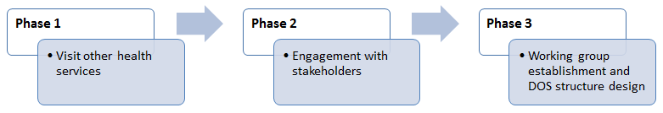

Figure 9: High-level phases to implementation

* **Phase 1:** Visit other health services that already have a Daily Operating System in place. Discover how they went about implementation, what challenges they experienced and source any templates or tools they used.
* **Phase 2:** Engage with the key stakeholders in your health service. For this system to be effective, it will require the whole organisation to change its way of working. Proper engagement and agreement that this new approach is the way forward needs to be gained. An accompanying Daily Operating System factsheet and presentation slide template can be used for this engagement. These tools can be branded and adapted to suit your own health service’s needs.
* **Phase 3:** Form a working group to determine the design and structure of a Daily Operating System that suits your health service’s needs. For example, the number of tiers, purpose of each tier, timing of tiers, frequency of tiers, who’s required at each tier, questions to be asked at each tier, agreement to the ways of working at each tier, templates to be used and rollout structure (whole-of-organisation or individual wards?).

Your health service should be ready to commence implementation once the three phases are complete.

## Implementation structure options

There a number of different structure options for a Daily Operating System. It’s up to the health service to design a structure that suits their own needs. The structure options should be workshopped and agreed upon by a working group. The outcomes should be tested with the relevant key parties.

Figure 10 provides the Daily Operating System structures used in four Victorian health services.

**Figure 10 Glossary**

|  |  |
| --- | --- |
| ACAS | Aged Care Assessment Service |
| AH | Allied Health |
| ANUM | Associate Nurse Unit Manager |
| CEO | Chief Executive Officer |
| Clin. | Clinical |
| COO | Chief Operations Officer |
| Direct./Dir. | Director |
| EDMS | Executive Director of Medical Services |
| EDON | Executive Director of Nursing |
| Exec. | Executive |
| GM | General Manager |
| HIS | Hospital Information Services |
| HR | Human Resources |
| Imag. | Imaging |
| IT | Information Technology |
| JMO | Junior Medical Officer |
| NIC | Nurse in Charge |
| NUM | Nurse Unit Manager |
| Ops. | Operations |
| Path. | Pathology |
| Pharm. | Pharmacy |
| PSM | Patient Services Manager |
| Rep. | Representative |
| Serv./Ser. | Services |
| T1 | Tier 1 Huddle |
| T2 | Tier 2 Huddle |
| T3 | Tier 3 Huddle |
| T4 | Tier 4 Huddle |

Figure 10: Daily Operating System structures

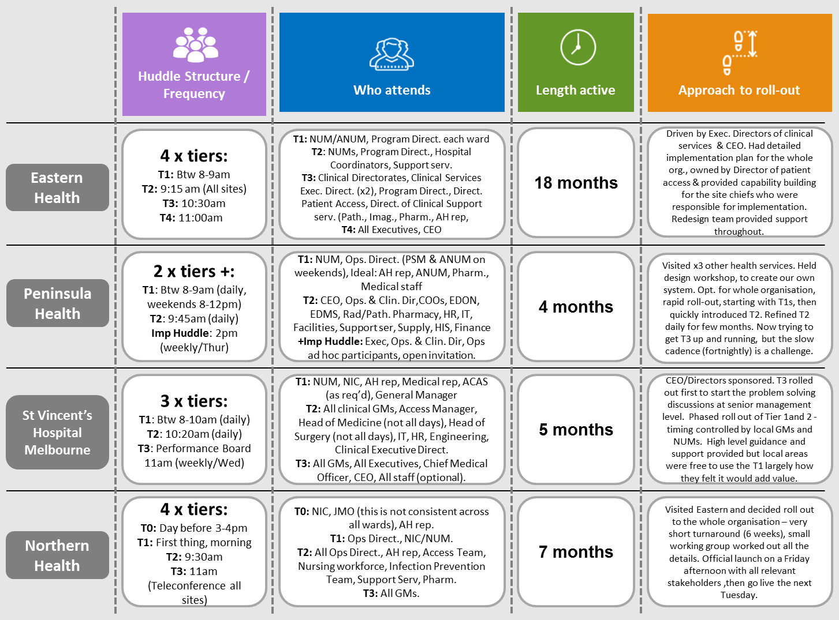

## Implementation challenges

Like all new ways of working, there will be some challenges that a health service needs to consider. The following challenges are not the only challenges your organisation might face, but have been identified as the most important ones.

### Strategic direction implications

### The Daily Operating System needs to align with the strategic direction of the organisation. The daily readiness assessment needs to factor in the strategic direction of the health service and ensure that the questions are asked daily, to align operational management with the strategic direction of the organisation.

### Systemic issues

### As part of establishing a Daily Operating System, health services need to determine a way to identify and manage systemic issues within this new way of working. If the problems identified through this structure as systemic, it can sometimes be a challenge to address them.

### Improvement framework

An established improvement framework is highly recommended for an effective Daily Operating System. Without a structured way to problem solve, root-cause problem solving might not occur, problems might take longer than planned to fix and the wrong people might be solving the problems. However, we recommend that a health service doesn’t delay implementing a Daily Operating System, even if they don’t have an improvement framework. The framework can be formed after the Daily Operating System is in place, together with on-the-job capability building.

### Whole-of-organisation oversight

### Some health services have experienced a lack of medical input in Daily Operating System huddles. All areas of the health service need to be part of the system for it to be most effective.

### Data management

It is important to get the right data to provide the information that leaders need to know, rather than reporting on data that is interesting. This may at times, impact on leaders reacting to normal variation. It’s essential for leaders to be able to distinguish when to react.

### Acceptance to a change in the way of working

### The Daily Operating System structure empowers leaders and staff to address problems, discuss people and resourcing and talk about performance every day. For some health services, this level of transparency and way of working would not normally occur and could potentially be challenging.

### Further information

For further information about implementing a Daily Operating System, contact the Safer Care Victoria team < bcv@safercare.vic.gov.au> or call 03 9096 2761.