|  |
| --- |
| Daily Operating Systems (DOS) in health services |
| Factsheet |



A structured whole-of-organisation approach to gain oversight on problems

**What is a Daily Operating System?**

A Daily Operating System (DOS) is a way of working to help a health service answer the fundamental question, ‘Are we ready today – if not, why not?’. In the healthcare context, this question is critical to help improve patient care, access and flow. This does not mean that this question cannot be answered in another way, but health services with a DOS in place are able to speed up their answer to this question in a structured, whole-of-organisation oversight way.

A DOS provides visibility of today’s operations and allows problems to be identified quickly. Frontline staff are empowered to solve these problems daily. The problems they cannot fix are escalated, allowing countermeasures to be created quickly.

**What are the benefits of having a Daily Operating System?**

Having a DOS in place can help health services to:

* Answer the question, ‘Are we ready today – if not, why not?’ quicker, increasing the pace at which problems are raised and solved.
* Have greater whole-of-organisation oversight, increasing everyone’s awareness of the whole system – improving teamwork and coordination of effort.
* Have regular, structured communication about daily operations and performance.
* Improve staff morale and accountability. Anecdotal reports indicate that staff feel like their problems are being heard and addressed.

**What are the components of a DOS?**

Not all DOS are the same – each health service needs to make the system relevant for their own organisation. It is recommended that the following elements be present for a DOS to work effectively:

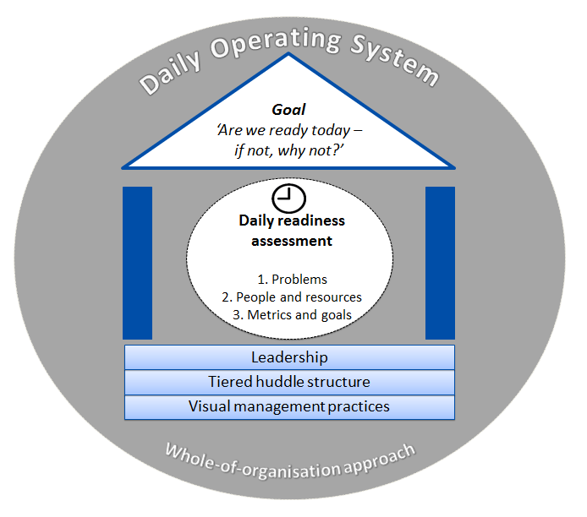

Working together, these elements can help health services achieve the primary goal of a DOS – determining if, as a whole organisation, we are ready to deliver care today.

**Supporting elements**

The supporting elements are fundamental to making a DOS work. Without these elements, this way of working will not be successful. These elements are:

* **Leadership** – for a DOS to work effectively, leaders need to change their way of working. They need to support their staff to problem solve on a daily basis. If these problems cannot be solved; the leaders need to escalate the problems through the tiered huddle structure.
* **Tiered huddle structure** – this usually involves a team or cross-functional group, coming together every day for a short, targeted discussion, with a focus on understanding the current status of the organisation. For huddles to be most effective, there should be a tiered structure to enable escalation, with a standard format and clearly defined components (for example, duration, venue, roles, responsibilities). Problems are identified during the huddle. If they cannot be solved by the staff in the huddle, it is the leader’s responsibility to escalate to the next huddle level. The huddle process can contribute significantly to team formation, coordination of effort and accountability of problems.
* **Visual management practices** – the purpose of this supporting element is to help drive conversations and promote problem solving. It involves the use of visual signals, instead of texts or other written instructions, and should enable quick recognition of the information, in order to increase efficiency and clarity. The focus of visual management practice should be about the discussion that supports it, rather than the activity of updating the visual management.

**Daily readiness assessment**

The daily readiness assessment is done every day in the tiered huddle structure to help the health service answer the question, ‘Are we ready today – if not, why not?’. It involves asking a series of questions about the following elements, which are foundational to operations management:

1. **Problems** – anecdotal reports of all health services with a DOS in place focus on problem solving as the primary purpose of the daily huddle. Staff are expected to solve any problems that impede their ability to deliver care that day. If a problem cannot be solved at a huddle, it is the leader’s responsibility to escalate the problem to the next huddle level.
2. **People and resources** – to determine if the health service is ready to deliver care that day, there needs to be a discussion about whether or not the right people and resources are available to deliver this care. In the tiered huddles, the question, ‘Do we have enough staff and resources today?’, is asked every day. It is the responsibility of those attending each huddle to raise any issues or concerns they have about people or resources.**Metrics and goals** – the final readiness assessment is about the organisation’s performance, by asking the question, ‘How did we go yesterday?’ and ‘What is our goal today?’. These discussions are more effective when the performance conversation is linked to the organisation’s strategic goals.

**Summary**

A Daily Operating System is one way that health services can quickly and systematically, from a whole-of-organisation perspective, answer the fundamental question, ‘Are we ready today – if not, why not?’. If your health service does not have a DOS in place, what system or structure do you use to help you answer this question?

**Further information**

The Daily Operating System supporting materials are available from the [Better Care Victoria website](http://www.bettercare.vic.gov.au) <www.bettercare.vic.gov.au>.

For further information, contact the Safer Care Victoria team at <bcv@safercare.vic.gov.au> or call   
03 9096 2761.

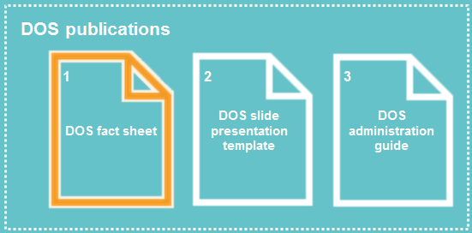

To receive this publication in an accessible format phone 03 9096 2761,   
using the National Relay Service 13 36 77 if required, or [email Safer Care Victoria](mailto:bcv@safercare.vic.gov.au)   
[bcv@safercare.vic.gov.au](mailto:bcv@safercare.vic.gov.au).

Authorised and published by the Victorian Government, 1 Treasury Place, Melbourne.

© State of Victoria (Safer Care Victoria) 2018

ISBN 978-1-76069-238-4 (pdf/online/MS word)

Available at [Better Care Victoria](https://www.bettercare.vic.gov.au/) [www.bettercare.vic.gov.au](http://www.bettercare.vic.gov.au)