Challenging antibiotic allergies to enable effective treatment

Austin Health and partner organisation Peter MacCallum Cancer Centre are trialling a program that identifies and tests patients with antibiotic allergies to ensure their allergy ‘label’ is accurate. By ‘de-labelling’ those with false antibiotic allergies, they can ensure patients are being treated with the most effective and appropriate antibiotic therapies.

## Background

More than two million Australians report an antibiotic allergy, but studies have shown that 85 per cent of these allergy ‘labels’ are false or can be removed through testing, with this group of people subsequently ‘de-labelled’. False labels can arise from an incorrect diagnosis or because the individual has grown out of the allergy over time.

False antibiotic allergy labels can result in patients receiving inappropriate or less effective antibiotic therapies, potentially leading to poor health outcomes, extended hospital stays and complications, increased antimicrobial resistance, higher hospital readmission rates, and sometimes even death.

Many health services fail to identify the 50 per cent of patients with low-risk antibiotic allergies who could potentially be de-labelled. Furthermore, only 48 per cent of Australian clinicians have access to the specialised testing required to verify a patient’s allergy label.

Austin Health piloted three initiatives that succeeded in discovering, assessing and de-labelling patients with antibiotic allergies:

* an antimicrobial stewardship-led antibiotic allergy ward round protocol, which identified over 200 patients with an antibiotic allergy that would have otherwise remained undiscovered
* an antibiotic allergy assessment tool, which correctly assessed patients with a penicillin allergy, with high sensitivity and specificity rates of 97.8 per cent and 96.6 per cent, respectively
* an oral penicillin challenge test, which de-labelled 100 per cent of penicillin allergy labels and reduced hospital length of stay amongst the 46 low-risk patients who received the test.

Austin Health aims to integrate all three solutions into a program that can be rapidly scaled across other health services, providing more appropriate and effective care.

Antibiotic allergy de-labelling program

**Lead** Austin Health

**Partner** Peter MacCallum Cancer Centre

**Funding round** 2018–19

**Status** In progress

**Objectives**

* Identify all patients admitted to Austin Health and Peter MacCallum Cancer Centre with a documented antibiotic allergy
* Standardise antibiotic allergy assessment and improve the accuracy of medical record antibiotic allergy documentation
* Implement an inpatient oral penicillin challenge program that successfully de-labels 85 per cent of patients tested, improves patient care, and reduces the financial and resource burdens antibiotic allergies place on the healthcare system
* Increase the use of preferred and appropriate antibiotics in de-labelled patients by 30 per cent to enhance their health outcomes and reduce their hospital length of stay

## Key activity

Austin Health’s project activities are divided into three main focus areas:

* To promote **discovery** ofantibioticallergies, Austin Health and Peter MacCallum Cancer Centre will increase awareness in all healthcare workers, incorporate weekly antimicrobial stewardship-led antibiotic allergy ward rounds at both health services, and develop an electronic report to help the project team to identify patients admitted with a documented antibiotic allergy label.
* To improve **assessment**, the two health services will use a validated antibiotic allergy assessment tool to categorise patients’ allergies as being no risk (i.e. no allergy), low-risk or high-risk.
* As part of a **de-labelling** program, no-risk patients will have their label directly removed from their medical record; low-risk penicillin allergy patients will be offered a safe oral penicillin challenge test and will be de-labelled if they have no reaction; and high-risk patients with a frequent need for antibiotics will be referred for specialist assessment and testing.

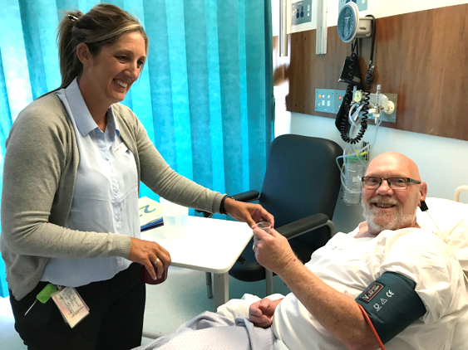

## Status

While this innovation project is still in the process of being finalised, early results have been positive.

Of the patients who received an oral penicillin challenge, 97 per cent had a false allergy label. The subsequent de-labelling of these patients led to a 10-fold increase in penicillin use.

Certain aspects of the project were published in [*Clinical Infectious Diseases*](https://academic.oup.com/cid/advance-article-abstract/doi/10.1093/cid/ciaa653/5879938)in August 2020.