Saving CARDIAC ARREST patient lives with artificial intelligence

For people experiencing a cardiac arrest outside of hospital, the Triple Zero (000) emergency call-taker’s ability to quickly detect the signs and act accordingly can be key to determining the patient’s outcome. Ambulance Victoria is using artificial intelligence to analyse incoming emergency calls and assist call-takers with cardiac arrest identification so Victorians can receive the appropriate care faster.

## Background

Cardiac arrest that occurs outside of hospital is a time-critical condition that affects all ages, with few survivors. Every minute that intervention is delayed is associated with a 10 per cent decrease in the odds of survival.

The chances of successful resuscitation and good recovery from any brain damage experienced increase when cardiopulmonary resuscitation (CPR) and defibrillation are provided quickly.

Emergency call-takers play a pivotal role in early detection and intervention for people experiencing cardiac arrest in the community. In addition to being able to dispatch the highest priority ambulance, call-takers can guide bystanders through CPR and defibrillation over the phone to provide immediate care while waiting for first responders to arrive.

However, bystander descriptions of the emergency can be highly variable, and because of this, call-takers have historically been unable to identify 15–20 per cent of cardiac arrest patients – the equivalent of approximately 1,000 Victorians each year.

If their condition is not identified in an emergency call and they do not receive bystander CPR, cardiac arrest patients have less than 1 per cent of survival.

The AIDE project aims to develop a decision support tool driven by artificial intelligence (AI) that will help emergency call-takers identify signs of cardiac arrest earlier and respond faster, saving more Victorian lives and delivering better long-term health outcomes.

**Artificial intelligence in cardiac arrest (AIDE)**

**Lead** Ambulance Victoria

**Partners** Emergency Services Telecommunications Authority, Monash University Faculty of Information Technology

**Funding round** 2019–20

**Status** In progress

**Objectives**

* Improve the accurate identification of cardiac arrest patients during emergency calls
* Increase the speed at which cardiac arrest cases are identified
* Increase the percentage of patients receiving bystander CPR, and the speed at which it is delivered
* Dispatch ambulances for non-identified cardiac arrest patients faster
* Develop an AI framework that can be easily and rapidly scaled to assist other patients, such as those experiencing a stroke, heart attack, or domestic violence

## Key activity

Ambulance Victoria will work with Monash University to design and train an AI framework using historical call recordings from ESTA.

The calls will be labelled using Ambulance Victoria’s data on confirmed cardiac arrest cases. They will then be used to train the AI to recognise key language specific to cardiac arrest cases.

The proposed framework would operate as follows:

* incoming calls will be converted to text using state-of-the-art speech recognition technology from Microsoft
* the AI decision support tool will use this text along with an audio component to look for cardiac arrest-specific language and then estimate the probability the call is a cardiac arrest
* the tool will notify the emergency call-taker of the likelihood the patient is having a cardiac arrest
* the call-taker will have the option to accept or reject the tool’s advice, with this decision recorded and used to further train and improve the AI framework.

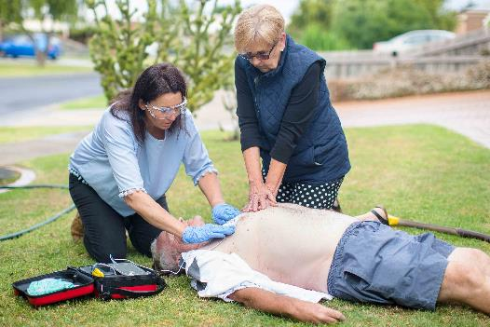

## Status

This innovation project was accepted in the Better Care Victoria 2019–20 funding round and is currently underway.