iNCREASING ACCESS TO YOUNG ONSET DEMENTIA services with TELEHEALTH

Young onset dementia affects more than 25,000 Australians but accessing specialist services to manage the condition can be challenging due to the distance, cost and time off work required. Melbourne Health harnessed telehealth technology to give more patients access to its tailored, specialist young onset dementia services and reduce the personal and economic costs for those requiring care in rural and regional Victoria.

## Background

Young onset dementia (YOD), dementia that occurs in people under 65 years of age, makes up 10 per cent of all dementia cases. It is a life-limiting illness that can cause those affected to lose up to 20 years of their life. They can also experience multiple, complex symptoms that require specific expertise for diagnosis and care.

Delayed diagnosis is a significant issue for these patients; 304 audited Melbourne Young Onset Dementia Service (MYOD) patients from 2014–17 had an average of five specialist assessments prior to receiving a dementia diagnosis, with a mean diagnostic delay of 2.9 years. The average life expectancy from onset of YOD symptoms is 1.3–7.9 years, so early intervention and treatment is critical to maximising patient quality of life.

Unfortunately, the needs of these patients often fall between clinical service gaps, as they are considered too young for some services, too old for others, and too complex for most. These patients also have markedly high rates of anxiety and depression, a feature shared by their carers. The lack of appropriate YOD specialist support and respite options can have a negative impact on carer quality of life, and high levels of carer burden can lead to YOD patients being admitted into crisis hospitals and residential care.

MYOD is part of NorthWestern Mental Health’s Neuropsychiatry Unit, which is located at The Royal Melbourne Hospital. It is one of the only services in Australia that provides tailored, flexible and integrated multidisciplinary specialist YOD services throughout the patient and carer journey.

Through the BRIGHT-YOD project, Melbourne Health sought to use telehealth technology to enhance its ability to deliver the MYOD model across Victoria – including in the state’s rural and regional areas – and provide more YOD patients with access to timely, specialist care.

**Bridging the gaps in health using telehealth for people with young onset dementia (BRIGHT-YOD)**

**Lead** Melbourne Health (NorthWestern Mental Health Neuropsychiatry Unit at The Royal Melbourne Hospital)

**Partners** Albury Wodonga Health, Royal Park Cognitive Dementia and Memory Service, Ballarat Health Service, Goulburn Valley Health, Dementia Australia, Huntington’s Victoria

**Duration** December 2018 – July 2020

**Key outcomes**

* Assessed 72 individuals through 186 appointments, with more than half receiving a neuropsychological assessment
* Significantly increased access for rural and regional Victorians
* Reduced the average number of specialists a patient saw prior to receiving their diagnosis from five to two
* More than halved the delay to diagnosis, from 64 months to 30 months
* Saved more than 100,000km in travel and up to 30 tonnes of carbon dioxide emissions

## Key activity

* Melbourne Health partnered with six organisations to plan and implement a telehealth pathway and model of care for suitable patients and carers at MYOD.
* The trial of the BRIGHT-YOD model ran for 12 months, with telehealth used to conduct:
  + **diagnostic assessments** for patients where travel was not feasible and investigations could be undertaken locally, recognising that face-to-face assessment remains the ‘gold standard’ for diagnosis
  + **review appointments** to provideongoing follow-up services and support to help patients with YOD and their carers manage the challenging medical, cognitive, behavioural and psychiatric issues associated with progressive illness
  + **carer interviews**, providing them with advice, support and education (and referrals to appropriate services where necessary) to help them cope with the high levels of anxiety, depression, stress and other health impacts associated with caring for a patient with YOD. Enhancing the general wellbeing and quality of life of carers aimed to reduce burnout and have flow-on benefits for YOD patients, including reducing crisis hospital/respite admissions and delaying entry into residential care
  + **secondary consultations** with partner organisations and/or mental health services to discuss issues such as diagnostic assessments, behavioural management, the management of complex family and psychosocial stressors, and/or to facilitate a second opinion as required
  + **specialist YOD education and training** to build capability for staff in partner organisations and facilitate earlier diagnosis and specialist treatment of YOD.

‘[Was] comfortable in own home. Saved us over five hours in travel time. Wife didn't have to take carer's leave to attend with me.’

**– Patient**

‘Felt like I was in the room.’

**– Patient**

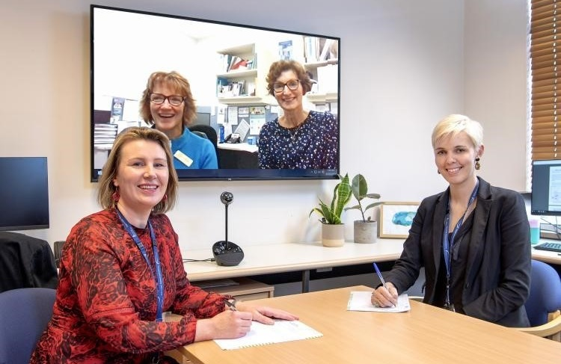

## Outcomes

* The MYOD telehealth service saw 72 patients over 186 appointments. Only three patients who were referred for telehealth declined the service.
* 56 per cent of patients received a neuropsychology assessment, with a total of 40 assessments completed.
* BRIGHT-YOD patients saw an average of two specialists before receiving a YOD diagnosis. Prior to the project, the average number of specialists seen was five.
* The average time it took for a BRIGHT-YOD patient to receive a YOD diagnosis was two years, six months compared with five years, four months for patients in a concurrent MYOD control group.
* The telehealth model significantly increased access for rural and regional Victorians, with the average distance of patients from the MYOD clinic increasing from 90km to 264km.
* Introducing the telehealth model saved more than 100,000km in travel and up to 30 tonnes of carbon dioxide emissions.
* The project helped build capability in clinicians through:
  + six conference presentations
  + 20 education and training seminars
  + six multidisciplinary case conferences
  + one telehealth client and carer support group
  + two ‘grand rounds’ events, where clinicians presented and discussed patient case studies
  + three international webinars.

## Key learnings

* **Engage all staff (both administrative and clinical) in planning and implementing the telehealth service –** Encouraging them to be part of the change process helps to foster a team culture. Understanding their fears and biases towards the use of telehealth can also be beneficial.
* **Ensure administrative processes are ready prior to implementing a telehealth service –** The administration load is high for telehealth, involving tasks such as booking appointments, telehealth setup protocols, troubleshooting, and record-keeping. As such, the administrative load needs to be to be factored into time and staff resourcing, and multi-site communication and coordination may be required. Best practice is to develop a telehealth administration procedures manual.
* **Clearly define and communicate referral processes, expectations and documentation –** For example, what is the referral question? Are scans and tests to be sent with the referral? Which service will follow up the patient? Which service will review the patient in 12 months? Being clear in these matters at the outset will avoid confusion down the line, ensuring a smoother experience for both patient and clinician.
* **Geography is key –** Patients and carers who lived more than three hours from the Melbourne CBD preferred the telehealth service option.
* **Where possible, use two cameras at the receiver end –** This is the gold standard in conducting a telehealth neuropsychological assessment.
* **Non-verbal cues are important –** These are key to proactive neuropsychological and neuropsychiatric assessment of the patient. Neuropsychologists can use the patient’s facial expressions, body language and eye movements as part of their telehealth assessment.
* **Leverage the insight telehealth provides into the patient’s home life –** Telehealth allows clinicians to see patients in their real-life environment. This can be beneficial for providing individually tailored, practical psychological and behavioural interventions.
* **Learn from others –** Ensuring ongoing collaboration with industry peers and networks that are also using telehealth (both nationally and internationally) can inform practice. It is also valuable to encourage cross-discipline feedback between clinicians. This upskills clinicians from different disciplines while also being useful for the patient as they do not have to re-tell their story.

### Consumer and carer insights

Patients and carers were involved throughout the project to ensure their needs and preferences were at the forefront of any decisions made around the service model.

As part of this involvement, a focus group was held with consumers and carers, with the following key learnings:

* Consumers want and expect to be able to choose face-to-face or telehealth for their consultation. Service providers should never assume that a rural-based patient would prefer a telehealth consult.
* Timely access to specialist diagnosis and ongoing care is the main driver for consumers.
* Consistency and continuity of care is of paramount importance to consumers, with general practitioners playing a central role.
* Detailed post-diagnosis information and ‘where to from here’ discussions should occur in follow-up sessions instead of at the time of diagnosis. Patients may be in shock and/or need time to process as a YOD diagnosis can be a lot take to in.
* Carer burden is vital to measure following a YOD diagnosis of a loved one/family member. There is a change in the role that occurs following a diagnosis of YOD which has a wide-ranging impact on lives.