A DATA-DRIVEN APPROACH TO IMPROVing OUTPATIENT CLINIC USE

Demand for outpatient services continues to grow. Improving clinic schedule efficiency is critical to reducing wait times and meeting patient expectations. Inspired by the airline industry, the Royal Children’s Hospital overbooked patients at its general medicine outpatient clinics so that they could fill appointments left vacant due to late cancellations, allowing more people to be seen.

## Background

Outpatient clinics at the Royal Children’s Hospital (RCH) see more than 240,000 people a year. Demand for services is growing, with families often facing long delays for an appointment.

In some clinics with particularly high demand, patients can wait as long as a year for a semi-urgent appointment and even longer for a routine appointment. One such clinic is the RCH general medicine clinic, which accounts for about 20 per cent of the health service’s outpatient appointments.

Approximately 10 per cent of RCH general medicine clinic patients do not attend their appointment. This wastes an appointment that could otherwise have gone to another patient, and rescheduling requires additional staff time. The backlog this creates in the system can also lead to longer wait times for other patients.

Attempts to reduce this ‘did not attend’ rate, such as by sending reminder letters and text messages, were having little impact, so the RCH looked to a different industry for an innovative solution.

The airline industry, accepting that it is inevitable some travellers will cancel before their trip, overbooks flights to compensate for, and lessen the impact of, last-minute cancellations.

Using this approach, the RCH sought to use data to predict the likelihood patients would not attend their appointments so that this analysis could be used to book additional patients to fill vacant spots and improve the efficiency of its general medicine clinics.

Using big data modelling and forecasting to improve access to outpatient clinics

**Lead** Royal Children’s Hospital

**Partner** Healthcare Resource Optimization

**Duration** August 2016 – March 2018

**Key outcomes**

* Filled 85 vacant appointments in the RCH’s general medicine clinic, allowing more patients to be seen, maximising scheduled resources and increasing the clinic’s throughput by 8 per cent
* Removed 155 patients from the waiting list
* Received positive feedback, with 85 per cent of patients surveyed saying they were very or somewhat satisfied with the access clinic established as part of the pilot, and 80 per cent saying they were satisfied with the length of time it took to see a clinician
* Generated more than $8,000 in clinic revenue

## Key activity

* The RCH and Healthcare Resource Optimization (HRO) developed a software application that analysed and modelled outpatient clinic attendance data. Using this ‘big data’, the application forecast patient ‘did not attend’ rates, estimating how many patients were likely to cancel their appointment.
* A pilot was conducted on Tuesday afternoons for 14 weeks in the RCH's general medicine clinic, which averages around 110 appointments per week.
* The RCH booked additional patients to an ‘access clinic’ based on forecasts from the data modelling application. These patients were triaged with the aim of selecting simple cases more likely to be discharged or require minimal additional follow up.
* When appointments at the main general medicine clinic were cancelled on short notice, access clinic patients were booked in to fill the gaps created, maximising the use of scheduled resources and allowing more patients to be seen.
* Importantly, the RCH’s model ensured all patients were seen, albeit sometimes in a busier clinic. This was fundamentally different to the airline industry’s approach, where an error in overbooking could lead to some passengers not flying.

## Outcomes

* The RCH succeeded in using the data modelling application to lessen the impact of patients who did not attend a general medicine clinic appointment, redistributing 85 access clinic patients to fill the gaps. This represented an 8 per cent increase in throughput for the general medicine clinic, which generated more than $8,000 in clinic revenue.
* A total of 155 patients were removed from the waiting list: the 85 who were seen by the general medicine clinic and a further 70 who said they no longer needed an appointment after being contacted to see if they were interested in participating in the pilot.
* Just over half (54 per cent) of 42 patients surveyed were seen by a clinician within 30 minutes, and 24 per cent were seen between 30 to 60 minutes. Overall, 88 per cent of patients were seen within the 90-minute target the RCH set for the project.
* 85 per cent of the patients who provided feedback said they were very or somewhat satisfied with the access clinic, and 80 per cent said they were satisfied with the length of time it took to see a clinician.

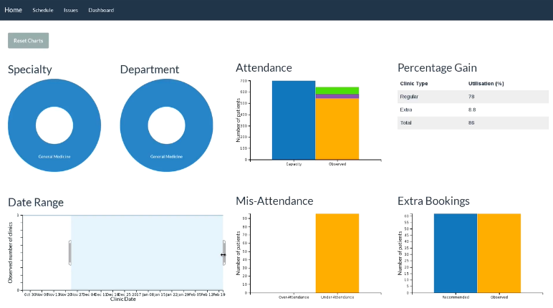

*A screenshot from the RCH and HRO’s data modelling application*

## Key learnings

* **The access clinic approach is best suited to ‘pooled’ clinics –** In pooled clinics, patients see the next available clinician, whereas in non-pooled clinics they are individually assigned to specific clinicians. Feedback showed that clinicians in a non-pooled structure could feel pressured when desk staff called to fill gaps in their schedule with access clinic patients. The access clinic approach may be more readily accepted in a structure where clinicians can draw from pool of patients when they are ready.
* **Clinicians’ priorities can impact their acceptance of an access clinic model –** Initial resistance from some clinicians to the access clinic revealed concerns with clinic time management. Clinicians felt there was insufficient time for patient administration, which could lead to feelings of being overworked when approached to see new patients. Some clinicians also felt a need to concentrate on review patients before accepting new patients. In response to this, the RCH began reviewing its clinics’ structure to ensure adequate time for administrative tasks and temporarily switched its focus to reducing the backlog of review patients.
* **Be clear in communicating the project’s purpose and benefits to clinicians –** While the project intended to ensure use of spaces that would otherwise be empty in the clinic schedule, some clinicians misconstrued this as asking them to see more patients. Having project champions and strong leadership can help to address this concern and keep clinical staff engaged.
* **Administrative staff are a vital to the project and should be involved early –** Involving scheduling and clinic desk management staff in project development created a lot of goodwill. They embraced the initiative with enthusiasm, appreciating the opportunity to contribute by refining the resources and processes used to run the access clinic, such as the script used to contact patients.
* **Using SMS is faster than calling when contacting patients to fill the access clinic –** Initially, desk staff called patients to fill the access clinic, which took three to five hours. This was unsustainable, so halfway through the pilot, the RCH switched to a system where patients were sent an SMS and would have to call to express their interest before they were booked into the access clinic. This immediately reduced the staff time required to fill access clinic spots to between one and one and a half hours.
* **Be upfront in setting waiting time expectations for patients –** As patients attending an access clinic do not have a prescribed time for seeing a clinician, it is important that communications to these patients are clear and concise, and provide them with realistic expectations of their experience.
* **‘Did not attend’ appointments can still occur in the access clinic –** Although 108 patients were booked to the access clinic with 85 patients seen in general medicine, the access clinic still had a 15 per cent ‘did not attend’ rate. To try and minimise this, the RCH used a standard script to provide clear messaging as well as an SMS to confirm the time the patient was to attend the access clinic. When patients cancelled their access clinic appointment ahead of time, they were offered a spot in a future access clinic and rebooked where possible.
* **Referral quality is key to effective triaging of patients for the access clinic –** Despite patients being triaged to try and keep access clinic cases simple, their referrals did not always contain complete descriptions of their health concerns. As a result, only 38 of the 85 patients seen were discharged, with the remaining 47 flagged for follow up. The RCH is now reviewing its referral templates and exploring the possibility of receiving electronic referrals to address this issue.