Improving communication and care for linguistically diverse patients

Interpreters help ensure appropriate and timely care by facilitating clear communication between clinicians and patients who speak a different language. However, an interpreter is not always available or appropriate to use in brief, daily care interactions. Western Health developed and implemented a new module for its CALD Assist app to improve communication with culturally and linguistically diverse patients during common day-to-day nurse and patient interactions.

## Background

The Victorian communities served by Western Health (WH) have some of the highest levels of socioeconomic and cultural diversity in Australia. As a result, interpreter services are in high demand at the health service – demand that sometimes exceeds the number of available qualified interpreters.

Nursing staff may use interpreters during patient assessment and to support consent and discharge. However, interpreter services are not always possible or practical to use in other common nurse-patient interactions, such as for basic but essential daily care tasks. These tend to be more frequent and shorter in duration. Examples include providing support with eating and drinking, checking if the patient needs pain medication or to use the bathroom, and prompting them to change position in bed.

Being unable to communicate directly with a patient can impact a clinician’s ability to assess and respond to that patient’s needs, which can then impact the patient’s care and experience.

In 2014, WH and the Commonwealth Scientific and Industrial Research Organisation (CSIRO) developed a mobile app known as CALD Assist to help with initial allied health assessments when interpreters were not present. WH aimed to create a new module for the app with nursing-specific content to enable staff to better meet the needs of their culturally and linguistically diverse (CALD) patients, reduce variance in practice, and provide a more positive experience by engaging patients in making decisions about their own care.

CALD Assist: nursing

**Lead** Western Health

**Partner** Commonwealth Scientific and Industrial Research Organisation (CSIRO)

**Duration** October 2016 – December 2017

**Key outcomes**

* Developed a new nursing module for the CALD Assist app with 143 phrases translated into 11 languages to assist daily nursing-patient interactions
* Received feedback from staff saying the app increased the success of their CALD patient interactions, with 90 per cent saying the app was useful for communicating with this group
* Received positive feedback from patients and families, with six of seven CALD patients who provided feedback saying it helped their nurse understand their needs
* Released the CALD Assist app on the Apple App Store, making it freely available for other health services to download and use

‘This [CALD Assist] is such a good idea. My mum can understand it. It is such a big help for her.’

**– Family member**

## Key activity

* WH conducted four focus groups with 16 nursing staff participants and nine one-on-one patient interviews to inform the content and functionality of the new CALD Assist nursing module.
* More than 285 phrases were identified through this user needs analysis, including phrases relating to pain management, mobility, medication, hygiene, toileting, and different procedures. Nursing staff also suggested phrases that would help them complete important paperwork such as for patient admission and discharge and to plan for a patient’s daily care.
* This was refined to 143 phrases following consultation with key users and after ensuring legal, cultural and safety requirements were met.
* The phrases were translated and audio recorded in 11 languages. Images and videos were also developed to accompany each phrase.
* 119 nursing staff were trained to use CALD Assist as part of their daily patient interactions.
* The new nursing module was implemented on four trial wards – two medical, one surgical, and one subacute – for 3.5 months. The CALD Assist app was used on iPads with infection control-compliant cases and screen protectors.
* Following the trial, the project team prepared and submitted CALD Assist to the Apple App Store to allow other health services to download and use the application.

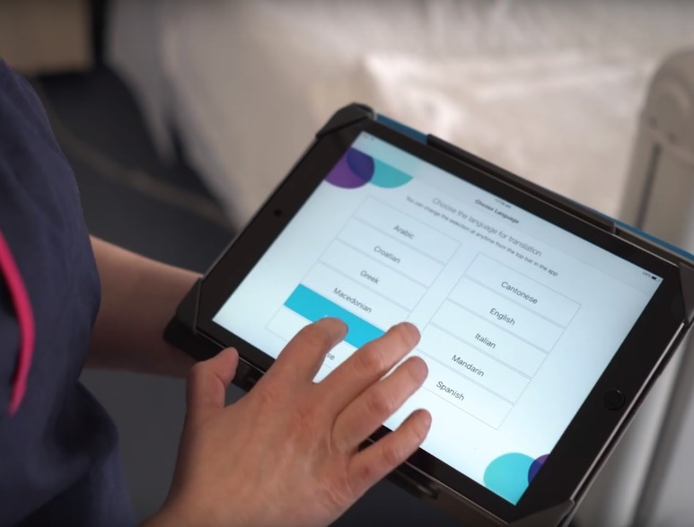

## Outcomes

* The app was used 396 times across all four wards over 15 weeks and interactions with 55 CALD patients were observed.
* There was high utilisation of phrases from the ‘pain’, ‘general’, ‘continence’ and ‘hygiene’ categories, suggesting the app was useful for nurses providing basic care to patients. In addition to language, phrase and category selection, the app’s audio and image functionalities were also highly used.
* Staff reported higher levels of confidence and success in interacting with CALD patients when using the CALD Assist app than without it.
* 90 per cent of staff who participated in the trial said they found the app useful for communicating with CALD patients.
* Staff reported that when CALD Assist was being used, CALD patients appeared to have a similar level of understanding of the interaction as their English-speaking peers, suggesting the app contributed towards equitable delivery of healthcare.
* It was harder than expected to recruit patients for project evaluation; some did not wish to participate, some did not meet the inclusion criteria, and some were unable to provide informed consent. However, six (86 per cent) of the seven CALD patients who did provide feedback said the app was useful, that it helped them understand their nurse, and that it helped their nurse understand their needs. Families were also positive about the use of the app.

‘That was so good to be able to use [CALD Assist] with my mum. It had appropriate questions in it for you to do a good assessment after she had a fall. I feel more at ease knowing that the nurses will try to understand my mum when I am not here.’

**– Family member**

‘I used the app with a Vietnamese patient and her face lit up when she first saw it. She appeared really excited and appreciative of us using it. We were able to ask if she had pain, in which she said “yes”, but she did [not] want any analgesia. It worked fantastically.’

**– Nursing staff**

## Key learnings

* The quality of the app translations can potentially impact the quality of patient care. WHused accredited translators during development and organised an additional independent check of the written translations’ accuracy. WH interpreters also performed a quality check to ensure the phrases were appropriate in health and cultural contexts.
* CALD Assist usage depends on iPad accessibility being optimised in the busy ward environment. It is essential to ensure the iPads are sufficiently charged and to have them in a convenient, easy to access location. For this project, WH chose to keep the iPads at the patient’s bedside.
* Staff felt more comfortable with CALD Assist the more they used it, especially as they became more familiar with the phrases, categories and functionality. Providing staff with a printed copy of the categories and phrases could help them familiarise themselves with the content faster.
* Strategies that helped drive change and uptake of the app during the project included:
  + strong leadership and engagement of nurse unit managers
  + visual reminders such as bedside signs and visual prompts on handover paperwork
  + systematic identification and communication of patients who might benefit from CALD Assist
  + making it easy to access the iPads in the wards.

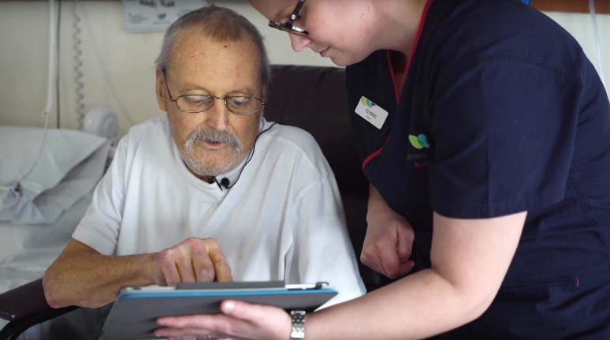

* Additional strategies later identified by the project team through consultation with nursing leaders included:
  + appointing ‘ward champions’
  + using the nursing education team to reinforce the app’s use
  + developing accessible resources such as a user guide.
* WH recommends that other health services seeking to implement CALD Assist consider who ‘owns’ or ‘manages’ the product at their health service to ensure consistent application and uptake of the app. Health services should also consider creating local guidelines for using CALD Assist, and identify and establish a method of referring patients who may benefit from the app’s use such as through their electronic medical record.