TACKLING CHRONIC DISEASE THROUGH EARLY DETECTION AND MANAGEMENT

Western Health worked with general practitioners to proactively stem the burden of chronic disease, trialling an e-technology program that not only helped to manage diagnosed chronic disease but also to improve its early detection, with the aim of preventing or delaying disease progression and complications.

## Background

Chronic disease is a major cause of death and disability in Australia and accounts for 35 per cent of the country’s healthcare spending. The significant cost of chronic disease is particularly pronounced in northwest Melbourne due to a growing population with lower socioeconomic status, higher rates of chronic disease, and lower uptake of private healthcare insurance.

These factors place a significant strain on the hospital services at Western Health, leading to long outpatient clinic wait lists, and increasingly complex and expensive hospital admissions.

Traditionally, healthcare models have targeted high risk patients – those with complex or multiple chronic diseases. However, modelling suggests that a more proactive approach, where patients with rising risk of chronic disease are managed in parallel with high risk patients, is a more cost-effective way of stemming the burden of chronic disease. This is because one fifth of rising risk patients become high risk patients each year.

Another key area of concern is the under or delayed diagnosis of chronic disease, which can lead to negative health outcomes for patients. Timelier referral to specialist care has been proven to result in better outcomes for patients as they are able to receive treatment earlier.

Building on the success of an earlier trial, Western Health developed an e-technology program to provide general practitioners (GPs) with a ‘one-stop shop’ for the detection and management of three target chronic diseases.

Chronic disease early detection and improved management in primary care (CD IMPACT)

**Leads** Western Health, Western Health Chronic Disease Alliance

**Partners** Former Macedon Ranges and North Western Melbourne Medicare Local, North Western Melbourne Primary Health Network, Murray Primary Health Network, Stroke Foundation, Heart Foundation, Diabetes Victoria, Kidney Health Australia, University of Melbourne, Victoria University, PEN Computer Systems

**Duration** September 2017 – March 2020

**Key outcomes**

* Improved the detection and management of patients with chronic disease during the initial 15-month program, potentially reducing disease progression and complications
* Sustained improvements in the detection and management of chronic disease 27 months after program commencement

## Key activity

### Program design

The project focussed on adult patients who had, or were at risk of developing, type 2 diabetes, chronic kidney disease or cardiovascular disease.

The CD IMPACT program was designed based on input from disease specialists, GPs and a population health expert in collaboration with Kidney Health Australia, Heart Foundation, Stroke Foundation and Diabetes Victoria.

Informed by the latest national chronic disease management and prevention guidelines, the e-technology program helped facilitate the detection and management of patients with, and at risk of, chronic disease in general practice.

### Program implementation

Nine general practices piloted the CD IMPACT e-technology program, which included education, monitoring and support.

GPs received disease-specific education from hospital specialists as well as training on how to use the e-technology program to create lists of patients:

* at risk of chronic disease
* with indicators of chronic disease but no coded diagnosis
* with a chronic disease diagnosis but who were not receiving management as per national recommendations.

Project officers assisted GPs in developing clinical audit plans targeting patients in these lists. These plans aimed to:

* provide a diagnosis for patients who had indicators for chronic disease but no coded diagnosis, helping to ensure they receive appropriate treatment
* ensure patients with a new diagnosis had commenced a management plan aligned to national guidelines.
* improve risk factor recording and disease risk detection to enable early identification of at risk patients.

The program was human resource intensive so it was initiated in two to three practices at a time, with new practices implementing the program every 16 weeks.

Practices were initially given a report that benchmarked their performance against other practices in the program. Later on, they also received reports comparing their latest data against their baseline data so they could track their progress.

### Further project phases

The initial nine practices involved in the project were monitored over the course of 15 months. Follow-up data was assessed for these practices 12 months later (at 27 months from the start of the project) to assess project sustainability, although one practice’s data was excluded from all analyses due to its involvement in a practice merger which affected data quality.

The project also included another phase to test reproducibility by rolling out the 15-month program in an additional 11 practices. One practice subsequently withdrew from the project, leaving 10 practices in this group.

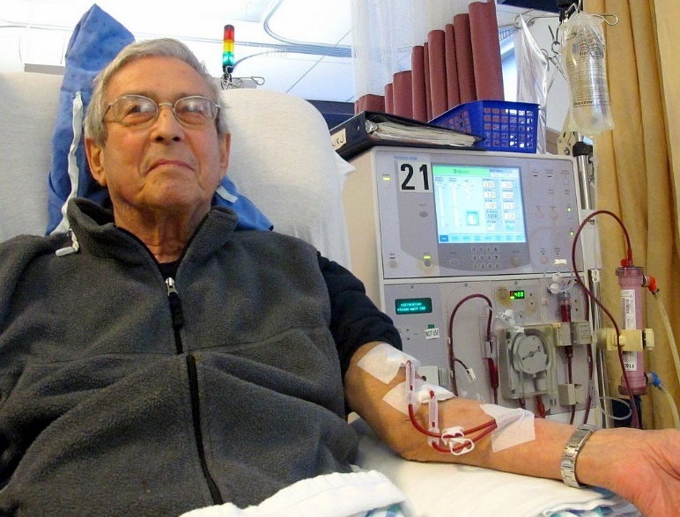

## Outcomes

* Across the initial eight practices:
  + 37,946 patients with, or at risk of, one of the target chronic diseases were managed at baseline
  + 37,385 were managed at 15 months
  + 37,813 were managed at 27 months.
* Over the course of 15 months, the practices showed improved management of chronic disease. For example, there was increased testing of urine albumin to creatinine ratio in patients with type 2 diabetes.

In addition to being part of the recommended management for type 2 diabetes, this testing can lead to the detection of chronic kidney disease and enable early treatment that can help delay progression to end-stage kidney disease and reduce cardiovascular morbidity.

* The practices showed improved detection of chronic disease over the same period. For example, there was an increase in the diagnosis of chronic kidney disease.
* There was also improved diagnostic testing for chronic disease in patients identified to be at risk.
* At 27 months, there was sustained improvement in chronic disease detection and management.
* The program also led to positive changes in the way the practices operated and in practice staff behaviour, with potential long-term benefits for quality improvement and chronic disease detection and management.
* At the time of writing, the results of the reproducibility phase had not yet been presented or published.

## Key learnings

* While GPs valued the education, monitoring and support, the program was extremely human resource intensive. For the program to be scaled, alternative education, monitoring and support options will need to be developed.
* The staggered approach to rolling out the program, where two to three practices were brought into the project every 16 weeks, meant the last practices to implement the CD IMPACT program had little time to demonstrate change prior to the 15-month follow up. It is important to allow time for an intervention to take effect before assessing results.
* The project team recruited practices from areas of socioeconomic disadvantage from a mix of metropolitan, regional and inner rural areas. This diversity was important to ensure the practices were representative of the population of interest and to more accurately demonstrate the ability of the project to be reproduced and generalised to other similar practices.