enhancing critical care for rural patients through telehealth

Limited capacity and access to intensivists in rural Victoria meant Mildura Base Hospital was transferring more than 100 patients to tertiary health services each year for critical care. Seeking to avoid unnecessary hospital transfers and allow patients to stay close to family and local support, the health service established a telehealth model of care that brought metropolitan specialist expertise into the intensive care unit via video.

## Background

Mildura Base Hospital (MBH) is a rural health service located in northern Victoria. It services approximately 80,000 people in Mildura and the surrounding regions and has the one of the highest Aboriginal populations in the state.

In 2016, approximately 600 patients were being admitted to MBH’s five-bed intensive care unit (ICU) each year, with many of these patients having chronic complex conditions.

Meeting the needs of these patients was challenging due to the MBH ICU’s limited capacity and minimal intensivist coverage, and the next nearest ICU was 400km away. These constraints led to the transfer of approximately 120 critical care patients from the MBH ICU to tertiary hospitals annually.

Patient transfers are particularly difficult for Aboriginal patients as the travel required has significant negative cultural connotations.

MBH decided that instead of moving patients to the medical expertise they required, the health service would bring the expertise to them using telehealth technology.

By connecting with intensivists and specialists at tertiary sites in metropolitan Melbourne through video technology, MBH aimed to reduce avoidable hospital transfers and improve the patient experience.

Critical care telehealth

**Lead** Mildura Base Hospital

**Partners** Alfred Hospital, Royal Melbourne Hospital, Paediatric Infant Perinatal Emergency Retrieval

**Duration** October 2016 – October 2018

**Key outcomes**

* Averted 34 critical care patient transfers in 12 months, including 23 ICU transfers and 11 renal transfers. This allowed more patients to stay at MBH ICU, close to family and supports, and reduced bed demand at tertiary sites
* Ensured the care provided at MBH ICU was comparable to that of a tertiary centre through a collaborative approach
* Saved more than $287,000 in ambulance retrieval costs
* Achieved 100 per cent staff satisfaction with the support received from telehealth
* Built strong interprofessional relationships and support networks across participating sites

‘The input from the intensivist through telehealth was invaluable in painting a complete clinical picture for our critically ill patients and ensured that all aspects of management were addressed thoroughly.’

**– Doctor**

## Key activity

MBH installed a high-definition camera and plasma television screen in its ICU that was remotely connected to participating tertiary health services.

Using telehealth technology, the MBH ICU received remote, 24/7 support from:

* adult intensivists at the Alfred Hospital
* nephrologists at the Royal Melbourne Hospital
* paediatric intensivists through the Paediatric Infant Perinatal Emergency Retrieval service (PIPER).

The technology enabled remote specialists to see patients and their environment clearly and in real time, allowing them to assist the MBH ICU team with assessment and advise them on other important aspects of care, such as blood circulation, monitoring, and ventilator settings.

In addition to providing MBH patients with access to tertiary specialist care without requiring transfer, the telehealth model provided valuable educational and learning opportunities for regional medical and nursing staff.

A staff education package was developed, ensuring all medical and nursing staff were familiar with the telehealth model, and education sessions were held fortnightly where staff would discuss case presentations. Clinical champions were also appointed to promote the telehealth model and reinforce education.

## Outcomes

* 170 telehealth consultations were completed in 12 months.
* 34 patient transfers were averted – a 21 per cent decrease compared with the previous year.
* Successfully managing these patients at MBH ICU reduced bed demand at tertiary sites where they would have otherwise been transferred.
* Eleven renal patient transfers were avoided, including four who received acute kidney injury treatment at MBH ICU. Previously, this intervention would have required patient transfer to a tertiary site.
* More than $287,000 in ambulance transfer costs were saved by managing patients at the MBH ICU via telehealth. This also helped families avoid costs such as transport, accommodation and lost wages.

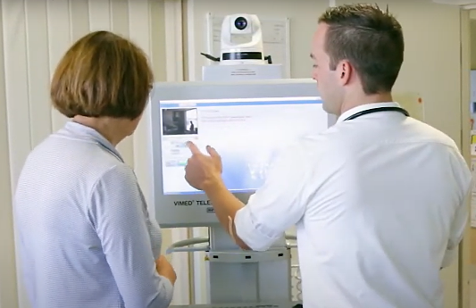

### Staff and consumer experience

* The experience for patients and families improved, with 100 per cent of survey respondents speaking positively about the telehealth model. Patients appreciated being able to stay close to family and families were reassured that their loved ones were receiving tertiary hospital-level care.
* The initiative improved MBH ICU clinicians’ capability in assessment, treatment, and end of life planning. It also decreased variation in practice.
* 90 per cent of staff surveyed said they felt adequately supported post-telehealth compared with 40 per cent pre-telehealth. 100 per cent of staff were satisfied with the learning and development.
* The project also helped build strong, collaborative relationships between metropolitan and regional health services.

‘Telehealth is an excellent way for staff, patients and family to be involved in care and be able to ask questions.’

**– Consumer**

‘I had a few occasions where I needed telehealth to assist me with very difficult cases probably beyond my skill and knowledge. [Thanks to] telehealth, we got through very difficult situations and the patients benefitted from it.’

**– Anaesthetist**

‘It was the best thing that I have experienced. You can get information   
from major hospitals and top doctors’ treatment advice.’

**– Consumer**

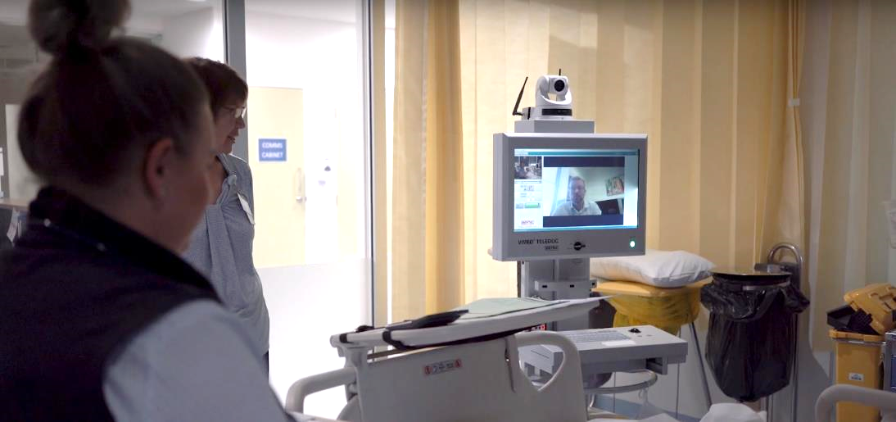

## Key learnings

* **Local executive input can be crucial for escalating information technology (IT) issues –** Despite extensive meetings and research to ensure the project was IT-ready, IT support issues ended up causing unexpected delays and prevented project progression. Involving the MBH chief executive officer in discussions with stakeholders eventually ensured the project received the help it required and MBH was able to secure the most appropriate telehealth platform for its ICU.
* **Strong stakeholder engagement is key to project success –** Involving all ICU staff early on in the project meant they experienced the initiative’s successes, failures and trials, which was beneficial during implementation. MBH appointed clinical champions and recruited a project officer to provide local support, maintained constant communication, and delivered ongoing education to keep staff engaged. MBHalsospoke with tertiary stakeholders regularly to discuss project improvements and processes.
* **Tertiary sites may require different models for successful telehealth delivery –** During the project planning phase, MBHconducted site visits toBarwon Health and other tertiary sites to learn from their telehealth experience. While this provided valuable insight into different video consultation designs, it was important for MBH to identify a robust platform specific to its local needs. MBH also had to cater to the different needs of partner hospitals. For example, by project close, strong processes and guidelines had been embedded for the Alfred Hospital arm of the telehealth initiative, while processes were still being developed and improved with the Royal Melbourne Hospital and PIPER.