Increasing support for older people beyond their hospital stay

Healthcare and aged care service provider Bolton Clarke will identify older hospital patients experiencing social isolation, loneliness or depression and match them with a volunteer, who will provide regular telephone support after they have been discharged to improve their quality of life and wellbeing.

## Background

Feelings of social isolation, loneliness and depression are prevalent among people aged 65 years and older and are a growing public health concern. Between 7 and 12 per cent of older Victorians (up to 150,000) experience chronic loneliness, and a recent Victorian population health survey showed that around one in five Victorian adults has unmet social needs, including feeling socially isolated or lacking social support.

Older people experiencing isolation, loneliness or depressive (ILD) symptoms are more likely to be at risk of poor health and hospitalisation. However, patients are not routinely screened for these factors during hospital admission, meaning vulnerable older people are often discharged to the community with inadequate social support.

Social networks and community connection can help people recover from illness, and telephone support has been found to reduce ILD symptoms and improve quality of life.

The ‘HOW-R-U?’ project will identify older patients admitted to Northern Hospital who are experiencing ILD symptoms and match them with a volunteer after they have been discharged. The volunteer will call them regularly for several weeks to provide social support and connect them with community-based services where appropriate.

The project aims to reduce ILD symptoms in older people who are discharged from Northern Hospital, and in doing so, reduce emergency department and hospital presentations for non-emergency care.

**Hospitals and patients working in unity (HOW-R-U?)**

**Lead** Bolton Clarke

**Partner** Northern Health

**Funding round** 2019–20

**Status** In progress

**Objectives**

* Reduce social isolation, loneliness and depression for participating patients, and keep their symptoms at the reduced levels
* Reduce participating patients’ unplanned hospital presentations for non-emergency care
* Increase the number of participating patients engaging with community social services

## Key activity

Instead of relying on the patient to seek help as per traditional approaches for accessing social support, this project focuses on the opportunistic identification of people experiencing social isolation and loneliness.

The program has already been piloted in two hospitals in southeast metropolitan Melbourne and has been successful in reducing patients’ feelings of social isolation and loneliness.

The program comprises two main components – screening and support.

### Screening

* People aged 65 years and older will be assessed for ILD symptoms at Northern Health.
* Those experiencing ILD symptoms will be referred to the HOW-R-U? program.

### Support

* Patients referred to the HOW-R-U? program will be matched with a trained volunteer.
* Patients will receive a 20–30-minute telephone call each week for 12 weeks. These calls aim to provide social contact and will be non-clinical. They will not involve counselling.
* Where appropriate, the patient will be referred to specialist services and/or local community services.

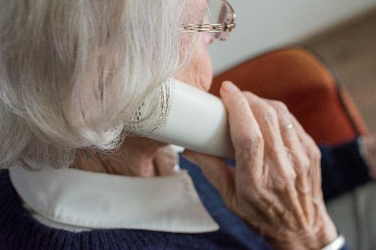

## Status

This innovation project was accepted in the Better Care Victoria 2019–20 funding round and is currently underway.