Digitising staff communication to enhance after-hours patient care

Effective communication and task management between clinical teams is critical to optimising the care of patients overnight. To ensure timely, quality patient care continued to be delivered outside of regular business hours, Monash Health implemented a web-based task management system to make it easier for overnight clinical staff to communicate and manage their workload.

## Background

As part of a broader, multifaceted effort to improve the delivery of patient care at night, Monash Health looked at how it could enhance communication between the after-hours clinical staff working between 9pm and 8.30am.

Monash Health’s existing paging system, which overnight clinical staff were using as their primary means of communication, was rudimentary, manual and inefficient. It could only send messages in one direction, was unable to do what staff needed – such as effectively prioritise and delegate tasks to medical staff – and was prone to communication errors, potentially contributing to delays in patient care at night.

The paging system was used in conjunction with a paper-based task list, making it difficult for after-hours staff to communicate and track patient-related tasks.

Other Melbourne health services had successfully implemented electronic task management systems to improve hospital care outside of business hours.

Electronic task management systems allow unit-based emergency, nursing and midwifery staff to electronically request medical staff to complete tasks. Staff can indicate the urgency of the task and monitor its progress from a desktop computer. The system can also be accessed via a smartphone app, enabling medical staff to instantly receive task requests, acknowledge receipt, indicate delays, and seek clarification.

Monash Health aimed to build and implement a customised electronic task management system that after-hours clinical staff could easily use to communicate and manage their workload, enhancing patient care.

Improving after hours care at Monash

**Lead** Monash Health

**Duration** September 2016 – September 2018

**Key outcomes**

* Improved the quality of information provided to medical teams after hours, with more staff complying with Monash Health's clinical communication protocol
* Improved patient care, according to reports from 94 per cent of staff, with 88 per cent of staff also reporting improvements in timely access to care
* Made it easier for staff to manage their workload, leading to savings of between 15 minutes and several hours per shift for 89 per cent of after-hours clinical staff surveyed
* Improved staff satisfaction, reducing frustration levels, perceived time pressure, and feelings of isolation in junior medical staff working overnight
* Reduced the volume of number/pager enquiries received by the contact centre by 24 per cent by enabling staff to directly message each other through the new task management system

## Key activity

Monash Health conducted an open public tender to purchase a mobile clinical task management solution, with Alcidion’s Smartpage Clinical application selected from among 19 submissions.

Smartpage is a web-based, mobile-friendly clinical task management application that enables instant two-way communication. This reduces delays and facilitates effective task management and prioritisation of care.

To prepare for implementation, Monash Health ran nine planning workshops that engaged key stakeholders, including nurses, midwives, junior and senior medical staff, emergency department staff, radiologists, and information technology (IT) professionals.

Medical, nursing and operations staff also helped to co-design a staff education package containing both practical and online content. Four face-to-face education sessions were delivered to key staff who would use the system.

The new electronic task management system was implemented at Monash Medical Centre and Monash Children’s Hospital in March 2018.

## Outcomes

### Team communication

* Compliance with Monash Health’s paging clinical communication protocol increased from 2 per cent at project start to 76 per cent, demonstrating an improvement in team communication. The protocol outlines the details required to effectively communicate a clinical request, such as the requesting staff member’s name, position and extension number; the patient’s name, ward and bed number; and the level of urgency. Prior to the project, medical staff often received messages with incorrect patient details and inadequate contact information, making it difficult to deliver optimal patient care.
* The volume of after-hours contact number and pager enquiries received by the health service’s contact centre decreased by 24 per cent as Smartpage allowed staff to easily contact one another.

Figure 1. Results of medical and nursing staff surveys on the impact of Smartpage

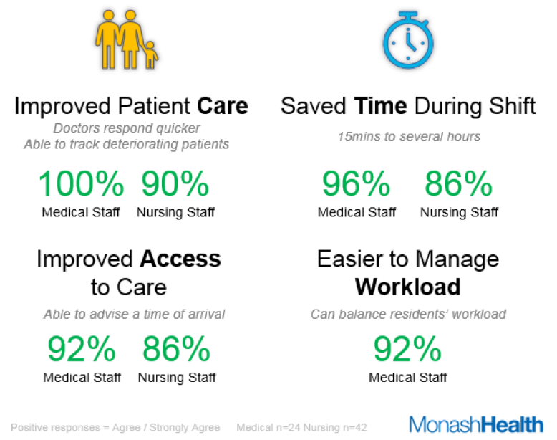

### Patient care

* 94 per cent of clinical staff surveyed reported improvements in patient care (see Figure 1 for a detailed breakdown of survey results).
* 88 per cent of staff said timely access to patient care had also improved.

### Staff satisfaction

* 94 per cent of clinical staff surveyed said the system was easy to use.
* 89 per cent of staff reported saving from 15 minutes to several hours during their night shift due to improvements in their workload (see Figure 1 for further survey results).
* Satisfaction ratings for junior medical staff working overnight improved, with their frustration levels dropping from 62 per cent to 42 per cent. They also felt they had more time to complete tasks, with their ratings of perceived time pressure decreasing from 71 per cent to 54 per cent.
* By enabling instant communication between staff, the new system allowed junior medical staff to learn who was working with them overnight, making them feel they were part of a team. Previously, the limited options for connecting with other colleagues left them feeling isolated at work.

‘[It’s now] easier to triage requests, respond in a timely manner and troubleshoot problems more effectively.’

**– Clinical staff**

‘[Smartpage] has allowed doctors to reply to questions faster… [which] allows us to change our care or provide further investigations more promptly.’

**– Clinical staff**

‘Not only does [Smartpage] make my life easier – I can balance my residents’ workload and keep track of patients who are deteriorating.’

**– Clinical staff**

### Data

The digital system provided Monash Health with a wide range of new, comprehensive, real-time data sets, and the health service is now able to measure and monitor response times for delivery of care. This data will be used to inform continuous improvement and identify opportunities to train staff.

## Key learnings

* **Learning from other health services’ experiences with similar systems is valuable** –As part of its research for the project, Monash Healthconducted benchmarking at other tertiary Melbourne health services that had successfully implemented an electronic task management system. St Vincent Hospital’s ‘Nightlife Program’ had very positive results for both staff and patients, and Alfred Health was also able to improve hospital care after hours through its ‘Out of the Dark’ model. Monash Health used the learnings from these health services to inform its own project.
* **Be detailed in tender specifications and provide adequate technical information –** A standard that was needed to enable smooth integration of the new system into Monash Health’s existing IT infrastructure was not listed in the tender. The project team later discovered Alcidion did not use the standard, which led to delays as more work was needed to ensure the systems could work together. Being clear and specific on the requirements of the new product before going out to tender will reduce ambiguity, prevent misinterpretation, and speed up the tender process.
* **Allow plenty of time to assess tender submissions –** The project team received more tender submissions than it expected, which meant more time was required to fairly process all applications.
* **Be clear on how and who will measure, monitor and evaluate the project before getting started –** While many metrics were available through Monash Health’s Business Intelligence team, several key evaluation measures proved hard to collect and analyse. It is important to understand and plan for limitations in data collection early, and if there are any project delays, the data collection plan should be reviewed and adjusted accordingly.
* **Be aware of other major initiatives within the organisation when considering project timing –**Competing change priorities may make it challenging for staff to adopt a new initiative. During the project, Monash Health was in the process of implementing two other major programs to improve patient access to care and introduce electronic medical records, respectively. To avoid overwhelming staff, the health service reviewed the Smartpage roll out schedule to identify the best times in the organisation’s schedule to progress system implementation.