SUPPORTING MOTHER AND NEWBORN BONDING with jaundice home care

The Royal Women’s Hospital developed a new care pathway for newborns with jaundice in 2017, enabling parents to spend more time bonding with their babies in the comfort of home. By expanding its existing services to enable the assessment and treatment of newborns with jaundice in the home, the health service has reduced disruption during the important postnatal period, saving parents the time and cost of travelling to hospital and decreasing the number of babies presenting to its emergency services for jaundice care.

## Background

At the time of the project, emergency presentations for the assessment and management of newborns with jaundice had been progressively increasing at the Royal Women’s Hospital (the Women’s). In 2016, presentations of newborns for jaundice care represented 4 per cent of all Women’s Emergency Care presentations – an average of three babies per day.

At the time, the Women’s care pathway for newborns involved having midwives screen babies for jaundice in their homes. If high levels of the jaundice-causing substance bilirubin were detected in the skin, the baby and mother would be referred to the Women’s Emergency Care for further assessment and a blood test. If this test indicated that treatment was required, mother and baby would be admitted as inpatients for phototherapy.

Returning to hospital during the immediate postnatal period for assessment – and potentially for treatment – can be inconvenient and disruptive to parents and their newborns. Keeping parents and newborns together during this time is important as it supports the development of strong bonds between parent and child, and the establishment of breastfeeding, sleeping and other parenting routines.

Furthermore, due to the nature of the emergency care environment, parents and babies presenting with jaundice at the time of the project were often required to wait long periods of time before being seen, with the average wait time being around 2.5 hours.

By delivering as much care in the community as possible through its innovation project, the Women’s aimed to improve the care and experience for parents and babies and allow them to stay together at home. The project had an additional benefit of reducing the number of emergency care newborn jaundice presentations and releasing maternity inpatient beds.

**Assessment and care of the jaundiced newborn at home**

**Lead** The Royal Women’s Hospital

**Duration** September 2017 – November 2018

**Key outcomes**

* Reduced newborn jaundice emergency care presentations by 52 per cent
* Improved patient care and experience, with 70 per cent of post-project survey respondents saying the care they received allowed them to establish a routine at home and 70 per cent rating their overall experience as very good
* Enabled phototherapy treatment at home, releasing an estimated 329 maternity bed/cot bed days and allowing more mothers and babies to stay together during the immediate postnatal period

‘Having the [phototherapy] blanket at home meant we could keep bonding and feeding as much as we wanted, all the time.’

**– Parent**

## Key activity

Expanding upon its existing neonatal home care service, the Women’s developed clinical guidelines, procedures, patient education and training resources to support two new pathways of care:

* **Providing an alternative to emergency care for further assessment –** Midwives conducting initial screening for jaundice at home could perform the additional blood test in the same visit if it was required. The blood specimen was then transported to the hospital for testing via a courier service. The midwife would check the results and communicate these to the parents via phone, along with a management plan. If the results indicated treatment was required, the midwife would consult with the hospital’s neonatal clinicians and the Women’s Neonatal Hospital in the Home (NHITH) team and arrange for the baby to be assessed.
* **Enabling the management of jaundice at home or direct hospital admission –** When a baby’s jaundice management necessitated a repeat blood test and further review, this was undertaken by a home-visit midwife instead of requiring parents to travel to hospital with their child.

Certain babies were able to receive phototherapy treatment at home using the BiliSoft light-pad blanket. These babies had to meet specific criteria to ensure they were suitable for this option and were managed by the Women’s NHITH team.

Where a newborn was not suited to phototherapy in the home as a management option, mother and baby would be directly admitted to the inpatient ward, maternity ward or the newborn intensive care unit (NICU) without having to present to emergency care.

## Outcomes

* **Reduced newborn jaundice emergency care presentations –** As a result of the program,an estimated 420 emergency care presentations were avoided over the project period. Emergency care presentations for neonatal jaundice fell 45 per cent compared with 2017, and 53 per cent compared with 2016. Average presentations per month decreased from 82 to 44.

Figure 1. Site of phototherapy treatment as reported by survey respondents

* **Enabled home treatment –** 88 babies received phototherapy at home within seven months of the service’s launch, an average of three babies per week. 81.25 per cent of consumers who responded to a post-project survey reported that they had accessed phototherapy at home (see Figure 1).
* **Released inpatient resources –** An estimated 329 maternity bed/cot days were released by facilitating phototherapy at home, allowing these resources to be allocated to other patients.
* **Improved patient care and experience –** The new pathways were positively received by consumers as indicated by both improved ratings of care and qualitative feedback:
  + 70 per cent of post-project survey respondents said the care they received allowed them to establish a routine at home (e.g. breastfeeding, sleeping patterns) compared with 54 per cent in the pre-project survey
  + 70 per cent of post-project survey respondents rated the quality of their overall experience as being very good compared with 54 per cent in the pre-project survey
  + 85 per cent of post-project survey respondents said they felt supported by RWH compared with 54 per cent in the pre-project survey.

‘After spending 10 days in hospital before the birth of our little miracle, it was so amazing to be able to give our baby treatment in the comfort of our own home.’

**– Parent**

‘By far the biggest positive aspect was being able to treat baby at home. As a first-time mum, it was an extremely tough time. It was great to be at home as it felt safe, and family was able to help out and provide emotional support.’

**– Parent**

* **Improved staff ratings of care –** Pre- and post-project surveys of staff also showed high levels of satisfaction:
  + 100 per cent of maternity staff, 100 per cent of NICU and NHITH staff, and 80 per cent of emergency staff who responded to a post-project survey rated the patient experience as ‘positive to excellent’
  + 90 per cent of staff respondents said the experience for women had improved overall.
* **Provided additional support for parents –** While not within the original project scope, the development of a series of educational videos on jaundice care in the home offered many benefits, providing: a resource for parents and carers that reinforced face-to-face instructions delivered by the Women’s staff, a consistent training resource for staff, and a resource that was accessible at any time to all parents and health professionals across the state.

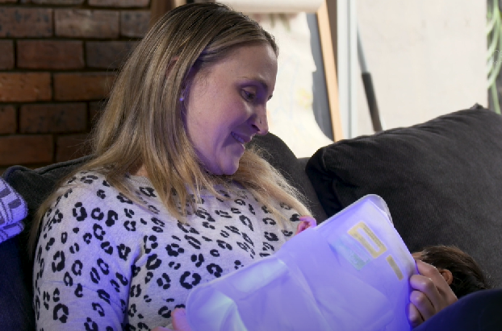

## **Key learnings**

* Having a multidisciplinary working group ensured the project was informed by all disciplinary areas involved with the new care pathways.
* Staff resources, flexibility and skills had to be reviewed to meet the increased demand for home-visiting neonatal staff. The Women’s was required to train more NICU staff on newborn jaundice home care than was first expected. The hospital identified additional staff who could educate parents and conduct baby assessments when NHITH staff were unavailable and revised rosters to ensure staff had sufficient time to complete referral assessments and admissions.
* The local environment is an important factor in designing a home care pathway. For example, the Women’s identified staff travel as a key issue, particularly the time it took for home-visit staff to negotiate traffic and find parking to provide care to the growing inner-city population. Engaging an external courier service to deliver blood specimens was the most effective option for the Women’s, but this may not be the case for other health services implementing a similar pathway in a regional or rural environment.