supporting equitable access to ROBOTICs-based REHABILITATION

Northeast Health Wangaratta developed a model of care that allowed more regional and rural Victorians to access state-of-the-art robotic-based therapy for upper-limb rehabilitation. By improving access to this therapy, which was previously only available in a metropolitan setting, the health service helped patients reduce travel time and costs while achieving positive clinical outcomes.

## Background

Robotic-based therapy (RBT) is an emerging technology that is increasingly being adopted overseas and in private Australian clinics to help patients recover movement following a neurological event, such as a stroke. It encourages patients to practise repetitive motor tasks by playing fun, engaging and motivating computer-based games.

Allied health therapists in regional and rural settings are often required to be generalists rather than specialists, which can lead to significant variations in patient treatment. RBT reduces therapist variation by providing a consistent platform for quality, task-specific movements. It has also been shown to increase repetition and support an intensive program, which is aligned with best practice for neurological rehabilitation.

On average, Northeast Health Wangaratta (NHW) admits 220 patients with neurological injury or illness per year, with up to 77 per cent of these patients having impaired function of their upper limb.

To better serve these patients, NHW raised $350,000 through community fundraising and philanthropic grants to purchase upper-limb RBT equipment and renovate a space in which to house it.

Previously, the only other comparable equipment was in Melbourne and it was only offered in three-week blocks, with the combined costs of travel, accommodation and the RBT itself making the program prohibitive for many patients. NWH aimed to develop and implement a safe, evidence-based and economically viable model of care (MOC) to support ongoing upper-limb RBT access for its regional and rural patients and increase the consistency and quality of their care.

North east robotics development

**Lead** Northeast Health Wangaratta

**Partners** Charles Sturt University, Alpha Crucis Group

**Duration** November 2017 – November 2018

**Key outcomes**

* Developed and successfully implemented a group-based MOC for upper-limb RBT, improving access for regional patients
* Achieved clinical improvements for each group under the new RBT MOC, with positive program ratings from the majority of participants and a low 6.8 per cent ‘did not attend’ rate
* Increased the therapy intensity and the number of movement repetitions per session in line with best practice upper-limb rehabilitation
* Increased RBT equipment utilisation by 30 per cent
* Increased the number of staff trained to deliver RBT from six to 19

## Key activity

* Developed and implemented an RBT MOC suited to a regional health service after visiting the Hand Hub at The Royal Melbourne Hospital to learn from the established RBT service’s group-based MOC.

The MOC involved a combination of qualified allied health professionals (physiotherapists and occupational therapists) and allied health assistants delivering RBT to groups of three to five patients in six-week blocks. Patients attended three times per week for 90-minute sessions, and a home exercise program was provided to all participants. See Table 1 for a comparison of the RBT MOC against the ‘usual care’ delivered through the standard MOC.

* Delivered workshops and education sessions in both small groups and individual sessions to increase staff competence and confidence in using the RBT equipment. Also developed an education package, including a video on the setup and use of the RBT equipment, guidelines on how to use the assessment tools, and a checklist for new staff moving into the RBT program.
* Conducted an interim evaluation and revised the MOC in response to feedback and data collected. This information also informed how the education program could be tailored to better meet staff needs.

Table 1. Comparison of standard upper-limb MOC and group-based upper-limb RBT MOC

|  |  |
| --- | --- |
| Standard MOC | Group-based RBT MOC |
| 30- or 60-minute sessions | 90-minute session (60 minutes spent ‘on robotics’ and 30 minutes ‘off robotics’, working on functional tasks) |
| 1 or 2 sessions per week | 3 sessions per week |
| No formal timeframe | 6-week block |
| Inconsistent assessments at variable intervals | Consistent standardised assessments at pre- and post-group intervals |
| 1:1 staff/patient ratio | 2:3–5 staff/patient ratio |
| 39 repetitions of movement achieved per session | 300+ repetitions of movement achieved per session |

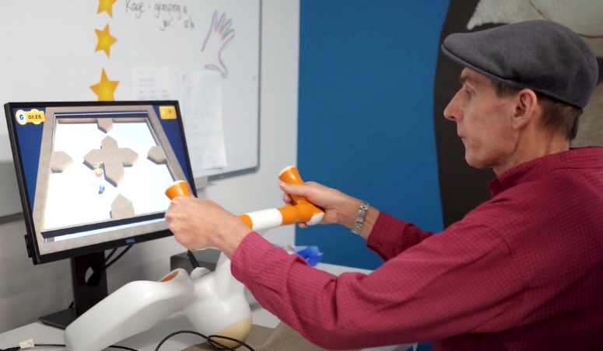

## Outcomes

* Successfully implemented the new RBT MOC in an existing regional sub-acute community service, improving access for regional patients. NHW ran six groups under the RBT MOC during the project period, delivering 20 episodes of care to 14 patients.
* Achieved clinical improvements for each group, suggesting that an RBT MOC does not disadvantage patients compared to usual care.
* Ensured consistency of therapy – regardless of staff experience levels – by using robotics in a structured group setting.
* Increased the intensity of therapy, delivering 270 minutes of therapy per week under the new RBT MOC compared with 60 or 120 minutes per week under the standard MOC.
* Increased the number of movement repetitions practised each session from 39 under the standard MOC to 300 or more under the RBT MOC.
* Positive sentiment from patients who completed the RBT program, with the majority of them rating it as very beneficial. This may also have contributed to a low ‘did not attend’ rate of 6.8 per cent.
* Increased RBT equipment utilisation by 30 per cent.
* Increased the number of staff trained to deliver RBT from six to 19. This has also increased the number of staff delivering individual RBT to patients who may not be suitable for a group setting or who may be waiting to join the next group.

‘Concentration on the games is very beneficial.’

**– Consumer**

## Key learnings

* A cost analysis of the project found that after initial setup costs, the MOC could be cost-effective for regional health services when compared to one-on-one therapy of the same intensity.
* Educating staff on how to deliver the RBT MOC was key to its sustainability. Developing a comprehensive education package not only helps to improve staff confidence and competence in delivering RBT – it also acts as a safeguard for when clinicians leave with their knowledge, which can have a significant impact on a regional health service.
* The success of the RBT program is dependent on the robotic equipment being in working order. NHW trained staff on how to troubleshoot basic issues and created troubleshooting videos as an additional resource. The health service also maintained an ongoing relationship with the supplier and put a plan in place to monitor the equipment for any repairs or replacements that might be required.
* It is helpful to consult the IT team on how best to integrate with patient information systems at the beginning of the project. NHW experienced some issues with IT compatibility and function that impacted RBT delivery. The health service addressed this by organising a dedicated contact person in the IT department for when issues arose, having key staff who were highly competent in using the RBT devices, and maintaining good relationships with robotic equipment suppliers so that it could request advice and support as needed.
* When considering investing in RBT, factor in room for patients and staff to move around the equipment when calculating space requirements. The limited space, in addition to staffing, impacted the maximum group size NHW could offer.

Case study

One patient had a stroke that resulted in chronic weakness in his left side, contractures and changes in his posture.

Under the RBT MOC, the patient made functional improvements, despite five years having passed since his stroke.

The patient’s sitting posture also improved. No other therapy occurred during this time, so it was likely that this was due to working intensively on the upper limb, including practising many bilateral tasks using the robotic devices.

Prior to joining the RBT group, the patient had been considering purchasing a customised wheelchair. After completing one six-week block of RBT, his postural improvements meant a customised wheelchair was no longer required.

‘Staff had a great understanding of my needs and the program was interesting. I now understand the need for repetitions to get better.’

**– Consumer**

