Engaging staff, patients and families in preventing delirium

Austin Health established a system to improve delirium identification and developed a bundle of delirium prevention strategies that both staff and consumers could implement. This increased the frequency and consistency of preventative care provided to at-risk patients, reducing their chance of acquiring delirium while in hospital.

## Background

Delirium is a serious medical condition which can cause disturbed thinking and behaviour, and fluctuating consciousness. Being in hospital can compound the challenges of this condition, as patients can find the environment unfamiliar and socially isolating.

People experiencing delirium have a higher risk of dying while in hospital, and many have ongoing problems with thinking and memory after they leave. The condition is difficult to treat, so prevention is key.

Research indicates that up to 40 per cent of delirium that occurs in hospital can be prevented, and there is evidence that strategies that do not involve medication are effective. Examples include making sure patients are well hydrated and nourished, getting adequate sleep, moving often, and wearing their glasses or hearing aids.

International guidelines recommend a combination of screening patients daily to identify whether they have or are at risk of delirium, and consistently engaging at-risk patients in these prevention strategies. Health services, both interstate and internationally, have also shown that training volunteers to assist in the delivery of prevention strategies can improve their frequency and consistency, which is key to their effectiveness.

Through its innovation project, Austin Health aimed to develop a multifaceted prevention program to support patients at risk of developing delirium and reduce the overall incidence of the condition in the health service.

**Preventing delirium**

**Lead** Austin Health

**Partner** La Trobe University

**Duration** December 2018 – April 2020

**Key outcomes**

* Decreased hospital-acquired delirium by 18 per cent
* Increased delirium screening for patients by 30 per cent
* Developed a delirium prevention bundle, with 86 per cent of activities implemented
* Developed a delirium e-learning program that was completed by 86 per cent of staff on target wards
* Increased the consistency of delirium prevention activities for at-risk patients
* Improved the patient experience, making them feel empowered in contributing towards their own healthcare
* Initiated a volunteer program on one of the target wards, which received overwhelmingly positive feedback

## Key activity

Austin Health’s delirium prevention program employed five strategies to drive behaviour change in three target wards:

* **Measurement and reporting of delirium –**Previously, the prevalence of delirium at Austin Heath was unknown. The project team integrated the Confusion Assessment Method (CAM) screening tool – which was formerly paper based – into the electronic medical record and made a short, daily CAM screen part of routine care for all at-risk patients. Real-time data was reported through a delirium dashboard.
* Delirium leads – Clinical experts and champions were appointed as delirium leads to engage point of care staff, identify and test change ideas, and maintain a focus on delirium in their respective clinical teams. The multidisciplinary team included six nurses, one dietician, three occupational therapists, three physiotherapists, and two social workers.
* Education on identifying and preventing delirium – Two co-design workshops were held to inform the development of educational resources for staff, patients, carers and families. Resources developed included four e-learning modules for clinical staff, including a module on delirium management, and an information brochure providing specific guidance for patients, carers and family members on what they could do to prevent delirium. This brochure was provided at all bedsides.
* Delirium prevention activities for at-risk patients – Staff trialled evidence-based delirium prevention tasks and activities on patients in target wards to assess their effectiveness in a local context. Progress of the prevention activities was monitored by the delirium leads and the most successful interventions were developed into a delirium prevention bundle (see Figure 1). The bundle was designed to be non-prescriptive, allowing point of care staff to apply as many or as few of the activities to patients depending on their individual needs.

Examples of activities included:

* + maximising use of day clothes instead of hospital gowns to encourage the patient to move about more
  + using bedside calendar clocks to help orient patients
  + having activities such as word searches, books and playing cards readily available to help patients keep their minds active
  + switching hot drinks in the afternoon to non-caffeinated options to improve sleep
  + changing morning routines to have patients sitting out of bed earlier, ready for breakfast.
* A delirium-specific volunteer program – Volunteers were recruited on one of the target wards to support the consistent delivery of delirium prevention strategies. They received staff education and a comprehensive volunteer pack detailing 11 specific tasks that had been identified as appropriate for them to carry out. These tasks can be summarised in the acronym ‘HOME’: hydration and nutrition, orientation, movement, and engagement. Activities could be recommended by point of care staff but were ultimately agreed upon between the patient and volunteer.

Figure 1. Austin Health’s delirium prevention bundle

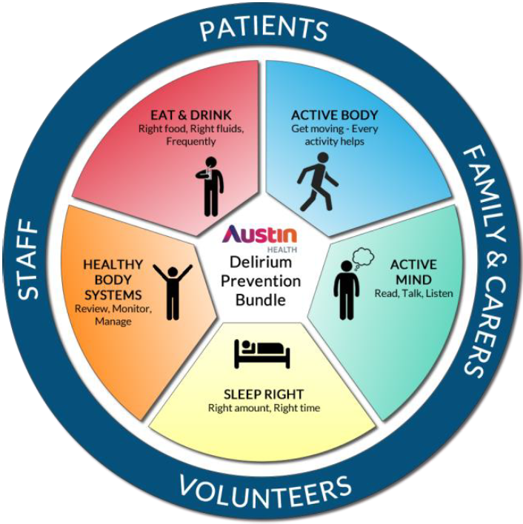

## Outcomes

* The proportion of patients at Austin Health with hospital-acquired delirium decreased from 13 per cent to 10.6 per cent, representing an 18 per cent reduction.
* CAM screening was completed on 88.4 per cent of all patients, representing a 30 per cent improvement.
* 78 per cent of patients had a CAM screening completed every day for the entire duration of their admission, representing a 24 per cent improvement.
* 86 per cent of activities in each patient’s delirium prevention bundle was implemented.
* 86 per cent of staff on target wards completed the delirium e-learning program. 96 per cent agreed it was engaging and 97 per cent said they felt confident to implement what they had learned.
* The project increased the consistency of prevention activities for patients and improved their experience. Patients reported that the simple, plain language information brochure helped them feel empowered to play a role in their own healthcare journey.
* The volunteer program received overwhelmingly positive feedback from patients.
* A cost analysis estimated that reducing hospital-acquired delirium in general medical patients by 2.4 per cent could save an estimated $1.55 million in health costs.

## Key learnings

* **Providing consistent education across all disciplines ensures core messages are reinforced –** Delivering one education program that was developed by an interdisciplinary team for an interdisciplinary team resulted in all teams working towards the same goals, using the same language in their clinical conversations, and documenting accurate and relevant information.
* **Integrating CAM into the electronic medical record has multiple benefits –** The integration allowed staff to receive daily, automated prompts, made it easy to see previous CAM results, and enabled more convenient recording. Increasing access to real-time, accurate delirium data and providing opportunities for monitoring led to a rapid improvement in consistent screening. Having the risk and delirium status for each patient clearly displayed on their record also helped increase awareness of delirium.
* **Education may translate differently into practice –** Austin Health took a systematic approach to understanding how staff would apply the e-learning, including conducting surveys, comparing CAM screening results, and performing rapid ‘plan, do, study, act’ testing of prevention bundle activities. This uncovered areas of improvement and opportunities to provide more clarity. For example, the health service discovered staff had different understandings of a patient’s ‘baseline mental state’. This varied interpretation could have influenced baseline data and the accuracy of all CAM records, however the timing of the evaluation meant the e-learning module could be modified.
* **It is essential to have a fit-for-purpose strategy to ensure prevention activities are consistently implemented –** The project’s aim of developing individualised delirium prevention plans for at-risk patients was changed as the original concept was too time intensive and duplicated existing work. Focus shifted instead to ensuring consistent delivery of the delirium prevention bundle, however, measuring this proved challenging. Prevention activities were being documented in various locations, including in electronic records, written records, and in nursing care plans. To address this, Austin Health developed an audit tool to determine the percentage of required bundle tasks completed each day. This was critical to identifying areas of improvement.