facilitating Osteoarthritis management in the community

St Vincent’s Hospital Melbourne trialled a community-based clinic to assess and support patients with osteoarthritis of the knee. The project aimed to increase capacity for musculoskeletal management in the community to improve patient outcomes by providing more timely access for patients in need of joint replacement surgery and/or offering non-surgical management options where appropriate.

## Background

Osteoarthritis (OA) can have an enormous impact on quality of life, psychological distress and work disability.1 In 2016, OA was a leading cause of pain and disability in Australia and was one of the most common conditions managed in general practice.

General practitioners (GPs) at times recommend surgery to treat OA over non-surgical management options such as physiotherapy, changes in diet, and counselling, advice and education. This can sometimes lead to patients being inappropriately referred to an orthopaedic surgeon.

High demand for specialist clinics for non-urgent patients and limited access to these services in the community contributes to long delays in accessing care, which can negatively impact a patient’s condition.

Inappropriate referral can also result in a patient having surgery with little benefit. Research shows that at least 15 per cent of all patients who receive a total knee joint replacement report no meaningful improvement from surgery. Furthermore, up to 20 per cent of patients experience ongoing pain and poor joint function post-surgery.2–5

To improve the delivery of best practice, holistic care for people with OA, St Vincent’s Hospital Melbourne (SVHM) trialled a community-based specialist OA clinic away from the hospital setting. This aimed to provide patients with assessment and access to treatment faster while reducing wait lists at the SVHM outpatient clinics. The clinic also featured a multidisciplinary team to facilitate non-surgical management as appropriate.

Rapid access musculoskeletal care

**Lead** St Vincent’s Hospital Melbourne

**Partners** North West Metropolitan Primary Health Network, Merri Health

**Duration** August 2016 – February 2018

**Key outcomes**

* Demonstrated that a community-based multidisciplinary specialist clinic can deliver:
  + a high uptake of ongoing therapy (84 per cent)
  + a low (12 per cent) referral rate to surgery
  + a high patient discharge rate from a clinic to the care of a GP
* Achieved patient satisfaction levels comparable to similar hospital-based clinics
* Achieved high satisfaction ratings of the service from GPs
* Developed and tested the use of the ‘SMART tool’, a decision aid that converts evidence-based outcome measures into a numeric score to determine the likelihood a patient will not respond to total joint replacement surgery

## Key activity

The project was conducted in inner-city Melbourne and implemented in two phases.

### Phase one – RAPID clinic

A short-term rapid assessment (RAPID) clinic ran from October to December 2016 from the SVHM’s Fitzroy campus with the aim of:

* testing components of the new specialist clinic model of care prior to its launch in a community location
* reducing SVHM specialist clinic wait lists.

The RAPID clinic was run by six advance practice musculoskeletal physiotherapists (AMP) two days a week, with an orthopaedic surgeon available for one hour during each clinic.

The clinic saw patients aged over 40 years who were waiting for a non-urgent specialist appointment for a knee-related problem. Eligible patients were contacted via phone and offered their choice of an in-person or telehealth appointment.

In the clinic, patients received an advanced OA assessment from an AMP. When further assessment was needed to identify optimal treatment, the patient was reviewed by the orthopaedic surgeon either directly or via a case review between the AMP and the surgeon.

### Phase two – COMET clinic

Building on the information gained from the first phase, SVHM and the North West Melbourne Primary Health Network established a specialist OA clinic at Merri Health, a metropolitan community health service in Brunswick, that included coordination of non-surgical management.

The COMET clinic was conducted once a week from April to December 2017. It was staffed by AMPs, general practitioners (GPs), a dietician, a care coordinator, an administration officer, and an orthopaedic surgeon who visited once a month for one hour. The care coordinator role facilitated timely, streamlined access to non-surgical management and support.

The clinic saw patients from northwest Melbourne who were aged over 40 years and who had a knee problem caused by OA.

Referrals came direct from GPs as well as from existing SVHM orthopaedic and OA knee and hip service (OAKHS) clinics.

Patients had to bring to their initial consultation a recent knee x-ray and two completed questionnaires self-assessing their general health and the condition of their knee.

Appointments were booked interchangeably with a GP or AMP, and a care plan was developed depending on the individual’s needs. Patients who were recommended both surgical and non-surgical management were advised to continue or commence therapy while waiting for a surgical decision to maximise health outcomes.

Patients were directed to further appointments with the dietician or care coordinator at the COMET clinic, or with a clinician closer to home, for non-surgical management as appropriate.

### Other initiatives

* The project included development of the **S**t Vincent’s **M**elbourne **Art**hroplasty (SMART) tool, a web-based decision-making aid used in the COMET clinic. The tool helped determine the probability a patient with OA would benefit from total joint replacement surgery. This was based on data entered by the administration officer, including the patient's body mass index score, information from the two pre-consultation questionnaires, and from the patient's knee x-ray.
* The Good Life with OA in Denmark (GLA:D) program was reviewed and subsequently introduced. GLA:D is an internationally recognised, evidence-based program developed in Denmark that aimed to improve health outcomes for OA patients through education and exercise delivered by a certified physiotherapist.

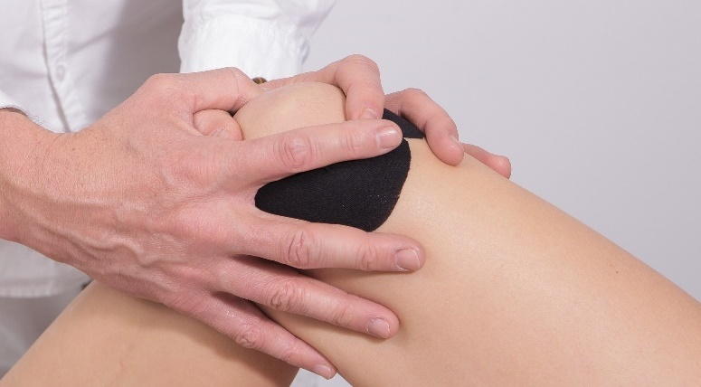

## Outcomes

### RAPID clinic

* Saw 316 patients, providing them with more timely access to assessment and treatment/management.
* 172 patients were discharged to their GP for ongoing non-surgical management, 112 were referred to orthopaedic clinics for surgical opinion, and 42 were referred to other specialist clinics, mainly for non-surgical management.
* Overall, 5 per cent of the patients seen at the RAPID clinic went on to have joint replacement surgery and 4 per cent resulted in other orthopaedic procedures including arthroscopy.
* The specialist clinic wait list was reduced by 75 per cent for patients over 40 years of age. This included the removal of 247 patients who no longer needed an appointment.
* 93 per cent of patients surveyed said they were satisfied or very satisfied with the care received and 90 per cent said they had a clear plan for managing their health condition.

### COMET clinic

* 153 patients were assessed over 32 weekly clinics.
* 53 patients received a dietitian consultation, 111 patients had a care coordinator consultation, and 19 patients were referred for surgery. Six patients had a total joint replacement.
* The clinic increased referrals to non-surgical management. 84 per cent of patients accessed ongoing therapy and almost all (98 per cent) patients referred for community physiotherapy attended a therapy session at least once, compared to 33 per cent of patients attending equivalent SVHM specialist clinics.
* Due to the new nature of the clinic, patients had a short wait time of about two weeks compared to 180–750 days at other equivalent SVHM specialist clinics.
* The discharge rate from the COMET clinic was 58 per cent, significantly higher than the OAHKs and orthopaedic clinic combined average discharge rate of 14 per cent.
* 95 per cent of patients surveyed were satisfied or very satisfied with the care they received and 98 per cent felt they had a clear plan for managing their condition.
* All COMET staff said they were satisfied or very satisfied with the way their professional skills were used in the clinic.
* 90 per cent of referring GPs surveyed said they would refer to the COMET clinic again and 83 per cent said the clinic facilitated better management for their patient than usual pathways.

## Key learnings

* Offering community-based management of OA has the potential to give patients faster access to clinical care closer to their home, with amenities such as easier parking. The non-hospital location can also positively influence uptake of non-surgical therapy.
* The new care coordinator role likely helped to support uptake of therapy by helping patients to identify suitable service providers and organising referral soon after the recommendations were made by the clinician undertaking the initial assessment.
* After being booked into an appointment at the COMET clinic, patients were sent a clinic-specific letter confirming their appointment time. However, due to the short wait list, some patients had not received the letter by the time of their appointment and subsequently did not attend. An alternative method for confirming an appointment time is recommended.
* A new referral process takes time to embed. Using the existing referral pathway known to GPs rather than introducing a new pathway may have been a more effective way to maximise the number of patients assessed in the clinic.