an alternative safe space for those seeking mental health support

People experiencing mental health issues may find visiting a hospital emergency department traumatising, yet they often view this as their only option when they feel unwell or unsafe. Through Safe Haven Café, St Vincent’s Hospital Melbourne helped improve mental health consumers’ experience of care and social connectedness by providing a non-clinical, therapeutic alternative.

## Background

One in nine patients who presented to the St Vincent’s Hospital Melbourne (SVHM) emergency department (ED) from 2015–17 cited mental health as their primary reason for attending.

Some of these individuals do not require clinical care but do not feel safe or well enough to manage independently. They may feel socially isolated and lonely, often due to mental health conditions, and while some limited after-hours services are available, many feel hospital EDs are their only avenue for face-to-face help and support.

However, EDs are complex clinical environments that are not always the most appropriate point of care for these individuals, with some mental health consumers describing these settings as traumatising, threatening, unsafe and dehumanising.

SVHM established Safe Haven Café to provide a non-clinical, therapeutic space where people seeking mental health care, respite and support outside of normal business hours could comfortably connect with mental health professionals, peer support workers and volunteers.

Through the café, SVHM sought to provide these consumers with better and more responsive care in a more appropriate setting, with a focus on helping them build resilience and self-manage.

The initiative also presented an opportunity to reduce the number of inappropriate mental health presentations at the SVHM ED.

Safe Haven Café

**Lead** St Vincent’s Hospital Melbourne

**Duration** April 2018 – June 2019

**Key outcomes**

* Improved consumers' experience of care
* Increased consumers' sense of social connectedness in the local community
* Reduced mental health presentations to the SVHM ED, releasing capacity and potentially reducing treatment delays for other ED patients
* Delivered estimated savings of more than $30,000 per annum by diverting consumers from the ED to a more appropriate model of care

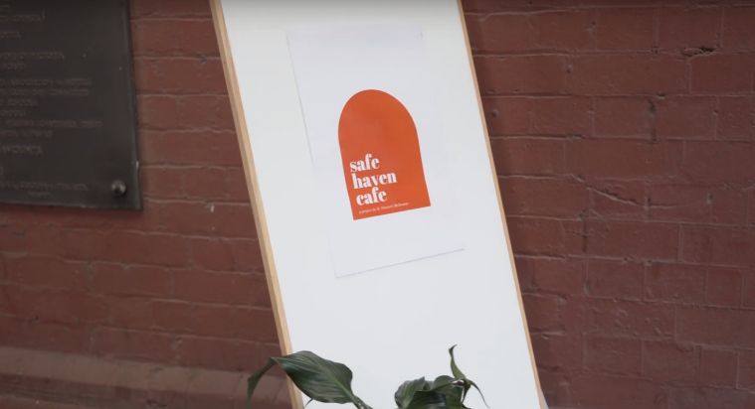

‘We are redefining what customer impact means – it can be as simple as helping someone smile that day.’

**– Safe Haven Café clinician**

## Key activity

* Engaged with colleagues who had successfully implemented the ‘Safe Haven Café’ model in the UK as well as with consumers and carers to inform the design of the SVHM Safe Haven Café pilot.
* Converted the existing SVHM Art Gallery into Safe Haven Café from 4pm to 8pm on Fridays and 2pm to 8pm on weekends.
* Offered free tea, coffee and light snacks at the café, providing an opportunity to connect with mental health clinicians, peer workers with lived experience of mental health issues and volunteers – or to simply relax in a safe, comfortable space.
* Educated SVHM ED and mental health staff on the café’s function to enable appropriate referral. Peer support workers were also stationed at the SVHM ED to help accompany consumers to the café.
* Engaged with stakeholders such as community services, food providers, drop-in centres and local charities to raise awareness of the café and encourage its promotion to their clients.

‘When you are in crisis, ED seems like the only answer, but when you engage with the café, there is a moment when you realise you just need support sometimes.’

**– Safe Haven Café visitor**

## Outcomes

Since opening in April 2018, Safe Haven Café has been attended more than 1,500 times by almost 170 unique individuals. 80 per cent of people who attended the café returned for a subsequent visit, suggesting consumers found it a valuable service and a safe alternative to the ED.

An economic review conducted by PwC found that Safe Haven Café:

* improved consumers’ experience of care and sense of social connectedness in the community
* reduced mental health presentations to the SVHM ED and delivered estimated savings of more than $30,000 per annum as a result
* potentially delivered additional benefits, such as reducing treatment delays for ED patients.

### Consumer experience

Café visitors said they felt ‘welcome’, ‘safe’, ‘comfortable’ and ‘relaxed’. They also reported gaining a sense of hope, feeling valued, heard and seen, and that the café helped them connect with people. This improved their confidence in settings outside of the café, enabling them to make other positive changes in their lives.

For example two visitors gained paid employment, one returned to paid employment and another sought volunteer work; two visitors reported improved family relationships and support; and others said they felt more confident to attend community groups run by their local church or to access health service support groups.

‘The calmness I feel at the cafe   
transferred to where I live.’

**– Safe Haven Café visitor**

### Alternative to ED

* Consumers appreciated that the café did not focus on assessment, diagnosis or driving towards an outcome. They explained that sometimes they did not need an action plan but rather for someone to listen to them.
* They described the café as safe and empowering because they were able to control their experience and the pace at which their relationships developed, feeling no expectation to share their stories or exchange information.
* Similarly, the fact that there was no expectation to disclose health concerns or diagnoses made consumers feel recognised as individuals that could be taken at face value, rather than labelled by their past history.

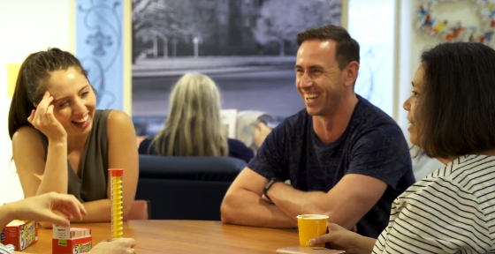

## Key learnings

* **Staff wellbeing must be considered in the model’s design**
  + Consumers valued connecting with peer workers who understood their struggles, but this placed a burden on peer support workers to be open about their lived experience on an ongoing basis. It is important to ensure adequate support and debriefing is available to staff to prevent burnout.
  + Hiring casual staff helped alleviate guilt for peer support workers who were unable to attend their shift or wanted to take leave.
  + Extending shifts to start before opening and end after closing enabled staff time to debrief and discuss current issues and concerns confidentially.
* **Set clear exclusion criteria and expectations for acceptable behaviour, and provide staff training to help uphold them**
  + SVHM promoted clear guidelines for attending the café on-site to ensure consumers, staff and volunteers could feel safe. For example, the café would not accept people under the influence of drugs or alcohol and was not a place to sleep.
  + Consumers were referred to appropriate support services as needed, such as when they required medical care or crisis intervention.
  + On the few occasions consumers were declined entry or asked to leave, this was done respectfully and the individuals felt comfortable to return at a later stage.
  + Providing all staff with training on how to approach difficult conversations will help equip them with the skills and confidence to uphold café guidelines and ensure a safe space for all.
* **Informal feedback collection proved more popular than formal approaches**
  + Consumer reluctance to engage with formal feedback surveys led SVHM to adopt alternative approaches, such as monitoring attendance and data and noting informal discussions.
  + This limited statistical analysis, but individuals were more likely to share their stories, providing meaningful qualitative data for project evaluation.
* **Word-of-mouth referrals were more effective than those from community services** 
  + Engagement with key community stakeholders had limited success in encouraging people to attend the café.
  + Consumers who had not been escorted to the café from the SVHM ED by a Safe Haven Café peer worker reported feeling anxious about attending for the first time.
  + Knowing someone who had had a positive experience visiting the café increased consumers’ confidence in attending.
  + Partnerships or co-locations with social services, building an online presence with testimonials and reviews, and encouraging existing consumers to spread the word to their friends are important avenues for reaching new consumers.