Centres of Clinical Excellence framework

July 2021

|  |
| --- |
|  |
| To receive this publication in an accessible format phone 03 9096 1384,  using the National Relay Service 13 36 77 if required, or [email Safer Care Victoria](https://intranet.dhhs.vic.gov.au/create-accessible-word-documents) <info@[safercarevictoria.vic](https://www.safercare.vic.gov.au).gov.au>.  Authorised and published by the Victorian Government, 1 Treasury Place, Melbourne.  © State of Victoria, Australia, Safer Care Victoria, July 2021.  ISBN 978-1-76096-460-3 (pdf/online/MS word)  Available at the [Safer Care Victoria website](mailto:info@safercarevictoria.vic.gov.au) <https://[www.safercare.vic](http://www.safercare.vic).gov.au>  Victoria State Government |

# About this framework

Safer Care Victoria’s Centres of Clinical Excellence framework details our new and improved approach to engaging with clinicians and consumers to improve the quality and safety of healthcare in Victoria. It spells out the purpose, role and structure of the Centres of Clinical Excellence (the Centres), which leads much of our targeted clinical engagement.

Continuing the work of Victoria’s clinical networks, our newly formed Centres work with clinicians and consumers to develop clinical guidance and advice, advocate for the voice of consumers and clinicians, and lead targeted healthcare improvement. We encourage clinicians, consumers and our partners to read this framework to understand how they can inform our work, and how we – in return – promise to seek their input.

This framework aligns with the Safer Care Victoria (SCV) Strategic Plan 2020–23. Through our core functions, the Centres contribute to the key strategic domains of leadership, partnership and planning, monitoring, and improvement, that are central to SCV’s aim of improving healthcare across Victoria, so it is safer, more effective and person-centred.

This framework should be read in conjunction with SCV’s [Partnering in healthcare framework](https://www.bettersafercare.vic.gov.au/publications/partnering-in-healthcare) <https://www.bettersafercare.vic.gov.au/publications/partnering-in-healthcare> which outlines best practice approaches to meaningful consumer engagement and partnership.

|  |
| --- |
| A note on terminology  We broadly use the term ‘consumers’ to refer to people, families, carers and communities who are current or potential users of healthcare services. Different health settings may use terms such as: patients, persons and families, carers, clients and residents.  The term ‘clinician’ includes practitioners from all professionally registered groups such as nurses, midwives, doctors, allied health professionals, paramedics, dentists and pharmacists. We acknowledge there are additional workforces we engage with. An example is the ‘lived experience workforce’ across Victoria, especially in mental health and wellbeing services.  ‘Clinical engagement’ refers to the methods, extent and effectiveness of both clinician and consumer involvement in the design, planning, decision making and evaluation of activities that affect the Victorian healthcare system. |

# Introduction

This framework takes the best of our current ways of working and addresses key gaps. It is informed by an evaluation of the clinical networks and complemented by extensive consultation with clinicians, consumers and many more. The result is a framework driving stronger, more purposeful and systematic engagement across Victoria. Over the coming years, we look forward to testing and refining this refreshed engagement approach.

## Background

Clinical networks were established in Victoria in 2008 and have continued to evolve over time to respond to the needs of the healthcare system. In 2017, we released our *Framework for clinical networks*, which provided a structured approach to how SCV collaborated with clinicians and consumers through the clinical networks.

In February 2020, SCV transitioned the clinical networks into four population health-based centres. The aim of this shift was to broaden our engagement with clinicians and consumers to include a greater diversity of experiences, roles, areas of specialty and geographic locations.

To inform the transition, we evaluated the *Framework for clinical networks* in November 2020, drawing on the concepts of a learning health system,[1] along with clinician and consumer feedback. The evaluation sought to inform how we could optimise resources and continue to drive innovation and promote safety in healthcare. The evaluation identified that we needed to become more agile and responsive as the healthcare needs of Victorians’ change.

The refreshed engagement structure of the Centres will not only allow us to engage with a broader and more diverse set of clinicians and consumers in Victoria, but also facilitate a population health approach. This means we are better placed to focus on system-wide issues facing our health sector today to inform not only SCV but the Department of Health.

Leveraging lessons learnt from SCV’s response to the coronavirus (COVID-19) pandemic, this new engagement framework aims to:

* enable collaboration with a more diverse cohort of clinicians and consumers to address complex health challenges through a population health approach
* diversify our clinical engagement in both who and how we engage
* improve prioritisation and integration of work to align with SCV’s strategic objectives
* build sustainable partnerships that foster mutual accountability between health systems and consumers
* develop centralised and accessible data processes to inform improvement opportunities.

# The Centres of Clinical Excellence

Comprising four population-based centres along with funded programs, the Centres engage clinicians and consumers to advise on and deliver healthcare improvement and evidence-based guidance.

Figure 1: Centres of Clinical Excellence

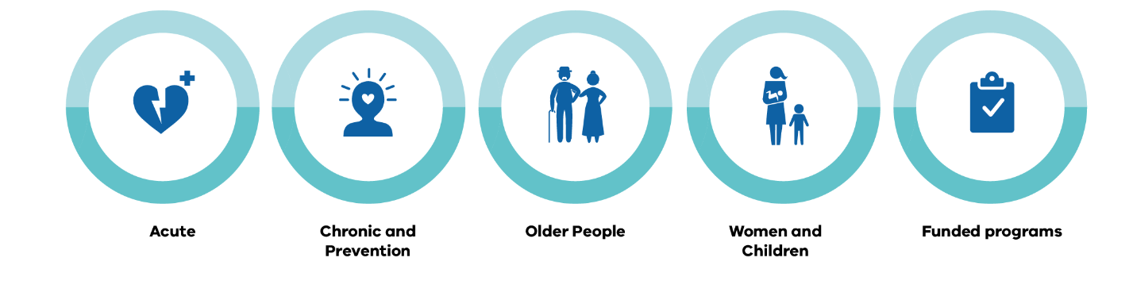

Each population health centre has several associated clinical networks, as outlined in Table 1.

Table 1: Alignment of centres to clinical networks

| Centre | Clinical networks |
| --- | --- |
| Acute | Critical Care Clinical Network  Infection Clinical Network  Emergency Care Clinical Network  Stroke Clinical Network |
| Chronic and Prevention | Renal Clinical Network  Cardiac Clinical Network |
| Older People | Palliative Care Clinical Network  Older People Clinical Network |
| Women and Children | Maternity and Newborn Clinical Network  Paediatric Clinical Network |

## Functions

The Centres have three core functions: guidance and advice, advocating and informing, and improvement. All of these are underpinned by purposeful and systematic clinical engagement.

Figure 2: The Centres’ core functions

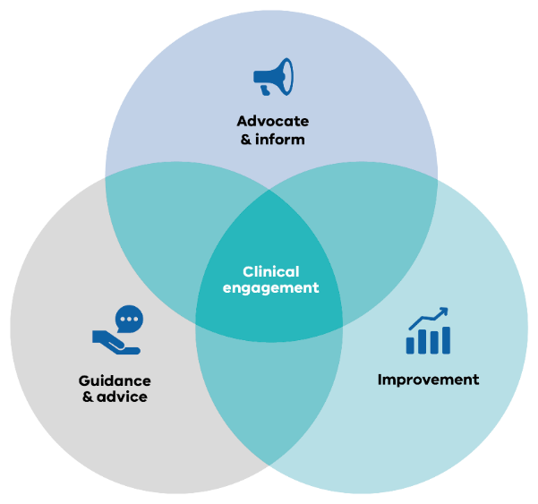

### Guidance and advice

The Centres endorse, adapt or develop high-quality and accessible evidence-based guidance, prioritising topics with the greatest potential to improve consumer outcomes. By partnering with clinicians and consumers to develop and implement evidence-based guidance, we support health services to deliver best practice care. For further detail on how the Centres deliver guidance, please see SCV’s [Evidence-based guidance: a new approach to sharing best practice](https://www.bettersafercare.vic.gov.au/publications/evidence-based-guidance) <<https://www.bettersafercare.vic.gov.au/publications/evidence-based-guidance>>.

We also partner with clinicians to ensure our response on a range of quality and safety matters is informed by the advice of clinical experts. These functions promote the delivery of key quality and safety information to the health sector, ensuring information provided is underpinned by the best available evidence and clinician insights.

### Advocacy

We advocate for consumers and clinicians to positively influence health system policy, planning and design. Our purposeful and systematic engagement structures enable us to have the greatest reach across Victoria, ensuring the voice of the clinicians and consumers to be heard. This allows for escalation of policy and reform feedback to the Department of Health.

### Improvement

We lead improvement initiatives that deliver measurable and sustained positive outcomes. We partner with health services and consumers to drive these initiatives and build knowledge and skills across the sector. Through the Clinical Fellowship program, we are building a network of future leaders to influence the health system in Victoria for the better. Our close links with the Victorian Agency for Health Information (VAHI) allow us to monitor system information and have consistent, supportive and tailored responses. Our engagement structures mean we have the expertise to respond to these issues and provide high-level support to the sector, allowing for a data-driven improvement culture.

# Engagement

Working in partnership with clinicians and consumers through purposeful and systematic engagement helps us to focus our activity on what matters most.

To achieve purposeful and systematic engagement, we:

* bring together clinicians and consumers across different specialties, disciplines, levels of experience, expertise and geographic locations in time-limited working groups, to inform and deliver priority improvement projects
* support purposeful collaboration via clinical networks to improve the quality and safety of healthcare delivery
* employ time-limited Clinical Leads, Practice Leads and develop secondment and sabbatical opportunities for members of the health sector, to lead and participate in SCV improvement priorities
* ensure consumers are represented on all groups and committees in accordance with our [Partnering in healthcare framework](https://www.bettersafercare.vic.gov.au/publications/partnering-in-healthcare) <https://www.bettersafercare.vic.gov.au/publications/partnering-in-healthcare>
* convene annual sector forums so clinicians and consumers can collaborate and showcase improvement initiatives
* work closely with VAHI to enable a data-driven improvement culture with consistent, supportive and tailored responses from the Centres
* contribute to key priority actions of the Department of Health where requested by accessing insights from clinical experts and advocating for the clinician perspective
* establish interstate and national partnerships to spread and promote improvement resources and share learnings in Victoria and across other jurisdictions.

We are committed to extending the reach of our networks and working groups to enable the representation of different voices. This is your opportunity to be involved regardless of your disciplinary background, experience level, geographical area or healthcare setting.

The following details the Centres’ key engagement structures.

## 1.Clinical Advisory Group

The purpose of the Clinical Advisory Group is to provide expert advice on healthcare issues and areas for improvement to the Centres, SCV and the Department of Health. The Clinical Advisory Group consists of a diverse range of clinicians, consumers and SCV staff who represent a breadth of clinical specialties, services and geographical locations.

When providing advice, the Clinical Advisory Group approaches solutions via the following three avenues:

* **advocate:** escalate an issue to relevant stakeholders such as the Department of Health on behalf of the Centres, the sector or consumers
* **partner:** recommend that a relevant centre addresses an issue through partnering with an external/internal body or agency, including the Department of Health
* **deliver:** recommend that a population health centre leads delivery of a piece of work to address an issue (approval to complete work will be subject to available budget and resources and require SCV Executive Leadership Team approval).

## 2.Time-limited working groups

Time-limited working groups may be required to deliver strategically aligned, priority projects for the Centres. Working groups can consist of expert clinicians and consumer representatives recruited to partner in the delivery of the work. Time-limited working groups are an opportunity for clinicians and consumers to contribute to improvements in healthcare delivery.

## 3.Clinical Network Coordinating Committees

The purpose of the Clinical Network Coordinating Committees is to drive and facilitate purposeful sector engagement within the clinical networks and population centres (see Table 1 for an overview of the Centres and their associated clinical networks). These committees have a pivotal role in working collaboratively with SCV to improve safety and quality of care for Victorians.

## 4.Clinical networks

Our new reshaped clinical networks will be a sector-led community of clinicians and consumers with a similar area of specialty interest. Clinical networks will aim to improve clinical care and delivery via collaboration, peer-to-peer learning, sharing and coaching, and will build upon past achievements of the clinical networks. Through an annual forum and an online platform, the sector-led networks provide an avenue for active and continuous collaboration between clinicians and consumers.

Collaboration across the clinical networks will be supported through the population health centres to enable a multispecialty and multidisciplinary problem-solving approach to complex system issues. The clinical networks will continually evolve over time to reflect the health needs of the Victorian population.

Figure 3: Centres of Clinical Excellence engagement structures

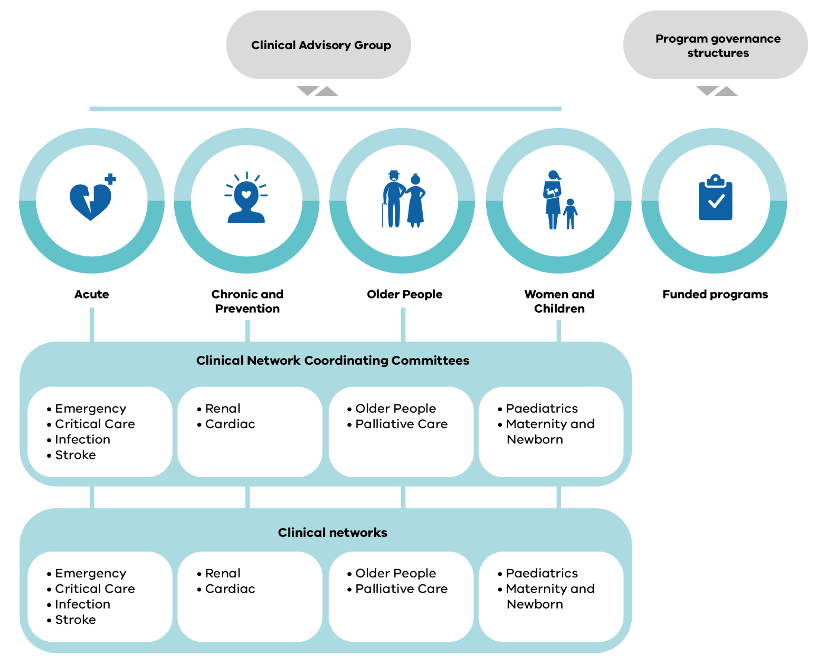

## Operational support

Each population health centre consists of staff who provide expertise in stakeholder engagement, improvement methodology and project management to support work within and across the centres.

Time-limited Clinical Leads, Practice Leads with lived experience, clinical fellows and sabbaticals offer further links with the sector to increase leadership in quality and safety both in the Centres and when they return to their health service.

# Key partners

This section describes key groups that the Centres partner with to plan and deliver its work.

### Consumers

A core principle of the Centres is to act in the best interests of consumers and the wider Victorian community. Consumers will be represented on all committees and working groups, ensuring the consumer voice is at the forefront of all work.

### SCV Consumer Caucus

Recognising the benefit of partnering with consumers, an annual ‘Consumer Caucus’ is convened to enable participating SCV consumers to come together to learn, share their experiences and inform future work.

### Healthcare agencies and providers

Engagement with external healthcare agencies and providers should reflect how consumers access healthcare. This means that engagement should be diverse, agile and address all parts of the healthcare system. The Centres engage with the following healthcare agencies and providers, where relevant, depending on the piece of work being delivered:

* public health services and hospitals (including acute and subacute services, metropolitan, regional and rural)
* private health services and day procedure centres
* residential aged care
* primary healthcare providers, including general practitioners and Primary Health Networks
* private medical specialists
* community health services
* community mental health services
* mental health and wellbeing services
* ambulance services and non-emergency transport services
* ancillary health services such as pharmacies, radiology and pathology providers.

### The Department of Health and the Department of Families, Fairness and Housing

Both departments deliver policies, programs and services that support and enhance the health and wellbeing of all Victorians. The Centres work closely with relevant areas in each department, affording them access to expert clinical advice. This enables a cohesive and strong approach to system improvement by leveraging the roles, functions and opportunities available in their respective domains and areas of influence.

### Victorian Agency for Health Information

The Centres work closely with VAHI, a division of the Department of Health, drawing on their data analytics to inform improvement initiatives.

### Consultative councils

Victoria’s independent consultative councils report on highly specialised areas of healthcare to improve health outcomes and reduce preventable mortality and morbidity.

Their relationship with the Centres primarily relates to system-level recommendations and findings for health outcome improvement initiatives. The Centres have a role in addressing clinical practice variation identified by the consultative councils. The Centres can contribute to disseminating council recommendations and key findings.

### SCV Office of the Clinical Chiefs

Our Clinical Chiefs and advisors are a key mechanism for sector engagement, championing key SCV projects and providing expert advice to the SCV CEO and the Department of Health.

The Centres and Office of the Clinical Chiefs work together to leverage and broker relationships with the clinical networks and their respective professional groups to receive feedback and communicate outcomes.

### SCV Quality and Safety Executive Council

The Quality and Safety Executive Council will provide expert advice on quality and safety in the health sector to the SCV Executive Leadership Team. This council will promote a strong link between system leaders in innovation, research, hospital executives, clinicians and consumers.

### SCV Quality and Safety Signals Group

The Quality and Safety Signals group builds on the collaborative approach founded in the Indirect Impacts Group during the coronavirus (COVID-19) pandemic, bringing together a multispecialty group of clinicians to review a spread of healthcare data. The Quality and Safety Signals Group is an evolution of former data review committees from the clinical networks. This group will review health sector data and proactively identify variations in care, which will be referred to the Clinical Advisory Group for interpretation.

### Other groups and organisations

Consideration will also be given to other stakeholder groups including:

* consumer peak and representative bodies
* lived experience workforce
* clinical colleges
* peak bodies
* insurers (including the Victorian Managed Insurance Authority)
* relevant advocacy-based non-government organisations
* research institutes
* healthcare education providers
* the Coroners Court of Victoria
* the Health Complaints Commissioner
* the Mental Health Complaints Commissioner, soon to be the Mental Health and Wellbeing Commissioner
* the Australian Commission on Safety and Quality in Health Care
* the Therapeutic Goods Administration
* the Australian Health Practitioner Regulation Agency.

1. Mullins C, Wingate L, Edwards H. Transitioning from learning healthcare systems to learning health care communities. Journal of Comparative Effectiveness Research [online]. 26 Feb 2018 [16 March 2021];7(6). Available from: https://www.futuremedicine.com/doi/10.2217/cer-2017-0105.