August 2022
Victorian perinatal services performance indicators
2020–21

Suggested citation:
Yuen, N, Farrell T, Hunt RW, Shub A, Watts S, on behalf of the Maternal and Newborn Clinical Network, Victorian perinatal services performance indicators 2020–2021, Safer Care Victoria, Victorian Government, Melbourne; 2022.
To receive this publication in an accessible format phone (03) 9096 1384, using the National Relay Service 13 36 77 if required, or email Safer Care Victoria <info@safercare.vic.gov.au>. | Authorised and published by the Victorian Government, 1 Treasury Place, Melbourne.  © State of Victoria, Australia, Safer Care Victoria, August 2022  ISSN 2207-3558 (online)  Available from the Safer Care Victoria website <https://bettersafercare.vic.gov.au>. | 


Contents
Contents 3
Foreword 6
About this report 7
How to use this report 8
About the data 9
Compare your performance 10
Inform quality improvement activities 10
Summary of results 12
Where we are getting better 12
Where we are doing less well 13
1a: Induction of labour in standard primiparae 16
About this indicator 16
Observations on the data 16
Definitions and data sources 18
1b: Caesarean sections in primiparae 20
About this indicator 20
Observations on the data 20
Definitions and data sources 24
1c: Perineal tears in primiparae 26
About this indicator 26
Observations on the data 26
Strategies for improvement 27
Definitions and data sources 31
1di and 1dii: Episiotomies in primiparae 33
About this indicator 33
Observations on the data 33
Strategies for improvement 33
2: Term babies without congenital anomalies who required additional care 39
About this indicator 39
Observations on the data 39
Definitions and data sources 42
3: Severe fetal growth restriction 44
About this indicator 44
Observations on the data 44
Definitions and data sources 47
4a and 4b: Vaginal birth after primary caesarean section 51
About this indicator 51
Observations on the data 51
Strategies for improvement 52
5: Five-year gestation standardised perinatal mortality ratio 57
About this indicator 57
Definitions and data sources 59
6a and 6b: Readmissions during the postnatal period 61
About this indicator 61
Observations on the data 61
Strategies for improvement 61
Definitions and data sources 67
7: Smoking cessation 70
About this indicator 70
Observations on the data 70
Strategies for improvement 70
Definitions and data source 73
8a, 8b and 8c: Breastfeeding in hospital 74
About this indicator 74
Observations on the data 74
Strategies for improvement 75
9: First antenatal visit 82
About this indicator 82
Observations on the data 82
Strategies for improvement 82
10: Low Apgar score 86
About this indicator 86
Observations on the data 86
Strategies for improvement 86
Definitions and data sources 90
11a and 11b: Women’s experiences of care 91
About these indicators 91
Observations on the data 91
Strategies for improvement 91
Definitions and data sources 96
12a and 12b: Maternal vaccination 97
About this indicator 97
Observations on the data 98
Strategies for improvement 98
Definitions and data sources 103
13: Women who had a severe postpartum haemorrhage within the 24 hours following birth 104
About this indicator 104
Observations on the data 104
Strategies for improvement 104
Definitions and data sources 107
Appendix 1: Data sources and reporting rules 108
Appendix 2: Total women and babies in Victorian maternity services 2020 109
Appendix 3: Overview of results 113
Appendix 4: Robson Classifications 118
Terminology 119
Acknowledgements 122
References 123

Foreword
The Perinatal Services Performance Indicator (PSPI) report details the ongoing commitment to safe quality care that is provided by the dedicated health practitioners in our perinatal services in Victoria, from public to private and regional to metropolitan settings. It highlights the areas where we are doing well and providing exceptional care and where we can make improvements for the families we care for. We express our enormous gratitude to our midwives, nurses, obstetricians, anaesthetists, paediatricians, physicians, paramedics, pharmacists, dieticians, physiotherapists, social workers, general practitioners, Aboriginal health workers and others who continue to make Victoria one of the safest places in the world to have a baby.
The last two years have presented unique challenges within the health sector and to our perinatal services. 2019 ended with bushfires across south-eastern Australia and the impact of the COVID-19 pandemic has been enormous. Every health care worker and person receiving pregnancy care has been affected by changes in how we deliver care in response to COVID-19.
The Consultative Council on Obstetric and Paediatric Mortality and Morbidity (CCOPMM) released a COVID-19 communique <https://www.safercare.vic.gov.au/publications/covid-19-communique-a-rapid-review> which reviewed the indirect impacts of the pandemic on perinatal care. The Collaborative Maternity and Newborn Dashboard for the COVID-19 pandemic (CoMaND project) produced a suite of 10 key maternity indicators from routinely collected data and compared this to pre-pandemic time points. This communique should be considered as an adjunct perspective to the environment that perinatal services have been operating in over the last 12–24 months and provides additional context to this PSPI report.
Highlights in this report should be recognised as examples of ongoing improvement in care delivery, including a decrease in the state-wide rate of severe growth restriction undelivered by 40 weeks’ gestation. But there are also areas where more needs to be done, as well as areas of our care that are not well covered by the current suite of indicators, including perinatal mental health care. Safer Care Victoria (SCV) remains committed to continuing to review and revise the indicators to ensure their currency and relevance to health care services and consumers.
Over the last two years, SCV, in partnership with the Institute for Healthcare Improvement (IHI) and the Stillbirth Centre for Research Excellence (CRE), has embarked on large scale quality improvement initiatives to reduce stillbirth and severe perineal tears. The outcomes are reflected in the data in this report, with participating health services achieving a reduction in stillbirth from 2.4 and 1.9 per thousand births an increase in smoking cessation rates from 11% to 33%, and a reduction in the rate of severe perineal tears from 4.4% to 2.4%. Building on this improvement science capability in Victorian perinatal services and with a focus on safe quality care, SCV has partnered with IHI in 2022 to reduce severe postpartum haemorrhage rates and we hope to see similar improvement in this indicator reflected in next year’s data.
We hope that this latest report continues to be a key document to assist health services in prioritising system improvement and a useful tool for all staff and consumers.
Dr Nicola Yuen, MBBS (Hons), FRANZCOG, Masters Hlth Mgt
Clinical Lead, Maternity and Newborn, Safer Care Victoria
This report provides insights into where we are providing exceptional care and where improvements can be made across our maternity services in Victoria. It provides data allowing health services to compare results and monitor variation within their own services over time and also against their peers. This report also helps health services prioritise their performance improvements by reviewing their practices and identifying areas of improvements for the care provided to women and their babies – from antenatal, through intrapartum (labour and birth) to postnatal care.

About this report
These performance indicators are widely accepted as appropriate, useful and insightful measures of the quality of care. They continue to be refined over time.
Figure 1. Perinatal services performance indicators by key performance area
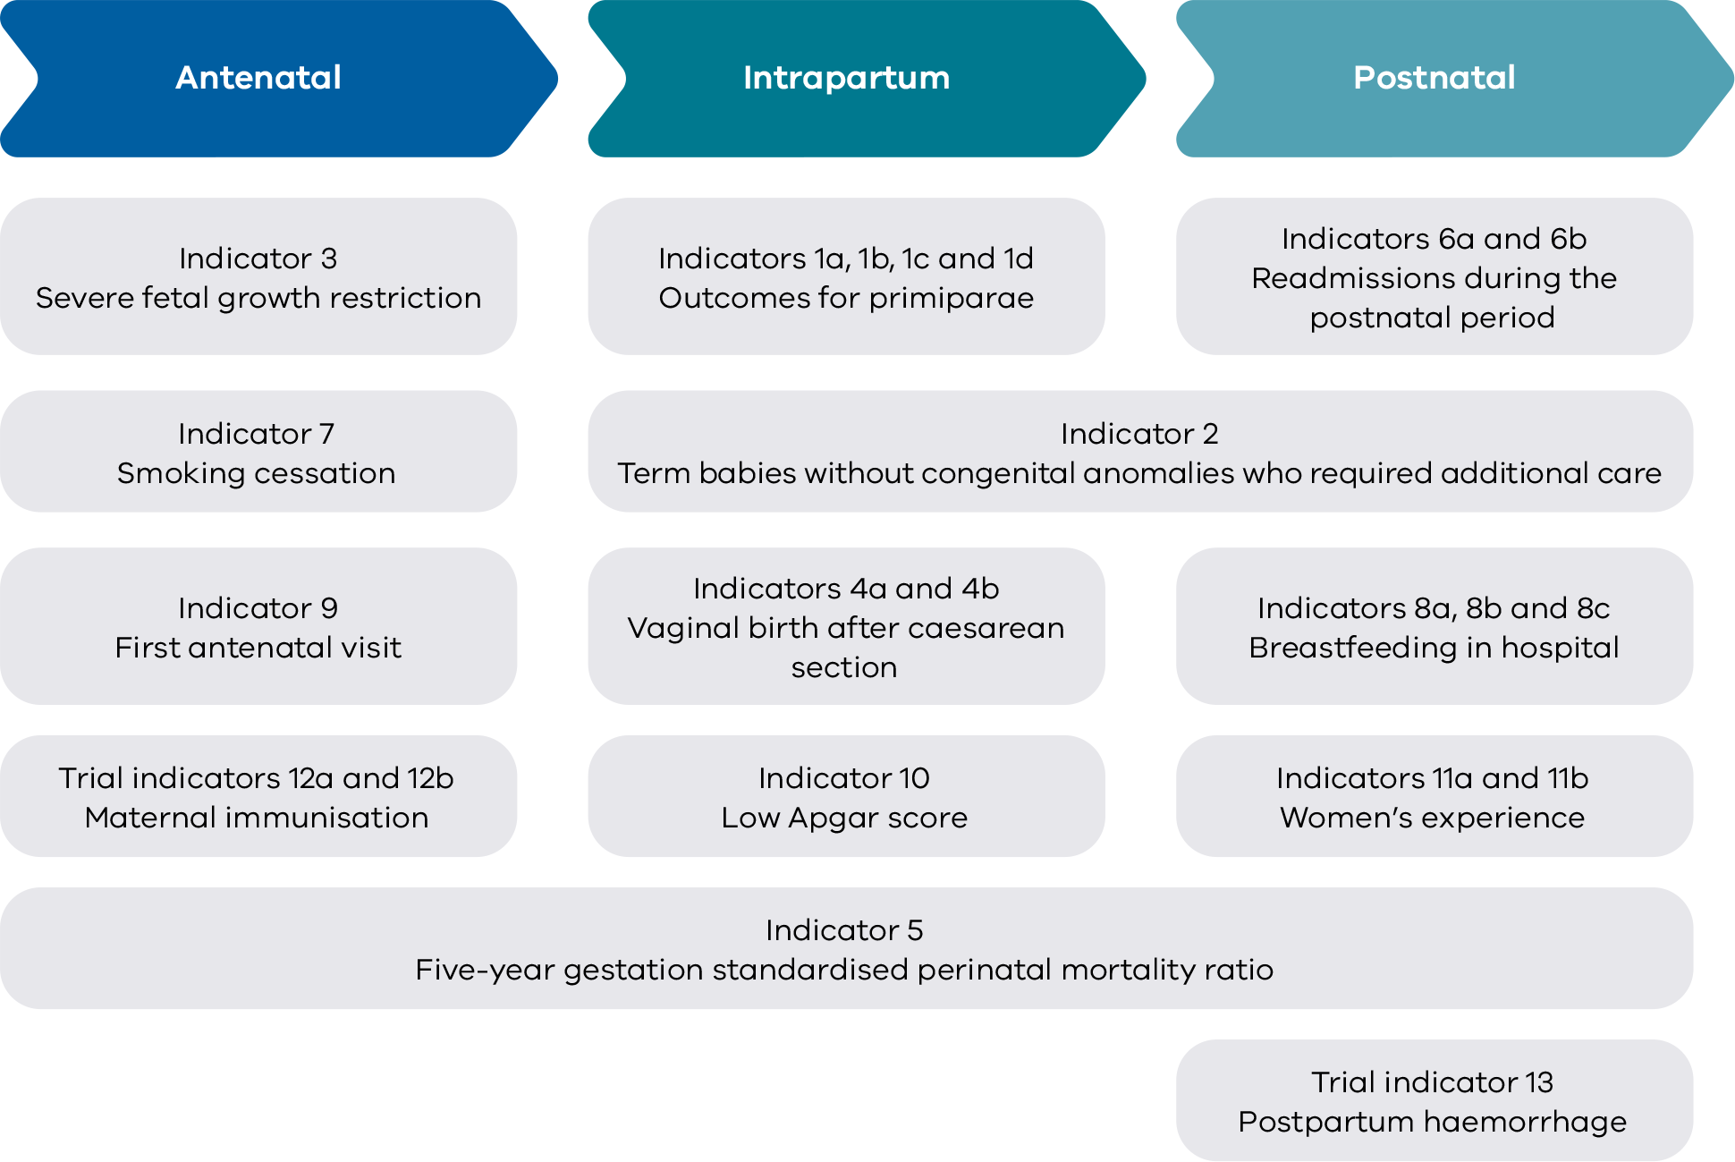

How to use this report
The main section of this report details statewide data observations and key information for clinicians and health services.
Outcomes are reported here by comparing services with each other and over time. We call this comparison ‘benchmarking’. It can be used to identify high performing services, performance of practices within a multi-site health service and compare practice over time.
Benchmarking can:
- allow you to assess performance relative to other health services
- identify services that are providing best practice that you may want to connect with
- highlight opportunities for improvements, particularly where improvement activities have led to success in other organisations.
Further detail is provided in the appendices.
- Appendix 1 details the data sources for this report.
- Appendix 2 lists Victoria’s maternity services and the number of women and babies cared for in 2020.
- Appendix 3 contains an overview of results for each individual health service.

Some indicators have 2019 results also included
Due to the impact of the pandemic – both at SCV and in health services – some indicators were not included in the 2019–20 report. Data is now available for all measures, including data for two years for the following indicators :
- Indicators 1di and 1dii: Episiotomies in primiparae
- Indicators 4a and 4b: Vaginal birth after primary caesarean section
- Indicators 8a, 8b and 8c: Breastfeeding in hospital
- Indicator 9: First antenatal visit
- Indicator 12a: Rate of women vaccinated for pertussis.
Please note, benchmarking graphics and funnel plots are not included for 2019.

Funnel plots have been provided for all indicators
Funnel plots consider the size of the maternity service which is an advantage over the interquartile ranges in identifying most favourable and least favourable outcomes. Please note that only the gestation standardised perinatal mortality ratio (GSPMR) funnel plot includes risk-adjusted rates. All other funnel plots present rates that have not been risk adjusted.
Only hospitals with at least 10 mothers or babies in the denominator for the individual indicator have been included in the funnel plots with the exclusion of the GSPMR funnel plot which applied a different threshold. For the GSPMR funnel plot, only hospitals with at least five deaths during the pooled five-year period (2015–2020) have been included.

About the data
Data for this report comes from the Victorian Perinatal Data Collection (VPDC), the Victorian Healthcare Experience Survey (VHES) and the Victorian Admitted Episodes Dataset (VAED).
- VPDC and VHES data is from 2019 and 2020.
- The VPDC and VHES are used for indicators 1, 3, 4, 5, 7, 8, 9, 10, 11, 12 and 13.
- VAED data is reported for the financial year 2020–21 and is used for indicators 2, 6a and 6b.

How to interpret the data

Statewide rates
These provide an average of all hospitals combined (public and private). The public rate is the average of all public hospitals combined and the private rate is the average of all private hospitals combined. They do not represent a desired target. In most cases, even where a hospital appears to be doing well in comparison to others, opportunities for improvement remain.

Interquartile ranges
These represent variation between services. The graphs throughout this report use red and green vertical lines and shading to show the least (red) and most (green) favourable 25 per cent of services. The most favourable rate may be high or low depending on the indicator. For example, we want rates of severe fetal growth restriction to be low and rates of smoking cessation to be high.

Funnel plots
These provide a good visualisation of each hospital’s rate compared to other hospitals and to a target or an average rate (usually the state rate or the median rate across hospitals) and take into consideration the size of the hospital. Each dot represents a hospital’s rate for the given indicator.
The solid horizontal line represents the average rate (median of hospital rates for all indicators except for indicators 5, 6a, 6b, 11a, 11b in which the state rate is used as the average rate). Hospitals (dots) that are above this line have a rate that is higher than the average rate. Hospitals below this line have a rate that is lower than the average rate.
The dashed and solid blue lines represent 95 per cent and 99 per cent control limits, respectively. Control limits can be used to test how different each hospital’s rate is from the average rate, taking the size of the hospital into consideration. If a hospital falls outside of the 95 per cent control limits of the funnel plot, its rate is considered to be statistically significantly different from the average rate. Hospitals that fall above the 95 per cent upper control limit have a rate that is statistically significantly higher compared to the average rate. Conversely, those that fall below the 95 per cent lower control limit have a rate that is statistically significantly lower compared to the average rate. A favourable outcome for most indicators is to be lower than the average rate except for indicators 7, 11a, 11b, and 12b. For these indicators, a rate that is higher than the average rate is most desirable.

Compare your performance
Each health service will receive their own profile detailing their individual results. These are confidential although some services choose to share their results with others. Consider sharing your service profile with others to help identify trends and opportunities for learning together, particularly services within your region and services of similar capability.

Capability levels
We have clustered health services by capability level so you can easily compare your service with others that care for mothers and babies with a similar level of complexity.
Figure 2. Levels of maternity and neonatal care
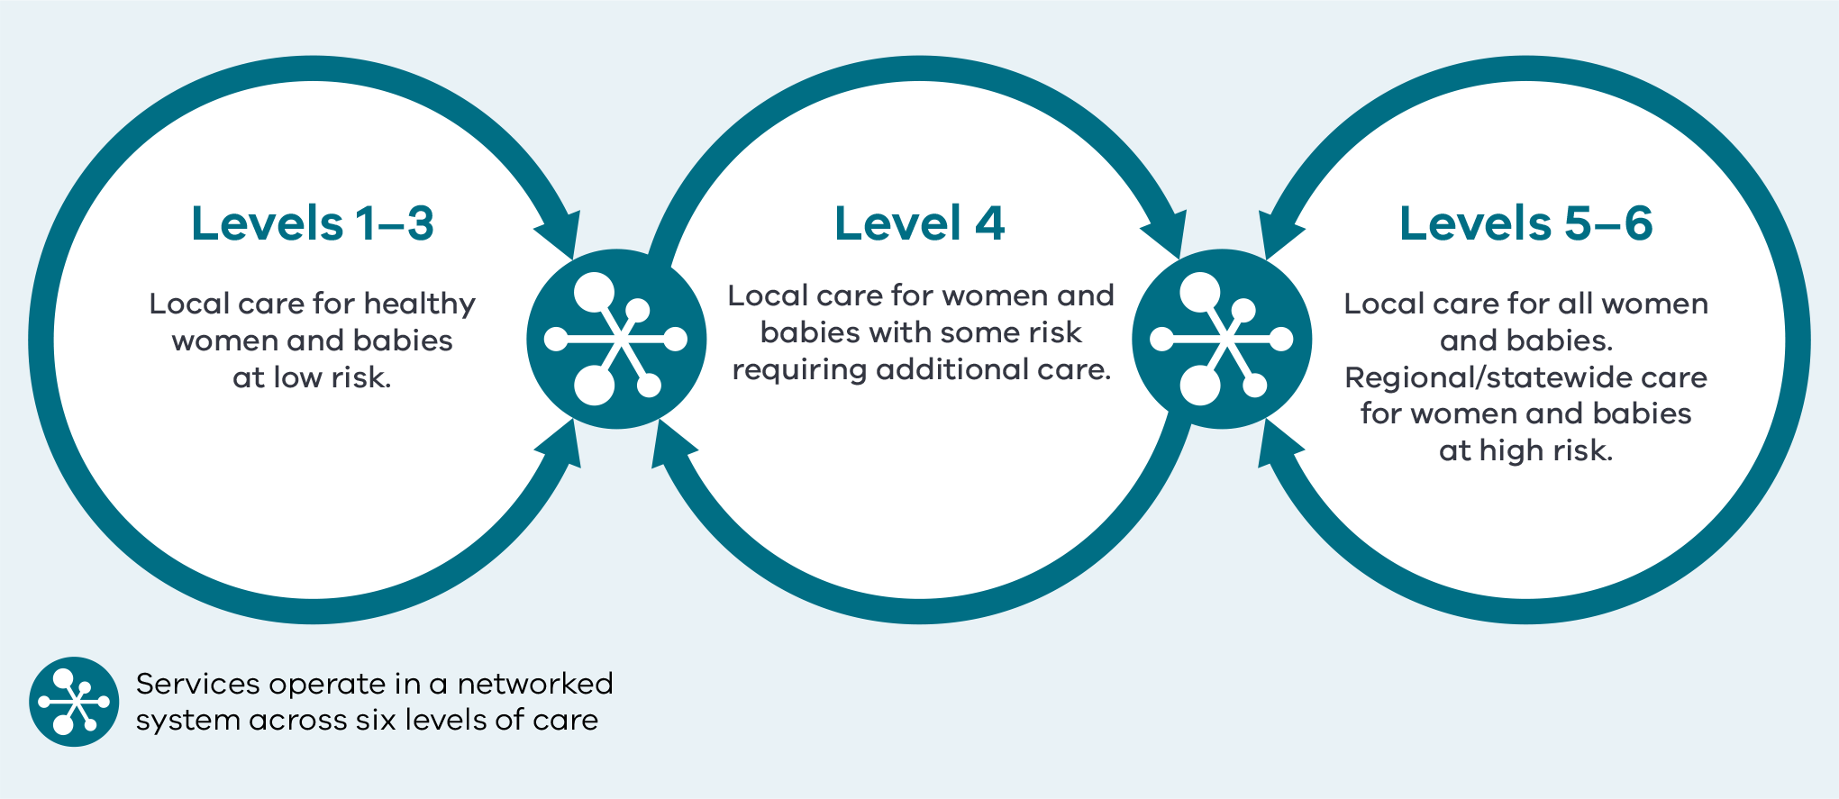
Source: Capability framework for Victorian maternity and newborn services.

Inform quality improvement activities
Analysis provided in this report can guide, inform and help you prioritise local audits and evaluations.
To further identify areas to implement improvement programs and measure the impact of your programs, you can share this with your:
- quality and safety, mortality and morbidity, and consumer advisory committees
- clinicians, managers, executive and board.
[Break out box text:

What pregnant women and families need to know
While this report is primarily for perinatal services, we want to make sure women and their families can read and understand it too.
Look out for this icon. It represents important information pregnant women need to know about each indicator. We’ve also included a list of terminology at page 119.
Please speak to your maternity service if you want more information about their results.
End of break out box text.]

Summary of results

Where we are getting better
Compared with previous years, the following indicators have improved in 2020.

Indicator 1a: Induction of labour
The statewide rate of induction of labour in standard primiparae has decreased by more than three percentage points from 17.3 per cent in 2019 to 13.9 per cent in 2020. Of note, the rate was 11.3 per cent in 2017. The rate across public hospitals decreased from 11.8 per cent in 2019 to 8.1 per cent in 2020. The rate in private hospitals also decreased from 26.5 per cent in 2019 to 23.7 per cent in 2020.
While induction of labour is sometimes necessary, it may increase the need for further intervention. Safely reducing the number of primiparous women who have an induced labour may reduce the number who require interventions during labour and birth.

Indicator 1ci: Rate of third and fourth-degree perineal tears during unassisted vaginal births to primiparae
The rate of third and fourth-degree perineal tears during unassisted vaginal births to primiparae has decreased from 4.2 per cent in 2019 to 3.7 per cent in 2020. The rate across public hospitals was 4.4 per cent in 2019 and 4.3 per cent in 2020. The rate in private hospitals was 1.0 per cent in 2019 and 0.8 per cent in 2020.

Indicator 12b: Maternal vaccination for influenza
For the fourth consecutive year there was an increase in the statewide rate of women vaccinated for influenza (flu) during pregnancy from 74.6 per cent in 2019 to 81.8 per cent in 2020. Vaccination for influenza (flu) during pregnancy has improved over time (53.7 per cent in 2017 to 81.8 per cent in 2020). In public hospitals, this rate increased from 75.8 per cent in 2019 to 82.3 per cent in 2020. In private hospitals, this rate increased from 70.9 per cent in 2019 to 80.7 per cent in 2020.
The influenza vaccine protects pregnant women from infections that can cause serious complications during pregnancy and affect the health of their babies. The ideal immunisation rate is 100 per cent.

Indicator 3: Severe fetal growth restriction
For the fifth consecutive year there was a decrease in the statewide rate of severe fetal growth restricted (FGR) babies undelivered by 40 weeks’ gestation.
The statewide (combined public and private) rate of undetected FGR dropped from 23.0 per cent in 2019 to 20.8 per cent in 2020. In public hospitals, the rate decreased from 22.1 per cent in 2019 to 20.5 per cent in 2020. There was greater improvement in private hospitals with the rate decreasing from 26.4 per cent in 2019 to 21.3 per cent. It should be noted that over the period of 2013 to 2020 there has been significant clinical and statistical improvement in this indicator with the rate reducing from 35.6 per cent in 2013 to 20.8 per cent in 2020.

Where we are doing less well
The following outcomes suggest the need for health services to comprehensively review their practices and then implement and monitor programs to improve performance.

Indicators 1bi and 1bii Caesarean sections in primiparae
The statewide rate of primiparae in Robson group 1 who gave birth by caesarean section after the spontaneous onset of labour (Indicator 1bi) increased slightly from 18.0 per cent in 2019 to 18.3 per cent in 2020. Of note, the rate was 16.4 per cent in 2016. In public hospitals, the rate has changed only slightly from 16.9 per cent in 2019 to 17.0 per cent in 2020. The rate in private hospitals has increased from 22.0 per cent in 2019 to 24.2 per cent in 2020.
The statewide rate of primiparae in modified Robson group 2 who gave birth by caesarean section after induction of labour (Indicator 1bii) also increased from 31.6 per cent in 2019 to 32.3 per cent in 2020. Of note, the rate was 31.0 per cent in 2016. In public hospitals, the rate was 31.2 per cent in 2019 and 32.2 per cent in 2020. The rate in private hospitals was similar at 33.2 per cent in 2019 and 32.6 per cent in 2020.
Table 1. Summary of statewide public and private maternity hospital rates
Indicator | Statewide 2019 | Statewide 2020 | Statewide public | Statewide private | Least favourable quartile | Most favourable quartile
1a  Rate of induction of labour in standard primiparae | 17.3% | 13.9% | 8.1% | 23.7% | 20.0% | 4.0%
1bi  Rate of caesarean section in Robson group 1 | 18.0% | 18.3% | 17.0% | 24.2% | 24.4% | 13.7%
1bii  Rate of caesarean section in modified Robson group 2 | 31.6% | 32.3% | 32.2% | 32.6% | 40.2% | 26.2%
1ci  Rate of third and fourth-degree perineal tears during unassisted vaginal births to primiparae | 4.2% | 3.7% | 4.3% | 0.8% | 3.6% | 0.0%
1cii  Rate of third and fourth-degree perineal tears during assisted vaginal births to primiparae | 5.6% | 5.4% | 6.4% | 2.6% | 7.6% | 1.2%
1di  Rate of primiparae who received an episiotomy during unassisted vaginal births | 27.7% | 27.5% | 27.3% | 30.4% | 31.3% | 16.4%
1dii  Rate of primiparae who received an episiotomy during assisted vaginal births | 84.0% | 86.4% | 90.8% | 73.2% | 75.6% | 91.8%
2  Rate of term babies without congenital anomalies who required additional care*† | 8.1% | NA | 11.7% | NA | 15.8%^ | 8.0%^
3  Rate of severe fetal growth restriction in a singleton pregnancy undelivered by 40 weeks | 23.0% | 20.8% | 20.5% | 21.3% | 25.4%^ | 15.4%^
4a  Rate of women who planned a vaginal birth after a primary caesarean section | 22.3% | 22.9% | 27.8% | 11.2% | 10.7% | 30.3%
4b  Rate of women who achieved a planned vaginal birth after a primary caesarean section | 53.2% | 52.2% | 52.5% | 48.8% | 45.3% | 63.5%
5  Five-year gestation standardised perinatal mortality ratio (GSPMR) for babies born at ≥ 32 weeks | 1.0 | 1.0 | NA | NA | NA | NA
6a  Rate of maternal readmissions during the postnatal period† | 2.6% | 2.3% | 2.5% | 1.7% | 3.1% | 1.5%
6b  Rate of newborn readmissions during the postnatal period*† | 4.1% | NA | 4.6% | NA | 5.4% | 2.7%
7  Rate of smoking cessation during pregnancy | 28.0% | 33.5% | 32.6% | 64.0% | 23.3%^ | 41.5%^
8a  Rate of breastfeeding initiation for babies born at ≥ 37 weeks’ gestation | 95.9% | 95.6% | 95.4% | 95.9% | 92.6% | 97.0%
8b  Rate of use of infant formula in hospital by breastfed babies born at ≥ 37 weeks’ gestation | 30.0% | 30.5% | 27.8% | 40.5% | 35.2% | 18.5%
8c  Rate of final feed being taken directly from the breast by breastfed babies born at ≥ 37 weeks’ gestation | 73.4% | 73.1% | 75.0% | 65.8% | 70.7% | 85.6%
9  Rate of women attending their first antenatal visit prior to 12 weeks’ gestation | 65.9% | 73.6% | 70.1% | 86.5% | 71.2% | 88.5%
10  Rate of term babies without congenital anomalies with an Apgar score < 7 at five minutes | 1.3% | 1.2% | 1.3% | 0.8% | 1.6% | 0.7%
11a  Rate of women who felt involved, as much as they wanted to be, in decisions about their care during labour and birth* | NA | NA | 81.4% | NA | 79.7%^ | 86.3%^
11b  Rate of women who felt that midwives and other health professionals gave them consistent advice about feeding their baby* | NA | NA | 49.2% | NA | 47.2%^ | 61.5%^
12a  Rate of women vaccinated for pertussis during pregnancy | 83.8% | 84.3% | 91.1% | 60.7% | 89.5% | 96.5%
12b  Rate of women vaccinated for influenza during pregnancy | 74.6% | 81.8% | 82.3% | 80.7% | 77.8% | 87.6%
13  Rate of women with severe postpartum haemorrhage | 2.5% | 2.6% | 3.0% | 1.1% | 3.1% | 0.8%
Notes:
Quartiles are calculated for statewide public and private health services combined, unless stated otherwise.
* Result includes public hospitals only
† Results shown are for 2019–20, 2020–21 FY as they are sourced from the VAED
^ Results include hospitals that meet thresholds only
NA – not applicable

1a: Induction of labour in standard primiparae
Induction of labour is defined as the stimulation of the process of cervical effacement / dilatation and uterine contractions during pregnancy before labour begins on its own with the aim of achieving a vaginal birth. A clinician may recommend induction of labour for various reasons when there is concern for the health of the mother or fetus. Victorian data indicates that induction of labour may increase the need for additional interventions including caesarean section (refer to Indicator 1bii).

About this indicator
This indicator shows the rate of induction of labour for the standard woman giving birth to her first child (primipara).
Excluding women with complicated pregnancies, this indicator considers patient complexity and compares between low-risk women at all hospitals. These women are expected to need little intervention.

Observations on the data
Like previous years, the rate in 2020 of standard primiparae having an induced labour in private hospitals was higher compared to public hospitals (23.7 per cent and 8.1 per cent respectively).
The statewide rate for 2020 was 13.0 per cent, which is more than four percentage points lower than last year’s rate which was 17.3 per cent. Of note, the rate was 11.3 per cent in 2017.
Like the previous year’s results, there was considerable variation in hospital rates for this indicator, from 0 to 48.1 per cent (Figure 3). Individual health services should consider their own data and reflect on their own practice for improvement.
[Break out box text:

What pregnant women and families need to know
Inducing, or bringing on labour is sometimes necessary. However, if you are healthy and having a normal first pregnancy, you will usually not require induction. Inducing labour for what we consider to be ‘low-risk’ births may lead to health problems that need help from doctors and midwives. The graph on the following page shows there is a big difference between Victorian hospitals in how many low-risk, first time mothers have labour induced.
End of break out box text.]
Figure 3. Indicator 1a: Rate of induction of labour in standard primiparae, 2020
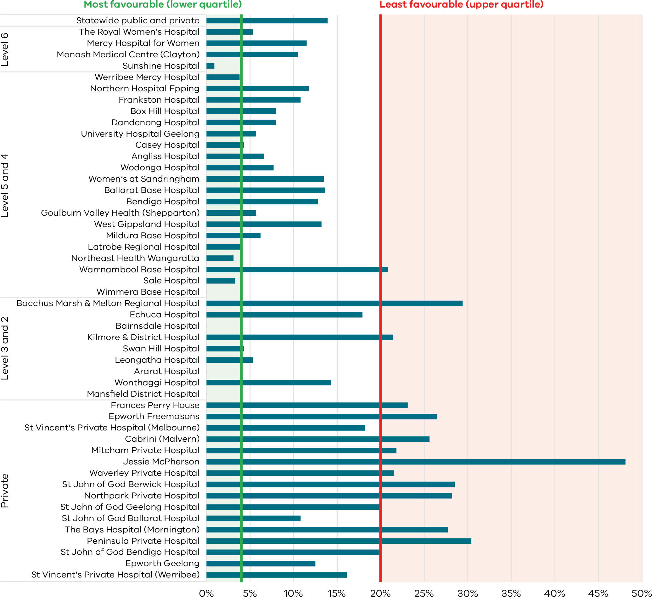
Figure 4. Funnel plot of the rate of induction of labour in standard primiparae, 2020
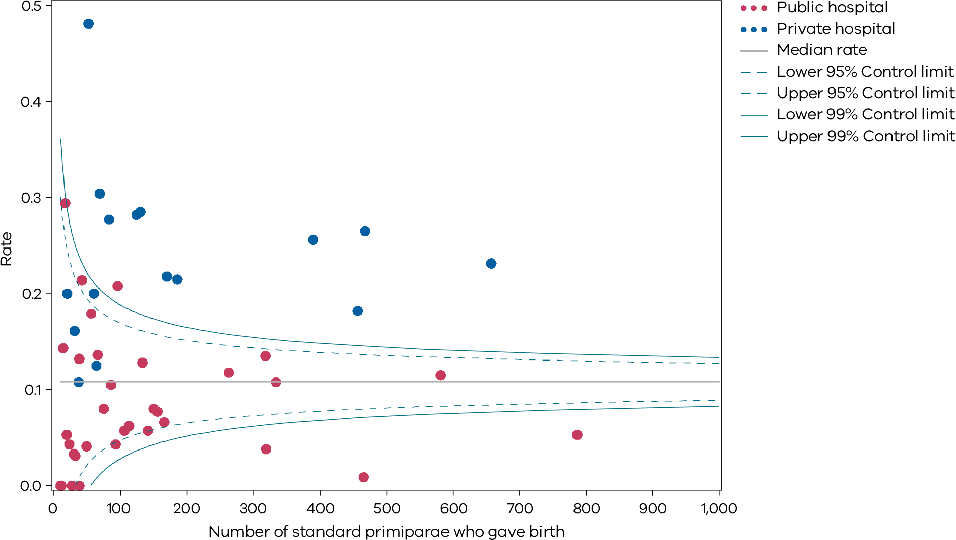
Please refer to page 9 for a guide on how to interpret funnel plots.
Table 2. Rate of induction of labour in standard primiparae, 2017–20
 | 2017 | 2018 | 2019 | 2020
Public | 7.4% | 9.4% | 11.8% | 8.1%
Private | 18.1% | 21.1% | 26.5% | 23.7%
Combined | 11.3% | 13.6% | 17.3% | 13.9%

Definitions and data sources
The standard primipara in this indicator is defined as a woman, 20 to 39 years of age, free of obstetric and specified medical complications (pre-existing hypertension, diabetes, cardiac disease or serious psychiatric conditions), giving birth for the first time with a singleton pregnancy between 37 and 40 weeks completed gestation (259–286 days), with a non-small for gestational age (greater than tenth centile) infant and a cephalic presentation.

Data source: Victorian Perinatal Data Collection (VPDC)
Data for this indicator is sourced from the VPDC for the calendar year from 1 January 2020 to 31 December 2020.
This indicator is derived using the following VPDC variables: ‘parity’, ‘maternal age’, ‘plurality’, ‘estimated gestational age’, ‘birth presentation’, ‘obstetric complications-ICD-10-AM code’, ‘maternal medical conditions-ICD-10-AM code’, ‘indication for induction-ICD-10-AM code’, ‘indications for operative delivery-ICD-10-AM code’, ‘birthweight’, and ‘labour type’.
The inclusion criteria for the standard primipara have been reviewed. The upper age limit has been increased to 39 years. The medical conditions that exclude women are now limited to pre-existing hypertension, diabetes, cardiac disease or serious psychiatric conditions (schizophrenia, other psychotic disorders and bipolar disorder). Women are excluded if they have any obstetric conditions recorded in the ‘complications of pregnancy’ or ‘indication for induction’ field (any condition listed in the ‘O’ chapter of ICD-10 that occurs before the onset of labour, but not those related to gestation or spurious labour).
Numerator/denominator
Indicator | Numerator | Denominator
Indicator 1a: Rate of induction of labour in standard primiparae | The number of standard primiparae who give birth undergoing induction of labour | The number of standard primiparae

1b: Caesarean sections in primiparae
Caesarean section is a surgical procedure in which a baby is delivered through an incision in the mother’s abdominal wall and the wall of the uterus. Caesarean sections are recommended when vaginal birth may pose a risk to the mother or baby and are also sometimes carried out for personal or social reasons for maternal request. Although a caesarean section is a relatively safe operation, there is the potential for complications for both mother and baby and an increased risk of complications in future births as well as an increased cost to the healthcare system.

About this indicator
Indicator 1b measures outcomes for women having their first birth (primiparae), either spontaneous or induced (but not by pre-labour, caesarean section). It includes only those that are singleton, presenting head-first, and at least 37 weeks’ gestation. The Robson classification system (also known as the 10-group classification) categorises all women into one of 10 groups that are mutually exclusive and exhaustive based on basic obstetric characteristics (see Appendix 4).
- Indicator 1bi (Robson group 1) considers the proportion of caesarean sections in women whose labour commenced spontaneously.
- Indicator 1bii (modified Robson Group 2) considers the proportion of caesarean sections in women whose labour was induced (but excludes those undergoing pre-labour caesarean).

Observations on the data
The statewide rate of primiparae in Robson group 1 who gave birth by caesarean section (Indicator 1bi) was 18.3 per cent. This is slightly higher compared to the rate in 2019 which was 18.0 per cent. Of note the rate was 16.4 per cent in 2016. The rate was lower across public hospitals (17.0 per cent) than private hospitals (24.2 per cent).
The statewide rate of primiparae in modified Robson group 2 who gave birth by caesarean section (Indicator 1bii) was 32.3 per cent and is less than one percentage point higher compared to the rate in 2019 which was 31.6 per cent. Of note, the rate was 31.0 per cent in 2016. The rate across public hospitals was also lower compared to private hospitals (32.2 and 32.6 per cent respectively).
There was considerable variation between hospitals across the state and within maternity capability levels as shown in Figures 5 and 6 (Indicator 1bi) and Figures 7 and 8 (Indicator 1bii).
[Break out box text:

What pregnant women and families need to know
Caesarean sections can be lifesaving. But if you are healthy and having your baby on time (or ‘at term’, after 37 weeks), and have started labour, you should usually be able to have a vaginal birth. Having a caesarean section (or surgical delivery) will slow your recovery and may increase their chances of needing a caesarean section for your next baby. The graph on the following page shows the rates of caesarean section for healthy first-time mothers having a baby on time. There is a lot of variation between hospitals and the rate for some hospitals is very high. Ideally this should be similar between hospitals.
End of break out box text.]
Figure 5. Indicator 1bi: Rate of caesarean section in Robson group 1, 2020
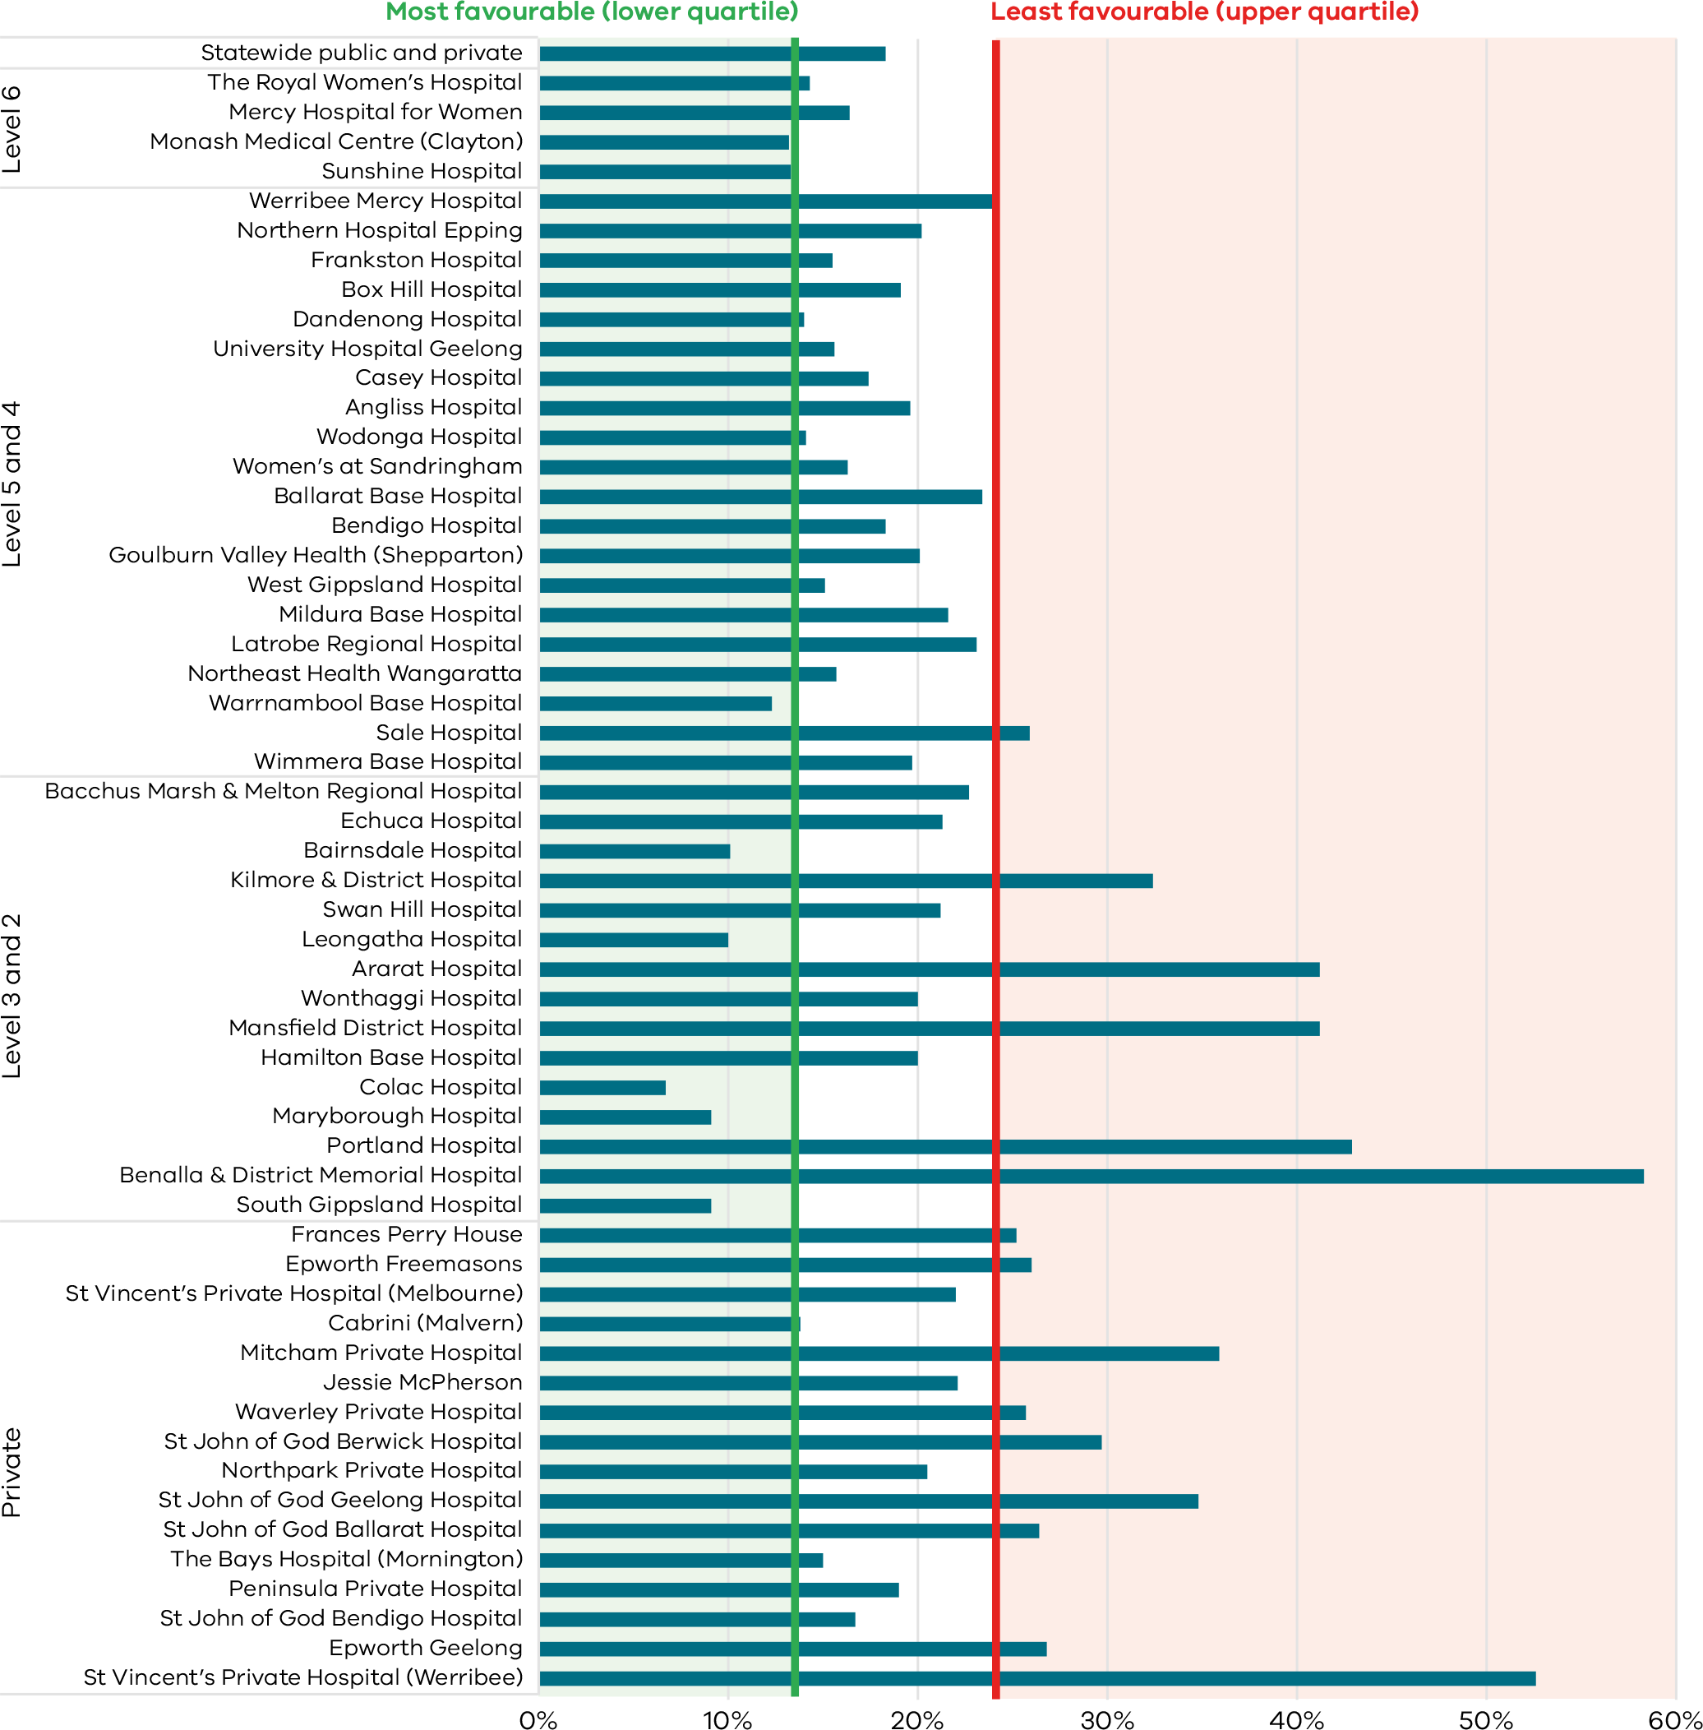
Figure 6. Funnel plot of the rate of caesarean section in Robson group 1, 2020
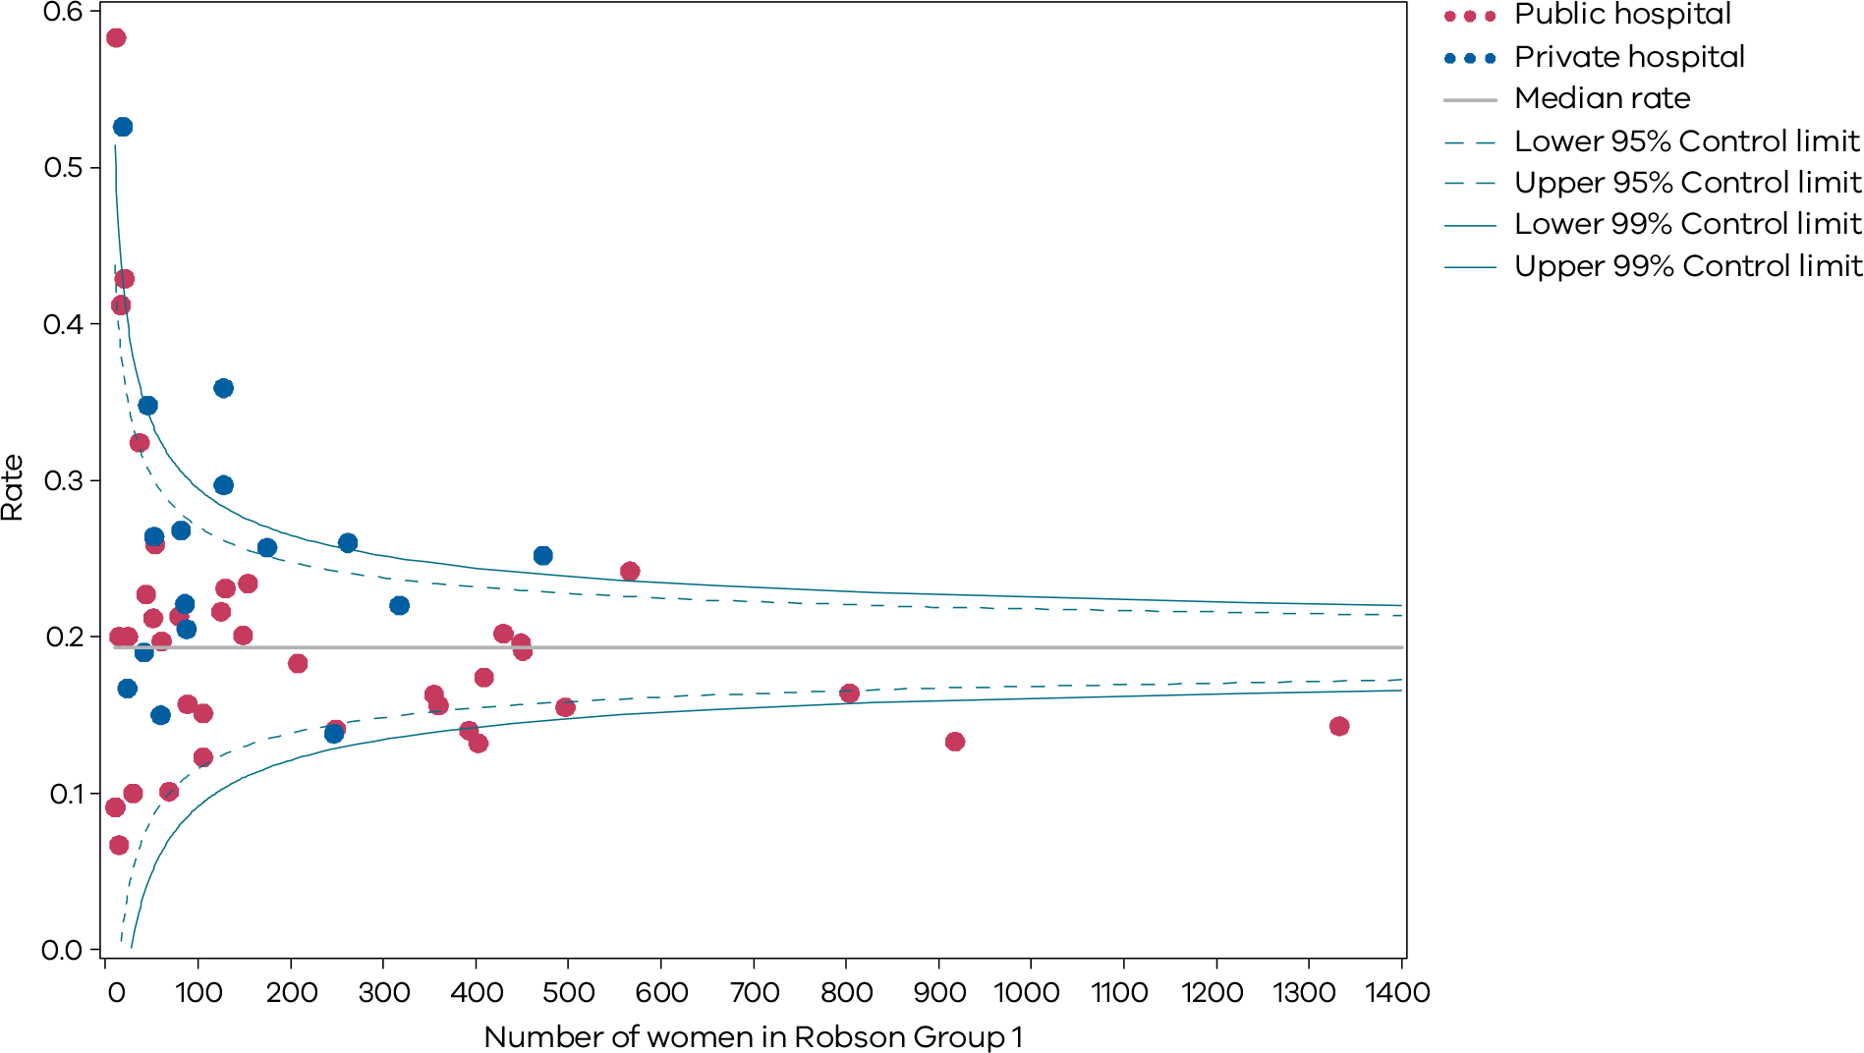
Figure 7. Funnel plot of the rate of caesarean section in modified Robson group 2, 2020
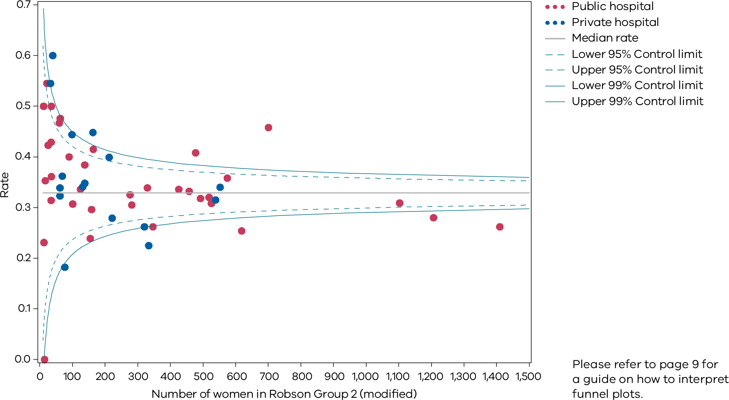
Please refer to page 9 for a guide on how to interpret funnel plots.
Figure 8. Indicator 1bii: Rate of caesarean section in modified Robson group 2, 2020
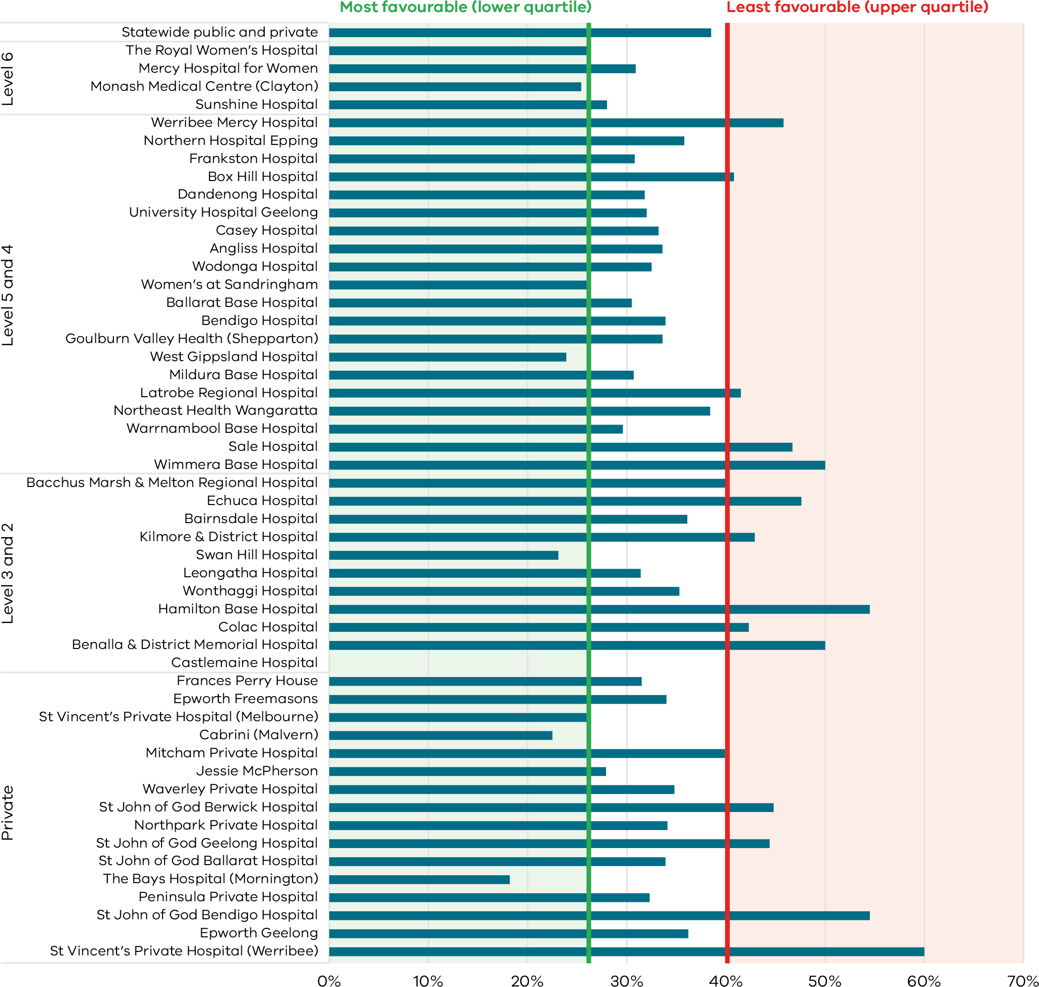
Table 3. Rate of caesarean section in Robson groups 1 and 2, 2017–20
 | Robson Group 1 | Robson Group 1 | Robson Group 1 | Robson Group 1 | Robson Group 2 | Robson Group 2 | Robson Group 2 | Robson Group 2
 | 2017 | 2018 | 2019 | 2020 | 2017 | 2018 | 2019 | 2020
Public | 15.0% | 15.3% | 16.9% | 17.0% | 29.6% | 30.2% | 31.2% | 32.2%
Private | 22.5% | 21.8% | 22.0% | 24.2% | 32.3% | 31.9% | 33.2% | 32.6%
Combined | 16.7% | 16.7% | 18.0% | 18.3% | 30.1% | 30.6% | 31.6% | 32.3%
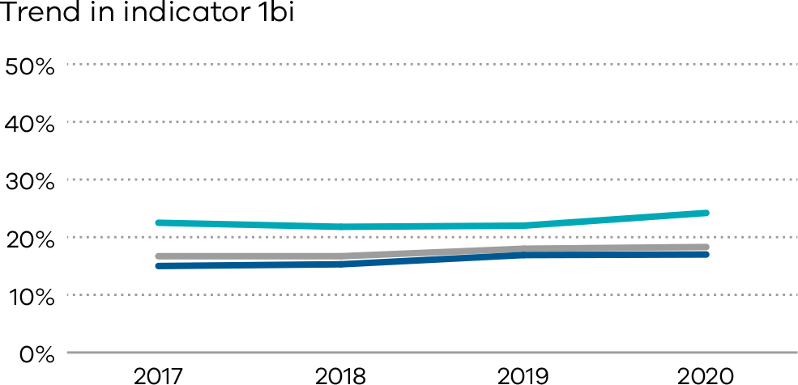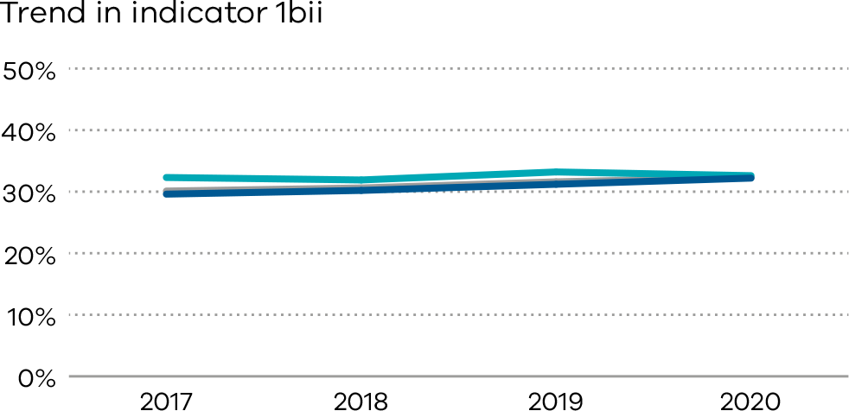

Definitions and data sources
Robson group 1 (Indicator 1bi) includes first-time birthing women with a singleton cephalic pregnancy, at greater than or equal to 37 weeks’ gestation in spontaneous labour.
Modified Robson group 2 (Indicator 1bii) includes women having their first baby with a singleton cephalic pregnancy, at greater than or equal to 37 weeks’ gestation who had labour induced. Modified Robson group 2 excludes pre-labour caesareans, which are included in the standard Robson group 2.

Data source: Victorian Perinatal Data Collection
Data for these indicators are sourced from the VPDC for the calendar year from 1 January 2020 to 31 December 2020.
The indicators are derived using the following VPDC variables: ‘parity’, ‘plurality’, ‘birth presentation’, ‘estimated gestational age’, ‘onset of labour’ and ‘method of birth’.
Numerator/denominator
Indicator | Numerator | Denominator
Indicator 1bi: Rate of caesarean section in Robson group 1 | The number of women giving birth for the first time, with spontaneous onset of labour and a singleton, cephalic-presenting baby born at 37 or more weeks by caesarean section | The number of women giving birth for the first time, with spontaneous onset of labour and a singleton, cephalic-presenting baby born at 37 or more weeks
Indicator 1bii: Rate of caesarean section in modified Robson group 2 | The number of women giving birth for the first time, with induced labour (excluding pre-labour caesarean) and a singleton, cephalic-presenting baby born at 37 or more weeks by caesarean section | The number of women giving birth for the first time, with induced labour (excluding pre-labour caesarean) and a singleton, cephalic-presenting baby born at 37 or more weeks

1c: Perineal tears in primiparae
A perineal tear is a laceration of the skin and other soft tissue structures separating the vagina from the anus. Perineal tears that are classified by grading as third- or fourth-degree tears (severe perineal tears) are a significant birth-related complication that can have long term sequelae. Women having their first vaginal birth are four times more likely to experience a severe perineal tear. There is significant variation of the rate of severe perineal tears between healthcare services in Victoria which may indicate differences in the accuracy of reporting but may also reflect variations in quality of care.
Maternity services that participated in the SCV Better births for women collaborative <https://www.safercare.vic.gov.au/improvement/projects/mbc/better-births> used improvement science methods to introduce an evidence-based bundle of clinical interventions. This bundle of interventions includes practices before, during and after birth to better prevent and recognise severe perineal trauma and reduce the rate of third- and fourth-degree tears and associated sequelae for all women giving birth vaginally.
The new Third and Fourth Degree Perineal Tears Clinical Care Standard <https://www.safetyandquality.gov.au/standards/clinical-care-standards/third-and-fourth-degree-perineal-tears-clinical-care-standard> recognises the significant clinical variation and aims to provide safe and appropriate care.

About this indicator
This indicator shows the rate of third- and fourth-degree perineal tears in women who gave birth for the first time and who had a vaginal birth (with or without the use of instruments).
An assisted (or operative/instrumental) vaginal birth refers to a forceps- or vacuum-assisted birth. Operative intervention in the second stage of labour may be indicated by conditions of the fetus or the mother.
An unassisted vaginal birth is one that occurs without the use of instruments (forceps or vacuum).
- Indicator 1ci refers to unassisted vaginal births
- Indicator 1cii refers to assisted vaginal births.

Observations on the data
The statewide rate of third- and fourth-degree perineal tears in unassisted vaginal births (Indicator 1ci) was 3.7 per cent, a slight decrease from the previous year’s rate of 4.2 per cent. Of note, the rate in 2016 was 4.3 per cent. The rate was higher in public hospitals (4.3 per cent) compared to private hospitals (0.8 per cent).
The statewide rate of third- and fourth-degree tears in assisted vaginal births (Indicator 1cii) was 5.4 per cent, also slightly lower compared to the previous year’s rate of 5.6 per cent. Of note, the rate was 6.2 per cent in 2016. The rate was again higher in public hospitals (6.4 per cent) compared to private hospitals (2.6 per cent).
Figures 9 and 10 (Indicator 1ci) and Figures 11 and 12 (Indicator 1cii) show that there is variation (zero to 25 per cent) between hospitals across the state and within maternity capability levels, also within private hospitals in the rate of third- and fourth-degree perineal tears in both assisted and unassisted vaginal births.

Strategies for improvement
- Health services should review and align current practices with the Third and Fourth Degree Perineal Tears Clinical Care Standard <https://www.safetyandquality.gov.au/publications-and-resources/resource-library/third-and-fourth-degree-perineal-tears-clinical-care-standard>.
- Health services could consider implementing the SCV Perineal protection auditing tool <https://www.safercare.vic.gov.au/improvement/projects/mbc/perineal-protection>.
[Break out box text:

What pregnant women and families need to know
A perineal tear is when the tissue at the opening of the birth canal tears. This is sometimes unavoidable with a vaginal birth, but the doctors and midwives should be doing their best to reduce the chances of a severe tear happening. They might cut an episiotomy to reduce the chance of severe tearing, and to make the opening big enough for the baby to fit through. More severe tears (referred to as third or fourth degree) can result in long term complications if they are not noticed and repaired well. The graphs on the following pages show a big difference between hospitals in how often severe tearing occurs. We aim to have the rate of severe tearing as low as possible, with the results similar between hospitals.
End of break out box text.]
Figure 9. Indicator 1ci: Rate of third- and fourth-degree perineal tears during unassisted vaginal births to primiparae, 2020
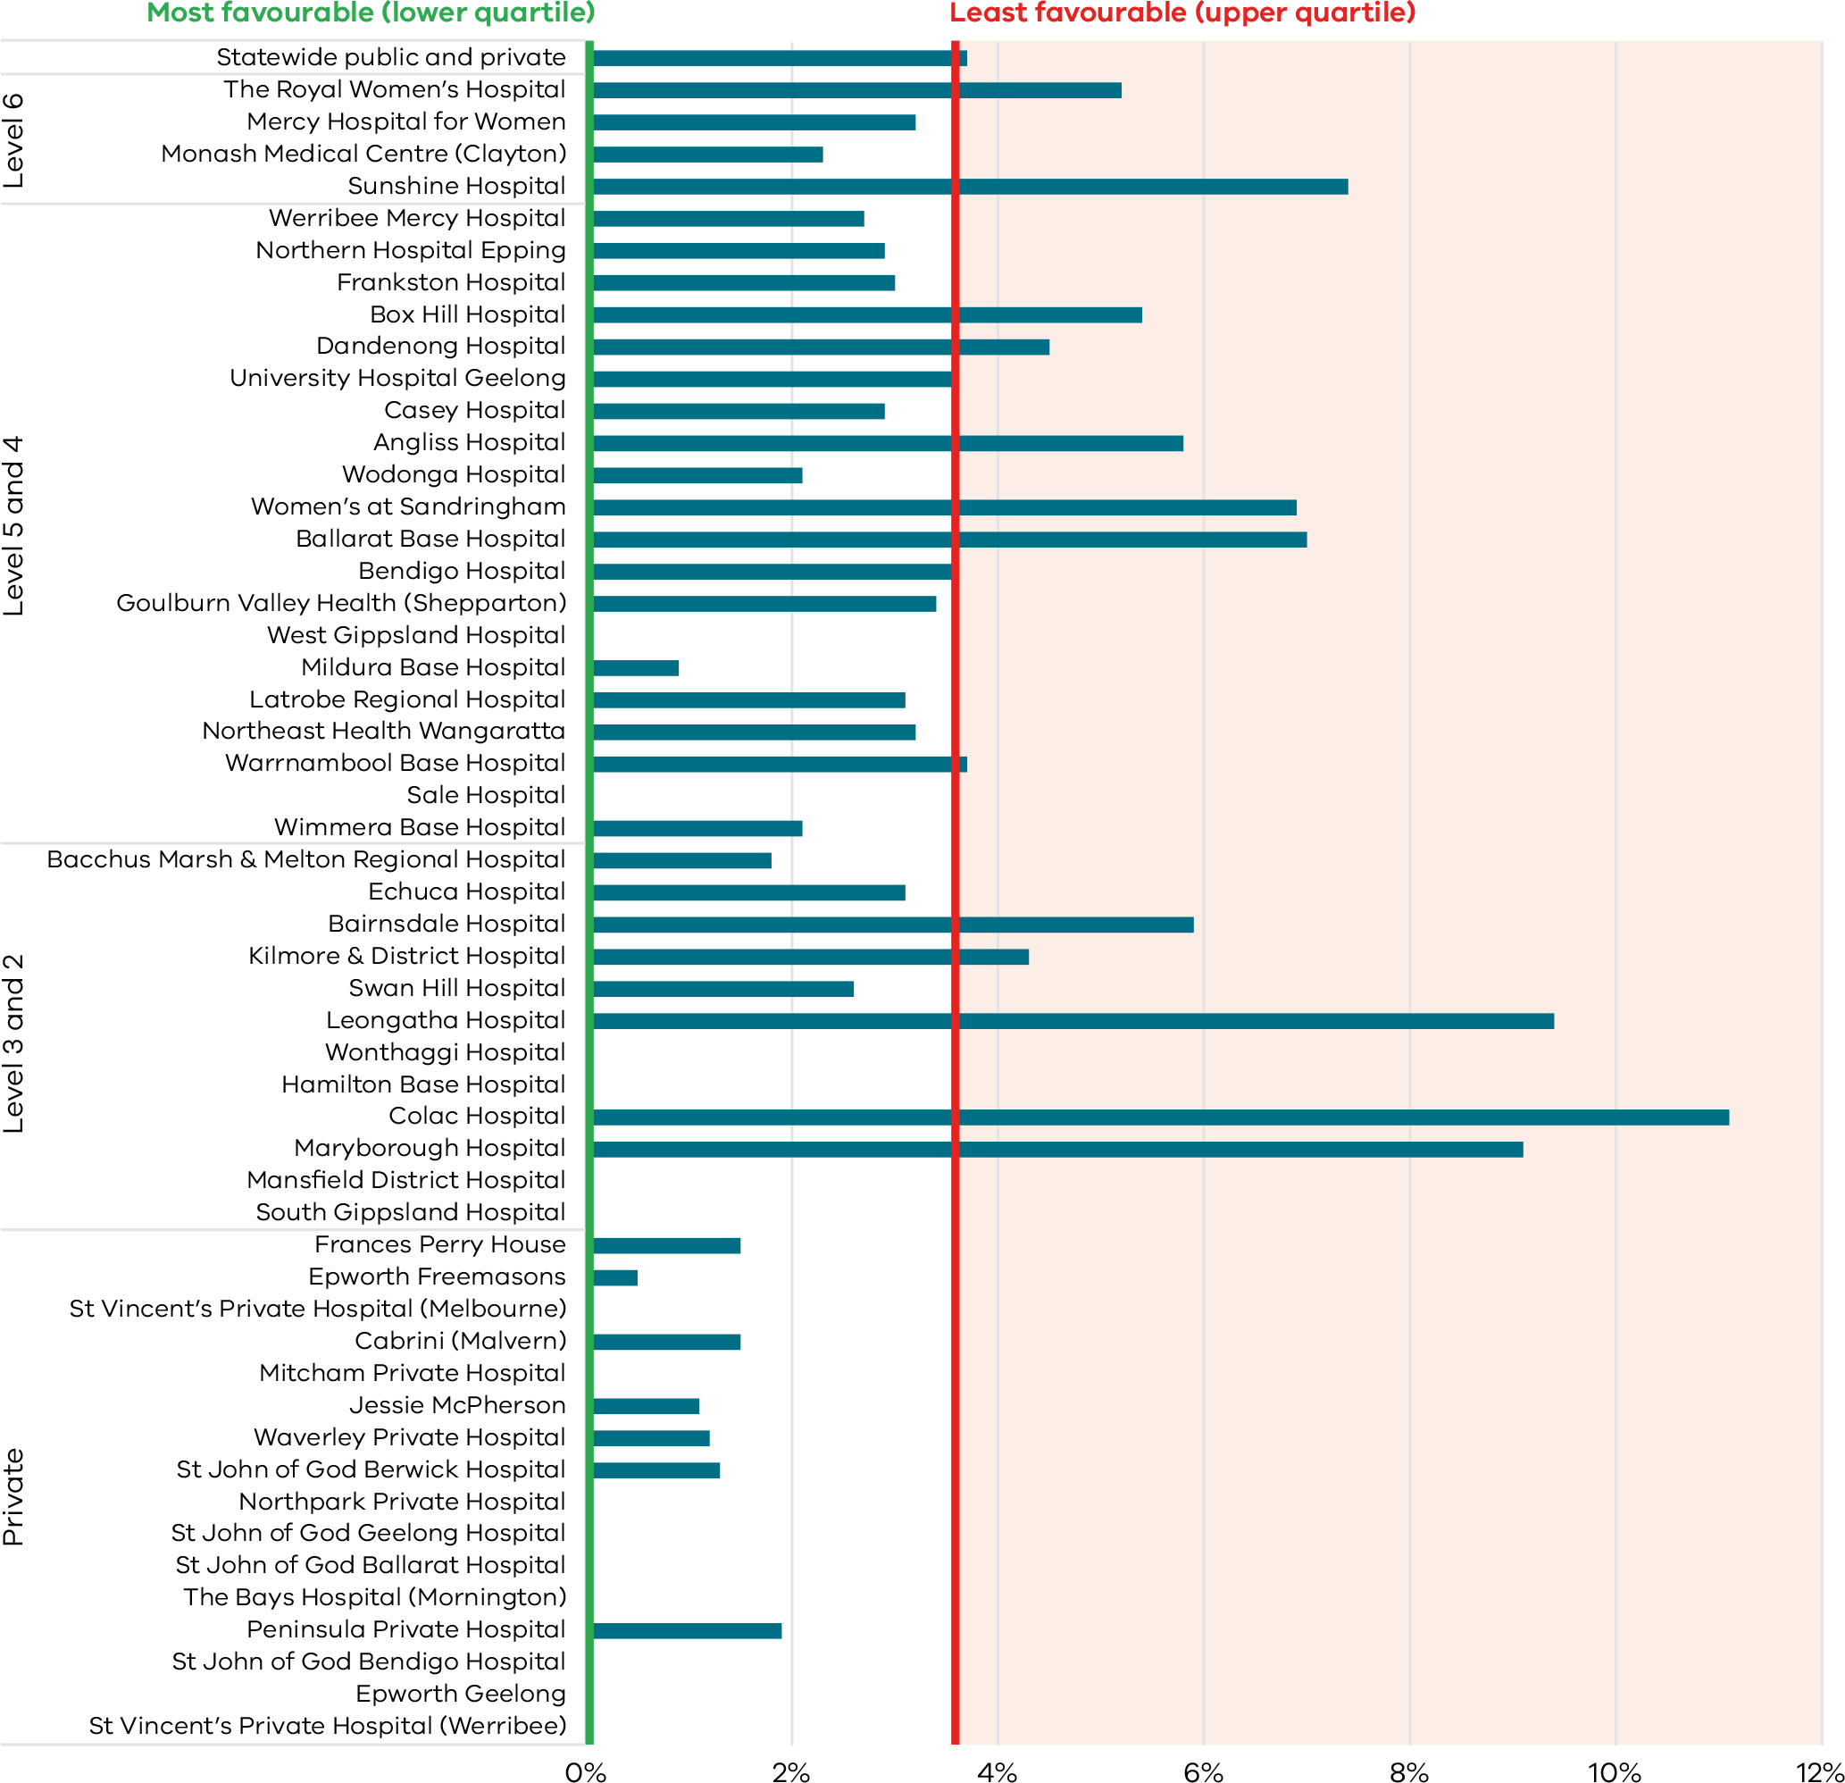
Figure 10. Funnel plot of the rate of third- and fourth-degree perineal tears during unassisted vaginal births to primiparae, 2020
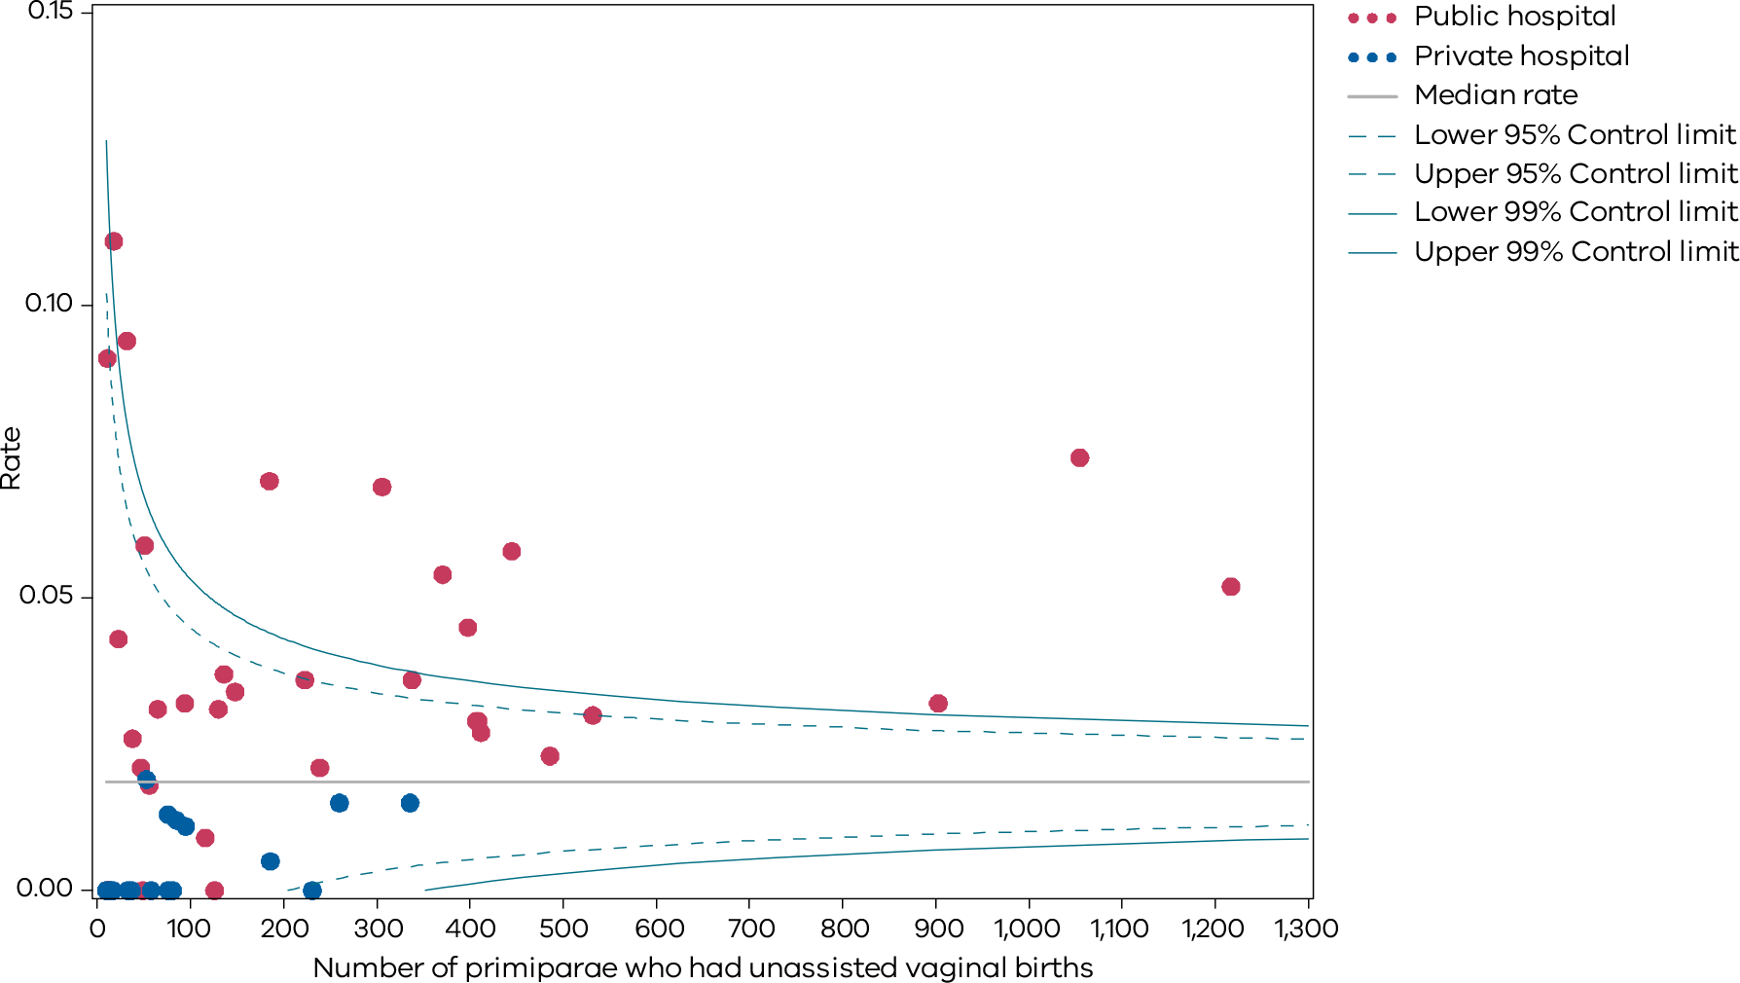
Figure 11. Funnel plot of the rate of third- and fourth-degree perineal tears during assisted vaginal births to primiparae, 2020
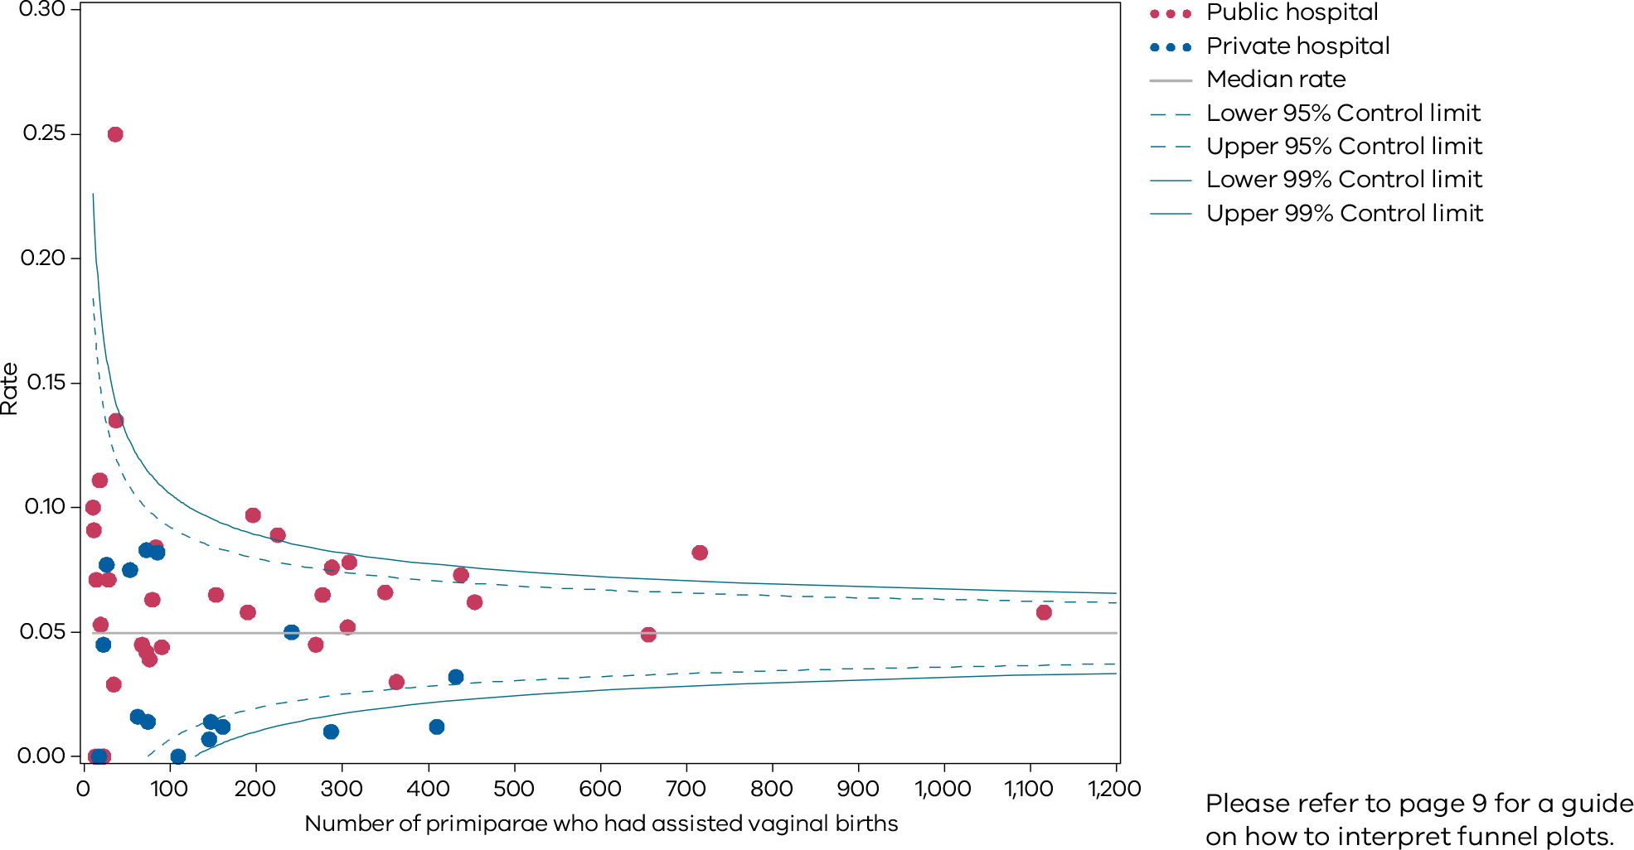
Please refer to page 9 for a guide on how to interpret funnel plots.
Figure 12. Indicator 1cii: Rate of third- and fourth-degree perineal tears during assisted vaginal births to primiparae, 2020
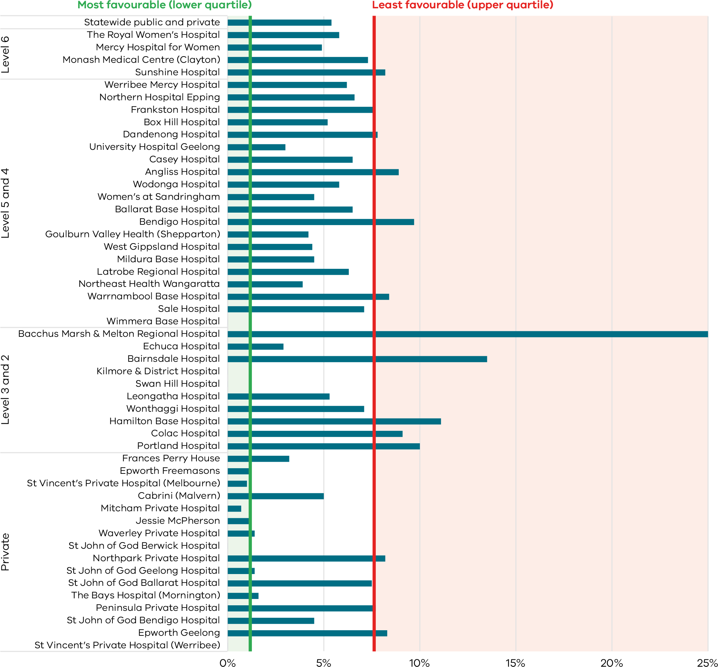
Table 4. Rate of third- and fourth-degree perineal tears, 2017–20
 | During unassisted vaginal births | During unassisted vaginal births | During unassisted vaginal births | During unassisted vaginal births | During assisted vaginal births | During assisted vaginal births | During assisted vaginal births | During assisted vaginal births
 | 2017 | 2018 | 2019 | 2020 | 2017 | 2018 | 2019 | 2020
Public | 3.6% | 4.4% | 4.7% | 4.3% | 5.5% | 6.0% | 6.5% | 6.4%
Private | 1.0% | 1.0% | 1.4% | 0.8% | 2.5% | 2.4% | 2.8% | 2.6%
Combined | 3.2% | 3.8% | 4.2% | 3.7% | 4.7% | 5.0% | 5.6% | 5.4%
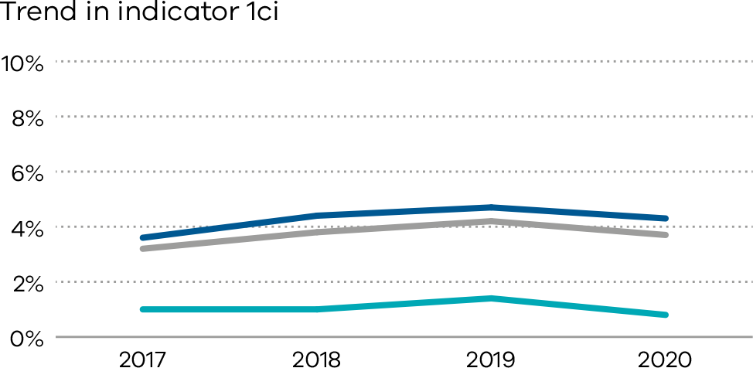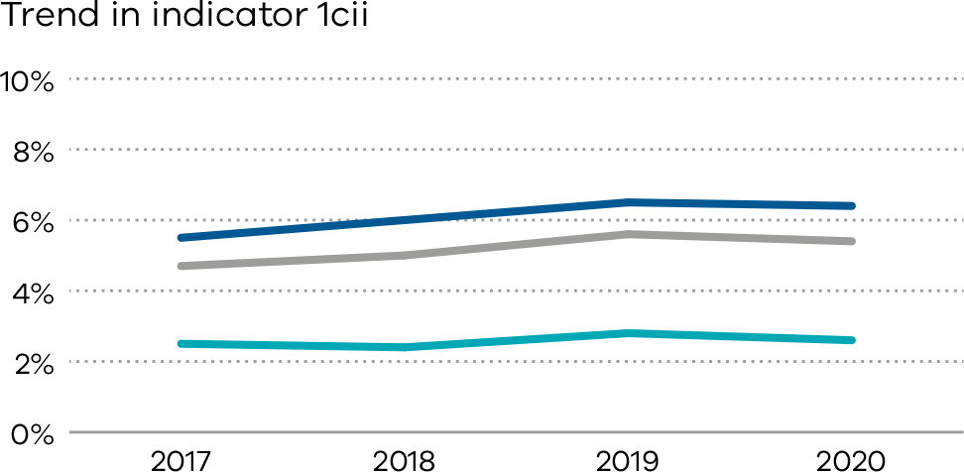

Definitions and data sources
For all primiparae, (i) the proportion who have a third- or fourth-degree perineal tear during an unassisted vaginal birth, and (ii) the proportion who had a third- or fourth-degree perineal tear during an assisted vaginal birth.
Included are those women who gave birth for the first time and had a vaginal birth, with or without instruments. Women who had a multiple birth are included if this was the first time they had given birth.
Excluded are those women who did not give birth for the first time or gave birth by caesarean section.
Third-degree perineal tear means a perineal laceration, rupture or tear also involving anal sphincter, rectovaginal septum and/or sphincter not otherwise specified. Excludes lacerations involving the anal or rectal mucosa.
Fourth-degree perineal tear means a perineal laceration, rupture or tear occurring during delivery, also involving anal mucosa and/or rectal mucosa.
The rates for third- and fourth-degree tears includes episiotomies extended by a laceration of a third- and fourth-degree type.

Data source: Victorian Perinatal Data Collection
Data for these indicators are sourced from the VPDC for the calendar year from 1 January 2020 to 31 December 2020.
Numerator/denominator
Indicator | Numerator | Denominator
Indicator 1ci: Rate of third- or fourth-degree perineal tears during unassisted vaginal births to primiparae | The number of primiparae who had a third- or fourth-degree perineal laceration during an unassisted vaginal birth | The number of primiparae who had an unassisted vaginal birth
Indicator 1cii: Rate of third- or fourth-degree perineal tears during assisted vaginal births to primiparae | The number of primiparae who had a third- or fourth-degree perineal laceration during an assisted (instrumental) vaginal birth | The number of primiparae who had an assisted vaginal birth

1di and 1dii: Episiotomies in primiparae
An episiotomy is a surgical incision made in the perineum – the skin and muscle between the vaginal opening and the anus – during childbirth. Episiotomy is not routinely performed but may be indicated to expedite delivery of the baby as well as to prevent extensive perineal injury including severe perineal tears. Selective use of episiotomy rates need to be considered as a balancing measure against the rate of severe perineal tears.

About this indicator
This indicator shows the rate of episiotomy in primiparae for:
- (1di) unassisted vaginal births
- (1dii) assisted vaginal births.
An episiotomy should only be performed when clinically indicated, such as in an instrumental birth, suspected fetal compromise, or when severe perineal trauma is anticipated.

Observations on the data

2019
The statewide rate of episiotomy in unassisted vaginal births (Indicator 1di) increased from 26.5 per cent in 2018 to 27.7 per cent in 2019.
The statewide rate of episiotomy in assisted vaginal births (Indicator 1dii) increased from 83.1 per cent in 2018 to 84 per cent in 2019.

2020
There was variation between individual hospitals in both unassisted and assisted vaginal births, including those of similar size and capability level (Figures 13 and 16).
The statewide rate of episiotomy in unassisted vaginal births (Indicator 1di) was 27.5 per cent in 2020. The rate was lower in public hospitals (27.3 per cent) than private hospitals (30.4 per cent) (Figure 14).
The statewide rate of episiotomy in assisted vaginal births (Indicator 1dii) was 86.4 per cent in 2020. The rate was higher in public hospitals than private hospitals at 90.8 and 73.2 per cent respectively (Figure 15).

Strategies for improvement
- Health services should refer to the Third and Fourth Degree Perineal Tears Clinical Care Standard <https://www.safetyandquality.gov.au/publications-and-resources/resource-library/third-and-fourth-degree-perineal-tears-clinical-care-standard> which states an episiotomy should be offered to primiparae in assisted vaginal births.
- Provide information (verbal and written) to women regarding the benefits and risks of an episiotomy based on best evidence.
[Break out box text:

What pregnant women and families need to know
Midwives and doctors looking after women in labour will sometimes have to cut the opening of the birth canal (perineum) to make it big enough for the baby to fit through safely. This is called an episiotomy. Midwives and doctors may do this if they think the baby needs to be born quickly or if the mother’s perineum might tear excessively if it isn’t cut. Almost all women having an assisted vaginal birth (forceps or vacuum) need an episiotomy. For healthy first-time mothers having a vaginal birth, the episiotomy rate should be low.
End of break out box text.]
Figure 13. Indicator 1di: Rate of primiparae who received an episiotomy during unassisted vaginal births, 2020
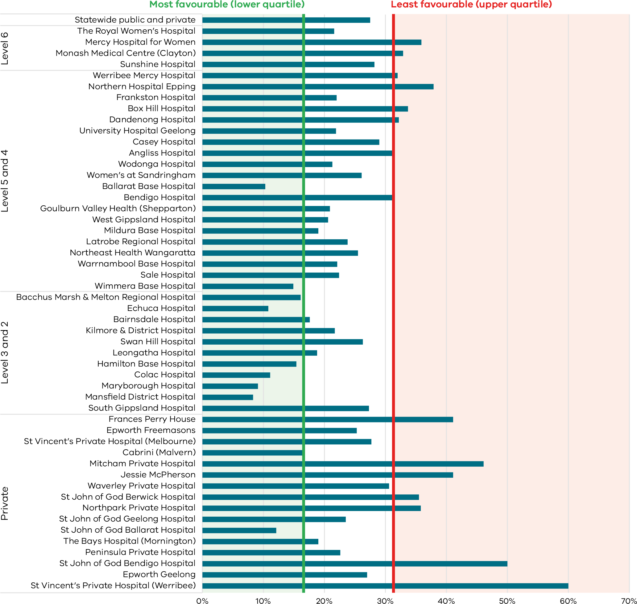
Figure 14. Funnel plot of the rate of primiparae who received an episiotomy during unassisted vaginal births, 2020
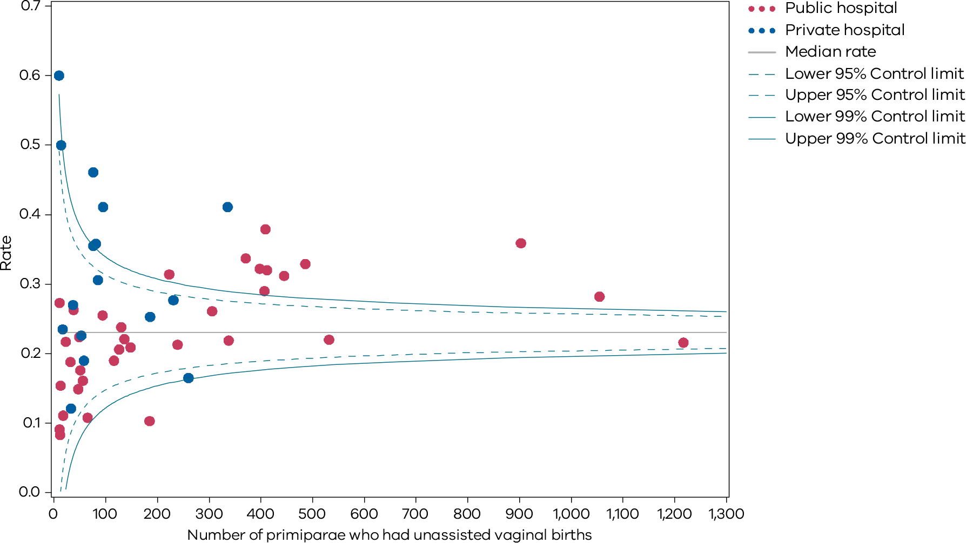
Figure 15. Funnel plot of the rate of primiparae who received an episiotomy during assisted vaginal births, 2020
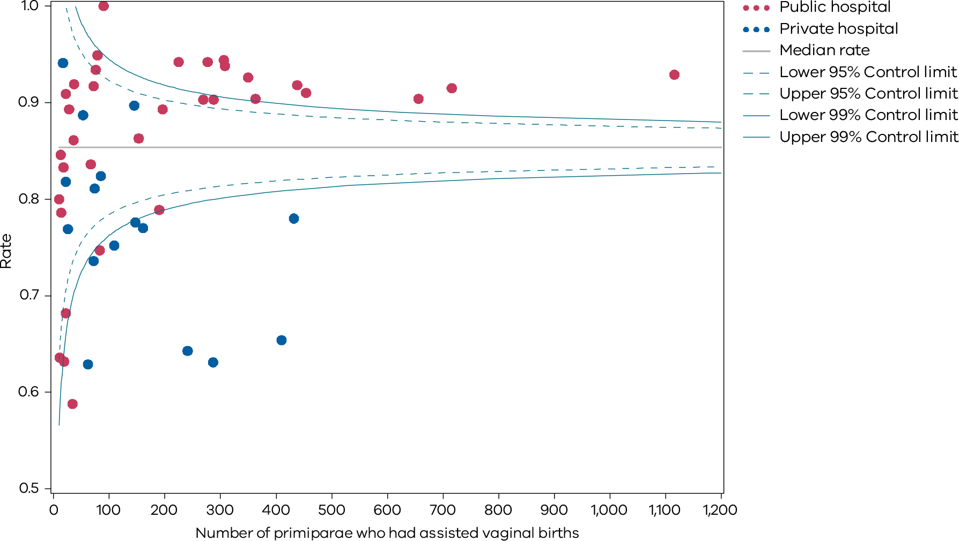
Figure 16. Indicator 1dii: Rate of primiparae who received an episiotomy during assisted vaginal births, 2020
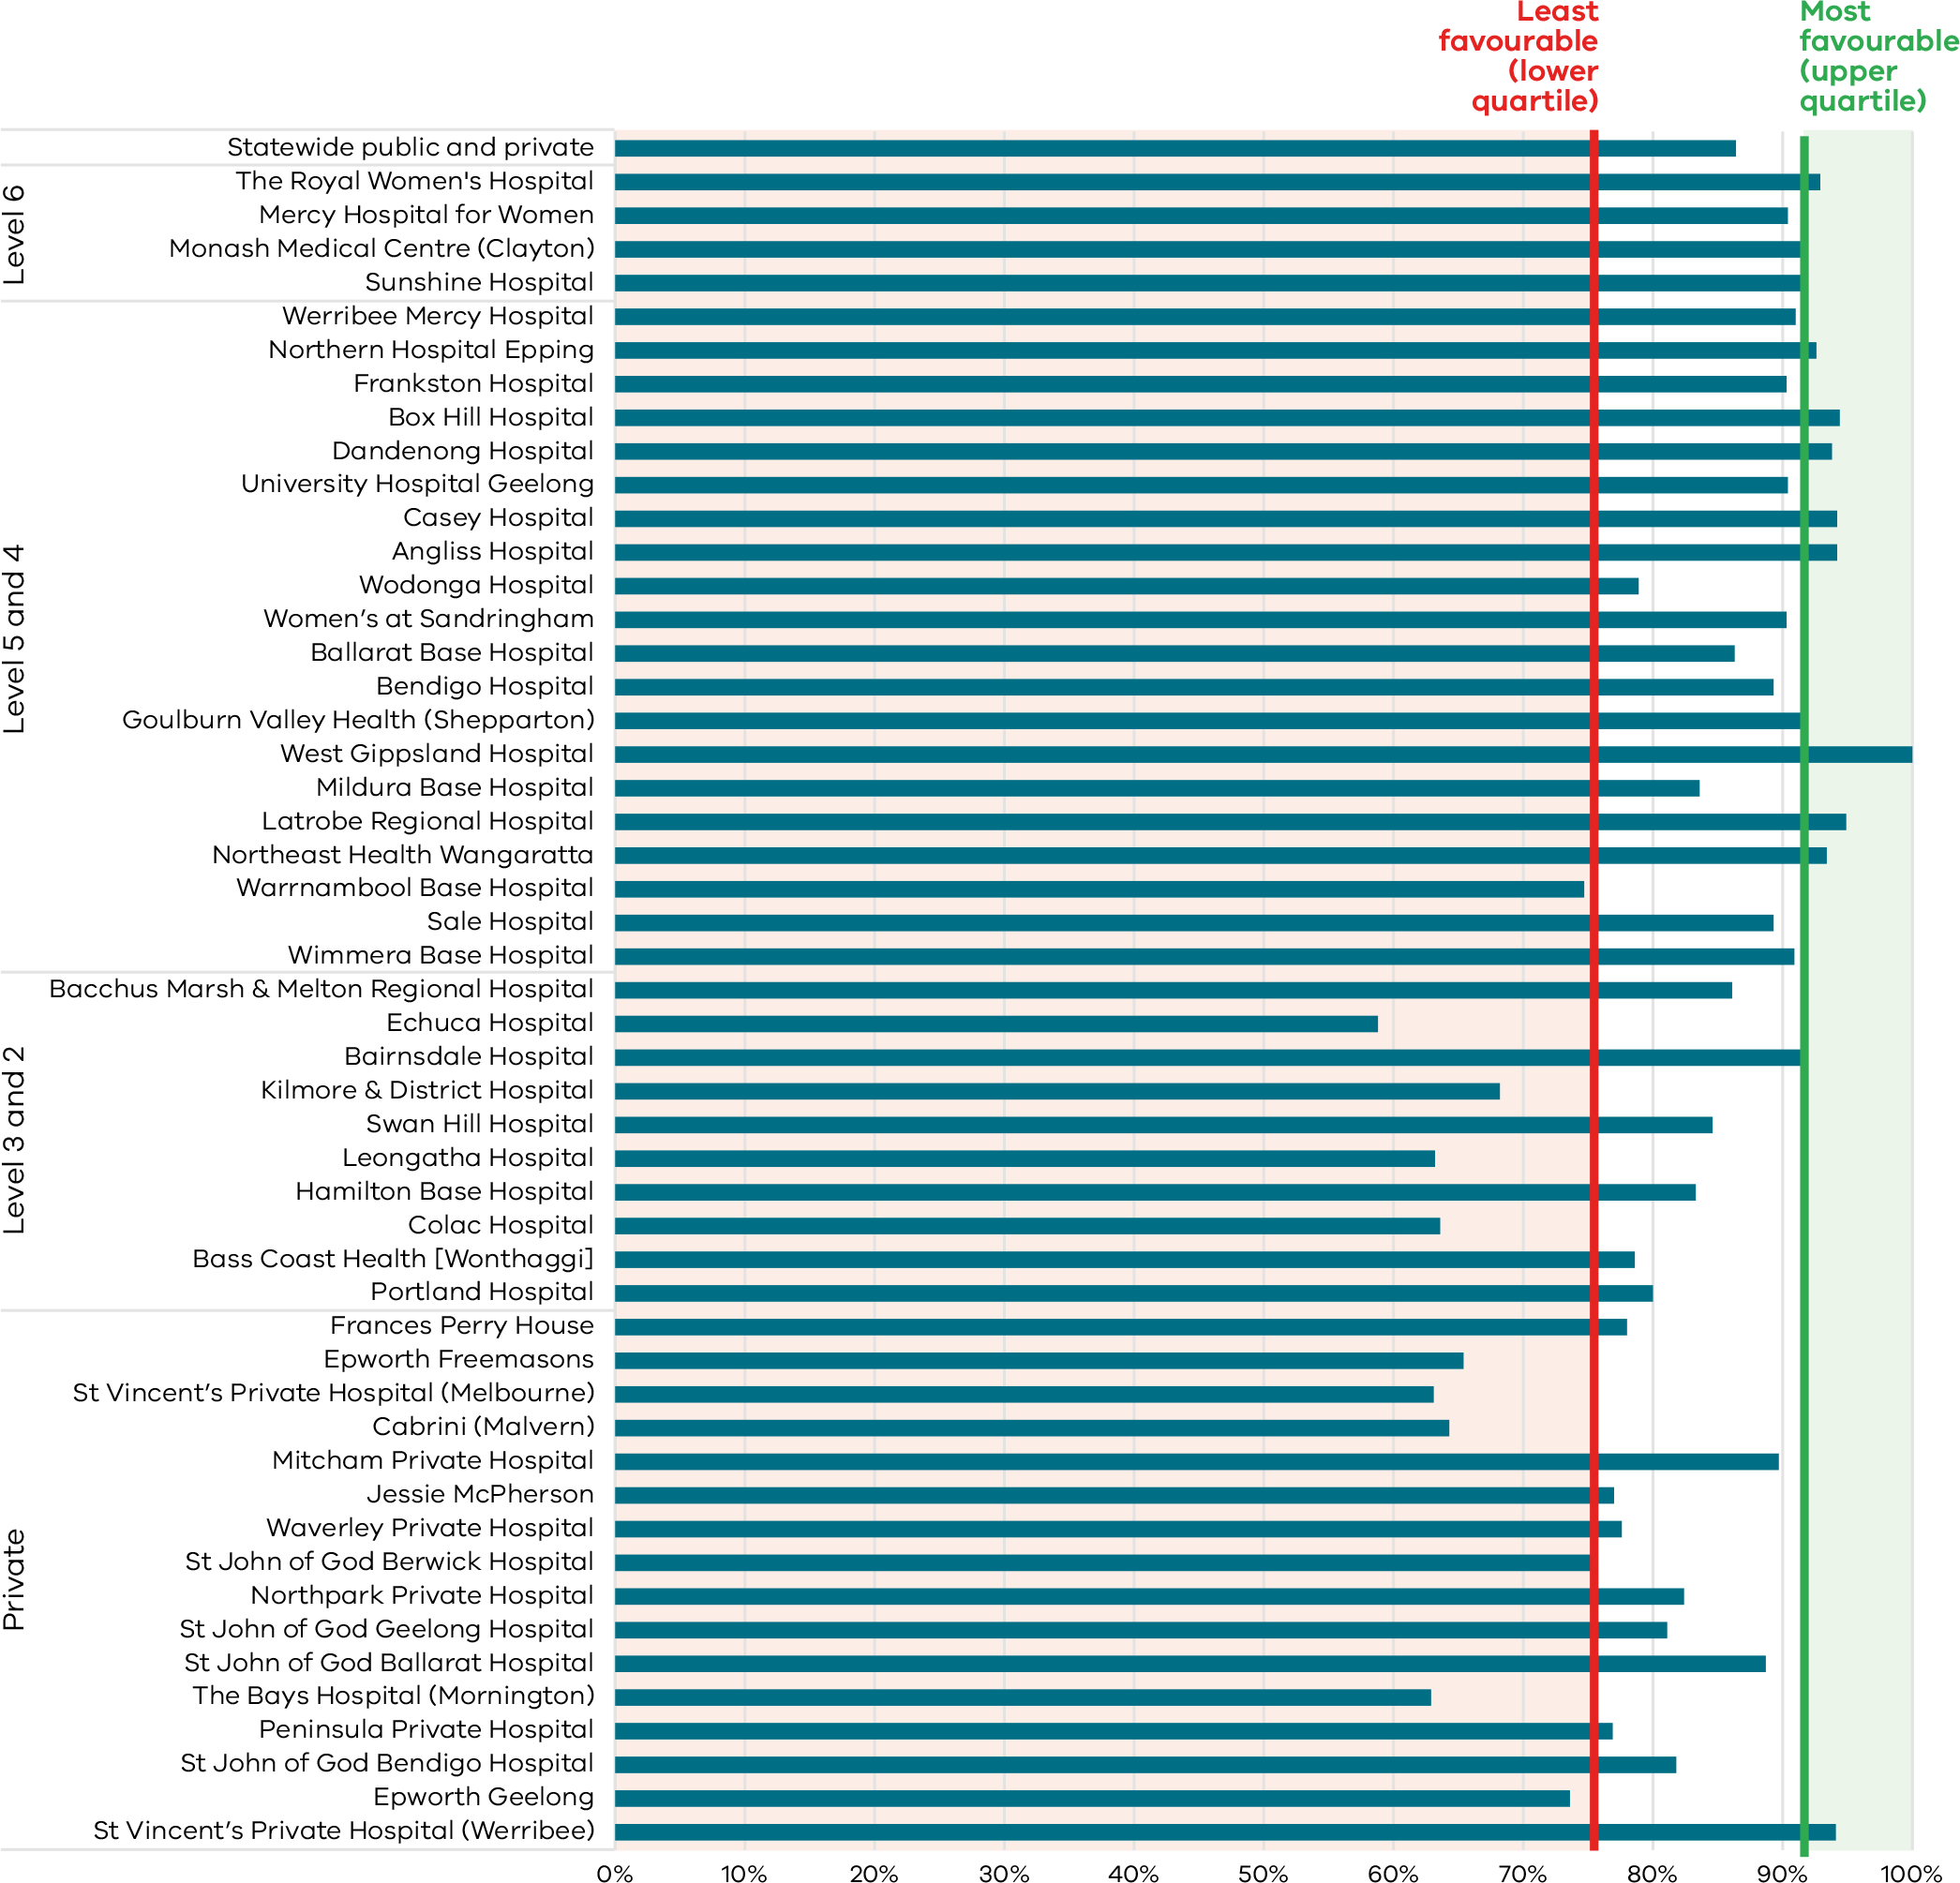
Table 5. Rate of primiparae who received an episiotomy, 2017–2020
 | During unassisted vaginal births | During unassisted vaginal births | During unassisted vaginal births | During unassisted vaginal births | During assisted vaginal births | During assisted vaginal births | During assisted vaginal births | During assisted vaginal births
 | 2017 | 2018 | 2019 | 2020 | 2017 | 2018 | 2019 | 2020
Public | 25.4% | 25.3% | 26.9% | 27.3% | 85.7% | 87.0% | 88.7% | 90.8%
Private | 31.1% | 33.9% | 32.7% | 30.4% | 71.7% | 72.3% | 70.6% | 73.2%
Combined | 26.2% | 26.5% | 27.7% | 27.5% | 81.9% | 83.1% | 84.0% | 86.4%
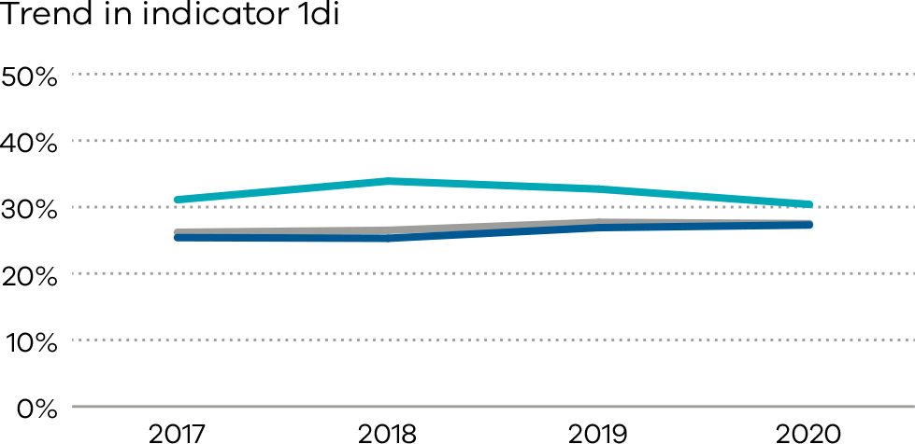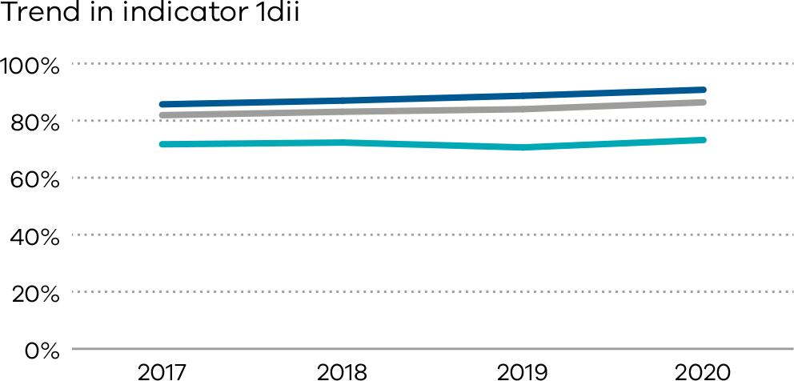

2: Term babies without congenital anomalies who required additional care
Most inborn babies, born at 37 weeks or more, with a birthweight of at least 2500 grams and without the presence of a congenital anomaly are not expected to require additional care following birth. Additional care after birth is more likely if the baby born is Indigenous, of low birth weight or part of a multiple birth, or born to mothers who smoke. As such, the indicator indirectly measures the quality of care provided during pregnancy, labour and birth, and in the early neonatal period.

About this indicator
This indicator aims to highlight variations in the care required for term babies (born at 37 weeks or more) without congenital anomalies (please note, this is only available for public hospitals).
While we know some babies will experience medical conditions following birth that require admission to hospital for additional care (for example, jaundice, low Apgar score, sepsis, seizures), we expect the need for additional care and treatment in this cohort to be low.
Higher rates may indicate quality of care issues during labour, birth and/or the immediate neonatal period.

Observations on the data
The statewide public hospital rate of term babies without congenital anomalies who required additional care in 2020–21 was 11.7 per cent. This has increased since 2019–20 (8.1 per cent). This is the highest rate for this indicator over the past five years (the rate during the previous five years ranged from 8.1 per cent to 9.4 per cent). This unexplainable trend will be closely monitored, and individual health services are encouraged to review locally.
Figures 17 and 18 show variation between hospitals in congenital anomaly rates, ranging from 31.3 per cent to 22.9 per cent.
[Break out box text:

What pregnant women and families need to know
Healthy babies should be kept with their mothers whenever possible therefore this rate should be low.
We measure how many babies we expect to stay with their mother but end up being separated from their mother and admitted to a nursery.
Sometimes this is necessary – for example if the baby develops jaundice or signs of an infection and needs to be treated.
End of break out box text.]
Figure 17. Indicator 2: Rate of term babies without congenital anomalies who required additional care, 2020–21
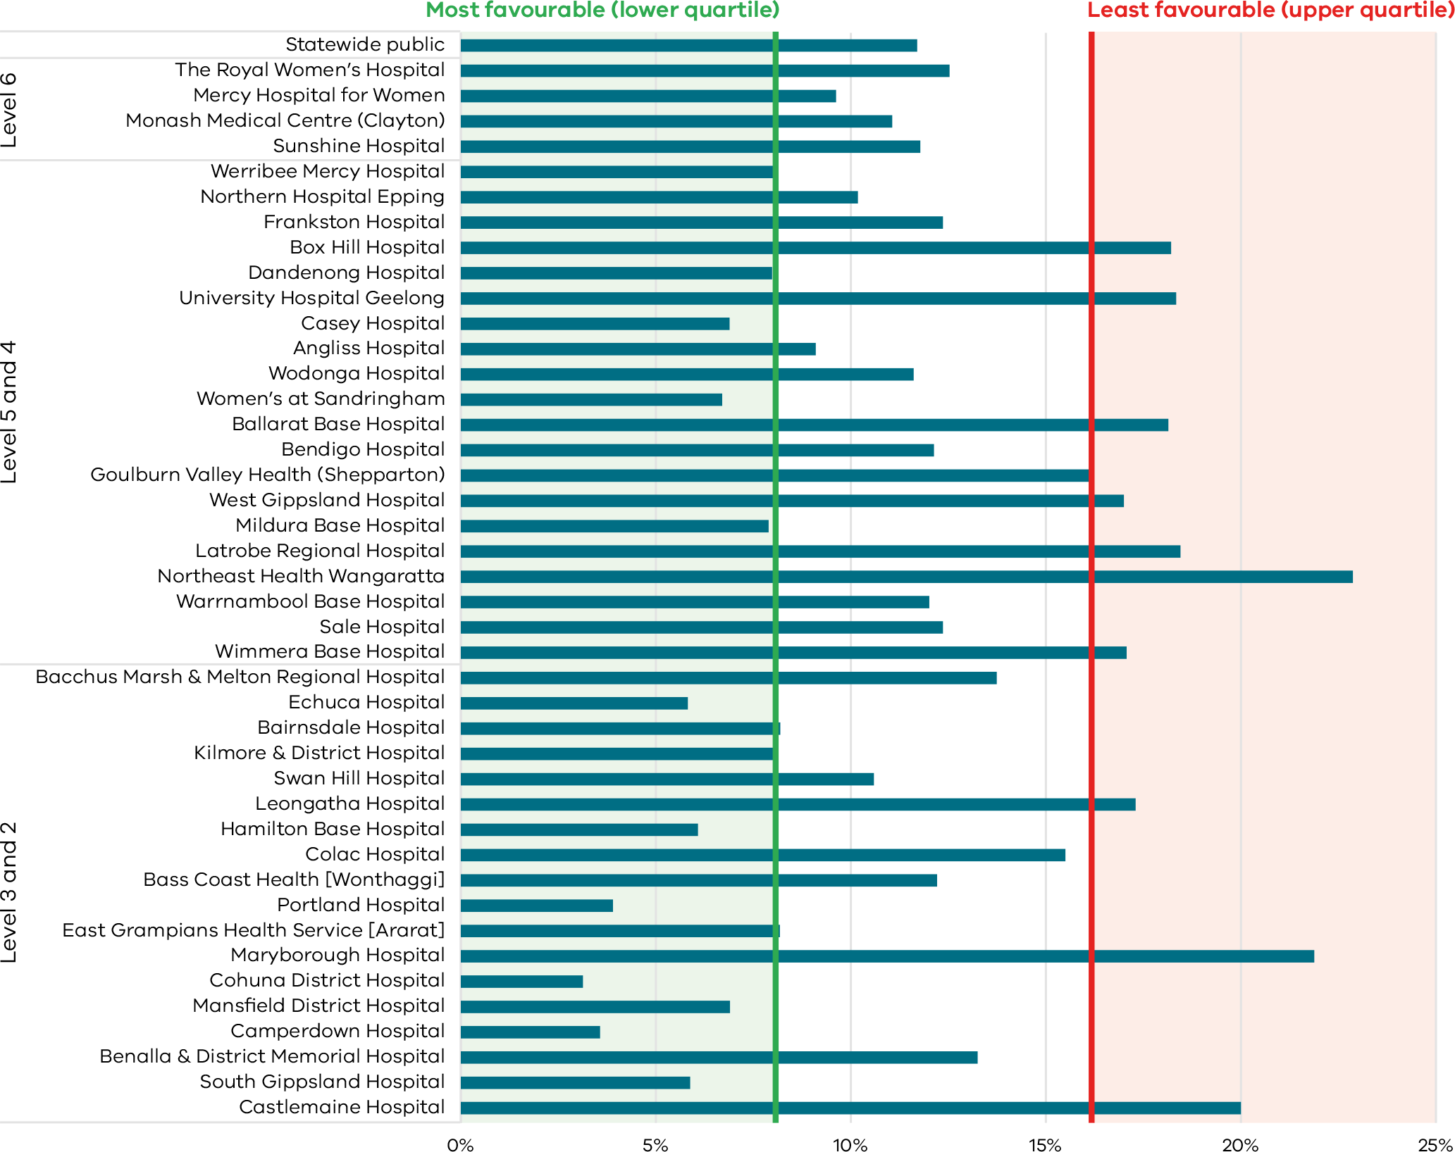
Note: Reporting of unqualified neonate admissions to the VAED for private hospitals is optional. It is therefore not possible to establish an accurate denominator (that includes public and private hospitals) for this indicator. As such, only public hospitals are included in the results.
Figure 18. Funnel plot of the rate of term babies without congenital anomalies who required additional care, 2020–21
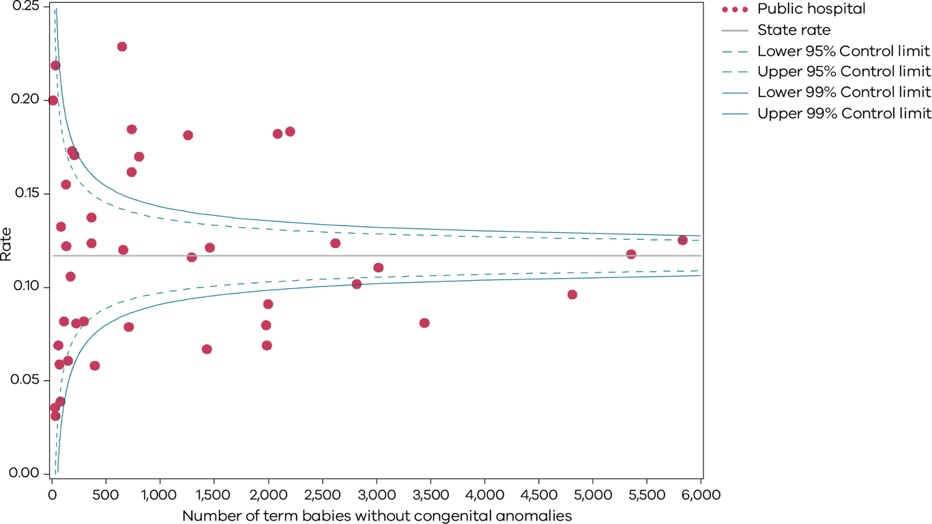
Please refer to page 9 for a guide on how to interpret funnel plots.
Table 6. Rate of term babies without congenital anomalies who required additional care, by financial year, 2017–18 to 2020–21
 | 2017–18 | 2018–19 | 2019–20 | 2020–21
Public | 8.7% | 9.2% | 8.1% | 11.7%
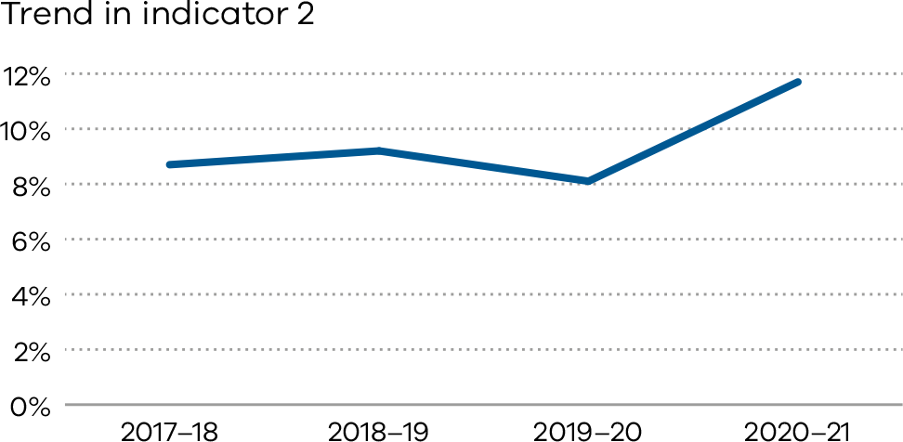

Definitions and data sources
This indicator includes inborn term babies. An inborn term baby is an infant born at the reporting hospital at a gestational age of 37 weeks or more. Term babies without congenital anomalies who require additional care are defined as newborns who:
- are not less than 37 weeks 0 days’ gestation
- weigh not less than 2,500 grams
- are without congenital anomalies
- are grouped to Victorian diagnostic-related groups (VIC-DRGs) representing the need for more than normal care (see list of VIC-DRGs provided below).
Excluded are:
- babies born at another hospital or before arrival
- pre-term newborn babies
- infants with congenital anomalies
- birthweight less than 2,500 grams
- stillborn babies
- readmission (separation not related to the birth episode).
The denominator for the 2020–21 reporting period is episodes grouped to the Version 9.0 VIC-DRGs:
- P68A (v7): Neonate, AdmWt ≥ 2,500g W/O Sig OR Proc ≥ 37 Comp Wks Gest W Mult Major Probs
- P68B (v7): Neonate, AdmWt ≥ 2,500g W/O Sig OR Proc ≥ 37 Comp Wks Gest W Major Problem
- P68C (v7) Neonate, AdmWt ≥ 2,500g W/O Sig OR Proc ≥ 37 Comp Wks Gest W Other Problem
- P68D (v7) Neonate, AdmWt ≥ 2,500g W/O Sig OR Proc ≥ 37 Comp Wks Gest W/O Problem
- P06A Neonate, Admission weight > 2,499g with Significant Operating Room Procedure with Multi Major Problems
- P06B Neonate, Admission weight > 2,499g with Significant Operating Room Procedure without Multi Major Problems
- P60A Neonate, Died or Transferred < 5 days of admission, without Significant Operating Room Procedure, Newborn
- P60B Neonate, Neonate W/O Sig OR Proc, Died or Transferred to Acute Facility Same Day.

Data source: Victorian Admitted Episodes Dataset
Data for this indicator is sourced from the VAED for the financial year from 1 July 2020 to 30 June 2021.
Numerator/denominator
Indicator | Numerator | Denominator
Indicator 2: Rate of term babies without congenital anomalies who required additional care | The number of inborn term babies without birth defects grouped to VIC-DRG P68A, P68B, P68C, P06A, P06B, P60A# and P60B# | The number of inborn term babies without congenital anomalies grouped to VIC-DRG P68A, P68B, P68C, P68D, P06A, P06B, P60A# and P60B#
# All newborns initially grouped to P60A and P60B were regrouped to the next logical VIC-DRG following removal of the separation mode ‘Died or Transferred’ and replaced with the separation mode of ‘Home’. This was done so that only those babies in P60A and P60B who require additional care are counted in the numerator. To include the whole of P60A and P60B in the numerator would overestimate the rate of newborns requiring additional care because some healthy newborns are transferred for other reasons.

3: Severe fetal growth restriction
Birthweight for gestational age is an important indicator of infant health that is used as both an outcome measure for antenatal maternal health and a prognostic indicator for a baby’s health, well-being and development. Fetal growth restriction is associated with increased risks of stillbirth and fetal compromise in labour and being born growth restricted increases an individual’s predisposition to hypertension and diabetes in adulthood.
The timely detection of severe FGR allows appropriate fetal surveillance and timing of birth to optimise short and longer-term outcomes, including reducing the risk of stillbirth. The Safer Baby Collaborative <https://www.safercare.vic.gov.au/improvement/projects/mbc/safer-baby> was a key piece of improvement work being undertaken in some Victorian maternity services, aimed at reducing the rate of stillbirths. The work had a strong focus on FGR, with the evidence-based bundle of interventions including consistent, reliable practices to assess the risk of FGR and screen for, and diagnose, slow or static fetal growth, enabling timely intervention.

About this indicator
This indicator shows the proportion of singleton babies with severe growth restriction who were born at or after 40 weeks’ gestation. Birth after 40 weeks’ gestation suggests that the growth restriction may not have been detected and acted on in a timely way.

Observations on the data
The rate of singleton babies with severe FGR who were born at 40 or more weeks’ gestation in public and private hospitals in 2020 was 20.8 per cent. This is more than two percentage point lower compared to the rate in 2019 which was 23.0 per cent. It is worth noting that the rate for this indicator in public hospitals has been steadily decreasing over the past five years. There has also been a considerable decline in the rate in private hospitals over this period.
The rate was lower in public hospitals (20.5 per cent) compared to private hospitals (21.3 per cent).

Strategies for improvement
- Heath services should ensure guidance and escalation follows the Stillbirth CRE Fetal Growth Restriction Care Pathway <https://resources.stillbirthcre.org.au/elearn/resources/FGR%20Management%20Pathway_V4.pdf>.
- Measure and record Symphysis Fundal Height (SFH) at each pregnancy care visit.
- Monitor and review cases where FGR is recorded.
[Break out box text:

What pregnant women and families need to know
Sometimes babies don’t grow as well as expected during pregnancy. The smallest babies (who we describe as having ‘fetal growth restriction’) are more likely to be sick at birth or sadly die before birth.
Doctors and midwives monitor the growth of babies during a pregnancy. If the baby isn’t growing well they should consider the safest time to deliver the baby – before the due date if the baby is severely growth restricted.
Recognising these very small unborn babies is not always easy. However, we want to see very low rates of these babies being born past their due date.
The graphs below and on the following pages show that over the past three years the rate has decreased.
End of break out box text.]
Figure 19. Indicator 3: Rate of severe fetal growth restriction in a singleton pregnancy undelivered by 40 weeks, 2020
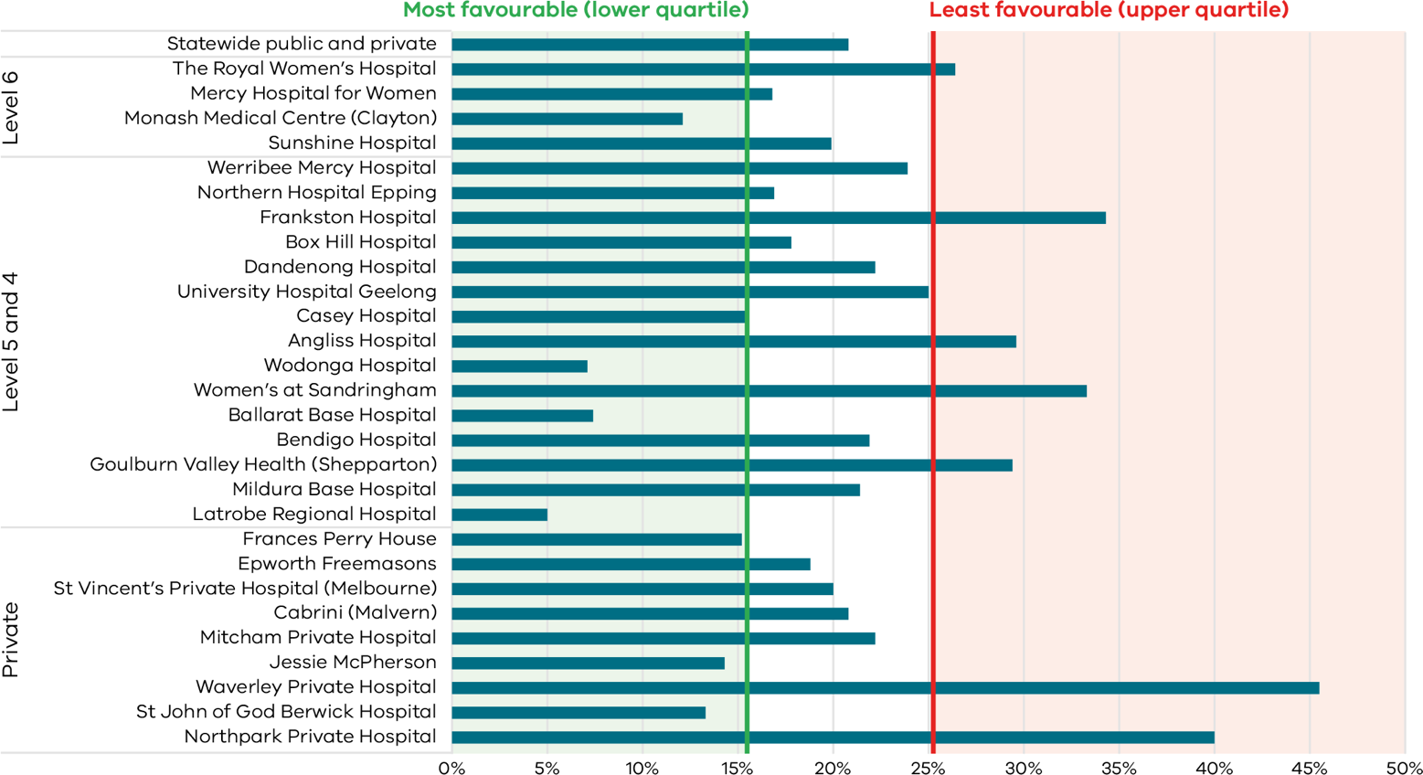
Figure 20. Funnel plot of the rate of severe fetal growth restriction in a singleton pregnancy undelivered by 40 weeks, 2020
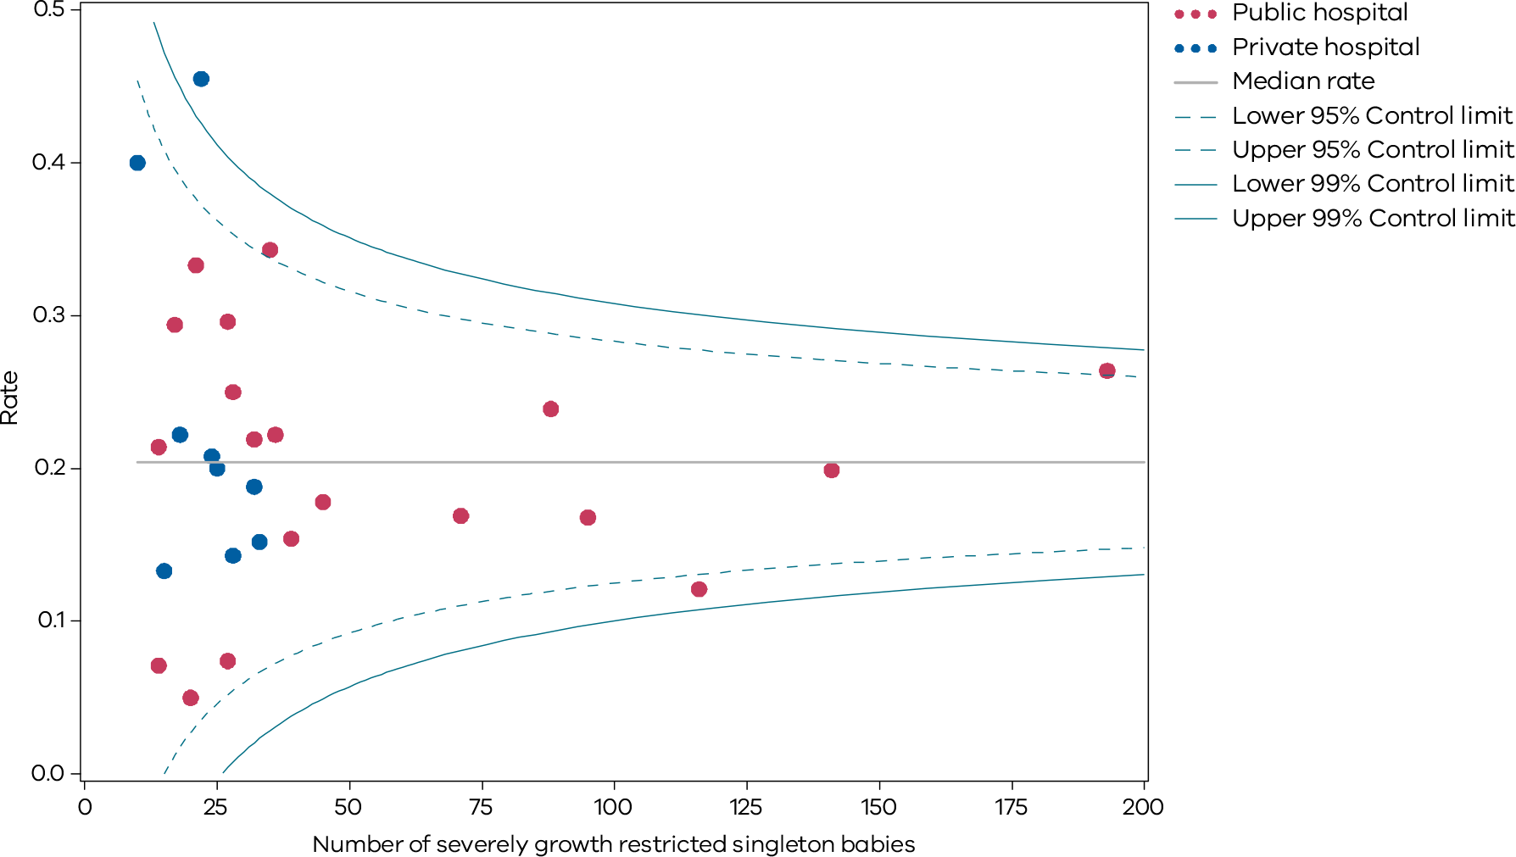
Please refer to page 9 for a guide on how to interpret funnel plots.
Table 7. Rate of severe fetal growth restriction in a singleton pregnancy undelivered by 40 weeks,
2017–20
 | 2017 | 2018 | 2019 | 2020
Public | 28.0% | 23.0% | 22.1% | 20.5%
Private | 28.8% | 30.2% | 26.4% | 21.3%
Combined | 28.1% | 24.3% | 23.0% | 20.8%
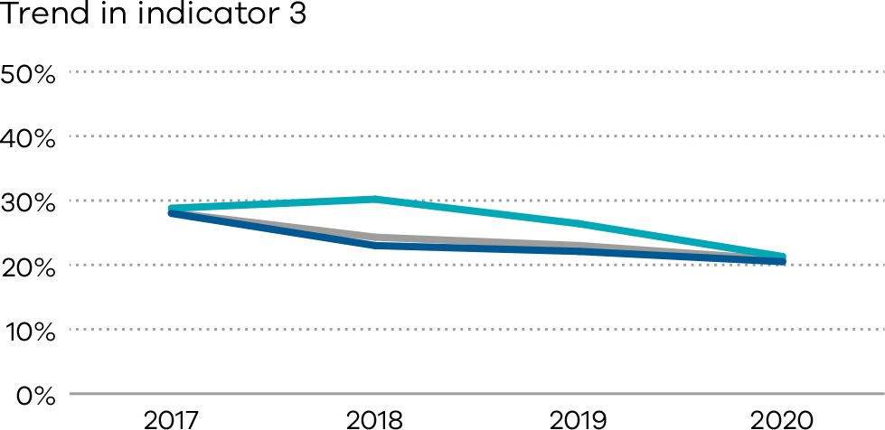

Definitions and data sources
Severe FGR is defined as a birthweight less than the third centile for gestation and sex whether liveborn or stillborn.
Excluded are:
- babies without severe FGR
- multiple births
- births at earlier gestations (less than 32 weeks).

Data source: Victorian Perinatal Data Collection
Data for this indicator is sourced from the VPDC for the calendar year from 1 January 2020 to
31 December 2020.
The indicator is derived using the following VPDC variables: ‘baby sex’, ‘gestation’, ‘birth weight’ and ‘plurality’.
Numerator/denominator
Indicator | Numerator | Denominator
Indicator 3: Rate of severe FGR in a singleton pregnancy undelivered by 40 weeks | Birth at 40 or more weeks’ gestation of a singleton baby with severe FGR | Singleton births (live and stillborn) with severe FGR born at and beyond 32 weeks’ gestation
For this indicator, a baby is considered to be severely growth-restricted when their birthweight is below the third centile for gestation, sex and plurality. It is calculated based on the study by Dobbins et al., which gives the tables for birthweight centiles according to the gestational week for live singleton male and female babies in Australia. If a male singleton baby weighing 1,700 grams is born at 35 weeks, it falls below the third centile for gestation, sex and plurality. The baby is then considered severely growth restricted (Indicator 3). The Australian national birthweight percentiles by sex and gestational age, 1998–2007 (Dobbins et al. 2012) is used to calculate the birthweight centiles for this indicator (see Tables 8 and 9).
Table 8. Birthweight centiles for live singleton male infants, Australia, 1998–2007
Gestational age (weeks) | Number of births | Mean (SD) birthweight (g) | Birthweight percentile (g)
 |  |  | 1st | 3rd | 5th | 10th | 25th | 50th | 75th | 90th | 95th | 97th | 99th
20 | 230 | 349 (60) | 210 | 248 | 254 | 273 | 310 | 340 | 390 | 430 | 450 | 470 | 500
21 | 335 | 418 (66) | 270 | 290 | 300 | 335 | 375 | 420 | 460 | 500 | 540 | 542 | 575
22 | 401 | 505 (76) | 350 | 370 | 390 | 410 | 460 | 500 | 554 | 600 | 630 | 650 | 690
23 | 395 | 595 (82) | 390 | 450 | 470 | 500 | 540 | 588 | 650 | 700 | 730 | 756 | 800
24 | 640 | 681 (105) | 426 | 470 | 500 | 550 | 618 | 684 | 750 | 810 | 850 | 875 | 970
25 | 715 | 783 (131) | 440 | 505 | 530 | 620 | 700 | 785 | 865 | 944 | 995 | 1,030 | 1,100
26 | 937 | 894 (152) | 500 | 576 | 621 | 680 | 802 | 900 | 996 | 1,078 | 1,130 | 1,155 | 1,210
27 | 1,069 | 1,016 (194) | 510 | 605 | 660 | 752 | 904 | 1,030 | 1,138 | 1,250 | 1,320 | 1,352 | 1,440
28 | 1,345 | 1,146 (217) | 591 | 680 | 735 | 844 | 1,030 | 1,165 | 1,295 | 1,395 | 1,470 | 1,522 | 1,640
29 | 1,524 | 1,301 (252) | 662 | 782 | 860 | 964 | 1,150 | 1,311 | 1,463 | 1,620 | 1,700 | 1,757 | 1,860
30 | 2,105 | 1,474 (283) | 774 | 900 | 984 | 1,091 | 1,300 | 1,498 | 1,650 | 1,800 | 1,920 | 1,980 | 2,182
31 | 2,576 | 1,666 (304) | 915 | 1,055 | 1,126 | 1,270 | 1,480 | 1,680 | 1,855 | 2,028 | 2,142 | 2,230 | 2,435
32 | 3,895 | 1,867 (331) | 1,075 | 1,214 | 1,294 | 1,430 | 1,659 | 1,880 | 2,080 | 2,270 | 2,405 | 2,503 | 2,710
33 | 5,599 | 2,106 (371) | 1,200 | 1,381 | 1,473 | 1,638 | 1,880 | 2,106 | 2,340 | 2,560 | 2,710 | 2,845 | 3,070
34 | 9,824 | 2,340 (385) | 1,400 | 1,580 | 1,690 | 1,860 | 2,100 | 2,340 | 2,580 | 2,810 | 2,990 | 3,120 | 3,343
35 | 16,054 | 2,585 (408) | 1,600 | 1,795 | 1,920 | 2,080 | 2,330 | 2,578 | 2,835 | 3,095 | 3,275 | 3,410 | 3,665
36 | 32,747 | 2,826 (428) | 1,805 | 2,015 | 2,120 | 2,295 | 2,550 | 2,820 | 3,095 | 3,360 | 3,550 | 3,690 | 3,930
37 | 73,986 | 3,093 (449) | 2,050 | 2,265 | 2,372 | 2,540 | 2,800 | 3,080 | 3,378 | 3,670 | 3,865 | 3,990 | 4,235
38 | 230,003 | 3,344 (439) | 2,340 | 2,540 | 2,640 | 2,800 | 3,050 | 3,330 | 3,625 | 3,910 | 4,090 | 4,215 | 4,445
39 | 293,109 | 3,486 (430) | 2,510 | 2,700 | 2,800 | 2,950 | 3,195 | 3,470 | 3,765 | 4,040 | 4,220 | 4,335 | 4,560
40 | 409,976 | 3,632 (434) | 2,650 | 2,840 | 2,940 | 3,090 | 3,340 | 3,620 | 3,915 | 4,195 | 4,370 | 4,490 | 4,708
41 | 192,154 | 3,769 (438) | 2,780 | 2,970 | 3,070 | 3,220 | 3,470 | 3,755 | 4,060 | 4,340 | 4,515 | 4,630 | 4,850
42 | 19,804 | 3,832 (462) | 2,760 | 2,980 | 3,095 | 3,250 | 3,520 | 3,820 | 4,130 | 4,430 | 4,615 | 4,740 | 4,970
43 | 797 | 3,761 (540) | 2,615 | 2,785 | 2935 | 3085 | 3,380 | 3,750 | 4,100 | 4,470 | 4,670 | 4,825 | 5,180
44 | 53 | 3,715 (563) | — | — | — | 3,110 | 3,300 | 3,620 | 4,070 | 4,415 | — | — | —
Table 9. Birthweight centiles for live singleton female infants, Australia, 1998–2007
Gestational age (weeks) | Number of births | Mean (SD) birthweight (g) | Birthweight percentile (g)
 |  |  | 1st | 3rd | 5th | 10th | 25th | 50th | 75th | 90th | 95th | 97th | 99th
20 | 197 | 333 (65) | 190 | 210 | 230 | 265 | 290 | 320 | 374 | 410 | 450 | 490 | 525
21 | 256 | 386 (69) | 210 | 250 | 270 | 300 | 340 | 390 | 433 | 470 | 510 | 515 | 530
22 | 333 | 474 (72) | 260 | 325 | 355 | 400 | 425 | 480 | 520 | 560 | 589 | 610 | 620
23 | 376 | 558 (89) | 320 | 375 | 400 | 445 | 506 | 560 | 615 | 660 | 700 | 725 | 800
24 | 528 | 637 (95) | 380 | 430 | 480 | 520 | 580 | 641 | 700 | 754 | 793 | 815 | 860
25 | 599 | 730 (128) | 410 | 470 | 498 | 559 | 645 | 740 | 817 | 884 | 940 | 975 | 992
26 | 809 | 825 (166) | 428 | 490 | 520 | 594 | 717 | 840 | 940 | 1,026 | 1,072 | 1,106 | 1,186
27 | 879 | 949 (188) | 500 | 568 | 598 | 675 | 840 | 965 | 1,077 | 1,175 | 1,240 | 1,280 | 1,390
28 | 1,136 | 1,073 (230) | 495 | 622 | 675 | 764 | 928 | 1,090 | 1,230 | 1,347 | 1,410 | 1,470 | 1,610
29 | 1,188 | 1,215 (252) | 572 | 712 | 790 | 870 | 1,055 | 1,240 | 1,380 | 1,494 | 1,595 | 1,680 | 1,840
30 | 1,656 | 1,394 (277) | 725 | 870 | 918 | 1,030 | 1,220 | 1,400 | 1,571 | 1,715 | 1,840 | 1,920 | 2,130
31 | 2,052 | 1,582 (302) | 880 | 1,000 | 1,060 | 1,190 | 1,385 | 1,590 | 1,780 | 1,948 | 2,065 | 2,146 | 2,338
32 | 3,119 | 1,772 (322) | 970 | 1,140 | 1,230 | 1,348 | 1,570 | 1,780 | 1,970 | 2,170 | 2,290 | 2,400 | 2,620
33 | 4,421 | 2,014 (356) | 1,180 | 1,330 | 1,424 | 1,560 | 1,790 | 2,011 | 2,235 | 2,450 | 2,616 | 2,746 | 2,970
34 | 8,108 | 2,242 (375) | 1,331 | 1,525 | 1,615 | 1,764 | 2,005 | 2,240 | 2,470 | 2,705 | 2,870 | 2,995 | 3,220
35 | 13,104 | 2,486 (403) | 1,525 | 1,710 | 1,820 | 1,980 | 2,230 | 2,480 | 2,735 | 2,995 | 3,175 | 3,300 | 3,516
36 | 28,386 | 2,720 (420) | 1,750 | 1,940 | 2,040 | 2,198 | 2,445 | 2,710 | 2,980 | 3,250 | 3,450 | 3,575 | 3,810
37 | 66,928 | 2,979 (439) | 1,970 | 2,175 | 2,275 | 2,430 | 2,690 | 2,965 | 3,255 | 3,545 | 3,735 | 3,865 | 4,100
38 | 214,002 | 3,215 (425) | 2,256 | 2,440 | 2,540 | 2,690 | 2,930 | 3,200 | 3,490 | 3,770 | 3,945 | 4,062 | 4,290
39 | 282,046 | 3,351 (415) | 2,420 | 2,600 | 2,690 | 2,830 | 3,070 | 3,340 | 3,620 | 3,890 | 4,060 | 4,175 | 4,390
40 | 398,257 | 3,493 (416) | 2,566 | 2,740 | 2,830 | 2,975 | 3,210 | 3,480 | 3,765 | 4,030 | 4,200 | 4,316 | 4,525
41 | 181,434 | 3,619 (424) | 2,680 | 2,855 | 2,945 | 3,090 | 3,330 | 3,605 | 3,900 | 4,170 | 4,340 | 4,455 | 4,670
42 | 17,701 | 3,665 (445) | 2,670 | 2,850 | 2,950 | 3,110 | 3,360 | 3,650 | 3,955 | 4,240 | 4,420 | 4,545 | 4,760
43 | 801 | 3,579 (463) | 2,660 | 2,800 | 2,865 | 3,010 | 3,240 | 3,560 | 3,880 | 4,210 | 4,385 | 4,560 | 4,760
44 | 52 | 3,705 (523) | — | — | — | 3,070 | 3,403 | 3,695 | 3,965 | 4,230 | — | — | —

4a and 4b: Vaginal birth after primary caesarean section
Vaginal birth after caesarean section describes a vaginal delivery in a woman who has given birth by caesarean section in a previous pregnancy. Labour in women desiring a VBAC without contraindications is accepted and generally safe but there is a risk of serious potential complications including uterine rupture or dehiscence and associated maternal or neonatal morbidity. When successful, VBAC is associated with a decrease in maternal morbidity and avoidance of surgical recovery in the postpartum period as well as a decreased risk of complications in future pregnancies.

About this indicator
Indicator 4a identifies the proportion of women who planned for a vaginal birth for their second baby after a caesarean section for their first (VBAC).
Indicator 4b shows the proportion of women who planned a VBAC who achieved a VBAC.
Caesarean sections are often necessary and can improve outcomes for women and babies. However, caesareans can prolong recovery after birth and may increase the chance of complications in subsequent pregnancies.
If there are no contraindications, women who have had prior caesareans should be encouraged to consider and plan a VBAC.
For health services, caesarean sections require additional resources and add costs. Level 1 and 2 services are not able to provide women with the opportunity for VBAC under the Capability frameworks for Victorian maternity and newborn services (2019).

Observations on the data

2019
The proportion of women planning a VBAC (Indicator 4a) decreased from 23.4 per cent in 2018 to 22.3 per cent in 2019.
The proportion of women who achieved a planned VBAC (Indicator 4b) was similar with 53.5 per cent in 2018 and 53.2 per cent in 2019.

2020
The proportion of women planning a VBAC (Indicator 4a) increased from 27.1 per cent in 2018 to 27.8 per cent in 2020 for public hospitals (p) but decreased from 14.7 per cent in 2018 to 11.2 per cent in 2020 for private hospitals. There was wide variation between hospitals, from zero to 56.8 per cent (Figure 21). Women in public hospitals were more likely than those in private hospitals to attempt a VBAC.
The proportion of women who achieved a planned VBAC (Indicator 4b) increased from 2017 in both public (55.0 per cent in 2018, 52.5 per cent in 2020 and private hospitals 46.9 per cent in 2018, 48.8 per cent in 2020). Again, there was wide variation in rates between hospitals, from zero to 88.0 per cent (Figures 23).

Strategies for improvement
- Women requesting a VBAC should be referred to a service with the capability to perform this.
- Health services should provide women with individualised counselling about their options for birth if they have had one previous caesarean section.
- Health services should review VBAC pathways offered to women and report on identified deficiencies to accessing facilities, specialists or standards of care.
- Provide evidence-based information (verbal and written) to women regarding the benefits and risks of VBACs.
[Break out box text:

What pregnant women and families need to know
Most women who have previously had one caesarean section can try to have a vaginal birth for their next baby. Around half of women who try will have the baby vaginally.
This indicator measures how many of these women intended to have a vaginal birth, and how many actually had a vaginal birth.
End of break out box text.]
Figure 21. Indicator 4a: Rate of women who planned a vaginal birth after a primary caesarean section, 2020
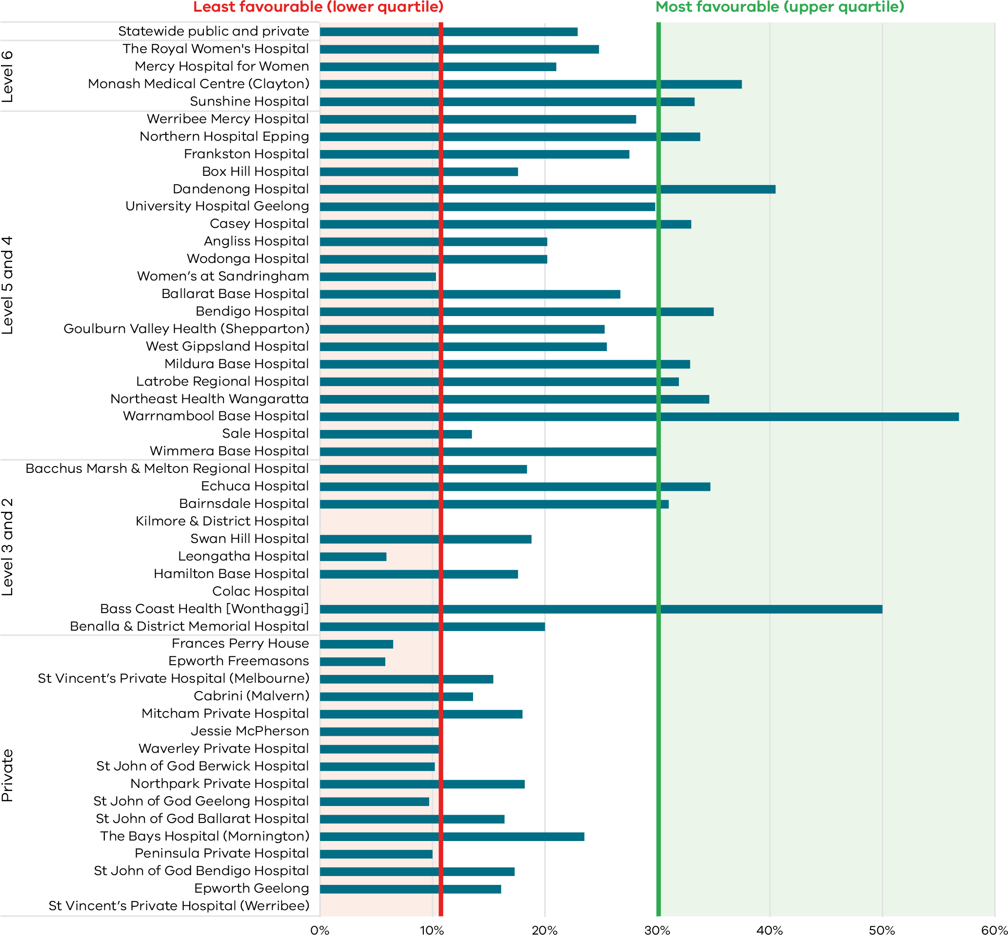
Figure 22. Funnel plot of the rate of women who planned a vaginal birth after a primary caesarean section, 2020
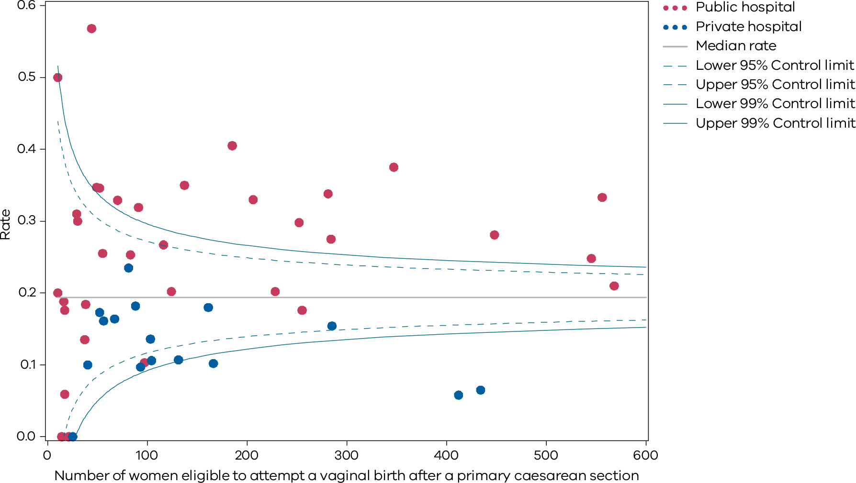
Table 10. Rate of women who planned a vaginal birth after a primary caesarean section, 2017–2020
 | 2017 | 2018 | 2019 | 2020
Public | 27.8% | 27.1% | 26.3% | 27.8%
Private | 14.3% | 14.7% | 13.2% | 11.2%
Combined | 23.7% | 23.4% | 22.3% | 22.9%
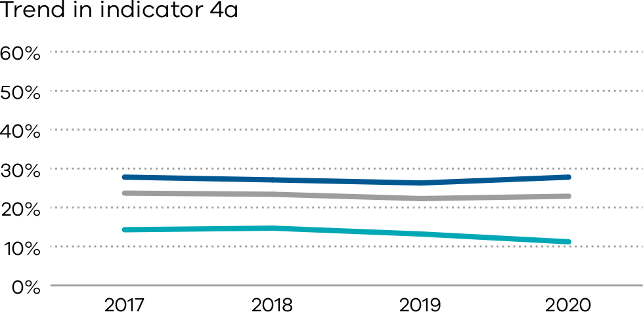

Figure 23. Indicator 4b: Rate of women who achieved a planned vaginal birth after a primary caesarean section, 2020
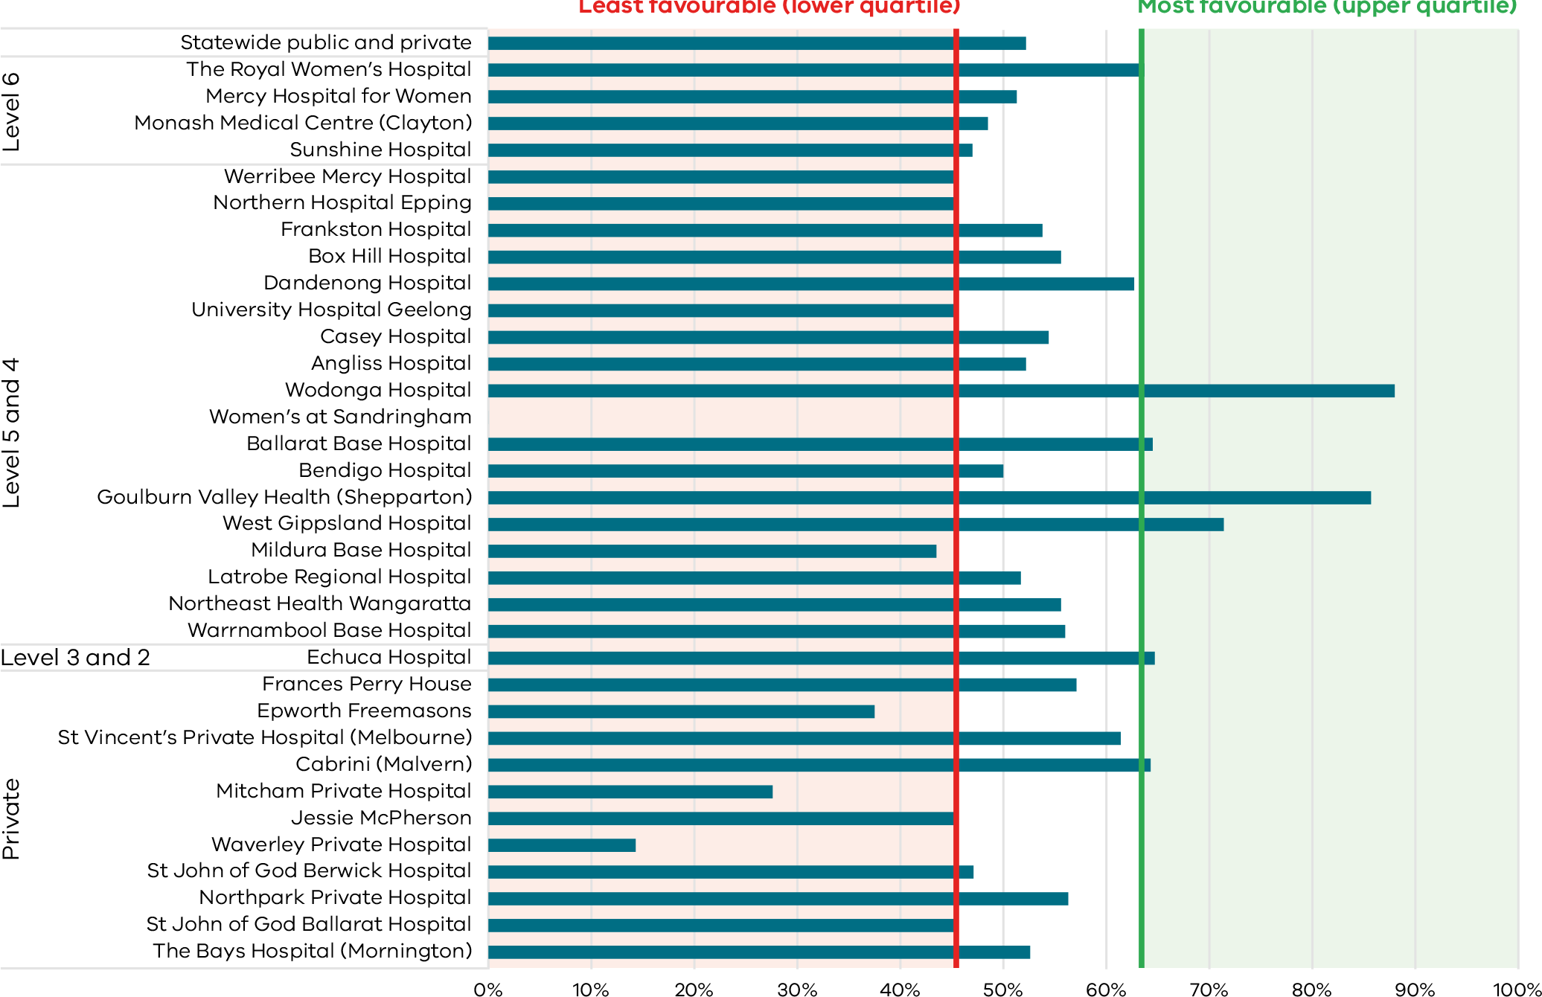
Figure 24. Funnel plot of the rate of women who achieved a planned vaginal birth after a primary caesarean section, 2020
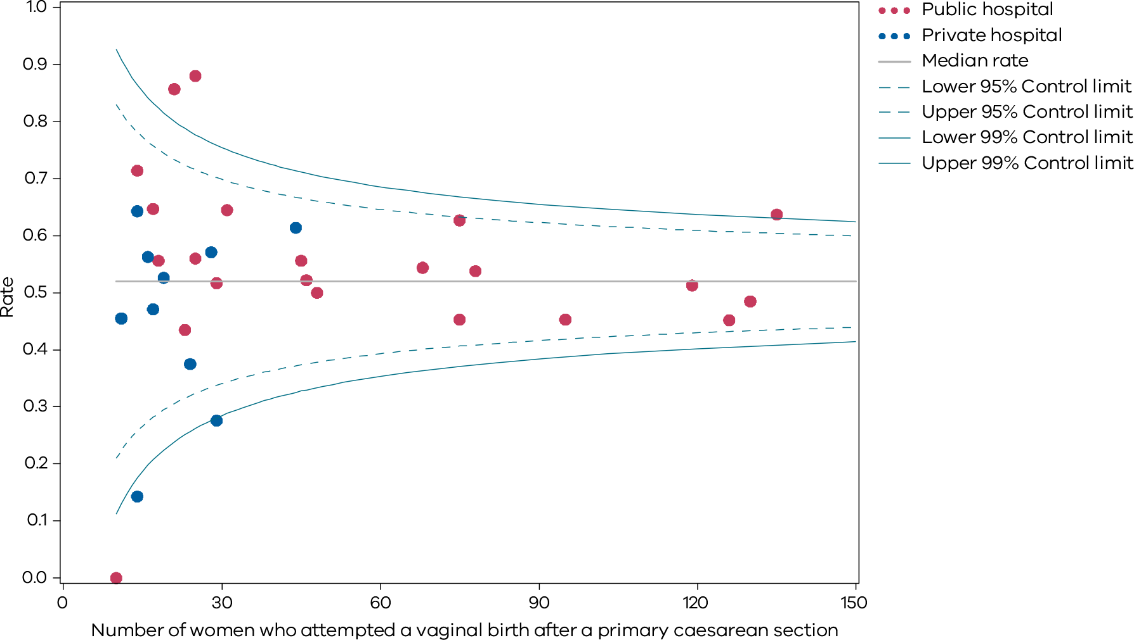
Table 11. Rate of women who achieved a planned vaginal birth after a primary caesarean section,
2017–2020
 | 2017 | 2018 | 2019 | 2020
Public | 54.4% | 55.0% | 54.1% | 52.5%
Private | 42.8% | 46.9% | 48.1% | 48.8%
Combined | 52.4% | 53.5% | 53.2% | 52.2%
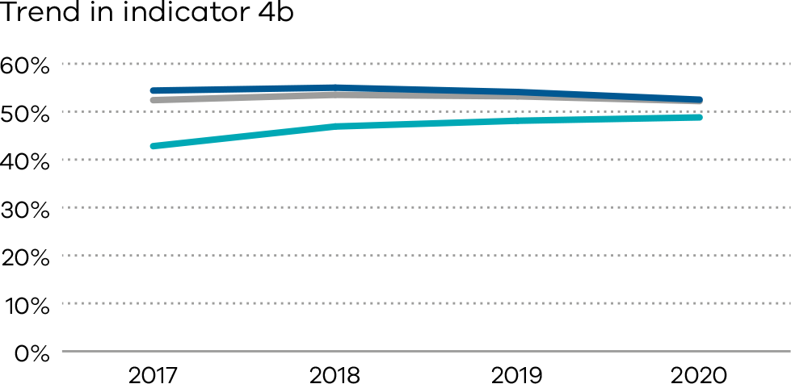

5: Five-year gestation standardised perinatal mortality ratio
Gestation standardised perinatal mortality ratio (GSPMR) is a measure of perinatal mortality that compares the observed perinatal mortality rate for babies born at individual hospitals with what would be expected, accounting for the gestation at birth. It is a partially risk-adjusted calculation, enabling hospitals with higher proportions of births at lower gestations (and therefore higher likelihood of perinatal mortality) to be validly compared with hospitals that have a different case mix.

About this indicator
Perinatal mortality includes stillbirths (death before birth) and deaths in the first 28 days of babies born alive.
Pooling the data over five-year periods adds stability to the data and reduces the risk of over-interpretation of chance fluctuations.
The indicator provides a visual representation of the variation in perinatal mortality occurring across Victorian public and private hospitals compared with the statewide rate.

How to interpret the ratio
The statewide ratio (the reference population) is set at ‘1’. A GSPMR of 1 indicates that the observed number of perinatal deaths at that hospital is exactly what would be expected, considering the gestation of babies born there.
An individual hospital with a ratio of:
- 0.5 has a perinatal mortality that is half the statewide rate
- 1 has a perinatal mortality that is equal to the statewide rate
- 1.5 has a perinatal mortality that is 50 per cent above the statewide rate
- 2 represents perinatal mortality that is double the statewide rate.
These rates include only babies who were born at 32 or more weeks’ gestation.
The statewide rate (1) does not necessarily represent the optimal or clinically appropriate rate for perinatal mortality. A rate greater than 1 indicates more deaths occurred than were expected, and a rate less than 1 indicates fewer deaths occurred than were expected.

What does the GSPMR tell us?
- It shows where there is variation in perinatal mortality rates for hospitals of similar capability or size.
- It adjusts for gestation, the most important risk factor for perinatal death.

What can’t the GSPMR tell us?
The GSPMR does not indicate:
- statewide or individual hospital perinatal mortality rates
- whether the results for a given hospital are improving over the five-year period
- the reasons for the deaths or how the babies died (a baby may have died before arriving at the birth hospital, while in the hospital or following discharge from hospital, for example, due to SIDS, a car accident or injury)
- whether the death could have been avoided
- whether the care around the time of death was provided by a different hospital (transfer) or health professional than the birth hospital
- where the baby died – it only tells us where the baby was born
- the safety of a maternity service
- the contribution of important risk factors associated with perinatal mortality such as obesity, smoking, pre-existing illness of the mother, low socioeconomic status and ethnicity.
[Break out box text:

What pregnant women and families need to know
Counting how many unborn and newborn babies die tells us part of the story about the quality of care for new mothers and babies.
We know some deaths are unexpected and could not have been prevented. We average the number of deaths over a five-year period to get a better sense of the overall care that a hospital provides. For this indicator we only look at babies born at or after 32 weeks’ gestation.
There should be very little difference between hospitals. The rates for Victorian hospitals are generally very good.
End of break out box text.]
Figure 25. Funnel plot of five-year GSPMR compared to statewide public rate 2016–20
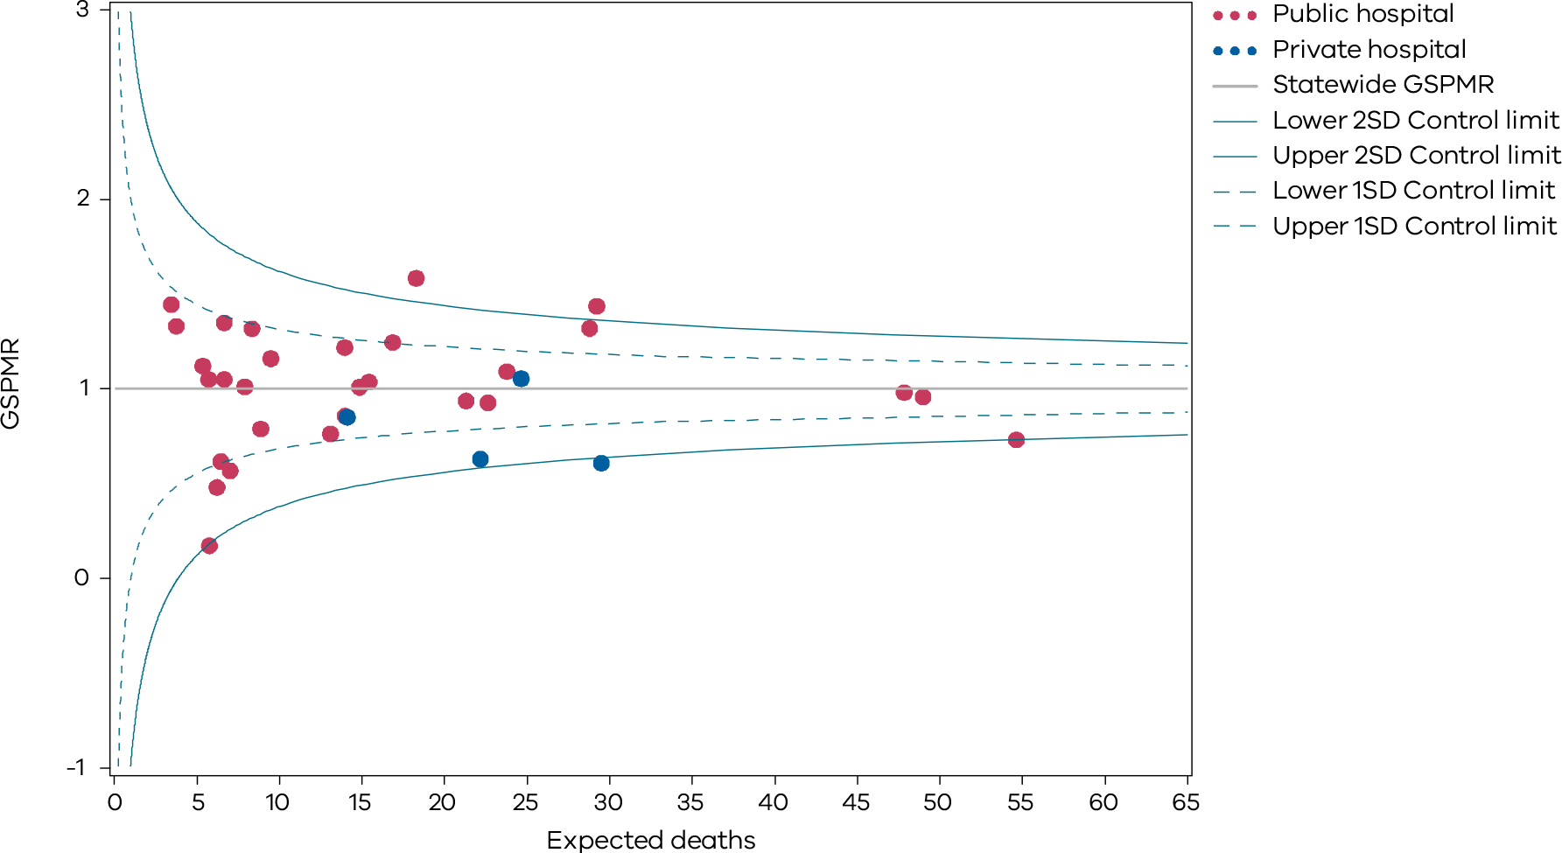
Only health services with at least five deaths during the five-year reference period are included in the funnel plot.
The GSPMRs for individual health services are given in Appendix 3.

How to read this plot
Note that the GSPMR is risk-adjusted, hence, interpretation of the funnel plot is slightly different. As with the other funnel plots, each dot represents one hospital. The solid horizontal line represents a GSPMR where the observed count of deaths is equal to the expected count of deaths (i.e. GSMPR=1). Hospitals (dots) that are above this line (i.e. above 1) have a GSPMR that suggests the observed count of deaths are higher than the expected count of deaths. Hospitals that are below this line have a GSPMR that suggests the observed count of deaths is lower than the expected count. It is desirable to have a GSPMR less than 1, however due to the nature of this indicator, around half of all hospitals will always have a GSPMR greater than 1 and around half will have a GSPMR less than 1.
The dashed and solid blue lines represent control limits based on one standard deviation (1SD) and two standard deviations (2SD) from the solid horizontal line, respectively. Control limits can be used to test how different a hospital’s GSPMR is from 1, taking the size of the hospital into consideration. If a hospital falls outside the 2SD control limits of the plot, its GSPMR is considered to be significantly different from 1. In the above funnel plot, hospitals that fall above the upper 2SD control limit have significantly higher than expected perinatal mortality. Hospitals that fall below the lower 2SD control limit have significantly lower than expected perinatal mortality.
It is important to note that the GSPMR is adjusted only for the gestation at birth. Many other factors also put babies at higher and lower risk of perinatal death, including the socio-economic situation of the woman. This may explain some of these results that are lower than average.

Definitions and data sources
The GSPMR is standardised according to the gestational age-specific perinatal mortality rates of the total population in Victorian hospitals. The standardisation does not adjust for inter-hospital transfers, and deaths are ascribed to the birth hospital regardless of the timing of the death in relation to the transfer.
The data in this report:
- is calculated from five years of pooled data between 2016 and 2020
- is standardised using gestational age
- excludes births earlier than 32 weeks 0 days
- excludes birthweights less than 150 grams regardless of gestation
- excludes all deaths due to congenital anomalies and all terminations of pregnancy.
These exclusions provide a more sensitive indicator to reflect the quality of care.
The GSPMR is presented with data for individual public and private hospitals being shown in relation to the statewide hospital perinatal mortality rate for each week of gestation as the standard or reference population. The GSPMR of the individual health service is published in this report only if there are five or more perinatal deaths (stillbirths and neonatal deaths) in the five pooled years (2015–2020).

Data source: Victorian Perinatal Data Collection
Data for this indicator is sourced from the VPDC for the calendar year from 1 January 2015 to 31 December 2020.
Observed/expected
Indicator | Observed | Expected
Indicator 5: Perinatal mortality ratio for babies born at 32 or more weeks (gestation standardised, excluding all terminations of pregnancy and deaths due to congenital anomalies) using five years’ pooled data in Victorian public and private hospitals (32 weeks or more GSMPR) | Observed perinatal deaths from 32 weeks 0 days (by weeks’ gestation at birth) | Expected perinatal deaths from 32 weeks 0 days (by weeks’ gestation at birth)

6a and 6b: Readmissions during the postnatal period
The postnatal period is a period of adjustment to early parenting and recovery that may include the establishment of breastfeeding. Readmissions to hospital in the postnatal period are unplanned and may be avoidable. Reducing avoidable hospital readmissions supports better health outcomes, improves patient safety and leads to greater efficiency in the healthcare system.
Higher readmission rates can be associated with discharge practices, the care provided during the days following birth and/or limited support in the community. Ensuring a successful transition from hospital to community-based care is important for the ongoing support of women, babies and families. For most women and babies admitted as public patients, this transition usually occurs after at least one home visit by a hospital midwife. This visit should occur between 24 to 48 hours after discharge from the hospital.

About this indicator
These indicators measure the rate of unplanned and potentially preventable readmissions of pregnant women (6a) and newborns (6b) to any hospital within 28 days of discharge from birth hospital.
High-quality care means most women and their babies should not return to hospital during the postnatal period. Unplanned and preventable hospital stays during this period reflects a deviation from the normal course of postnatal recovery. This results in increased healthcare costs and possible impacts on health and wellbeing for women and their babies.

Observations on the data
In 2020, the statewide rate of unplanned maternal readmissions within 28 days of discharge (Indicator 6a) was 2.3 per cent, a slight improvement from the previous year’s rate of 2.6 per cent.
As in previous years, the rate was higher in public hospitals at 2.5 per cent compared to private hospitals at 1.7 per cent.
The public hospital statewide average rate of unplanned newborn readmissions within 28 days of discharge (Indicator 6b) was 4.6 per cent.

Strategies for improvement
Health services should consider the following:
- whether the length of stay in hospital following birth is appropriate to the individual needs of women and babies
- which groups of women and babies have higher readmission rates for the purpose of implementing improvement initiatives
- providing individualised (verbal and written) information and education tools for women and their families at discharge and appropriate ie, maybe in primary language if English is second language or using interpretor if needed.
- the number of home-based visits and the extent of care different groups of women can expect from hospital midwives
- an analysis of the reasons for readmission of pregnant women and newborns
- a review of the effectiveness of postnatal programs, including identifying areas of risk to women and babies
- access to local services and pathways across health services to support regional and rural areas.
[Break out box text:

What pregnant women and families need to know
Healthy babies born to healthy mothers generally don’t need to go back to hospital in their first month.
Sometimes it is completely unavoidable and readmitting the baby or the mother is the safest thing to do because a condition has developed since discharge.
The graphs on the following pages show how many mothers and babies needed to go back to hospital within 28 days of birth for each hospital. The rate will never be zero, but it should be low.
End of break out box text.]
Figure 26. Indicator 6a: Rate of maternal readmissions during the postnatal period, 2020–21
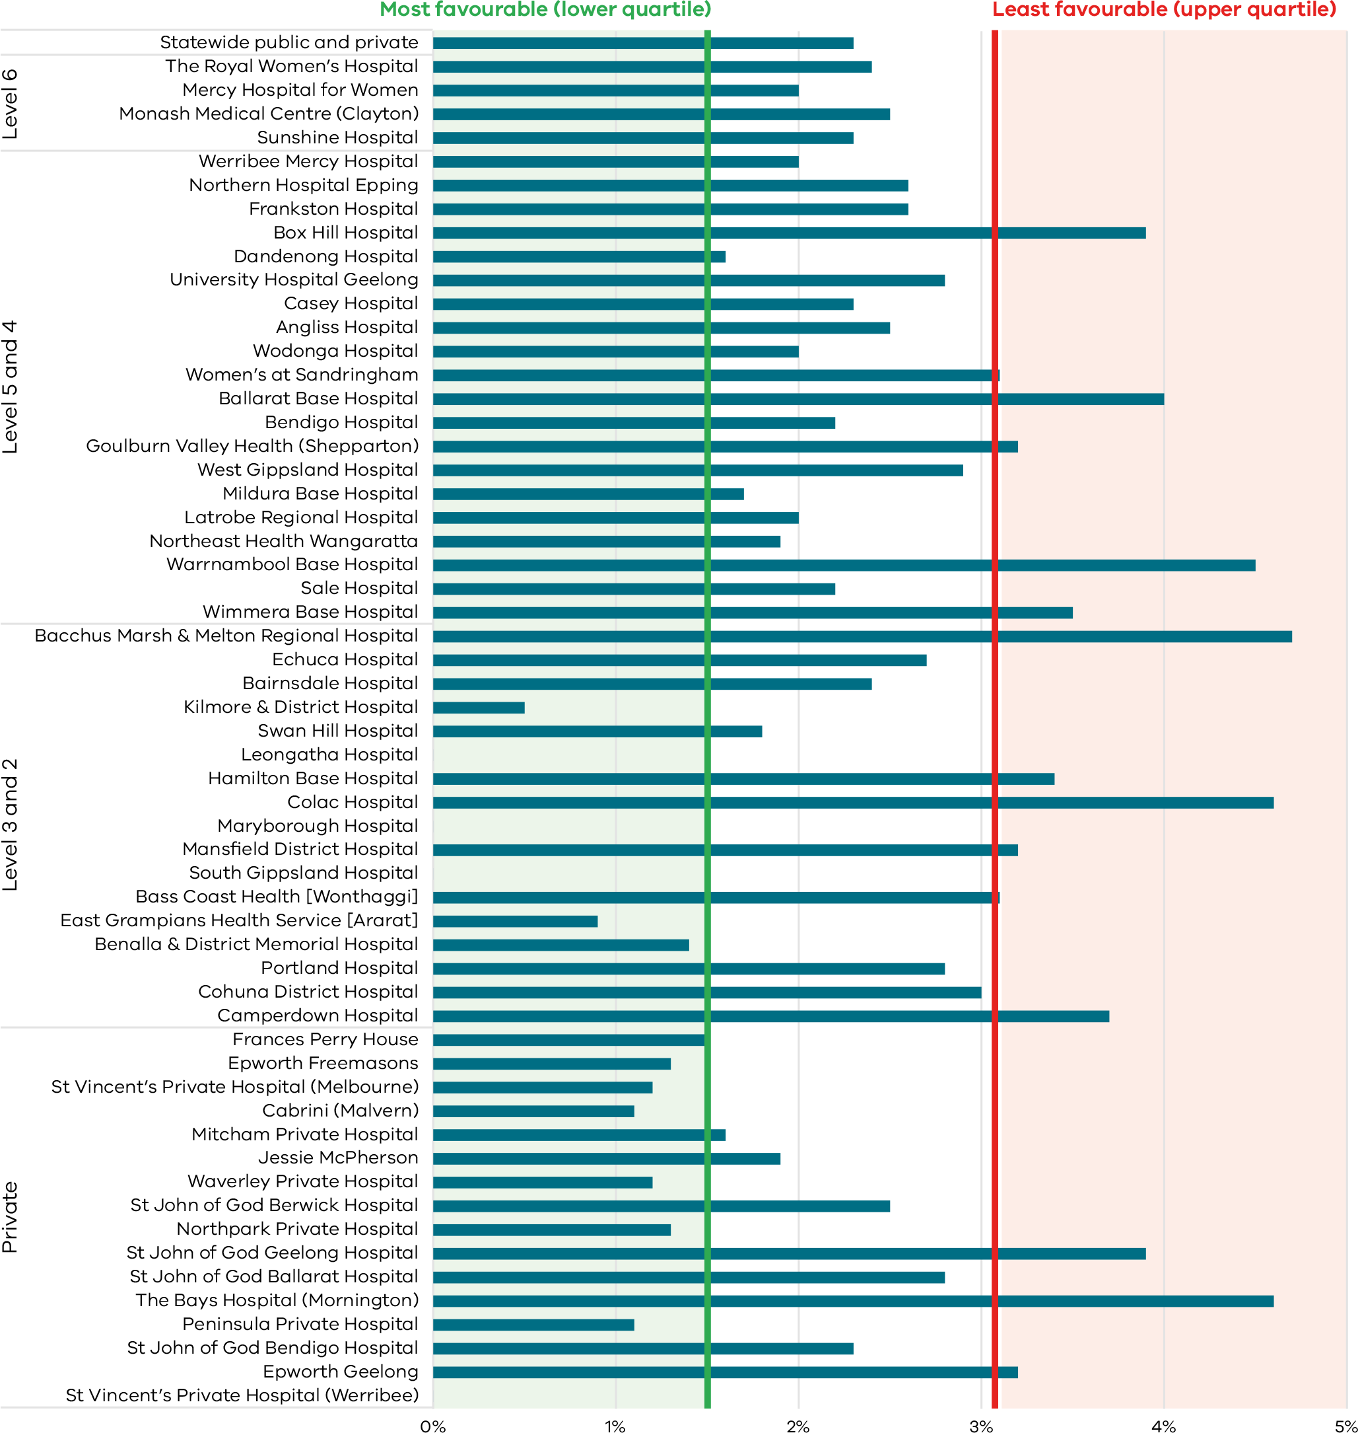
Figure 27. Funnel plot of maternal readmissions during the postnatal period, 2020–21
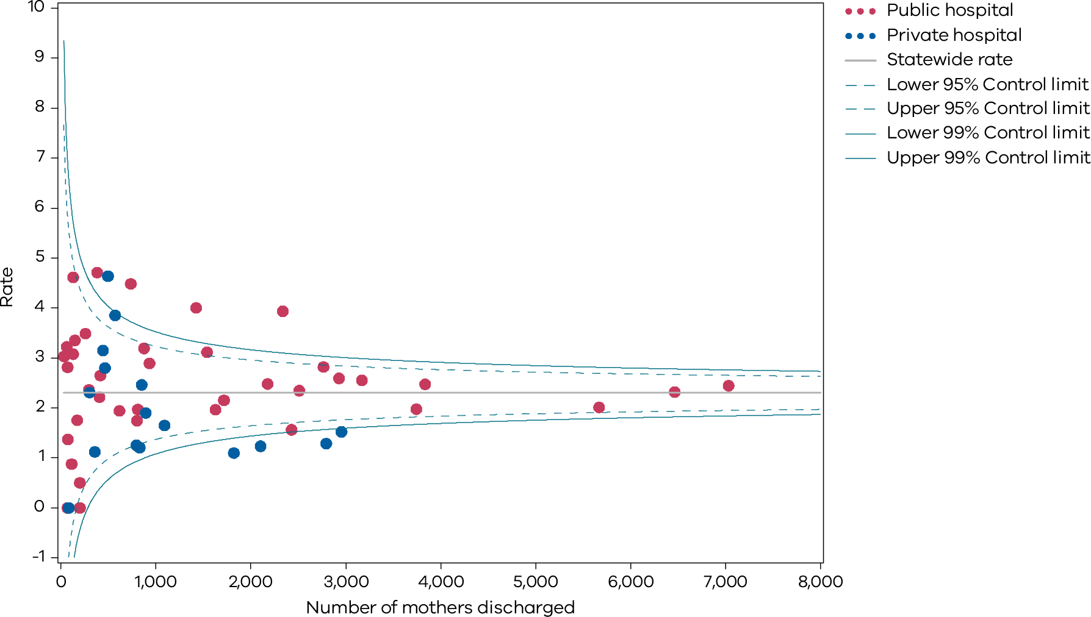
Please refer to page 9 for a guide on how to interpret funnel plots.
Table 12. Rate of maternal readmissions during the postnatal period, by financial year 2017–18 to 2020–21
 | 2017–18 | 2018–19 | 2019–20 | 2020–21
Public | 2.5% | 2.7% | 2.4% | 2.5%
Private | 2.5% | 2.0% | 1.7% | 1.7%
Combined | 2.5% | 2.6% | 2.3% | 2.3%
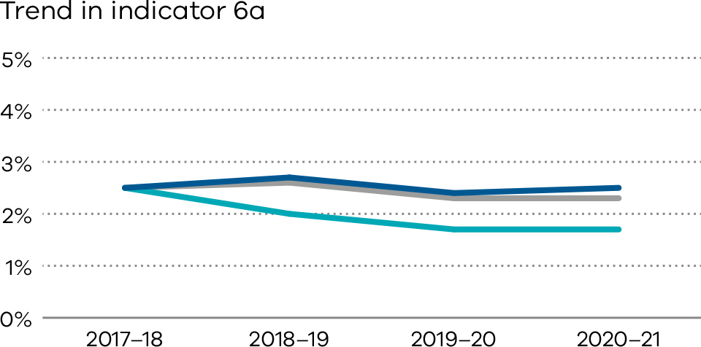
Figure 28. Indicator 6b: Rate of newborn readmissions during the postnatal period, 2020–21
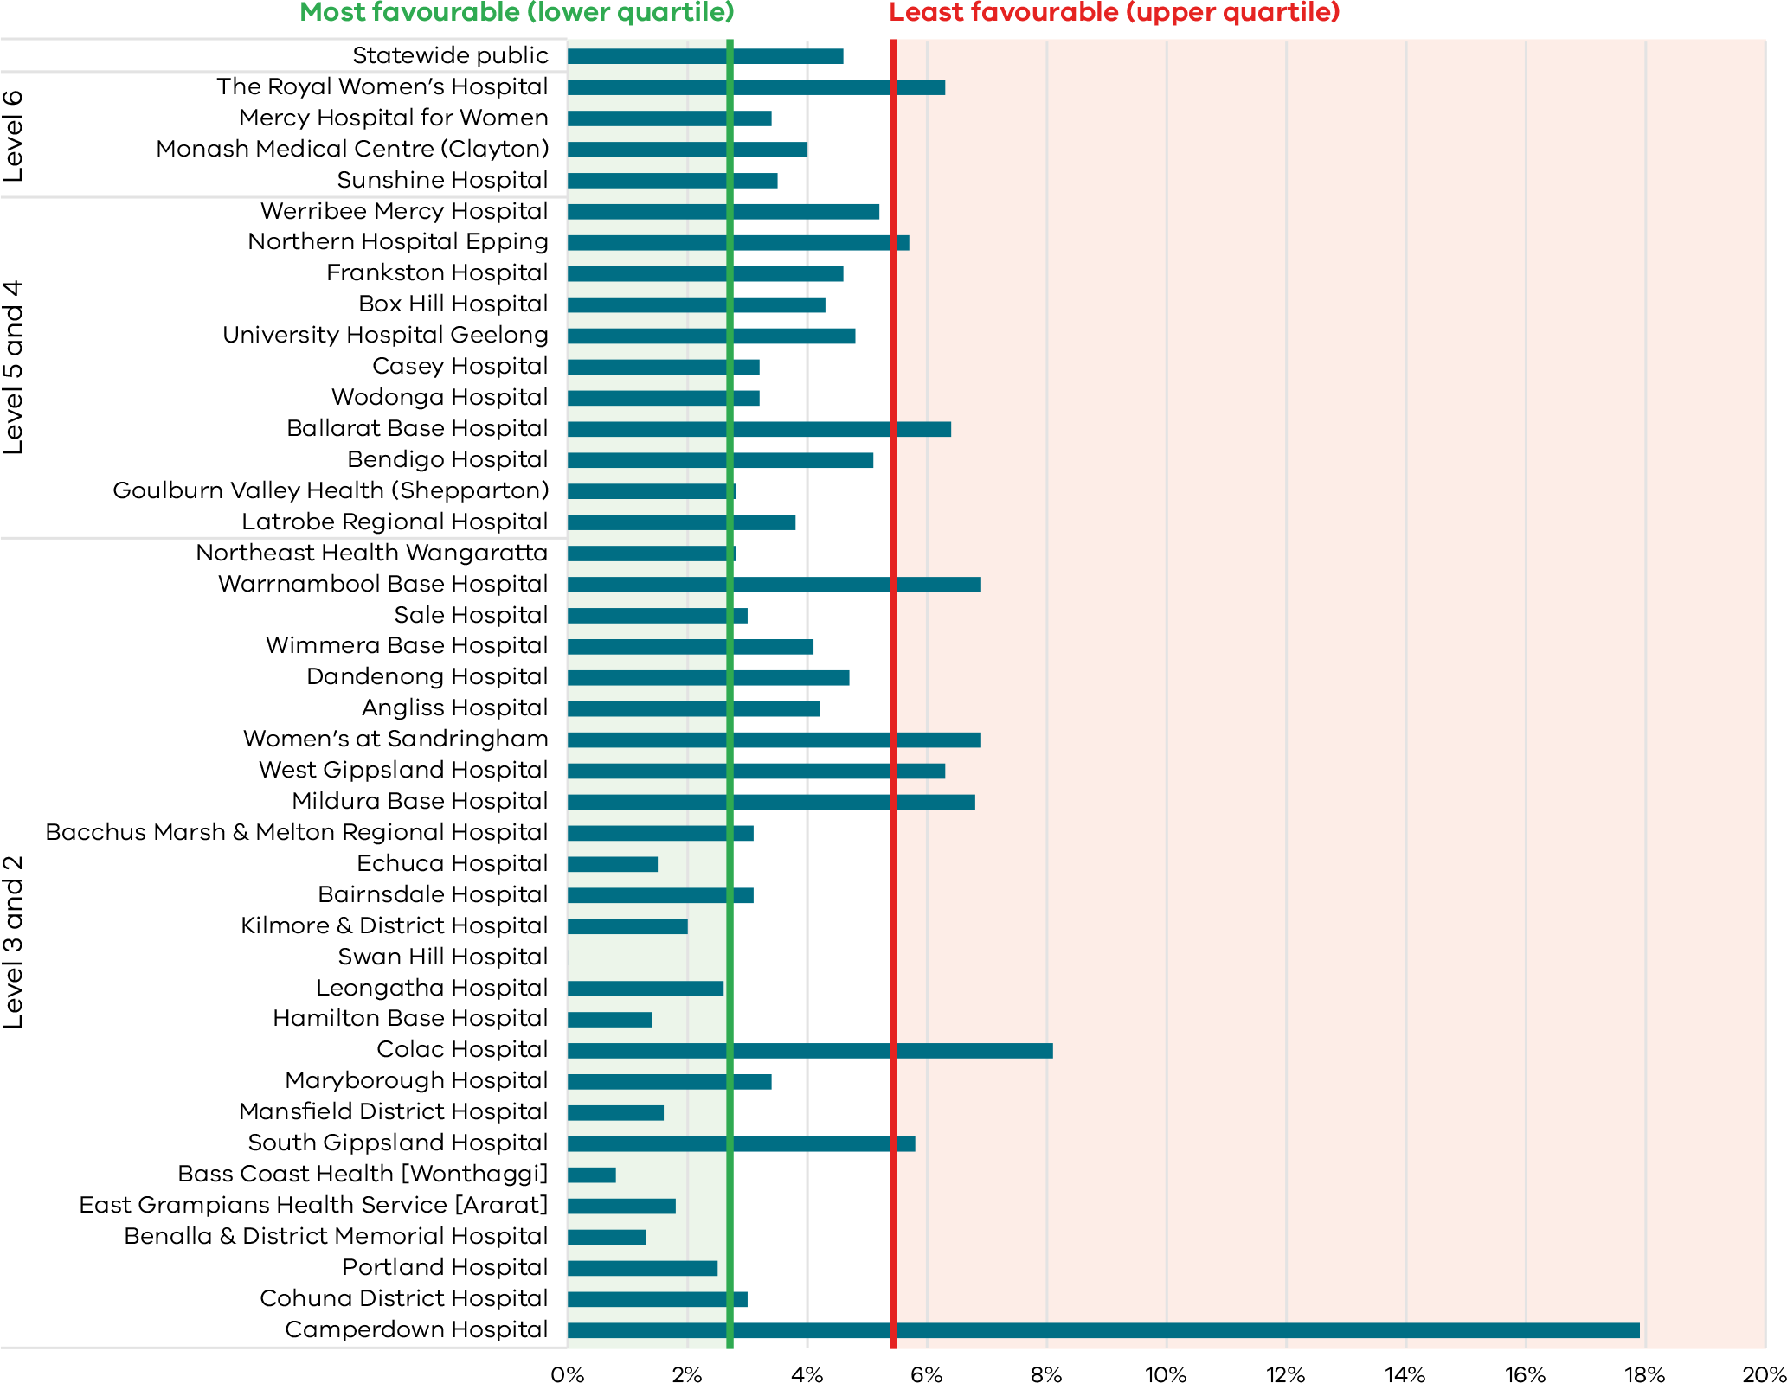
Note: Reporting of unqualified neonate admissions to the VAED for private hospitals is optional. It is therefore not possible to establish an accurate denominator (that includes public and private hospitals) for this indicator. As such, only public hospitals are included in the results.
Figure 29. Funnel plot of newborn readmissions during the postnatal period, 2020–21
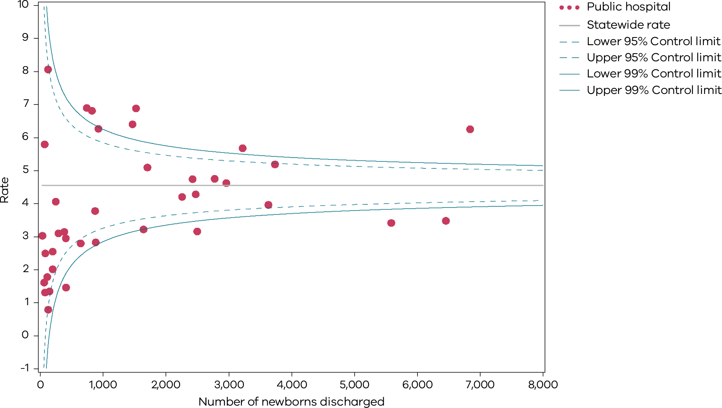
Please refer to page 9 for a guide on how to interpret funnel plots.
Table 13. Rate of newborn readmissions during the postnatal period, by financial year 2017–18 to 2020–21
 | 2017–18 | 2018–19 | 2019–20 | 2020–21
Public | 4.1% | 4.1% | 4.1% | 4.6%
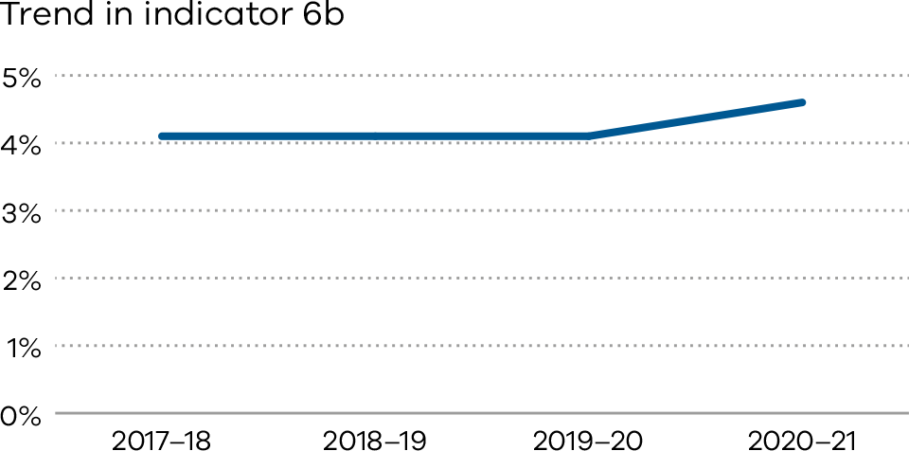

Definitions and data sources

Indicator 6a: Maternal readmissions during the postnatal period
The readmission rate is calculated for the hospital that discharged the mother from the birth episode. The rate includes admissions to any Victorian health service after the birth episode, not just a readmission to the birthing service.
Women transferred to another health service following a birth separation are excluded from the numerator total. Women who present to an emergency department or urgent care centre, but who are not admitted, are excluded from the numerator total. Women who are readmitted and have a principal diagnosis related to their pregnancy and/or birth are included in the numerator total. However, diagnosis codes that are associated with a complexity that cannot be prevented (or managed) through postnatal care and/or that are associated with a condition(s) that manifests after discharge from hospital without any indication of its presence prior to this time are excluded (see list below).
The denominator is the total number of birth episodes at a health service. The only exclusion is maternal death.
Potentially preventable readmission principal diagnosis codes are limited to the following:
- O722 – Delayed and secondary postpartum haemorrhage
- O860 – Infection of obstetric surgical wound
- O85 – Puerperal sepsis
- O9120 – Non-purulent mastitis without attachment difficulties
- Z466 – Fitting and adjustment of urinary device
- O901 – Disruption of perineal obstetric wound
- O149 – Pre-eclampsia (unspecified)
- O16 – Unspecified maternal hypertension
- O9903 – Anaemia complicating childbirth and the puerperium
- O731 – Retained portion placenta and membranes without haemorrhage
- O721 – Other immediate postpartum haemorrhage
- O902 – Haematoma of obstetric wound
- O862 – Urinary tract infection following delivery
- O900 – Disruption of caesarean section wound
- Z391 – Care and examination of lactating mother
- O13 – Gestational hypertension
- N390 – Urinary tract infection (site not specified)
- O9121 – Non-purulent mastitis with attachment difficulty
- F531 – Severe mental and behavioural disorder associated with puerperium (not elsewhere classified)
- F530 – Mild mental and behavioural disorder associated with puerperium (not elsewhere classified)
- G971 – Other reaction to spinal and lumbar puncture
- R509 – Fever (unspecified)
- R33 – Retention of urine
- O152 – Eclampsia in the puerperium
- O720 – Third-stage haemorrhage
- T8852 – Failed moderate sedation during procedure.

Data source: Victorian Admitted Episodes Dataset (VAED)
Data for this indicator is sourced from the VAED for the financial year 1 July 2020 to 30 June 2021.
Numerator/denominator
Indicator | Numerator | Denominator
Indicator 6a: Readmission of a mother within 28 days of discharge from a birthing episode admission in a Victorian public or private hospital | The number of women readmitted to any health service within 28 days with a potentially preventable readmission diagnosis code | The total number of birth episodes at a health service

Indicator 6b: Newborn readmissions during the postnatal period
Readmissions that meet the criteria for inclusion are attributed to the health service that provided postnatal care as part of the birthing episode.
The readmission rate is calculated for the hospital that discharged the neonate from the birth episode. The rate includes admissions to any Victorian health service after birth, not just a readmission to the birthing service. Babies transferred to another health services following a birth separation are excluded from the numerator total.
Neonates who are readmitted on the same day of discharge are also excluded. This is because it is not possible to determine from the dataset whether these are genuine readmissions or a new separation following a planned transfer of care.
Neonates who present to an emergency department or urgent care centre, but who are not admitted, are excluded from the numerator total.
Neonates who are readmitted and have a principal diagnosis related to the pregnancy and/or birth are included in the numerator total. However, diagnosis codes that are associated with a complexity that cannot be prevented (or managed) through postnatal care and/or that are associated with a condition(s) that manifests after discharge from hospital without any indication of its presence prior to this time are excluded (see list below).
The denominator includes the total number of neonates discharged from a health service. Stillbirths and neonatal deaths prior to discharge are excluded. Qualified and unqualified neonates are included – irrespective of their accommodation type during the birth episode (if they spent time in neonatal intensive care or in a special care nursery).
Potentially preventable readmissions are limited to the following list of principal diagnoses:
- P599 – Neonatal jaundice (unspecified)
- P929 – Feeding problem of newborn (unspecified)
- R628 – Other lack of expected normal physiological deviation
- P369 – Bacterial sepsis of newborn (unspecified)
- P928 – Other feeding problems of newborn
- P590 – Neonatal jaundice with pre-term delivery
- P598 – Neonatal jaundice from other specific causes
- P0732 – Other pre-term infant ≥ 32 weeks’ gestation but < 37 completed weeks
- P551 – ABO isoimmunisation of fetus and newborn
- Z0371 – Observation of newborn for suspected infectious condition
- P2840 – Apnoea of newborn, unspecified
- P282 – Cyanotic attacks of newborn
- A870 – Enteroviral meningitis
- P38 – Omphalitis newborn with or without mild haemorrhage
- P741 – Dehydration of newborn
- P809 – Hypothermia of newborn unspecified
- P90 – Convulsions of newborn
- R634 – Abnormal weight loss.

Data source: Victorian Admitted Episodes Dataset
Data for this indicator is sourced from the VAED for the financial year 1 July 2020 to 30 June 2021.
Numerator/denominator
Indicator | Numerator | Denominator
Indicator 6b: Readmission of a newborn within 28 days of discharge from a birthing episode admission in a Victorian public hospital | The number of neonates readmitted to any health service with a potentially preventable readmissions diagnosis code within 28 days of birth | The number of neonates provided with admitted postnatal care prior to discharge

7: Smoking cessation
Women who smoke while pregnant, and their babies, are at risk of various preventable adverse outcomes and health complications including stillbirth, fetal growth restriction and pre-term birth. During pregnancy, women are motivated to protect their baby’s health. It is therefore an important time for health professionals to assist women to quit smoking. This indicator can be used by hospitals to measure how effective their interventions are and recognises hospitals making the greatest impact towards smoking cessation.

About this indicator
This indicator assesses the effectiveness of health services in providing support for women who smoke in early pregnancy to quit. This includes smoking cessation advice, assistance and follow-up during the antenatal period. The aim is to reduce both the rate of smoking among pregnant women and the risk of smoking-associated adverse health outcomes for women and their babies.
The data in this report relates to the percentage of women who were reported as not smoking after 20 weeks’ gestation among those who smoked before 20 weeks.
This indicator has limitation as it does not capture data on whether women continue to not smoke after pregnancy.

Observations on the data
The percentage of women who smoked in the first 20 weeks of their pregnancy and did not smoke in the last 20 weeks of their pregnancy across all hospitals, and within public and public hospitals, has increased from 28.0 per cent in 2019 to 33.5 per cent in 2020 (Table 14). The rate for private hospitals continued to be higher compared to public hospitals (64.0 per cent and 32.6 per cent, respectively).
The smoking cessation rate between individual hospitals ranged from zero to 93.8 per cent (Figure 30). Also note some outliers as shown in Figure 31.

Strategies for improvement
- Assess and screen all pregnant women for smoking at all pregnancy care appointments and in the postnatal period.
- Implement Stillbirth CRE Smoking cessation strategies and referral processes.
- Provide individualised (written and verbal) information to pregnant women on benefits of quitting smoking.
- Develop processes for recording smoking status.
[Break out box text:

What pregnant women and families need to know
Smoking is bad for your health. If women smoke while they are pregnant then there is a risk that this will harm their baby.
Health services monitor how many women in antenatal clinics smoke and provide advice and support to help women stop smoking while they are pregnant.
We measure how many women stop smoking while they are pregnant, and the results are very different between hospitals.
End of break out box text.]
Figure 30. Indicator 7: Rate of smoking cessation during pregnancy, 2020
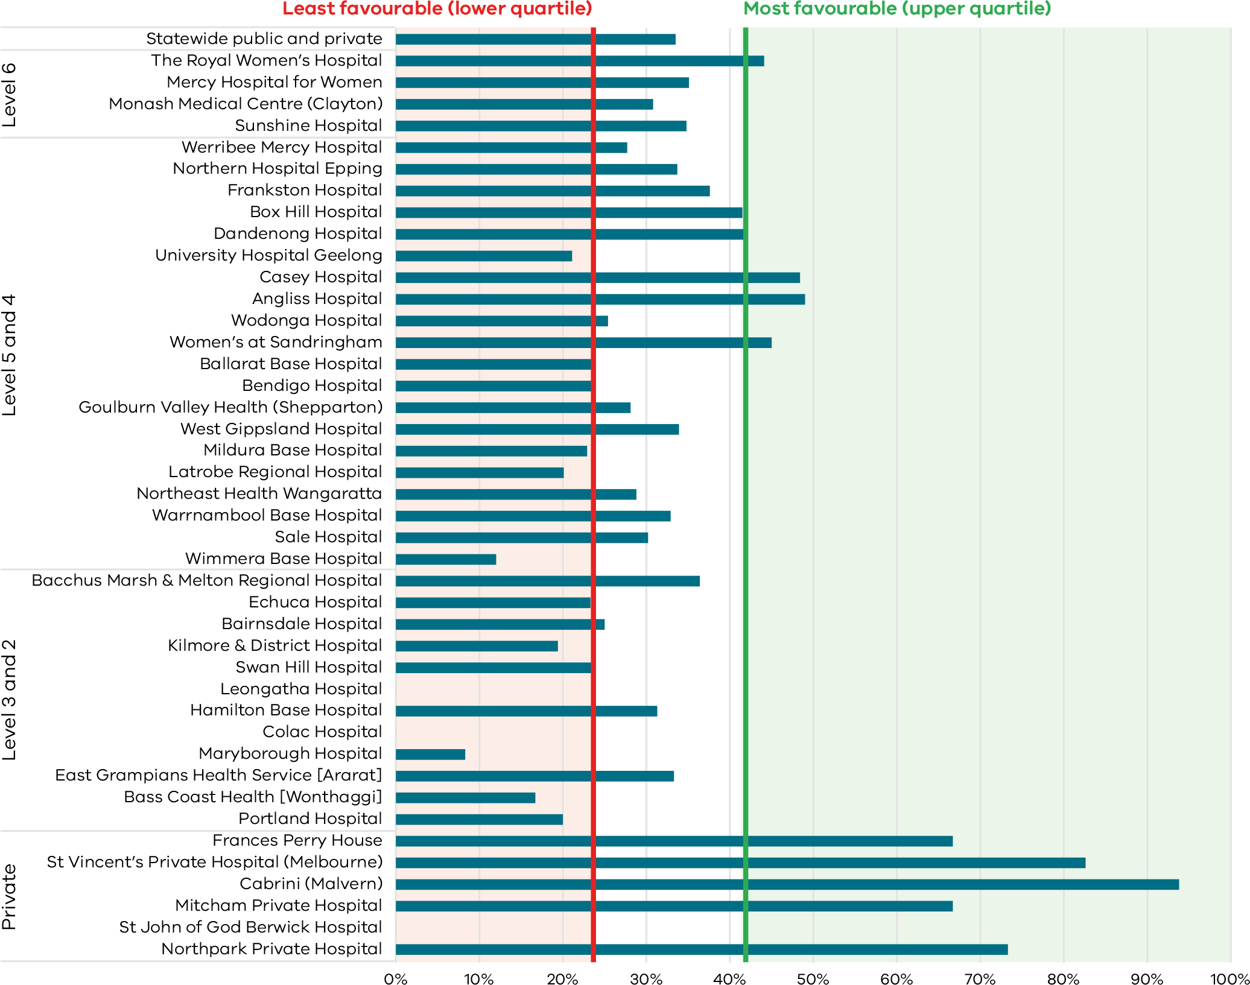
Note: The following services had greater than 20 per cent missing data for smoking in the second half of pregnancy.
As such they have been excluded from the publishable range. Colac Hospital.
Figure 31. Funnel plot of the rate of smoking cessation during pregnancy, 2020
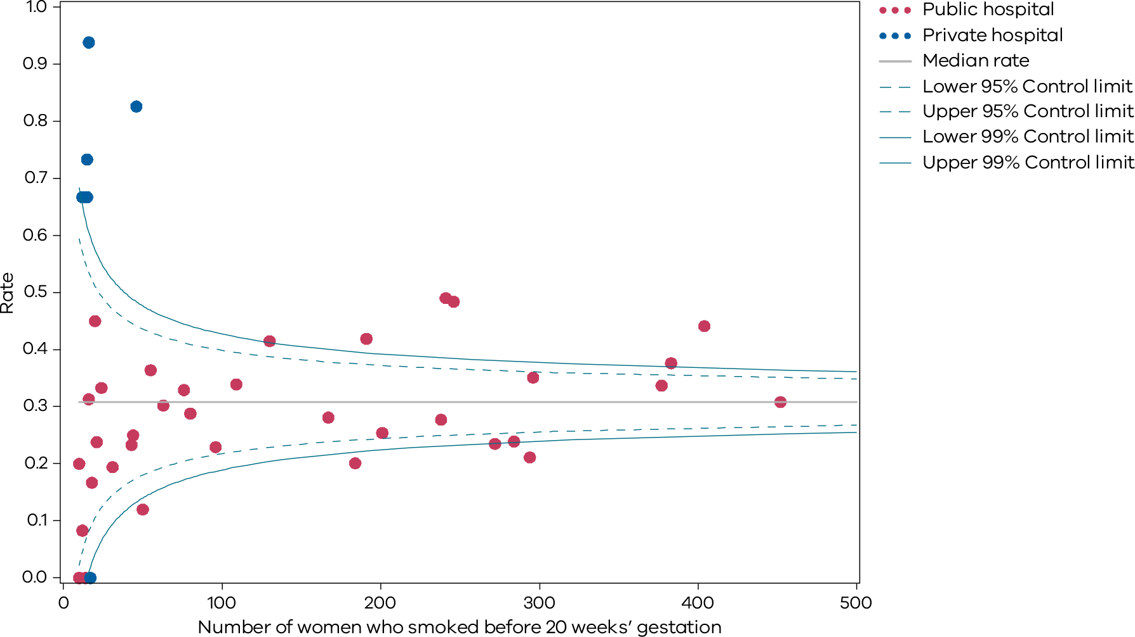
Please refer to page 9 for a guide on how to interpret funnel plots.
Table 14. Rate of smoking cessation during pregnancy, 2017–20
 | 2017 | 2018 | 2019 | 2020
Public | 25.5% | 26.6% | 26.8% | 32.6%
Private | 65.2% | 60.3% | 59.3% | 64.0%
Combined | 27.1% | 28.0% | 28.0% | 33.5%
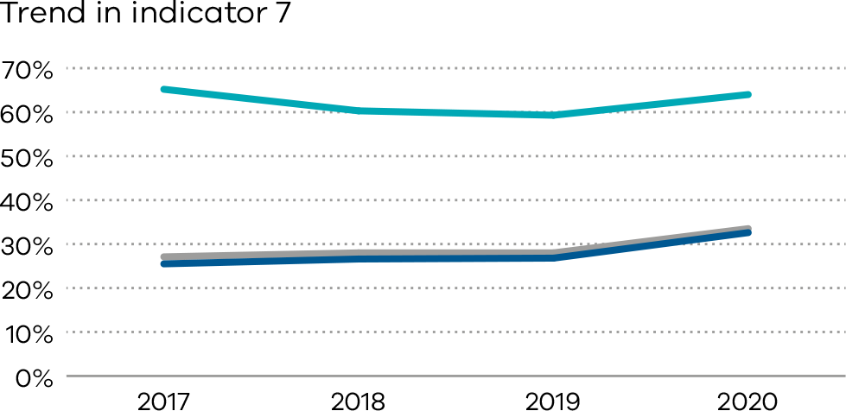

Definitions and data source
The percentage of women who were reported as not smoking after 20 weeks’ gestation among those who were reported as having smoked before 20 weeks. Women who were reported as not smoking before 20 weeks and women whose smoking status before 20 weeks was missing are excluded from the denominator. Women whose smoking status at 20 or more weeks was not reported are included in the denominator.
Services with fewer than 10 women who reported as having smoked before 20 weeks’ gestation are excluded from public reporting. Services with 10 or more women who reported as having smoked before 20 weeks’ gestation are only included if they are missing less than 20 per cent of data about smoking in the second half of pregnancy. Missing data in individual services ranged from zero to 75 per cent.

Data source: Victorian Perinatal Data Collection
Data for this indicator is sourced from the VPDC for the calendar year from 1 January 2020 to 31 December 2020.
This indicator is derived using the following VPDC variables: ‘maternal smoking at less than 20 weeks’ and ‘maternal smoking at more than or equal to 20 weeks’.
Numerator/denominator
Indicator | Numerator | Denominator
Indicator 7: Rate of smoking cessation during pregnancy | The number of women who were reported as having not stopped smoking after 20 weeks’ gestation among those who smoked before 20 weeks | The number of women who smoked before 20 weeks’ gestation

8a, 8b and 8c: Breastfeeding in hospital
Monitoring indicators of breastfeeding practices is important to protect and evaluate progress of breastfeeding promotion efforts. Current breastfeeding practices in most high-income countries including Australia fall short of the international recommendations of exclusive breastfeeding under six months and continued breastfeeding until two years.

About this indicator
These indicators assess the initiation of breastfeeding in Victorian hospitals during the birthing episode (hospital admission only), namely:
- Indicator 8a: rate of breastfeeding initiation in mothers of term babies
- Indicator 8b: rate of use of infant formula in hospital in term breastfed babies
- Indicator 8c: rate of final feed before discharge taken exclusively from the breast for term breastfed babies.
These indicators do not capture data on whether breastfeeding is maintained longer term.
There are short and long-term health benefits for women and their babies associated with breastfeeding. Breastfeeding provides optimal nourishment for a growing baby’s physical, cognitive and immunological development. It improves the bond between mother and baby and lowers the risk of various long-term health issues for both mothers and babies.
Health services have a responsibility to promote and support breastfeeding. Clinicians should assist women to recognise when their babies need feeding and offer help if required. Providing women with accurate information about the importance of breastfeeding to their health and their babies’ health can influence infant feeding decisions.

Observations on the data

2019
The statewide rate of women with term babies who initiated breastfeeding (Indicator 8a) was 95.9 per cent in 2019.
The statewide rate of term breastfed babies given infant formula in hospital (Indicator 8b) was 30 per cent in 2019.
The statewide rate of final feed exclusively from the breast for term breastfed babies (Indicator 8c) was 73.4 per cent in 2019.

2020
The statewide rate of women with term babies who initiated breastfeeding (Indicator 8a) in 2020 was 95.6 per cent (Figure 32). This rate has been relatively consistent over time.
30.5 per cent of term breastfed babies were given infant formula in hospital (Indicator 8b). The rate varied between hospitals including those providing a similar level of care (Figure 34). Overall, private hospitals had a higher rate of use of infant formula compared with public hospitals (40.5 and 27.8 per cent respectively).
The statewide rate of final feed exclusively from the breast for term breastfed babies (Indicator 8c) fell for the fifth consecutive year from 76.8 per cent in 2016, 75.1 per cent in 2017, 74.1 per cent in 2018, 73.4 in 2019 to 73.1 per cent in 2020 (Figure 36). This rate varied from 48.4 per cent to 100 per cent in 2020.

Strategies for improvement
- Consider achieving and maintaining up to date evidence-based policies and practices that align with the Baby Friendly Health Initiative <https://bfhi.org.au>.
- Ensure referral pathways to specialist lactation services are clear and accessible.
- Analyse the factors associated with reduced rates of breastfeeding in hospital.
- Ensure formula use for breastfed babies is limited to those who have a clear medical indication. Educate women on the reasons for this.
- Promote the competency and confidence of midwives and other clinicians in providing breastfeeding support and education.
- Provide women of culturally diverse backgrounds with additional support. This may include providing accurate and appropriately translated (verbal and written) information about the importance of breastfeeding.
[Break out box text:

What pregnant women and families need to know
Breastfeeding is best for newborn babies.
Hospitals should encourage new mothers to breastfeed by providing the right environment, and the right support from midwives and lactation specialists.
We measure three things:
(a) how many women start feeding their babies with breast milk
(b) how many also give formula to their breastfed babies while they are still in hospital
(c) how many women give their baby’s last feed completely from the breast before they go home from hospital.
We’re pleased to see most babies are fed first with breast milk, and this rate is high across nearly all hospitals. However, some hospitals have a high rate of breastfed babies who are supplemented with formula while in hospital. This might mean that hospitals can’t provide enough support for new mothers to breastfeed.
By the time new mothers and babies are going home from hospital many are not fully breastfeeding. This could also be improved and women will continue to be supported at home.
End of break out box text.]
Figure 32. Indicator 8a: Rate of breastfeeding initiation by women who gave birth at ≥ 37 weeks’ gestation, 2020
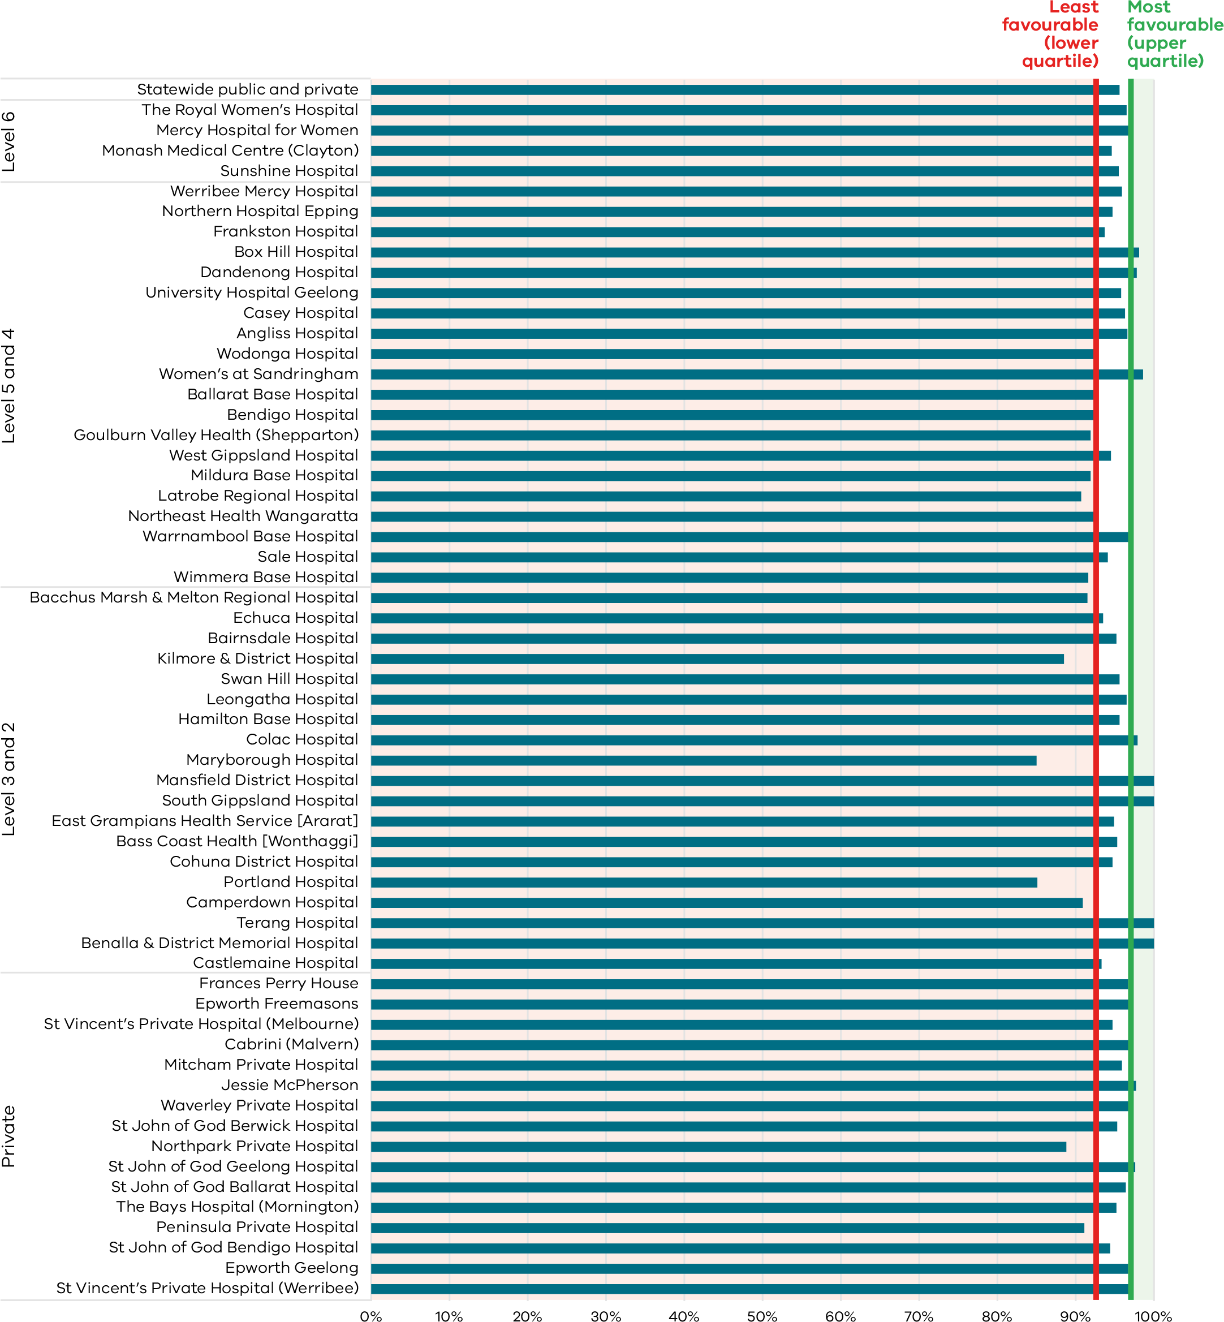
Figure 33. Funnel plot of the rate of breastfeeding initiation by women who gave birth at ≥ 37 weeks’ gestation, 2020
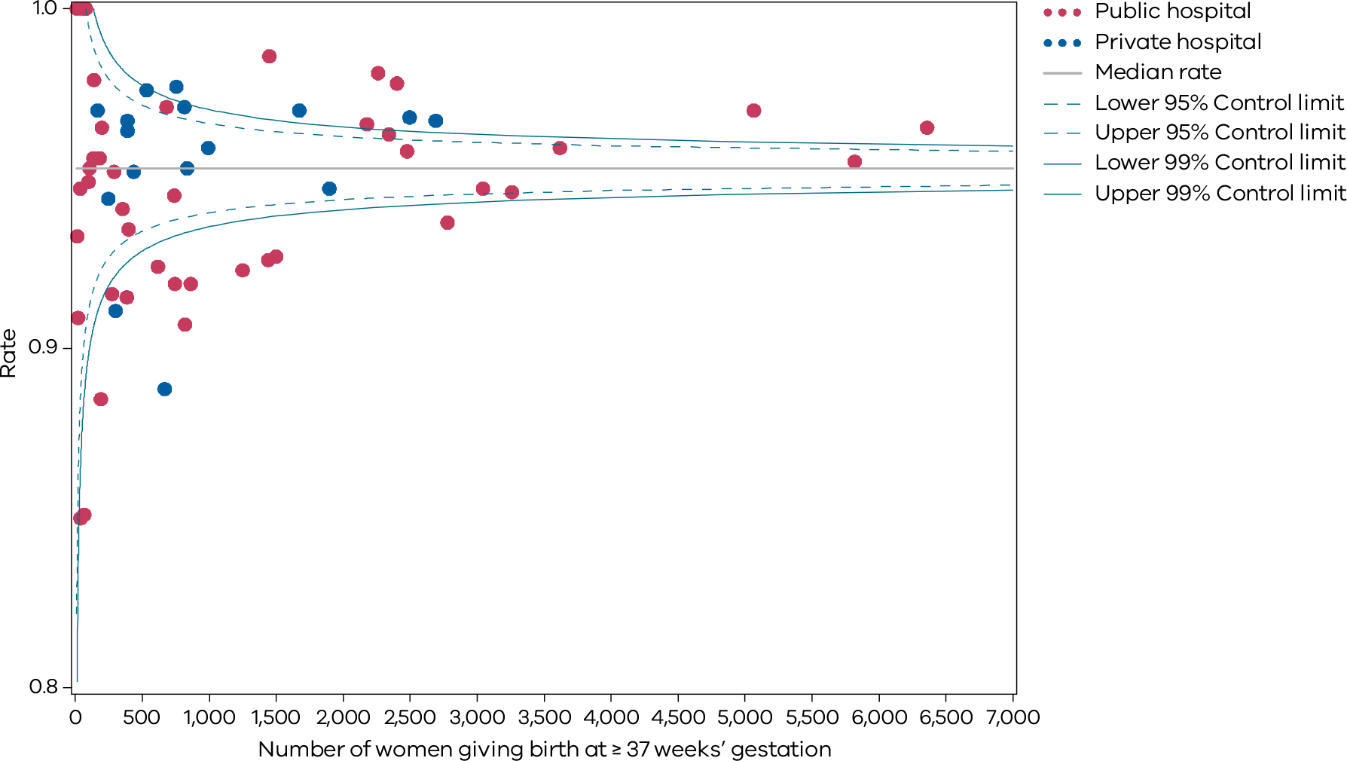
Table 15. Rate of breastfeeding initiation for babies born at ≥ 37 weeks’ gestation, 2017–2020
 | 2017 | 2018 | 2019 | 2020
Public | 95.0% | 95.4% | 95.6% | 95.4%
Private | 96.5% | 96.7% | 97.0% | 95.9%
Combined | 95.4% | 95.7% | 95.9% | 95.6%
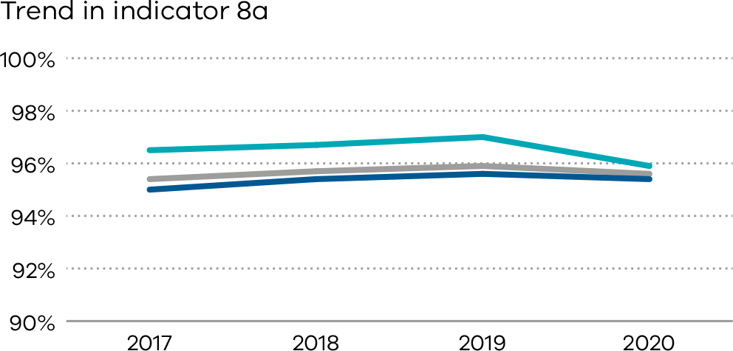
Figure 34. Indicator 8b: Rate of use of infant formula in hospital by breastfed babies born at ≥ 37 weeks’ gestation, 2020
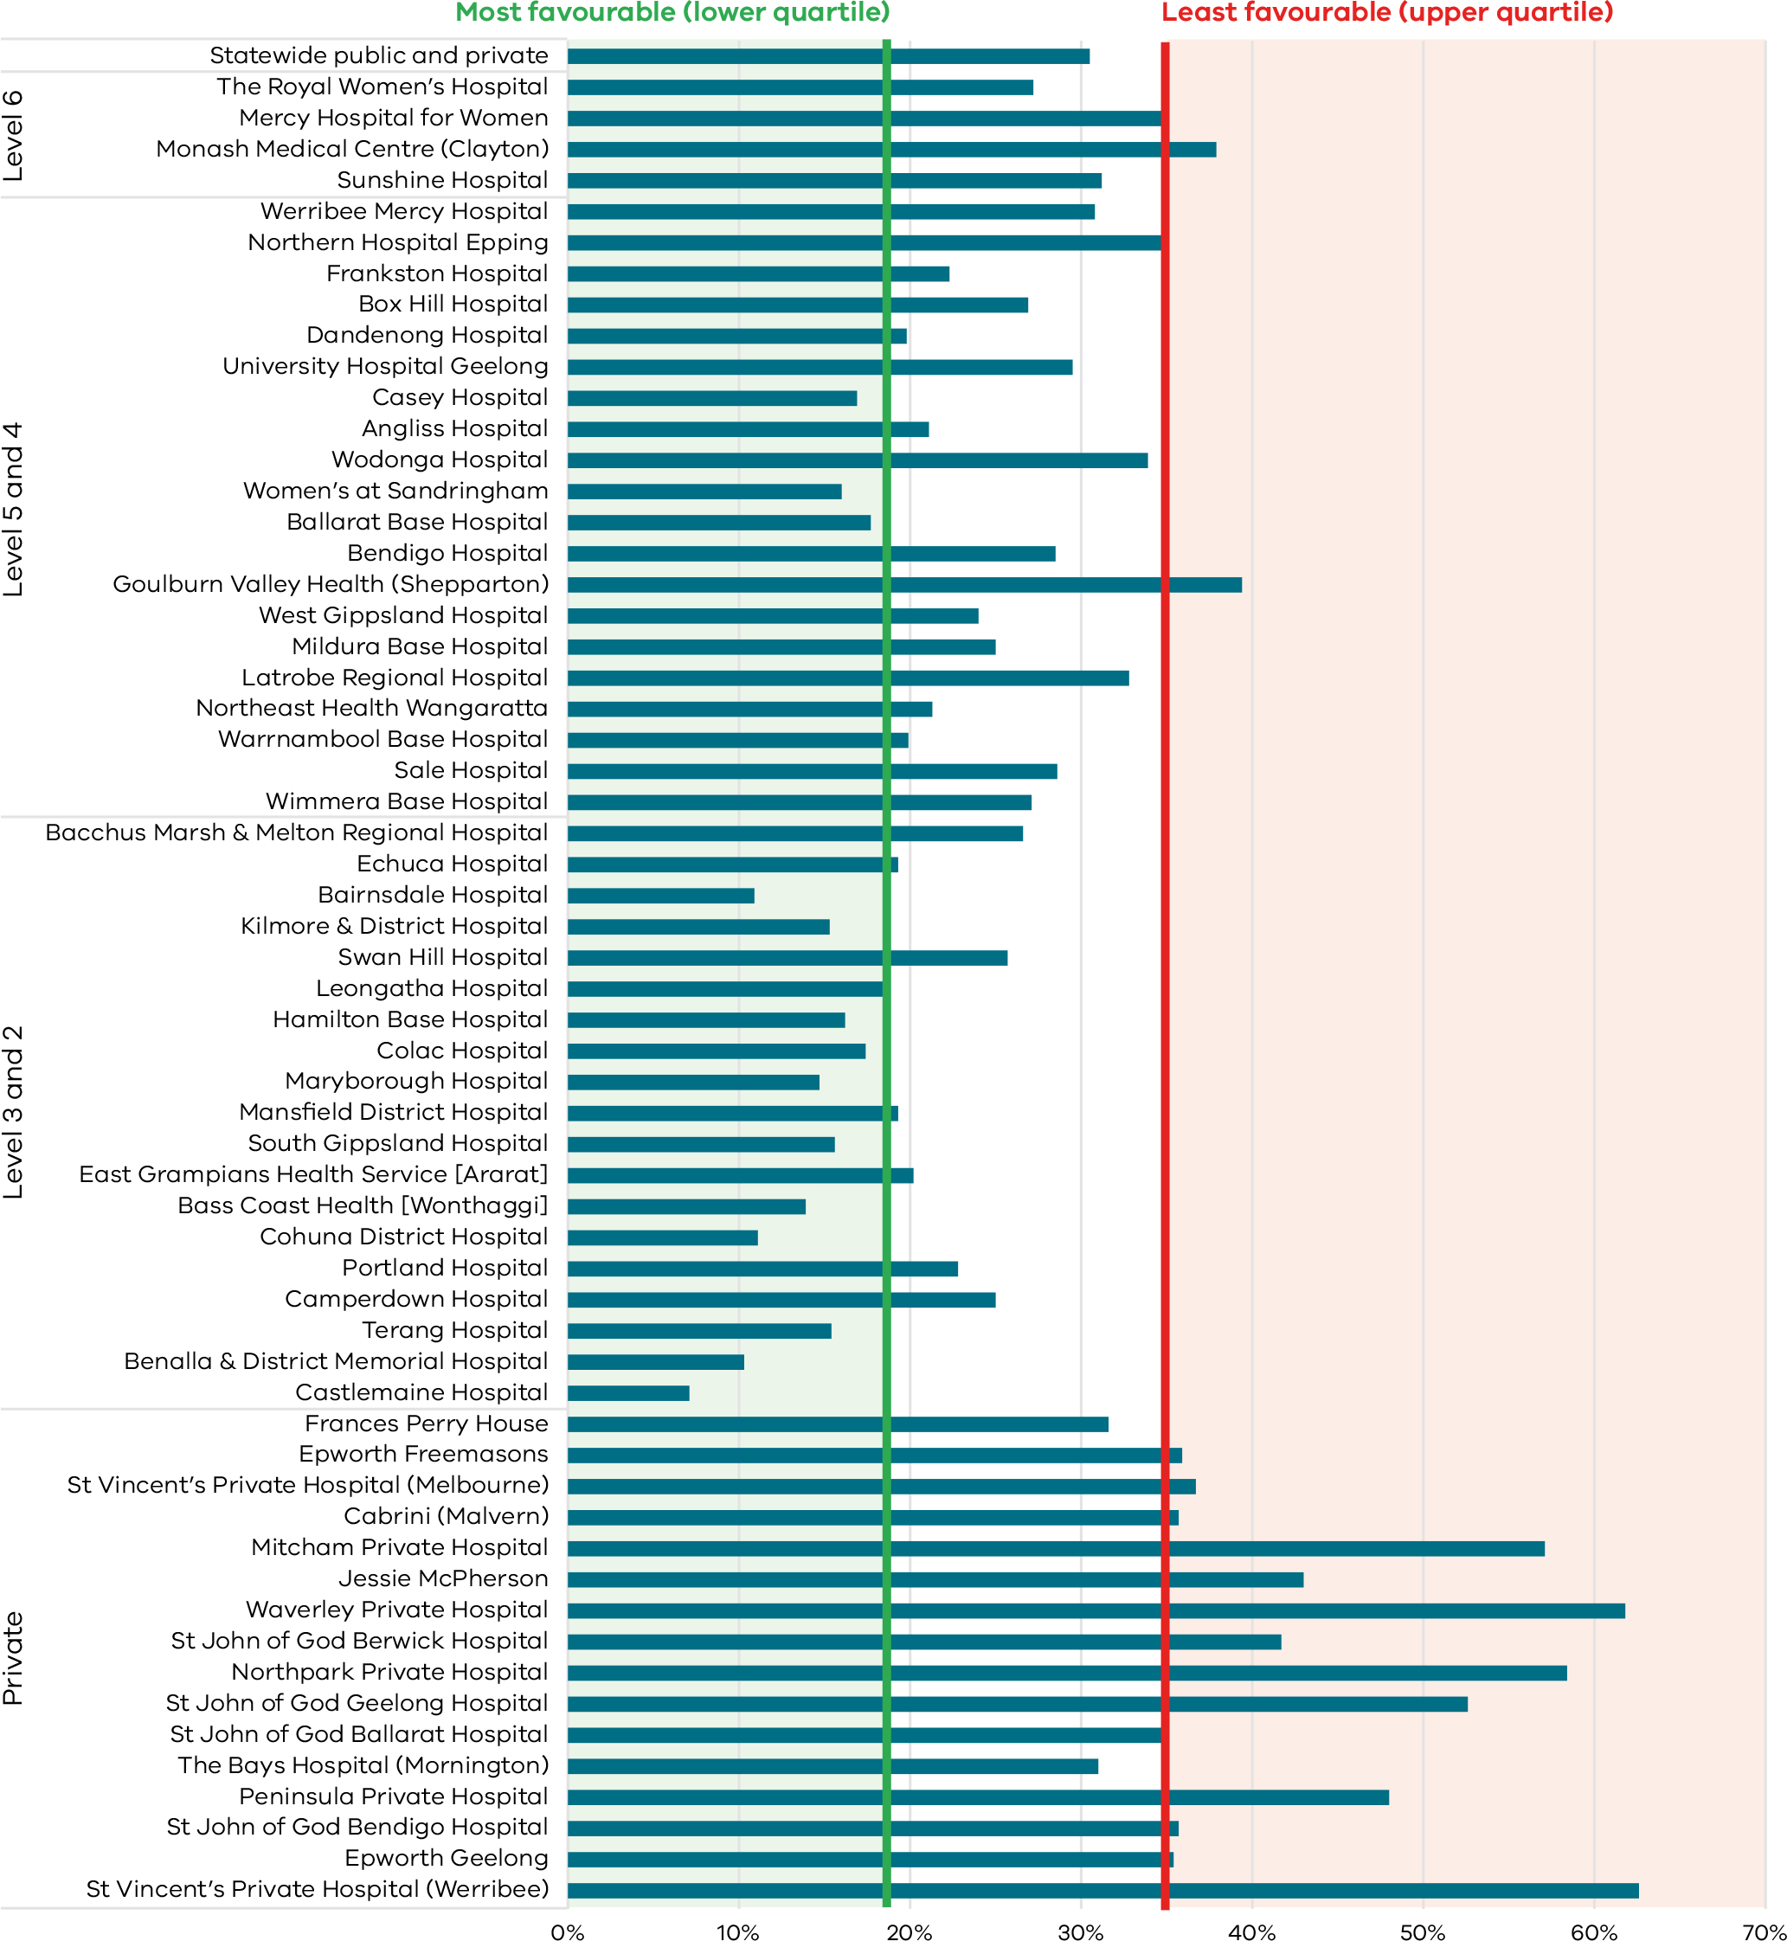
Figure 35. Funnel plot of the rate of use of infant formula in hospital by breastfed babies born at ≥ 37 weeks’ gestation, 2020
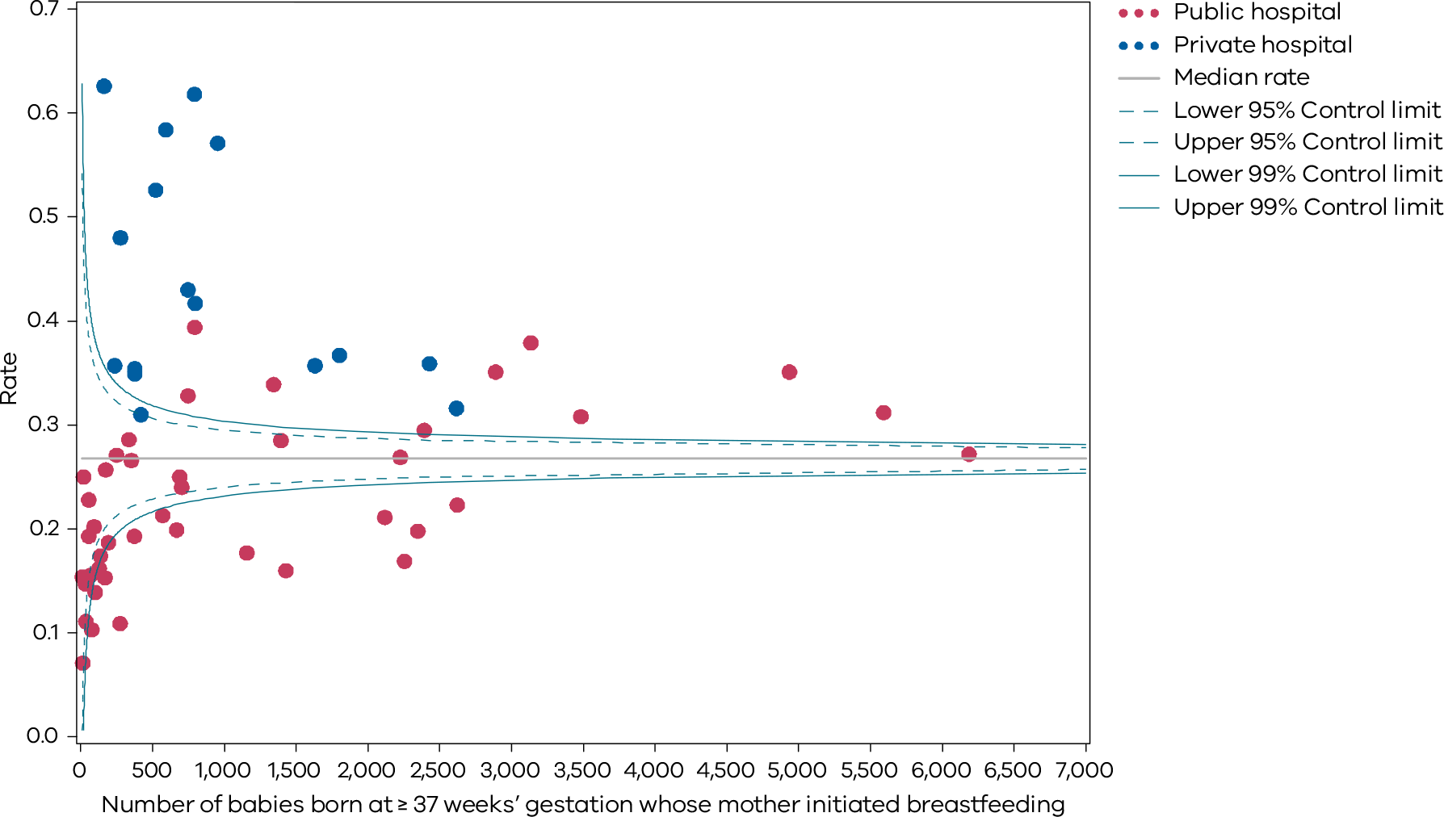
Table 16. Rate of use of infant formula in hospital by breastfed babies born at ≥ 37 weeks’ gestation, 2017–2020
 | 2017 | 2018 | 2019 | 2020
Public | 25.2% | 27.0% | 27.6% | 27.8%
Private | 38.2% | 37.8% | 38.5% | 40.5%
Combined | 28.2% | 29.4% | 30.0% | 30.5%
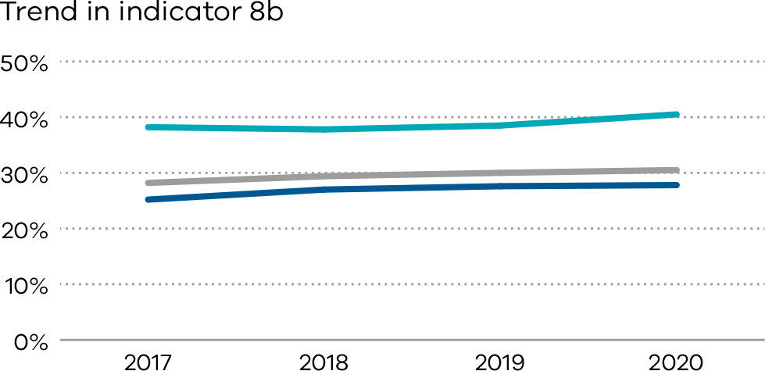
Figure 36. Indicator 8c: Rate of final feed being taken directly from the breast by breastfed babies born at ≥ 37 weeks’ gestation, 2020
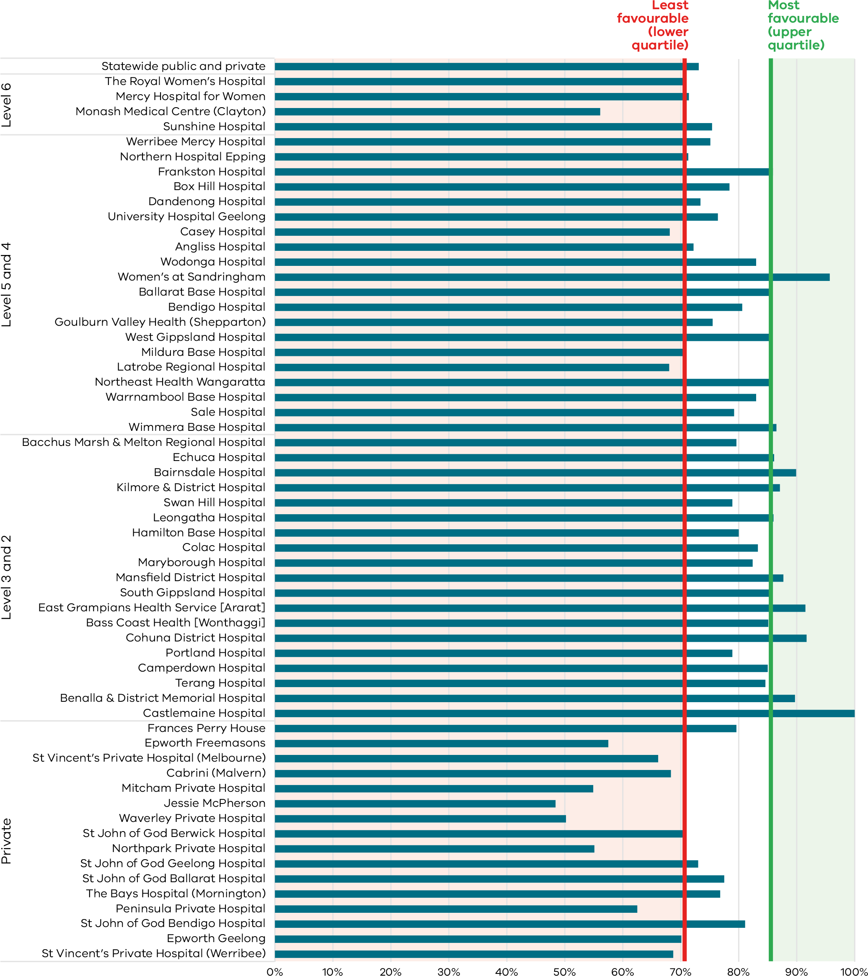
Figure 37. Funnel plot of the rate of final feed being taken directly from the breast by breastfed babies born at ≥ 37 weeks’ gestation, 2020
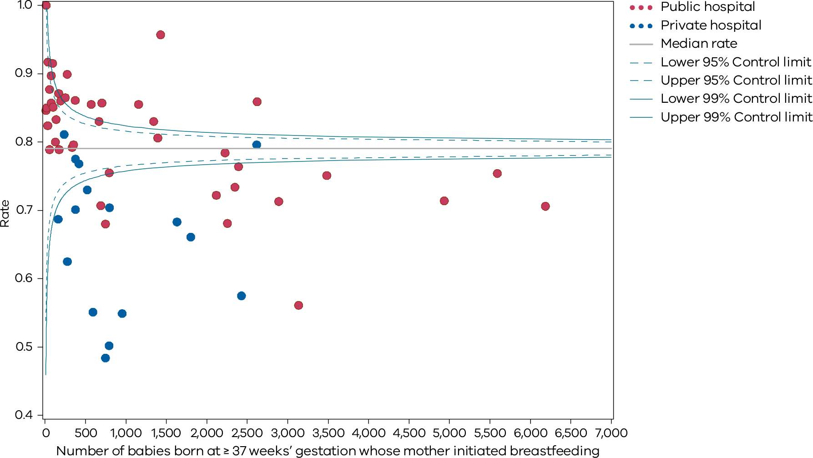
Table 17. Rate of final feed being taken directly from the breast by breastfed babies born at ≥ 37 weeks’ gestation, 2017–2020
 | 2017 | 2018 | 2019 | 2020
Public | 76.1% | 75.3% | 74.9% | 75.0%
Private | 71.5% | 69.6% | 68.1% | 65.8%
Combined | 75.1% | 74.1% | 73.4% | 73.1%
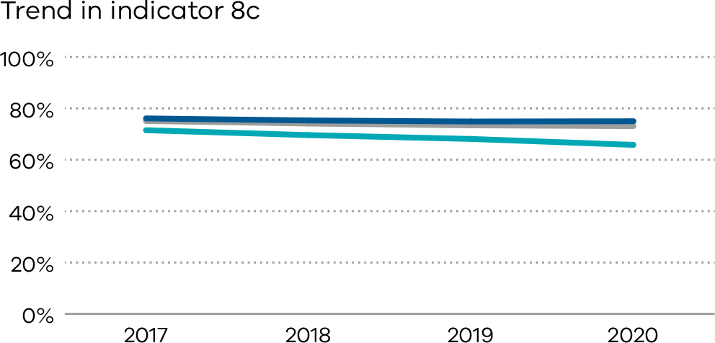

9: First antenatal visit
Antenatal care is a planned visit between a pregnant woman and a maternity healthcare provider to assess and improve the health of the mother and baby during pregnancy. Early antenatal care represents an opportunity to treat and provide advice on existing health conditions and plan ongoing investigations and management. Regular antenatal care, and especially that starting in the first trimester, is associated with fewer pregnancy related complications and with positive maternal and child health outcomes

About this indicator
This indicator reports the rate of women who had their first antenatal visit with a maternity care provider prior to 12 weeks’ gestation. The first antenatal visit is defined as the first visit to a midwife or doctor arranged specifically for providing pregnancy care.
This first antenatal visit may occur in the community or at a hospital and may be facilitated by a range of health professional groups. This diversity is important as it allows different approaches to care and choices for women.
It is recommended that women attend their first antenatal care visit within the first 12 weeks of pregnancy. Timely access to care allows for early detection of certain conditions and appropriate management of the pregnancy.
Late access to antenatal care is associated with less favourable outcomes for women and their babies.

Observations on the data

2019
The overall proportion of women who had their first antenatal visit recorded as occurring before 12 weeks’ gestation was 65.9 per cent in 2019.

2020
The overall proportion of women who had their first antenatal visit recorded as occurring before 12 weeks’ gestation increased to 73.6 per cent in 2020 from 65.9 per cent in 2019 (Figure 38). The rate varied between public and private hospitals (70.1 and 86.5 per cent respectively).
The data reported to the VPDC for this measure has limitations. Data may not include early antenatal visits to a general practitioner that include referral for antenatal investigations or may include visits for reasons other than pregnancy care. Given this, hospitals should review their data collection processes to ensure accurate capture of care provided in the community.

Strategies for improvement
- Health services should develop strategies to address barriers to early antenatal care.
- Identify high-risk women who may require a more focused approach to ensure early and ongoing access to antenatal care.
- Improve the accuracy of data by educating maternity staff to ask about antenatal care provided in the community – for example, by a general practitioner.
- Agree on local targets to guide incremental improvement and monitor progress.
[Break out box text:

What pregnant women and families need to know
During pregnancy there are some very specific health issues that can arise, and it is important that women who are pregnant see their midwife or doctor early in the pregnancy.
This indicator measures how many women see their midwifery or medical carers before the pregnancy is 12 weeks so that any special needs can be met.
We aim for all pregnant women to attend an antenatal visit before the pregnancy is 12 weeks, but the graph on the following page shows that in some areas the rate is quite low.
End of break out box text.]
Figure 38. Indicator 9: Rate of women attending their first antenatal visit prior to 12 weeks’ gestation, 2020
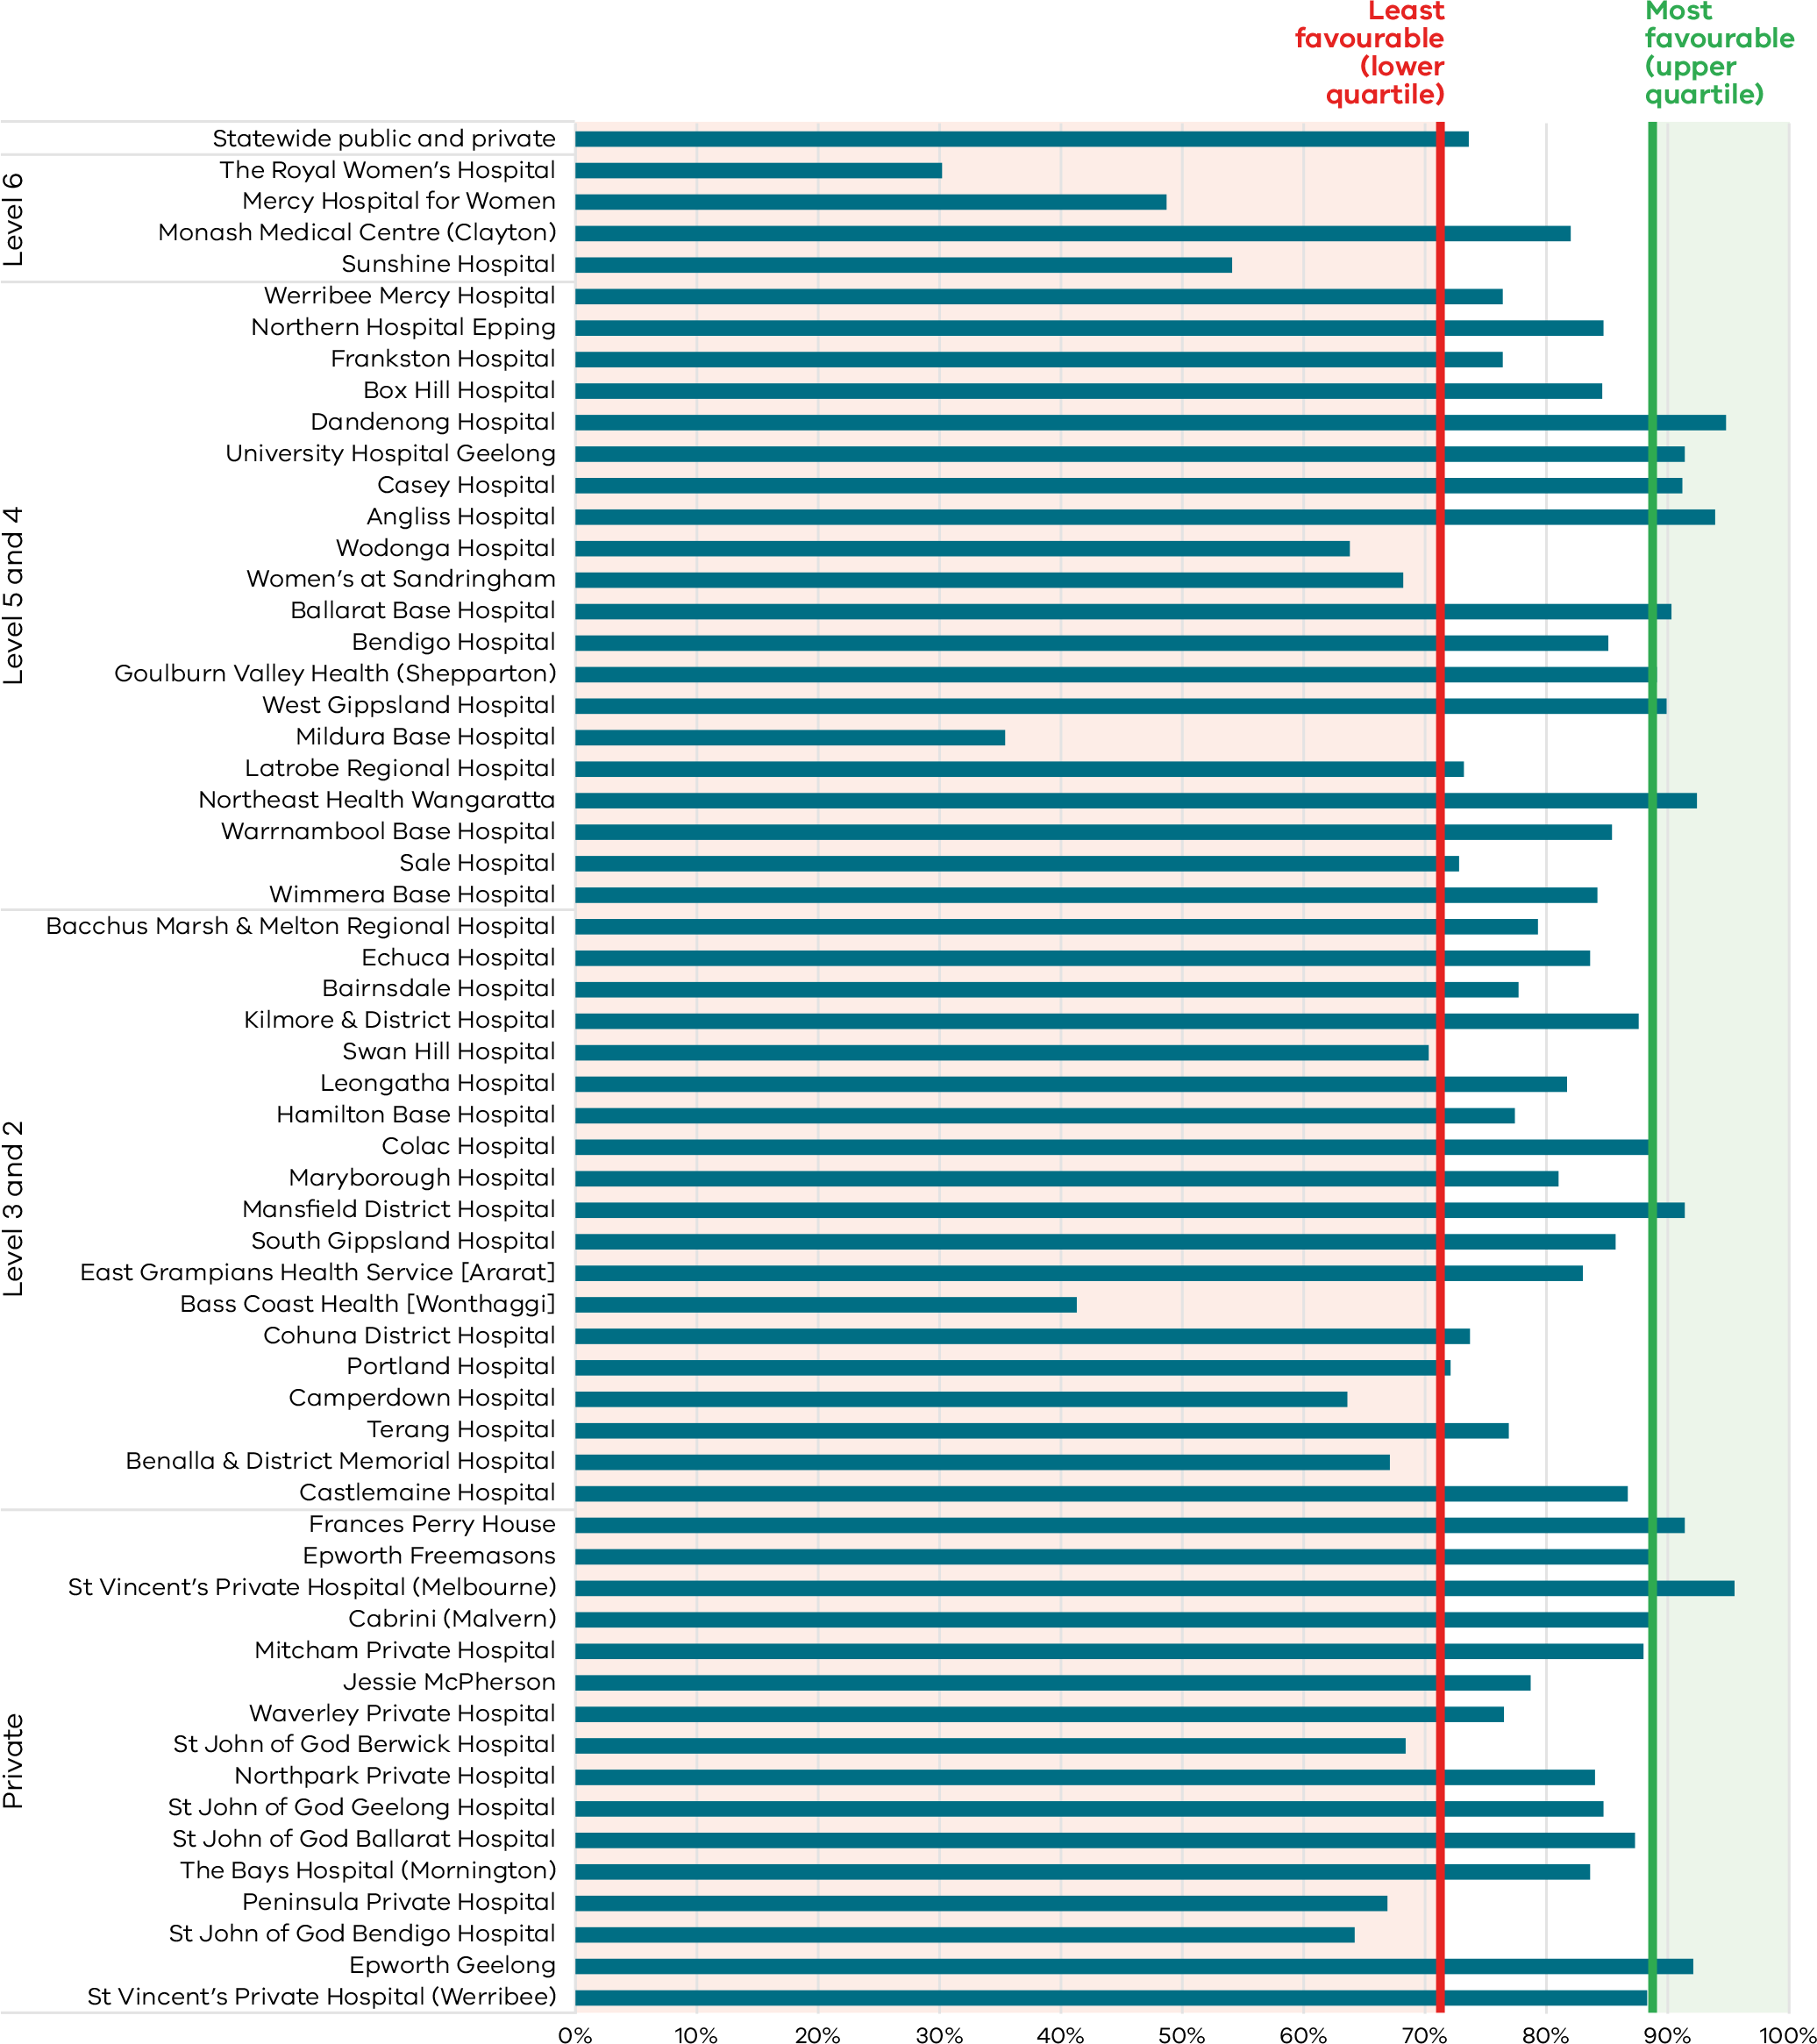
Figure 39. Funnel plot the rate of women attending their first antenatal visit prior to 12 weeks’ gestation, 2020
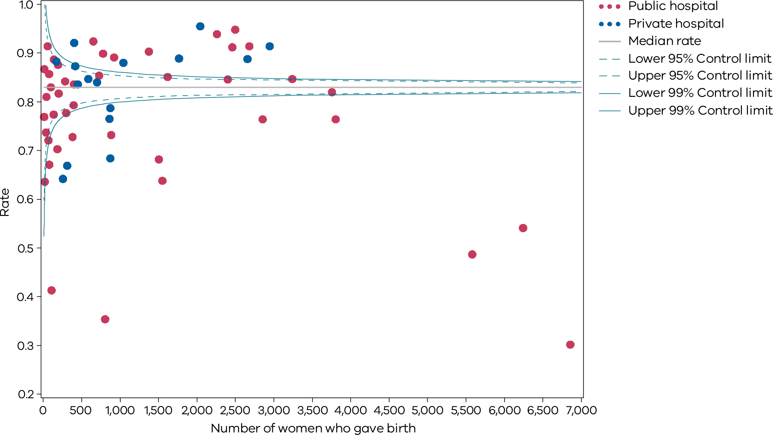
Table 18. Rate of women attending their first antenatal visit prior to 12 weeks’ gestation, 2017–2020
 | 2017 | 2018 | 2019 | 2020
Public | 44.5% | 51.5% | 59.9% | 70.1%
Private | 86.9% | 87.1% | 86.8% | 86.5%
Combined | 54.1% | 59.5% | 65.9% | 73.6%
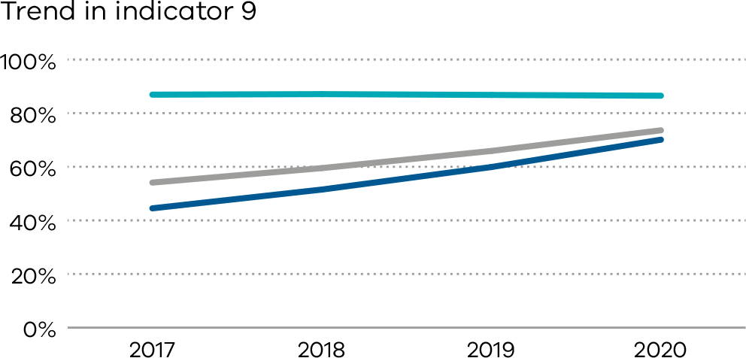

10: Low Apgar score
Apgar scores are clinical indicators of a baby’s condition shortly after birth. We expect babies who are born at 37 or more weeks’ gestation and without congenital anomalies to show a healthy physiological adaption to birth (be born in a healthy state) and not require significant resuscitation or immediate medical care. A low Apgar score at five minutes may reflect congenital anomaly, prematurity, perinatal infection, effects of maternal drug administration, ineffective resuscitation or prolonged hypoxia before birth. Maternal factors including increased maternal age, obesity, morbidity, diabetes and smoking in pregnancy may contribute to a baby being born with a low Apgar score.
The Apgar score is an assessment of a newborn’s wellbeing at birth based on five physiological attributes. This is recorded at one and five minutes (and longer if applicable). The five attributes are colour (circulation), breathing, heart rate, muscle tone and reflexes.
Each attribute is given a score of 0, 1 or 2, with a total minimum score of 0 (indicating no or greatly diminished signs of life) and a maximum score of 10 (indicating optimal outcome). An Apgar score below 7 at five minutes indicates a baby who requires ongoing resuscitation measures or additional care. This may be due to avoidable factors during labour, birth or resuscitation.

About this indicator
This indicator measures the wellbeing of babies who are born in hospital or as planned home births at 37 or more weeks’ gestation and without congenital anomalies at birth. It is used as a proxy for the quality of care during labour and birth and neonatal resuscitation, where necessary, following birth. The Apgar score is a validated measure of adverse long-term outcomes. This is potentially an important indicator for longer-term infant outcomes.

Observations on the data
In 2020, a five-minute Apgar score less than 7 was reported for 1.2 per cent of singleton, term babies across public and private hospitals combined. This was slightly less than the rate reported for 2019. The rate for private hospitals is lower compared to public hospitals (0.8 per cent and 1.3 per cent, respectively).
The rate varied between individual hospitals, from zero to 4.8 per cent (Figures 40 and 41); however, overall rates continued to remain stable over time (Table 19).

Strategies for improvement
- Health services should provide mandatory annual fetal surveillance education and competency.
- Have multi-disciplinary review of all cases with low Apgar scores at local level.
- Ensure clinicians are accurately recording Apgar scores.
- Facilitate education to all clinicians that may be involved in neonatal resuscitation <https://www.safercare.vic.gov.au/clinical-guidance/neonatal/resuscitation-of-neonates>. This may include midwives, doctors, code blue teams, emergency doctors and nurses.
- Have clear escalation pathways for deteriorating neonates.
[Break out box text:

What pregnant women and families need to know
The Apgar score is a score out of 10 used to measure how well a baby is soon after birth. It is usually measured twice – at one minute of age, and five minutes of age. If the score at five minutes is less than 7, babies need extra attention.
The rate of babies born with a five-minute Apgar score of less than 7 should be very low.
The graph on the following page shows that there is lots of variation between different hospitals.
End of break out box text.]
Figure 40. Indicator 10: Rate of term inborn babies without congenital anomalies with an Apgar score < 7 at five minutes, 2020
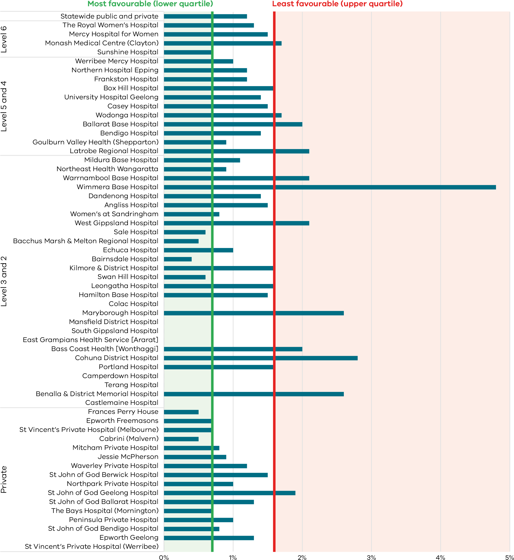
Figure 41. Funnel plot of the rate of term babies without congenital anomalies with an Apgar score < 7 at five minutes, 2020
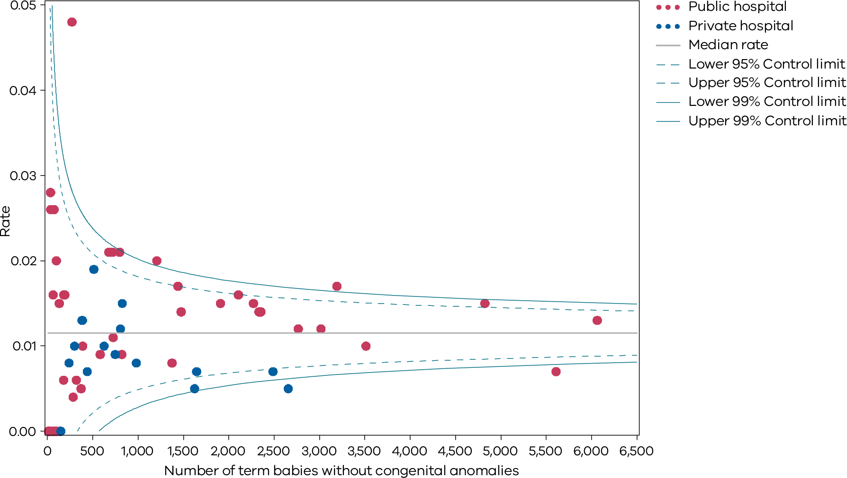
Please refer to page 9 for a guide on how to interpret funnel plots.
Table 19. Rate of term inborn babies without congenital anomalies with an Apgar score < 7 at five minutes, 2017–2020
 | 2017 | 2018 | 2019 | 2020
Public | 1.5% | 1.3% | 1.3% | 1.3%
Private | 1.0% | 1.1% | 1.0% | 0.8%
Combined | 1.3% | 1.3% | 1.3% | 1.2%
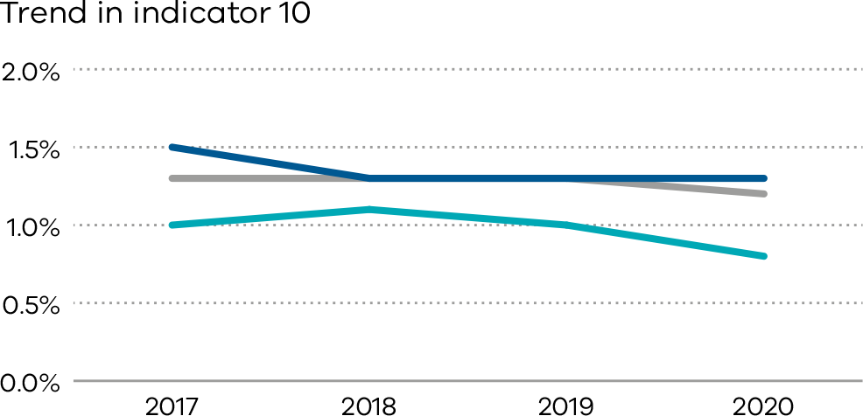

Definitions and data sources
The rate of term babies without congenital anomalies with an Apgar score of less than 7 at five minutes in Victorian hospitals.
Excludes babies born at less than 37 weeks’ gestation, infants born with congenital anomalies, stillbirths and babies born before arrival at hospital.
The Apgar score is used to evaluate the fitness of a newborn infant based on heart rate, respiration, muscle tone, reflexes and colour. The maximum or best score is 10. The Apgar score should be determined consistently and reliably according to best practice guidelines. Rates for this indicator should show little variation among peer-group services, and inter-rater reliability should be high within health services. This supports quality reporting of neonatal outcomes for meaningful comparisons.
Inborn is defined as a baby born at the reporting hospital.

Data source: Victorian Perinatal Data Collection
Data for this indicator is sourced from the VPDC for the calendar year from 1 January 2020 to 31 December 2020.
This indicator is derived using the following VPDC variables: ‘Apgar score at five minutes’, ‘estimated gestational age’, ‘birth status’, ‘setting of birth actual’ and ‘congenital anomalies indicator’.
Numerator/denominator
Indicator | Numerator | Denominator
Indicator 10: Rate of term babies without congenital anomalies with an Apgar score < 7 at five minutes | The number of inborn, liveborn, term babies without congenital anomalies with an Apgar score less than 7 at five minutes | The number of inborn, liveborn, term babies without congenital anomalies

11a and 11b: Women’s experiences of care
Any report on maternity and newborn outcomes cannot be complete without women’s voices being present, guiding plans for future improvement. Women are uniquely positioned to provide insightful comments about their care. Acknowledging that health outcomes and perceptions are not only influenced by the nature and quality of the clinical care provided but how that care is delivered, patient experience is critical to providing and improving healthcare. Through monitoring indicators of experience, it is possible to improve our understanding of women’s experience of care and identify areas for quality improvements and service redesign.

About these indicators
These indicators assess the experience of women who participated in the Victorian Healthcare Experience Survey and who received care from Victorian public hospital services during their labour and birth episode. The indicators are derived from two questions in the maternity questionnaire of the VHES:
- Indicator 11a: Question 36: Thinking about your care during labour and birth, were you involved, as much as you wanted to be, in decisions about your care?
- Indicator 11b: Question 51: Did you feel that midwives and other health professionals gave you consistent advice about feeding your baby?

Observations on the data
In 2020, 81.4 per cent of women who completed the survey across public hospitals responded that they felt involved, as much as they wanted to be, in decisions about their care (Indicator 11a, a slight increase from 80.0 per cent in 2018 (Figure 42). The funnel plot in Figure 43 shows a few hospitals with rates that were different from the state rate.
The proportion of women who felt they received consistent advice about feeding their baby from midwives and other health professionals (Indicator 11b) across public hospitals increased in 2020 to 49.2 per cent from a rate of 49.0 per cent in 2018. Figures 44 and Figure 45 show considerable variation between hospitals.

Strategies for improvement
- Work in partnership with women to deliver women-centred, coordinated care by promoting discussion regarding plans and expectations of labour and birth.
- Ensure there are adequate mechanisms to capture, review, report and act on feedback.
- Engage with women, carers and families to hear first-hand about their experiences.
- Ensure there is adequate time during both the antenatal and postnatal period to discuss and express concerns related to the information being provided.
[Break out box text:

What pregnant women and families need to know
We care what women think about the care they receive during pregnancy and birth.
We specifically measure what women think about how much their carers listened to their wishes, and the information they received about feeding their babies.
Most women are satisfied with the care they received. We hope to see women’s satisfaction with their birthing experience improve further.
End of break out box text.]
Figure 42. Indicator 11a: Rate of women who felt involved, as much as they wanted to be, in decisions about their care during labour and birth, 2020
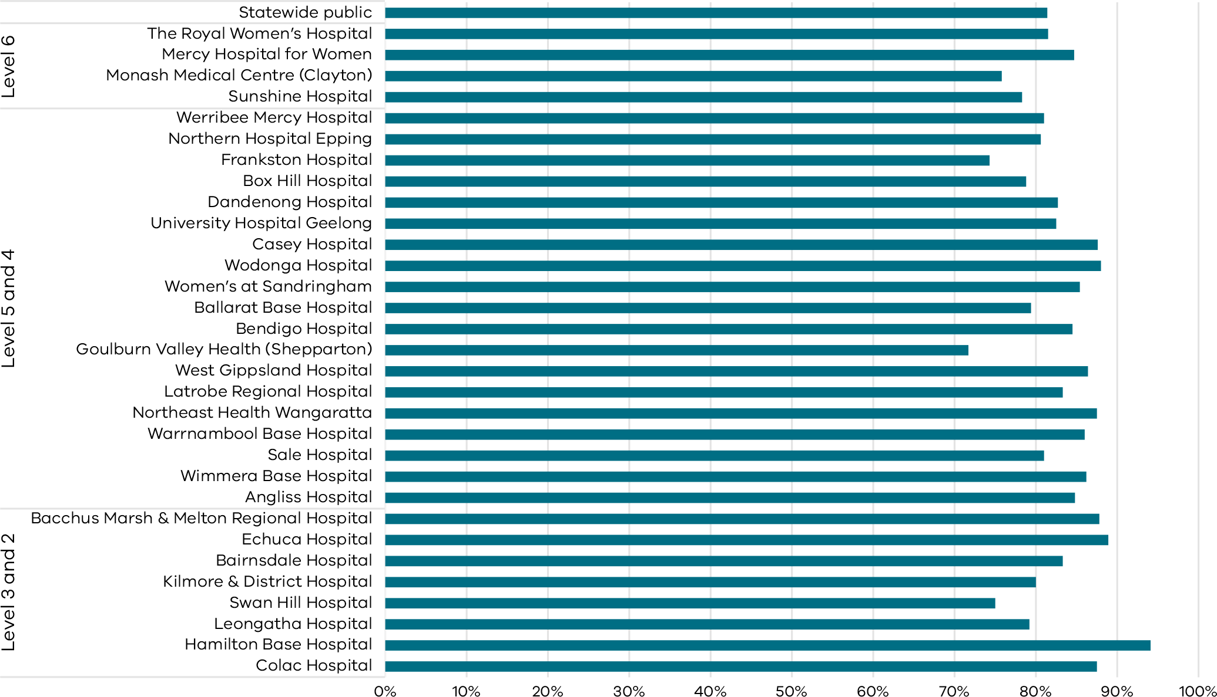
Note: No quartiles are presented for Indicator 11 since the measure is calculated from survey data and a different method of determining least and most favourable outcomes was applied (i.e. tested for significant difference compared to the rate for public hospitals).
The VHES only collects data from public hospitals and reports only on services with more than 10 responses in a year. As such, this indicator is only reported for public health services.
Figure 43. Funnel plot of the rate of women who felt involved, as much as they wanted to be, in decisions about their care during labour and birth, 2020
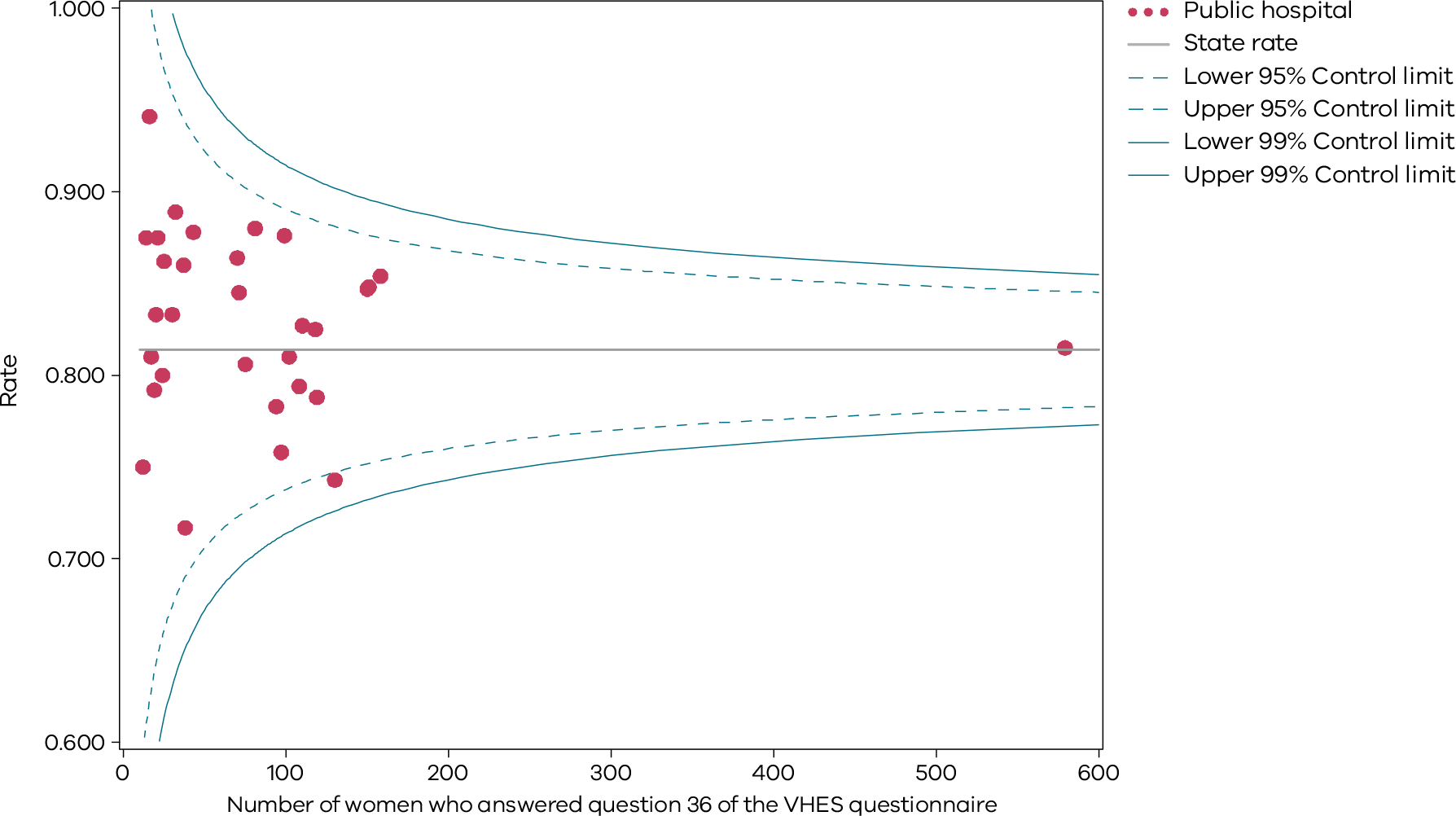
Please refer to page 9 for a guide on how to interpret funnel plots.
Table 20. Rate of women who felt involved, as much as they wanted to be, in decisions about their care during labour and birth, 2017–20
 | 2017 | 2018 | 2019 | 2020
Public | 78.9% | 80.0% | 80.0% | 81.4%
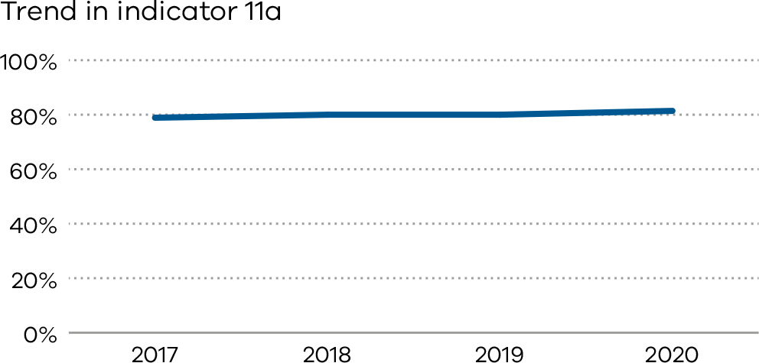
Figure 44. Indicator 11b: Rate of women who felt that midwives and other health professionals gave them consistent advice about feeding their baby, 2020
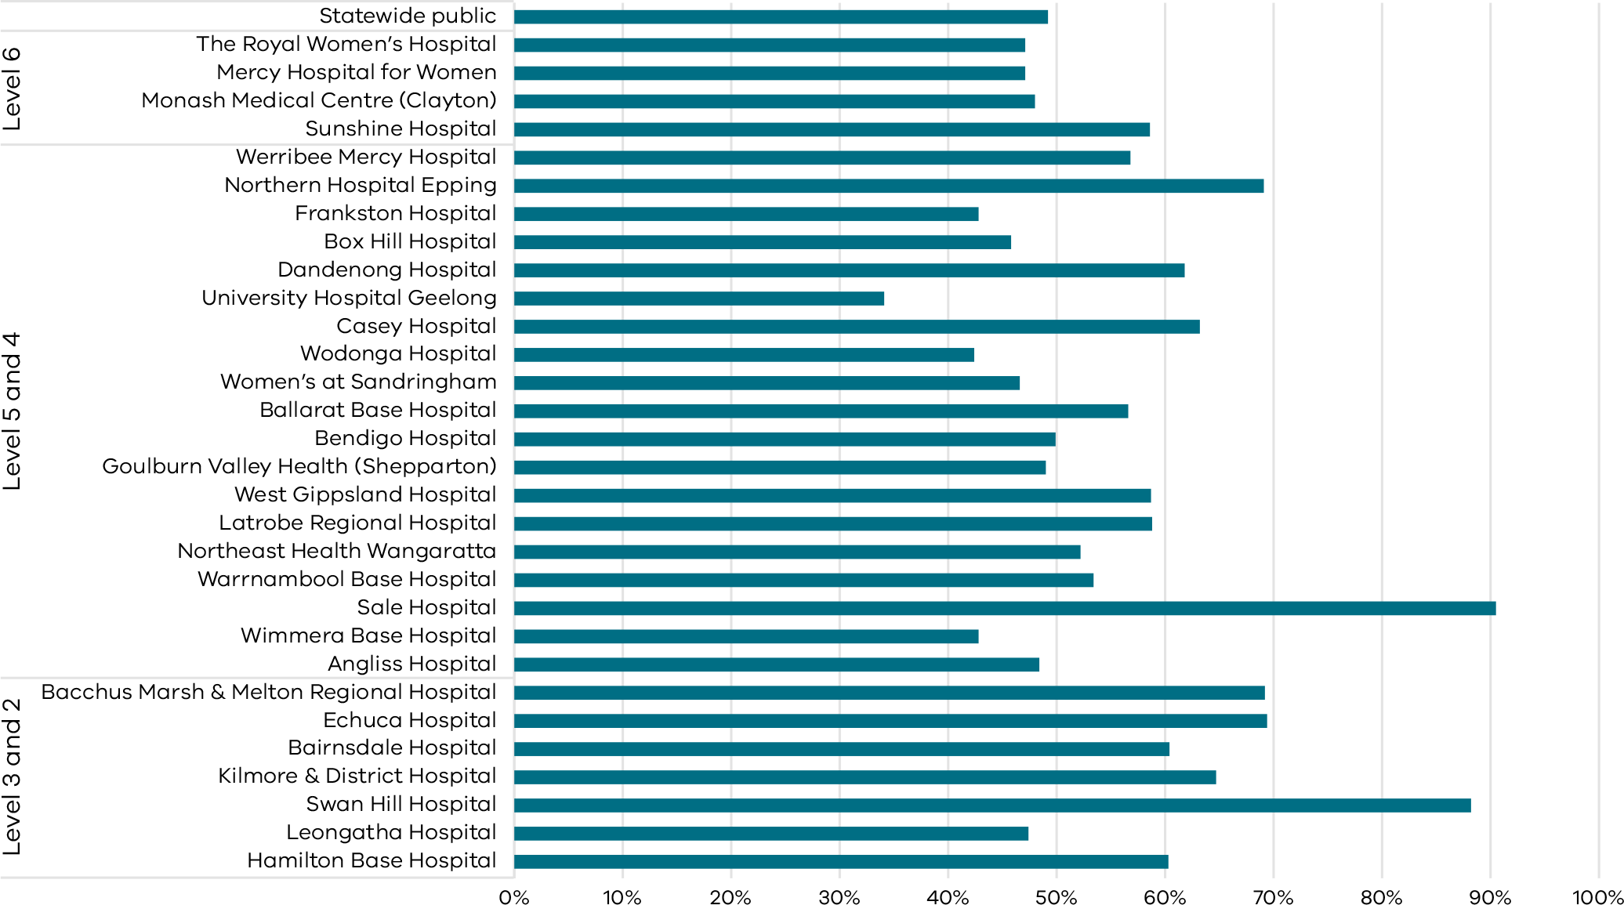
Note: No quartiles are presented for Indicator 11 since the measure is calculated from survey data and a different method of determining least and most favourable outcomes was applied (i.e. tested for significant difference compared to the rate for public hospitals).
The VHES only collects data from public hospitals and reports only on services with more than 10 responses in a year. As such, this indicator is only reported for public health services.
Figure 45. Funnel plot of the rate of women who felt that midwives and other health professionals gave them consistent advice about feeing their baby, 2020
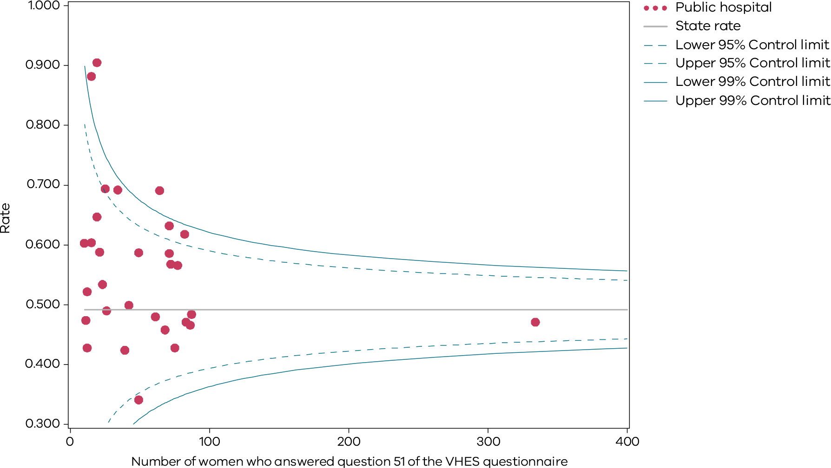
Please refer to page 9 for a guide on how to interpret funnel plots.
Table 21. Rate of women who felt that midwives and other health professionals gave them consistent advice about feeding their baby, 2017–20
 | 2017 | 2018 | 2019 | 2020
Public | 49.5% | 49.0% | 47.2% | 49.2%
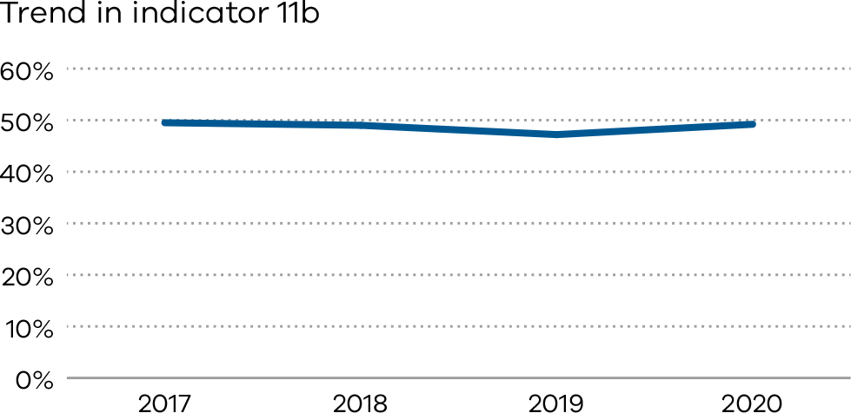

Definitions and data sources

Data source: IPSOS Social Research Institute analysis of the Victorian Healthcare Experience Survey
Data for this indicator is sourced from VHES for the calendar year from 1 January 2020 to 31 December 2020.
Results are not reported when there are fewer than 10 responses for a health service over a year, or when data were not provided by the health service.
Note: The VHES maternity questionnaire is distributed to a random sample of consumers following a hospital admission for pregnancy and birth.
Numerator/denominator
Indicator | Numerator | Denominator
Indicator 11a: Rate of women who felt involved, as much as they wanted to be, in decisions about their care during labour and birth | The number of women who answered ‘yes, always’ to question 36 of the VHES maternity questionnaire | The number of women who answered question 36 of the VHES maternity questionnaire
Indicator 11b: Rate of women who felt that midwives and other health professionals gave them consistent advice about feeding their baby | The number of women who answered ‘yes, always’ to question 51 of the VHES maternity questionnaire | The number of women who answered question 51 of the VHES maternity questionnaire

12a and 12b: Maternal vaccination
Pertussis and influenza vaccinations protect pregnant women and babies and are free to all pregnant women in Victoria.
Pertussis can cause serious complications including brain damage, pneumonia and sometimes death. Babies under six weeks of age are too young to be vaccinated so the best way of protecting young babies from pertussis is to vaccinate the mother during pregnancy. Vaccination during pregnancy reduced whooping cough disease in babies under three months by over 90%.
Influenza is a serious disease for pregnant women and the developing and newborn baby. Changes to immune, heart and lung function during pregnancy makes pregnant women more vulnerable to severe disease from influenza and pregnant women are twice as likely to require hospital admission for influenza.
Influenza vaccination is recommended for all pregnant women during any trimester. Pertussis vaccination is recommended to all pregnant women as a single dose between 20- and 32-weeks gestation.
The indicator includes women vaccinated at any point during their pregnancy.

About this indicator
These indicators present the proportion of women who were vaccinated against pertussis (whooping cough) and influenza (flu) at any time during their pregnancy. Specifically:
- Indicator 12a: the rate of women vaccinated for pertussis
- Indicator 12b: the rate of women vaccinated for influenza.
Influenza and pertussis vaccines protect pregnant women and babies from infections. These vaccines are available free to all pregnant women in Victoria. Influenza vaccination is recommended for all pregnant women during any trimester, while pertussis vaccination is recommended after 20 weeks. The indicator includes women vaccinated at any point during their pregnancy.
This indicator (Indicator 12b) presents the proportion of women who were vaccinated against influenza (flu) at any time during their pregnancy.
Influenza vaccine protects pregnant women from viral and bacterial infections, complications while pregnant and serious complications in their babies.

Observations on the data

2019
The rate of women who were vaccinated for pertussis during pregnancy (Indicator 12a) increased from 81.8 per cent in 2018 to 83.8 per cent in 2019.
The rate of women who were vaccinated for influenza during their pregnancy (Indicator 12b) increased from 67.1 per cent in 2018 to 74.6 per cent in 2019. The rate was higher in public than private hospitals, with 75.8 and 70.9 per cent respectively.

2020
84.3 per cent of women in 2020 were vaccinated for pertussis during pregnancy (Indicator 12a). The rate varied between public and private hospitals, with 91.1 per cent and 60.7 per cent respectively. There was variation between individual hospitals, ranging from 4.4 to 100.0 per cent (Figure 46).
The rate for influenza was slightly lower, with 81.8 per cent of women receiving vaccination for influenza during their pregnancy (Indicator 12b). This was an improvement from 2019 where only 74.6 per cent of women received vaccination for influenza. The rate was similar between public and private hospitals, with 82.3 and 80.7 per cent respectively. There was variation between individual hospitals, ranging from 53.3 per cent to 95.3 per cent (Figure 48).

Strategies for improvement
- Offer all women vaccination against pertussis and influenza.
- Provide women and their families with information about the risks associated with pertussis and influenza during pregnancy and the risks of these infections to their baby after birth.
[Break out box text:

What pregnant women and families need to know
Whooping cough (pertussis) and flu (influenza) are dangerous infections for pregnant women and newborn babies.
Whooping cough and flu vaccines are free for all pregnant women in Victoria.
Getting immunised reduces the chance of women or babies suffering any bad effects from these infections. Health services should offer immunisation for whooping cough and flu to all pregnant women. This is the only way we currently have to protect mothers and babies from these infections. The rates of vaccination are very different between hospitals. We hope more hospitals have higher vaccination rates in the future.
End of break out box text.]
Figure 46. Indicator 12a: Rate of women vaccinated for pertussis during pregnancy, 2020
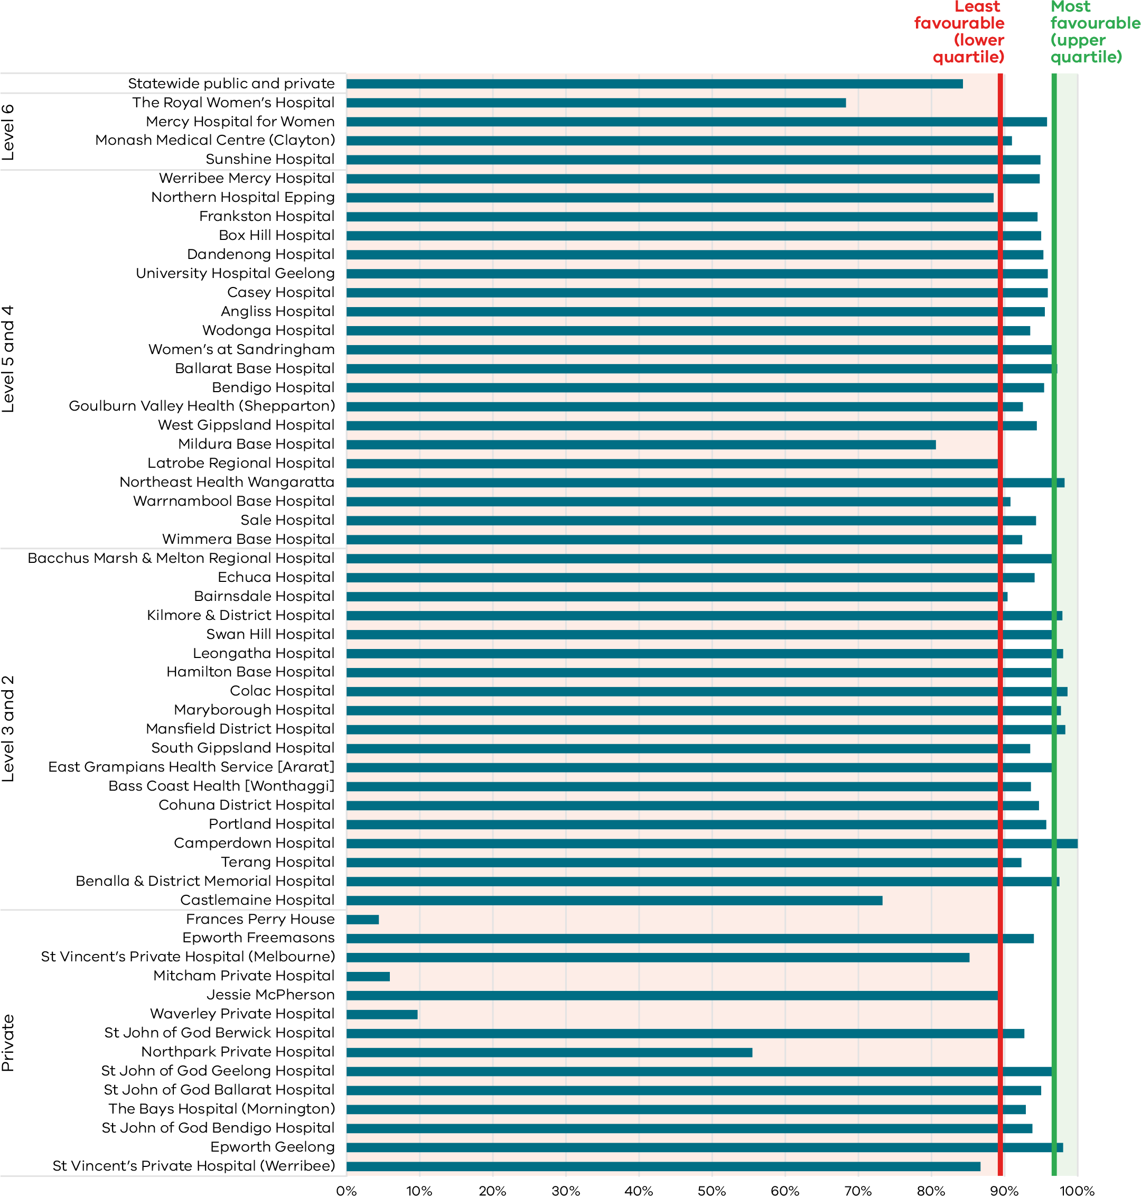
Figure 47. Funnel plot of the rate of women vaccinated for pertussis during pregnancy, 2020
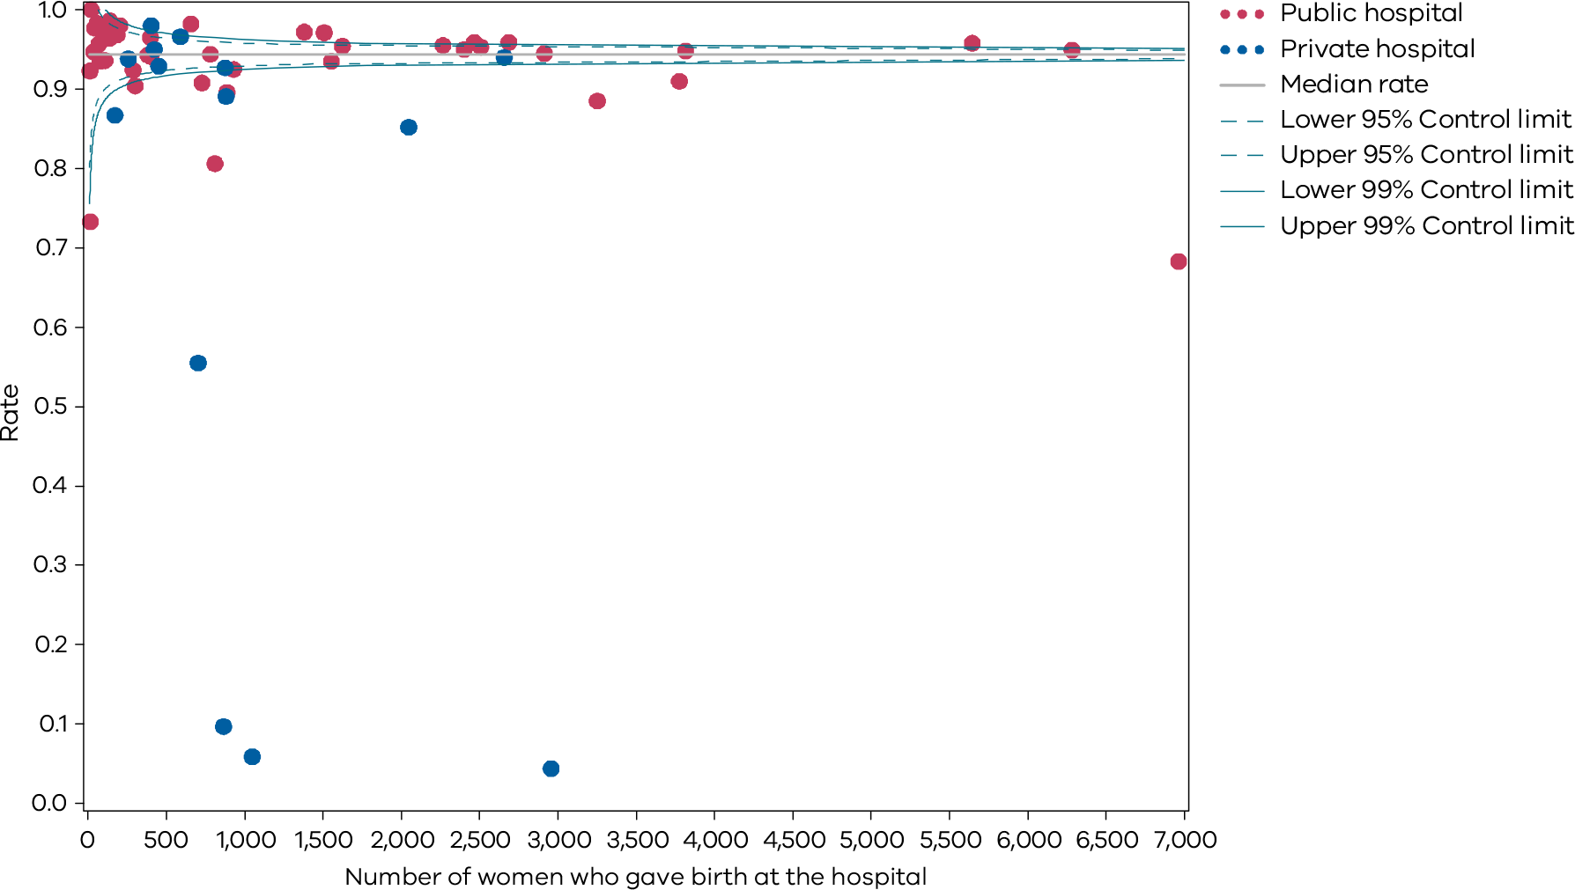
Table 22. Indicator 12a: Rate of women vaccinated for pertussis during pregnancy, 2017–20
 | 2017 | 2018 | 2019 | 2020
Public | 83.0% | 88.2% |  | 91.1%
Private | 59.9% | 60.4% |  | 60.7%
Combined | 77.5% | 81.8% |  | 84.3%
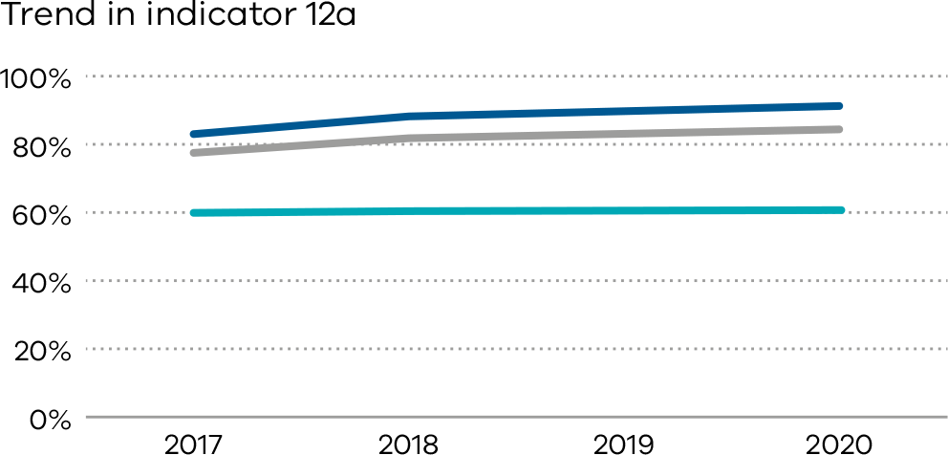
Figure 48. Indicator 12b: Rate of women vaccinated for influenza during pregnancy, 2020
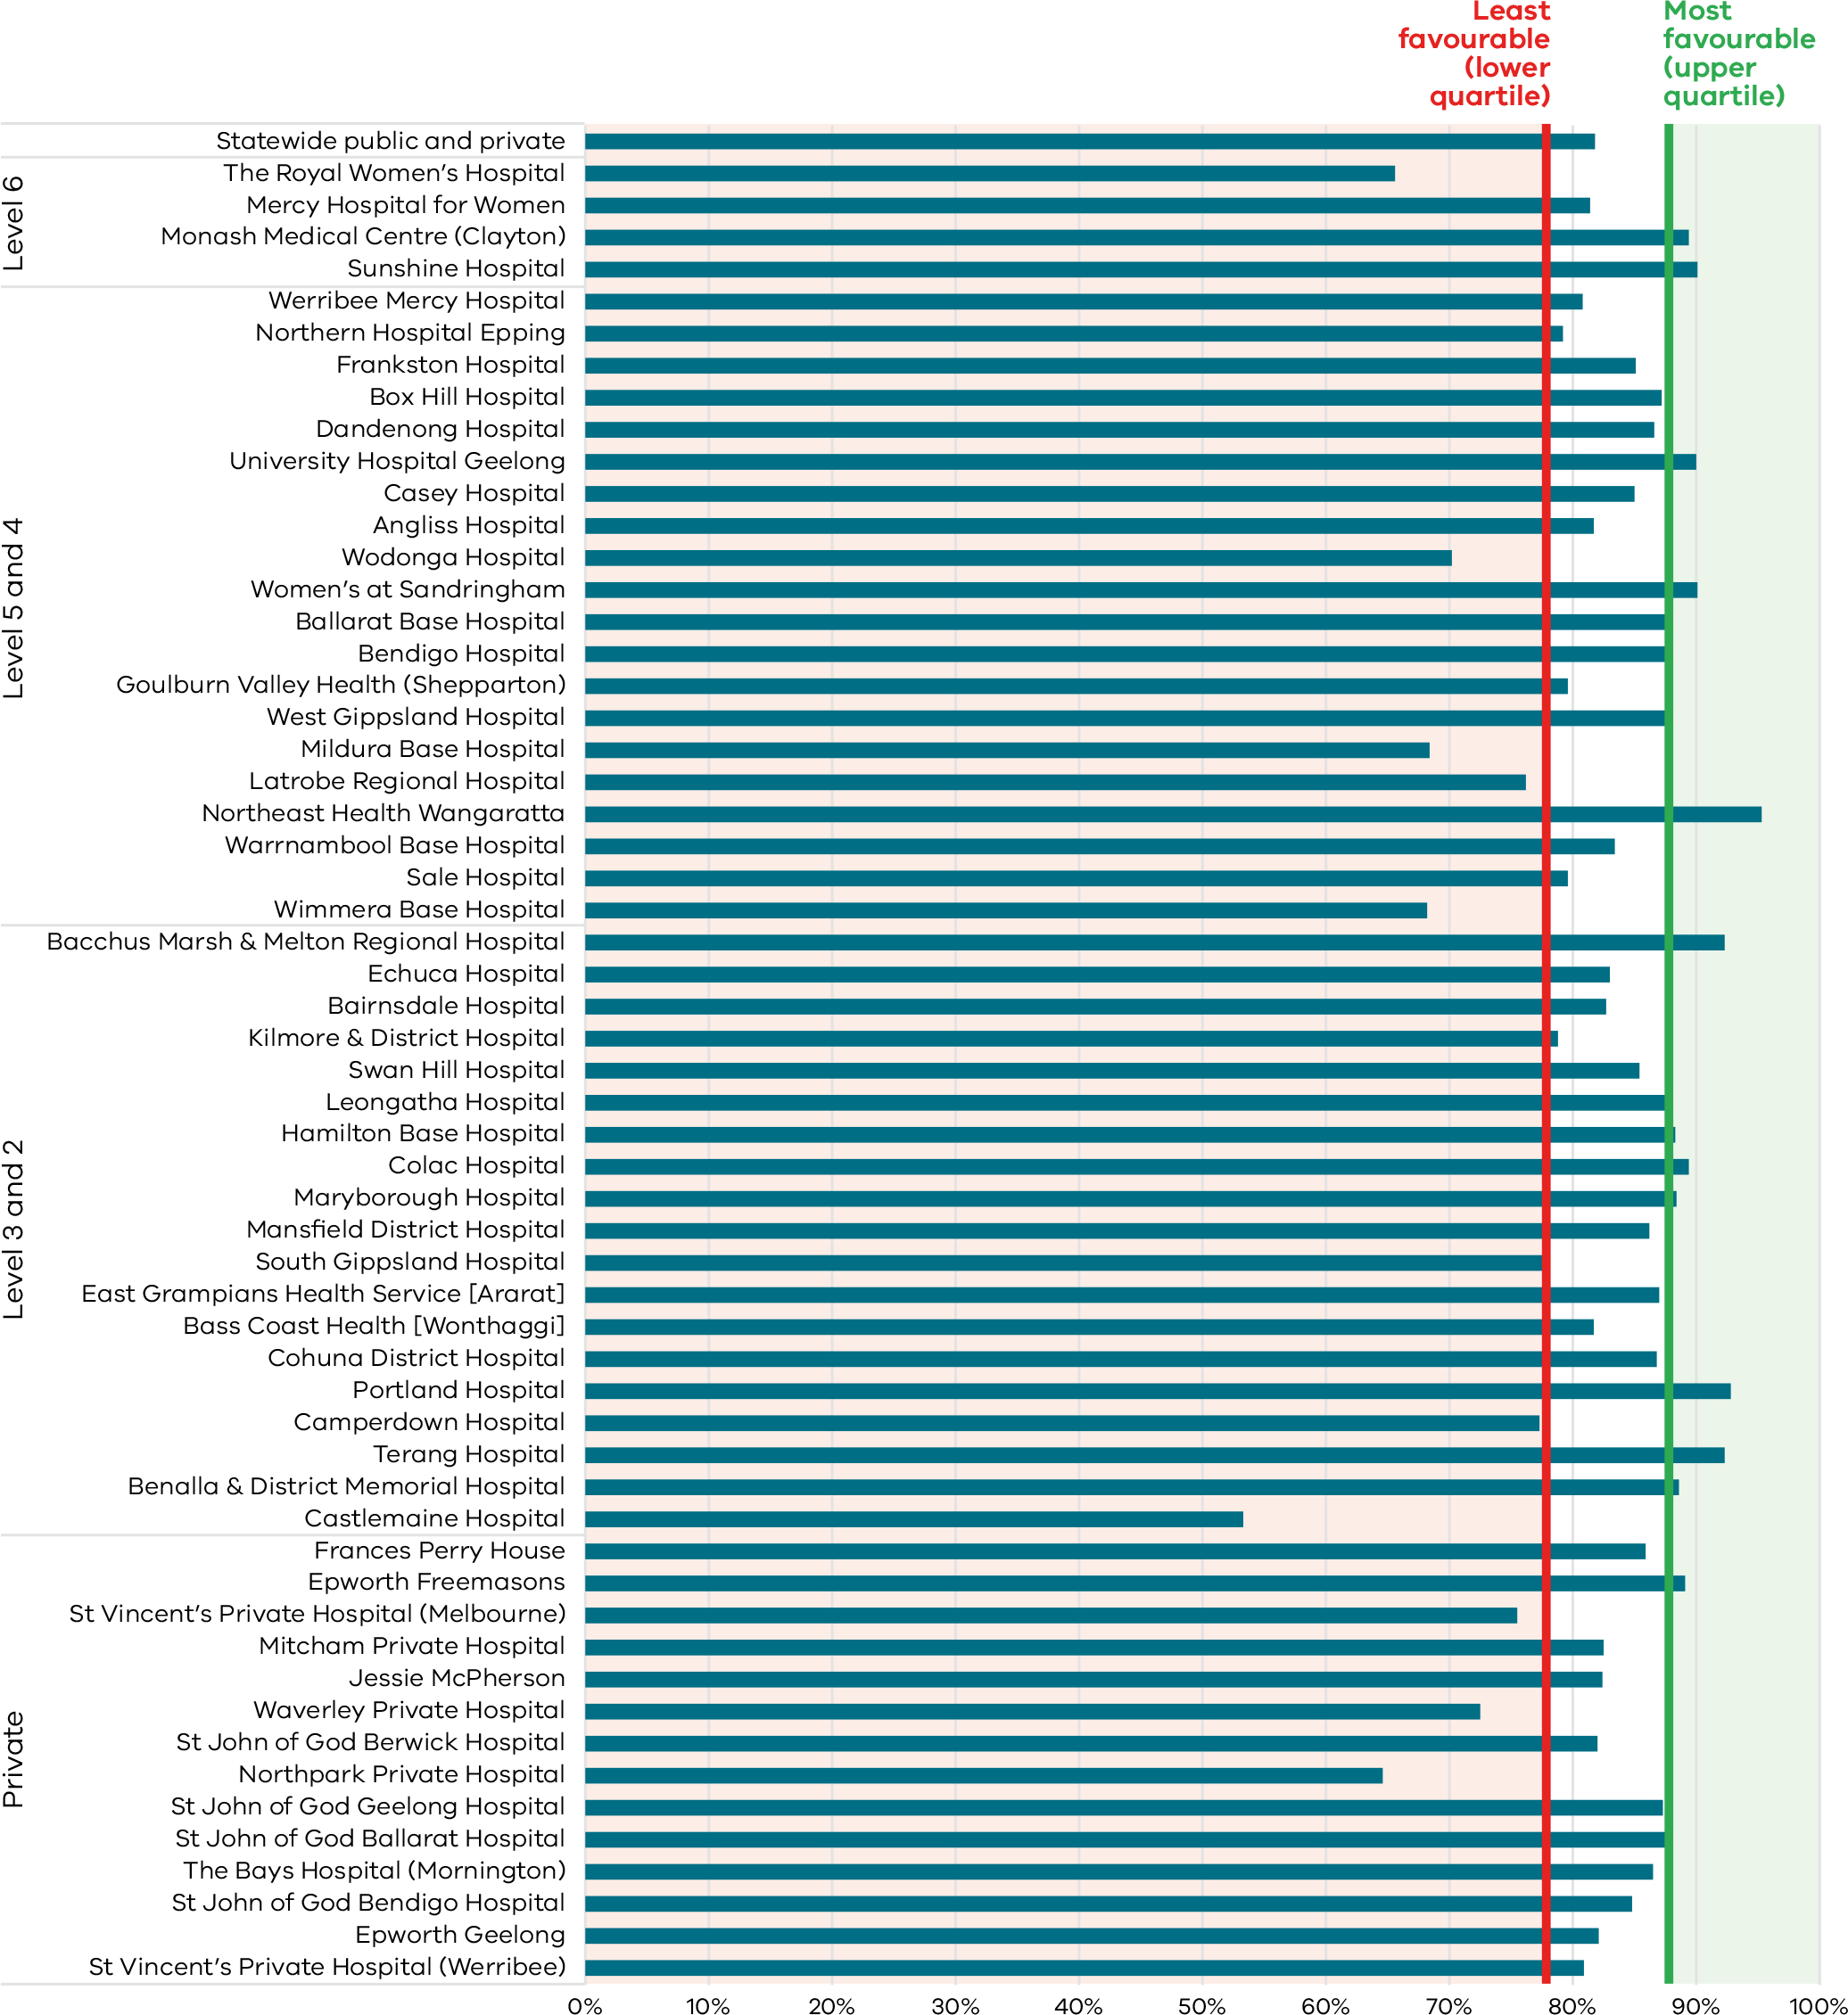
Figure 49. Funnel plot of the rate of women vaccinated for influenza during pregnancy, 2020
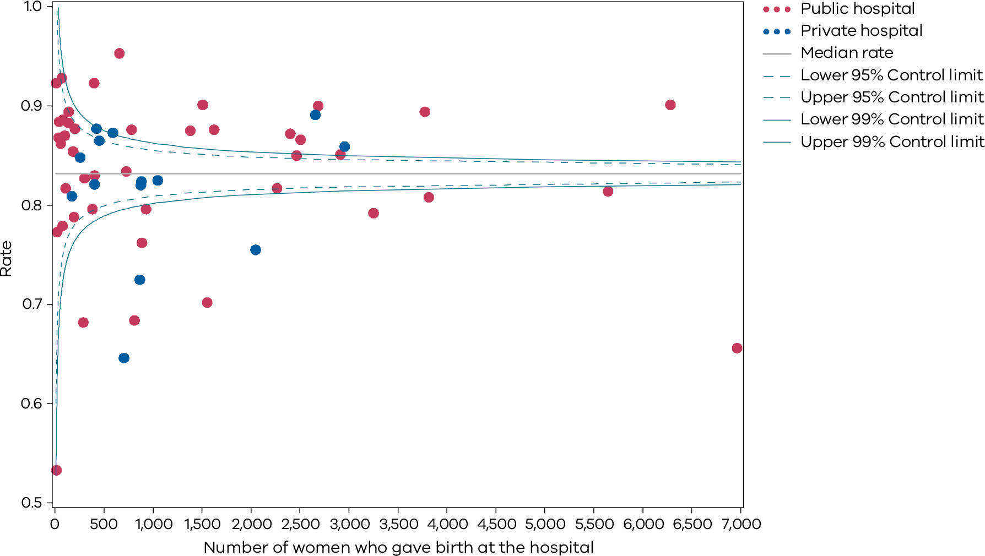
Please refer to page 9 for a guide on how to interpret funnel plots.
Table 23. Indicator 12b: Rate of women vaccinated for influenza during pregnancy, 2017–20
 | 2017 | 2018 | 2019 | 2020
Public | 53.9% | 67.8% | 75.8% | 82.3%
Private | 53.4% | 65.0% | 70.9% | 80.7%
Combined | 53.7% | 67.1% | 74.6% | 81.8%
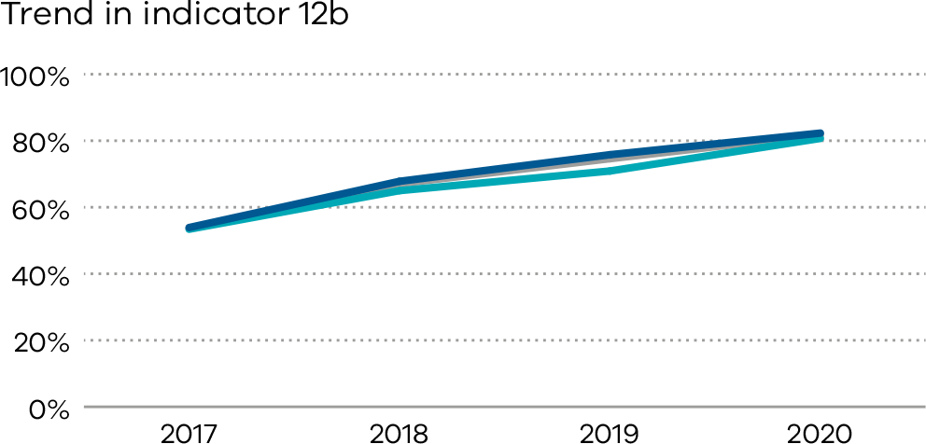

Definitions and data sources
The proportion of women who were vaccinated for influenza at any time during their pregnancy.

Data source: Victorian Perinatal Data Collection
Data for this indicator is sourced from the VPDC for the calendar year from 1 January 2020 to 31 December 2020.
This indicator is derived using the following VPDC variables: ‘influenza vaccination status’ and ‘birth order’.
Numerator/denominator
Indicator | Numerator | Denominator
Indicator 12a: The rate of women vaccinated for pertussis during pregnancy | The number of women who received a pertussis vaccine at any point during pregnancy | The number of women who gave birth in Victoria
Indicator 12b: The rate of women vaccinated for influenza during pregnancy | The number of women who received an influenza vaccine at any point during pregnancy | The number of women who gave birth in Victoria

13: Women who had a severe postpartum haemorrhage within the 24 hours following birth

Postpartum haemorrhage (PPH) is a common and potentially serious complication of pregnancy. While the majority of PPH cases are minor, severe PPH (defined in this report as blood loss of 1,500ml or more) is a major cause of maternal mortality and morbidity in Australia. It is important that clinicians can prevent, recognise and treat PPH.

About this indicator
This indicator presents the proportion of women who had a severe postpartum haemorrhage (defined as blood loss of at least 1,500ml) within the 24 hours following birth.

Observations on the data
In 2020, 2.6 per cent of women had a severe postpartum haemorrhage. This was a slight increase from the previous year’s rate of 2.5 per cent. The rate for public hospitals was higher compared to private hospitals (1.1 per cent and 3.0 per cent respectively). Figures 50 and 51 show variation between individual hospitals.

Strategies for improvement
- Health services should have robust processes for recognising and responding to PPH.
- Include PPH in multidisciplinary obstetric emergency training, including teams outside the maternity service.
- Health services should ensure local guidance meets SCV Maternity e-Handbook Postpartum haemorrhage guidance <https://www.safercare.vic.gov.au/clinical-guidance/maternity/postpartum-haemorrhage-pph-prevention-assessment-and-management>.
- Health services should monitor their own data for trends and audit accordingly.
- All PPHs greater than 1,500 should be reviewed.
[Break out box text:

What pregnant women and families need to know
Most women will have some bleeding after the birth of their baby. A small number of women will have excess bleeding. This can be very dangerous for the women. The rate of excess bleeding (> 1,500ml) should be low.
End of break out box text.]
Figure 50. Trial indicator 13: Rate of women with severe postpartum haemorrhage, 2020
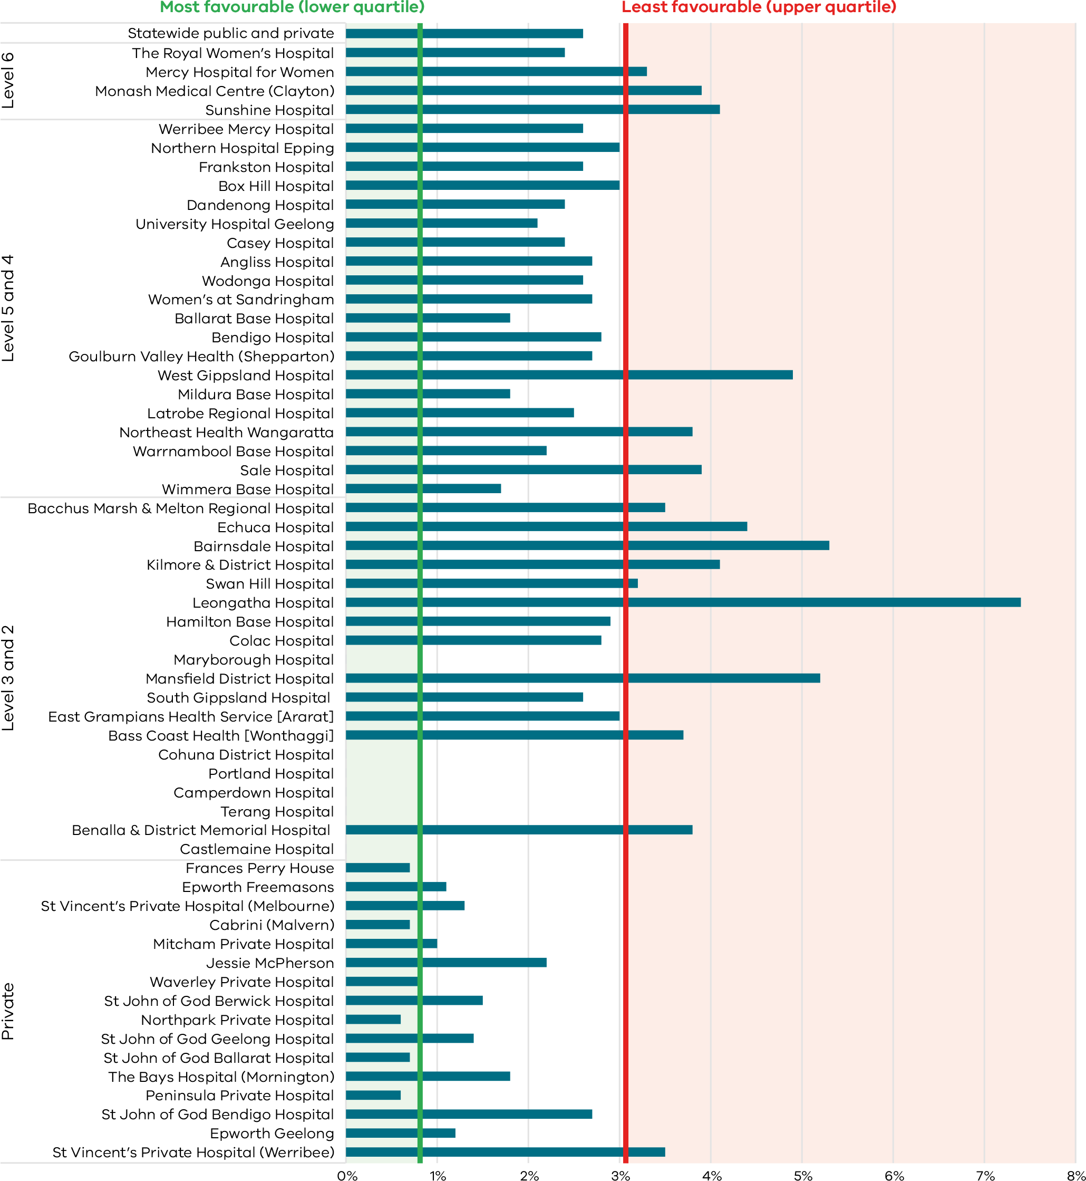
Figure 51. Funnel plot of the rate of women with severe postpartum haemorrhage, 2020
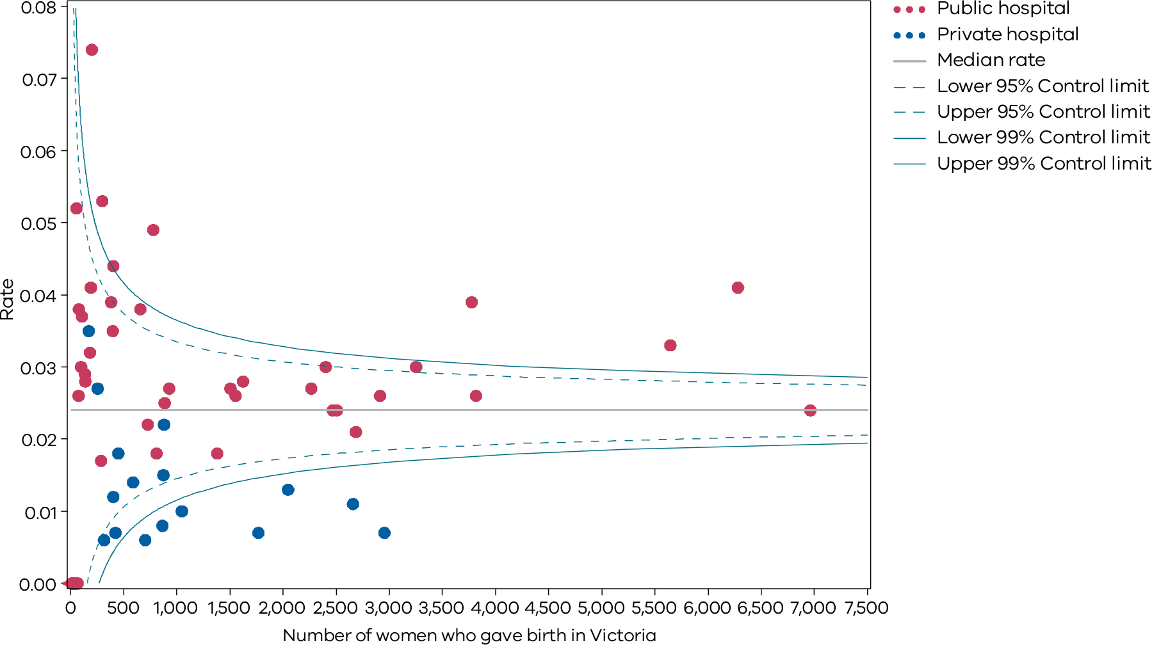
Please refer to page 9 for a guide on how to interpret funnel plots.
Table 24. Indicator 13: Rate of women with severe postpartum haemorrhage, 2018–20
 | 2018 | 2019 | 2020
Public | 2.5% | 2.9% | 3.0%
Private | 1.0% | 0.9% | 1.1%
Combined | 2.2% | 2.4% | 2.6%
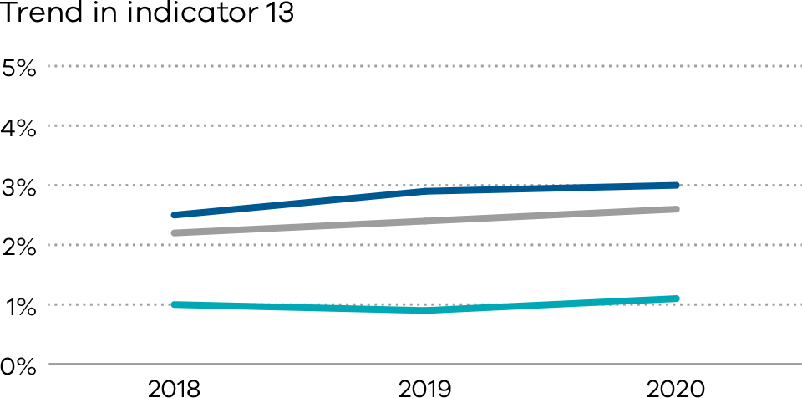

Definitions and data sources
The proportion of women who had a severe postpartum haemorrhage (blood loss over 1,500ml) within the 24 hours following birth.

Data source: Victorian Perinatal Data Collection
Data for this indicator is sourced from the VPDC for the calendar year from 1 January 2020 to 31 December 2020.
The indicator is derived using the following VPDC variables: ‘estimated blood loss’.
Numerator/denominator
Indicator | Numerator | Denominator
Trial indicator 13: The rate of women with severe postpartum haemorrhage | The number of women with blood loss of at least 1,500 ml | The number of women who gave birth in Victoria

Appendix 1: Data sources and reporting rules

Safer Care Victoria (SCV) and the Department of Health manage the health data collections used for this report:
- Victorian Perinatal Data Collection (VPDC) Victorian public and private health services are required to submit specific data to the Consultative Council on Obstetric and Paediatric Mortality and Morbidity (CCOPMM).
- Victorian Healthcare Experience Survey (VHES) collects data for public health services only.
- Victorian Admitted Episodes Dataset (VAED) Victorian public and private health services are required to submit specific data.
Further information on the data sources and the business rules for each indicator can be found under each indicator.
When interpreting the data in this report, it is important to note the following:
- Apart from Indicator 5, data is only reported when a health service has had a minimum of 10 occasions for an event (denominator). For example, a hospital that has not had 10 standard primiparae give birth in 2020 (denominator) will not be included in the results for Indicator 1a.
- Due to small numbers, data from smaller health services are subject to wide variation and should be interpreted with caution.
- Private patients admitted to a public health service are reported in the results for the relevant public health service.
- Outcomes for public health services are presented in order of clustered maternity service capability and then by the number of women who gave birth at each health service in 2020 (in descending order so hospitals with more births in each capability level appear first).
- Outcomes for private health services are presented in descending order according to the number of women who gave birth at each health service in 2020.
- Although the statewide rates provided for each indicator are a suitable measure for comparing health services, they do not necessarily represent the optimal rate.
- The indicators in this report do not adjust for maternal characteristics such as obesity, mental health conditions, chronic illnesses, socioeconomic status or IVF pregnancies. Health services should consider individual patient profiles when reviewing their data.
- Some of the variation between hospitals may reflect incomplete reporting. To ensure the accuracy of indicators, health services should make sure they have accurate capture and reporting of diagnostic and treatment codes.

Appendix 2: Total women and babies in Victorian maternity services 2020
Table 25. Total number of women and babies, by maternity service of birth, 2020
Health service | Maternal capability level of service* | Number of  women | Number of  babies
The Royal Women's Hospital | 6 | 6,964 | 7,130
Mercy Hospital for Women | 6 | 5,647 | 5,759
Monash Medical Centre (Clayton) | 6 | 3,777 | 3,936
Western Health (Sunshine) | 6 | 6,283 | 6,390
Northern Hospital Epping | 5 | 3,253 | 3,281
Peninsula Health (Frankston) | 5 | 2,914 | 2,953
Eastern Health (Box Hill) | 5 | 2,403 | 2,427
University Hospital Geelong | 5 | 2,687 | 2,732
Wodonga Hospital | 5 | 1,555 | 1,580
Bendigo Hospital | 5 | 1,626 | 1,643
Ballarat Base Hospital | 5 | 1,382 | 1,405
Goulburn Valley Health (Shepparton) | 5 | 930 | 939
Latrobe Regional Hospital | 5 | 888 | 900
Werribee Mercy Hospital | 4 | 3817 | 3,840
Monash Health (Dandenong) | 4 | 2,508 | 2,508
Monash Health (Casey) | 4 | 2,468 | 2,469
Eastern Health (Angliss) | 4 | 2,267 | 2,290
Women’s at Sandringham | 4 | 1,508 | 1,508
West Gippsland Hospital | 4 | 781 | 788
Mildura Base Public Hospital | 4 | 811 | 822
Warrnambool Base Hospital | 4 | 729 | 743
Northeast Health Wangaratta | 4 | 658 | 667
Sale Hospital | 4 | 383 | 389
Wimmera Base Hospital | 4 | 289 | 289
Bacchus Marsh & Melton Regional Hospital | 3 | 400 | 400
Echuca Hospital | 3 | 405 | 407
Bairnsdale Hospital | 3 | 301 | 302
Kilmore & District Hospital | 3 | 193 | 193
Swan Hill Hospital | 3 | 185 | 186
Leongatha Hospital | 3 | 203 | 203
Wonthaggi Hospital | 3 | 109 | 109
Hamilton Base Hospital | 3 | 137 | 137
Colac Hospital | 3 | 141 | 141
Benalla & District Memorial Hospital | 3 | 79 | 79
Ararat Hospital | 3 | 100 | 100
South Gippsland Hospital | 3 | 77 | 77
Mansfield District Hospital | 3 | 58 | 58
Camperdown Hospital | 3 | 22 | 22
Portland Hospital | 2 | 69 | 69
Maryborough Hospital | 2 | 43 | 43
Castlemaine Hospital | 2 | 15 | 15
Cohuna District Hospital | 2 | 38 | 38
Terang Hospital | 2 | 13 | 13
Kyneton District Health Service | 1 | NA | NA
Yarrawonga District Health Service | 1 | 2 | 2
Other public hospitals | N/A | 11 | 11
Frances Perry House | Private | 2,957 | 3,025
Epworth Freemasons | Private | 2,659 | 2,701
St Vincent’s Private Hospital (Melbourne) | Private | 2,049 | 2,084
Cabrini (Malvern) | Private | 1,769 | 1,789
Mitcham Private Hospital | Private | 1,049 | 1,054
Jessie McPherson | Private | 882 | 925
Waverley Private Hospital | Private | 866 | 869
St John of God Berwick Hospital | Private | 876 | 881
Northpark Private Hospital | Private | 704 | 709
St John of God Geelong Hospital | Private | 591 | 602
Knox Private Hospital | Private | NA | NA
The Bays Hospital (Mornington) | Private | 452 | 457
St John of God Ballarat Hospital | Private | 424 | 428
Epworth Geelong | Private | 403 | 406
Peninsula Private Hospital | Private | 316 | 319
St John of God Bendigo Hospital | Private | 257 | 261
St Vincent’s Private Hospital (Werribee) | Private | 173 | 173
Total public | NA | 59,129 | 59,993
Total private | NA | 16,428 | 16,684
Private home births | NA | 313 | 313
Statewide total | NA | 75,870 | 76,990
Notes: Excludes babies born ≤ 20 weeks’ gestation, all terminations of pregnancy and birthweight ≤ 150 g. Babies born before arrival are counted at the hospital the mother and baby are subsequently transported to. Public hospitals with ≤ five births are included in ‘Other public hospitals’. Non-maternity public hospitals with occasional births are also included in ‘Other public hospitals’.
* Capability service as at 2020–21

Appendix 3: Overview of results
Table 26. Overview of indicator results, 2020–21
Hospital campus | Mat capability level | Number of births (babies, 2020) | Indicator 1a | Indicator 1bi | Indicator 1bii | Indicator 1ci | Indicator 1cii | Indicator 1di | Indicator 1dii | Indicator 2 | Indicator 3 | Indicator 4a | Indicator 4b | Indicator 5* | Indicator 6a* | Indicator 6b* | Indicator 7 | Indicator 8a | Indicator 8b | Indicator 8c | Indicator 9 | Indicator 10 | Indicator 11a* | Indicator 11b* | Indicator 12a | Indicator 12b | Indicator 13 | Indicators in most favourable | Indicators in least favourable
Statewide | - | 76,990 | 13.9% | 18.3% | 32.3% | 3.7% | 5.4% | 27.5% | 86.4% | NA | 20.8% | 22.9% | 52.2% | 1.1 | 2.3% | NA | 33.5% | 95.6% | 30.5% | 73.1% | 73.6% | 1.2% | NA | NA | 84.3% | 81.8% | 2.6% | - | -
Public hospitals | - | 59,993 | 8.1% | 17.0% | 32.2% | 4.3% | 6.4% | 27.3% | 90.8% | 11.7% | 20.5% | 27.8% | 52.5% | NA | 2.5% | 4.6% | 32.6% | 95.4% | 27.8% | 75.0% | 70.1% | 1.3% | 81.4% | 49.2% | 91.1% | 82.3% | 3.0% | - | -
Private hospitals | - | 16,684 | 23.7% | 24.2% | 32.6% | 0.8% | 2.6% | 30.4% | 73.2% | NA | 21.3% | 11.2% | 48.8% | NA | 1.7% | NA | 64.0% | 95.9% | 40.5% | 65.8% | 86.5% | 0.8% | NA | NA | 60.7% | 80.7% | 1.1% | - | -
Least favourable quartile | - | NA | 20.0% | 24.4% | 40.2% | 3.6% | 7.6% | 31.3% | 75.6% | 15.8%^ | 25.4%^ | 10.7% | 45.3% | NA | 3.1% | 5.4% | 23.3%^ | 92.6% | 35.2% | 70.7% | 71.2% | 1.6% | 79.7% | 47.2% | 89.5% | 77.8% | 3.1% | - | -
Most favourable quartile | - | NA | 4.0% | 13.7% | 26.2% | 0.0% | 1.2% | 16.4% | 91.8% | 8.0%^ | 15.4%^ | 30.3% | 63.5% | NA | 1.5% | 2.7% | 41.5%^ | 97.0% | 18.5% | 85.6% | 88.5% | 0.7% | 86.3% | 61.5% | 96.5% | 87.6% | 0.8% | - | -
The Royal Women’s Hospital | 6 | 7,130 | 5.3% | 14.3% | 26.2% | 5.2% | 5.8% | 21.6% | 92.9% | 12.5% | 26.4% | 24.8% | 63.7% | 1 | 2.4% | 6.3% | 44.1% | 96.5% | 27.2% | 70.6% | 30.2% | 1.3% | 81.5% | 47.1% | 68.3% | 65.6% | 2.4% | 4 | 8
Mercy Hospital for Women | 6 | 5,759 | 11.5% | 16.4% | 30.9% | 3.2% | 4.9% | 35.9% | 90.4% | 9.6% | 16.8% | 21.0% | 51.3% | 0.7 | 2.0% | 3.4% | 35.1% | 97.0% | 35.1% | 71.4% | 48.7% | 1.5% | 84.7% | 47.1% | 95.8% | 81.4% | 3.3% | 1 | 4
Sunshine Hospital | 6 | 6,390 | 0.9% | 13.3% | 28.0% | 7.4% | 8.2% | 28.2% | 91.5% | 11.8% | 19.9% | 33.3% | 47.0% | 1 | 2.3% | 3.5% | 34.8% | 95.5% | 31.2% | 75.4% | 54.1% | 0.7% | 78.3% | 58.6% | 94.9% | 90.1% | 4.1% | 5 | 5
Monash Medical Centre (Clayton) | 6 | 3,936 | 10.5% | 13.2% | 25.4% | 2.3% | 7.3% | 32.9% | 91.8% | 11.1% | 12.1% | 37.5% | 48.5% | 1 | 2.5% | 4.0% | 30.8% | 94.6% | 37.9% | 56.1% | 82.0% | 1.7% | 75.8% | 48.0% | 91.0% | 89.4% | 3.9% | 6 | 6
Northern Hospital Epping | 5 | 3,281 | 11.8% | 20.2% | 35.8% | 2.9% | 6.6% | 37.9% | 92.6% | 10.2% | 16.9% | 33.8% | 45.3% | 1.4 | 2.6% | 5.7% | 33.7% | 94.7% | 35.1% | 71.3% | 84.7% | 1.2% | 80.6% | 69.1% | 88.5% | 79.2% | 3.0% | 3 | 4
Frankston Hospital | 5 | 2,953 | 10.8% | 15.5% | 30.8% | 3.0% | 7.6% | 22.0% | 90.3% | 12.4% | 34.3% | 27.5% | 53.8% | 1.1 | 2.6% | 4.6% | 37.6% | 93.7% | 22.3% | 85.9% | 76.4% | 1.2% | 74.3% | 42.8% | 94.5% | 85.1% | 2.6% | 1 | 4
Box Hill Hospital | 5 | 2,427 | 8.0% | 19.1% | 40.8% | 5.4% | 5.2% | 33.7% | 94.4% | 18.2% | 17.8% | 17.6% | 55.6% | 0.9 | 3.9% | 4.3% | 41.5% | 98.1% | 26.9% | 78.4% | 84.6% | 1.6% | 78.8% | 45.8% | 95.0% | 87.2% | 3.0% | 3 | 8
University Hospital Geelong | 5 | 2,732 | 5.7% | 15.6% | 32.0% | 3.6% | 3.0% | 21.9% | 90.4% | 18.3% | 25.0% | 29.8% | 45.3% | 0.9 | 2.8% | 4.8% | 21.1% | 95.8% | 29.5% | 76.4% | 91.4% | 1.4% | 82.5% | 34.1% | 95.9% | 90.0% | 2.1% | 2 | 5
Wodonga Hospital | 5 | 1,580 | 7.7% | 14.1% | 32.5% | 2.1% | 5.8% | 21.3% | 78.9% | 11.6% | 7.1% | 20.2% | 88.0% | 0.9 | 2.0% | 3.2% | 25.4% | 92.6% | 34.0% | 83.0% | 63.8% | 1.7% | 88.0% | 42.4% | 93.5% | 70.2% | 2.6% | 3 | 5
Bendigo Hospital | 5 | 1,643 | 12.8% | 18.3% | 33.9% | 3.6% | 9.7% | 31.4% | 89.3% | 12.1% | 21.9% | 35.0% | 50.0% | 1.2 | 2.2% | 5.1% | 23.9% | 92.7% | 28.5% | 80.6% | 85.1% | 1.4% | 84.5% | 49.9% | 95.4% | 87.6% | 2.8% | 2 | 3
Ballarat Base Hospital | 5 | 1,405 | 13.6% | 23.4% | 30.5% | 7.0% | 6.5% | 10.3% | 86.3% | 18.1% | 7.4% | 26.7% | 64.5% | 1 | 4.0% | 6.4% | 23.5% | 92.3% | 17.7% | 85.5% | 90.3% | 2.0% | 79.4% | 56.6% | 97.2% | 87.5% | 1.8% | 6 | 7
Goulburn Valley Health (Shepparton) | 5 | 939 | 5.7% | 20.1% | 33.6% | 3.4% | 4.2% | 20.9% | 91.7% | 16.2% | 29.4% | 25.3% | 85.7% | 1.3 | 3.2% | 2.8% | 28.1% | 91.9% | 39.4% | 75.5% | 89.1% | 0.9% | 71.7% | 49.0% | 92.5% | 79.6% | 2.7% | 2 | 6
Latrobe Regional Hospital | 5 | 900 | 4.1% | 23.1% | 41.5% | 3.1% | 6.3% | 23.8% | 94.9% | 18.5% | 5.0% | 31.9% | 51.7% | 1 | 2.0% | 3.8% | 20.1% | 90.7% | 32.8% | 68.0% | 73.2% | 2.1% | 83.3% | 58.8% | 89.6% | 72.6% | 2.5% | 3 | 7
Werribee Mercy Hospital | 4 | 3,840 | 3.8% | 24.2% | 45.8% | 2.7% | 6.2% | 32.0% | 91.0% | 8.1% | 23.9% | 28.1% | 45.2% | 1.3 | 2.0% | 5.2% | 27.7% | 95.9% | 30.8% | 75.1% | 76.4% | 1.0% | 81.0% | 56.8% | 94.8% | 80.8% | 2.6% | 1 | 3
Dandenong Hospital | 4 | 2,508 | 8.0% | 14.0% | 31.8% | 4.5% | 7.8% | 32.2% | 93.8% | 8.0% | 22.2% | 40.5% | 62.7% | 1.6 | 1.6% | 4.7% | 41.9% | 97.8% | 19.8% | 73.4% | 94.8% | 1.4% | 82.7% | 61.8% | 95.3% | 86.6% | 2.4% | 7 | 3
Casey Hospital | 4 | 2,469 | 4.3% | 17.4% | 33.2% | 2.9% | 6.5% | 29.0% | 94.2% | 6.9% | 15.4% | 33.0% | 54.4% | 1.3 | 2.3% | 3.2% | 48.4% | 96.3% | 16.9% | 68.1% | 91.2% | 1.5% | 87.6% | 63.2% | 95.9% | 85.0% | 2.4% | 9 | 1
Angliss Hospital | 4 | 2,290 | 6.6% | 19.6% | 33.6% | 5.8% | 8.9% | 31.2% | 94.2% | 9.1% | 29.6% | 20.2% | 52.2% | 1 | 2.5% | 4.2% | 49.0% | 96.6% | 21.1% | 72.2% | 93.9% | 1.5% | 84.8% | 48.4% | 95.5% | 81.7% | 2.7% | 3 | 3
Women’s at Sandringham | 4 | 1,508 | 13.5% | 16.3% | 26.2% | 6.9% | 4.5% | 26.1% | 90.3% | 6.7% | 33.3% | 10.3% | 0.0% | 1.2 | 3.1% | 6.9% | 45.0% | 98.6% | 16.0% | 95.7% | 68.2% | 0.8% | 85.4% | 46.6% | 97.1% | 90.1% | 2.7% | 8 | 8
West Gippsland Hospital | 4 | 788 | 13.2% | 15.1% | 23.9% | 0.0% | 4.4% | 20.6% | 100.0% | 17.0% | 25.0% | 25.5% | 71.4% | 0.6 | 2.9% | 6.3% | 33.9% | 94.5% | 24.0% | 85.7% | 89.9% | 2.1% | 86.4% | 58.7% | 94.4% | 87.6% | 4.9% | 8 | 4
Mildura Base Public Hospital | 4 | 822 | 6.2% | 21.6% | 30.7% | 0.9% | 4.5% | 19.0% | 83.6% | 7.9% | 21.4% | 32.9% | 43.5% | 1.1 | 1.7% | 6.8% | 22.9% | 91.9% | 25.0% | 70.7% | 35.4% | 1.1% | NA | 0.0% | 80.6% | 68.4% | 1.8% | 2 | 9
Northeast Health Wangaratta | 4 | 667 | 3.1% | 15.7% | 38.4% | 3.2% | 3.9% | 25.5% | 93.4% | 22.9% | 0.0% | 34.6% | 55.6% | 1.1 | 1.9% | 2.8% | 28.8% | 92.4% | 21.3% | 85.5% | 92.4% | 0.9% | 87.5% | 52.2% | 98.2% | 95.3% | 3.8% | 8 | 3
Warrnambool Base Hospital | 4 | 743 | 20.8% | 12.3% | 29.6% | 3.7% | 8.4% | 22.1% | 74.7% | 12.0% | 0.0% | 56.8% | 56.0% | 1.1 | 4.5% | 6.9% | 32.9% | 97.1% | 19.9% | 83.0% | 85.4% | 2.1% | 86.0% | 53.4% | 90.8% | 83.4% | 2.2% | 4 | 7
Sale Hospital | 4 | 389 | 3.3% | 25.9% | 46.7% | 0.0% | 7.1% | 22.4% | 89.3% | 12.4% | 25.0% | 13.5% | 20.0% | 1.5 | 2.2% | 3.0% | 30.2% | 94.1% | 28.6% | 79.2% | 72.8% | 0.6% | 81.0% | 90.5% | 94.3% | 79.6% | 3.9% | 4 | 4
Wimmera Base Hospital | 4 | 289 | 0.0% | 19.7% | 50.0% | 2.1% | 0.0% | 14.9% | 90.9% | 17.1% | 28.6% | 30.0% | 44.4% | NA | 3.5% | 4.1% | 12.0% | 91.6% | 27.1% | 86.5% | 84.2% | 4.8% | 86.2% | 42.8% | 92.4% | 68.2% | 1.7% | 4 | 10
Bacchus Marsh & Melton Regional Hospital | 3 | 400 | 29.4% | 22.7% | 40.0% | 1.8% | 25.0% | 16.1% | 86.1% | 13.7% | 50.0% | 18.4% | 28.6% | NA | 4.7% | 3.1% | 36.4% | 91.5% | 26.6% | 79.6% | 79.3% | 0.5% | 87.8% | 69.2% | 96.5% | 92.3% | 3.5% | 6 | 7
Echuca Hospital | 3 | 407 | 17.9% | 21.3% | 47.6% | 3.1% | 2.9% | 10.8% | 58.8% | 5.8% | 33.3% | 34.7% | 64.7% | NA | 2.7% | 1.5% | 23.3% | 93.5% | 19.3% | 86.1% | 83.6% | 1.0% | 88.9% | 69.4% | 94.1% | 83.0% | 4.4% | 8 | 5
Bairnsdale Hospital | 3 | 302 | 0.0% | 10.1% | 36.1% | 5.9% | 13.5% | 17.6% | 91.9% | 8.2% | 0.0% | 31.0% | 55.6% | NA | 2.4% | 3.1% | 25.0% | 95.2% | 10.9% | 89.9% | 77.7% | 0.4% | 83.3% | 60.4% | 90.4% | 82.7% | 5.3% | 8 | 3
Kilmore & District Hospital | 3 | 193 | 21.4% | 32.4% | 42.9% | 4.3% | 0.0% | 21.7% | 68.2% | 8.1% | 50.0% | 0.0% | NA | NA | 0.5% | 2.0% | 19.4% | 88.5% | 15.3% | 87.1% | 87.6% | 1.6% | 80.0% | 64.7% | 97.9% | 78.8% | 4.1% | 7 | 11
Swan Hill Hospital | 3 | 186 | 4.3% | 21.2% | 23.1% | 2.6% | 0.0% | 26.3% | 84.6% | 10.6% | 0.0% | 18.8% | 66.7% | NA | 1.8% | 0.0% | 23.8% | 95.6% | 25.7% | 78.9% | 70.3% | 0.6% | 75.0% | 88.2% | 96.8% | 85.4% | 3.2% | 8 | 3
Leongatha Hospital | 3 | 203 | 5.3% | 10.0% | 31.4% | 9.4% | 5.3% | 18.8% | 63.2% | 17.3% | NA | 5.9% | 100.0% | NA | 0.0% | 2.6% | 0.0% | 96.5% | 18.7% | 86.0% | 81.7% | 1.6% | 79.2% | 47.4% | 98.0% | 87.7% | 7.4% | 7 | 8
Wonthaggi Hospital | 3 | 109 | 14.3% | 20.0% | 35.3% | 0.0% | 7.1% | 33.3% | 78.6% | 12.2% | 100.0% | 50.0% | 20.0% | NA | 3.1% | 0.8% | 16.7% | 95.3% | 13.9% | 85.1% | 41.3% | 2.0% | NA | 70.0% | 93.6% | 81.7% | 3.7% | 5 | 8
Colac Hospital | 3 | 141 | 0.0% | 6.7% | 42.3% | 11.1% | 9.1% | 11.1% | 63.6% | 15.5% | NA | 0.0% | NA | NA | 4.6% | 8.1% | 0.0% | 97.9% | 17.4% | 83.3% | 88.7% | 0.0% | 87.5% | 49.3% | 98.6% | 89.4% | 2.8% | 10 | 8
Hamilton Base Hospital | 3 | 137 | 0.0% | 20.0% | 54.5% | 0.0% | 11.1% | 15.4% | 83.3% | 6.1% | 0.0% | 17.6% | 0.0% | NA | 3.4% | 1.4% | 31.3% | 95.6% | 16.2% | 80.0% | 77.4% | 1.5% | 94.1% | 60.3% | 96.4% | 88.3% | 2.9% | 9 | 4
Ararat Hospital | 3 | 100 | 0.0% | 41.2% | 28.6% | 0.0% | 0.0% | 25.0% | 100.0% | 8.2% | 0.0% | 16.7% | 100.0% | NA | 0.9% | 1.8% | 33.3% | 94.9% | 20.2% | 91.5% | 83.0% | 0.0% | NA | NA | 97.0% | 87.0% | 3.0% | 11 | 1
Mansfield District Hospital | 3 | 58 | 0.0% | 41.2% | 75.0% | 0.0% | NA | 8.3% | NA | 6.9% | NA | 0.0% | NA | NA | 3.2% | 1.6% | 40.0% | 100.0% | 19.3% | 87.7% | 91.4% | 0.0% | NA | NA | 98.3% | 86.2% | 5.2% | 10 | 5
Benalla & District Memorial Hospital | 3 | 79 | 12.5% | 58.3% | 50.0% | 0.0% | 0.0% | 12.5% | 80.0% | 13.3% | NA | 20.0% | 50.0% | NA | 1.4% | 1.3% | 28.6% | 100.0% | 10.3% | 89.7% | 67.1% | 2.6% | NA | 62.5% | 97.5% | 88.6% | 3.8% | 11 | 5
South Gippsland Hospital | 3 | 77 | 0.0% | 9.1% | 33.3% | 0.0% | 0.0% | 27.3% | 100.0% | 5.9% | NA | 25.0% | 100.0% | NA | 0.0% | 5.8% | 33.3% | 100.0% | 15.6% | 85.7% | 85.7% | 0.0% | NA | NA | 93.5% | 77.9% | 2.6% | 12 | 1
Camperdown Hospital | 3 | 22 | 50.0% | 0.0% | 0.0% | 0.0% | 0.0% | 25.0% | 100.0% | 3.6% | NA | NA | NA | NA | 3.7% | 17.9% | 0.0% | 90.9% | 25.0% | 85.0% | 63.6% | 0.0% | NA | NA | 100.0% | 77.3% | 0.0% | 9 | 7
Portland Hospital | 2 | 69 | 0.0% | 42.9% | 16.7% | 0.0% | 10.0% | 0.0% | 80.0% | 3.9% | NA | 33.3% | 50.0% | NA | 2.8% | 2.5% | 20.0% | 85.1% | 22.8% | 78.9% | 72.1% | 1.6% | NA | NA | 95.7% | 92.8% | 0.0% | 9 | 5
Castlemaine Hospital | 2 | 15 | 0.0% | 0.0% | 0.0% | 20.0% | 0.0% | 0.0% | 0.0% | 20.0% | NA | NA | NA | NA | 0.0% | 0.0% | 100.0% | 93.3% | 7.1% | 100.0% | 86.7% | 0.0% | NA | NA | 73.3% | 53.3% | 0.0% | 12 | 5
Maryborough Hospital | 2 | 43 | 0.0% | 9.1% | 0.0% | 9.1% | 0.0% | 9.1% | 75.0% | 21.9% | NA | 0.0% | NA | NA | 0.0% | 3.4% | 8.3% | 85.0% | 14.7% | 82.4% | 81.0% | 2.6% | NA | 33.3% | 97.7% | 88.4% | 0.0% | 10 | 8
Cohuna District Hospital | 2 | 38 | 0.0% | 25.0% | 50.0% | 0.0% | 0.0% | 0.0% | 25.0% | 3.1% | NA | 0.0% | NA | NA | 3.0% | 3.0% | 0.0% | 94.7% | 11.1% | 91.7% | 73.7% | 2.8% | NA | NA | 94.7% | 86.8% | 0.0% | 8 | 6
Terang Hospital | 2 | 13 | 20.0% | 0.0% | 0.0% | 0.0% | 50.0% | 0.0% | 0.0% | NA | NA | NA | NA | NA | 0.0% | 14.3% | 0.0% | 100.0% | 15.4% | 84.6% | 76.9% | 0.0% | NA | 83.3% | 92.3% | 92.3% | 0.0% | 11 | 5
Yarrawonga Hospital | 1 | 2 | NA | NA | 0.0% | NA | NA | NA | NA | NA | NA | NA | NA | NA | NA | NA | 0.0% | 100.0% | 0.0% | 100.0% | 100.0% | 0.0% | NA | 100.0% | 100.0% | 100.0% | 0.0% | 10 | 1
Kyneton Hospital | 1 | NA | NA | NA | NA | NA | NA | NA | NA | NA | NA | NA | NA | NA | NA | NA | NA | NA | NA | NA | NA | NA | NA | NA | NA | NA | NA | - | -
Frances Perry House | P | 3,025 | 23.1% | 25.2% | 31.5% | 1.5% | 3.2% | 41.1% | 78.0% | NA | 15.2% | 6.5% | 57.1% | 0.6 | 1.5% | NA | NA | 96.7% | 31.6% | 79.6% | 91.4% | 0.5% | NA | NA | 4.4% | 85.9% | 0.7% | 5 | 5
Epworth Freemasons | P | 2,701 | 26.5% | 26.0% | 34.0% | 0.5% | 1.2% | 25.3% | 65.4% | NA | 18.8% | 5.8% | 37.5% | 1.1 | 1.3% | NA | NA | 96.8% | 35.9% | 57.5% | 88.8% | 0.7% | NA | NA | 94.0% | 89.1% | 1.1% | 5 | 7
St Vincent’s Private (Melbourne) | P | 2,084 | 18.2% | 22.0% | 26.2% | 0.0% | 1.0% | 27.7% | 63.1% | NA | 20.0% | 15.4% | 61.4% | 0.6 | 1.2% | NA | NA | 94.7% | 36.7% | 66.1% | 95.5% | 0.7% | NA | NA | 85.2% | 75.5% | 1.3% | 6 | 5
Cabrini (Malvern) | P | 1,789 | 25.6% | 13.8% | 22.5% | 1.5% | 5.0% | 16.5% | 64.3% | NA | 20.8% | 13.6% | 64.3% | 0.9 | 1.1% | NA | NA | 97.0% | 35.7% | 68.3% | 88.9% | 0.5% | NA | NA | NA | NA | 0.7% | 7 | 4
Mitcham Private | P | 1,054 | 21.8% | 35.9% | 39.9% | 0.0% | 0.7% | 46.1% | 89.7% | NA | 22.2% | 18.0% | 27.6% | 0.8 | 1.6% | NA | NA | 95.9% | 57.1% | 54.9% | 88.0% | 0.8% | NA | NA | 5.9% | 82.5% | 1.0% | 2 | 7
Jessie McPherson | P | 925 | 48.1% | 22.1% | 27.9% | 1.1% | 1.2% | 41.1% | 77.0% | NA | 14.3% | 10.6% | 45.5% | 0.8 | 1.9% | NA | NA | 97.7% | 43.0% | 48.4% | 78.7% | 0.9% | NA | NA | 89.1% | 82.4% | 2.2% | 3 | 6
Waverley Private Hospital | P | 869 | 21.5% | 25.7% | 34.8% | 1.2% | 1.4% | 30.6% | 77.6% | NA | 45.5% | 10.7% | 14.3% | 1.4 | 1.2% | NA | NA | 97.1% | 61.8% | 50.2% | 76.5% | 1.2% | NA | NA | 9.7% | 72.5% | 0.8% | 3 | 9
St John of God Berwick Hospital | P | 881 | 28.5% | 29.7% | 44.8% | 1.3% | 0.0% | 35.5% | 75.2% | NA | 13.3% | 10.2% | 47.1% | 0.5 | 2.5% | NA | NA | 95.3% | 41.7% | 70.4% | 68.4% | 1.5% | NA | NA | 92.7% | 82.0% | 1.5% | 2 | 9
Northpark Private Hospital | P | 709 | 28.2% | 20.5% | 34.1% | 0.0% | 8.2% | 35.8% | 82.4% | NA | 40.0% | 18.2% | 56.3% | 0.2 | 1.3% | NA | NA | 88.8% | 58.4% | 55.1% | 84.0% | 1.0% | NA | NA | 55.5% | 64.6% | 0.6% | 3 | 9
St John of God Geelong Hospital | P | 602 | 20.0% | 34.8% | 44.4% | 0.0% | 1.4% | 23.5% | 81.1% | NA | NA | 9.7% | 33.3% | 0.6 | NA | NA | NA | 97.6% | 52.6% | 73.0% | 84.7% | 1.9% | NA | NA | 96.6% | 87.3% | 1.4% | 3 | 7
The Bays Hospital (Mornington) | P | 457 | 27.7% | 15.0% | 18.2% | 0.0% | 1.6% | 19.0% | 62.9% | NA | 0.0% | 23.5% | 52.6% | NA | 4.6% | NA | NA | 95.2% | 31.0% | 76.8% | 83.6% | 0.7% | NA | NA | 92.9% | 86.5% | 1.8% | 4 | 3
St John of God Ballarat Hospital | P | 428 | 10.8% | 26.4% | 33.9% | 0.0% | 7.5% | 12.1% | 88.7% | NA | 0.0% | 16.4% | 45.5% | NA | 2.8% | NA | NA | 96.4% | 34.9% | 77.5% | 87.3% | 1.3% | NA | NA | 95.0% | 87.7% | 0.7% | 5 | 1
Peninsula Private Hospital | P | 319 | 30.4% | 19.0% | 32.3% | 1.9% | 7.7% | 22.6% | 76.9% | NA | 25.0% | 10.0% | 50.0% | NA | 1.1% | NA | NA | 91.1% | 48.0% | 62.5% | 66.9% | 1.0% | NA | NA | NA | NA | 0.6% | 2 | 7
Epworth Geelong | P | 406 | 12.5% | 26.8% | 36.2% | 0.0% | 8.3% | 27.0% | 73.6% | NA | 0.0% | 16.1% | 66.7% | NA | 3.2% | NA | NA | 96.7% | 35.4% | 70.1% | 92.1% | 1.3% | NA | NA | 98.0% | 82.1% | 1.2% | 5 | 6
St John of God Bendigo Hospital | P | 261 | 20.0% | 16.7% | 54.5% | 0.0% | 4.5% | 50.0% | 81.8% | NA | 25.0% | 17.3% | 77.8% | NA | 2.3% | NA | NA | 94.4% | 35.7% | 81.1% | 64.2% | 0.8% | NA | NA | 93.8% | 84.8% | 2.7% | 2 | 5
St Vincent’s Private Hospital (Werribee) | P | 173 | 16.1% | 52.6% | 60.0% | 0.0% | 0.0% | 60.0% | 94.1% | NA | 50.0% | 0.0% | NA | NA | 0.0% | NA | NA | 97.0% | 62.6% | 68.7% | 88.3% | 0.0% | NA | NA | 86.7% | 80.9% | 3.5% | 6 | 9
Knox Private | P | NA | NA | NA | NA | NA | NA | NA | NA | NA | NA | NA | NA | 1.3 | NA | NA | NA | NA | NA | NA | NA | NA | NA | NA | NA | NA | NA | - | -
* For these indicators, funnel plots were used to determine most favourable and least favourable outcomes.
Most favourable outcomes are shown in green; least favourable quartiles are shown in red.
NA indicates the service did not meet the threshold for public reporting for that indicator or that the indicator is not relevant to the service; all numbers presented are percentages except for Indicator 5 results which are a ratio.
P indicates Private hospitals

Appendix 4: Robson Classifications
World Health Organization. WHO Statement on Caesarean Section Rates WHO/RHR/15.02. 2015.
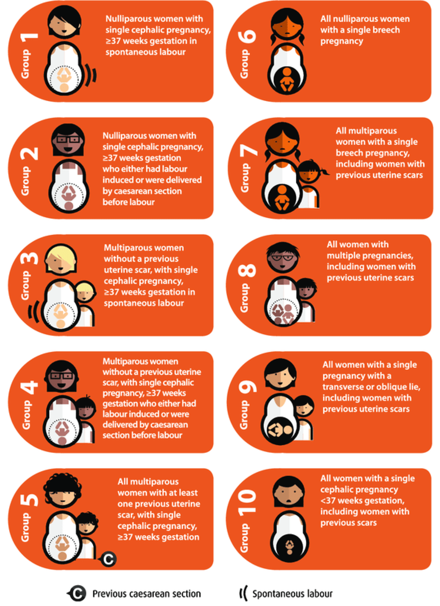

Terminology
Antenatal: Before birth – the period between conception and birth. Also called prenatal.
Apgar score: A measure of the condition of a baby at birth based on measures including the baby’s colour, heart rate, and breathing. Scores range from 0 to 10, where a higher number is better.
Assisted vaginal birth: Birth of a baby with forceps or vacuum. Also called instrumental birth.
Caesarean section: A surgical operation to deliver the baby.
Centile: A measure indicating the value below which a given percentage of observations fall. For example, the 10th centile is the value (or score) below which 10 per cent of the observations may be found.
CCOPMM: Consultative Council on Obstetric and Paediatric Mortality and Morbidity.
Congenital anomaly: An abnormality present in the baby at birth. Also called birth defect, congenital malformation or congenital disorder.
Cephalic: A baby presenting head-first.
Episiotomy: A cut in the perineum to enlarge the opening for the baby to be born.
FGR: Fetal growth restriction. Severe fetal growth restriction is birthweight below the third centile for gestational age and sex.
Forceps birth: Assisted vaginal birth using a metal instrument on each side of the baby’s head.
Fourth-degree tear: A tear of the perineum into the anal sphincter, extending into the lining of the anus.
Gestation: The number of weeks of pregnancy from the first day of the mother’s last normal menstrual period.
Gestation standardised perinatal mortality rate (GSPMR): The GSPMR is a measure of perinatal mortality that compares the observed perinatal mortality rate for babies born at individual hospitals with what would be expected, accounting for the gestation at birth.
ICD-10-AM: The International Statistical Classification of Diseases and Related Health Problems, Tenth Revision, Australian Modification (ICD-10-AM) is a codified nomenclature used by healthcare providers to classify and code all diagnoses and symptoms during admitted care.
Inborn: Baby born at the reporting hospital.
Induction of labour: Medications, rupture of membranes or mechanical means such as a balloon catheter to start labour.
Intrapartum: During labour.
Live birth: The birth of a baby, at any gestational age, who has breathed or shown other signs of life after birth.
Maternity care provider: A clinician who provides maternity care, including doctors and midwives.
Morbidity: Having a disease, a symptom of disease, or ill health, including medical problems caused by a treatment.
Mortality: Term used to describe death, including death rates or the number of deaths in a certain group of people during a certain time.
Neonatal: Newborn; from birth until the 28th day.
Nullipara: A woman who has not given birth previously. Often used interchangeably with primparous.
Perinatal: The period before, during and after birth.
Perinatal mortality: Stillbirths and neonatal deaths. Deaths between 20 weeks’ gestation and birth are referred to as stillbirths, and deaths in the first 28 days after birth are referred to as neonatal deaths.
Perineal tear: A tear of the perineum which may include the area of skin between the anus and the vagina, the vaginal mucosa and the muscles of the pelvic floor See third degree tear, fourth degree tear.
Postnatal /Puerperium: The six-week period after birth.
Postpartum haemorrhage: Blood loss of 500ml or more in the 24 hours following childbirth. Severe postpartum haemorrhage is blood loss of 1,500ml or more in the 24 hours following childbirth.
Prenatal: Before birth – the period between conception and birth. Also called antenatal.
Pre-term: Prior to 37 weeks’ gestation.
Primipara/primiparae: A woman who has given or is giving birth for the first time. Often used interchangeably with Nulliparous.
Qualified neonate: An infant who is the second or subsequent live born infant of a multiple birth, whose mother is currently an admitted patient or who is admitted to an intensive care facility in a hospital, or who is admitted to, or remains in, hospital without their mother.
Robson classification system: The Robson classification system of 10 groups of women based on obstetric characteristics. The system can be used to compare outcomes in different health services with different population demographics. See Appendix 4 for a description of the Robson classifications.
Robson group 1: Robson group 1 includes women giving birth for the first time, with a singleton cephalic pregnancy, at greater than or equal to 37 weeks’ gestation in spontaneous labour (see Appendix 4).
Robson group 2 (modified): Modified Robson group 2 includes women giving birth for the first time, with a singleton cephalic pregnancy, at greater than or equal to 37 weeks’ gestation who had labour induced. Modified Robson group 2 excludes pre-labour caesareans, which are included in the standard Robson group 2 (see Appendix 4).
Singleton pregnancy: pregnancy with one fetus, as opposed to twins, triplets, etc.
Standard primipara: A woman, 20 to 39 years of age, free of obstetric and specified medical complications (pre-existing hypertension, diabetes, cardiac disease or serious psychiatric conditions), giving birth for the first time with a singleton pregnancy between 37 and 40 weeks’ completed gestation (259–286 days), with a non-small for gestational age (greater than tenth centile) infant and a cephalic presentation.
Term infant/term baby: An infant born between 37 and 42 weeks’ gestation (259–283 days).
Third-degree tear: A tear of the perineum into the anal sphincter that does not extend to the lining of the anus.
Unqualified neonate: A neonate who does not meet at least one of the criteria of a qualified neonate.
Vacuum birth: Assisted vaginal birth with a suction cup on the baby’s head.
VAED: Victorian Admitted Episodes Dataset.
Vaginal birth: A birth of a baby through the vagina.
Vaginal birth after caesarean (VBAC): A woman who has a vaginal birth following a caesarean section birth.
VHES: Victorian Healthcare Experience Survey.
VPDC: Victorian Perinatal Data Collection.

Acknowledgements
This report was produced by Safer Care Victoria with expert advice from a sub-group of the Maternity and Newborn Clinical Network Coordinating Committee.
Member | Affiliations
Dr Nicola Yuen | Safer Care Victoria  Bendigo Health
Adj/Prof Tanya Farrell | Consultative Council on Obstetric and Paediatric Mortality and Morbidity (CCOPMM)  Safer Care Victoria
Prof Rod Hunt | Monash Children’s Hospital  Monash University
A/Prof Alexis Shub | Mercy Hospital for Women  PIPER Perinatal
Sarah Watts | Bendigo Health
Adnan Ansar | Safer Care Victoria
Anueja Gopalakrishnan | Safer Care Victoria
Courtney Lynch | Safer Care Victoria
Jake Valentine | Safer Care Victoria
Joanna Gaston | Safer Care Victoria
Mary-Ann Davey | Safer Care Victoria
Melissah Burnett | Safer Care Victoria
Michelle Hawke | Safer Care Victoria
Sharon Le | Safer Care Victoria
Tali Ryan-Atwood | Safer Care Victoria

References
Australian Commission on Safety and Quality in Health Care 2021, Third and Fourth Degree Perineal Tears Clinical Care Standard, <https://www.safetyandquality.gov.au/standards/clinical-care-standards/third-and-fourth-degree-perineal-tears-clinical-care-standard#:~:text=Rates%20of%20third%20and%20fourth,their%20physical%20and%20psychological%20recovery>
Baby Friendly Health Initiative, Baby Friendly Health Initiative Australia, <https://bfhi.org.au/>
Dobbins T, Sullivan E, Roberts C, Simpson J 2012, ‘Australian national birthweight percentiles by sex and gestational age, 1998–2007’, The Medical Journal of Australia, viewed 15 November 2016, <https://www.mja.com.au/journal/2012/197/5/australian-national-birthweight-percentiles-sex-and-gestational-age-1998-2007>
Robson MS 2001, Classification of caesarean sections, Fetal and Maternal Medicine Review, <https://www.cambridge.org/core/journals/fetal-and-maternal-medicine-review/article/classification-of-caesarean-sections/1489F66B41725CF7719525EC11655D4C>
Safer Care Victoria 2021, Perineal protection project – audit tool, <https://www.bettersafercare.vic.gov.au/improvement/projects/mbc/perineal-protection>
Safer Care Victoria 2022, Better Births for women collaborative, <https://www.bettersafercare.vic.gov.au/improvement/projects/mbc/better-births>
Safer Care Victoria 2022, Resuscitation of neonates, <https://www.bettersafercare.vic.gov.au/clinical-guidance/neonatal/resuscitation-of-neonates>
Safer Care Victoria 2022, Safer baby collaborative, <https://www.bettersafercare.vic.gov.au/improvement/projects/mbc/safer-baby>
Stillbirth Centre of Research Excellence, Fetal Growth Restriction (FGR) Care Pathway for singleton pregnancies, <https://resources.stillbirthcre.org.au/elearn/resources/FGR%20Management%20Pathway_V4.pdf>
Stillbirth Centre of Research Excellence, Smoking Cessation, <https://stillbirthcre.org.au/about-us/our-work/the-safer-baby-bundle/smoking-cessation/>
Victorian Government Department of Health 2011, Capability framework for Victorian maternity and newborn services, Victorian Government, Melbourne. <https://www2.health.vic.gov.au/hospitals-and-health-services/patient-care/perinatal-reproductive/maternity-newborn-services/maternity-newborn-care>
Department of Health 2021, Pertussis (whooping cough) | The Australian Immunisation Handbook (health.gov.au), Australian Government. <https://immunisationhandbook.health.gov.au/vaccine-preventable-diseases/pertussis-whooping-cough>
Department of Health 2019, Influenza and pertussis (whooping cough) vaccination in pregnancy | Australian Government Department of Health, Australian Government. <https://www.health.gov.au/news/influenza-and-pertussis-whooping-cough-vaccination-in-pregnancy>



Safer Care Victoria 2022, Better Births for women collaborative, <https://www.bettersafercare.vic.gov.au/improvement/projects/mbc/better-births> Safer Care Victoria 2022, Safer baby collaborative, <https://www.bettersafercare.vic.gov.au/improvement/projects/mbc/safer-baby>
Dobbins T, Sullivan E, Roberts C, Simpson J 2012, ‘Australian national birthweight percentiles by sex and gestational age, 1998–2007’, The Medical Journal of Australia, viewed 15 November 2016, <https://www.mja.com.au/journal/2012/197/5/australian-national-birthweight-percentiles-sex-and-gestational-age-1998-2007>.
Adjusting for transfers has been tested and has been found to not affect the results significantly.
Vaccination during pregnancy reduces the risk of pertussis in young infants by 90%. <https://immunisationhandbook.health.gov.au/vaccine-preventable-diseases/pertussis-whooping-cough>
<https://www.health.gov.au/news/influenza-and-pertussis-whooping-cough-vaccination-in-pregnancy>

