Acute Care Learning Health Network Advisory Group

Terms of reference

OFFICIAL

# 1.Context

Safer Care Victoria (SCV) is the state’s healthcare safety and quality improvement agency. SCV works with consumers, families and carers, clinicians, and health services to monitor and improve the safety and quality of care delivered across our health system. SCV works to eliminate avoidable harm and strengthen quality of care.

SCV puts patient safety front and centre, supporting health services to provide the safest and best possible care to patients, always.

The Centre of Clinical Excellence (CoCE) is the primary mechanism for SCV to engage clinicians and consumers to drive and promote quality improvement and innovation and address variation in clinical practice. Meaningful engagement with clinicians, healthcare leaders, consumers and the wider health sector will enable sustained improvement in the safety and quality of health care. The CoCE works collaboratively across SCV drawing on expertise in leadership development, innovation, system improvement, and consumer experience to achieve improvement objectives.

The CoCE is establishing Learning Health Networks (LHN) to drive and deliver priority work. LHNs bring together clinicians, consumers, data experts, researchers, health system leaders and improvement specialists to use data and evidence to improve clinical care and patient outcomes with a system level view.

# 2. Purpose

## 2.1 Learning Health Networks

LHNs bring together clinicians, consumers, data experts, researchers, health system leaders and improvement specialists to use data and evidence to improve clinical care and patient outcomes. A LHN functions to gather and analyse evidence to implement decisions and monitor the effectiveness of the decision.

Characteristics of a LHN include:

* **Shared vision:** to align multiple stakeholders around a common goal
* **Co-production:** facilitate collaboration, at scale, among multiple stakeholders to co-produce information, knowledge, and resources for creating improvement.
* **Transparent data sharing:** generate a rich data stream to gain insights and rapidly respond to the gap between current and desired performance
* **Widespread capacity to change systems:** apply a quality improvement method to rapidly test, spread, and scale ideas to achieve new levels of performance
* **Culture of trust:** encourage curiosity, shared learning, contribution, and respect
* **Governance:** operate within a framework for governance and management for the design, implementation, and cycles of evaluation to improve outcomes.

The CoCE LHN structure will include two ongoing and overarching streams: Acute Care and Continuing Care. These streams encompass a dedicated Acute Care LHN and a Continuing Care LHN. Time-limited priority areas and funded programs will be aligned to either the Acute Care or Continuing Care streams and proceed on a time-limited basis.

## 2.2 Learning Health Network Advisory Groups

LHN Advisory Groups consist of clinicians, consumers, data experts, researchers, health system leaders and improvement specialists to oversee the LHNs. LHN Advisory Groups will drive and facilitate purposeful consumer and sector engagement within the LHN. The Advisory Groups will provide advice on work of the LHN, with a focus on system level issues, and provide advice and direction to support SCV and the Department of Health (DH) as required. LHN Advisory Group membership and function may vary based on programs of work. LHN Advisory Groups support the identification and escalation of system-level issues relevant to their network; respond to specific data or safety and quality issues identified including those by the Clinical Advisory Group (CAG). Each LHN Advisory Group will act in the best interests of consumers, health care workers and the wider Victorian community to provide a mechanism for broader sector consultation.

Figure 1: Learning Health Network Structure

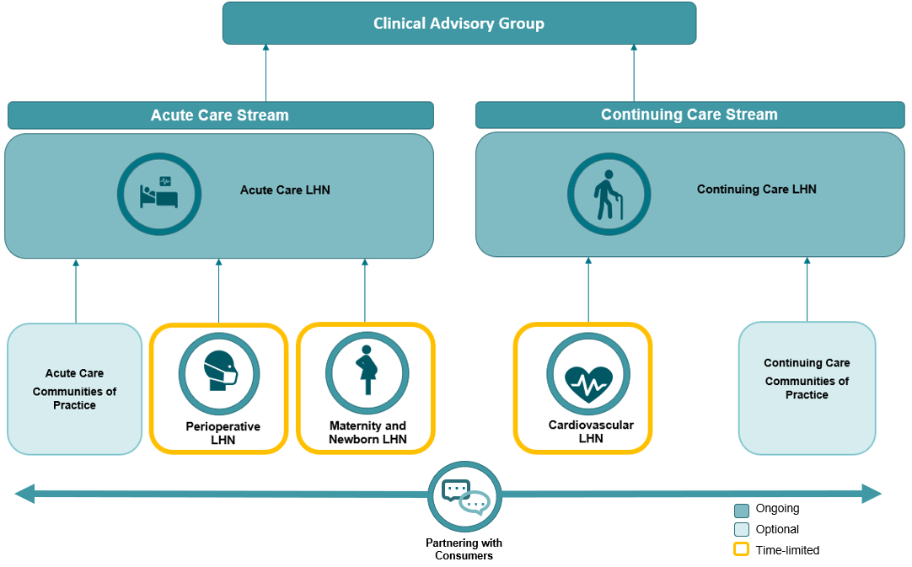

## 2.3 Core operating principles

LHN Advisory Groups will:

* act in the best interests of consumers, health care workers and the wider Victorian community
* ensure consumers participate in a meaningful way in all activities of LHN Advisory Groups, including decision making
* function in alignment with the CAG, the CoCE and SCV’s strategic plan and priorities
* not share confidential information (received in their capacity as members) with the sector as specified in the SCV confidentiality agreement
* regularly review progress against its roles and responsibilities
* be politically neutral as an Advisory Group, not endorsing politically focused advocacy
* act in accordance with the values and behaviours of the [Code of Conduct for Victorian Sector Employees](https://vpsc.vic.gov.au/html-resources/code-of-conduct-for-victorian-public-sector-employees/).

## 2.4 Roles and responsibilities of the LHN Advisory Group

Co-chaired by the LHN Clinical and Consumer Leads, the LHN Advisory Group will provide guidance, advice, and direction to support the work of the LHN.

This may include, but is not limited to:

* leverage expertise and sector relationships to provide expert advice about emerging safety and quality issues
* facilitate analysis of system and service level data, by working with the Quality and Safety Signals (QASS) group
* provide insight and specialty clinical advice about data variation as required
* identify and/or review existing safety and quality metrics for the relevant health network
* generate a strategic workplan (for approval by SCV Executives)
* lead and promote sector engagement
* enable broad consultation and engagement with the sector via networking, peer-to-peer learning and collaboration across the health network
* lead meaningful consumer engagement
* offer advice or guidance on clinical reform, improvement and measures to support SCV and the DH as required
* share best practice resources
* triage and raise emerging system-level themes or issues to the CAG as appropriate; in turn respond to requests from the CAG
* review and provide advice on work in progress, which may include practice changes, safety, and improvement, with a focus on system level issues
* work with other health networks to identify shared priorities and opportunities to collaborate
* promote SCV work, particularly CoCE activities and projects.

## 2.5 Data

The Acute Care LHN will have access to system level data through the QASS group. The purpose of QASS is to recognise system vulnerabilities and key risks, identify improvement opportunities, identify data variations that indicate adverse consumer outcomes, and monitor improvements delivered.

A Data Expert Working Group may be formed to aid in the establishment of priority measures and to guide direction of the Acute Care LHN.

# 3 Accountability

## 3.1 Clinical Advisory Group

Each LHN Advisory Group will report to the CAG, chaired by the CEO of SCV. The CAG provides multidisciplinary expert clinical and consumer guidance and advice to the CoCE, SCV Senior Leadership Group and the broader DH when required. All LHNs will be accountable to the SCV Executive.

Acute Care LHN Clinical and Consumer leads, in their role as Co-Chairs of the LHN Advisory Group, will also be members of the CAG. They will be the key conduit for escalation and reporting to the CAG from their LHN. The CAG will provide endorsement of recommendations and advice to the LHN.

The Acute Care LHN Advisory Group will:

* inform the CAG of system-level issues identified in their respective health network
* respond to requests from the CAG about system-level themes in their area
* provide insight into data variation as required by the CAG.

# 4. Membership

## 4.1 Members

Membership will include a broad range of consumers, data experts, researchers, health system leaders and clinicians from varying disciplines, career stages and healthcare settings (across regional and metropolitan Victoria), to enable balanced representation of perspectives in the relevant health population.

Each Advisory Group will comprise of approximately 20 members. Acute Care LHN Advisory Group membership and function may vary based on programs of work. The Acute Care LHN Advisory Group will be co-chaired by the LHN Clinical and Consumer Leads.

Acute Care LHN Advisory Group membership will include one SCV Chief Professional Officer. The Chief Professional Officer will play a key role in providing a two-way conduit between SCV and DH.

Members are non-representative, that is, they do not represent an entity, organisation, or any vested interests.

### Membership includes:

* Acute Care LHN Clinical Lead (Co-Chair)
* Acute Care LHN Consumer lead (Co-Chair)
* Consumers (three)
* Clinical members including medical, nursing, and allied health
* Metropolitan, regional, and rural health service representatives
* General Practitioner or Primary Health Network representative
* LHN Community of Practice Chair/s* (where applicable)
* SCV Chief Professional Officer

*In the instance of multiple CoPs within the same speciality area, one CoP Chair will be nominated by the relevant LHN Advisory Group to represent the specialty area.

### Expert Working Groups

Time limited Expert Working Groups (EWGs) of the LHN Advisory Group may be established to rapidly progress specific pieces of work. Membership will be drawn from the Acute Care LHN Advisory Group and additional members may be recruited to provide further specialist clinical expertise or consumer insights not available in the LHN Advisory Group membership.

The EWGs will:

* provide subject matter expertise on the identified pieces of work
* oversee the full life cycle of individual pieces of work
* be time limited

## 4.2 Proxies

Absent members cannot be represented by proxy unless otherwise agreed by the Co-Chairs.

## 4.3 Tenure

The Acute Care LHN Advisory Group members will have a tenure of two years. Should a mid-term vacancy arise, a replacement will be sought.

# 5. Meetings

## 5.1 Meeting frequency

The Acute Care LHN Advisory Group will:

* meet a **minimum** of 4 times per year
* meetings will be conducted via videoconference using Microsoft Teams, with potential for face-to-face meetings if required
* Expert Working Groups will meet as required to complete an allocated piece of work.

## 5.2 Chairs

The Clinical and Consumer Leads will co-chair the Acute Care LHN Advisory Group.

The Advisory Group Co-Chairs will:

* set the agenda for the meeting, supported by the relevant senior project officer
* chair meetings
* maintain order during meetings
* ensure the conventions of the meeting are being followed
* ensure fairness and equity at the meeting
* keep the meeting to time
* approve the formal actions of the meeting
* hold members accountable to the values and behaviours of the [Code of Conduct for Victorian Sector Employees](https://vpsc.vic.gov.au/html-resources/code-of-conduct-for-victorian-public-sector-employees/)
* act as the conduit between the LHN Advisory Group and the CAG
* maintain active membership on the QASS group and CAG
* represent the Acute Care LHN Advisory Group (this responsibility may be delegated)

## 5.3 Secretariat

A Senior Project Officer will provide the secretariat function for the Acute Care LHN Advisory Group and EWGs. The role of the secretariat is to:

* support the day-to-day running of the group by developing the agenda, preparing and distributing background papers, recording and preparing meeting minutes
* update, manage or log any potential conflicts of interest
* ensure group decisions or recommendations are accurately documented
* prepare briefing papers or reports on behalf of the group to the SCV executive team, the Department or other groups or agencies.

## 5.4 Decision making

Decision making in the Acute Care LHN Advisory Group will be on a consensus basis. In the event where there is no consensus, a majority will suffice. In the event of a deadlock, the Co-Chairs will have the casting vote.

Scope of the work will need approval from SCV Executives.

## 5.5 Out of session resolutions

When an issue arises that, in the opinion of the Co-Chairs, requires resolution before the next scheduled meeting, the Co-Chairs may seek an out-of-session resolution.

An out-of-session resolution shall be achieved and may be acted on if:

* written information about the issue, together with a proposed resolution, is distributed to all members of the group, and;
* 50 per cent of the group respond (constituting a quorum), and a consensus or simple majority agree with the proposed resolution, or an amended form of the resolution, within a timeframe agreed on by the Co-Chairs.

## 5.6 Attendance

All meetings will be held virtually, with potential for face-to-face meetings if required.

Members are expected to actively participate in meetings and attend a minimum of 75 per cent of meetings.

## 5.7 Quorum

To achieve a quorum, attendance is required by 50 per cent of members. In the event a quorum is not achieved, a decision to continue with the meeting will be made by the Co-Chairs. Should the meeting proceed, voting will be held over until a quorum is achieved.

## 5.8 Confidentiality

All Acute Care LHN Advisory Group members will:

* be required to sign a confidentiality agreement on commencement of their term of appointment (**Appendix 1**)
* not reveal any confidential or proprietary information that they obtained while a member of the LHN Advisory Group during or on cessation of membership, or attempt to use or retain any such information, documents, or data
* not distribute any information, papers or Acute Care LHN Advisory Group material or make available to non-members.

## 5.9 Conflict of interest

A conflict of interest will arise if a person’s personal interest (actual or perceived) conflicts with their duties as an Acute Care LHN Advisory Group member, such that the person may not be independent, objective, or impartial in relation to their duties. All conflicts of interest must be declared as part of the membership documentation, and where appropriate for additional circumstances in any given meeting.

Where a potential conflict of interest has been declared and accepted as a conflict by the Co-Chairs, the member will remove themselves from voting on matters concerning the declared conflict; and be guided by the Co-Chairs on how best to proceed and advise the meeting accordingly. A formal declaration will be completed and signed along with documented action taken by the Co-Chairs.

All Acute Care LHN Advisory Group members will be required to sign a potential conflict of interest declaration on commencement of their term of appointment (**see Appendix 2**).

## 5.10 Remuneration

Consumer members and private practitioners (such as General Practitioners) will be eligible for remuneration for attending Acute Care LHN Advisory Group meetings. The manager of the relevant centre will review and approve all remuneration requests in line with the Victorian Government Appointment and remuneration guidelines and SCV’s [Guide to consumer remuneration](https://www.bettersafercare.vic.gov.au/publications/a-guide-to-consumer-renumeration).

# 6. Review

The Acute Care LHN Advisory Group will review its progress against its stated role, functions and work plans every twelve months and the Terms of Reference updated accordingly.

Changes to the Terms of Reference will be subject to approval by the Co-Chairs and Director, Centre of Clinical Excellence at SCV.

# Appendix 1. Confidentially agreement

All members of the Acute Care Learning Health Network (LHN) Advisory Groups are requested to complete this agreement prior to commencing duties, as described in the terms of reference.

I, _______________________________hereby indicate that I understand and agree to abide by the confidentiality provisions set out in Section 42 of the *Public Health and Wellbeing Act 2008.*

I acknowledge that I must not directly or indirectly make a record of, divulge, or communicate to any person any information gained by or conveyed to me by reason of my office, employment, or engagement; or make use of the information for any purpose other than in the performance of the functions of the Acute Care LHN Advisory Group and expert working groups.

Upon cessation of membership/attendance at a meeting, and thereafter, the member/guest shall not reveal any confidential or proprietary information that they obtained while a member of the group or in attendance at a meeting, and may not use or retain, or attempt to use or retain, any such information, documents, or data.

Signed: __________________________________________________

Witness: __________________________________________________

Date:

# Appendix 2. Potential conflict of interest declaration

All members of the Acute Care Learning Health Network (LHN) Advisory Groups are requested to complete this declaration prior to commencing LHN Advisory Group duties, as described in the terms of reference.

## Conflict of interest

Acute Care LHN Advisory Groups members must declare any potential personal, professional, or work-related conflict of interest:

* on commencing involvement with LHN Advisory Groups, as applicable
* where a matter giving rise to a potential conflict of interest is to be tabled, prior to the commencement of the LHN Advisory Group meeting or expert working groups
* where a matter giving rise to a potential conflict of interest is raised within the LHN Advisory Group as soon as practicable during the LHN Advisory Group meeting.

A conflict of interest may include, for example, where there may be possible financial or professional gain for the member or their employing organisation through knowledge, decisions or information obtained as an LHN Advisory Group member of the LHN Advisory Groups.

In the event an Acute Care LHN Advisory Group member has declared a potential conflict of interest, and it is accepted as a conflict by the Co-Chairs, the LHN Advisory Group member must comply with the identified method of addressing the conflict of interest (for example, by removing themself from the meeting for the duration of any discussion regarding the matter giving rise to the conflict of interest). Any declared conflict of interest will be recorded in the minutes/action log of the meeting.

I ______________________________________ agree to disclose any potential conflict/s of interest and comply with the identified methods of addressing the conflict/s of interest as described above.

Signed: __________________________________________

Date: