Learning Health Network Advisory Group

Questions and answers

OFFICIAL

## What is Safer Care Victoria’s purpose?

Safer Care Victoria (SCV) is Victoria’s healthcare safety and quality improvement agency. SCV works with consumers, families, carers, clinicians, and health services to monitor and improve care for patients across our health system.   
  
SCV was established in 2017 in response to the recommendations within the report *Targeting Zero: the review of hospital safety and quality assurance in Victoria.* SCV works to eliminate avoidable harm and strengthen quality of care. SCV puts patient safety front and centre, supporting health services to provide the safest and best care to patients, always.

Relevant resources

Follow the links below to learn more about the work we do:

* [Safer Care Victoria website](https://www.bettersafercare.vic.gov.au/)
* [Partnering in Healthcare Framework](https://www.bettersafercare.vic.gov.au/sites/default/files/2019-02/Partnering%20in%20healthcare%20framework%202019_WEB.pdf)

## What is the Centre of Clinical Excellence?

The Centre of Clinical Excellence (CoCE) is the primary mechanism for SCV to engage clinicians and consumers to drive and promote quality improvement and innovation and address variation in clinical practice. Meaningful engagement with clinicians, healthcare leaders, consumers and the wider health sector will enable sustained improvement in the safety and quality of health care. The CoCE works collaboratively across SCV drawing on expertise in leadership development, innovation, system improvement, and consumer experience to achieve improvement objectives.

## What is a Learning Health Network?

SCV is currently establishing Learning Health Network (LHNs) to drive and deliver priority work, for a sustainable impact across the health system. LHNs bring together clinicians, consumers, and improvement specialists, using data and evidence to improve clinical care and patient outcomes. A LHN functions to gather and analyse evidence to implement decisions and monitor the effectiveness of the decision.

Characteristics of a LHN include:

* **Shared vision:** to align multiple stakeholders around a common goal
* **Co-production:** facilitate collaboration, at scale, among multiple stakeholders to co-produce information, knowledge, and resources for creating improvement.
* **Transparent data sharing:** generate a rich data stream to gain insights and rapidly respond to the gap between current and desired performance
* **Widespread capacity to change systems:** apply a quality improvement method to rapidly test, spread, and scale ideas to achieve new levels of performance
* **Culture of trust:** encourage curiosity, shared learning, contribution, and respect
* **Governance:** operate within a framework for governance and management for the design, implementation, and cycles of evaluation to improve outcomes.

The LHNs will play an essential role in fostering purposeful engagement with consumers and the sector. Each LHN will have associated Advisory Groups, comprising of clinicians and consumers with diverse expertise and interest in the target speciality areas.

Figure: Learning Health Network Structure

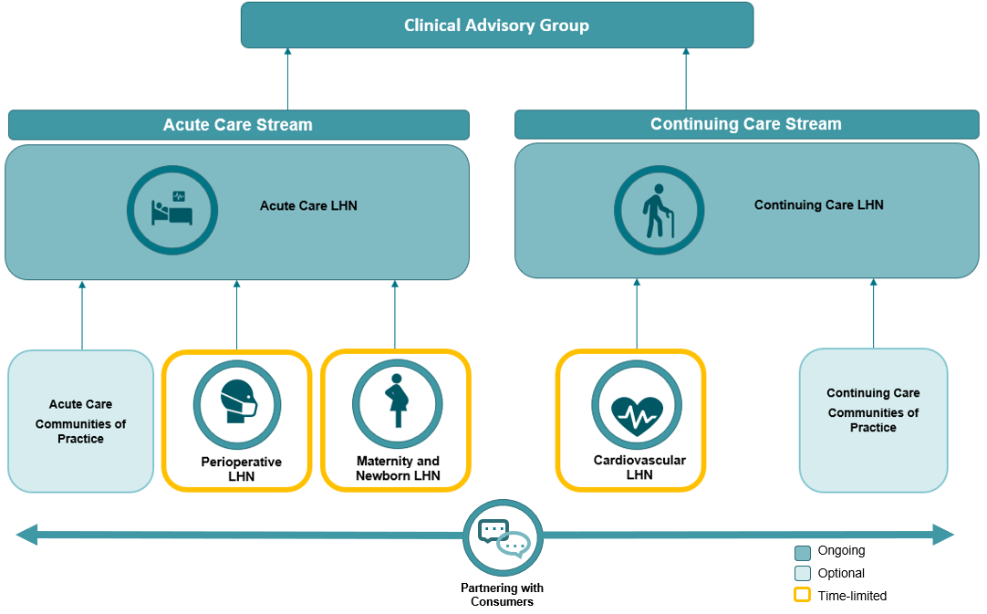

## What is a LHN Advisory Group?

LHN Advisory Groups will consist of clinicians, consumers, data experts, researchers and health system leaders to oversee the LHNs. The LHN Advisory Groups will drive and facilitate purposeful consumer and sector engagement. LHN Advisory Groups will provide advice on work of the LHN, with a focus on system level issues, and provide advice and direction to support SCV and the Department of Health (DH) as required.

The LHN Advisory Groups support the identification and escalation of system-level issues relevant to their health network; respond to specific data or safety and quality issues identified.

LHN Advisory Group membership and function may vary based on programs of work and will act in the best interests of consumers, health care workers and the wider Victorian community to provide a mechanism for broader sector consultation.

## What is the time commitment for this role?

All meetings will be held virtually via the Microsoft Teams platform for approximately one hour. Please note that there may be occasions where face-to-face meetings may be required.

Meeting attendance will be required approximately 6 times per year. Members are expected to actively participate in meetings and attend a minimum of 75 percent of the meetings.

There will be an agenda and at times papers to be reviewed prior to meetings. Document review and some out of session feedback and decisions may be required on an ad hoc basis.

SCV staff will support the organisation and running of the meetings, including onboarding of all members.

## How many positions are available in the Groups?

It is expected that the Advisory Group will include 2 Co-chairs (Clinical Lead and Consumer Lead). In addition, there will be 10 to 15 other members comprising of clinicians, researchers, data experts, researchers, health system leaders and improvement specialists and three consumers. However, this number may vary depending on skills needed.

## Can I apply for more than one LHN Advisory Group?

You may apply for multiple LHN Advisory Groups, if successful, you will be asked to select one of the Groups. Please consider the specific LHN group where you would be able to bring the most relevant knowledge and experience.

## Will I be remunerated for my time?

Public health service employees will not be directly remunerated for their time.

Consumer members and private practitioners (such as General Practitioners) will be eligible for remuneration for attending Continuing Care LHN Advisory Group meetings. The manager of the relevant LHN will review and approve all remuneration requests in line with the Victorian Government Appointment and remuneration guidelines and SCV’s [Guide to consumer remuneration](https://www.bettersafercare.vic.gov.au/publications/a-guide-to-consumer-renumeration).

## Can I apply if I live and work in a regional or rural area?

Yes, people living in regional and rural areas are encouraged to apply. Meetings wherever possible will be held virtually (via Microsoft Teams platform) and should in person meetings be required, reasonable travel expenses will be considered for reimbursement.

Please refer to the above section *“What is the time commitment for this role?”* for details surrounding virtual meetings and expectations.

## When do I start?

We are expecting the first Continuing Care LHN Advisory Group meeting to be in January or February 2023. An in-person LHN Planning Forum is planned for March 2023.

## Who do I contact if I would like more information?

For further information please contact Katherine Valastro at [continuingcarelhn@safercare.vic.gov.au](mailto:continuingcarelhn@safercare.vic.gov.au).