December 2022

Consumer involvement following a serious adverse patient safety event

A 9-step guide for health services

OFFICIAL

Contents

Contents 2

1. Introduction 3

Definitions 3

Aim of this guide 3

Legislative, legal and community expectations 4

The purpose and benefits of engaging with impacted consumers 4

2. Guiding Principles 6

Put the impacted consumer first 6

Encourage honesty, openness, and transparency 6

Engage with purpose 7

Support the impacted consumer’s sense of safety 7

Practise inclusiveness 8

3. Impacted consumer engagement process 9

Step 1: Inform the impacted consumer that an adverse event has occurred 10

Step 2: Plan for ongoing engagement 10

Step 3: Arrange engagement logistics 11

Step 4: Explain the review process to the impacted consumer 12

Step 5: Listen to the impacted consumer’s story 13

Step 6: Ensure consumer voices are heard by the review team 13

Step 7: Communicate review outcomes to the impacted consumer 14

Step 8: Evaluate the engagement process 14

Step 9: Follow up with the impacted consumer on actions taken 15

4. What to do and what to avoid 16

5. Appendix 17

A. Family feedback survey example (Healthcare Safety Investigation Branch UK) 17

# Introduction

## Definitions

An **adverse patient safety event (adverse event)** is an event that resulted in harm to a person receiving care (Australian Commission on Safety and Quality in Health Care. Harm includes disease, suffering, impairment (disability) and death.

**SAPSE** is a serious adverse patient safety event that occurred while the patient was receiving care from a health service entity; and in the reasonable opinion of a registered health practitioner, has resulted in or is likely to result in unintended or unexpected moderate or severe harm, or prolonged psychological harm by the patient.

An **impacted consumer** is a patient who has been harmed or has died as a result of an adverse patient safety event, and/or their family members or carers. If the patient is deceased or is otherwise not able to engage in the review process, the health service should engage a carer or loved one to represent the patient.

A **consumer representative** is a consumer with a specific role in the health system. They provide independent advice to health services on behalf of consumers and the community more broadly and often sit on health service committees or working groups. On review teams, they provide an objective consumer viewpoint, ask questions from the consumer perspective, and contribute to the development of patient-centred recommendations.

**Open Disclosure** is a formal process of open communication that occurs between a health service and an impacted consumer following an adverse event.

**Statutory Duty of Candour** (SDC) builds on the Australian Open Disclosure Framework and requires health services to apologise to any person seriously harmed while receiving care, explain what went wrong, and describe what remedial actions will be put in place. It also offers legal protections around apologies. The legislation came into effect on 30 November 2022. Read more: [Duty of candour and review protections | Safer Care Victoria](https://www.safercare.vic.gov.au/support-training/adverse-event-review-and-response/duty-of-candour).

**Family Liaison Person** (FLP) is a staff member assigned to act as a central liaison point for the impacted consumer throughout the review process. This can be assigned on a case-by-case basis to the most appropriate role, such as a Patient Liaison Officer, Aboriginal Liaison Officer, clinician, manager or executive.

## Aim of this guide

This guide aims to assist health services to increase the prevalence and quality of impacted consumer engagement in reviews of adverse patient safety events. It outlines a best practice approach to communicating with impacted consumers after adverse events and builds on and supports the requirements of **Victoria’s Statutory Duty of Candour**[1] (**SDC)**, the **Australian Open Disclosure Framework[2]**,and the Australian Commission for Safety and Quality in Healthcare’s **National Safety and Quality in Health Service Clinical Governance Standard**[3] and **Incident Management Guide**[4].

The guide identifies areas for improvement along the impacted consumer engagement journey. It aims to strengthen existing engagement practices by:

* facilitating a consistent approach to engaging with impacted consumers
* encouraging increased impacted consumer participation in adverse event reviews
* enabling impacted consumers to develop a sense of contribution to improvements and solutions arising from the adverse event review
* providing health services with information and strategies to effectively engage impacted consumers.

“I was determined to be kind [to staff] but wanting a discussion to happen. I imagine a sentinel event would be one of the hardest things to face as a health worker, so for the hospital to include me in the review was brave, was acknowledging their transparency, their openness to discussion. It made a huge difference to me.” [Impacted consumer]

## Legislative, legal and community expectations

Expectations around communication after harm occurs in healthcare is changing, and health services must modify their approaches to meet those expectations. It is expected that health services will involve and openly communicate with impacted consumers. This is included in the SDC legislation, which now legally obliges health service entities to communicate openly and honestly with impacted consumers when they have experienced a SAPSE.

Public health services are also legally obliged to discuss an adverse event with the impacted consumer under the *Victorian Charter of Human Rights and Responsibilities Act 2006*.

Consumer expectations of health practitioners and health services have developed through generational change. Socio-political changes and increasing higher education participation in the general population has raised community expectations about health services’ communication and involvement in their own healthcare. Today’s consumers have significantly higher expectations than their predecessors did in relation to how health services interact with them following an adverse event.

## The purpose and benefits of engaging with impacted consumers

Adverse events are reviewed by a team that was not directly involved in the event itself. Review teams rely on information obtained from multiple sources to gain the fullest understanding of how and why an event occurred.

* Impacted consumers can offer a unique perspective on the adverse event that caused their harm, potentially providing critical information and powerful insights to the review team.
* Impacted consumer involvement can be healing and restorative for the consumer(s) involved.
* Impacted consumers may provide insights into possible improvements and solutions to reduce the risk of harm reoccurring.
* Meaningful and transparent engagement in the review process may help restore goodwill between health services and impacted consumers.

“Being included [in the process] reduced my anger and frustration and showed the humanity of the health service.” [Impacted consumer]

If an impacted consumer’s perspective is not known to the review team, their experience cannot be accurately represented.

**The Impacted Consumer Engagement Process**

The 9-step end-to-end impacted consumer process focusses on all engagement phases between a health service and an impacted consumer following an adverse event. This guide can be used as part of the adverse event review.

# Guiding Principles

When engaging impacted consumers, health services should be guided by principles that focus on the needs of the impacted consumer.

Note: This guide describes a best-practice approach to improving impacted consumer engagement. It provides guidance that will assist health services to maximise the effectiveness of impacted consumer engagement. As such, the contents of this guide do not replace existing guidance, which provides health services with support in delivering mandatory legislative requirements.

## Put the impacted consumer first

The impacted consumer, who has already undergone a traumatic event, may be concerned about further engaging with the health service, but a good faith invitation to participate must still be made. You may convince yourself that including the impacted consumer in the review process may cause them further harm, however you should make every reasonable effort to support them in their recovery and participate in the review process. You can do this by using effective communication that focuses on their needs.

Impacted consumers deserve an honest discussion of the facts known at any given point. They may equate any perceived lack of direct, one-on-one communication from the health service throughout the review process as a lack of concern. This could increase the psychological and emotional distress they feel, which is a key contributor to decisions around potential legal recourse.

“[They] sought to dissuade us from seeking answers around her care and did not do what they promised.” [Impacted consumer]

## Encourage honesty, openness, and transparency

When communicating about an adverse event, disclosure is only one aspect of the overall process.

“The biggest hurt for our family has been inflicted by the doctors and senior hospital staff we initially dealt with, who we feel were not honest with us.” [Impacted consumer]

It is now expected that health services will involve and openly communicate with impacted consumers. Staff should:

* be candid, willing to acknowledge mistakes, and transparent with any available information
* demonstrate integrity by following through on agreed actions and being responsive to the impacted consumer
* build trust and compassion
* set realistic expectations with the impacted consumer about how their input will be factored into the review team’s deliberations.

“We relied on the health service staff to honour the doctors’ oath and act ‘with conscience and dignity’. However, our experience suggests the interests of the health service were placed above transparency and justice for her.” [Impacted consumer]

## Engage with purpose

Health services and impacted consumers could have different expectations of the engagement process. To build lasting goodwill with impacted consumers, aim to:

* clearly understand the consumer’s motivation for engagement and that this may change over time, e.g. at different times, the consumer may be driven by a need to understand what happened to them; they may feel frustrated or angry by not being listened to; or they may have a desire to improve the system to prevent further harm
* be respectful, inclusive, and supportive of individual consumer engagement capabilities
* engage for the time required to hear, share, and understand the information being exchanged
* commit to actioning agreed recommendations
* communicate in a timely and personalised way.

“[Due to lack of effective communication] we question the health service’s capacity to conduct an unbiased, thorough assessment of the systemic failures contributing to the loss of our son.” [Impacted consumer]

## Support the impacted consumer’s sense of safety

In the aftermath of an adverse event, health services have already compromised the safety of the impacted consumers who they now seek to actively engage. Health services must take actions to ensure that impacted consumers feel safe throughout the review process involvement. Staff attitudes play a critical role in building and maintaining impacted consumers’ confidence and sense of safety within the engagement process. This in turn encourages and supports active and effective participation.

Having sound processes and procedures and support from leadership will contribute to creating a psychologically safe environment. This will allow impacted consumers to talk more openly about their concerns, interact with the review process more effectively, and feel safe while making their contributions.

Impacted consumers’ sense of safety will be impacted by their perception of:

* equality in the process, and the weight given to information they provide
* quality and timeliness of information provided to them by health service staff
* the level to which they are given opportunities to meaningfully participate in the process.

Processes that support timely, open, and inclusive engagement with impacted consumers following adverse events have a beneficial impact on organisational reputation and build trust within the community. Health services earn trust through their processes when they:

* reach agreement on when and how to engage
* listen to and act on impacted consumer needs and feedback
* respect impacted consumers’ expertise and appreciate the benefits of mutual learning
* place impacted consumers’ needs ahead of organisational interests
* communicate frequently and honestly with impacted consumers about the review process
* are accountable for the review outcomes.

## Practise inclusiveness

Impacted consumers are representative of diversity in the Victorian community and health service engagement processes and resources should reflect this. Regardless of any perceived barriers to engagement, health services should aim to:

* encourage review process involvement from all impacted consumers and use engagement techniques to enable their voices to be heard
* recognise and meet the different communication needs and preferences of individual impacted consumers.

# Impacted consumer engagement process

This guide outlines a 9-step process for Victorian health services and has drawn inspiration from a similar process developed by the Health Quality & Safety Commission, New Zealand[5].

The 9-steps outline a planned and meaningful end-to-end engagement process with impacted consumers. The impacted consumer is at the centre of the adverse event that caused their harm, and they should be at the centre of the associated review process. This process describes a best-practice approach.

The contents of this guide do not replace existing guidance, which provides health services with support in delivering to mandatory legislative requirements. The guide builds on the Australian Open Disclosure Framework by outlining how to involve impacted consumers in the adverse event review process to ensure their voices and perspectives are taken into account.

An image of a group of five people of differing ages appears in the centre of the page. Around them are nine numbered circles representing the nine steps of the engagement process. The nine steps are listed as:
1: Inform, 2: Plan, 3: Arrange, 4: Explain, 5: Listen, 6: Give voice, 7: Share findings, 8: Evaluate, and 9: Follow up.
There is additional text in each of the circles expanding briefly on these steps.

## Step 1: Inform the impacted consumer that an adverse event has occurred

This first step in the process is critical to setting up positive, ongoing engagement. When something has gone wrong during their care, consumers want information. This typically includes an explanation of what happened, including what is known at the time about how and why the adverse event occurred. This is the first step in Open Disclosure discussions, and a requirement of the SDC process. It is required of the health service with responsibility for the consumer’s care.

Many impacted consumers respond positively if health services acknowledge an adverse event and assume appropriate responsibility. If an impacted consumer perceives that a health service is acting in a defensive manner or attempting to minimise what has occurred, they are more likely to perceive the health service as trying to protect itself. This creates the risk of further damaging the relationship with the consumer.

“I received a call from a patient representative asking if I’d like to be part of the review and straight away, I thought, ‘Oh, that's fabulous’ – it meant I was going to be able to speak for my daughter.” [Impacted consumer]

It is important that health services recognise and are sensitive to the potential broad-ranging effects of adverse events on impacted consumers. In addition to health impacts, these effects may be emotional or financial and may cause life disruptions. Recognition of the wide-ranging impacts on consumers conveys caring, can restore trust, and assist in building and maintaining strong engagement with the consumer.

In line with Open Disclosure and SDC requirements, communication with an impacted consumer should:

* be timely
* include acknowledgement of the event and an explanation of what happened
* where appropriate, explain what actions have already been taken to prevent a reoccurrence
* include a sincere apology.

The impacted consumer should be informed that an adverse event review will take place and that they will have the opportunity to contribute information. You can use our Next Steps pamphlet (Step 4) to assist in providing this information.

Refer to the Australian Commission for Safety and Quality in Healthcare website for more information about Open Disclosure: [The Australian Open Disclosure Framework | Australian Commission on Safety and Quality in Health Care](https://www.safetyandquality.gov.au/our-work/open-disclosure/the-open-disclosure-framework#:~:text=The%20Australian%20Open%20Disclosure%20Framework%20provides%20a%20nationally,when%20health%20care%20does%20not%20go%20to%20plan.).

## Step 2: Plan for ongoing engagement

To ensure effective impacted consumer engagement, the health service should resource some critical responsibilities, which may be carried out by one or more people:

* **ongoing liaison** with the impacted consumer throughout the review process. This role represents the main conduit for communication between the impacted consumer and the review team, including coordinating delivery of the impacted consumer’s written account, i.e. role of FLP.
* **leading an interview with the impacted consumer** if a meeting is to take place and preparing a written account of this discussion
* **conveying the impacted consumer’s input to the review team** and ensuring that their words are understood in context.

Accurate and consistent delivery of the impacted consumer’s input is best supported by having the last two roles filled by one person who is also a review team member, although there may be circumstances where this is not practical.

Written summaries or submissions should be made available to the review team. The team member that spoke to the impacted consumer could provide any insights into the impacted consumer’s viewpoints that may assist review team discussions.

Consider documenting the following aspects of the engagement process:

* clearly define the purpose and rationale of the engagement activity
* identify objectives, resources required and risks
* assess the impacted consumer’s capacity to engage
* document the purpose and appropriate engagement methods
* establish a timeline, risk management plan, roles, and responsibilities.

Consideration should be given to designing an engagement survey to be completed by the impacted consumer at the completion of the process. Feedback could be sought around:

* the structure of the engagement process
* their experience of the process
* their understanding of how effective their involvement in was the process and their influence on recommendations.

Refer to Step 8: Evaluate engagement process for more about the survey. See the UK’s **Healthcare Safety Investigation Branch survey** (Appendix A) for an example.

Health services should be aware that impacted consumers might be experiencing stress, distress, grief and/or trauma, and discussions during the engagement process might trigger or exacerbate these experiences. Impacted consumers may still be in the midst or aftermath of a personal crisis associated with or independent of the adverse event, e.g. bereavement, health issue, mental health crisis, job loss, homelessness, financial hardship. This can have a range of consequences, including making it difficult for the impacted consumer to take in or share information. Sensitive and appropriate engagement in these circumstances may include:

* asking when it is the best time to engage and regularly checking in with the consumer throughout the process
* identifying and confirming the best way to communicate with the consumer
* ensuring support is available to consumers by informing them of relevant internal or external support services
* ensuring they are given appropriate time to prepare and participate, while giving due consideration to meeting overall review timeframes.

## Step 3: Arrange engagement logistics

When arranging to meet with an impacted consumer, discuss options that will be suitable for them, such as offering telephone or online meetings. Check with the consumer about their communication needs, such as providing information in large print, audio, or video, or engaging a language interpreter.

“Communication from the hospital was great – it was mainly by email, which in hindsight I really appreciated because I then had documentation to refer to.” [Impacted consumer]

Let the consumer know in advance who will be attending the meeting and advise that they may bring a support person/s.

When choosing a meeting venue, make every effort to select and prepare a comfortable and welcoming environment for the impacted consumer and other participants.

* Consider meeting the impacted consumer at their home address.
* If meeting at the health service, consider accessibility needs, including arrangements for wheelchair users, people with vision impairment, and people who are deaf or have a hearing impairment.
* Provide clear directions to the venue and ensure that it is well-signposted.
* Ensure that the layout of seating and other aspects of the room will not be considered intimidating.

Be mindful that there may be cultural sensitivities around certain topics or practices.

* Discuss any areas of concern with appropriate health service and/or community advisors prior to engagement to ensure that the engagement is culturally appropriate.
* Follow cultural protocols and seek advice if you are in doubt.

Seek permission before recording, photographing, or filming impacted consumers.

## Step 4: Explain the review process to the impacted consumer

A key aspect of open communication about an adverse event is providing a full explanation of what happened. This is often not possible until an adverse event review has taken place, so early communication should focus on providing information about the review process itself, including:

* what will be involved, e.g. a team will be convened to review the adverse event and develop recommendations to prevent recurrence
* the focus of the review on systems and processes, not on attributing blame or accountability
* how long it will take, e.g. projected review and SDC timeframes
* who the FLP will be
* how the consumer can contribute to the review.

Impacted consumers should be made aware that participating in the review is voluntary and they have a choice about how much or little they wish to be involved. Not all impacted consumers will want to be interviewed or provide feedback, however they must be offered the opportunity.

Help impacted consumers to prepare for the review by providing them with clear information about what will happen and what they can expect. Provide them with the [Next steps pamphlet | Safer Care Victoria](https://www.safercare.vic.gov.au/publications/next-steps-pamphlet) and with the contact details of the FLP, which must be recorded on the pamphlet. The consumer can liaise with this person throughout the review process.

The FLP should ensure regular updates about the review’s progress are communicated with consumers.

“[We felt] completely ignored, belittled, patronise, and delayed. They told us to expect their internal investigation to take twenty days. That was ten months ago." [Impacted consumer]

The health service should address impacted consumer expectations about how their input will be used and endeavour to set realistic expectations. For example, impacted consumers may feel unheard if they seek answers that the review may not be able to provide. Failure to address these potential issues could cause further distress. Explain to the consumer that any issues they raise beyond the scope of the review will be appropriately referred for consideration within the health service.

While health services are committed to learning from adverse events, to maintain and improve patient safety many consumers will also consider the prevention of harm to others as motivation for speaking up. Consumers will often express the need to ensure that others do not suffer as they have. Staff should make every effort to reassure the consumer that their involvement will assist in preventing recurrences at the individual and system level.

“The doctor also told us an in-depth case review would occur, but that they might eventually decide a detailed review was not necessary. [In his words,] it could be ‘downgraded’. We were left with the impression he thought we were over-reacting.” [Impacted consumer]

## Step 5: Listen to the impacted consumer’s story

All impacted consumers should be offered the opportunity to provide their experience of the adverse event and must feel safe while doing so. Offer the consumer options for providing the information, such as:

* attending a meeting or formal interview where they can provide details of their experience
* providing a written account of their experience.

If a meeting or interview takes place, the staff member leading discussions must prepare a written transcript of the account. This transcript must be checked by the consumer for accuracy, with any changes or additions made before providing a finalised copy to both the review team and the impacted consumer. This transcript will also form part of the required SDC meeting report.

A written account may include:

* a description of the event from the consumer’s perspective
* the factors the consumer believes may have contributed to the event
* how the event has affected the consumer, e.g. health, wellbeing, personal, employment, financial
* what might prevent the event from reoccurring
* how the consumer feels about what happened, e.g. let down, loss of confidence
* questions/issues that the consumer wants the review team to consider.

“Throughout this process, we’ve had to return, time after time, to describe the mismanagement of his care, the resultant decline in his health, the events surrounding his death and its aftermath. We do this to save others from the pain that we now live with. But we worry about other [consumers’] capacity to hold their health services accountable. And accountability is essential in shaping change.” [Impacted consumer]

## Step 6: Ensure consumer voices are heard by the review team

Consumer perspectives should be integrated into review team discussions. This can be done by:

* ensuring an independent or organisational **consumer representative** is part of the review team (Note: per the definitions section, this is *not* the impacted consumer)
* sharing the impacted consumer’s approved written account alongside all other relevant review information. The account should be provided in full and not summarised to avoid missing information or misrepresenting the impacted consumer’s account.

If the person who led discussions with the impacted consumer is a member of the review team, they may also provide a verbal summary of those discussions and represent the views of the impacted consumer throughout review deliberations.

If the FLP led discussions with the impacted consumer but is not on the review team, they should be given the opportunity to present the written account to the review team and answer any questions.

The impacted consumer’s contribution should be considered at different stages of the review process, including timeline development and information analysis. The review team should also consider any questions raised by the consumer. Equal consideration should be given to the consumer’s account of events and the health service perspective. Ensure the consumer’s ideas and improvement suggestions are considered by the review team when developing recommendations. Consider how information provided by the consumer may impact on staff wellbeing to ensure information is shared appropriately.

## Step 7: Communicate review outcomes to the impacted consumer

In line with requirements of section 12.1.2 of the Australian Open Disclosure Framework and the principles of honest and full communication, the final review report should be shared with impacted consumers in a language and communication style they understand. This is also a requirement of the SDC process (see [Duty of candour and review protections | Safer Care Victoria](https://www.safercare.vic.gov.au/support-training/adverse-event-review-and-response/duty-of-candour)). The report should be written in plain language, with any clinical terms or acronyms clearly explained.

Provide the impacted consumer with the option of a meeting or discussion about the review report and outcomes.

“We were disappointed when our request for a copy of the final report was declined. The overwhelming impression of this, and the unacceptable delays in receiving other communication from the health service, was that legal implications were being prioritised over our family’s need to have our concerns acknowledged.” [Impacted consumer]

If the impacted consumer wishes to remain updated on the progress of recommendations being implemented, the health service should agree on a schedule for this to occur, e.g. quarterly updates, single update after six months.

## Step 8: Evaluate the engagement process

Post-review surveys with impacted consumers should be undertaken after every review. This can also act as evidence for National Safety and Quality Health Service accreditation purposes. The evaluation could be a survey (see Appendix A for an example from the UK’s Healthcare Safety Investigation Branch).

In line with the evaluation plan created at Step 2:

* evaluate the engagement outcomes, experience, and process
* confirm the achievement of engagement objectives and impacted consumer satisfaction
* collate evidence for the level of engagement success
* document, share, and implement lessons learned to continually improve processes.

“The hospital’s approach was better than I’d ever expected. I felt like it was collaborative, transparent and that my information would count.” [ Impacted consumer]

Maintain an awareness of methods to improve sharing ideas, knowledge and resources with impacted consumers. Investigate other consumer engagement methods implemented elsewhere in your health service and/or the broader health system.

## Step 9: Follow up with the impacted consumer on actions taken

(This step should be taken if the impacted consumer has indicated a desire for it.)

As per the schedule agreed at Step 7, provide the impacted consumer with updates on the implementation of review recommendations. A consumer and their broader social networks may be reassured by understanding that remedial actions have occurred to improve patient safety.

# What to do and what to avoid

Impacted consumers will not fully engage with or trust the review process unless they feel that those communicating with them are trustworthy, respectful, and empathetic to their situation. There are several things that health services should do and should avoid when communicating with impacted consumers to ensure they are engaging openly and respectfully.

**Do**

* Communicate early and regularly.
* Sincerely acknowledge the impacted consumer’s concerns and apologise appropriately.
* Be aware of the impacted consumer’s needs.
* Be honest and transparent.
* Use supportive communication to reduce anxiety when engaging with an impacted consumer.
* Provide the opportunity for the impacted consumer to ask questions.
* Follow through on responding to questions and enquiries.
* Understand and pay attention to non-verbal communication including body language, personal space, eye contact, posture, facial expressions, gestures, and vocal cues.
* Understand how to read the situation and employ communication skills to recover and build the relationship with the impacted consumer.
* Be prepared: consider scenarios that the impacted consumer may have experienced and may raise.

**Avoid**

* Waiting for the review to be completed before communicating its progress.
* Complex language and/or medical jargon.
* Minimising the event or its impact.
* Using defensive language.
* Withholding relevant information.
* Speculation – it is preferable to say that you don’t know.

# Appendix

## Family feedback survey example (Healthcare Safety Investigation Branch UK)

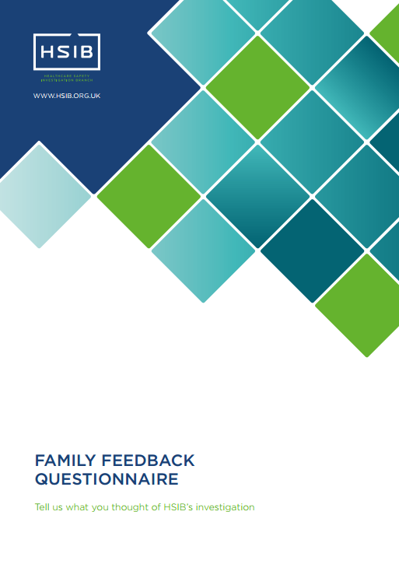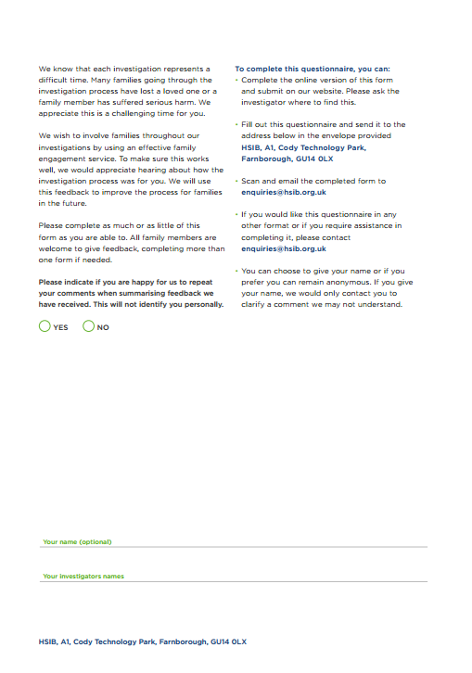

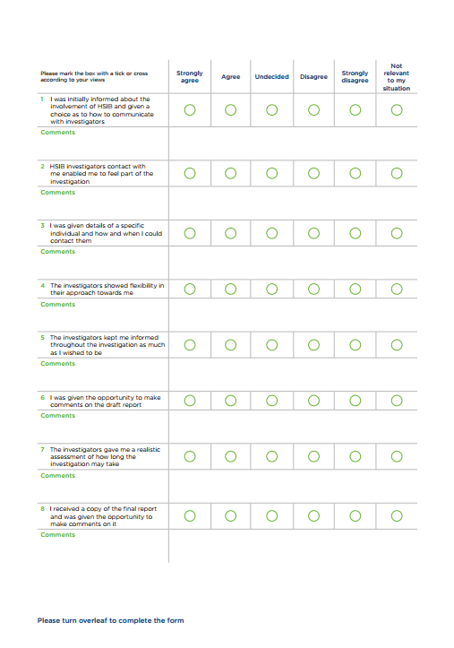Page four of the sample questionnaire. There are a further four questions listed, along with the Lickert scale, making a total of twelve questions.
There are three open comment questions at the bottom of the page asking what the person found most helpful from the investigation process, anything that could have been improved, and asking for any other comments.

|  |
| --- |
| To receive this publication in an accessible format phone 03 9096 1384,  using the National Relay Service 13 36 77 if required, or [email Safer Care Victoria](mailto:info@safercare.vic.gov.au) <info@safercare.vic.gov.au>  Authorised and published by the Victorian Government, 1 Treasury Place, Melbourne.  © State of Victoria, Australia, Safer Care Victoria, December 2022  Available at the [Safer Care Victoria website](https://www.safercare.vic.gov.au) <https://www.safercare.vic.gov.au>  Victoria State Government |

1. Section 128ZC of the *Health Services Act 1988*; section 22I of the *Ambulance Services Act 1986*; section 345B of the *Mental Health Act 2014*
2. https://www.safetyandquality.gov.au/our-work/open-disclosure/the-open-disclosure-framework
3. https://www.safetyandquality.gov.au/standards/nsqhs-standards/clinical-governance/clinical-governance-standard
4. https://www.safetyandquality.gov.au/publications-and-resources/resource-library/incident-management-guide
5. [Guide to partnering with whānau following an adverse event | Health Quality & Safety Commission (hqsc.govt.nz)](https://www.hqsc.govt.nz/resources/resource-library/guide-to-partnering-with-whanau-following-an-adverse-event/)