Mental Health Learning Health Network - Advisory Group & Data Group

Questions and answers

OFFICIAL

## What is Safer Care Victoria?

Safer Care Victoria (SCV) is Victoria’s healthcare safety and quality improvement agency. We work with consumers, families, carers, clinicians, and health services to monitor and improve care for patients across our health system.   
  
SCV was established in 2017 in response to the recommendations within the report *Targeting Zero: the review of hospital safety and quality assurance in Victoria.* We aim to eliminate avoidable harm and strengthen quality of care. We always put patient safety front and centre, supporting health services to provide the safest and best care to patients, always.

## What is the Mental Health Improvement Program?

The Mental Health Improvement Program (MHIP) is a critical function in Victoria’s mental health and wellbeing quality and safety architecture. It was established in response to a key recommendation made by the Royal Commission into Victoria’s Mental Health System. The MHIP aims to *improve mental healthcare in Victorian publicly funded mental health and wellbeing services so it safer, more effective, appropriate and connected by June 2026.* Achieving this aim involves the design and delivery of a suite of improvement initiatives linked leadership, capability and improvement across Victorian mental health services.

The MHIP improvement initiatives will be supported by a Learning Health Network (LHN). Each group that contributes to the Mental Health LHN governance will have links to the Department of Health’s Mental Health and Wellbeing Division, the Victorian Collaborative Centre, the Office of the Chief Psychiatrist, SCV Quality and Safety Signals Group, SCV Clinical Advisory Group, Victorian Agency for Health Information, and other key peak bodies within mental health.

## What is a Learning Health Network?

The LHN will drive and deliver priority work for a sustainable impact across the mental health system. LHNs bring workforce (clinical, non-clinical and lived experience), individuals with lived experience of mental-ill health (consumers, carers/family/supporters), healthcare management, academics, and improvement specialists together to improve clinical care and patient outcomes using data and evidence. Their function is to gather and analyse evidence to implement decisions and monitor their effectiveness.

To ensure impactful partnerships, improvements and safety across the health system, the MHIP is establishing Victoria’s first Mental Health LHN and aims to launch an *Improvement Conversations* webinar series in December 2022. Its first session will address SCV’s Suicide Prevention work.

Through purposefully partnering, the LHN will allow data, best-practice evidence, clinical expertise and lived experiences to inform decisions for co-design and delivery of strategic and scalable improvements to directly and systematically impact mental health care, lived experiences and outcomes across Victoria.

Characteristics of a LHN include:

* **shared vision:** to align multiple stakeholders around a common goal
* **co-production:** to facilitate collaboration, at scale, among multiple stakeholders to co-produce information, knowledge, and resources for creating improvement
* **transparent data sharing:** to generate a rich data stream to gain insights and rapidly respond to the gap between current and desired performance
* **widespread capacity to change systems:** to apply a quality improvement method to rapidly test, spread, and scale ideas to achieve new levels of performance
* **a culture of trust:** to encourage curiosity, shared learning, contribution, and respect
* **governance:** to operate within a framework and manager the design, implementation, and cycles of evaluation to improve outcomes.

Figure 1: Mental Health LHN structure

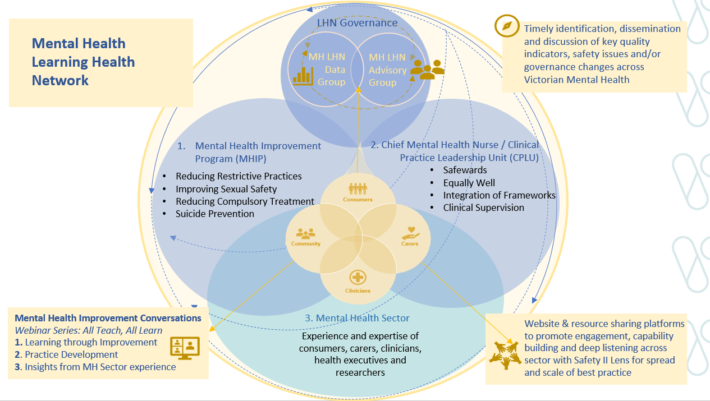

## What is a LHN Advisory Group?

LHN Advisory Groups will consist of workforce, individuals with lived experience of mental-ill health, academics, improvement specialists and health system leaders. They will drive and facilitate purposeful lived experience and sector engagement, and provide advice on LHN work, with a focus on system level issues.

## What is a LHN Data Group?

LHNs use data and evidence to improve clinical care and patient outcomes, with a system-level view. LHN Data Groups will be established to support LHN work and ensure that the decisions are evidence-based. The groups will review, interpret and provide advice about data, evidence, safety and quality measures.

## What is the time commitment for this role?

Meeting attendance will be held virtually, approximately 6 times per year for around one hour each. Members are expected to actively participate in meetings and with a minimum 75 per cent attendance rate. Please note that there may be occasions where face-to-face meetings may be required.

An agenda and papers will be circulated for review prior to meetings with some document review and out of session feedback and decisions required on an ad hoc basis.

SCV staff will support the organisation and running of the meetings, including the onboarding of all members.

## How many positions are available in the Groups?

The Advisory Group will include 2 co-chairs (a lived experience lead and a clinical lead). There will also be 10 to 15 other members with lived experience, clinicians, researchers, data experts, researchers, health system leaders and improvement specialists. This number may vary depending on the skills needed. The Data Group will include one chair and similarly comprise a group of individuals from a variety of backgrounds with a focus on skills pertaining to health data analytics and interpretation to guide decision-making.

## How long is the tenure of these groups?

Both LHN groups will have a tenure of 3 years. Progress against stated role, functions and work plans will be reviewed every 18 months and the Terms of Reference and/or membership updated accordingly.

Changes to the Terms of Reference and/or membership will be subject to approval by Co-Chairs and the Director, MHIP.

## Will I be remunerated for my time?

Public health service employees will not be remunerated. Consumers and private practitioners will be eligible for remuneration for attending Continuing Care LHN Advisory Group meetings. The manager of the relevant LHN will review and approve all remuneration requests in line with the Victorian Government Appointment and remuneration guidelines and SCV’s [Guide to lived experience remuneration](https://www.bettersafercare.vic.gov.au/publications/a-guide-to-consumer-renumeration).

## Can I apply if I live and work in a regional or rural area?

Yes, people living in regional and rural areas are encouraged to apply. Wherever possible, meetings will be held virtually (via Microsoft Teams platform). If in person meetings are required, reasonable travel expenses will be considered for reimbursement.

## If successful, when do I start?

We expect the first Mental Health LHN Advisory Group and Data Group meetings to take place in late February or early March of 2023.

## Who do I contact if I would like more information?

For further information, please contact [mentalhealthlhn@safercare.vic.gov.au](mailto:mentalhealthlhn@safercare.vic.gov.au).

Relevant resources

Follow the links below to learn more about the work we do:

* [Safer Care Victoria (SCV) website](https://www.bettersafercare.vic.gov.au/)
* [Partnering in Healthcare Framework](https://www.bettersafercare.vic.gov.au/sites/default/files/2019-02/Partnering%20in%20healthcare%20framework%202019_WEB.pdf)
* [SCV Mental Health Improvement Program](https://www.safercare.vic.gov.au/improvement/mental-health-improvement-program)
* [SCV Learning Health Network (LHN)](https://www.safercare.vic.gov.au/improvement/learning-health-networks)