Maternity and Newborn Learning Health Network Advisory and Data Groups

Frequently Asked Questions (FAQ)

## What is Safer Care Victoria’s purpose?

Safer Care Victoria (SCV) is Victoria’s healthcare safety and quality improvement agency. SCV works with consumers, families, carers, clinicians, and health services to monitor and improve care for patients across our health system.   
  
SCV was established in 2017 in response to the recommendations within the report *Targeting Zero: the review of hospital safety and quality assurance in Victoria.* SCV works to eliminate avoidable harm and strengthen quality of care. SCV puts patient safety front and centre, supporting health services to provide the safest and best care to patients, always.

Relevant resources

Follow the links below to learn more about the work we do:

* [Safer Care Victoria website](https://www.bettersafercare.vic.gov.au/)
* [Partnering in Healthcare Framework](https://www.bettersafercare.vic.gov.au/sites/default/files/2019-02/Partnering%20in%20healthcare%20framework%202019_WEB.pdf)

## What is the Centre of Clinical Excellence?

The Centre of Clinical Excellence (CoCE) is the primary mechanism for SCV to engage clinicians and consumers to drive and promote quality improvement and innovation and address variation in clinical practice. Meaningful engagement with clinicians, healthcare leaders, consumers and the wider health sector will enable sustained improvement in the safety and quality of health care. The CoCE works collaboratively across SCV drawing on expertise in leadership development, innovation, system improvement, and consumer experience to achieve improvement objectives.

## What is a Learning Health Network?

SCV’s Learning Health Networks (LHNs) drive and deliver priority work, for a sustainable impact across the health system. LHNs bring together clinicians, consumers, and improvement specialists, using data and evidence to improve clinical care and patient outcomes. A LHN functions to gather and analyse evidence to implement decisions and monitor the effectiveness of the decision.

Characteristics of a LHN include:

* **Shared vision:** to align multiple stakeholders around a common goal
* **Co-production:** facilitate collaboration, at scale, among multiple stakeholders to co-produce information, knowledge, and resources for creating improvement.
* **Transparent data sharing:** generate a rich data stream to gain insights and rapidly respond to the gap between current and desired performance
* **Widespread capacity to change systems:** apply a quality improvement method to rapidly test, spread, and scale ideas to achieve new levels of performance
* **Culture of trust:** encourage curiosity, shared learning, contribution, and respect
* **Governance:** operate within a framework for governance and management for the design, implementation, and cycles of evaluation to improve outcomes.

The LHNs play an essential role in fostering purposeful engagement with consumers and the sector. Each LHN have associated Advisory and Data Groups, comprising of clinicians and consumers with diverse expertise and interest in the target speciality areas.

Figure: Learning Health Network Structure

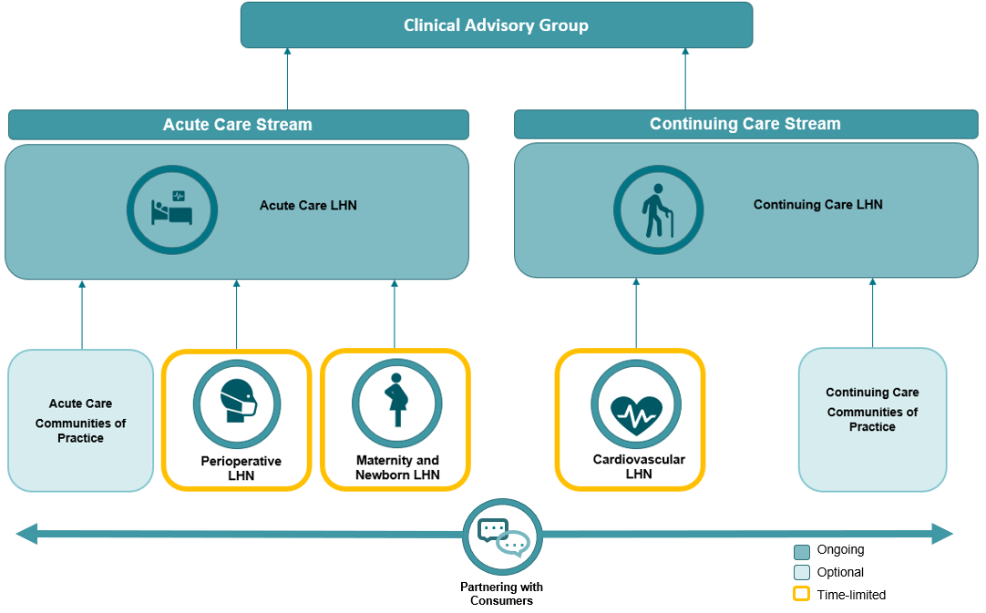

## What is a LHN Advisory Group?

LHN Advisory Groups consist of clinicians, consumers, data experts, researchers and health system leaders to oversee the LHNs. The LHN Advisory Groups will drive and facilitate purposeful consumer and sector engagement. LHN Advisory Groups will provide advice on work of the LHN, with a focus on system level issues, and provide advice and direction to support SCV and the Department of Health (DH) as required.

The LHN Advisory Groups:

* gather and analyse evidence to implement decisions and monitor the effectiveness of the decision
* respond to specific system level data or safety and quality issues identified
* provide insight and specialty clinical advice about data variation
* support the identification and escalation of issues relevant to the MNLHN
* lead clinical and consumer engagement, and review work in progress, with a focus on system level issues
* respond to specific data or safety and quality issues identified including those by the Safer Care Victoria Advisory Group

LHN Advisory Group membership and function may vary based on programs of work and will act in the best interests of consumers, health care workers and the wider Victorian community to provide a mechanism for broader sector consultation.

**What is a LHN Data Group?**

LHNs use data and evidence to improve clinical care and patient outcomes, with a system level view. Data will be accessible to all time limited LHNs through the establishment of their respective LHN Data Groups, to ensure that the work of the LHN is informed by current data, variation and trends.

The groups will review, interpret, and provide advice to their respective LHNs and SCV more broadly about data, evidence, and safety and quality measures to help inform decisions and measure outcomes. The duration of the time limited LHN Data Groups will align with the time length of the associated LHN. The LHN Data Groups will be governed by the LHN Advisory Groups.

## What is the time commitment for this role?

All MNLHN Advisory and Data Group meetings will be held virtually via the Microsoft Teams platform for approximately 1.5 hours. Please note that there may be occasions where face-to-face meetings may be required.

The MNLHN Advisory and Data Groups have scheduled meetings throughout the year. The Advisory Group meets every three months throughout the year. The Data Group meets every two months throughout the year. Members are expected to actively participate in meetings and attend a minimum of 75 percent of the meetings.

There will be an agenda and at times papers to be reviewed prior to meetings. Document review and some out of session feedback and decisions may be required on an ad hoc basis.

SCV staff will support the organisation and running of the meetings, including onboarding of all members.

## Will I be remunerated for my time?

Public health service employees will not be directly remunerated for their time.

Consumer members and private practitioners (such as General Practitioners) will be eligible for remuneration for attending MNLHN Advisory or Data Group meetings. The MNLHN manager will review and approve all remuneration requests in line with the Victorian Government’s Appointment and remuneration guidelines.

## Can I apply if I live and work in a regional or rural area?

Yes, people living in regional and rural areas are encouraged to apply. Meetings wherever possible will be held virtually (via Microsoft Teams platform) and should in person meetings be required, reasonable travel expenses will be considered for reimbursement.

Please refer to the above section *“What is the time commitment for this role?”* for details surrounding virtual meetings and expectations.

## When do I start?

You would start at the next meeting.

The MNLHN Advisory Group meets approximately four times a year. The meeting dates for 2023 are:

* Friday 24th August 11am
* Friday 24th November 11am

The MNLHN Data Group meets approximately six times a year. The meeting dates for 2023 are:

* Friday 2nd June 11am
* Friday 4th August 11am
* Friday 6th October 11am
* Friday 1st December 11am

## Who do I contact if I would like more information?

For further information please contact the Maternity and Newborn Learning Health Network team via [maternityandnewbornlhn@safercare.vic.gov.au](mailto:maternityandnewbornlhn@safercare.vic.gov.au)