Sample Acute Pain and Opioid Analgesic Discharge Guideline

*Adapted from Alfred Health

# Target Audience

Medical, nursing and pharmacy staff across [HEALTH SERVICE]

# Purpose

This guideline is to:

* Provide a summary of management of acute pain in the adult population at [HEALTH SERVICE] and outline an approach to treating acute pain using a multimodal analgesic approach based on the WHO analgesic ladder.
* Support clinicians support transfer of care patients discharged with opioid analgesics at [HEALTH SERVICE]. The guideline is for use for clinicians to wean and cease analgesics, provide guidance on required documentation to be provided to patients or carers and clinical handover documentation to be provided to general practitioners or other primary care clinicians.

# Scope

This guideline is applicable to [HEALTH SERVICE TO DETERMINE]

# Pharmacological Management of Acute Pain

* Goal is to improve function
* Start treatment appropriate for the reported severity of pain
* **Aim for pain scores of < 4 & Functional Activity Scores of A or B**

|  |  |  |
| --- | --- | --- |
| **Mild Pain**  Pain Score 1-3  FAS A | **Moderate Pain**  Pain Score 4-7  FAS B | **Severe Pain**  Pain Score 8-10  FAS C |
| **Paracetamol** 1 g PO QID  AND/OR  **Celecoxib** 100 - 200mg BD (unless contraindicated) or **Ibuprofen** 400mg TDS-QID#  *Consider all precautions, contraindications and side effects* | **Paracetamol** 1 g PO QID  AND  **Celecoxib** 100 - 200mg BD (unless contraindicated) or **Ibuprofen** 400mg TDS-QID#  ***Consider adding:***   * **Tramadol** 50 – 100 mg PO or IV QID (Avoid in >75 years old, history/risk seizures, hyperbaric)     ***And if above unsuccessful/not suitable add:***   * **Tapentadol immediate release**   < 70 years: 50mg every 3 hours   * **Oxycodone immediate release**   < 70 years: 5mg every 3 hours PRN   * Halve the dose in the elderly and specify maximum dose per 24 hours.   *Consider all precautions, contraindications and side effects* | **Paracetamol** 1 g PO QID  AND  **Celecoxib** 100 - 200mg BD (unless contraindicated) or **Ibuprofen** 400mg TDS-QID#  ***Strong opioids are usually required:***   * **Oxycodone immediate release**   < 70 years: 5mg every 3 hours PRN  **If the patient has *NO ENTERAL ACCESS* to tolerate oral meds:**   * **Morphine subcutaneous OR Oxycodone**   < 70 years: 1 - 2mg every 4 hours PRN   * Halve the dose in the elderly and specify maximum dose per 24hrs * **Consider referral to Acute Pain Service (APS)**   *Consider all precautions, contraindications and side effects* |

#Considerations for NSAIDs: - Post GI/colorectal surgery confirm with OGB/HPB/CRS for appropriateness - Cardiovascular adverse effects -> celecoxib, ibuprofen or naproxen may be preferred

### Referral to Acute Pain Service

[HEALTH SERVICE TO DETERMINE CRITERIA FOR REFERRAL TO ACUTE PAIN SERVICE AND PROCESS]

# Principles of pain management

### Performing a comprehensive pain assessment

Obtain basic elements of the patient’s pain history including:

* Onset and timing of pain(s)
* Locations of pains(s) and radiation
* Description of pain(s) to determine type of pain (nociceptive, neuropathic, or mixed) and cause of pain
* Severity of pain(s) and impact of pain on function/activities (refer to Appendix 1 for pain assessment and Functional Activity Score)
* Aggravating factors
* Relieving factors
* Associated symptoms
* Impact of pain
* Current and prior treatments for pain
* Relevant medical +/- surgical history
* Other patient factors which includes the psycho-social aspects like beliefs, expectations, coping skills and mood disorders like anxiety and depression

### Set realistic expectations around pain

* Expect some pain after acute injury, especially after surgery
* Use of pre-emptive pain medication for incidental/procedural pain
* Goal is to improve function

Management should include non-pharmacological treatments such as:

* Physical therapy (splinting, dressings, positioning, plaster cast)
* Physiotherapy exercises +/- Occupational Therapy
* Psychological approaches (relaxation, education)

### Pharmacological Management of pain:

The pharmacological management of acute pain is based on the WHO analgesic ladder. The key principle is to use a *multimodal approach*. The goal of analgesia is to improve **FUNCTION**.

General principles​ for **opioids**

* Effective in acute pain; *not* in chronic non-cancer pain​
* Use age to guide dose​, lower doses in the elderly/frail
* One strong opioid at a time​
* Start with PRN and **limit use of slow-release opioids**to prolonged painful situations such as major surgery or multi-trauma patients
* Prescribe regular laxatives and antiemetics

# Assessment of analgesic side effects and review of analgesia

Assessment of potential side effects of analgesics

Assessment should include:

* Sedation score
* Respiratory Rate
* Oxygen saturation (Sp02)

All patients receiving opioids or sedative agents should have their sedation score and respiratory rate assessed and documented regularly on EMR interactive document.

**Escalate care per [HEALTH SERVICE] METCALL or clinical review criteria.

|  |  |
| --- | --- |
| Sedation (0-3 score) | Respiratory depression is almost always preceded by sedation. The best early clinical indicator of respiratory depression is increasing sedation. If you are unable to rouse a patient to have 30 seconds of eyes open with appropriate conversation, they may be over sedated. |
| Respiratory Rate (RR) | <8 breaths/min **Unreliable indicator as respiratory depression can coexist with normal RR |
| Oxygen Saturation (Sp02) | Unreliable indicator of respiratory depression, especially if the patient is receiving supplemental O2 |

Regular review of analgesia

Regular review to adjust or de-escalate and cease, if short-term use is expected.

* Where possible, wean opioids prior to discharge

# Opioid analgesic weaning and cessation

### General principles for weaning and ceasing analgesics

* If applicable, de-escalate analgesics per the Acute Pain Service (APS) plan outlined in the medical notes
* Weaning and cessation of analgesic should follow a multimodal analgesia and opioid-sparing strategy to minimise overall opioid analgesic use
* Consider the individual patient’s characteristics such as age, weight, hepatic and renal function, allergies, other health conditions, other medicines prescribed and patient’s opioid status
* Wean and cease one, at most two, analgesics at a time
* In acute on chronic pain aim to wean and/or cease analgesics to baseline medications and/or doses before discharge
* If weaning and cessation cannot be completed in hospital, then provide a medication management plan with a specific weaning and cessation plan on discharge

### Criteria to commence de-escalation of analgesics

Patients who meet ALL of the following criteria:

* Nil further surgery or painful intervention (e.g. theatre, dressing or VAC change) in the short-term
* Functional activity score (FAS) A or B, refer to Appendix 1 for definition
* Limited use of PRN analgesia (i.e. < 4 doses in the preceding 24 hours)
* No reports of uncontrolled pain in the preceding 24 hours (i.e. pain score < 8 and FAS A/B)

### De-escalating analgesics in those treated for ≤ 2 weeks

Aim to de-escalate analgesics prior to discharge. The order and rate of de-escalation for analgesics may be adjusted based on the patient’s type of pain, response, side effects and risk of adverse effects.

[INSERT DE-ESCALATION FLOWCHART – SEE ADAPTABLE SAMPLE FROM ALFRED HEALTH (ACKNOWLEDGEMENT TO ALFRED HEALTH FLOWCHART REQUIRED]

# Discharge of patients on analgesics

### Paracetamol and NSAIDs

* Use the smallest dose for the shortest time and consider risks.
* 5 to 7 days’ supply is usually adequate.
* Consider using a proton pump inhibitor in patients who must have a NSAID but are at risk of GI adverse effects.

### Opioid analgesics

* Where possible, wean patients from opioids prior to discharge. If this is not possible, a documented medication management plan for opioid analgesic weaning and cessation and/or follow-up and information for the GP is required.
* Prescribing of opioid analgesics at discharge should be guided by the assessment of the patient’s functional activity and pain scores and the amount of opioid analgesic use in the 24 hour period before discharge, using an OMEDD.

### Supply of opioid analgesics at discharge

* Strong opioids are not recommended for routine prescription on discharge, particularly in opioid naïve patients. This can be dangerous or even fatal.
* If opioids need to be prescribed on discharge, they should be prescribed at the **lowest appropriate dose** and for the **shortest time**. It is recommended that if a patient requires greater than 3-day supply, they are reviewed by their GP prior to continuation of opioid therapy.
* If a patient is discharged with an opioid analgesic, the quantity should be for up to a **maximum of seven days treatment** with a planto reduce and stop the opioid analgesic
* The quantity of supply should take into account the day of discharge and when the patient can reasonably be expected to access primary care and other healthcare services post-discharge
* For patients who live in locations with limited access to prescribers and pharmacies, consider their individual circumstances and expected course of their condition
* Prescribing of **modified-release opioid analgesics** should be limited for acute pain to specific circumstances, and for as short a duration as possible, before ceasing opioid analgesics or changing to an immediate release opioid analgesic if required.

### Supply of immediate release opioid analgesic at discharge

If immediate release opioid analgesics are required at discharge

* Prescribe necessary quantities, **NOT** full packs
* Assess number of PRN doses in **last 24 hours** to guide quantities
* Prescribe at the lowest appropriate dose for the shortest time, a **maximum of 3-5 days** supply is recommended

Eg. If a patient has used TWO 5mg doses of Oxycodone in the last 24hours, a maximum of 10 tablets supply should be prescribed. (2 tablets x 5 days = 10 tablets)

### Opioid discharge quantity for short stay surgical patients

For post-operative surgical patients admitted for <48 hours and discharged from a surgical unit, the highest reported pain score in the previous 24 hours (documented using the Numerical Rating Score – NRS) should determine the quantity of immediate release opioid analgesics supplied to patients on discharge;

|  |  |
| --- | --- |
| **Numerical Rating Score (NRS)** | **Quantity of immediate release opioid** |
| NRS ≤1 | **Nil**, prescribe simple analgesics e.g. paracetamol +/-  NSAIDs (if NSAID is not appropriate/contra-indicated  consider tramadol) |
| NRS ≥2 but ≤5 | **5 tablets**, prescribe simple analgesics e.g.  paracetamol +/- NSAID (if NSAID is not  appropriate/contra-indicated consider tramadol) |
| NRS ≥5 | **10 tablets**, see GP if any concerns**;** prescribe simple  analgesics e.g. paracetamol +/- NSAID (if NSAID is not  appropriate/contra-indicated consider tramadol) |

### SafeScript

Clinicians should obtain and check information from SafeScript to identify and assess patients at risk of harm including their opioid status and existing opioid analgesics in their possession, prior to the supply or prescription of opioid analgesics.

[INCLUDE RELEVANT LOCAL SAFE SCRIPT PROCESSES]

# Documentation for patients and carers

Patients or carers should receive written patient information and medication management plan that includes recommendations for reducing and cease opioid analgesics where appropriate. The medication management plan should be developed in discussion and agreeance with the patient or carer.

Patients should be provided a copy of the relevant short term pain relief leaflet and a medication management plan (available on [HEALTH SERVICE DEPENDENT])

# Clinical Handover

Clinicians should ensure there is prompt communication of a clinical handover to the patient’s general practitioner or other primary care clinician that includes

* Cause of the pain for which the opioid analgesic was prescribed
* Medication management plan that includes recommendations for reducing and ceasing the opioid analgesic as appropriate.

This should be documented in the medical discharge summary.

[REFER TO RELEVANT CLINICAL HANDOVER GUIDANCE EG SPECIFIC DOCUMENT OR AUTOTEXT OR TEMPLATE AVAILABLE LOCALLY]

### Referral to specialist services

For patients with pain post discharge that require support services and aids and equipment to manage safety post discharge, consider referrals to allied health services.

Patients ‘at risk’ of chronic pain issues who may be amenable and agreeable to further assessment or management can be referred to a chronic pain management service for follow up post discharge. [REFER TO RELEVANT SERVICE AVAILABLE AT HEALTH SERVICE OR IN AREA]

For opioid dependent patients (ie. patients admitted on regular opioid medications) and current or ex-intravenous drug users (IVDU) or patients who cannot communicate a verbal numerical pain score (VNPS) consider referral to Acute Pain Service and Drug and Alcohol Services.

# Review and adherence to guideline

Use and adherence to this guideline will be monitored through regular auditing and monitoring via the Analgesic Stewardship Program’s Committee [INCLUDE LOCAL GUIDELINE EVALUATION PROCESSES]

# Keywords

Pain management, acute pain, analgesic, weaning, opioids, discharge

# Relevant guidelines

[LIST RELEVANT LOCAL GUIDELINES]

# References

Therapeutic Guidelines. *eTG complete*. [Internet] Melbourne: Therapeutic Guidelines Limited; n.d. [updated 2019 June; cited 2022 January 14] Available from: https://www.tg.org.au.

Bui T et al. The impact of an innovative pharmacist-led inpatient opioid de-escalation intervention in post-operative orthopaedic patients. *J Opioid Manag* 2020;16(3):167-176.

Schug S, Palmer G, Scott DA, Alcock M, Halliwell R, Mott J, editors. Acute pain management: scientific evidence. 5th ed. Melbourne: Australian and New Zealand College of Anaesthetists; 2020.

3. Australian and New Zealand College of Anaesthetists. Position statement on the use of slow-release opioid preparations in the treatment of acute pain. Melbourne: ANZCA; 2018.

Kral LA. Opioid Tapering Safely Discontinuing Opioid Analgesics. Pain Treatment Topics 2006. http://www.Pain-Topics.com

# Appendices

### Appendix 1

**Comprehensive Pain Assessment Including Pain Assessment Tools**

Obtain basic elements of the patient’s pain history including:

* Primary site of pain and any radiation
* Conditions associated with the onset of pain
* Character of the pain – nociceptive or neuropathic, somatic or visceral, or combinations thereof
* Intensity of the pain
* Associated symptoms e.g. nausea, vomiting, sweating
* The pain’s effects on the patient’s function, measured by the Functional Activity Score (FAS)
* Current and prior treatments for pain
* Relevant medical and surgical history
* Other patient factors, which includes the psycho-social aspects like beliefs, expectations, coping skills and mood disorders like anxiety and depression

A full pain history should be obtained from the patient as part of their initial assessment and thereafter should be obtained;

* As part of routine observations
* Pre- and post- administration of analgesia
  + Within 60 minutes of administration of oral analgesia
  + More frequently if alternate route of administration
  + If patient is experiencing pain

**FUNCTIONAL ASSESSMENT**

The more the pain is interfering with a patient’s ability to function e.g. deep breath, cough, mobilise, the more likely they will have complications like chest infections or deep vein thrombosis (DVT). The goal of pain management should be to improve patient’s functional ability and in turn to reduce the risk of complications.

The ability to function with pain can be graded by using the Functional Activity Score (FAS).

* **FAS A** — no limitation; the patient is able to undertake the activity without limitation due to pain (pain intensity score is typically 0 to 3);
* **FAS B** — mild limitation; the patient is able to undertake the activity but experiences moderate to severe pain (pain intensity score is typically 4 to 7);
* **FAS C** — severe limitation; the patient is unable to complete the activity due to pain, or analgesic-related side effects (pain intensity score is 8-10)

**UNIDIMENSIONAL PAIN ASSESSMENT TOOLS FOR THOSE WHO CAN SELF-REPORT**

Examples include:

**Numeric Rating Scale (NRS)**

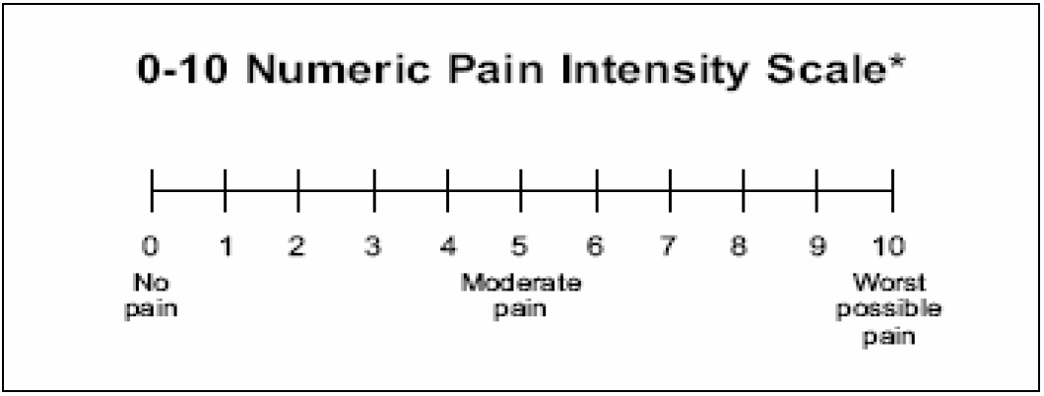

**Verbal Descriptor Scale (VDS)**

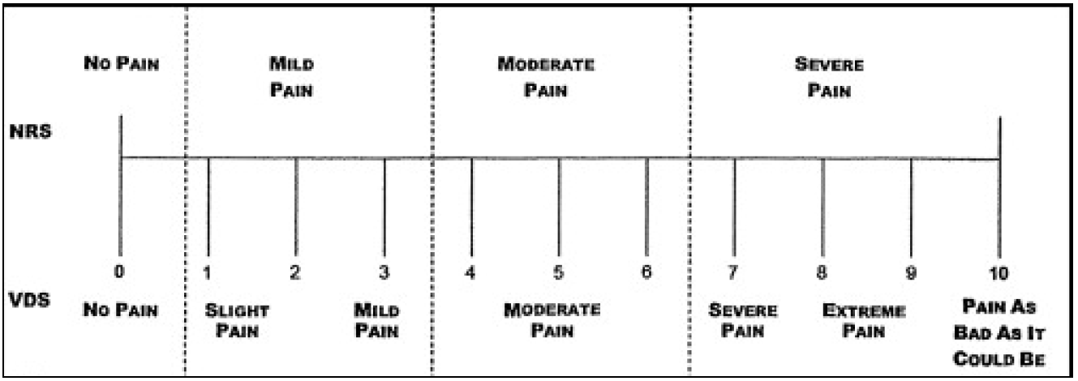

**A pictorial pain scale, (FACES pain scale)**

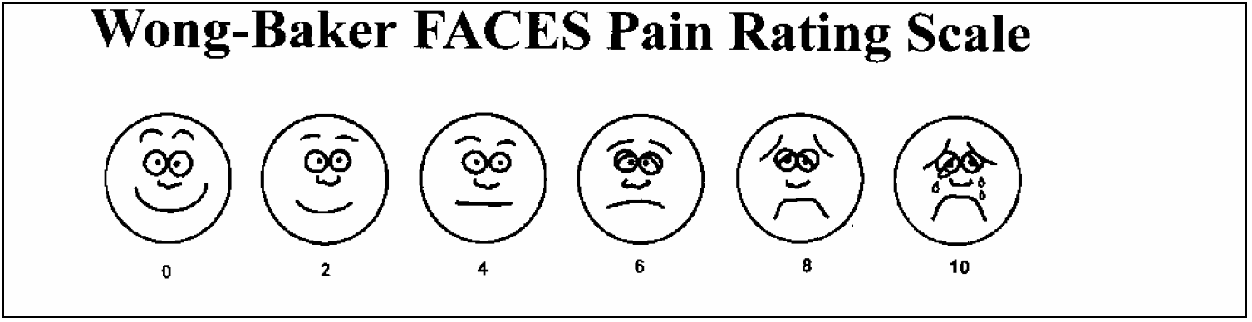

**BEHAVIOURAL RATING SCALE FOR PATIENTS WHO ARE UNABLE TO SELF-REPORT PAIN**

For patients unable to provide a self-report of pain: scored 0–10 clinical observation

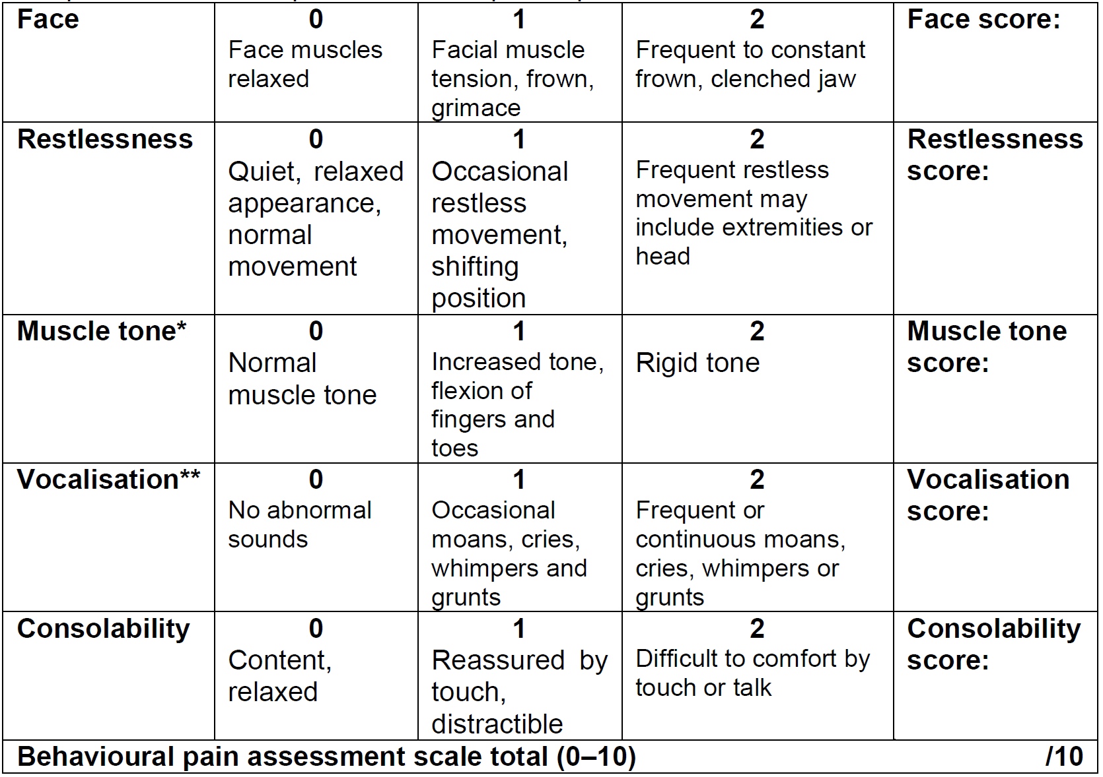

* Assess muscle tone in patients with spinal cord lesion or injury at a level above the lesion injury. Assess patients with hemiplegia on the unaffected side. ** This item cannot be measured in patients with artificial airways.

Other recommended observational scales include:

* Pain assessment checklist for seniors with limited ability to communicate (PACSLAC)
* Pain Assessment in Advanced Dementia (PAINAD)
* Abbey pain scale

### Appendix 2

**Initial Opioid Prescribing Based on Age**

|  |  |
| --- | --- |
| **Initial Endone® (immediate release oxycodone) dose, 4 hourly PRN\*** | |
| **Age (years)** | **Dose range (mg)** |
| 18 – 39 | 10 – 15 |
| 40 – 59 | 5 – 15 |
| 60 – 69 | 5 – 10 |
| 70 – 79 | 5 |
| >80 | 2.5 |

*Specify maximum dose in 24 hours

### Appendix 3

In order to calculate an oral Morphine Equivalent Daily Dose (oMEDD), multiply the current daily opioid dose by the conversion in column 2. For example, oMEDD of oxycodone 40mg/day = 40 x 1.5 = 60mg/day

|  |  |  |  |
| --- | --- | --- | --- |
| **Opioid Dose Equivalence Calculation Table** | | | |
| **Current Opioid** | | **Conversion Factor** | **Proprietary Names** |
| **ORAL PREPARATIONS** | | | |
| Morphine | mg/day | 1 | Anamorph, Kapanol (MR), MS Contin (MR), MS Mono (MR), Ordine, Sevredol |
| Oxycodone | mg/day | 1.5 | Endone, OxyContin (MR), OxyNorm, Targin (MR) |
| Hydromorphone | mg/day | 5 | Dilaudid, Jurnista (MR) |
| Codeine | mg/day | 0.13 | Aspalgin, Codalgin, Panadeine, Panadeine Forte, Mersyndol, Nurofen Plus, others |
| Tramadol | mg/day | 0.2 | Durotram-XR (MR) , Tramal, Tramadol SR (MR), Zydol, Zydol SR (MR), others |
| Tapentadol | mg/day | 0.3 | Palexia-SR (MR), Palexia-IR |
| **SUBLINGUAL PREPARATIONS** | | | |
| Buprenorphine | mg/day | 40 | Suboxone, Subutex, Temgesic |
| **TRANSDERMAL PREPARATIONS** | | | |
| Buprenorphine | mcg/hr | 2 | Norspan |
| Fentanyl | mcg/hr | 3 | Denpax, Durogesic, Dutran, Fenpatch, Fentanyl Sandoz |
| **PARENTERAL PREPARATIONS** | | | |
| Morphine | mg/day | 3 | DBL morphine sulphate injection, DBL morphine tartrate injection |
| Oxycodone | mg/day | 3 | OxyNorm FI |
| Hydromorphone | mg/day | 15 | Dilaudid FI, Dilaudid-HP FI |
| Fentanyl | mcg/day | 0.2 | DBL fentanyl injection, Sublimaze |

*Adapted from Faculty of Pain Medicine, ANZCA – June 2021

This opioid dose equivalence table is intended for comparison of different opioid and opioid formulations in individual patients or in patient cohorts. Caution is required if opioid dose equivalence tables are used to guide opioid switching, as the administration of a calculated ‘equivalent’ dose of the replacement opioid may lead to overdosage. It should be noted that there is considerable variability in pharmacokinetics and pharmacodynamics of the different opioids, within and between individual patients. In addition interactions with non-opioid drugs can strongly influence opioid pharmacokinetics. Modified-release formulations can be sub-classified as delayed- or extended- release. Extended release of a drug can be achieved using sustained- or controlled-release delivery systems. When the opioid regimen includes modified- and immediate-release preparations, both should be included in calculation of the oMEDD.