Quality Improvement in Action

Participant Workbook

OFFICAL

Safer Care Victoria acknowledges the information included in this presentation draws upon content developed by the Institute for Healthcare Improvement. As such, the material may not be reproduced for commercial or for-profit use.

Agenda​
Time | Session | Presenter
9.00 am | Introduction and welcome
9:35 am | Creating conditions for change
10:50am | Morning tea
11:05 am | Understanding the system
11:25 am | Variation
12:00pm | Understanding the problem
12:30 pm | Developing an aim
1:00 pm | Lunch
1:30 pm | Change ideas
1:35 pm | Theory of Change
2:05 pm | Testing changes
3:05 pm | Afternoon tea
3:20pm | Measurement
3:50 pm | Sustainability
4:00 pm | Finish

*Times may be subject to change

Introduction
This program is designed for healthcare workers, managers, and consumers who are interested in improving the quality and safety of healthcare. It’s an introductory course that will help participants understand their system, the conditions for change, introduce the Institute for Healthcare Improvement (IHI) Model for Improvement and how to use the framework to make change. It will also outline the type of data used to inform quality improvement.

By the end of the day, you will be able to:​
- Create conditions of change to enable quality improvement. ​
- Understand how your system assesses itself to identify where and when change can occur​.
- Use the Model for Improvement as a framework for improvement projects. ​
- Use quality improvement tools and methods to understand the problem, set a goal, design the solution, implement solution, evaluate the outcome, and sustain improvement.

Figure 1: Model for Improvement
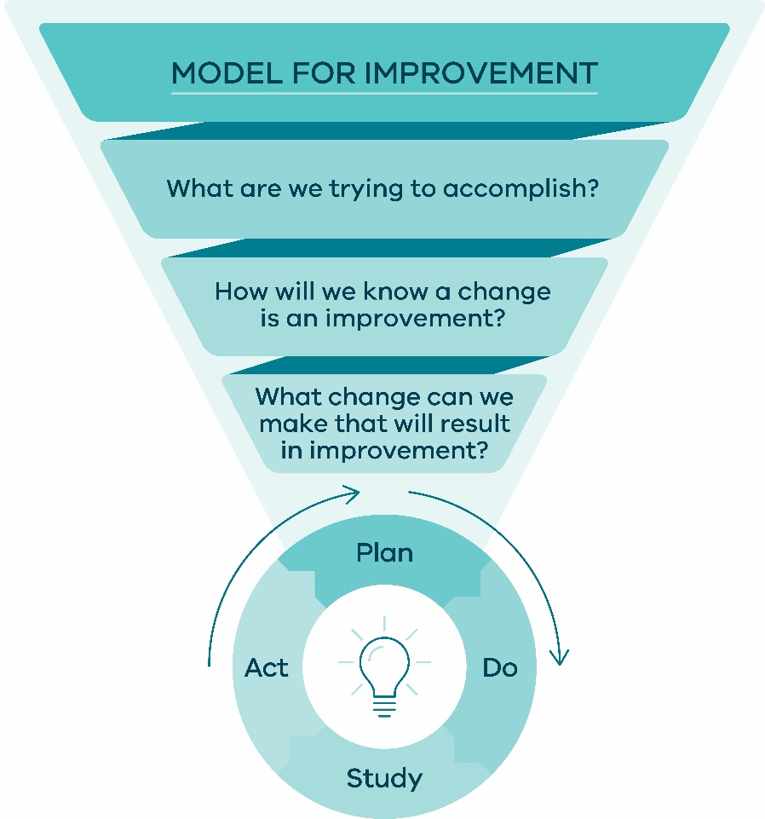

This workbook is designed to support your learning as you work through each component of the model. Examples are included in this workbook to help consolidate your learning. These may differ from the examples provided during the session today.

Session 1: Conditions for change

Activity 1: Drawing
Use the template on the next page as your person. This person can represent you, your patient, your team, or your community.

Instructions ​
- Illustrate on your person your thoughts and feelings about Quality Improvement.
- Why is quality improvement important to you?
- What do you think learning about quality improvement and partnering will do to your work?
- What does it mean for the patients, families, and carers you care for?
- Why is quality improvement important to patients, families, and carers?



Why do quality improvement projects?
Why for patients?
- Ensures patient safety​.
- Ensures patients receive care that is evidence based.
- Ensures patients receive consistent care. ​

Why for staff and organisation level?​
- Reduces variation and improves reliability of achieving a consistent outcome or result (ensures processes are not person dependent)​.
- Keeps staff safe at work​.
- Removes waste​.
- Allows measurement and continuous improvement.
- Ensures staff know what is expected​.

Case Scenarios
Your group has been assigned one case scenario based on the six domains of healthcare quality. You will use these to applying your learning using the same scenario for all activities during the day.

Scenario 1: Safety
Discussion is currently focussed on an incident where a patient had multiple falls resulting in harm, and later, palliation. Family has formally requested action be taken so that this doesn’t happen to another patient in the future.

This is an opportunity for your team to look at ways to reduce falls on the ward and improve safety. Your current data shows that your ward has an average of 12 falls each month.

Scenario 2: Equity
You work in an outpatient clinic. Clinic hours are Monday–Friday, 8am – 4pm. You book appointments, noting that some are not being attended. During a follow up phone call to understand why a patient of yours has not come in, they tell you that they cannot take more time off from their job when they know appointments don’t run on time, and they don’t have the luxury to go somewhere else that can be relied upon!

You now suspect there are several patients with the same concerns. Data shows 48% of bookings each month show a greater than 40-minute wait and you would like this to improve.

Scenario 3: Timeliness
An improvement opportunity has emerged to reduce delays in theatre. When pulling data on cases that were delayed this month, 32% were preventable if the patients scheduled for surgery had been fasted correctly. Looking through recent cases you identify themes about why this has been happening, including patients not being clear on what ‘fasting’ means.

Your manager has asked you to create a project plan to improve these delays.

Scenario 4: Patient centred
You are new to your role and keen to make a positive impact in your organisation through quality improvement. When looking through compliments and complaints for your area, you come across feedback from a family member of a patient who had been in your care. Their experience in the system was not positive. They struggled to get information from the treating team despite the ‘what matters to me’ form stating the importance of including family.

You become curious about the team’s practice around using the ‘what matters to me’ information. When exploring this further, you note only 30 per cent of patients report that care received in your organisation was consistent with what matters to them, and you want to improve this.
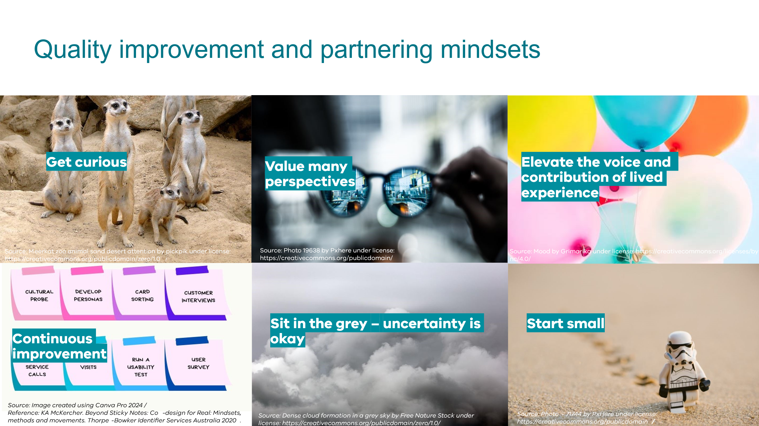

- Get curious - and stay curious for as long as possible. Use empathy when working with others. Get inspired the stories they share. Question your own assumptions. Why am I disagreeing? What part and why?

- Value many perspectives – diversity is not a nice to have its key! Understanding diverse views helps uncover the systemic causes of issues and overlooked resources as well as individual and community needs. Your QI and Partnering with consumers work will value hugely from having many perspectives.

- Elevate the voice and contribution of lived experience - elevate means to raise or lift something to a higher position. It requires more than just telling or sharing a story. It requires having a seat at the table, so voices can be heard and elevated and they can be used to make a positive impact not only for the health service but also for stakeholders.

- Continuous Improvement – this really speaks to the notion that even if we are happy with the way our system is performing, we are continuously reviewing how we are doing things, what our systems outcomes are and looking for ways to perform even better.

- Sit in the grey – uncertainty is okay - We need to grow our willingness to be uncomfortable, unclear, and confused while learning and opportunities emerge.

- Start small – the improvement methodology that we teach and advocate for is the Model for Improvement. There are other models out there, but one thing many have in common is that they advocate for small scale testing of change ideas in the real world BEFORE any changes are implemented.

Activity 2: Human Side of Change – who is affected?

Using the above case studies allocated to your table, discuss, in your groups, the following questions.

- Who is affected by the problem?
- Are there different levels of engagement for different groups? Consider the partnering gradient when thinking about how you engage the different stakeholders.
- How might you want to engage those who are affected by the improvement process?

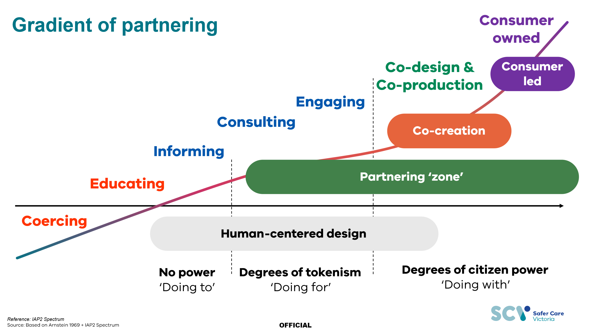

Session 2: Understanding the system
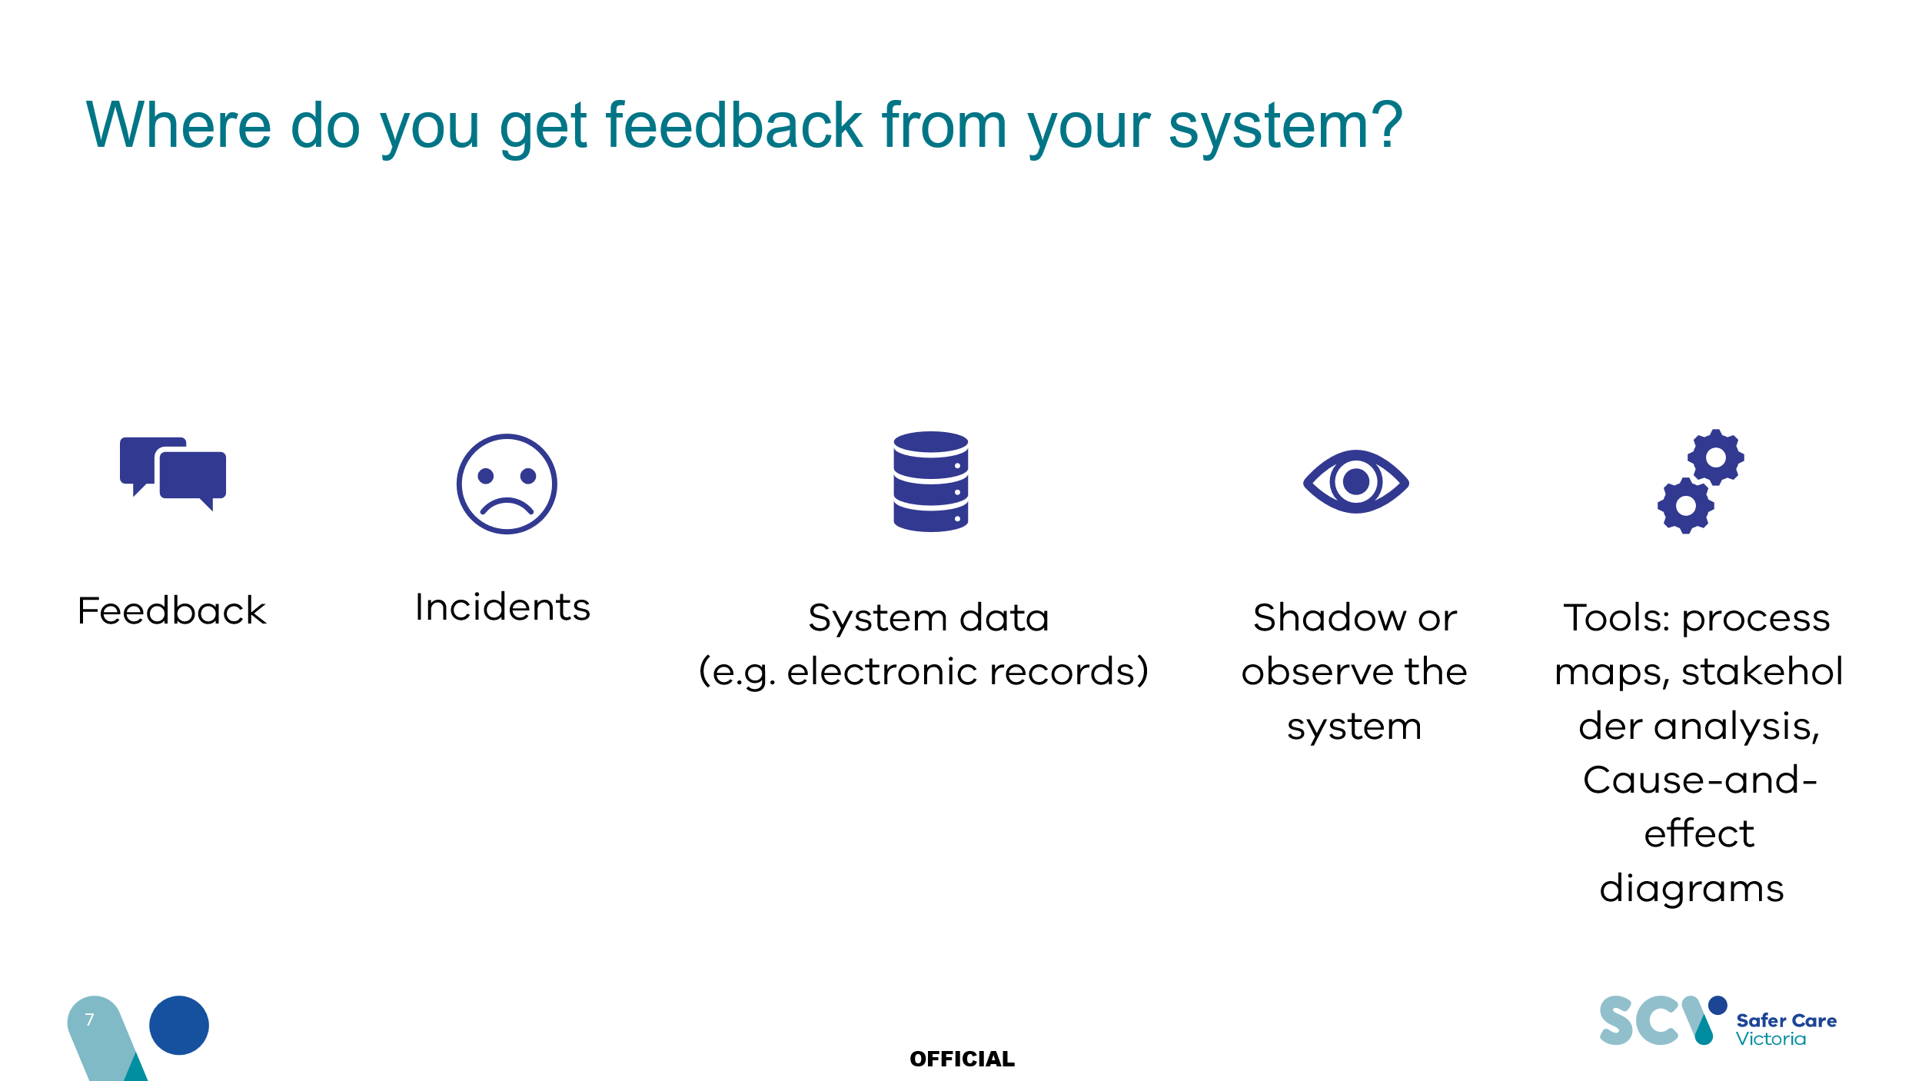
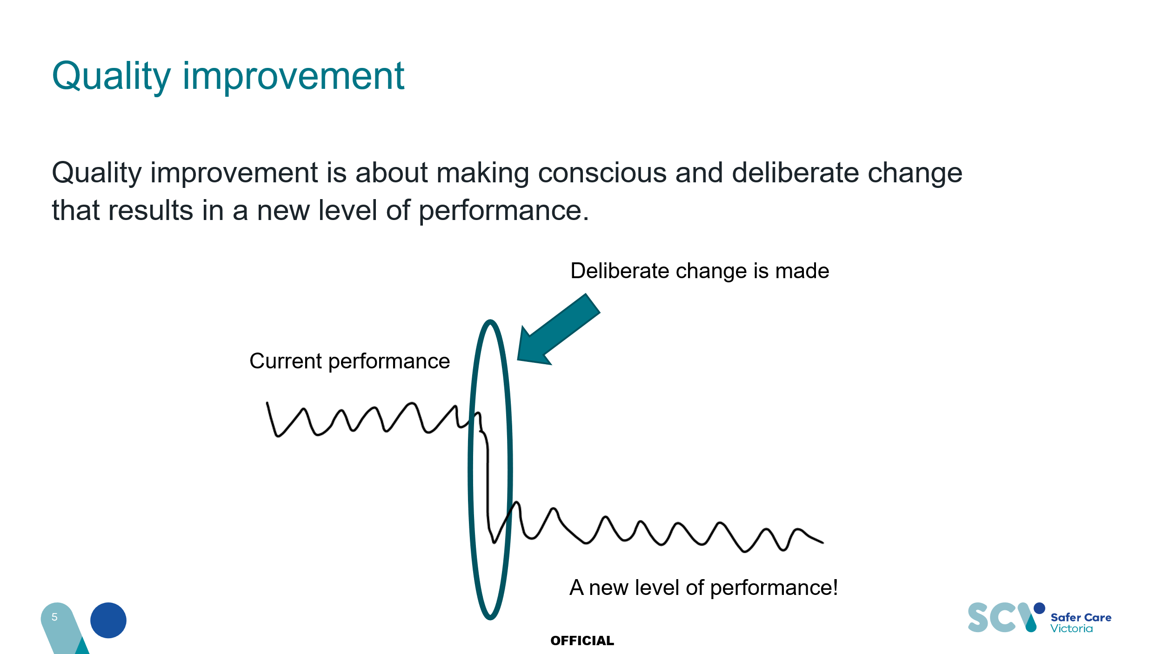

Understanding variation
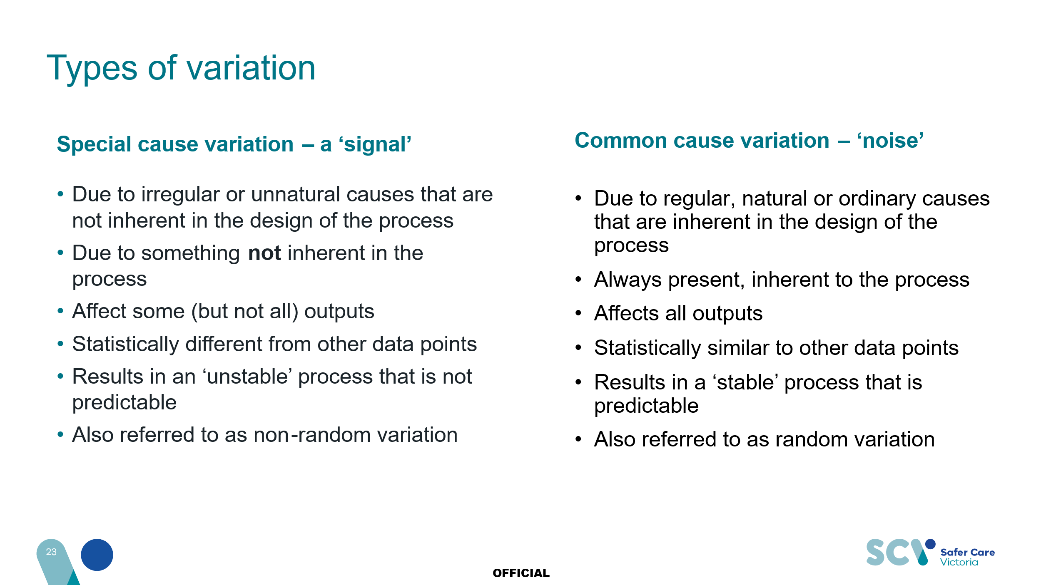
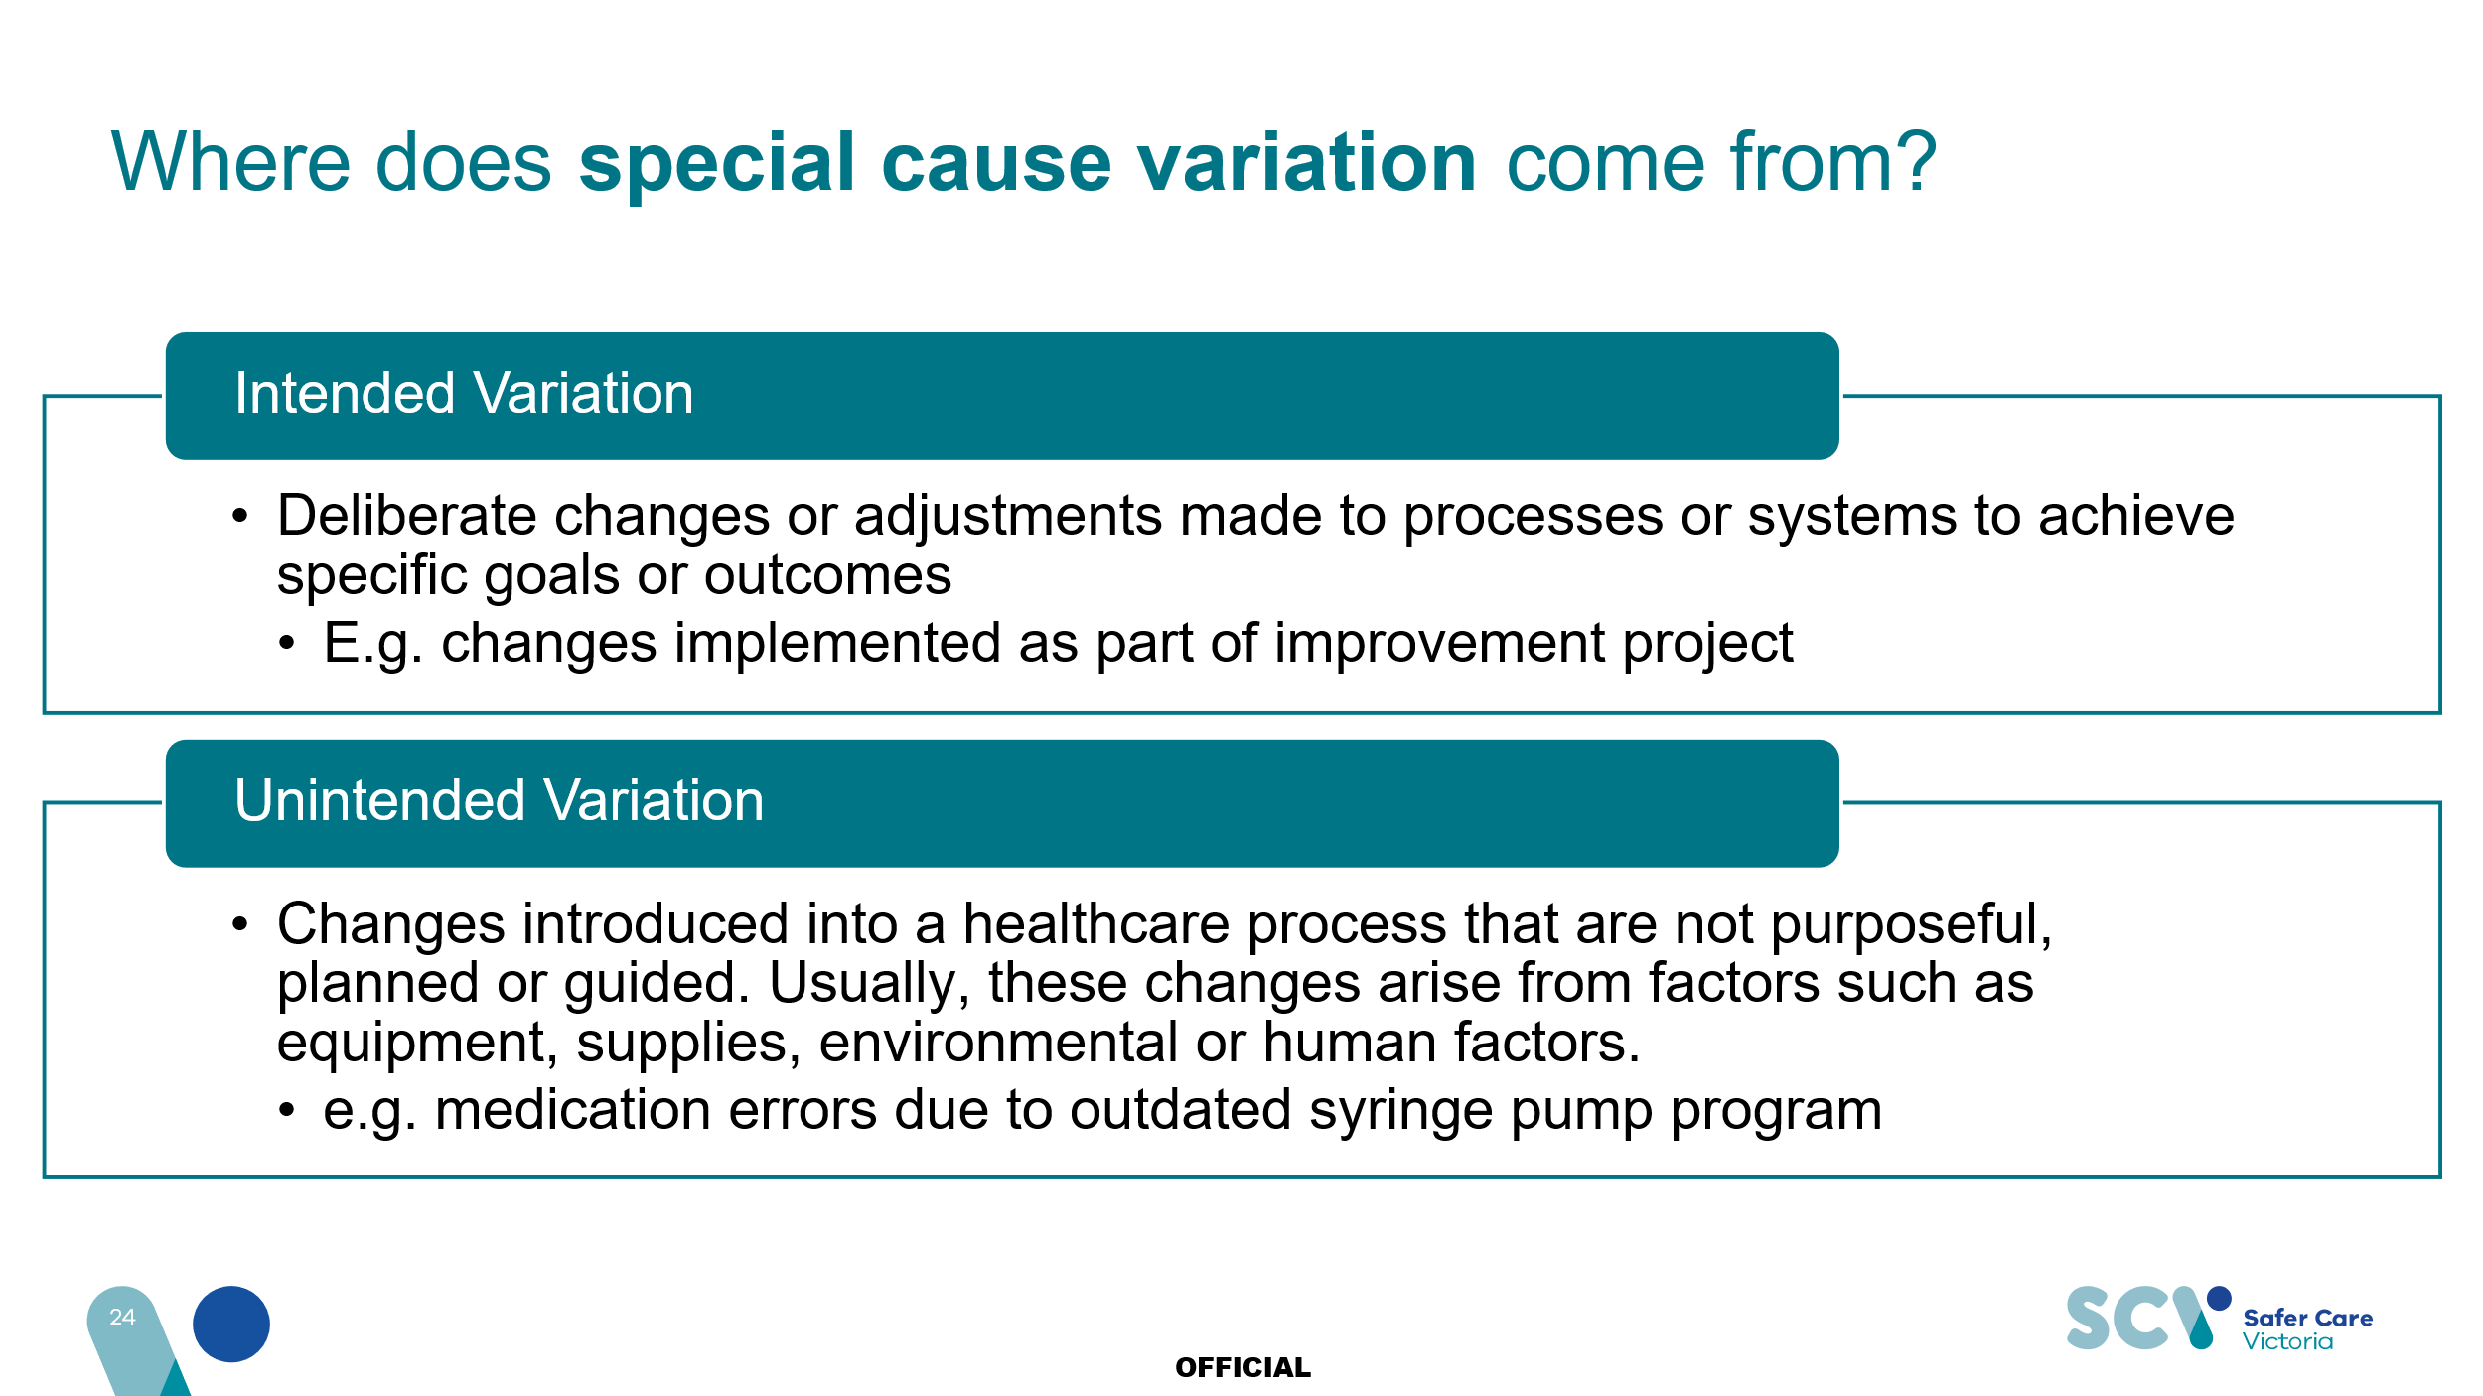

Responding to variation in your system
Examine your data over time. What trends are you seeing? What is the direction of ‘goodness’? For example, if you are collecting data on the percentage of monthly hospital acquired infections, the direction of goodness would be down. If you are collecting data on patient satisfaction your direction of goodness will be up. When did you make changes in your system? Is this visible in your data? What does it tell you about your change? Are you seeing normal variation in your system?

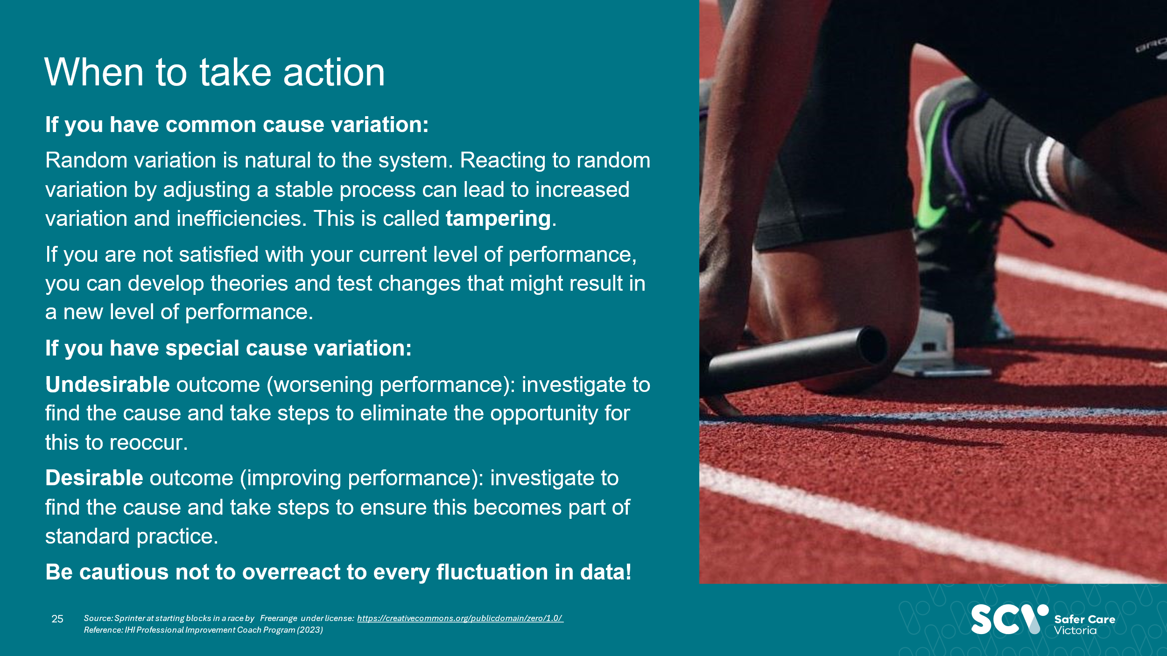

Activity 3: Variation
At your tables:
- Look at the 3 graphs you have been given in handouts.
- Discuss and answer the following questions for each graph.
- Are there patterns or changes in the data that may indicate non-random variation?
- Would you take action?
- Has a new level of performance been reached?

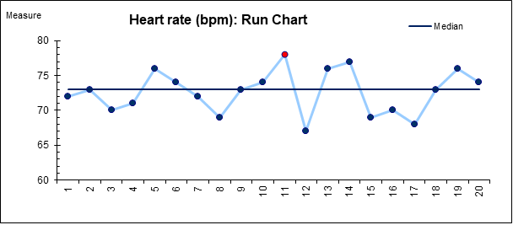
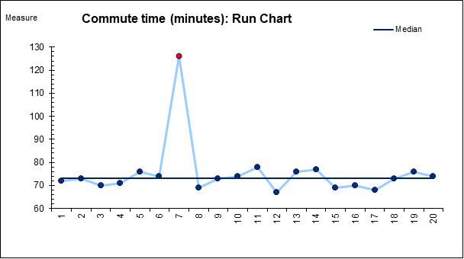

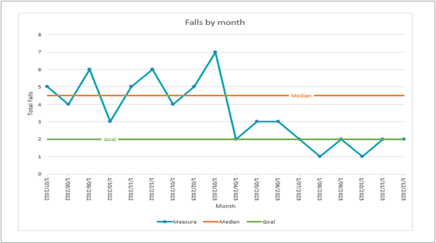

Understanding the problem

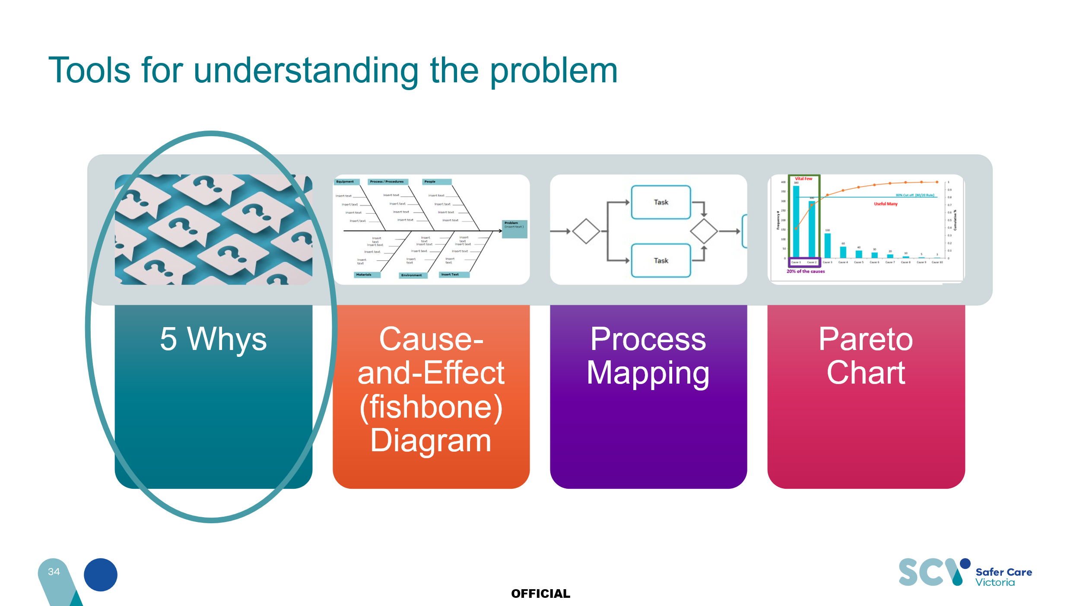

Activity 4: 5 Whys
On your allocated case study, you will find a Cause-and Effect diagram. Use the 5 Whys to try and understand the circled problem to find the root cause.
- What seems to be the problem?
- Where is there opportunity for improvement?

Identifying this now will help you to develop an aim statement later in the session. Use the 5 Whys template on the next page to help you document your 5 whys.


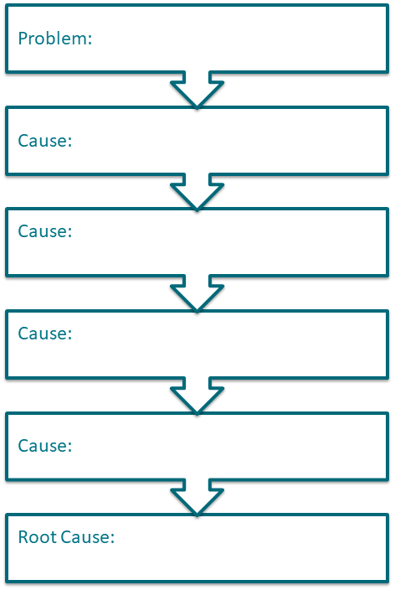
5 Whys template

Example of using the 5 Whys with a Cause-and-Effect diagrams
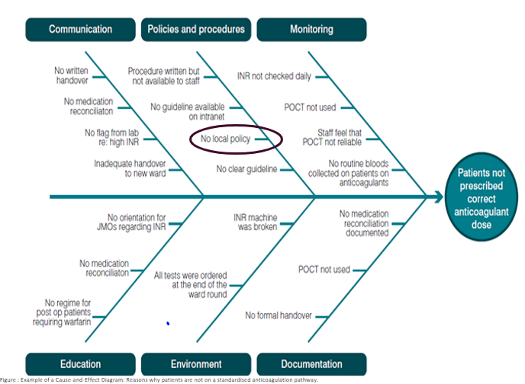
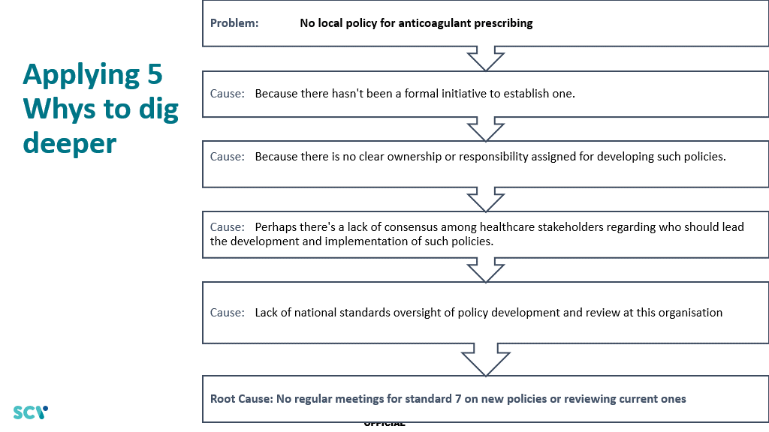

Crafting an aim statement
Key questions to address in your improvement aim statement:
- What are we improving?
- Who is this work in service of?
- Why does it matter?
- By how much are you hoping to improve?
- What is the deadline?
Note: Do not include solutions in your aim statement.

An example of an aim statement:
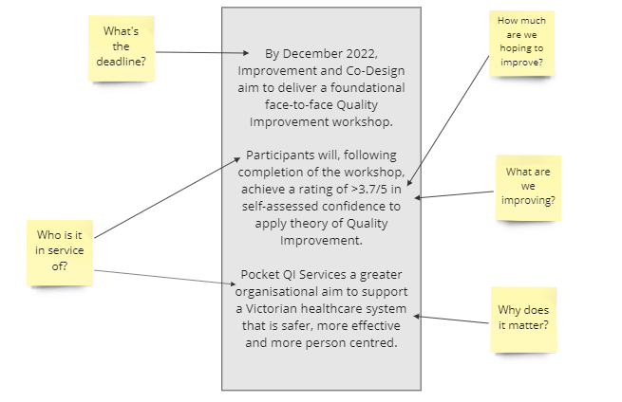

Case Scenarios cont.

The quality improvement teams have had a go at creating an aim statement for their improvement project.

Scenario 1: Safety
An opportunity has been identified for your team to look at ways to reduce falls on the ward and improve safety. Your current data shows that your ward has an average of 12 falls each month.

Aim statement: We hope to reduce falls on the ward by the end of the year.

Scenario 2: Equity
Data shows 48% of bookings each month show a greater than 40-minute wait and you would like this to improve.

Aim statement: Waiting times for appointments will be reduced by January.

Scenario 3: Timeliness
Your manager has asked you to create a project plan to improve fasting delays for theatre.

Aim statement: More patients will have their surgery on time in the next six months.

Scenario 4: Patient centred
You become curious about the team’s practice around using the ‘what matters to me’ information. When exploring this further, you note only 30 per cent of patients report that care received in your organisation was consistent with what matters to them, and you want to improve this.

Aim statement: More patients will say that their care improved by the end of this year.

Activity 5: Writing an aim statement
In your groups, review your scenario and its associated aim statement. How can you improve this aim statement? Re-write your aim statement as a group. Collaborate with your group to review and refine the aim statement provided.
Consider these questions:
- What improvements can you make?
- For whom or what?
- How good?
- By when?
- Why?

Developing an aim statement worksheet
Use the prompts below to help your team write an effective aim statement.
Use the checklist to double-check your work.
What? What is the problem or opportunity?
How good? By how much will you improve?
By when? What is the date by which you will achieve your improvement?
For whom? Who is the consumer or population who will benefit from the improvement?
Where? What are the boundaries of the process or system you’re trying to improve?
Why? What is at the heart of what you are trying to achieve?
Complete aim statement: Combine the above answers to complete your aim statement.
Aim statement review checklist
​​☐​ | Is the problem or opportunity clearly stated?
​​☐​ | Do you know what the team is going to do about the problem?
​​☐​ | Has the team set a numerical goal to quantify the amount of improvement they would like to achieve?
​​☐​ | Do you know the calendar date by which the team plans to achieve the goal?
​​☐​ | Is it clear who will benefit from the improvement?
​​☐​ | Is the scope of the project clear?
​​☐​ | Is it clear why this improvement activity is important?

Session 3: Change ideas and testing changes
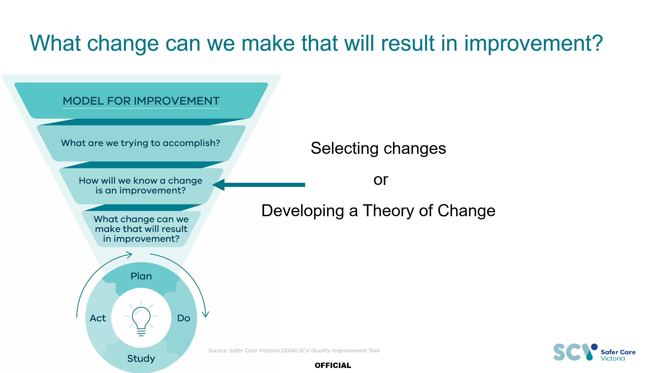

Generating change ideas
There are a number of ways as a team we can generate change ideas for our improvement work. These may include:
- QI tools: fishbone (cause and effect) diagrams, process maps.
- Creativity sessions and brainstorming.
  - People in the system: link in with those most AFFECTED by the improvement work, chances are they have already thought of some ideas and way to improve things.

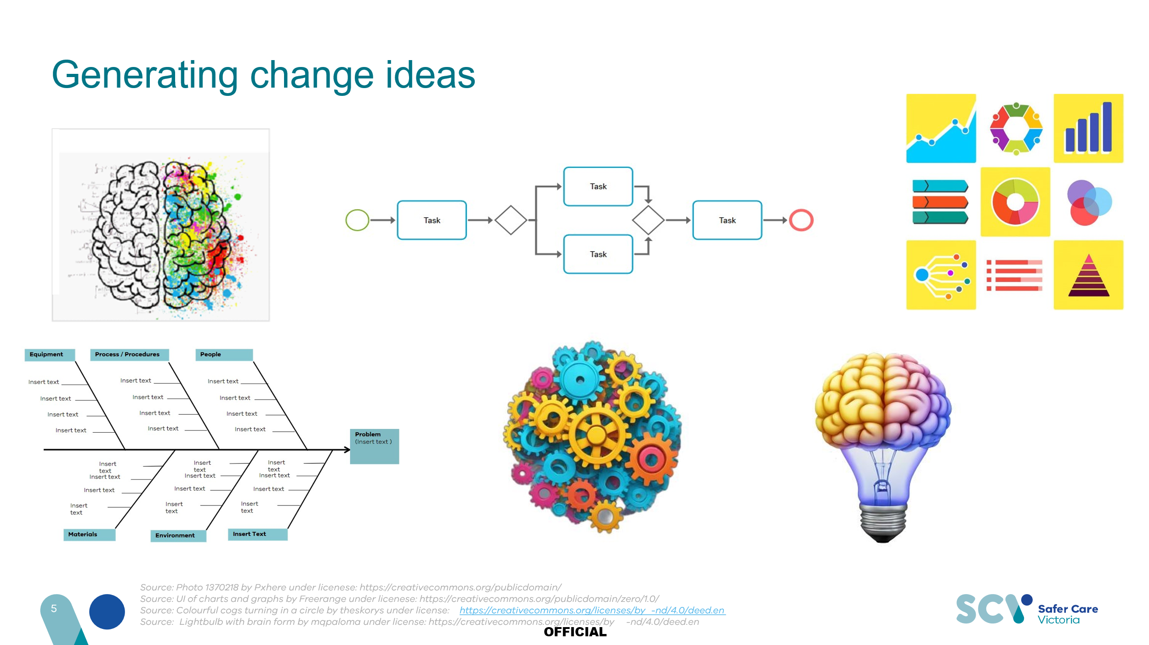

Building a Theory of Change
A theory of change is a communication tool used to show how your change ideas are directly related to the aim of your project.

Key questions you might ask to help you build your theory of change:
- What change ideas do you already have that might service your aim?
- What are the structures, processes, and norms that exist in your system?
- Where and when are the opportunities that change ideas can be applied?

In the below example we have mapped out our theory that developing this workbook, giving it to you on arrival, and allowing you to work through it during this course, will improve your self-assessment scores (in service of our aim).
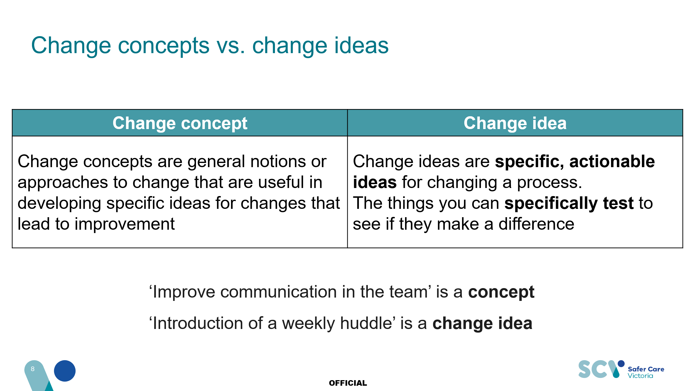

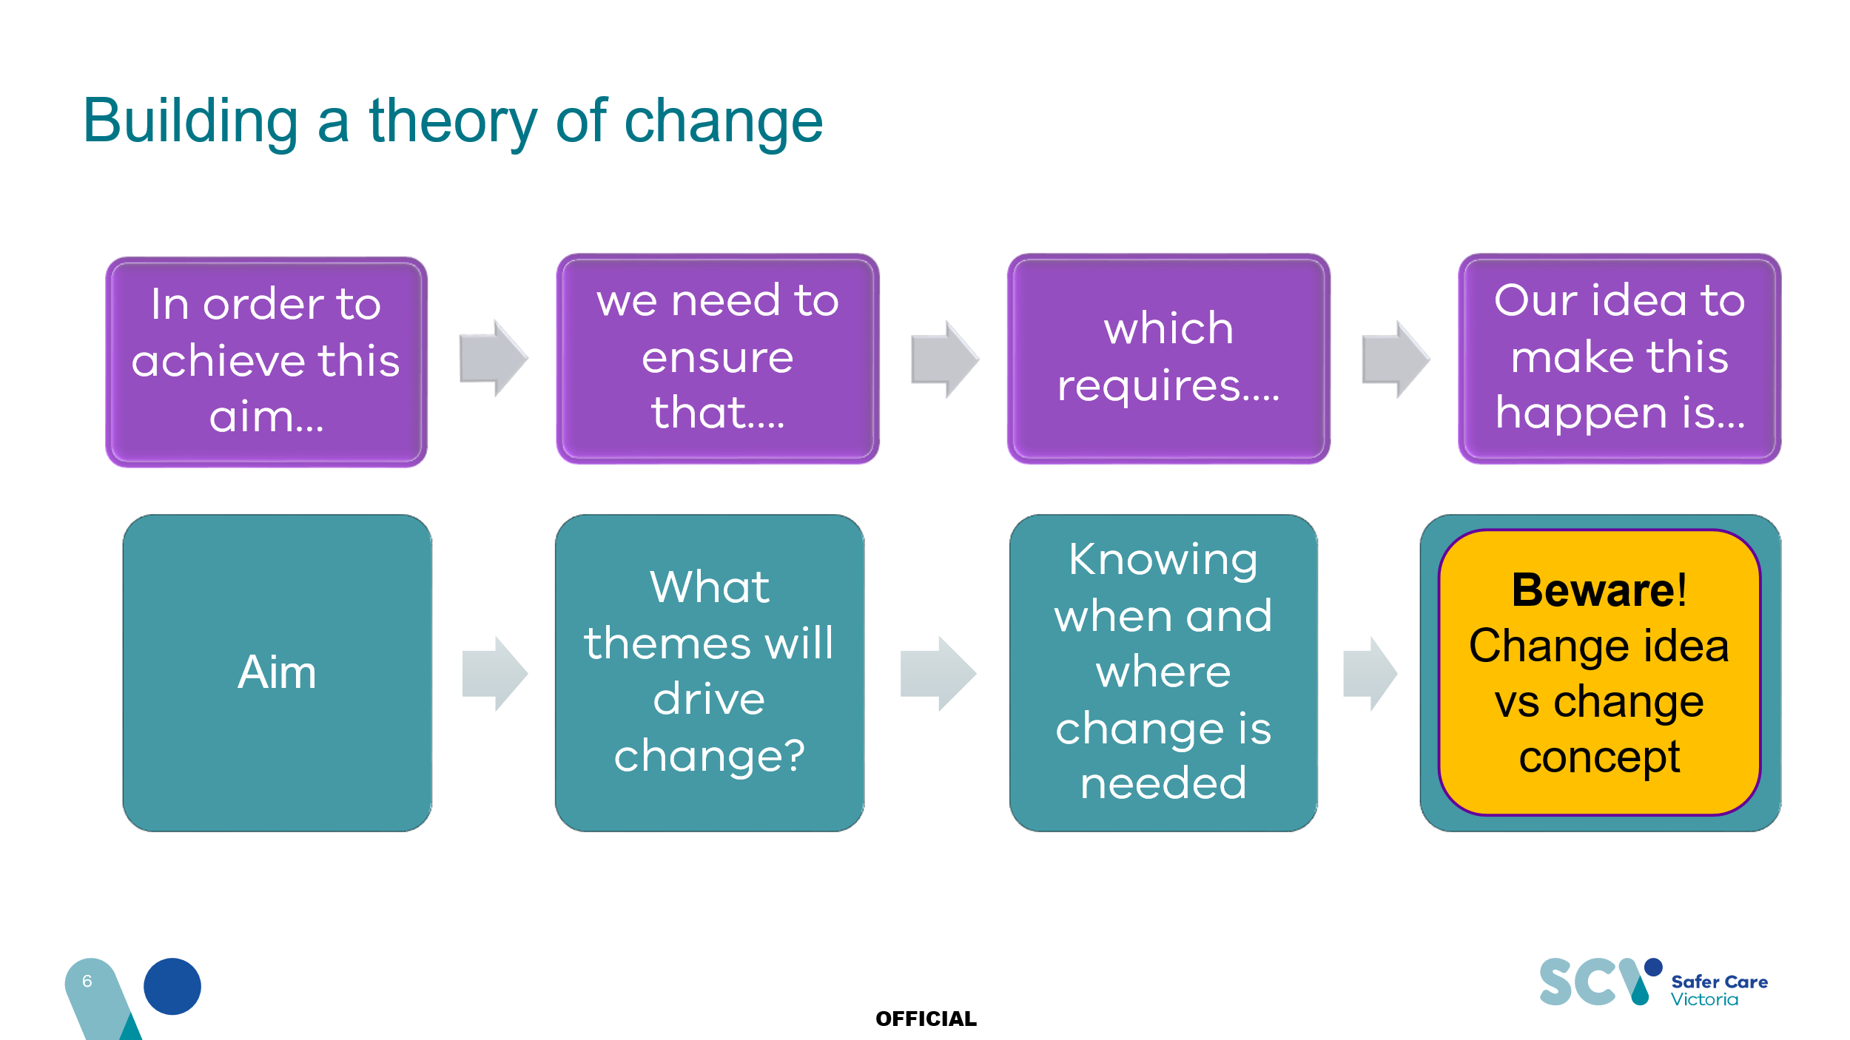

Activity 6: Theory of Change
Now that your team has come up with an aim statement for your improvement work, you will be provided with a prompt sheet for your Theory of Change. Using the post-it notes and pens provided, build your group’s Theory of Change.
- Start with the aim statement you created earlier.
- What are your change ideas? Get creative, and make sure they are change ideas – not change concepts.
- Group your change ideas into themes. We have provided you with some prompts for
themes. Please change, remove, and add themes of your own!
- Don’t forget to interrogate how your change ideas will influence the success of your aim.

An example of a theory of change visualisation:

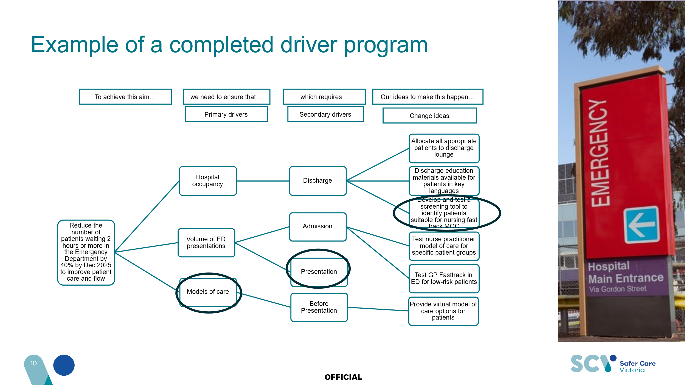

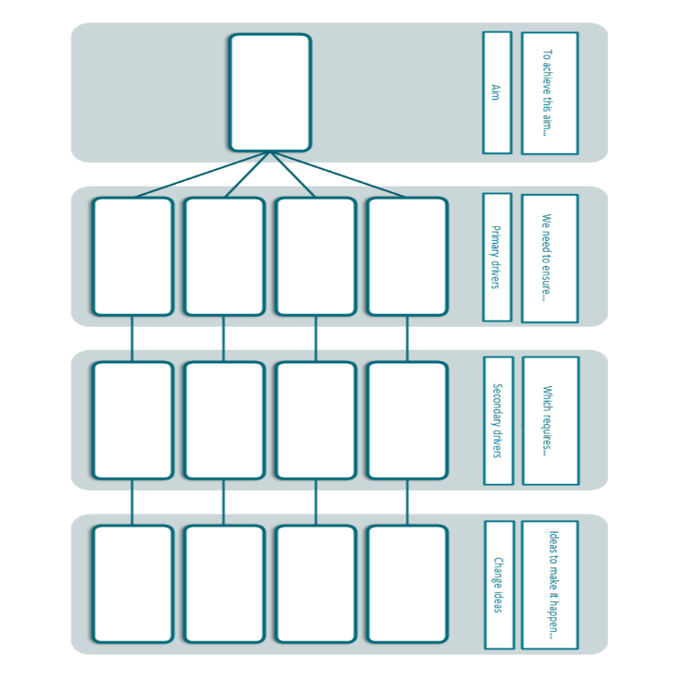

Testing and learning using PDSA
Some questions to consider when building a plan to test:
- Plan: What do we want to test first? What do we predict will happen? How are we going to measure our change? How are we going to test? Where are we testing and when? With whom? Who is involved in the work?
- Do: Who is performing the first round of testing? Who is collecting the data?
- Study: What happened? What did you observe? Were you right in your predictions? Was the data being collected useful, or have you decided on a different tact?
- Act: This is where we take all we have learnt from our first cycle and decide: adapt, adopt, or abandon.​ Do you want to continue testing and collecting data? Do you want to alter how or what you measure? If you feel what you tested was effective, you can consider testing on a larger scale i.e. a whole ward. Or should you abandon this change idea entirely?

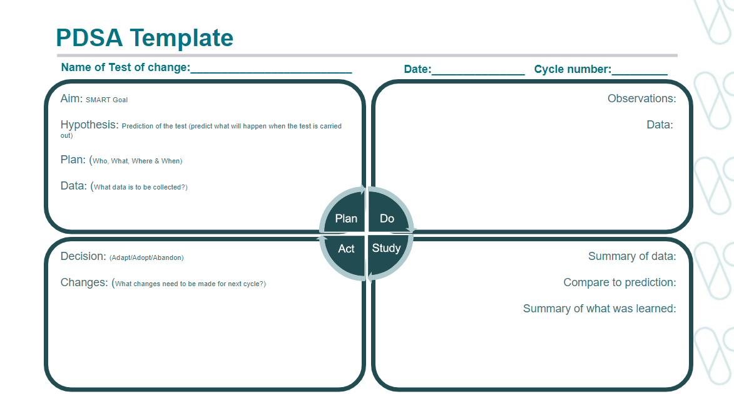

Activity 7: PDSA in action (coin spin)
Objective: ​
To achieve a coin spin that lasts no less than 10 seconds. How to play:​
Cycle 1: 5 minutes
- Assign roles
- Choose the following: coin, spinning technique, person, or surface
- Document on your PDSA Template
- Collect baseline data (minimum 10 spins)
- Plot your spin results on your run chart
- What were the results?
- Will you adopt/adapt/abandon your method?

# | PLAN |  | DO | STUDY | ACT
 | Questions? Theories? | Predictions | What happened? | How did this match your prediction? | Adopt/Adapt/Abandon?  What is next action?
1 | 20c coin  Table  One hand spin  Yolly | The bigger, round, coin on a hard, smooth surface, using a one-handed technique will spin for >10 sec | Random numbers with some consistency | Didn’t make it to 10 seconds, the coin kept falling over | Adapt – change technique
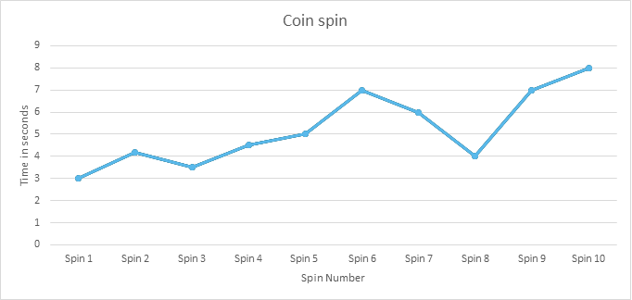

Cycle 2: 5 minutes
- As a group, choose one change idea to start testing (e.g. change coin, surface, person, technique)
- Collect data (5 spins)
- Plot your spins on your run chart and document results on PDSA Template
- Are you going to adopt, adapt or abandon the change idea?

# | PLAN |  | DO | STUDY | ACT
 | Questions? Theories? | Predictions | What happened? | How did this match your prediction? | Adopt/Adapt/Abandon?  What is next action?
2 | 20c coin  Table  Two handed techniques  Yolly | Using a two-handed technique offers mores stability and will spin for >10sec | Longer spins consistently | The two-spin technique gave more stability and the coin spun longer | Adapt – change person
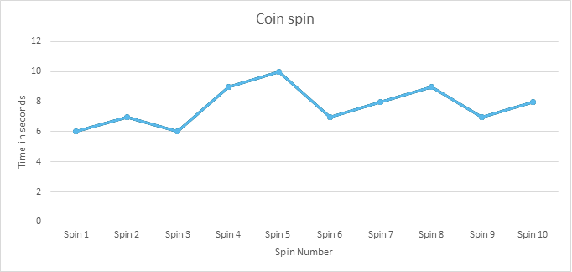

Cycle 3: 5 minutes
- As a group, choose one change idea to start testing (e.g. change coin, surface, person, or technique)
- Collect data (5 spins)
- Plot your spins on your run chart & document results on PDSA Template
- Are you going to adopt, adapt or abandon the change idea?

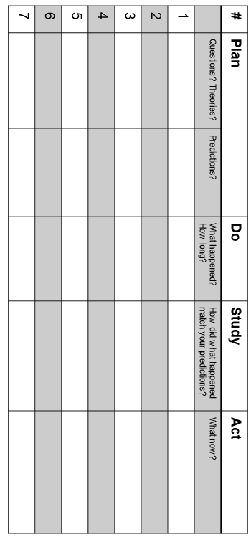

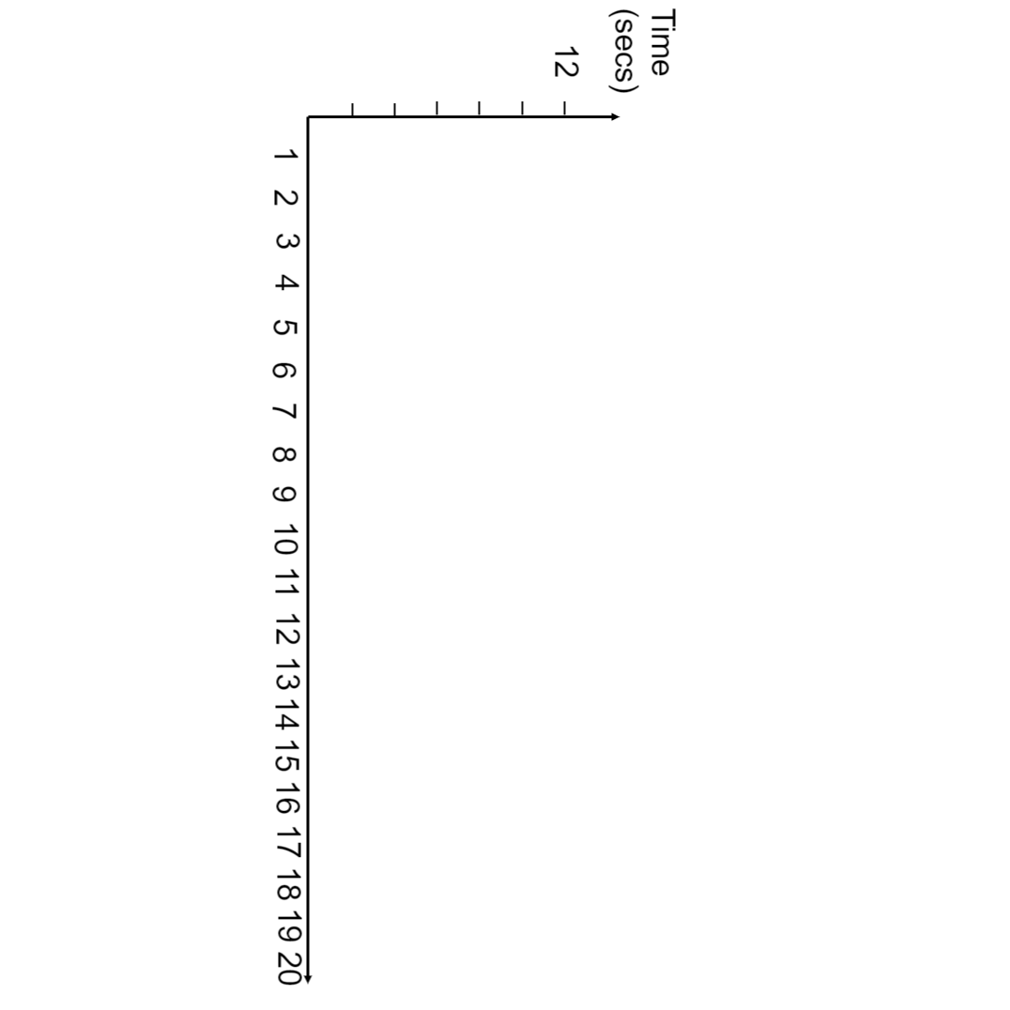

PDSA form – completed example

Plan |  |  | Cycle #: 2 |  | Date: 12/9/2023
Change you will be testing:  Describe the change you will be testing | ​​We will be testing use of a new patient feedback survey using QR code access to gain better understanding of patient satisfaction​.
Aim  What are your predictions? | ​​We aim to test the patient feedback survey and QR code access on 5 patients attending the podiatry outpatient clinic next Tuesday (19/09/2023) to find out if the survey is easy to read, understand. We predict that patients will find the tool easy to access and understand and that it will help motivate them to provide feedback. ​
Team members and roles  Names, roles, and responsibilities | ​​Sue – podiatrist  ​Mike – allied health assistant  ​Beth – administration ​
How are you going to test?  What / when / how | ​​During clinic hours we will ask 5 patients if they would like to test and provide feedback on the newly developed tool and the method for completion. ​
Data to be collected.  What / when / how | Survey completion.  Time to complete.  Number of issues faced by participants.  Qualitative data / feedback on tool and collection method.
Do
Observations  What happened? | ​​Most patients found the survey easy to complete. One patient required carer/relative support to complete.​
Problems/ barriers  Did PDSA go as planned?  If not, why not? | ​​PDSA went as planned – patients were eager to provide feedback  and overall found it easy to access and use but language was a difficulty for 1 patient. ​
Study
Data analysis:  What did you learn?  Any surprises?  Were your predictions accurate? | ​​5 people tested survey.  ​Average completion time was 4.5 mins.  ​For patients who spoke English the tool worked well.  ​Adaptation needed to support patients who speak languages other than English to complete the survey. ​
Act
Decision: | Adopt: ☐ | Adapt: ☒ |  | Abandon: ☐
Next Steps:  Is this change ready to be scaled up, implemented, or spread? | Identify main language groups among patients. Translate main language other than English & test.

Activity 8: What change can you make that will result in improvement?
Continue with your scenario.

Case Scenarios cont.
Scenario 1: Safety
Your team have now completed their aim statement and developed a theory of change and driver diagram. It is now time to test one of your change ideas and document it with the PDSA template.

The team have decided to test coloured wrist bands on high-risk patients. This is their first test of a yellow wrist band on high-risk patients.

Scenario 2: Equity
Your team have now completed their aim statement and developed a theory of change and driver diagram. It is now time to test one of your change ideas and document it with the PDSA template.

The team have been testing the introduction to telehealth appointments as an appointment option to help reduce delays. The team is on cycle 3 of their PDSA testing.

Scenario 3: Timeliness
Your team have now completed their aim statement and developed a theory of change and driver diagram. It is now time to test one of your change ideas and document it with the PDSA template.

The team have come up with some change ideas and have decided to test a fasting brochure. Patients will receive a fasting info brochure on how, when, and why to fast in their pre-op info pack. This team is only on their first PDSA cycle.

Scenario 4: Patient centred
Your team have now completed their aim statement and developed a theory of change and driver diagram. It is now time to test one of your change ideas and document it with the PDSA template.

This team has been working on their change idea for some time, imbedding ‘what matters to me’ in patient handover form from nurse to nurse each shift. The team are up to cycle 5 of this change idea.

As a group, discuss your PDSA cycle for the scenario and how you will make decisions about your next testing steps.

- Will you adopt, adapt or abandon?
- What will your next test look like?
You can use either the 4-quadrant template or form template for the activity.

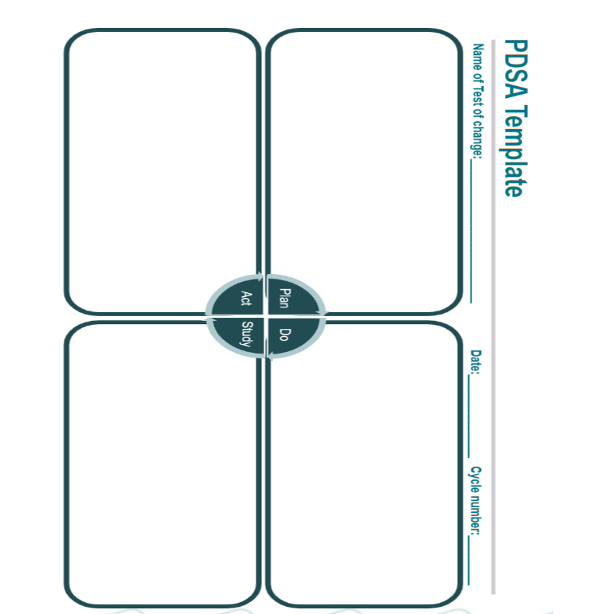
PDSA Form Template

Plan |  |  | Cycle #: |  | Date:
Change you will be testing:  Describe the change you will be testing | ​​Click or tap here to enter text.​
Aim  What are your predictions? | ​​Click or tap here to enter text.​
Team members and roles  Names, roles, and responsibilities | ​​Click or tap here to enter text.​
How are you going to test?  What / when / how | ​​Click or tap here to enter text.​
Data to be collected  What / when / how | ​​Click or tap here to enter text.​
Do
Observations  What happened? | ​​Click or tap here to enter text.​
Problems/ barriers  Did PDSA go as planned?  If not, why not? | ​​Click or tap here to enter text.​
Study
Data analysis:  What did you learn?  Any surprises?  Were your predictions Accurate? | ​​Click or tap here to enter text.​
Act
Decision: | Adopt: ​☐​ | Adapt: ​☐​ |  | Abandon: ​☐​
Next Steps: Is this change ready to be scaled up, implemented, or spread? | ​​Click or tap here to enter text.​

Scenario 1: Reducing falls (Safety)
Plan |  |  | Cycle #: 1 |  | Date: 30/1/24
Change you will be testing:  Describe the change you will be testing | ​​Identify patients who are at high risk of falls with coloured wrist bands.
Aim  What are your predictions? | ​​Identifying patients will ensure staff and family are aware and vigilant with patients identified as high risk.
Team members and roles  Names, roles, and responsibilities | ​​Admission nurse – completes falls assessment and applies the wristband to high-risk patient cohort.  Patients were asked if wearing a wrist band was ok to help prevent falls.  Staff and families were informed that if a patient has this wrist band, they must wait for a nurse to assist the patient to mobilise.
How are you going to test?  What / when / how | ​​Tested a yellow wrist band.  1 admission nurse on morning shift on Tuesday
Data to be collected  What / when / how | ​​Did any patients fall?  Number of patients that wore wrist bands and those who declined.  Time taken to complete the assessment.  Feedback from admission nurse around process.
Do
Observations  What happened? | ​​Patients agreed to wear wrist bands.  Yellow wrist band was not visible against pale skin.  Increased supervision of patients with the wrist bands did not happen all the time.
Problems/ barriers  Did PDSA go as planned?  If not, why not? | ​​Nurses didn’t know patient needed help mobilising.  The yellow wrist band was not easily visible on all skin types.  The admission nurse liked the new system.
Study
Data analysis:  What did you learn?  Any Surprises?  Were your predictions accurate? | ​​5 patients were identified as high risk.  2 patients with wrist bands fell.  Yellow wrist band was an issue.  Patients like the wristband.  Admission nurse liked the process.  Nursing staff found it easier to identify who was at risk of falling.
Act
Decision: | Adopt: ​☐​ | Adapt: ​☐​ |  | Abandon: ​☐​
Next Steps:  Is this change ready to be scaled up, implemented, or spread? | ​​Does identifying the patients prompt preventative action?

Scenario 2: Waiting times (Equity)
Plan |  |  | Cycle #: 3 |  | Date: 8/1/24
Change you will be testing:  Describe the change you will be testing | ​​Introducing optional telehealth for more types of appointments.  The team has previously tested optional telehealth appointments for prescription repeats in the clinic and found greater uptake in telehealth appts, reduced wait time and increased patient satisfaction with the new appointment option. They would now like to try telehealth as an option for patient review appointments.
Aim  What are your predictions? | ​​Patients attending follow-up appointments in outpatient will be seen on time if they chose the optional telehealth appointment.
Team Members and roles  Names, roles, and responsibilities | ​​Doctor B – completing telehealth appointments  Nurse J – scheduling appointments  Nurse M – collecting data
How are you going to test?  What / when / how | ​​From Monday 1/1/24 patients who need to book a follow up appointment will be offered the choice of a face-to-face or telehealth appointment.
Data to be collected.  What / when / how | ​​Total number of patients  Total number of patients seen with telehealth  Number Of appointments running on time  Number of telehealth appointment that experience tech issues
Do
Observations  What happened? | ​​9 out 15 patients chose telehealth for their follow-up appointment.  6 out 9 telehealth appointments were on time. Two were not on time (1 due to patient logging in late and 1 due to doctor logging in late) and one person couldn’t work out how to log into the telehealth system
Problems/ barriers  Did PDSA go as planned?  If not, why not? | ​​Reminder text came 24 hours before the appointment and the patient couldn’t find the text, so logged on late to the appointment.  1 person couldn’t work out how to log into the system.
Study
Data analysis:  What did you learn?  Any surprises?  Were your predictions accurate? | ​​All telehealth patients liked the telehealth option as they could continue their work and just log in when the time came.  Some patients preferred face-to-face appointments.  Having dedicated doctors for both face-to-face and telehealth allowed for appointments to on time.
Act
Decision: | Adopt: ​☐​ | Adapt: ​☐​ |  | Abandon: ​☐​
Next Steps:  Is this change ready to be scaled up, implemented, or spread? | ​​Click or tap here to enter text.​

Scenario 3: Surgery on time (Timeliness)
Plan |  |  | Cycle #: 1 |  | Date: 5/3/23
Change you will be testing:  Describe the change you will be testing | ​​Patients will receive a fasting info brochure on how, when, and why to fast in their pre-op info pack.
Aim  What are your predictions? | ​​There will be a reduction in surgery cancellations if patients read the fasting info brochure because they know when and how to fast prior to their surgery.
Team Members and roles  Names, roles, and responsibilities | ​​Nurse K – admission nurse  Nurse R – theatre list nurse
How are you going to test?  What / when / how | ​​On 1/3/23 all patients on the gastroscopy list will receive a fasting info brochure with their preop info pack.  Nurse K will then ask follow-up questions on admission.
Data to be collected  What / when / how | ​​Number of patients sent info brochure.  Number of patients fasted as per guidelines.  Number of patients’ surgeries cancelled.  Patient Feedback  Number of patients that read the brochure
Do
Observations  What happened | ​​12 patients on the list were sent a pre-op info pack.  3/12 patients remembered seeing the fasting brochure in the paperwork.  1/12 patient was prompted to fast after reading the brochure.  2/12 patients saw the brochure but threw it out.
Problems/ barriers  Did PDSA go as planned?  If not, why not? | ​​Only 3/12 patients remembered seeing the fasting brochure when they were asked by the admission nurse.  6/12 admitted to only completing the paperwork and threw out all other brochures/papers in the pack.  3/12 saw the brochure but couldn’t understand what it meant
Study
Data analysis:  What did you learn?  Any surprises?  Were your predictions accurate? | ​​Only 3/12 saw the documentation.  Pre-op pack wasn’t the best place to give fasting info.  Need to review the language given to patients as some patients couldn’t understand the brochure.
Act
Decision: | Adopt: ​☐​ | Adapt: ​☐​ |  | Abandon: ​☐​

Scenario 4: Improved care (patient centred)
Plan |  |  | Cycle #: 5 |  | Date:
Change you will be testing:  Describe the change you will be testing | ​​Imbedding ‘what matters to me’ in patient handover form from nurse to nurse each shift.  The team have been testing ‘what matters to me’ in different formats to increase collaboration with patients and their care team. The team have responded well to adding ‘what matters to me’ in their daily practice. They want to formalise this by adding it to their nursing handover form.
Aim  What are your predictions? | ​​By adding ‘what matters to me’ to the nursing handover form, all staff will engage with patients and provide more patient centred care.
Team Members and roles  Names, roles, and responsibilities | ​​Ward M  All nurses
How are you going to test?  What / when / how | ​​Nursing handover form has been updated to include ‘what matters to me’ as a standard question and a place to document the patient’s answer.
Data to be collected  What / when / how | ​​Audit data on nursing handover form completion rates.  Patient satisfaction and feedback.  Feedback form nurses.
Do
Observations  What happened? | ​​After 2 weeks, 80% of nursing handover documentation had the ‘what matters to be’ section completed.  Nurses were observed to be completing handover in the patient room with the patient.
Problems/ barriers  Did PDSA go as planned?  If not, why not? | ​​Nurses liked the prompt and ability to document and include patient concerns and discussions.  Some nurses were concerned with completing full handover in patient room or with patient if they perceived there was sensitive information or felt like they needed to ‘protect’ the patient and/or family.
Study
Data analysis:  What did you learn?  Any surprises?  Were your predictions accurate? | ​​80% nurses had completed the documentation.
Act
Decision: | Adopt: ​☐​ | Adapt: ​☐​ |  | Abandon: ​☐​

Session 4: Measuring and sustainability
Introduction to measurement for improvement

Key questions:
- What are you aiming to achieve?
- How will you know you have achieved it?
- How can you measure your changes to know what impact they have in service of your aim?

Outcome measures: often linked to consumers within your system and will indicate that you have met your aim.
Process measures: linked to the system itself, measuring the impact of change ideas tested in your system to help you to meet your aim.
Balancing measures: determine whether changes designed to improve one part of your system are having unexpected consequences (positive or negative) in another part of your system.

Examples of some measures:

Outcome measure Process Measure Balancing measure

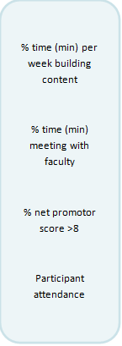

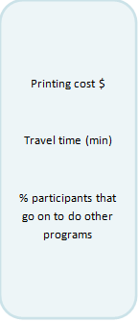
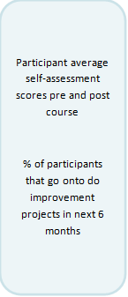

Activity 9: Family of Measures
Continue with your assigned scenario. Using the Family of Measure list, as a group, allocate each measure to its appropriate category:
- Outcome measure
- Process Measure
- Balancing Measure

Scenario 1 – Reducing/preventing falls | Scenario 2 – Improving attendance/reducing waiting times | Scenario 3 – Reducing theatre delay | Scenario 4 – Improving care
- Number of pressure injuries  - % of patients with falls assessment completed  - Number of falls by month in ward X  - % of patients who have documented fall management plan in EMR/medical file | - Number of follow-up calls made per week  - % of appointments attended per week  - Staff satisfaction  - Time in waiting room from arrival to seeing the doctor. | - % of patients that have surgery on the day booked  - % of patients that received fasting information  - % of cancelled surgeries  - Surgery waitlist time | - Weekly % of patients that report on discharge that care was consistent with that they said mattered most to them  - Time (min) spent doing handover at bedside  - % of patients with documented care plan that included what matters to them  - % of patients/families being asked ‘what matters to me?’
If you have time, consider what other measures you could come up with or whether you would change any.

Family of Measures template


Document your Family of Measures based on your scenario below.

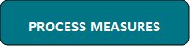
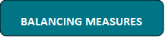
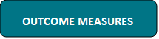

Sustainability
Now that you have the methods and tools to do quality improvement you can ask yourself, ‘Have you reached your new level of performance?’
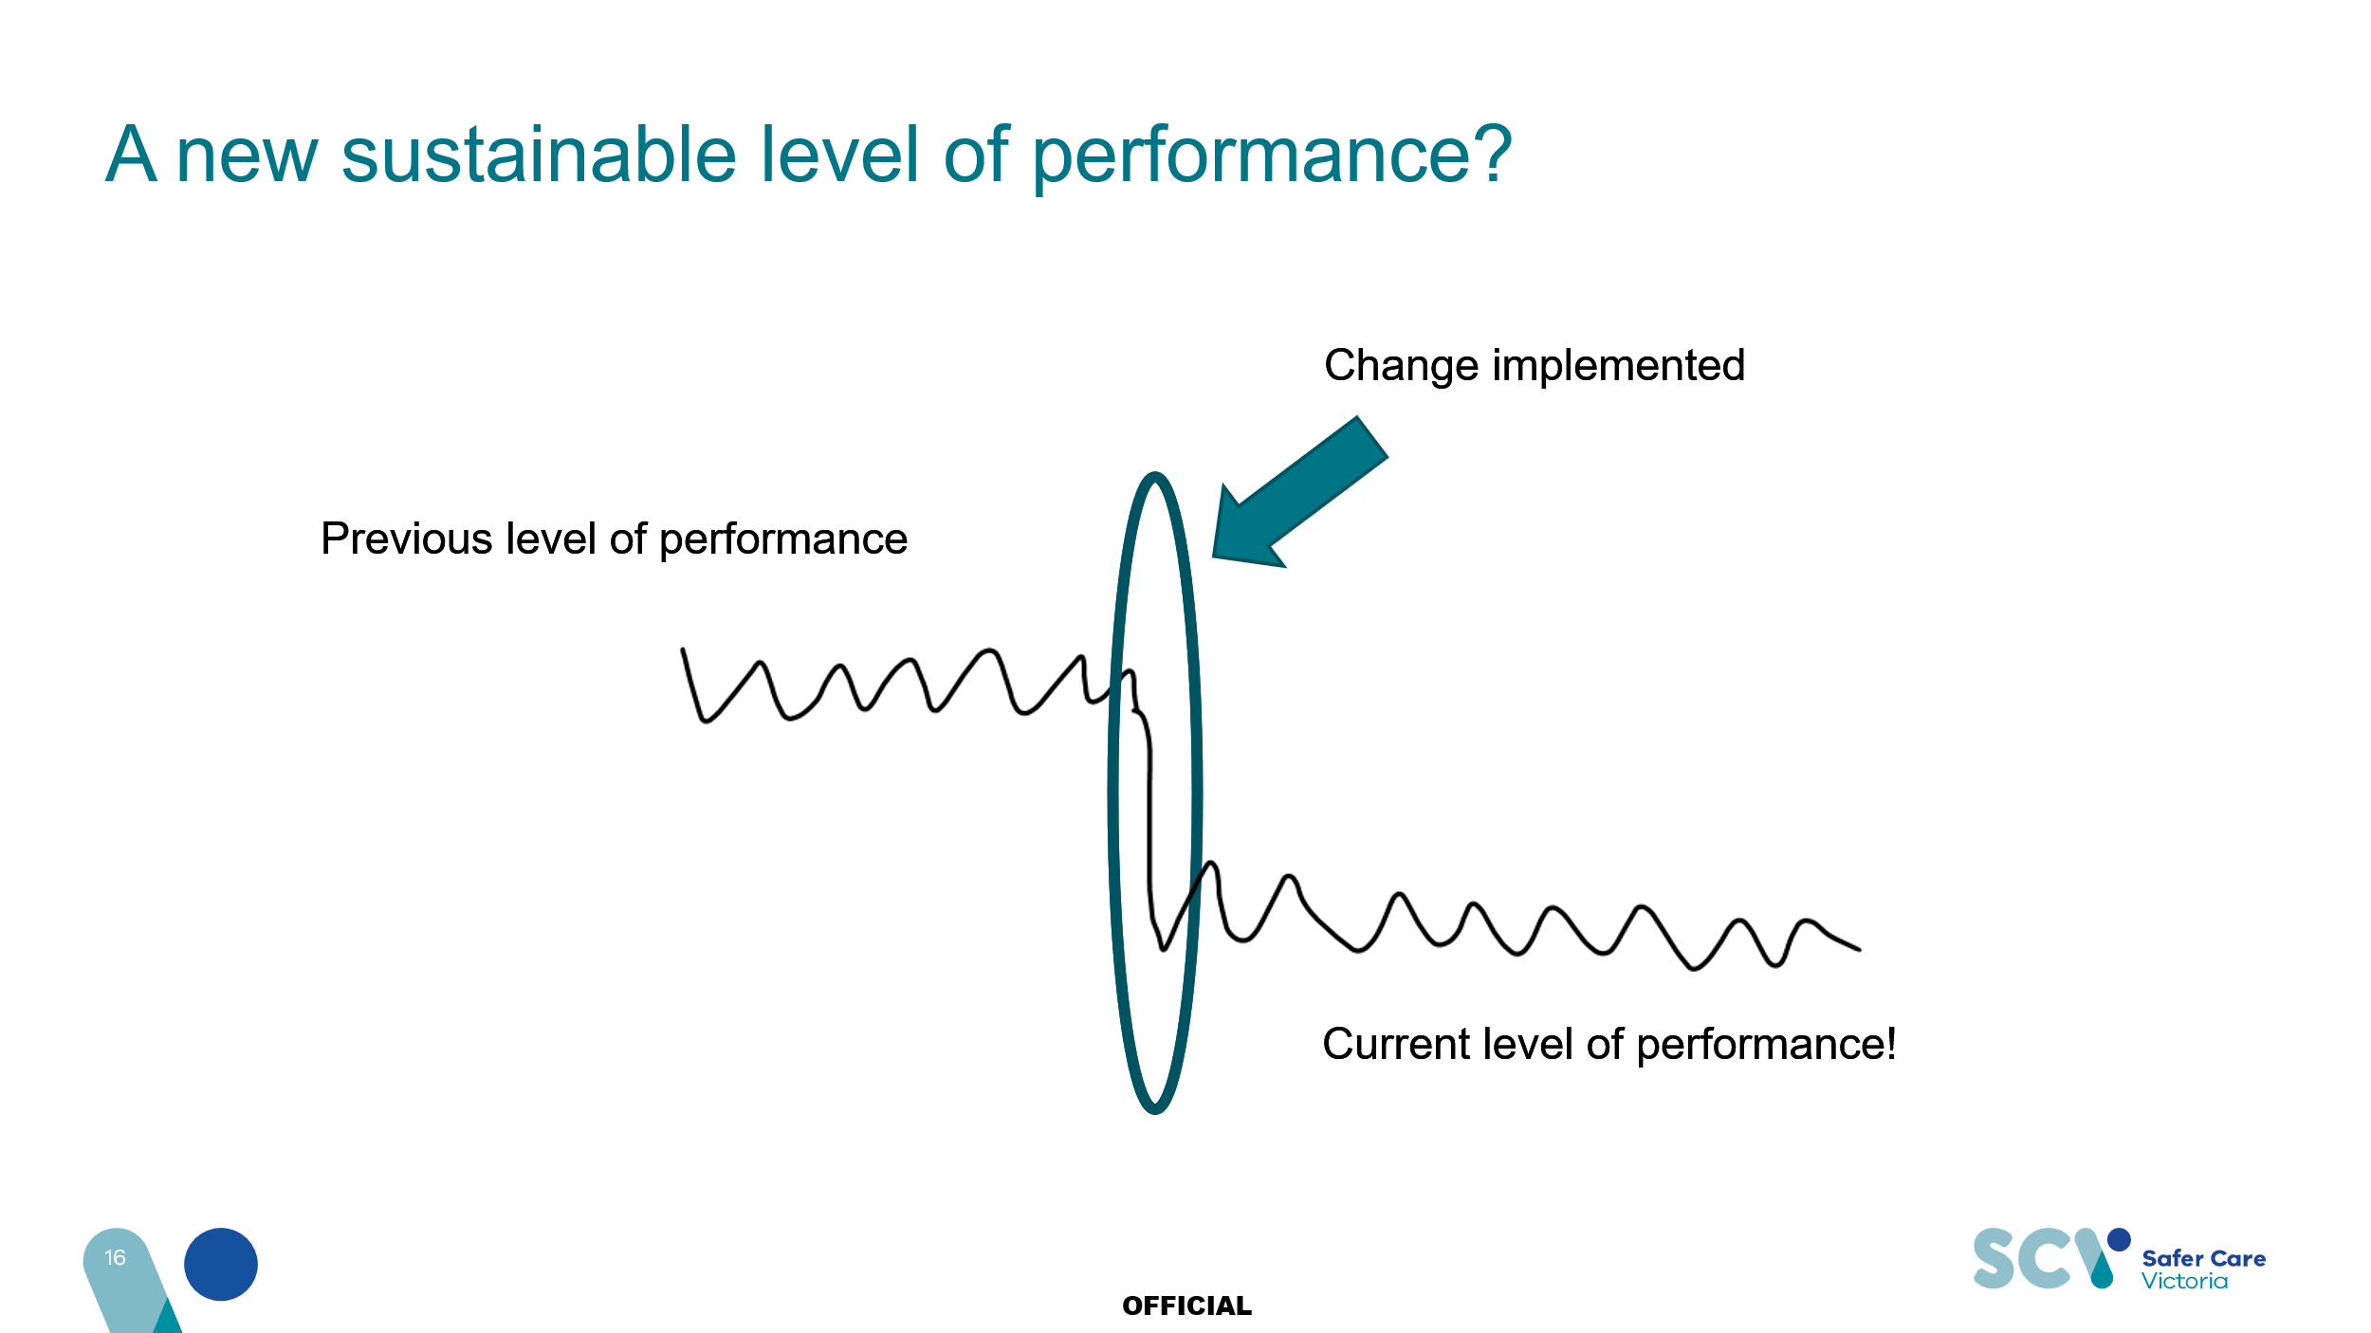

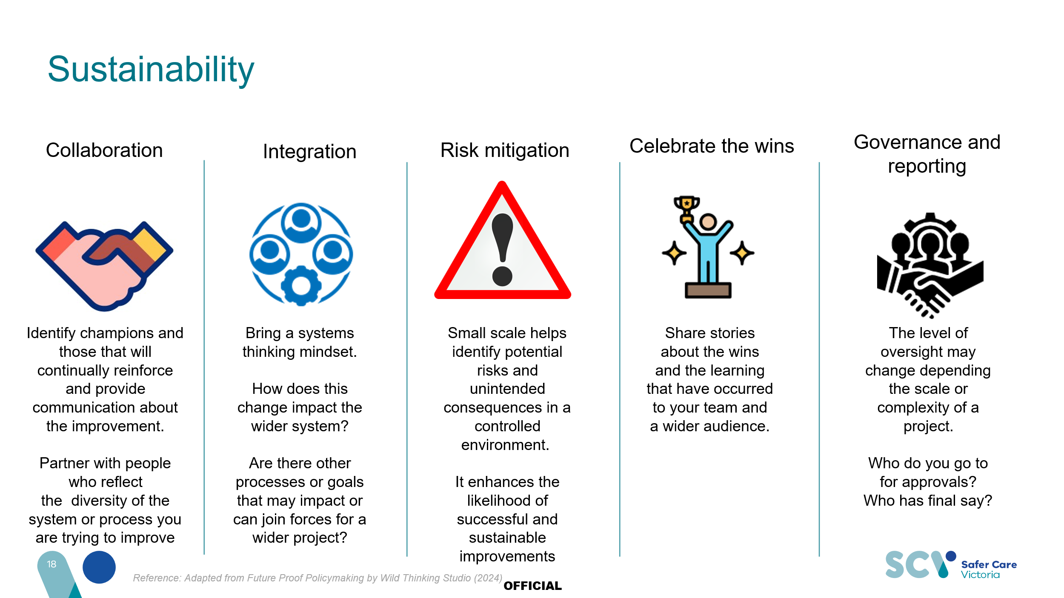

To receive this publication in an accessible format email Safer Care Victoria <info@safercarevictoria.vic.gov.au>
Authorised and published by the Victorian Government, 1 Treasury Place, Melbourne.
© State of Victoria, Australia, Safer Care Victoria, February 2025
ISBN/ISSN 978-1-76131-712-5
Available at the Safer Care Victoria website <https://www.safercare.vic.gov.au>


