AGS newsletter sample content

Did you know?
Use of common opioids (eg. oxycodone, codeine) is 4 x higher than 10 years ago.

In 2018, the number of Victorian drug overdose deaths from prescription medications (422) was higher than the road toll (213) and number of deaths from illicit drugs (263).

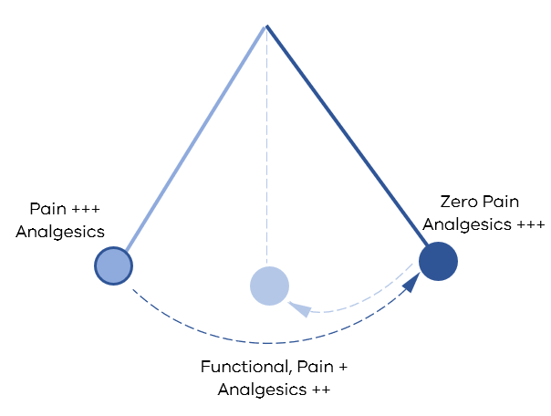
Has the pendulum swung too far for pain management?

Key Activities for the Analgesic Stewardship Program

Why calculate oMEDD?  Doses ≥ 50mg oMEDD* increases risk of overdose by at least 2 x doses < 20mg oMEDD  Avoid or carefully justify doses ≥ 90mg MOE/day  To calculate total oMEDD or equivalent opioid doses: Refer to guideline or use the app  *oral Morphine Equivalent Daily dose (oMEDD) | 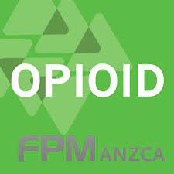  

The more opioid you give the greater the risk of continued use  Prescribing 6 days of opioids on discharge compared to 3 days DOUBLES the risk of long-term opioid use.  Where possible,  - Use non-opioid analgesics first  - Assess pain regularly and wean opioids/analgesics in hospital and on discharge  - Think twice about the discharge quantity of Endone® and other opioids | 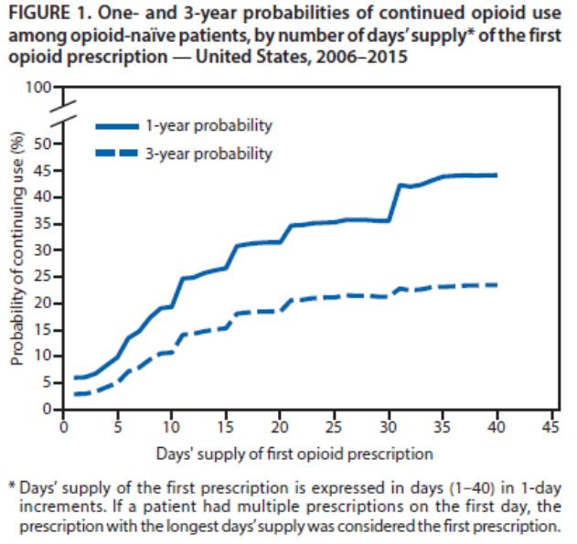

Use of slow-release opioid preparations in the treatment of acute pain
Inappropriate use of slow-release opioids is associated with significant harm

Practice points:
- Initial treatment includes simple analgesics, paracetamol +/- anti-inflammatory medication, PRN immediate-release opioids
- Opioid naïve patients, initial opioid dosing should be age-based
- Slow-release opioids may be necessary in post major surgery or trauma patients with or expected to have prolonged pain
- Regularly review, wean and aim to cease opioids

Refer to Australian and New Zealand College of Anaesthetists (ANZCA) statement on the Use of Slow-Release Opioid Preparations in the Treatment of Acute Pain, https://www.anzca.edu.au/getattachment/d9e2a7c5-0f17-42d3-bda7-c6dae7e55ced/Position-statement-on-the-use-of-slow-release-opioid-preparations-in-the-treatment-of-acute-pain

Warnings for Gabapentinoids  Boxed warnings in product and consumer medicines information leaflets include:  - Risk of misuse for pregabalin  - Risk of abuse or dependence for pregabalin and gabapentin  When prescribing gabapentinoids consider:  - Informing/checking for Hx of drug misuse/abuse/dependence  - Consider other sedating medications and/or alcohol  - Do not stop abruptly, gradual reduction over ≥ 1 week. | Pregabalin-related deaths  16 deaths in 2013  121 deaths in 2016

SafeScript  What is SafeScript?  Computer software that allows prescribing and dispensing records for certain high-risk medicines to be transmitted in real-time to a centralised database which can then be accessed by doctors and pharmacists. | 
What medicines are monitored?  All Schedule 8 medicines  Benzodiazepines such as diazepam  ‘Z-drugs’ (zolpidem, zopiclone)  Quetiapine  Codeine containing products  Pregabalin, gabapentin, tramadol | How can you access SafeScript?  All clinicians can access the SafeScript portal on their computer or via a tablet or mobile device.  When do you use SafeScript?  Clinicians should use SafeScript when considering prescribing on admission and at discharge

Opioid induced constipation  Up to 95% of patients prescribed an opioid reported constipation | Increased risk of developing constipation post-operatively in hospital due to  - Reduced mobility  - Decreased fluid and fibre intake  - Hospital stay  - Medications  - Gender  Consideration of initiation of aperients with opioids is recommended for prevention

