**Victorian Perioperative Consultative Council Annual Report 2023**

**Improving care, before, during and after surgery**

|  |
| --- |
|  |
| To receive this publication in an accessible format phone 03 9096 1384,  using the National Relay Service 13 36 77 if required, or [email Safer Care Victoria](mailto:info@safercarevictoria.vic.gov.au) <info@[safercare.vic](mailto:safercarevictoria@dhhs.vic).gov.au>  Authorised and published by the Victorian Government, 1 Treasury Place, Melbourne.  © State of Victoria, Australia, Safer Care Victoria, April 2025.  ISSN 2652-9947 - Online (pdf/word)  Available at the [Safer Care Victoria website](https://www.safercare.vic.gov.au) <https://[www.safercare.vic](http://www.safercare.vic).gov.au>  Victoria State Government |

**Disclaimer**: This document was accurate at the time of download from the official website of Safer Care Victoria. However, Safer Care Victoria cannot guarantee the integrity, accuracy, or currency of this content if it has been obtained from any external or unofficial sources. Users are responsible for ensuring that any adaptations or redistributed versions preserve the accuracy and intent of the original document.

# Abbreviations

ANZCA – Australian and New Zealand College of Anaesthetists

ANZELA-QI – Australian and New Zealand Emergency Laparotomy Audit – Quality Improvement

ANZHFR – Australian and New Zealand Hip Fracture Registry

ASA – American Society of Anaesthesiologists

ASC – Anaesthetic Subcommittee

CCoV – Coroners Court of Victoria

CGA – comprehensive geriatric assessment

CMI – clinical management issue

CQR – clinical quality registries

CVC – central venous catheter

DVT – deep vein thrombosis

E-Deps – e-depositions

EL – emergency laparotomy

GIRFT – Getting It Right First Time

PE – pulmonary embolism

PLHN – Perioperative Learning Health Network

RACS – Royal Australasian College of Surgeons

SCV – Safer Care Victoria

SSC – Surgical Subcommittee

VAHI – Victorian Agency for Health Information

VASM – Victorian Audit of Surgical Mortality

VIFM – Victorian Institute of Forensic Medicine

VPCC – Victorian Perioperative Consultative Council

Acknowledgement of Country

We proudly acknowledge Victoria’s Aboriginal communities and their rich culture and pay respect to their Elders past and present. We acknowledge Aboriginal people as Australia’s First Peoples and as the Traditional Owners and custodians of the land and water on which we rely. We recognise and value the ongoing contribution of Aboriginal people and communities to Victorian life and how this enriches us. We embrace the spirit of reconciliation, working towards the equality of outcomes and ensuring an equal voice.



Contents

Abbreviations 1

Chair’s report 6

Victorian Perioperative Consultative Council 8

About us 8

Governing legislation 8

Membership 8

Aim 8

Roles and responsibilities 8

Referrals 9

Reporting 9

Case confirmation 9

Engaging with consumers 10

A well-prepared and informed patient is a key protective factor for good surgical outcomes 10

2023 themes 10

Anaesthetic Subcommittee 13

2023 themes 15

Conclusion 17

Surgical Subcommittee 18

2023 themes 18

Learning from good practice – Safety II – Quality Improvement 24

Australia and New Zealand Emergency Laparotomy Audit – Quality Improvement 24

ANZELA-QI in Victoria 25

Australian and New Zealand Hip Fracture Registry 27

Perioperative morbidity – sentinel events 35

Sentinel events: categories 1–10 36

Sentinel events: category 11 36

Perioperative mortality: Victorian Audit of Surgical Mortality report 38

Perioperative Mortality Committee 40

Victorian Institute of Forensic Medicine and the Coroners Court of Victoria 41

Examination of perioperative deaths at VIFM 41

Collaboration between VIFM and VPCC 42

Projects with Safer Care Victoria and the Department of Health 44

Perioperative Learning Health Network 44

Quality and Safety dashboard 44

Other activities 45

Getting It Right First Time initiative 46

Successes in the Hume region 46

Perioperative care 48

Comprehensive geriatric assessment 48

Perioperative nursing 50

Retained surgical items 50

Delayed diagnosis of spinal cord neurology 51

Post-anaesthesia care unit escalation of care 51

Goals of care during surgery 51

Report summary 52

Appendix 1: VPCC and subcommittee members 54

Appendix 2: Statutory Duty of Candour 56

Appendix 3: Recommendation – central venous catheter insertion 57

Appendix 4: Anaesthesia mortality glossary of terms – case classification 58

Appendix 5: Sentinel event categories (Victoria) 59

Appendix 6: Descriptions of the figures and graphs in this report 60

References 65

# Chair’s report

I am privileged to lead the Victorian Perioperative Consultative Council (VPCC) in its ongoing commitment to improving perioperative health outcomes for patients across Victoria. Our work is dedicated to ensuring the highest standards of care before, during and after surgery. We continue to strive for a healthcare system that is safe, effective and patient-centred.

Surgery, whether elective or urgent, is fundamentally aimed at improving a patient’s quality of life. In most cases, surgical procedures successfully achieve their intended outcomes. However, there are instances where complications arise, leading to patient harm or, in the most tragic cases, loss of life.

The VPCC plays a crucial role in enhancing perioperative health outcomes across Victoria. As outlined in this report, the VPCC is committed to identifying opportunities for best practice and highlighting areas where the healthcare system can improve. Through its case review process – supported by legislated confidentiality provisions under the *Public Health and Wellbeing Act 2008* – the VPCC and its subcommittees analyse cases from various sources to drive continuous improvements in perioperative care.

Healthcare is an inherently complex system. While patient care remains our primary focus, the principles underpinning safety and improved outcomes in healthcare mirror those in other high-risk industries. The NASA Columbia space shuttle investigation in 20031 identified several cultural issues that contributed to the disaster, many of which are relevant to health care, including:

* the assumption that past success would continue
* organisational issues that inhibited communication
* siloed management practices
* informal authority structures
* organisational silence
* normalisation of deviance.

In our 2023 annual report, the VPCC has uncovered many circumstances that reflect these.

**Challenging assumptions of past success:** While our healthcare system maintains a high degree of safety, this success can lead to complacency, particularly in the face of increasing caseloads and the pressures of expediency. The assumption that what has worked before will continue to be effective fails to account for evolving challenges such as the growing complexity of surgical cases and patient conditions. Maintaining vigilance in quality and safety processes is essential to ensuring continued excellence in care delivery.

**Breaking down communication barriers:** Communication failures remain a key contributor to adverse outcomes. These breakdowns can occur between clinicians and patients, among healthcare teams and across institutions. Ineffective handovers, siloed practices and inadequate knowledge sharing hinder the coordination of care and can lead to inefficiencies, misunderstandings and missed opportunities for improvement.

**Encouraging open dialogue across all levels:** While authority structures are necessary, they should never prevent staff from voicing concerns or seeking guidance. Encouraging junior doctors and nurses to ask for help when needed fosters a safer and more collaborative environment. Fortunately, barriers to open communication have diminished in recent years, but we must continue to ensure a culture of psychological safety in all healthcare settings.

**Fostering a culture of learning, not silence:** Ignoring or minimising adverse events results in lost opportunities for learning and improvement. In Victoria, we are fortunate to have a strong safety reporting culture at both the organisational and systemic levels. Mechanisms such as the Sentinel Event Program and administrative datasets facilitate transparent reporting. The confidentiality provisions governing the VPCC and other safety review bodies, along with the Statutory Duty of Candour (Appendix 2), encourage reviewing and discussing critical events.

**Addressing variability in clinical practice:** The concept of the ‘normalisation of deviance’ – where deviations from best practice become accepted over time – highlights the need for following evidence-based protocols. The VPCC advocates for engaging with clinical practice registries that promote best practice and enable timely self-assessment of compliance. Notable examples include the Australian and New Zealand Hip Fracture Registry and the Australia and New Zealand Emergency Laparotomy Audit – Quality Improvement, both of which emphasise the importance of early geriatrician involvement in managing older patients.

**Enhancing collaboration across the perioperative pathway:** For urgent cases, the perioperative pathway often begins in emergency departments. Effective collaboration, clear communication and adequate resource allocation can significantly improve early diagnosis and timely treatment for critical conditions. One example of VPCC’s impact is its support for Safer Care Victoria’s initiatives in identifying and addressing gaps in the diagnosis and surgical intervention for testicular torsion.

**Expanding the scope of perioperative care:** As the complexity of interventional procedures increases, the VPCC recognises the need to extend its oversight beyond the operating room. Many procedures requiring anaesthetic support – such as structural heart interventions in cardiology, complex oesophageal procedures in gastroenterology and interventional radiology procedures – now warrant focused attention. Plans to formally expand the VPCC’s scope to encompass these areas will be discussed in a dedicated workshop in early 2024.

Finally, I extend my sincere gratitude to all members of the VPCC and its Anaesthesia and Surgical subcommittees for their dedication and invaluable contributions. I also wish to acknowledge the outstanding support provided by the Consultative Council Unit, based at Safer Care Victoria, whose efforts are instrumental in supporting and advancing the work of the VPCC.



**David A Scott**

VPCC Chair

# Victorian Perioperative Consultative Council

## About us

The Victorian Perioperative Consultative Council (VPCC) was established as a multidisciplinary council in 2019 to build on the work of the former Victorian Consultative Council of Anaesthetic Mortality and Morbidity and the Victorian Surgical Consultative Council. The VPCC membership includes experts with a surgical, anaesthetic, nursing, consumer or other medical background. Members bring their diverse experiences, expertise, perspectives and lived experience to the council’s agenda and deliberations.

## Governing legislation

The VPCC operates in keeping with ss 33–43 of the *Public Health and Wellbeing Act 2008* (the Act). Any discussions involving the identity of patients, clinicians or healthcare services are protected under Victorian legislation.

* Under s 39 of the Act, the chairperson of a consultative council may request general or specific information from a Victorian health service provider or pathology service that the chairperson considers is necessary to enable the council to perform its functions.
* Section 40 of the Act requires that the health service provider is authorised to provide such requested information.
* Section 41 of the Act outlines the circumstances in which information can be disclosed by the council.
* Sections 42 and 43 of the Act describe the confidentiality obligations that apply to the council.

## Membership

Members of the council are appointed by the Minister for Health for a 3-year term. Members may serve multiple terms if renominated and then reappointed. The Minister for Health must approve any proposed council subcommittees, while the council determines membership.

Full details of the members of VPCC and its subcommittees are included in **Appendix 1**.

## Aim

To improve perioperative care through engaging with clinicians and healthcare services, Safer Care Victoria (SCV) and the Department of Health.

## Roles and responsibilities

The VPCC:

* investigates and reviews cases of perioperative mortality and morbidity in Victoria to improve outcomes for patients before, during and after surgery
* identifies improvement opportunities in perioperative care and shares these with the health sector for the benefit of patients, their families and the wider healthcare community
* provides deidentified quarterly reports, including thematic analysis and key findings, to the Minister for Health
* holds workshops, forms working groups and commissions other activities, as necessary.

SCV supports the VPCC in its functions through providing secretariat support, data analysis, communication and publication support.

## Referrals

The VPCC receives cases for review from numerous sources:

* Department of Health
* Sentinel Event Program
* Victorian Audit of Surgical Mortality (VASM) through its Perioperative Mortality Committee
* Coroner’s Court of Victoria (CCoV) through e-depositions (E-Deps) and Coronial Admission and Enquiries
* direct referrals from healthcare services and clinicians via the [VPCC e-form](https://865164.my.site.com/VPCCFormNotification/s/) <https://865164.my.site.com/VPCCFormNotification/s/>
* other referrals via the Victorian Agency for Health Information (VAHI).

## Reporting

Reporting to the VPCC is not mandatory. But healthcare services are encouraged to report on mortality and morbidity so the council can carry out its legislated functions effectively. We note that some adverse events do not reach the threshold for being identified via the above processes.

## Case confirmation

Case reviews provide valuable insights and help identify emerging safety trends. The council’s 2 subcommittees, the Anaesthetic and Surgical subcommittees, conduct case analyses. These analyses include input from multidisciplinary professional and consumer representatives.

To recognise patterns in outcomes of interest, the VPCC also assesses various clinical quality registries such as the Australian and New Zealand Hip Fracture Registry (ANZHFR).

# Engaging with consumers

### by Liat Watson, Denice Spence (VPCC members) and Annie McPherson (ASC member)

## A well-prepared and informed patient is a key protective factor for good surgical outcomes

It is with pleasure to announce that, in response to key needs identified in previous reports, several system-level resources were developed in 2023 to enhance patient support and healthcare navigation. These initiatives aim to improve communication, transparency and care escalation for patients and families.

* **My Surgical Journey:** A website co-designed with consumer representatives and clinicians that maps out a patient’s surgical journey, providing valuable information and resources for patients and families.
* **Urgent Concern Helpline:** In response to feedback from affected families and issues highlighted by the VPCC and other bodies, an urgent concern helpline was scoped, planned and developed to provide a care escalation and advocacy service. This independent, external escalation point will support families who are worried about potential patient deterioration while waiting for planned surgery when local staff do not respond. This pilot program is planned for rollout in 2024.

## 2023 themes

While the 2022 annual report emphasised the critical role of effective communication in improving surgical outcomes and reducing the risk of adverse events, the most serious adverse events that the VPCC reviewed in 2023 continued to show elements of communication failures.

#### 1. Communication and informed consent

One of the most pressing concerns was poor communication during the informed consent2 process. This has a ripple effect on patients and families, particularly when unexpected complications arise. Families that were poorly prepared for adverse events struggled to make sense of what had happened, making it harder for them to cope, recover and maintain trust in the healthcare system.

Several cases highlighted situations where patients consented to treatment despite receiving inadequate, incomplete or poorly understood information. These gaps in communication became particularly evident in cases where patients had complications or unfavourable outcomes, leaving families feeling ill-equipped to manage the situation. Insufficient follow-up communication from healthcare providers about adverse event processes amplified distress, leaving families without the answers or support they needed.

Conversely, when informed consent and shared decision making were carried out effectively, a strong collaboration and understanding between patients, families and clinicians was evident. Patients and families who were well-informed before treatment were better able to engage in advance care planning and consider alternative treatment options, ultimately leading to better outcomes.

#### 2. Variability in informed consent quality

Despite its importance, the quality of informed consent remains highly variable, often depending on individual practitioners. This leads to significant inconsistencies in the content, quality and timing of the information provided to perioperative patients.

For informed consent to fulfill its legal, ethical and professional purpose, it must be undertaken early and serve as a 2-way exchange of information. Clinicians should provide patients with risk-based information about treatment options, aligning discussions with patients’ values, priorities and overall wellbeing.

When unexpected outcomes or adverse events occur, a lack of Open Disclosure3 or Duty of Candour4 conversations can damage trust between clinicians and families (refer to Appendix 2 for an example).

#### 3. Patient and family access to information

Families frequently report frustration and difficulty in accessing information about their rights and next steps after experiencing harm in a hospital setting. A common concern is the disconnect between the information they need and want and:

* what healthcare services actually provide
* what is available online
* having important information buried in medical jargon.

For example, terms such as ‘Duty of Candour,’ ‘Open Disclosure’ or ‘adverse event’ may exist in resources but are often difficult for the public to locate or interpret. The lack of clear, accessible explanations can give families the impression that healthcare services are failing to take responsibility when harm occurs.

#### Case study: When things go wrong – support and accountability

**Background**

An 89-year-old woman was admitted to a private hospital for treatment for a pre-existing condition. Staff completed a falls assessment, putting in place appropriate measures to minimise her risk. However, during her stay, she fell from her hospital bed while reaching for the bedside phone to answer a call, resulting in a fractured neck of femur (NOF).

**Initial response**

Following surgery to repair the fractured NOF, the patient received physiotherapy along with treatment for her other health issues. However, the family received inconsistent and, at times, conflicting information about the timing and location of her rehabilitation. During her inpatient rehabilitation, both the patient and her family felt she was being rushed through the process, despite her other health issues potentially affecting her physical recovery. The patient’s family also struggled with last-minute directives to arrange transitional care, which they believed resulted from communication breakdowns among the patient’s care team.

Tragically, the patient did not recover from her injuries and passed away within 8 weeks.

As part of an investigation following family concerns, staff discussed the events leading to the fall. While the patient’s medical expenses related to the incident were eventually covered by private health insurance, this incident caused significant pain and distress for both the patient and her family. They were deeply concerned about prolonged hospitalisation, rehabilitation and the financial burden of ongoing treatment.

**Outcome**

In the end, the hospital provided the family with emotional and practical support. The family came to understand that the appropriate procedures were followed, but they wondered if the processes were adequate. The family not only endured the emotional toll of losing a loved one but also faced the logistical challenges of navigating a healthcare system that provided little clarity or guidance.

This case study highlights the need for transparent processes that provide straightforward, easily accessible guidance to patients and families affected by adverse events. Although the SCV website includes a Duty of Candour, its lack of visibility in search results suggests that many families struggle to find relevant information when they need it most.

The emotional toll on families dealing with medical complications is significant, particularly when systems fail to provide even basic information. In many cases, a lack of communication is what pushes families to file formal complaints or pursue legal action, even when the actual care provided meets clinical standards.

By improving communication, transparency and access to information, healthcare providers can reduce distress, enhance trust and strengthen patient outcomes. Ensuring patients and families are well-informed, supported and actively involved in decision making will ultimately lead to a safer and more patient-centred healthcare system.

#### Conclusion

To address some of the identified key issues above, VPCC consumer representatives have outlined the following priority areas for the next 12 months:

* **Healthcare services:** Enhance communication, transparency, accountability and navigational support for families affected by adverse events.
* **VPCC website:** Make urgent updates to create a centralised, searchable resource for Victorian surgical processes, providing patients, clinicians and the public with easier access to essential information and support.

# Anaesthetic Subcommittee

by Ben Slater (VPCC member, ASC chairperson)

The VPCC’s Anaesthetic Subcommittee (ASC) has a broad membership, including anaesthetists, surgeons, perioperative nurses and consumers, who provide expert opinions. In 2023 we increased our consumer representation from 1 to 2 members, allowing the subcommittee to better incorporate patient and family perspectives into case reviews.

This year, the ASC triaged 64 cases from VASM and 41 cases from SCV’s Sentinel Event Program (Figure 1A). Of these, 37 cases of potential mortality or morbidity involving anaesthetic practice were allocated to members for more in-depth review (Figure 1B).

Figure 1A: Number of triaged cases by the ASC chair, grouped into referral sources

PMC = Perioperative Mortality Committee; SEP = Sentinel Events Program

Figure 1B: Triaged cases grouped into different classification categories

Refer to Appendix 4 for an explanation of case classifications.

The ASC also ran a trial analysis of data from E-Deps. These E-Deps, forwarded to the VPCC by the CCoV, detailed hospital deaths, particularly those occurring close to a surgical procedure or other intervention. Of the 861 cases referred to the VPCC in 2023, about 20% had an in-depth evaluation by the ASC members (Figures 1A and 1B). Based on the outcomes of this trial, E-Deps will be adopted as the primary source of mortality data for the ASC starting in 2024. Moving forward, the ASC will continue to assess the quality of E-Deps and collaborate with the CCoV to enhance data accuracy and reliability.

While sentinel event reporting will remain the primary source of morbidity data, encompassing cases ranging from moderate to severe morbidity, the ASC acknowledges ongoing challenges in capturing minor morbidity and near-miss events. However, recognising that healthcare services have well-established internal risk management, quality improvement and adverse event review processes for these cases, we anticipate that most will be effectively managed at the health service level.

## 2023 themes

In 2023 the ASC met 4 times as scheduled. During these meetings, cases were classified according to Australian and New Zealand College of Anaesthetists (ANZCA) guidelines. Overarching themes and systemic issues were identified to inform future improvements in anaesthetic practice and patient safety. The findings and meeting outcomes were reported to the VPCC quarterly, with relevant data collected and submitted to ANZCA as part of its triennial mortality report.

The key themes identified throughout 2023 can be grouped based on time into the following 4 categories.

#### 1. Perioperative period: Inadequacies in preoperative assessment

An older patient consulted his orthopaedic surgeon due to worsening hip pain, prompting the surgeon to expedite his surgical date. During the appointment, the surgeon identified anaemia and poor glycaemic control and referred the patient to a perioperative physician for more assessment.

Fortunately, the hospital offered an even earlier surgery date. However, this meant the patient bypassed the standard preadmission clinic, resulting in the perioperative referral and assessment not being conducted.

On the morning of surgery, the anaesthetist assessed the patient, who appeared well and was eager to proceed due to increasing pain and a declining quality of life. The intraoperative period was uneventful, and the perioperative physician reviewed the patient on returning to the ward.

About 12 hours postoperatively, the patient developed fever and hypotension, necessitating an intensive care unit admission. Despite intensive care, his condition deteriorated, and he passed away. The cause of death was determined to be febrile neutropenia. A subsequent review of the patient’s medical records revealed that a recent blood test had detected neutropenia, but the perioperative team had not recognised this critical finding.

#### 2. Intraoperative period: Including drug errors or reactions

While anaphylaxis remains a persistent concern, the ASC has found that most reviewed cases were managed appropriately.

Drug administration errors, though more often linked to morbidity than mortality, remain a significant and largely preventable issue. Contributing factors commonly include the use of small, similar-looking vials and the impact of distractions or time pressure during drug preparation and administration.

The ASC has also focused on mechanical complications related to central venous catheter (CVC) access. Despite the widespread adoption of ultrasound guidance for insertion and a reduction in line-associated infections, mechanical complications continue to occur. These complications can be severe or even fatal and include vessel trauma, bleeding and arterial thromboembolic events such as stroke.

Through the VPCC, the ASC has contributed recommendations to the CCoV and ANZCA (Appendix 3). The primary recommendation is that, before vessel dilation, thorough verification must confirm venous rather than arterial access. Since no single test is infallible, a combination of assessments – including blood colour evaluation, manometry, ultrasound visualisation of the guidewire and blood gas analysis – is advised. In cases of inadvertent arterial puncture or dilation, the ASC strongly recommends early consultation with a vascular surgeon.

#### 3. Postoperative period: Postoperative complications including thromboembolism and aspiration

Aspiration remains a leading cause of mortality in postoperative patients, occurring along a spectrum from microaspiration in those with reduced consciousness or impaired airway reflexes to severe aspiration events linked to postoperative ileus. The ASC has been particularly surprised by the number of cases occurring in patients who have undergone non-abdominal surgery. Given the significant risks associated with ileus – including delayed recovery, increased morbidity and potential mortality – it is crucial to recognise this complication early, facilitate appropriate referrals and initiate timely treatment.

Also, as more data becomes available from the CCoV, there is growing awareness of patients dying at home from thromboembolic events. Previously, such cases were not systematically documented. As a next step, efforts will focus on analysing these cases and comparing findings with the recently published SCV thromboprophylaxis guidelines.

#### 4. Futile (non-beneficial) surgery

A review of cases across various surgical disciplines have revealed instances where ASC members felt surgery was performed despite being unlikely to improve a patient’s lifespan or quality of life.

To reduce the incidence of futile surgeries, introducing high-risk multidisciplinary meetings could be beneficial. These meetings could be scheduled for non-urgent cases or convened on an ad hoc basis in emergencies. They should involve surgeons, anaesthetists, intensive care physicians and medical team members familiar with the patient’s values and who can advocate on their behalf.

As well as evaluating the necessity of surgery, these discussions should also establish appropriate limitations of care in the postoperative period. A senior medical team member should ensure the outcomes of these meetings are clearly communicated to patients and their carers.

## Conclusion

The ASC is widening its review process by incorporating E-Deps received from the CCoV. We anticipate that this data source will enable a concurrent review of anaesthesia-related mortalities in Victoria. Moving forward, we will continue to identify not only system errors but also examples of excellent practice that can inform and benefit the perioperative community.

A number of key areas of concern have been identified.

Special thanks to the members of the ASC and to the SCV staff who supported this work throughout 2023.

# Surgical Subcommittee

by Wendy Brown (VPCC member, SSC chairperson)

Similar to the ASC, the Surgical Subcommittee (SSC) comprises a diverse group of members including anaesthetists, surgeons from various specialties, a GP representative, nursing professionals and a consumer representative. Together, they provide expert insights and multidisciplinary perspectives to support perioperative safety and quality improvement.

A key role of the SSC is to identify learning points from surgical deaths deemed potentially preventable and to collate and classify all surgical deaths in Victoria. This process helps uncover systemic issues contributing to surgical mortality, supporting ongoing improvements in patient care and safety.

## 2023 themes

In 2023 the SSC triaged 141 cases from various referral sources (Figure 2A). During the 4 planned meetings, SSC members conducted detailed reviews of 11 cases, identifying:

* the primary cause of death (Figure 2B)
* the Clavien-Dindo grade (all classified as Grade 5 – Death)
* the underlying contributing or preventable factors (Figure 2C).

The SCC also reviewed 8 annual registry reports across various surgical specialties to ensure no system-level concerns needed more attention (Table 1).

Figure 2A: Number of triaged cases by the SSC chair, grouped into referral sources

Figure 2B: Primary cause of death of the reviewed cases

Figure 2C: Contributing or preventable factors identified from the reviewed cases

Table 1: Eight annual registries reviewed by SSC members

|  |  |
| --- | --- |
| Year | Registry annual report |
| 2021 | Australian Breast Device Registry |
| 2022 | Australian Spine Registry |
| 2022 | Australian and New Zealand Hip Fracture Registry |
| 2021 | Australia New Zealand Trauma Registry |
| 2022 | Bariatric Surgery Registry |
| 2022 | National Cardiac Registry |
| 2022 | Victorian Cardiac Outcomes Registry |
| 2021 | Victorian Orthopaedic Trauma Outcomes Registry |

While each individual case offered valuable learning points, several, high-level recurring themes emerged throughout the review process. These highlighted opportunities for reflection, education and system-wide improvement.

#### 1. Communication

Poor communication among healthcare professionals was a consistent factor in cases where patients experienced suboptimal outcomes. Several key areas for improvement have been identified:

* hospital-to-community practitioner communication
* patient information sharing within the hospital
* direct communication between specialists.

A common issue was delegating important communication tasks to junior surgical team members. This often led to misunderstandings that could have been avoided through direct specialist-to-specialist communication.

Recognising the significant impact of effective communication on patient safety, the SSC is exploring opportunities to host educational workshops to promote best practices and improve communication within healthcare teams and with patients.

#### 2. Transfers between hospitals

Patient transfers are a critical part of the healthcare system, ensuring patients receive the right care in the right place. This may involve moving a patient from a regional hospital to a specialised urban centre or transitioning from a surgical facility to a rehabilitation unit.

However, transfers also present inherent risks, contributing to adverse outcomes. These risks may arise from limited bed or ambulance availability, delays in recognising the need for transfer, or poor communication between transferring hospitals and clinicians, including clinical records. In many cases, the success of a transfer depends on informal relationships between clinicians at different hospitals – an approach that is unreliable.

Recognising these challenges, the SSC has been actively advocating for system-wide reforms to develop a more structured, reliable and efficient transfer process. The goal is to ensure patients receive timely and appropriate care as close to home as possible, reducing delays and improving overall patient outcomes.

#### 3. Delayed diagnosis and treatment of testicular torsion

Testicular torsion, a condition where the testicle twists within the scrotum and cuts off its own blood supply, is a time-critical surgical emergency. If detorsion (untwisting) does not occur within 6 hours, the testicle is unlikely to survive and will often require removal.

In 2023 the SSC identified multiple cases of delayed diagnosis and treatment of testicular torsion. A key contributing factor was an over-reliance on ultrasound. While ultrasound can assist diagnosis, obtaining an ultrasound often causes critical delays – sometimes taking several hours, by which point the testicle may no longer be viable. The gold standard for managing testicular torsion remains early clinical diagnosis and prompt surgical intervention. In some cases, this may lead to surgery where no torsion is found, but the risk of unnecessary surgery is far outweighed by the risk of testicular loss, reinforcing the need for urgent surgical exploration.

Traditionally, general surgeons have managed testicular torsion, but in recent years, more urologists have undertaken corrective surgery. The SSC noted that in many cases of delayed treatment, patients presented to facilities where the treatment pathway was unclear or where the on-call surgeon lacked the necessary experience to perform the procedure. As a result, patients were transferred to another facility, causing more delays and increasing the risk of testicular loss.

To address this issue, the SSC has recommended escalation to the Royal Australasian College of Surgeons (RACS), advocating that all general surgeons and urologists receive appropriate training to manage testicular torsion as an emergency procedure. SCV has also supported updates to the clinical guidelines developed by the Royal Children’s Hospital in Melbourne to reinforce best practices in early diagnosis and surgical management. Following a detailed review, SCV has subsequently published the recommendations.

#### 4. Thromboprophylaxis

Blood clots are a common complication following surgery, primarily due to periods of immobility. Despite proactive measures to prevent deep vein thrombosis (DVT) and pulmonary embolism (PE), these conditions remain a significant cause of post-surgical morbidity and mortality, affecting both elective and emergency surgical patients.

To address this, SCV published the [Victorian guideline for the prevention of venous thromboembolism in adult hospitalised patients](https://www.safercare.vic.gov.au/best-practice-improvement/clinical-guidance/venous-thromboembolism/victorian-guideline) <https://www.safercare.vic.gov.au/best-practice-improvement/clinical-guidance/venous-thromboembolism/victorian-guideline>5 in 2023.

To assess the effectiveness of these newly established guidelines, the SSC will continue to monitor the incidence of DVT and PE across the sector, ensuring prevention strategies are effectively reducing risk and improving patient outcomes.

#### 5. Deterioration while waiting for planned surgery

The Victorian healthcare system’s response to the COVID-19 pandemic meant that many planned surgical procedures between 2020 and 2022 were deferred. As a result, most patients needing elective surgery faced extended wait times, particularly those in category 2b (recommended wait time: 60–90 days) and category 3 (recommended wait time: < 365 days).

In 2023 an unprecedented number of planned procedures were performed as part of the COVID-19 recovery plan. However, the SSC identified cases where patients’ conditions had deteriorated while waiting, sometimes necessitating a change in the planned procedure or causing more delays. And, although patients were often aware their condition had worsened, many were uncertain about who to contact for a reassessment.

To address these challenges, the Department of Health launched the Surgery Recovery and Reform Program, aimed at enhancing the timeliness and effectiveness of surgical care. As part of this initiative, the *My Surgical Journey* resource, as mentioned in the ‘Engaging with consumers’section of this report, was developed to give patients clear guidance and support while on surgical waiting lists (now referred to as preparation lists), helping them navigate their care and seek timely intervention when needed.

**Case study**

A 60-year-old patient suffered a massive PE and stroke one day after a prolonged surgical procedure at a private hospital. The patient was classified as American Society of Anaesthesiologists (ASA) 2, with no significant chronic comorbidities. Physical DVT prophylaxis was used, including sequential compression devices during surgery, followed by static thromboembolic deterrent stockings. However, anticoagulant thromboprophylaxis was not administered.

After the patient’s collapse, investigations revealed bilateral PEs and a patent foramen ovale, which allowed some of the blood clot to pass into the systemic circulation, resulting in the stroke. Clot retrieval was attempted but did not reverse the patient’s condition, which deteriorated subsequently.

As well as the prolonged surgery, other risk factors included a recent long flight and the use of hormone replacement therapy. Upon review, there was no definitive case to classify this event as preventable. However, the use of anticoagulant prophylaxis, considering the patient’s risks factors and prolonged surgery, may have been warranted.

The SSC also discussed the balance between the risk of bleeding in these cases associated with anticoagulant use versus the need for effective thromboprophylaxis. Noting that some surgical procedures carry significantly higher bleeding risks than others (neurosurgery or free-flap microsurgery, for example), the SSC recommends that a clear, documented risk assessment be undertaken whenever departing from recommended guidelines.

# Learning from good practice – Safety II – Quality Improvement

## Australia and New Zealand Emergency Laparotomy Audit – Quality Improvement

by James Aitken (ANZELA-QI Working Party chairperson)

Emergency laparotomy (EL) is a high-risk surgical procedure often performed in acutely unwell patients with a range of intra-abdominal pathologies. The significant morbidity and mortality associated with this intervention underscore the critical need for continuous quality improvement in delivering care to these vulnerable patients. The Australia and New Zealand Emergency Laparotomy Audit – Quality Improvement (ANZELA-QI) aims to address the challenges and opportunities in managing EL, with a focus on enhancing patient outcomes and optimising healthcare delivery. It encourages using a well-established set of clinical interventions for timely assessment and management of these patients. The program also tries to promote a patient-centred care approach, recognising the profound impact of postoperative outcomes on patients’ quality of life.

Establishing Australia’s clinical quality registries (CQRs) has lagged behind other countries, evident in:

* low hospital participation
* incomplete case confirmation
* poor data completeness.

But this is changing, and Australia has the potential for significant improvement in the next 24 months.

ANZELA-QI has consistently met these standards since its launch in 2018, providing monthly data in exactly that format and recently adopting Statistical Process Control charts in collaboration with the Western Australian Department of Health. This shift has greatly enhanced data presentation.

### Key updates

* **Improved reporting:** Hospitals have received their reports showing data for the preceding 24 months in a new format for 6 months, meeting the commission’s requirement for timely, longitudinal data.
* **Expanded metrics:** Secondary key performance indicators, such as hospital journey times, have been introduced for a deeper understanding of care pathways.
* **Data quality tracking:** Monthly data completeness metrics for each hospital and key performance indicator are addressing the commission’s focus on data quality.
* **State-level benchmarking:** Consolidated state-level reports for interhospital comparisons are driving improvement.
* **Real-time reporting:** Plans are underway to develop a real-time dashboard, with a draft anticipated by mid-2025, subject to funding and resources.

### Future developments

In 2025 the commission plans to develop EL Clinical Care Standards, with publication expected in mid-2026. Healthcare services will have to comply with these standards under the National Safety and Quality Health Service Standards.

Participation in CQRs is still a major issue, with voluntary engagement proving insufficient. This is clearly reflected in ANZELA-QI’s state reports. After the EL symposium, the VPCC encouraged participation, but ANZELA-QI data shows this has not been effective. The VPCC was created in response to the *Targeting Zero Report,* which emphasised data quality. Other countries have addressed this by mandating participation in priority CQRs. As Australian CQRs move towards real-time dashboards, participation will become even more critical in ensuring comprehensive and actionable data.

Ultimately, mandatory participation in CQRs appears inevitable. Governments cannot justify funding these registries if the data remains incomplete and unreliable. Such an approach would be unacceptable in any other safety-critical industry. Would anyone book a flight if only half the airlines completed in safety checks, or if data was only collected for selected flights?

## ANZELA-QI in Victoria

by David A Scott (VPCC chairperson)

According to RACS, which co-led the ANZELA-QI initiative with ANZCA, there are currently 12 Victorian hospitals taking part in ANZELA-QI, with 3 of these beginning in October 2023. Within these hospitals, about 1,450 ELs were performed over the aggregated reporting period of January 2022 to December 2023. While data was available between 70% and 80% of cases, which is similar to the national average, some hospitals have yet to contribute or engage with ANZELA-QI. Previous ANZELA-QI reports can be found [Royal Australian College of Surgeons website](https://www.surgeons.org/research-audit/morbidity-audits/morbidity-audits-managed-by-racs/anz-emergency-laparotomy-audit-quality-improvement) <https://www.surgeons.org/research-audit/morbidity-audits/morbidity-audits-managed-by-racs/anz-emergency-laparotomy-audit-quality-improvement>.

The VPCC strongly recommended involving geriatricians in perioperative planning and management of older EL patients in 2022. Linking to this, early risk assessment can facilitate shared decision making between clinicians and patients.

However, the completion rate for perioperative risk assessments in Victoria for the period of 1 January 2022 to 31 December 2023 was 36.8%, which was lower than the national average of 44.6% (Figure 3A). There is significant variability among hospitals, with rates ranging from 6.8% to 74.1%, which shows that high rates are achievable. Despite some improvement over time, the rates are still below the desired target minimum of 75% (solid red line). Given its critical role in perioperative care and patient–clinician communication, increasing the risk assessment completion rate should be a priority.

Figure 3A: Risk assessment completion rate over time for Victoria

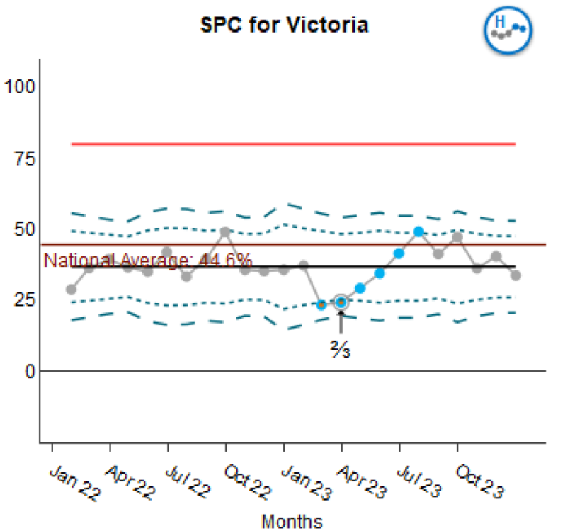

Adapted from an unpublished report created by ANZELA-QI and the Western Australia Department of Health. Blue dots indicate favourable. The solid red line indicates the target rate, the brown solid line indicates the national average rate, whereas the black solid line indicates the Victorian average rate. The 2 dotted lines indicate the national upper and lower warning (95%) and control (99.8%) limits respectively.

For this period, only 22.8% of patients aged over 65 years in Victoria are assessed by a specialist in geriatric medicine (a geriatrician). While this is higher than the national average of 20.7%, it is concerningly low (Figure 3B) and well below the target of 75%. This shortfall may be due to organisational factors and resource constraints. It is important to note that the input of geriatricians, particularly in procedures such as total hip replacement for hip fracture patients, significantly improves perioperative outcomes. Therefore, Victorian healthcare services must prioritise increasing specialist involvement in surgical decision making.

Figure 3B: Proportion of patients age ≥ 65 years assessed by a specialist in elderly medicine in Victoria

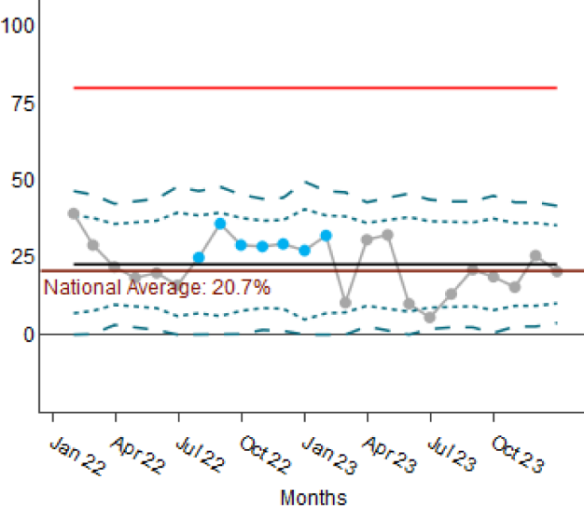

Adapted from an unpublished report created by ANZELA-QI and Western Australia Department of Health. Blue dots indicate favourable, whereas orange dots indicate unfavourable. The red solid line indicates the target rate, the brown solid line the national average, whereas the black solid line the Victorian average. The 2 dotted lines indicate the national’s upper and lower warning (95%) and control (99.8%) limit respectively.

### Conclusion

Participation in ANZELA-QI remains incomplete, with key performance indicators still unmet at both the national and state levels. The VPCC strongly recommends that hospitals performing emergency laparotomies, including private hospitals, take an active part in ANZELA-QI.

## Australian and New Zealand Hip Fracture Registry

by Marinis Pirpiris (VPCC deputy chairperson, SSC member)

Hip fractures remain a major public health concern, particularly among older people, leading to significant morbidity, mortality and healthcare system burden. In 2023, ANZHFR offers a comprehensive analysis of hip fracture care across Australia and New Zealand. It critically examines key findings from 2023, identifying strengths, ongoing challenges and the impact of standardised care pathways on patient outcomes. Drawing from data collected from 100 hospitals and 17,732 patients, the report highlights essential aspects of care, from preoperative assessments to postoperative recovery. It emphasises the importance of evidence-based protocols in optimising hip fracture management and improving patient outcomes.

In 2023, 14 out of 20 eligible public hospitals in Victoria, including a private hospital, took part in the ANZHFR, covering 2,743 patients out of the 3,894 hip fracture procedures recorded in the Victorian Admitted Episodes Dataset. Among the actively participating hospitals, 87% of cases were recorded in the ANZHFR. However, overall statewide coverage remained at 70% of cases. While it is encouraging that 2 more hospitals were in the process of obtaining governance approval to join the registry in 2023, further efforts are needed to engage the remaining hospitals and ensure comprehensive patient registration. Complete data collection is essential for hospitals to assess their performance and identify areas for improvement effectively.

The ANZHFR’s 2023 annual report highlights several positive and successful indicators in hip fracture care, as illustrated in Figure 4. The figure uses a colour-coded system: a green dot indicates improvement, a blue dot signifies no change, and a red dot represents a decline in performance. This visual representation provides a clear overview of trends in care delivery, helping to identify areas of progress as well as those requiring more attention.

Figure 4: Trends in hip fracture care performance indicators

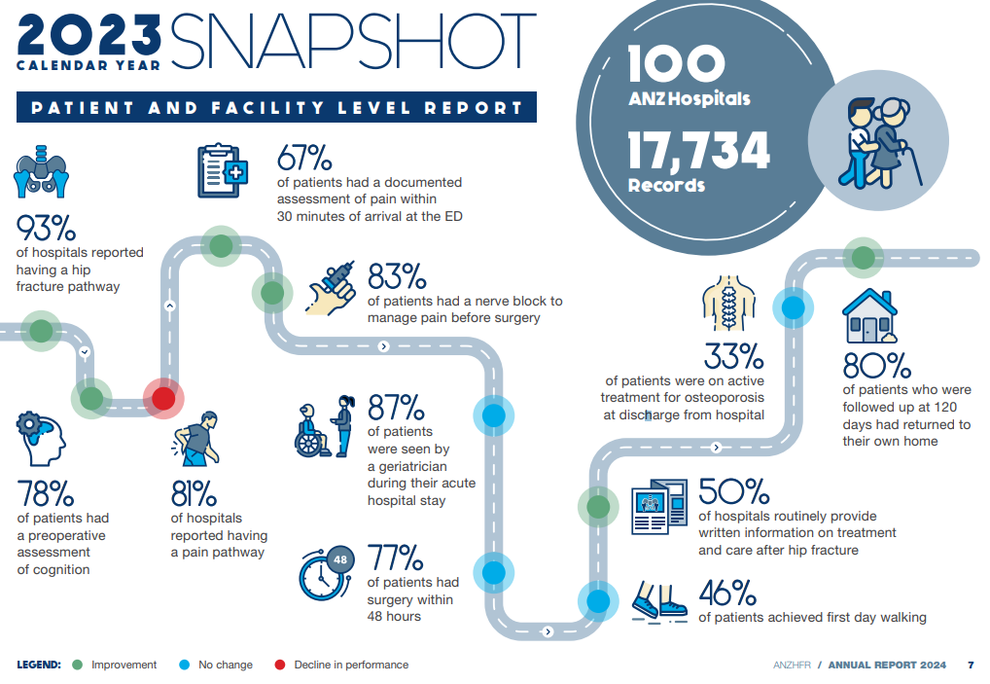

A green dot indicates improvement, a blue dot signifies no change, and a red dot represents a decline in performance.

Adapted from the ANZHFR annual report.7

Beyond evaluating adherence to national clinical care standards, the report also highlights persistent regional disparities in care delivery. It also emphasises the need for enhanced coordination and the sharing of best practices to ensure all patients receive high-quality, timely and equitable care.

#### Key findings and improvement opportunities

The ANZHFR provided the following insights into where the healthcare system can leverage opportunities to improve care to patients.

#### 1. Regional disparities and the need for standardisation

About 76% of patients underwent surgery within 48 hours of admission (Figure 5). There are significant regional variations, with the percentage of patients receiving surgery within 48 hours varying from 70% to over 90% across different hospitals. These inconsistencies in care delivery emphasise the need for standardised national guidelines. The variation suggests that hospitals with lower compliance rates could improve by adopting best practices from higher performing institutions. The ANZHFR report calls for consistent national protocols to reduce these discrepancies and ensure all hip fracture patients have equitable access to timely surgery and high-quality care.

Figure 5: Surgery conducted within 48 hours for patients presenting to a hospital with a hip fracture, Australia

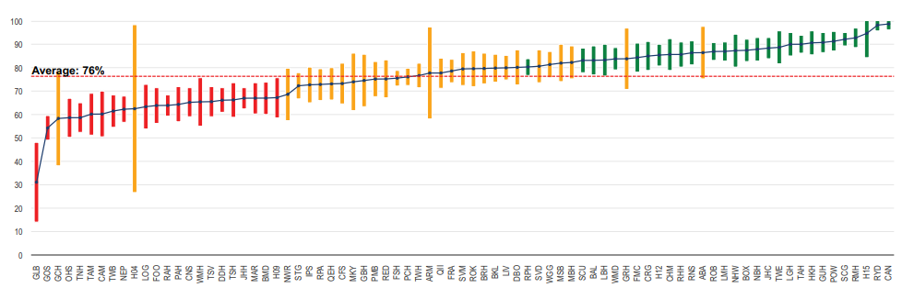

Adapted from the ANZHFR annual report.6.

#### 2. Timeliness of surgical intervention and direct oral anticoagulants management

Although timely surgery is critical for reducing mortality and complications, delays are still a challenge. The primary causes of surgical delays were theatre unavailability (34%), medical instability (25%) and anticoagulation management (10%) (Figure 6).

While little improvement has been made from the previous year, it is important to note that the Australian Commission on Safety and Quality in Health Care recommends surgery within 36 hours.

Regarding direct oral anticoagulant management, the ANZHFR report cites UK evidence suggesting that surgery on patients taking direct oral anticoagulants without prolonged delays can be safe. Therefore, developing clear, standardised guidelines for anticoagulation management in hip fracture patients could help reduce delays and improve outcomes, particularly for those at higher risk of complications.

Figure 6: Reasons for hip fracture surgical delays exceeding more than 48 hours

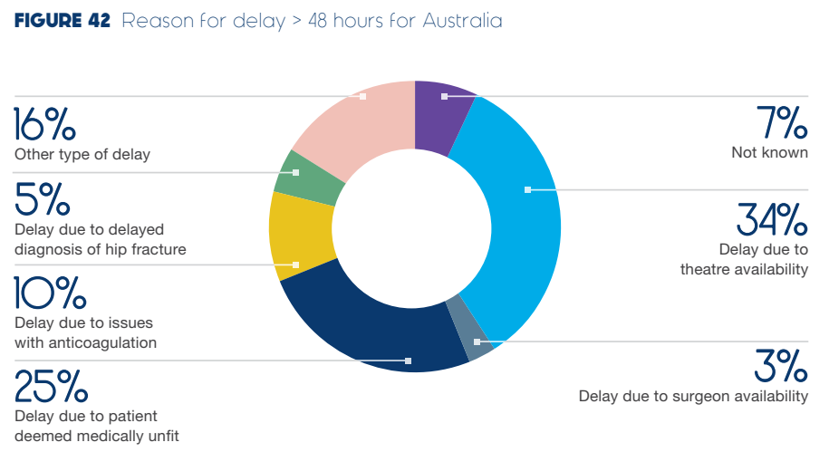

Adapted from the ANZHFR supplementary e-report.7.

Overall, improving theatre access and streamlining anticoagulation management are key to meeting this standard and enhancing patient outcomes.

#### 3. Multidisciplinary care

About 87% of patients were managed by a multidisciplinary team during their admission (Figure 7). The involvement of this team, which typically includes orthopaedic surgeons, geriatricians, anaesthetists, physiotherapists and other allied health professionals, is linked to improved patient outcomes. The orthogeriatric model of care has shown positive results such as:

* reduced mortality rates
* faster recovery times
* better management of older patients’ overall health needs.

Figure 7: Data illustrating the overall percentage of patients with a hip fracture assessed by geriatric medicine during their acute admission, Australia

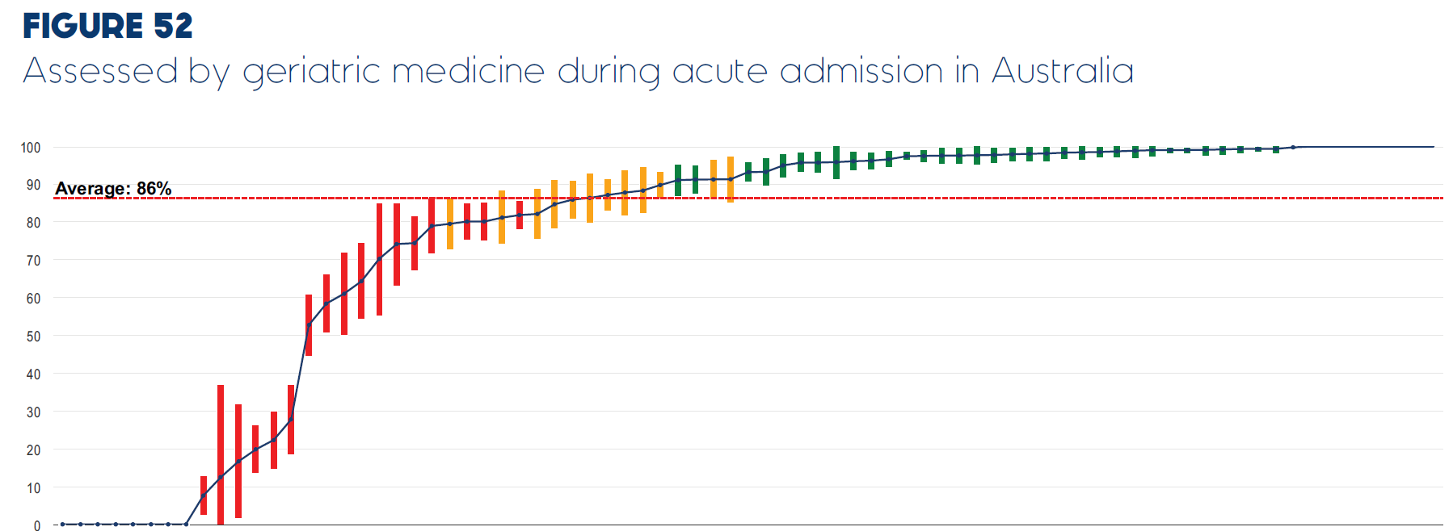

Adapted from the ANZHFR supplementary e-report.7.

Geriatric medicine assessment in Victoria has varied over the past few years, highlighting the need for improvement to ensure better patient care (Figure 8). A more coordinated, team-based approach, especially for complex cases with multiple comorbidities, would be essential in addressing this gap.

Figure 8: Data illustrating the overall percentage of patients with a hip fracture who had a geriatric medicine assessment during their acute admission, Victoria

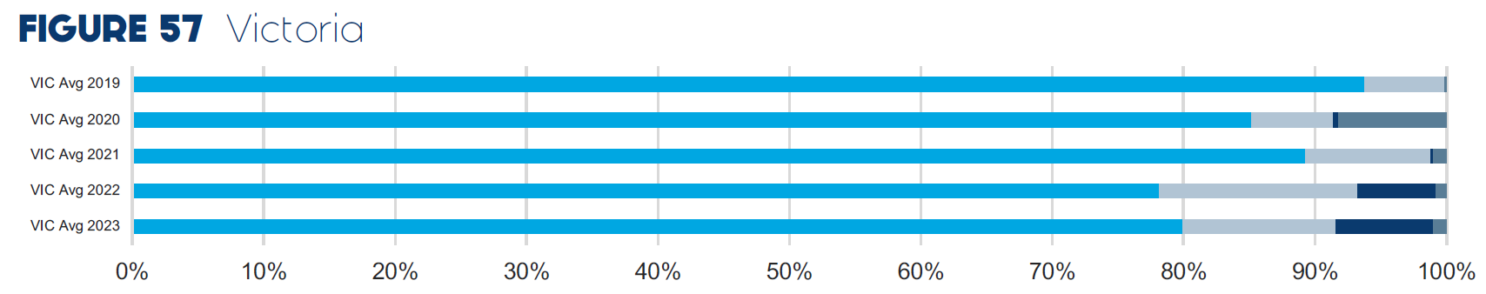

Figure legend. Refer to Appendix 6 for a description of this figure.

Adapted from the ANZHFR supplementary e-report. 7.

#### 4. Focus on secondary prevention of osteoporosis

Only 32% of patients were receiving active osteoporosis treatment at discharge (Figure 9). This low rate of osteoporosis management represents a missed opportunity for secondary prevention. As a major risk factor for hip fractures, untreated osteoporosis greatly increases the risk of future fractures. The report advocates for routine screening and treatment protocols for osteoporosis, particularly in older patients, to reduce the risk of recurrent fractures and alleviate the long-term healthcare burden.

Figure 9: Data illustrating the overall percentage of patients with hip fracture receiving bone protection medication on discharge, Australia

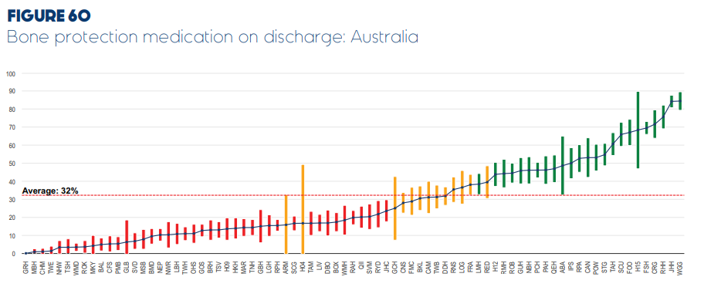

Adapted from the ANZHFR supplementary e-report. 7.

#### 5. Individualised patient care plans

About 50% of patients received personalised information on fall and fracture prevention (Figure 10). Delivering individualised care plans, including strategies for fall prevention and fracture risk reduction, has gradually increased over the past 5 years. However, the report stresses the need for further efforts to ensure all patients receive tailored prevention strategies. These are essential for long-term health and reducing the risk of future fractures.

Figure 10: The overall proportion of hospitals providing individualised written information on preventing future falls and fractures, Australia and New Zealand

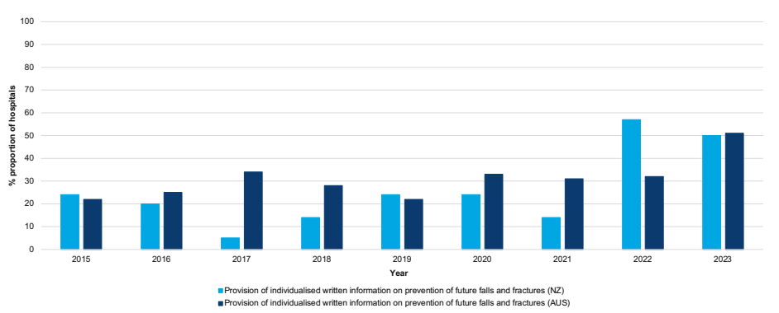

Adapted from the ANZHFR annual report 7.

#### 6. Sip Til Send and fasting protocols

An unpublished pilot project at Prince of Wales Hospital (New South Wales) showed a reduction in fasting times from 671 minutes to 128 minutes by introducing the ‘Sip Til Send’ protocol. Prolonged fasting is a common issue for patients awaiting hip fracture surgery, often leading to patient discomfort and potential complications. Sip Til Send allows patients to sip clear fluids until they are sent to the operating theatre, reducing the duration of fluid fasting before surgery while maintaining a 6-hour food fasting period.

The success of the Sip Til Send protocol at Prince of Wales Hospital highlights the potential benefits of reducing fasting times in other institutions. Broader implementation of such protocols could improve patient comfort, reduce perioperative complications and ultimately enhance surgical outcomes. It is noted that SCV has subsequently supported [Sip Til Send](https://www.safercare.vic.gov.au/best-practice-improvement/clinical-guidance/non-urgent-elective-surgery/sip-til-send-fluid-fasting) <https://www.safercare.vic.gov.au/best-practice-improvement/clinical-guidance/non-urgent-elective-surgery/sip-til-send-fluid-fasting> in appropriate patients.

#### Conclusion

The ANZHFR annual report underscores ongoing advancements in hip fracture care across Australia and New Zealand, driven by evidence-based practices, multidisciplinary care models and a stronger emphasis on timely surgical intervention. However, challenges persist, including regional disparities, inconsistencies in anticoagulation management and gaps in osteoporosis treatment and secondary prevention. Addressing these issues will require a concerted effort from clinicians, hospitals and policymakers. By standardising protocols and promoting best practices across all healthcare settings, there is a significant opportunity to enhance patient outcomes, particularly as the ageing population leads to a rising incidence of hip fractures.

# Perioperative morbidity – sentinel events

by Andrew Jeffreys (VPCC member)

A sentinel event is ‘an unexpected and adverse event that occurs infrequently in a health service entity and results in the death of, or serious physical or psychological injury/harm to a patient as a result of system and process deficiencies at the health service entity’.8 In Victoria, category 11 exists to include ‘All other adverse patient safety events resulting in serious harm or death’. This differs from other states (Appendix 5).

Serious harm, on the other hand, is considered to have occurred when, due to a serious adverse patient safety event, a patient has either:

* required life-saving surgical or medical intervention
* a shortened life expectancy, or
* experienced permanent or long-term physical harm, or experienced permanent or long-term loss of function.

In 2023 the VPCC reviewed 63 sentinel event reports, mostly related to perioperative care (Figure 11). This was up from 39 the previous year. This increase is attributed to improvements in triage and referral processes, with most cases being category 11. The chair of the SSC and/or ASC reviewed these referrals, identifying and reporting key themes presented in their reports above.

Figure 11: The grouping of the 63 sentinel event reports reviewed by the VPCC

## Sentinel events: categories 1–10

Twelve reports were classified under one of the 10 primary Australian Commission on Safety and Quality in Health Care sentinel event categories, including 3 deaths (Table 2). The remaining cases involved varying degrees of serious harm, as defined above.

Table 2: The category, number of cases and outcome of the sentinel events classified within categories 1–10

|  |  |  |
| --- | --- | --- |
| Category | N | Outcome |
| Category 1: Wrong site  Femoral venous line incorrectly sited in the femoral artery | 1 | Surgical remediation |
| Category 3: Wrong procedure  Incorrect level cervical discectomy; reoperation required | 1 | Surgical remediation |
| Category 4: Unintended retention of a foreign object  Retained pack/swab  Retained PEG tube component and small bowel perforation | 2  1 | Surgical remediation  Death |
| Category 7: Medication error  Venous thromboembolism (VTE) prophylaxis error  VTE prophylaxis error  Insulin dosage error  Analgesia and pain-related respiratory depression  Muscle relaxant reversal error – neostigmine overdose  Drug administered with known allergy | 1  2  1  1  1  1 | Significant medical intervention  Death  Significant medical intervention  Death  Significant intervention  Significant medical intervention |

## Sentinel events: category 11

SCV uses category 11 for all other patient safety events leading to serious harm or death. Of the 63 perioperative care–related reports, 51 were category 11 events, with death recorded as the outcome in 22 cases. The VPCC identified several themes during analysis, including:

* delay in diagnosis
* delay in care
* missed diagnosis
* errors in communication.

In some cases, delays in obtaining and reviewing pathology and imaging results contributed to worse outcomes and psychological distress for patients due to the loss of opportunity for earlier intervention. Contributory factors included systemic communication failures and misalignment of review appointments and result availability.

**Case study**

During the course of reviewing the patient’s results the treating team discovered that a poorly differentiated adenocarcinoma had been reported on a biopsy performed 6 months previously. This was a missed result. The patient was informed and referred to an oncologist, but the cancer had progressed to a stage 4 diagnosis and the patient died 5 weeks later.

As in past reports, the VPCC noted that category 11 reports often described complex chains of events involving multiple teams caring for critically unwell patients and/or those undergoing high-risk surgeries or procedures.

The VPCC also highlighted the importance of systematically analysing such events to improve future care. These lessons are valuable to the broader healthcare sector because systemic issues can often be identified even when the outcome is satisfactory.

**Case study**

A 14-year-old patient suffered a massive haemorrhage 9 hours after an uneventful tonsillectomy and adenoidectomy. He was taken back to theatre but rapidly deteriorated and suffered a hypovolaemic cardiac arrest soon after anaesthetic induction. He responded to a brief period of advanced life support and circulatory parameters returned towards normal with ongoing fluid and blood product resuscitation. The source of bleeding was identified, haemostasis was achieved, and he was transferred to a paediatric tertiary hospital. He was extubated later that day and discharged home 5 days later.

The care provided by the anaesthetic, surgical and perioperative nursing teams was excellent, and there is no doubt that a young life was saved. However, the analysis revealed systemic issues that caused unnecessary delays and significantly added to the stress experienced by the treating team, as well as to the patient and her family. These included:

* lack of clarity about when to activate a Medical Emergency Team call
* communication issues with the on-call theatre team
* unfamiliarity with the process of urgently opening a theatre after hours, including the location of keys and equipment.

In response, the organisation developed and implemented recommendations to address these issues, enabling an improved response to rare, time-critical postoperative events to be executed in the future.

# Perioperative mortality: Victorian Audit of Surgical Mortality report

by Philip McCahy (VASM Clinical Director, VPCC member)

The initial analysis of the 2022–23 Victorian mortality data reveals a slight increase (5.5%) in the number of reported surgical deaths (1,832 vs 1,736). Alongside this, there has been a positive increase in the number of cases that have completed the surgical case assessment form (57.6% vs 40.8%), accompanied by a reduction in cases pending submission or assessment. This improvement is likely linked to the return to pre-COVID working patterns and the increased publicity surrounding changes to RACS continuing professional development requirements. The median delay in notifying deaths was 32 days, while the median time for surgical case form completion by the surgeon was 82 days. Changes in workflow and policy will be implemented by VASM to move it closer to real-time reporting so notifications of patient deaths and submitting the surgical case form can be completed within the recommended 30 and 60 days respectively.

Peer review of cases found no issues in 78.3% of cases, which is consistent with previous years. The least concerning classification (area of consideration) was reported in 12.2% of cases, while an area of concern was reported in 4% and an adverse event in 5.5%. This represents a continued downward trend over the past 5 years (11% reported in 2019). Of the reported clinical management issues (CMI), 52.4% were considered preventable, with 14 cases (6.1% of CMI) where CMIs were identified as significant contributors to a patient’s death.

VASM has also conducted a detailed analysis of the audited cases from 1 July 2022 to 30 June 2023 (Figure 12). These data are reviewed by the VPCC through the conjoint Perioperative Mortality Committee and further analysed by VASM before being compared against national data. The findings will be included in the VASM 2023 report.

Figure 12: Audited data from VASM’s 1 July 2022 to 30 June 2023 unpublished report, presented into demographic, risk and key findings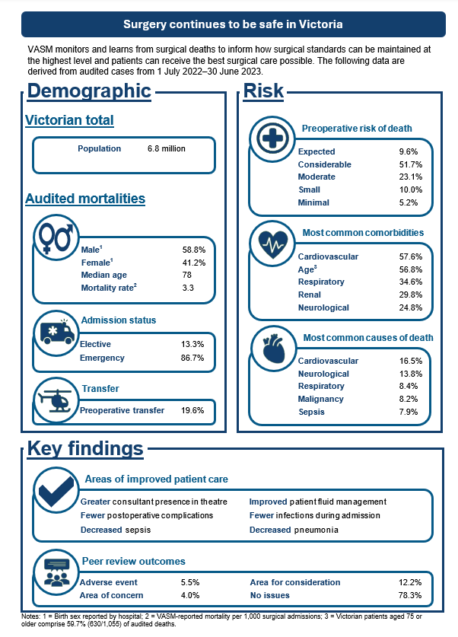

## Perioperative Mortality Committee

VASM’s Perioperative Mortality Committee was established in 2021 after Commonwealth legislation on ‘qualified privilege’ was adjusted to allow VASM data to be shared with the VPCC. The committee includes:

* a consumer representative
* the chairs of the VPCC and the surgical and anaesthetic subcommittees
* a geriatrician
* other ad hoc specialists as needed
* the VASM Clinical Director
* support staff from both the VPCC and VASM.

It reviews VASM cases deemed preventable, those that may benefit from multidisciplinary assessment, or cases related to anaesthesia.

In 2023, 64 cases were triaged, with 11 referred to the SSC and 11 to the ASC. Also, 22 cases were set aside for noting, such as those involving fractured neck of femur, with no other action required for the remaining case.

The Perioperative Mortality Committee has facilitated a successful multidisciplinary review of surgical deaths, enabling SCV, through VPCC, to access potentially preventable cases that would otherwise go unreported or only be identified after a coronial review. No other state has a similar government–regulatory–clinical interface, generating significant interest from other jurisdictions in the Victorian model. From a surgeon’s perspective, VASM processes remain unchanged, and there has been no breach of previously considered privileged information.

# Victorian Institute of Forensic Medicine and the Coroners Court of Victoria

by Hans de Boer (VPCC member)

The VIFM is a statutory agency that serves the community and the courts by providing expert opinions. This helps reduce preventable deaths and promotes public health and safety. The institute also engages in research, education and training for medical and legal professionals.

VIFM’s primary role is to provide expert services in forensic pathology, clinical forensic medicine and related disciplines. Its main stakeholder is the Coroners Court of Victoria (CCoV), to which it offers medical expertise for investigating deaths under coronial jurisdiction (‘reportable deaths’). Other key partners include:

* Victorian courts
* Victoria Police
* Monash University
* the University of Melbourne
* the Australian Federal Police
* legal and medical professionals
* public and private hospitals.

As outlined in the *Coroners Act 2008* (Vic), a wide range of deaths must be reported to the Coroner as soon as possible. This includes all deaths that are unnatural or unexplained. These cases are referred to VIFM, where the forensic pathology department examines deaths resulting from homicides, accidents, suicides and natural causes when the initial cause of death is unclear. In 2023, VIFM investigated about 7,100 deaths.

Deaths reportable to the CCoV explicitly include those occurring during a medical procedure and those following a procedure, where the fatal outcome was not reasonably expected. All such perioperative deaths are examined by VIFM pathologists to determine the medical cause of death and assess whether human or systemic factors contributed to the outcome.

## Examination of perioperative deaths at VIFM

VIFM is a world leader in researching and developing ancillary techniques that complement invasive autopsy procedures. Advanced techniques employed at VIFM include full-body CT scanning, rapid screening toxicological analysis, a wide range of biochemical analyses and targeted post-mortem angiography. In 2025 MRI imaging will be added to its diagnostic capabilities. The availability of these advanced techniques means that not all examinations require a full autopsy. In some cases, examinations may be limited to a specific anatomical region, and in certain instances, an autopsy can be avoided entirely.

The coroner is solely responsible for determining the extent of a postmortem examination. However, this decision is typically preceded by a case discussion with a VIFM forensic pathologist who has conducted a preliminary assessment of the deceased. This assessment includes:

* reviewing medical records
* performing an external and radiological examination
* gathering information from the next of kin.

VIFM ensures cultural and religious beliefs are respected and provides an opportunity for families to express concerns about the medical care received by the deceased.

For hospital deaths, medical practitioners complete the E-Deps form, where they can specify aspects of the postmortem investigation they would like addressed. This information is crucial in guiding the examination and identifying relevant issues, but the quality of information provided varies significantly.

## Collaboration between VIFM and VPCC

Effective collaboration is essential for improving patient safety and healthcare outcomes. The VPCC works closely with the CCoV and VIFM, using their data for individual case reviews and broader trend analysis to identify key learning opportunities. To enhance data interpretation and sharing, a forensic pathologist from VIFM sits on both the VPCC and its ASC, providing expert insights and facilitating collaboration.

VIFM automatically refers most perioperative deaths occurring in hospitals to the VPCC. Also, to ensure comprehensive case review, VIFM also refers all deaths following an anesthetic procedure. In 2023, 861 cases were referred to the VPCC, where they were triaged for discussion within the VPCC’s subcommittees, ensuring significant cases received a detailed review.

Added to the referrals already mentioned, VIFM identifies and refers perioperative deaths occurring after hospital discharge to the VPCC. Since these deaths are not always reported back to the treating hospital, they represent a potential gap in health system reporting and learning. In 2023 VIFM referred 31 such cases to the VPCC. While most were ultimately unrelated to surgery, key quality themes emerged, including the risks of post-discharge pulmonary thromboembolism and postoperative hemorrhage. Also, preliminary data indicated a heightened risk of sudden cardiac death in the postoperative period, highlighting the need for more analysis (Figure 13).

Figure 13: Themes from the 31 cases referred to the VPCC

Some of the key highlights of our collaboration is the ability to identify recurring patient safety concerns and drive system-wide improvements. First, the CCoV identified a case in which a fatal stroke occurred due to the inadvertent arterial placement of a CVC. The VPCC, having observed similar incidents, provided guidance to SCV based on ASC recommendations to improve placement of CVCs (Appendix 3).

Second, through the referral of perioperative deaths occurring after hospital discharge, PE has been identified as a significant cause of mortality. In response, the VPCC, in collaboration with SCV, is conducting another review of the effective implementation of thromboprophylaxis guidelines. The findings will be presented in the 2024 report.

Last, the VPCC has identified considerable variability in the quality of E-Deps forms completed by junior doctors across the state. Inconsistent and inaccurate reporting can have a negative impact on data accuracy, hindering efforts to identify system-wide improvements in perioperative care. In response, the VPCC plans to work with CCoV and VIFM to enhance E-Deps data quality. This initiative aims to standardise reporting processes, improve data reliability and support better-informed decision making across the healthcare system.



# Projects with Safer Care Victoria and the Department of Health

## Perioperative Learning Health Network

by David Watters (PLHN chairperson, SCV Director of Surgery)

SCV established the PHLN in mid-2022 to support and inform the Department of Health’s Surgical Recovery and Reform Program, with this report covering activities conducted in 2023. The PLHN formed an expert advisory group with perioperative representatives from across the sector, including members of VPCC and its subcommittees. Short-term working groups were also created to provide advice on specific recovery and reform opportunities.

In 2023 the Department of Health published its *[Planned surgery reform blueprint](https://www.health.vic.gov.au/planned-surgery-reform-blueprint)* <https://www.health.vic.gov.au/planned-surgery-reform-blueprint>. This included a shift in terminology, changing ‘elective surgery’ to ‘planned surgery’ and ‘waiting list’ to ‘preparation list’. This shift underscores that planned surgery is still crucial and necessary, while also recognising the pre-surgery period as an opportunity to explore alternatives and improve patients’ conditions through prehabilitation and/or optimising comorbidities.

Throughout 2023, the PLHN provided reports to the Surgical Recovery and Reform Program and led a series of webinars focusing on:

* increasing day surgery
* implementing strategies for high-intensity or high-throughput theatre lists
* advising on improving theatre efficiency and activity
* enhancing recovery after surgery programs.

## Quality and Safety dashboard

VAHI developed a Quality and Safety dashboard to complement the planned surgery activity dashboard. This dashboard tracks key surgical outcomes following both planned and emergency surgeries, providing essential data for monitoring the safety and quality of services across Victoria. It represents a world-first advancement, offering near real-time data on surgical outcomes. The dashboard also allows healthcare services to compare their performance with peers in various areas, including:

* unplanned readmissions within 48 hours and 28 days
* unplanned emergency department visits within 28 days
* major medical complications (such as myocardial infarction, PE and cerebrovascular accident [stroke]) within 30 days of surgery (including after discharge and readmission to any campus)
* days spent at home within 30 days of the index procedure
* mortality rates within 30, 90 and 365 days of the index procedure.

EL provides a useful example (Figure 14). In 2023 about 160 emergency laparotomies were performed in Victoria each month, totalling nearly 2,000 cases for the year. However, these figures rely on the accuracy of data coding and may not fully account for all emergency, unplanned returns to the operating theatre or expedited surgeries performed on planned surgery lists.

## Other activities

The Director of Surgery at SCV has maintained active participation in and support for the VPCC and its subcommittees. This involvement includes:

* screening sentinel events
* representing Victoria on the ANZELA-QI (Emergency Laparotomy Registry)
* promoting regional perioperative clinical governance
* supporting the Getting It Right First Time (GIRFT) pilot project in the Hume region.

Figure 14: An example of the Surgery Quality and Safety dashboard showing graphs of the major medical complication rates following emergency laparotomy, myocardial infarction, pulmonary embolism and stroke

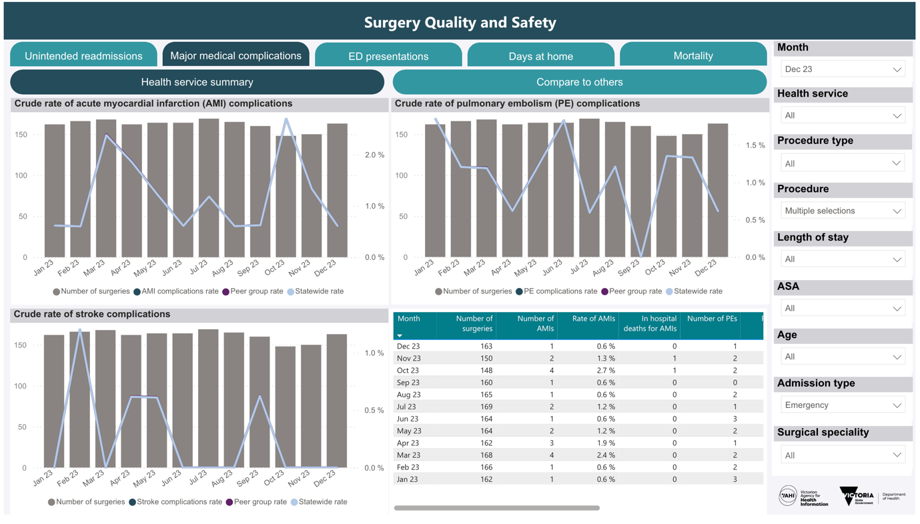

The right-hand column of the dashboard allows users to apply filters to search by specific dates, individual healthcare services, procedures, anaesthetic risk (ASA), age range, admission type (emergency or planned) or surgical specialty. The rates of these complications are displayed on the graph. The bottom right-hand table can be expanded to tabulate the PE and stroke data.

## Getting It Right First Time initiative

by Marinis Pirpiris (VPCC deputy chairperson, SSC member)

The GIRFT initiative, which originated in the UK, is designed to improve medical care within the NHS by reducing unwarranted variations in clinical practice and outcomes. One of its major successes has been reducing the cost of orthopaedic implants, such as hip and knee replacements, without compromising patient care. This was accomplished by standardising procurement practices and leveraging bulk purchasing. Standardisation of clinical practices has resulted in faster recovery times and reduced length of stay post-surgery, enabling better allocation of staff and beds. GIRFT has also led to a decrease in complications, like infections, and has lowered readmission rates, resulting in substantial cost savings, driven by fewer extra surgeries, extended hospital stays and treatment costs. The initiative has also optimised the use of surgical theatres and hospital resources by streamlining orthopaedic procedures with better scheduling, fewer cancellations and more efficient operating time. These savings have been reinvested into other areas of patient care, ultimately improving the overall quality and efficiency of NHS services.

The success of the GIRFT initiative has attracted international interest, leading to adaptations in healthcare systems around the world, including in Australia. In Victoria, the GIRFT program has been adopted as a Victorian Managed Insurance Authority–funded pilot project in the Hume region. This project aims to enhance clinical outcomes, improve patient safety and optimise resource use, particularly in the perioperative setting. The Hume region, which includes both rural and regional communities, faces unique challenges in delivering consistent, high-quality care, especially in specialised areas like orthopaedic surgery and perioperative care. Initial participants in the program included Northeast Health Wangaratta, Goulburn Valley Health, Albury Wodonga Health and Kyabram District Health Service. The region’s diversity presents specific obstacles to ensuring equitable care across all healthcare services.

To monitor the successes of the GIRFT program in the participating hospitals, a Victorian orthopaedic clinical leadership group identified a series of parameters. These parameters were based on data from the ANZHFR, the Australian Orthopaedic Association National Joint Replacement Registry, VAHI and local hospitals.

## Successes in the Hume region

**Tailored implementation:** Adapting the program to the local context has been essential. By offering flexible guidelines that meet the varying needs of healthcare providers in the Hume region, GIRFT is effectively addressing the challenges of delivering consistent, high-quality care in rural and regional communities.

**Strong leadership and collaboration:** Leadership and collaboration among local healthcare providers, especially clinical leaders, have been key to the initiative’s success. Their dedication has driven the program forward, fostering a culture of continuous improvement and quality care.

**Data-driven decision** **making:** GIRFT’s use of data to pinpoint areas for improvement and track progress has been critical to its success. This evidence-based approach has enhanced the quality of care and increased clinician engagement by ensuring decisions are based on actionable insights.

**Focus on perioperative care:** The program’s focus on perioperative care has led to significant improvements in patient outcomes, such as fewer surgical complications, shorter hospital stays and better resource use. This focus has been particularly beneficial in areas with limited access to specialised care.

#### Challenges and considerations

**Cultural shift:** Implementing GIRFT’s recommendations requires a shift towards a culture of continuous quality improvement, which can be difficult in established systems.

**Patient-centred care versus standardisation:** While standardisation improves efficiency, there are concerns it may neglect individual patient needs, potentially resulting in suboptimal care.

**Sustainability:** The long-term success of GIRFT hinges on sustaining changes in clinical practice, which demands ongoing monitoring and adequate resources, posing challenges in resource-limited areas.

#### Conclusion

The GIRFT program in the Hume region represents a significant step towards improving healthcare quality and efficiency. It has provided a framework through which improvements in the quality, equity and cost of patient-centred care can be achieved. Despite challenges, the tailored program implementation, strong leadership and data-driven approach have yielded positive outcomes. Ensuring the sustainability of these improvements while maintaining a balance between standardisation and patient-centred care will be crucial for the program’s continued success.

# Perioperative care

### by Dr Margot Lodge (SSC member)

In 2023 there was increasing recognition of the need for care models that proactively identify and manage patients at higher risk for adverse perioperative outcomes. As a multidisciplinary perioperative team, we acknowledge the importance of optimising factors like frailty, multimorbidity, cognitive impairment and disability to improve outcomes. A specialised, comprehensive approach tailored to support complex shared decision making is now necessary for this optimisation. This process should start early in the patient’s clinical pathway to ensure patient-centred decision making includes a discussion about options (for example, no surgery or type and extent of surgery) and expected outcomes.

## Comprehensive geriatric assessment

There is strong evidence supporting the role of geriatricians and comprehensive geriatric assessment (CGA) in perioperative care for older patients. CGA has been shown to be clinically and cost-effective in both planned and emergency settings. It is recommended in various national and international guidelines, such as the ANZCA *Perioperative care framework* and the Australian and New Zealand Society for Geriatric Medicine’s *Perioperative care of older people position statement*. CGA is foundational to the orthogeriatric model of care, and geriatrician involvement is now part of the Australian Commission on Safety and Quality in Health Care’s Hip Fracture Clinical Care Standard9 and the ANZELA-QI key performance indicators.

Despite the acknowledged clinical need, there remains a gap in implementing evidence-based, best-practice perioperative care for older patients. Professional organisations and clinical champions are working to address this gap. ANZCA is leading efforts to promote a holistic perioperative pathway, while the Australian and New Zealand Society for Geriatric Medicine and the Internal Medicine Society of Australia and New Zealand are advocating for improved care at the societal level. Clinicians are championing best practices and striving for optimal patient outcomes. To close this gap, these efforts must be supported by a systems-level approach to implementing evidence-based care models, requiring support, resources and advocacy across various sectors. Implementation science and innovative research methodologies will be essential in achieving this goal.

#### Case study: Complex decision making

Bill, an 83-year-old man, lives at home with his wife, Elaine. He was diagnosed with bowel cancer following a routine colonoscopy and is being considered for colorectal surgery to remove the cancer. Bill also has severe aortic stenosis, heart failure and type 2 diabetes. Over the past few years his frailty has increased, and he now relies more on Elaine for assistance with day-to-day tasks, such as taking medications, preparing meals and supervising his showering and dressing. Bill’s memory and cognition has been declining over the past 5 years, and Elaine suspects he may have some degree of dementia.

Bill was seen in a preoperative shared decision-making clinic by the perioperative multidisciplinary team. This team included a surgeon, anaesthetist, geriatrician, pharmacist and perioperative nurse. Together, this team worked closely with Bill and Elaine to understand his values and preferences. Bill really valued living in his own home and preserving his independence as much as possible. Also, the team communicated the risks of surgery to Bill and Elaine, including complications related to his heart, delirium, long-term decline in independence and the need for a stoma.

After careful consideration, Bill and Elaine decided that surgery was not the right option for him. They felt the risks of surgery outweighed the benefits and chose to focus on optimising Bill’s quality of life and supporting him to live at home. The perioperative team referred Bill to a geriatrician for ongoing care in the community and discussed the need for an advance care directive and future palliative care.

# Perioperative nursing

by Elyse Coffey (VPCC member), Paula Foran (VPCC member)

The perioperative pathway of patients involves significant interaction with skilled nursing staff across various roles, including in the emergency department, post-anaesthesia care unitand hospital wards. Nurses are responsible for monitoring for potential deterioration and providing support in the operating room to ensure safe outcomes for anesthesia and surgical teams. The VPCC has included perioperative nursing representatives who contribute valuable insights during reviews of perioperative events. The following key themes were identified in 2023.

## Retained surgical items

Retained surgical items remain a reported issue. According to a large Australian study,10 poor adherence to current standards and guidelines is a major contributing factor. The Australian College of Perioperative Nurses provides evidence-based standards and guidelines for managing the surgical count process. Perioperative nurses and hospitals should follow these guidelines to minimise the risk of retained surgical items.

**Case study: A lesson in diligence – managing accountable items**

Jane, a 32-year-old female with a BMI of 40, was admitted for a laparoscopic cholecystectomy. However, due to excessive bleeding obstructing the surgical view, the procedure was converted to an open cholecystectomy.

One week after discharge, Jane developed redness at the surgical site and a fever of 38°C. Feeling extremely unwell, she presented to an emergency department at a different hospital closer to her home.

X-ray imaging revealed findings of a large abdominal collection and a single surgical (Raytec) gauze (not related to the collection). Emergency exploratory laparotomy was arranged. During the exploratory laparotomy, a large abscess was discovered, which contained an abdominal pack. The pack was removed, and the abscess was washed out. The separate single Raytec gauze was also found and removed. Due to the risk of sepsis, the patient was started on intravenous antibiotics and admitted for overnight observation. She spent an extra 4 days in hospital before being safely discharged home. There were no long-term effects.

Perioperative nurses are reminded to exercise diligence when:

* separating surgical gauze and packs while counting in – especially if there are more than routine expected numbers
* documenting during a case – failing to update the count sheet with subsequent items can cause discrepancies
* counting out process – to ensure all accountable items are removed.

All operating room personnel are also reminded to minimise distractions, such as noise and production pressure, during this critical task.

## Delayed diagnosis of spinal cord neurology

Clinical observations are critical for identifying unexpected changes or deterioration in a patient’s condition. These include neurological status, accurate documentation and timely escalation of care. Due to reports of delayed recognition and management of spinal cord injuries, it’s important to emphasise the need for continuous, high-quality neurological monitoring in emergency department and postoperative care. This is particularly the case in patients who may have communication difficulties and also after spinal surgery or central neural blockade.

## Post-anaesthesia care unit escalation of care

PACU nurses must be vigilant and escalate care promptly when signs of patient deterioration occur. In situations where escalation is delayed, such as when the anaesthetist is engaged in another case, a clear hospital policy should ensure an alternative medical opinion can be promptly sought.

## Goals of care during surgery

For patients with advance care plans, reassessing their needs in consultation with the perioperative multidisciplinary team at the time of surgery has proven successful. Nurses play a vital role in providing ongoing support and clear communication to patients and families, ensuring care goals are met and understood.

# Report summary

**1. Develop and provide guidance to healthcare providers on reducing vascular-related procedural complications associated with central venous line insertion and removal**

**Outcome:** Recommendations (Appendix 3) were made to CCoV and ANZCA to develop guidelines in this area, noting that these cases are mostly vascular injuries, often with significant consequences.

**Recommendation:** Central venous catheterisation should only be undertaken by, or under the direct supervision of, an appropriately trained and credentialled practitioner. Guidelines/protocols and training for CVC insertion should include steps to verify that the correct vessel has been accessed. This should occur before vessel dilation occurs and before the definitive catheter or sheath is inserted (Appendix 3).

**2. Increase geriatricians’ extensive and consistent involvement in decision making and care planning for older surgical patients**

**Outcome:** For urgent or emergency procedures, the VPCC is advocating for a comprehensive and stronger engagement of healthcare services in ANZHFR and ANZELA-QI programs, where both emphasise the value of measuring and improving geriatric physician involvement.

**Recommendation:** Healthcare services should involve geriatricians and promote perioperative CGAs for high-risk patients or those having complex procedures. Healthcare services must also promote more multidisciplinary meetings to inform shared decision making for older patients.

**3. Improve identification of care delays and patient deterioration while awaiting surgery**

**Outcome:** The Department of Health through SCV has planned to launch the Urgent Concern Helpline, My Surgical Journey and the Surgical Recovery and Reform Program, all aimed at improvingcommunications between patients and hospitals while on the preparation list for planned surgery.

**4. Improve access to information on Open Disclosure and Statutory Duty of Candour to help patients and carers understand the processes when care does not go as expected**

**Outcome:** The SCV and VPCC websites will be refined for better usability by consumers, carers and families.

**5. Improve perioperative thromboembolic prophylaxis management**

**Outcomes:** SCV has published the [*Victorian guideline for the prevention of venous thromboembolism in adult hospitalised patients*](https://www.safercare.vic.gov.au/best-practice-improvement/clinical-guidance/venous-thromboembolism/victorian-guideline) <https://www.safercare.vic.gov.au/best-practice-improvement/clinical-guidance/venous-thromboembolism/victorian-guideline>. The VPCC continues to monitor and collaborate with CCoV in reporting fatal events.

**6. Ensure consistent assessment and documents of patient preferences, goals and values, particularly for those with advance care plans**

**Outcome:** TheVPCC will emphasise and address the significance of this topic in future workshops or symposium.

**7. Improve communication between clinical teams throughout the patient’s journey, particularly during patient transfers. This includes interhospital and unit-to-unit transfers**

**Outcomes:** Patient transfer information and revised guidelines from ANZCA, the Australasian College for Emergency Medicine and the College of Intensive Care Medicine of Australia and New Zealand for critical patient transport were considered during a previous VPCC workshop. The VPCC will address this topic in a future workshop or symposium.

**8. Develop a guideline for the timely identification and management of testicular torsion**

**Outcomes:** The VPCC and SCV advocated to RACS for all general surgeons and urologists to receive appropriate procedural training in the emergency management of testicular torsion. SCV has convened an expert working group to revise clinical guidelines, with the VPCC contributing.

**9. Recognise the development and progress of key healthcare quality and safety initiatives**

**Outcomes:** (i) The development of the Quality and Safety dashboard by VAHI, (ii) GIRFT project that is supported by the Victorian Managed Insurance Authority and (iii) the work of the PLHN including producing reports and a series of webinars focusing on increasing day surgery, implementing high-intensity throughput theatre lists, advising on improving theatre efficiency and activity, and enhancing recovery after surgery programs.

**10. Expand the VPCC’s scope to non-surgical interventional procedures**

**Outcome:** The VPCC is considering expanding our role to include interventional procedures performed outside the operating theatre and without direct surgical involvement. These procedures typically require anaesthesia or sedation, including structural heart interventions in cardiology laboratory, major interventional gastroenterology in endoscopy suites and interventional medical imaging procedures.

# Appendix 1: VPCC and subcommittee members

**VPCC members**

* David A Scott (Chairperson)
* Phillipa Hore (Deputy Chairperson)
* Marinis Pirpiris (Deputy Chairperson)
* Allison Evans
* Andrew Jeffreys
* Ben Slater
* Denice Spence (consumer representative)
* Fiona Brew
* Graeme Campbell
* Hans de Boer
* Liat Watson (consumer representative)
* Paula Foran
* Philip McCahy
* Rebecca Donald
* Wendy Brown

**Anaesthetic Subcommittee members**

* Ben Slater (Chairperson)
* Nam Le (ex officio – ANZCA VRC)
* Andrew Jeffreys
* Annette Holian
* Annie McPherson
* Craig Ironfield
* Graeme Campbell
* Hans de Boer
* Helen Roberts
* Hilary Madder
* Paula Foran
* Philip McCahy
* Pierre Bradley
* Sharryn McKinley
* Tim Coulson

**Surgical Subcommittee members**

* Wendy Brown (Chairperson)
* Matthew Hadfield (ex officio – VSC RACS)
* Allison Evans
* Denice Spence (consumer representative)
* Julian Smith
* Jennifer Reilly
* Liat Watson (consumer representative)
* Marinis Pirpiris
* Margot Lodge
* Michael Homewood
* Patrick Lo
* Phillipa Hore
* Rebecca Donald
* Susan Shedda
* Tony Gray

The work of VPCC would not be possible without the generous assistance of many individuals and organisations, as listed below, who provide vital information on perioperative care. We thank them for their continued support and diligence in providing us with information to improve perioperative care for all Victorians:

* healthcare services
* individual practitioners
* VASM
* CCoV
* VIFM
* SCV
* VAHI
* Department of Health
* Victorian State Committee, Royal Australasian College of Surgeons
* Victorian Regional Committee, Australian and New Zealand College of Anaesthetists.

The VPCC developed this report with support from the following SCV staff:

* David Watters
* Joanna Gaston
* Michelle Hawke
* Maryjane Tattersall
* Shirin Anil
* Erin Smith
* Ryan Hon.

# Appendix 2: Statutory Duty of Candour

Relevant health service entities are required to provide a patient with a Statutory Duty of Candour (SDC) when they have suffered a serious adverse patient safety event (SAPSE) while receiving healthcare. The SDC builds on the principles and elements of Open Disclosure within the *Australian open disclosure framework*, currently used for all cases of harm and near miss.

When a patient has suffered a SAPSE, the health service entity will be legally required to provide the patient or their next of kin or carer with:

* a written account of the facts regarding the SAPSE
* an apology for the harm the patient suffered
* a description of the health service’s response to the event
* the steps that the health service has taken to prevent the event reoccurring.

They will also be required to comply with any timelines and requirements set out in the Victorian Duty of Candour guidelines.

More information is on the [Safer Care Victoria website](https://www.safercare.vic.gov.au/report-manage-issues/sentinel-events/adverse-event-review-and-response/duty-of-candour) <https://www.safercare.vic.gov.au/report-manage-issues/sentinel-events/adverse-event-review-and-response/duty-of-candour>.

# Appendix 3: Recommendation – central venous catheter insertion

**Background**

Guidelines from the Australian and New Zealand Intensive Care Society (ANZICS) and others address the prevention of central line-associated infections. However, mechanical complications during central venous catheter (CVC) insertion remain a significant concern. These complications, often resulting from unintentional placement into an adjacent artery, occur with concerning frequency and are associated with substantial morbidity and mortality.

Despite the prevalence of these complications, there is limited robust evidence to guide safe practices, with most recommendations based on expert opinion. Experts suggest that ultrasound should be used whenever possible to guide percutaneous CVC insertion, and venous placement must be confirmed before dilatation and line placement.

**Assessment**

The VPCC and its Anaesthetic Subcommittee have reviewed multiple cases related to CVC insertion, highlighting the need for improved practices to enhance patient safety and reduce complications.

To ensure safe and accurate CVC placement, confirmation of venous cannulation must employ multiple strategies. These may include:

* evaluating the colour of aspirated blood
* measuring pressure from the insertion needle or cannula
* analysing blood gas samples from aspirated blood
* using ultrasound to visualise the wire within the vein lumen.

A credentialling process is also essential to ensure practitioners performing CVC insertions have adequate training and experience. Those without credentials must be supervised appropriately. Since CVC placement is performed by various medical specialties, any developed guidelines must include representation from all relevant stakeholders.

**Recommendations**

After careful consideration, the following recommendations for maximising correct vessel access during CVC insertion have been strongly endorsed by the VPCC:

* CVC insertion should only be undertaken by, or under the direct supervision of, an appropriately trained and credentialled practitioner.
* Guidelines/protocols and training for CVC insertion should include steps to verify that the correct vessel has been accessed. This should occur before vessel dilation occurs and before the definitive catheter or sheath is inserted.

# Appendix 4: Anaesthesia mortality glossary of terms – case classification

Table 3: Case classification adapted from ANZCA11

|  |  |
| --- | --- |
| A. Deaths attributable to anaesthesia | |
| Category 1 | Where it is reasonably certain that death was caused by the anaesthesia or other factors  under control of the anaesthetist |
| Category 2 | Where there is some doubt whether death was entirely attributable to the anaesthesia or other factors under the control of the anaesthetist |
| Category 3 | Where death was caused by both surgical and anaesthesia factors |
| B. Death in which anaesthesia played no part | |
| Category 4 | Surgical death where the administration of the anaesthesia is not contributory and  surgical or other factors are implicated |
| Category 5 | Inevitable death, which would have occurred irrespective of anaesthesia or surgical procedures |
| Category 6 | Incidental death which could not reasonably be expected to have been foreseen by  those looking after the patient, was not related to the indication for surgery and was not  due to factors under the control of anaesthetist or surgeon |
| C. Unassessable death | |
| Category 7 | Those that cannot be assessed despite considerable data but where the information is conflicting or key data is missing |
| Category 8  Category 9 | Cases which cannot be assessed because of inadequate data  A critical incident where a problem is identified but no morbidity occurs12. |

# Appendix 5: Sentinel event categories (Victoria)

Figure 15: Sentinel event categories 1 to 10 apply nationally, whereas category 11 is specific only to Victoria

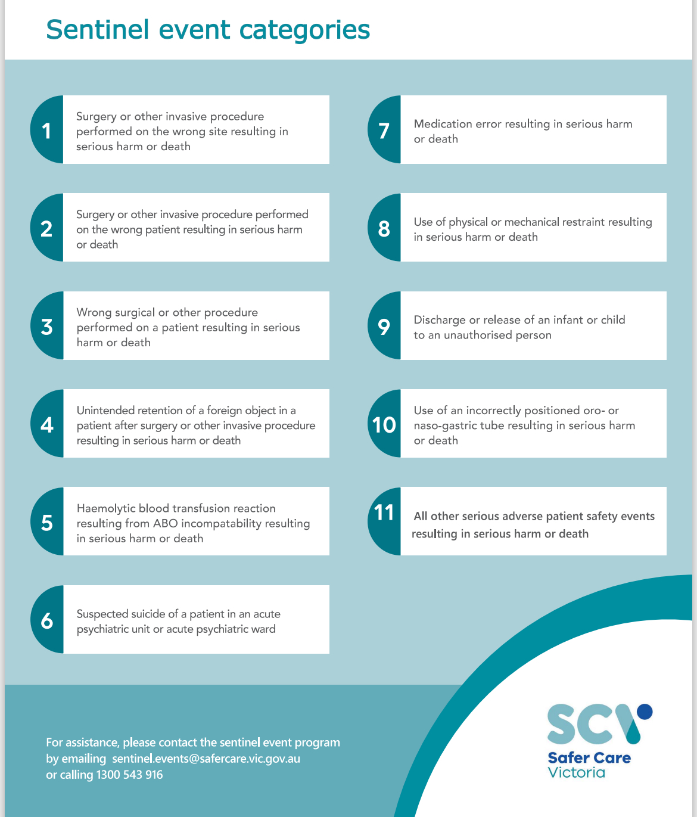

# Appendix 6: Descriptions of the figures and graphs in this report

Figure 1A: Number of triaged cases by the ASC chair, grouped into referral sources

This figure shows that 64 cases were triaged from the Perioperative Mortality Committee and 41 from the Sentinel Events Program.

Figure 1B: Triaged cases grouped into different classification categories

This figure shows how the Anaesthetic Subcommittee classifies deaths and morbidity attributable to anaesthesia into several categories. For the 2023 cases, they applied the Australian and New Zealand College of Anaesthetists classification, categorising them into 7 groups based on whether the deaths or morbidity were directly related to anaesthesia or not.

Figure 2A: Number of triaged cases by the SSC chair, grouped into referral sources

This figure shows that 34 cases were triaged from E-Deps, 64 from the Perioperative Mortality Committee and 43 from the Sentinel Events Program.

Figure 2B: Primary cause of death of the reviewed cases

This figure shows the following breakdown of cases:

* haemorrhage = 3
* PE = 2
* sepsis = 1
* multiorgan failure = 1
* cardiac arrest = 1
* retained surgical pack = 1
* other = 2.

Figure 2C: Contributing or preventable factors identified from the reviewed cases

This figure shows the number of contributing or preventable factors identified from the reviewed cases. Six cases were related to communication failures. Three cases were associated with personnel issues involving inexperienced junior medical staff, facility or equipment issues, potentially avoidable factors, and intraoperative issues, respectively. Two cases involved protocol breaches, other personnel issues, lack of surgical skill at the site of surgery, inadequate personnel resources, inadequate preoperative investigations for specific conditions and failure or problem recognition, respectively.

One case was related to the lack of timely staff involvement, incorrect or delayed diagnosis, and inappropriate preoperative preparation, respectively

Figure 3A: Risk assessment completion rate over time for Victoria

This figure shows the risk assessment completion rate over time for Victoria, which was 36.8% between 1 January 2022 and 31 December 2023.

Figure 3B: Proportion of patients age ≥ 65 years assessed by a specialist in elderly medicine in Victoria

This figure shows the proportion of patients aged 65 years or older who were assessed by a specialist in elderly medicine in Victoria. Between January 2022 and December 2023, Victoria performed above the national average of 20.7% but remain below the desired target of 75%.

Figure 4: Trends in hip fracture care performance indicators

This figure provides an overview of activities related to hip fracture care that have shown improvement, remained unchanged or declined in performance.

Several key activities showed improvement. Notably, 93% of hospitals reported having a hip fracture pathway and 78% of patients underwent a preoperative cognitive assessment. Pain management also showed progress, with 67% of patients receiving a documented pain assessment within 30 minutes of arrival at the emergency department and 83% receiving a nerve block before surgery. Furthermore, 50% of hospitals routinely provided written information on treatment and care after hip fracture. Encouragingly, 80% of patients who were followed up at 120 days had returned to their own home.

Some activities remained unchanged. The data shows that 87% of patients were seen by a geriatrician during their acute hospital stay, while 77% had surgery within 48 hours. In terms of mobility, 46% of patients achieved first-day walking and 33% were on active treatment for osteoporosis at discharge.

However, one area declined in performance. The proportion of hospitals with a dedicated pain pathway remained stagnant at 81%.

Figure 5: Surgery conducted within 48 hours for patients presenting to a hospital with a hip fracture, Australia

This figure shows the percentage of hip fracture surgeries performed within 48 hours for patients presenting to hospitals in Australia. On average, only 76% of patients underwent surgery within this timeframe.

Figure 6: Reasons for hip fracture surgical delays exceeding more than 48 hours

This figure shows the reasons for hip fracture surgery delays exceeding 48 hours. The most common reason was theatre availability (34%), followed by patients being deemed medically unfit (25%). Other delays accounted for 16%, while anticoagulation-related issues contributed to 10%. Furthermore, 7% of delays were due to unknown reasons, 5% were due to a delayed diagnosis of hip fracture, and 3% were attributed to surgeon availability.

Figure 7: Data illustrating the overall percentage of patients with a hip fracture assessed by geriatric medicine during their acute admission, Australia

This figure shows the overall percentage of patients with a hip fracture who were assessed by geriatric medicine during their acute admission in Australia. On average, only 86% of patients received a geriatric assessment during their acute admission.

Figure 8: Data illustrating the overall percentage of patients with a hip fracture who had a geriatric medicine assessment during their acute admission, Victoria

This figure shows the overall percentage of patients with a hip fracture who underwent a geriatric medicine assessment during their acute admission in Victoria. In 2023, about 80% of patients received a geriatric assessment compared with 77% in 2022 and 88% in 2021.

Figure 9: Data illustrating the overall percentage of patients with hip fracture receiving bone protection medication on discharge, Australia

This figure shows the overall percentage of patients with hip fractures receiving bone protection medication upon discharge in Australia. On average, only 32% of patients in Australia received this medication at discharge.

Figure 10: The overall proportion of hospitals providing individualised written information on preventing future falls and fractures, Australia and New Zealand

This figure shows the overall proportion of hospitals in Australia and New Zealand that provide individualised written information on preventing future falls and fractures. Notably, in 2023, Australia achieved about 50% compared with 68% in 2022, 14% in 2021 and 23% in 2020.

Figure 11: The grouping of the 63 sentinel event reports reviewed by the VPCC

This figure shows the following results:

* category 1 = 1
* category 3 = 1
* category 4 = 3
* category 7 = 7
* category 11 = 51.

Figure 12: Audited data from VASM’s 1 July 2022 to 30 June 2023 unpublished report, presented into demographic, risk and key findings

This figure shows data derived from audited cases between 1 July 2022 and 30 June 2023. The population during this period was 6.8 million. Among the reported surgical deaths, 59% were male and 41% were female. The median age of audited cases was 78 years, with a mortality rate of 3.3 per 1,000 surgical admissions. Of these cases, 87% were emergency surgeries, while 13% were elective. Also, 19.6% of cases involved preoperative transfer.

Among the audited mortality cases, 9.6% were expected preoperatively, while 51.7% were deemed to have considerable risks. 23.1% of cases had moderate risks, 10% had small risks and 5.2% were considered minimal risk.

The top 5 most common comorbidities identified were cardiovascular conditions (57.6%), followed by age-related factors (56.8%), respiratory conditions (34.6%), renal conditions (29.8%) and neurological conditions (24.8%). The top 5 most common causes of death were cardiovascular disease (16.5%), neurological conditions (13.8%), respiratory conditions (8.4%), malignancy (8.2%) and sepsis (7.9%).

Several positive findings emerged from these audited cases. There was greater consultant presence in the operating theatre, fewer postoperative complications and a decreased incidence of sepsis. Patient fluid management improved, while infection rates during admission decreased, and the incidence of pneumonia was lower.

Peer review outcomes showed that 78.3% of cases had no identified issues, while 12.2% were classified as an area for consideration. Also, 5% of cases were deemed an adverse event and 4% were identified as an area of concern.

Figure 13: Themes from the 31 cases referred to the VPCC

The themes from the 31 cases referred to the VPCC were:

* risks of post-discharge thromboembolism
* postoperative hemorrhage
* heightened risk of cardiac death.

Figure 14: An example of the Surgery Quality and Safety dashboard showing graphs of the major medical complication rates following emergency laparotomy, myocardial infarction, pulmonary embolism and stroke

Example only.

Figure 15: Sentinel event categories 1 to 10 apply nationally, whereas category 11 is specific only to Victoria

This figure shows the different sentinel event categories, ranging from 1 to 11. Category 1 is classified as surgery or other invasive procedure performed on the wrong site resulting in serious harm or death. Category 2 is classified as surgery or other invasive procedure performed on the wrong patient resulting in serious harm or death. Category 3 is classified as the wrong surgical or other procedure performed on a patient resulting in serious harm or death. Category 4 is classified as unintended retention of a foreign object in a patient after surgery or other invasive procedure resulting in serious harm or death. Category 5 is classified as haemolytic blood transfusion reaction resulting from ABO incompatibility resulting in serious harm or death. Category 6 is classified as suspected suicide of a patient in an acute psychiatric unit or acute psychiatric ward. Category 7 is classified as medication error resulting in serious harm or death. Category 8 is classified as the use of physical or mechanical restraint resulting in serious harm or death. Category 9 is classified as discharge or release of an infant or child to an unauthorised person. Category 10 is classified as use of incorrectly positioned oro- or naso-gastric tube resulting in serious harm or death. Category 11, which applies to Victoria only, is classified as all other serious adverse patient safety events resulting in serious harm or death.

# References

1. NASA. Columbia crew survival investigation report. <https://www.nasa.gov/wp-content/uploads/2015/01/298870main_sp-2008-565.pdf>

2. Australian Commission on Safety and Quality in Health Care. Informed consent. <https://www.safetyandquality.gov.au/our-work/partnering-consumers/informed-consent>

3. Australian Commission on Safety and Quality in Health Care. The open disclosure framework. <https://www.safetyandquality.gov.au/our-work/open-disclosure/the-open-disclosure-framework>

4. Safer Care Victoria. Victorian duty of candour framework. <https://www.safercare.vic.gov.au/sites/default/files/2022-10/Victorian%20Duty%20of%20Candour%20Framework%20-%20FINAL.docx>

5. Safer Care Victoria. Victorian guideline for the prevention of venous thromboembolism in adult hospitalised patients. <https://www.safercare.vic.gov.au/best-practice-improvement/clinical-guidance/venous-thromboembolism/victorian-guideline>

6. ANZHFR. 2024 annual report. <https://anzhfr.org/wp-content/uploads/sites/1164/2024/09/ANZHFR-2024-Annual-Report_PRINT-REPORT_FINAL.pdf>

7. ANZHFR. 2024 supplementary e-report. <https://anzhfr.org/wp-content/uploads/sites/1164/2024/09/ANZHFR-2024-Annual-Report_Supplementary-Australian-State-Report.pdf>.

8. Health Services (Quality and Safety) Regulations 2020 – Reg 3A. https://classic.austlii.edu.au/au/legis/vic/consol_reg/hsasr2020454/s3a.html

9. Australian Commission on Safety and Quality in Health Care. Hip Fracture Clinical Care Standard. <https://www.safetyandquality.gov.au/sites/default/files/2023-09/hip-fracture-clinical-care-standard-2023.pdf>

10. Warwick V, Gillespie B, McMurray A, Clark-Burg K. The patient, case, individual and environmental factors that impact on the surgical count process. Journal of Perioperative Nursing. 2019;32(3):9–19.

11. ANZCA. Glossary of terms. <https://www.anzca.edu.au/getContentAsset/518af3ad-6616-4ed1-a6bc-fed4364675e3/80feb437-d24d-46b8-a858-4a2a28b9b970/Glossary-of-Terms-Case-Classification.pdf?language=en>

12. Victorian Consultative Council on Anaesthetic Mortality and Mortality Triennial report 2015 – 2017. <https://www.safercare.vic.gov.au/sites/default/files/2019-09/02025_VCCAMM_triennial_2015_2017_WEB.pdf>