May 2025
Victorian perinatal services performance indicators
2022

To receive this publication in an accessible format phone (03) 9096 1384, using the National Relay Service 13 36 77 if required, or email Safer Care Victoria <info@safercare.vic.gov.au>. | Authorised and published by the Victorian Government, 1 Treasury Place, Melbourne.  © State of Victoria, Australia, Safer Care Victoria, May 2025  ISSN 2207-3558 - Online (pdf/word)  Available from the Safer Care Victoria website <https://bettersafercare.vic.gov.au>. | 


Acknowledgement of Country
We proudly acknowledge Victoria’s Aboriginal communities and their rich culture and pay respect to their Elders past and present.
We acknowledge Aboriginal people as Australia’s First Peoples and as the Traditional Owners and custodians of the land and water on which we rely.
We recognise and value the ongoing contribution of Aboriginal people and communities to Victorian life and how this enriches us.
We embrace the spirit of reconciliation, working towards the equality of outcomes and ensuring an equal voice.

Acknowledgement of lived experience
We acknowledge the lived experience of mothers, babies and families who receive care in Victorian maternity and newborn services.
We are committed to improving and creating a system that is safe for all.

Foreword

From the Maternity and Newborn Leads
As the Consumer and Clinical Leads for the Maternity and Newborn Improvement Team, we are delighted to present the 2022 Victorian Perinatal Services Performance Indicators (PSPI) report for the consideration of consumers (women and families), clinicians and health services.
In 2023, we worked with the Maternity and Newborn Learning Health Network Advisory Group and Data Group members to prepare the narrative for the annual PSPI report. Our consumers provided insightful observations, suggested improvement strategies and ensured the language used in the report was consumer friendly. This was a welcome opportunity and approach. We were also grateful for the expertise of our clinicians, academics and researchers.
The 2022 PSPI report is designed to act as a supplement to the 2021 report, presenting data and trends in 2022.
Readers of this report are invited to refer to the 2021 PSPI report for:
- Information about each indicator
- What pregnant women and families need to know
- Strategies for improvement
- Definitions and data sources
This report uses the terms ‘woman’ and ‘women’ and ‘mothers’ when referring to people who were pregnant. We respectfully acknowledge that this report includes people who do not identify as women or mothers and that individual parents and families may use different words from those used in this report. This may include women, transgender men, intersex people, non‑binary and gender diverse people.
Please use the 2022 PSPI data to work together to identify the challenges facing Victoria’s maternity and newborn services. Use the observations of the data to identify opportunities for improvement and explore innovations in practice that can be shared between services. Focus on connecting and working with consumers to overcome the identified challenges in improvement work. Remember to look at each health service across all indicators, rather than by a single indicator, reflecting on overall strengths.
Bronwyn Hogan
Consumer Lead
Dr Penny Sheehan
Clinical Lead

From the Consultative Council on Obstetric and Paediatric Mortality and Morbidity Chair
As custodians of the Victorian Perinatal Data Collection (VPDC) the Consultative Council on Obstetric and Paediatric Mortality and Morbidity (CCOPMM) is pleased to produce the annual PSPI report. This abbreviated report provides a view of key outcomes, from our largest tertiary metropolitan services to smaller rural health services, including public and private hospitals.
CCOPMM are committed to providing access to more contemporaneous data for consumers and clinicians.
The data and analysis for this report was provided by Safer Care Victoria’s Safety Intelligence, Safety Insights Program, and the Governance Secretariat.
Professor Mark Umstad AM
Chair CCOPMM

Contents

Foreword 4
Contents 6
Introduction to this report 8
Who is this report for? 9
What doesn’t this report do? 9
How to use this supplementary report 10
About the data 11
Comparing health service performance 15
Capability levels of maternity and newborn health services 16
Informing quality improvement activities 17
Observations on the data 18
1a: Induction of labour in standard primiparae 25
1bi and 1bii: Caesarean section in primiparae 28
1ci and 1cii: Perineal tears in primiparae 33
1di and 1dii: Episiotomies in primiparae 38
2: Term babies without congenital anomalies who required additional care 43
3a and 3b: Severe fetal growth restriction 45
4a and 4b: Vaginal birth after primary caesarean section 50
5: Five-year gestation standardised perinatal mortality ratio 55
6a and 6b: Readmissions during the postnatal period 58
7: Smoking cessation 63
8a, 8b and 8c: Breastfeeding in hospital 66
9: First antenatal visit 73
10: Low Apgar score 76
11a and 11b: Women’s experiences of care 79
12a and 12b: Maternal vaccination 84
13: Women who had a severe postpartum haemorrhage within 24 hours of giving birth 89
Appendix 1: Data sources and reporting rules 92
Appendix 2: Total women and babies in Victorian maternity services 2022 93
Appendix 3: Overview of results 95
Acknowledgements 99
Further reading 100
Useful online resources 101

Introduction to this report
This report provides insights into where maternity and newborn services across Victoria are delivering high-quality care and where improvements can be made. The information allows health services to compare results and monitor variation within their own services over time and against their peers. This report also helps health services prioritise their performance improvements by reviewing their practices and identifying areas of improvements for the care provided to women and their babies – from antenatal, through intrapartum (labour and birth) to postnatal care.
The performance indicators (Figure 1) are useful and insightful measures of the quality of care. They continue to be refined over time.
Figure 1. Perinatal services performance indicators by key performance area
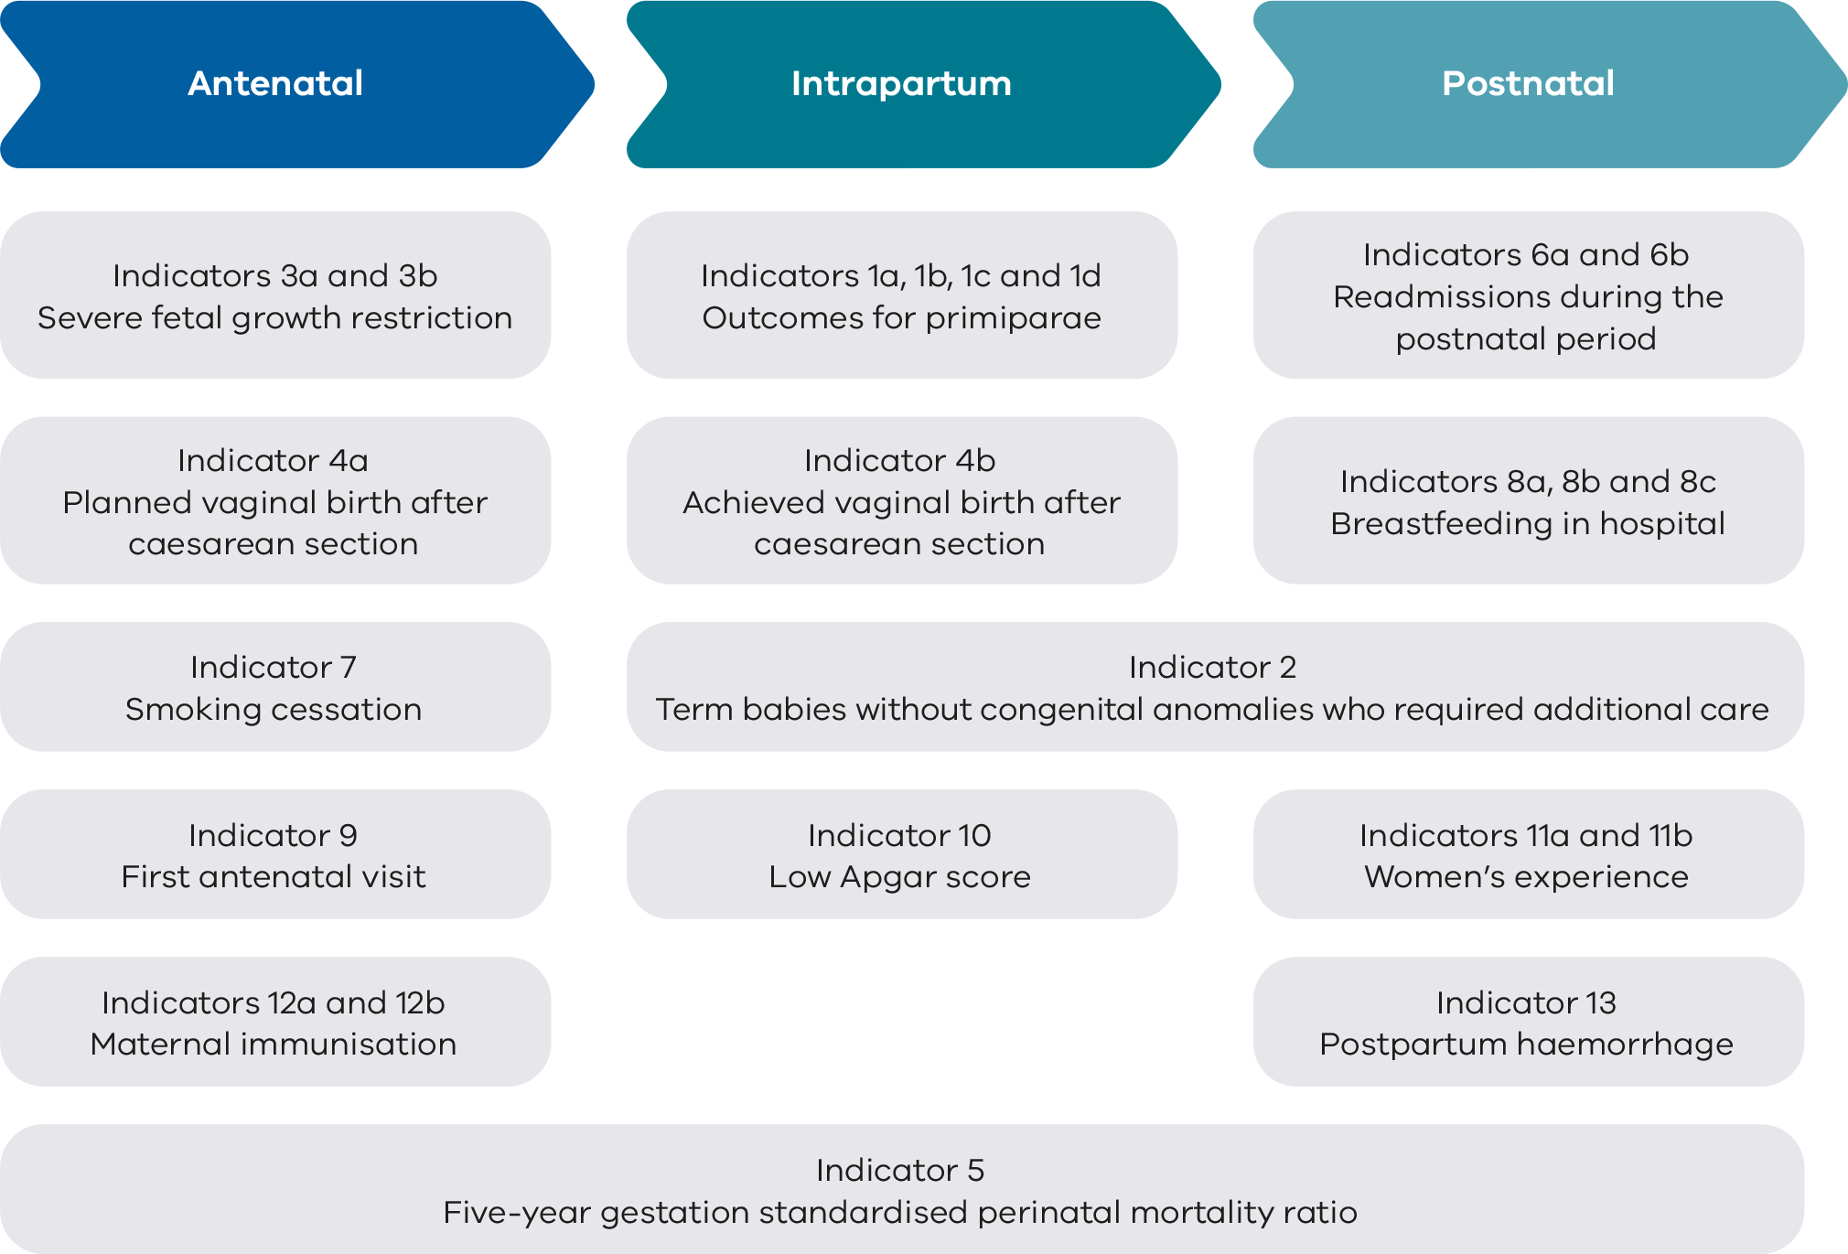

Who is this report for?
This report is for health professionals and health services to monitor their performance across a range of maternity and newborn indicators.
Pregnant women, their families and interested consumers and community members are encouraged to view this report for information about maternity care in Victoria. Every effort has been made to ensure the report has been produced in a way that women, their families and the community can read and understand.

What doesn’t this report do?
This report is not intended to set targets for individual health services to achieve, compare Victorian data with other jurisdictions, or for national benchmarking.
For more information you may wish to look at the following similar reports:
- Australian Institute of Health and Welfare Australia’s mothers and babies report
<https://www.aihw.gov.au/reports-data/population-groups/mothers-babies/reports>
- New South Wales Health Mothers and babies reports
<https://www.health.nsw.gov.au/hsnsw/Pages/mothers-and-babies-reports.aspx>.

How to use this supplementary report
Readers of this report are invited to refer to the 2021 PSPI report <https://www.safercare.vic.gov.au/sites/default/files/2024-03/safer_care_PSPI_2021.pdf> for:
- Information about each indicator
- What pregnant women and families need to know
- Strategies for Improvement
- Definitions and data sources
This report details statewide data observations and key information about Victorian maternity health services. The report includes summary tables, bar graphs, funnel plots and trend tables.
Outcomes are reported by comparing health services with each other and across the state over 12 months. We call this comparison ‘benchmarking’. It can be used to identify higher performing services, performance of practices within a multi-site health service and compare practice over time. It is important to note this report provides a snapshot in time and longitudinal trends should be cautiously interpreted. A health service may have improved its performance, but if peers of similar capability have also improved, they may appear to be underperforming in comparison.
Benchmarking can:
- allow you to assess performance relative to other health services,
- identify other services that are providing those practices that your health service may want to learn from,
- highlight opportunities for improvements, particularly where improvement activities have led to success in other organisations.
More detail is provided in the Appendices.
- Appendix 1 details the data sources for this report.
- Appendix 2 lists Victoria’s maternity services and the number of women and babies cared for in 2022.
- Appendix 3 has an overview of results for each health service.

About the data
Data for this report comes from several sources including the Victorian Perinatal Data Collection (VPDC), the Victorian Healthcare Experience Survey (VHES) and the Victorian Admitted Episodes Dataset (VAED).
- VPDC data is from the 2022 calendar year and is used for indicators 1, 3, 4, 5, 7, 8, 9, 10, 12 and 13.
- VHES data is from January 2022 to December 2022 and is used for indicator 11.
- VAED data is reported for the 2022–23 financial year and is used for indicators 2 and 6.
This report uses the terms ‘woman’ and ‘women’ when referring to data collected in the VPDC, VHES and VAED. Information on gender is not recorded in these data collections. The terms ’women’ and ‘mothers’ refers to people who were pregnant and within the scope of these data collections. We respectfully acknowledge that this report includes people who do not identify as women or mothers and that individual parents and families may use different words from those used in this report. This may include women, transgender men, intersex people, non-binary and gender diverse people.

Indicator modifications and notes in 2022
For the 2022 PSPI Report, the indicator specifications were reviewed to ensure the data presented are contemporary, relevant and meaningful. The following modifications were applied, together with important observations on the data:

Indicator 1a
- For the derivation of a standard primiparae, the following ICD-10-AM codes have been removed from the exclusions list: O121, O324, O420, O641, O644, O658, O998. The following ICD-10-AM codes have been added to the exclusions list: O100, O101, O102, O103, O104, O109, O150, O211, O223, O225, O240, O241, O2411, O2412, O2414, O2419, O242, O2421, O2422, O2423, O2424, O2429, O243, O2431, O2432, O2433, O2434, O2439, O2452, O2453, O2454, O2459, O249, O2492, O2493, O264, O265, O289, O350, O351, O352, O353, O354, O355, O356, O357, O359, O362, O411, O4212, O439, O440, O441, O450, O458, O460, O883, O888, O980, O988, O991, O993, O9932, O995.
- The body mass index (BMI) criterion applied to the data definition for a standard primiparae has been revised to women with a known BMI less than 40 kg/m², excluding women with an unknown BMI.

Indicator 2
- ICD-10-AM code E884 (new code introduced in ICD-10-AM Twelfth Edition) has been added to the exclusions list.

Indicator 7
- Services with 10 or more women who reported as having smoked before 20 weeks’ gestation are only included if they are missing less than 20% of data about smoking in the second half of pregnancy. Missing data in individual services ranged from zero to 75% in 2022.

Indicators 11a and 11b
Weights are applied to responses based on patient age and sex and the campus they attended. Rates are calculated according to the sum of expansion weights among women who responded as ‘Yes, definitely’ divided by the sum of expansion weights among eligible women included in the denominator.
For Indicator 11a (VHES Question 6), women who responded with values ‘No, but I did not want or need this’, ‘No but this was not possible’, ‘I’m not sure’ or had missing responses were excluded from the denominator count.
- For Indicator 11b (VHES Question 29), women who had missing responses were excluded from the denominator count.
- The following health services had fewer denominator counts (i.e., fewer women sampled in the survey) in 2022 compared with 2021, despite the 2021 data only comprising six months of data (July through December 2021): Bairnsdale Regional Health Service, Bendigo Hospital, Casey Hospital, East Grampians Health Service [Ararat], Northeast Health Wangaratta, Portland District Health, Shepparton Hospital, Sunshine Hospital, Werribee Mercy Hospital and West Gippsland Hospital.
  - The decline in sample size may be due to a reduction in the valid sample cases that are received from the services. The removal of postal invitations in October to December 2022 may have contributed to this decline, particularly amongst smaller campuses that may be less likely to provide a digital contact point for maternity patients. The VHES also started sending higher volumes of digital invitations across other survey types when postal invitations were removed.
  - Valid cases could also have been impacted by a greater number of exclusions applied in 2022 given patients who receive a VHES invitation in the previous 6 months are excluded from the sample.

Indicators 12a and 12b
The definition for indicators 12a and 12b has been revised to the proportion of women with a known vaccination status who were vaccinated for pertussis and influenza at any time during their pregnancy.
For indicators 2, 6a and 6b, effective 6 February 2023, the management of maternity, neonatal and gynaecology services at The Women’s at Sandringham (The Royal Women’s Hospital) transitioned to Monash Health at Sandringham (Monash Health). Results for The Women’s at Sandringham and Monash Health at Sandringham are presented for the period 1 July 2022 through 5 February 2023 and 6 February 2023 through 30 June 2023, respectively.

How to interpret the data
- The data relies on accurate reporting by health services to VPDC mandatory fields.
- This report uses the terms numerator and denominator. In this context, denominator is the entire pool of women or babies included, and numerator is the group that have had the intervention or event. For example, at a particular hospital, 100 women had babies (denominator) and 20 of those women had excess bleeding (numerator). The rate of excess bleeding is the numerator over the denominator, expressed as 20/100 or 20%.
- Information is only reported when a health service has a minimum of 10 occasions for an event (denominator). For example, a hospital that had fewer than 10 women (standard primiparae) give birth in 2022 (denominator) will not be included in the results for Indicator 1a.
- Due to smaller numbers, data from smaller health services are subject to wide variation and should be interpreted with caution.
- Indicators 11a and 11b using VHES survey data is limited by the small number of respondents, acknowledging that responses to the survey are voluntary. As such, the data should be cautiously interpreted.

Statewide rates
The statewide rates provide an average of all hospitals combined (public and private), including homebirths and freebirths or births at a community health centre. The statewide public and private rates presented in the bar charts provide an average of all combined public and private hospitals only. The public rate is the average of all public hospitals combined, and the private rate is the average of all private hospitals combined. They do not represent a desired target. In most cases, even where a hospital appears to be doing well in comparison with others, opportunities for improvement remain. Interquartile ranges
Interquartile ranges show the variation between services and can be used to find outliers in the data. The graphs throughout this report use red and green vertical lines and shading to show the least (red) and most (green) favourable 25% of services, respectively. The most favourable rate may be high or low depending on the indicator. For example, we want rates of severe fetal growth restriction to be low and rates of smoking cessation to be high.

Funnel plots
Funnel plots provide a visualisation of each hospital’s rate compared with other hospitals and to an average rate (usually the state rate or the median rate across hospitals) and take into consideration the number of births at the hospital. Refer to Figure 2 for an example of a funnel plot. The example used in this graph is Indicator 6a (Rate of maternal readmissions).
Funnel plots consider the number of births at the maternity service, which is an advantage over the interquartile ranges in identifying most favourable and least favourable outcomes.
Figure 2. Example funnel plot
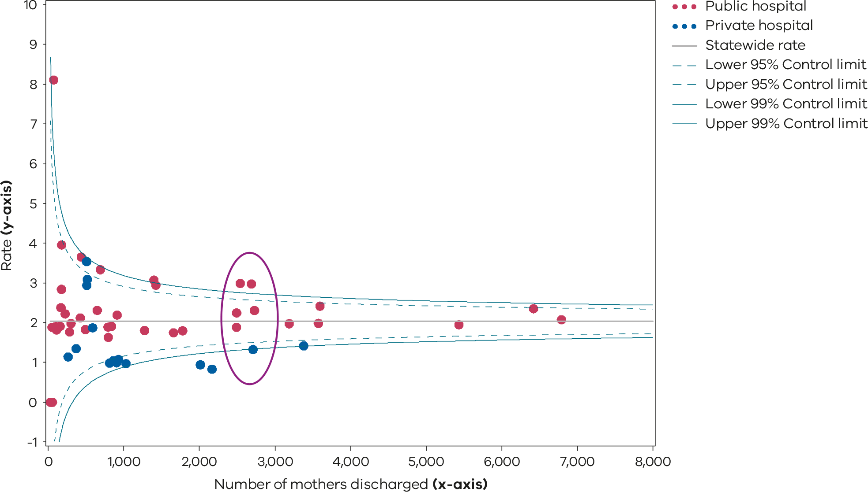

The dots
Each dot represents a hospital’s rate for the given indicator. The dots are relative to denominator (e.g. number of women discharged) and the rate. It is best to compare hospitals of a similar size and capability level. In this example, hospitals within the purple oval have a similar number of women discharged (x-axis) and are in general, more readily comparable.

The x and y-axis
The X-axis (the bottom horizontal line) shows the denominator, which in this example is the number of women discharged from the health service.
The Y-axis (vertical line on the left) shows the rate, which in this example is the rate of maternal readmissions.

The horizontal line
The solid grey horizontal line in the middle of the funnel represents the statewide median (rate) or average rate for the indicator. For most indicators, this is the median of the hospital rate, except for indicators 5, 6a, 6b, 11a, 11b in which the state rate is used as the average rate.
Hospitals (dots) that are above this line have a rate that is higher than the median or average rate. Hospitals below this line have a rate that is lower than the average rate.

The curved lines
The dashed and solid blue lines represent 95% and 99% control limits, respectively. Control limits can be used to test how different each hospital’s rate is from the average rate, taking the size of the hospital into consideration with the observed denominator.
If a hospital falls outside of the 95% control limits of the funnel plot, its rate is considered statistically significantly different from the average rate. A statistically significant result means the value is unlikely to be due to chance variation.
Hospitals that fall above the 95% upper control limit have a rate that is statistically significantly higher compared with the average rate. Conversely, those that fall below the 95% lower control limit have a rate that is statistically significantly lower compared with the average rate.
A favourable outcome for most indicators is to be lower than the average rate except for indicators 1dii, 4a, 4b, 7, 8a, 8c, 9, 11a, 11b, 12a and 12b. For these indicators, a rate that is higher than the average rate is most desirable.
Please note that only the gestation standardised perinatal mortality ratio (GSPMR) funnel plot includes risk-adjusted rates. All other funnel plots present rates that have not been adjusted for the risk profile of the population.
Only hospitals with at least 10 mothers or babies in the denominator in 2022 for the individual indicator have been included in the funnel plots, with the exclusion of the GSPMR funnel plot, which applied a different threshold. For the GSPMR funnel plot (Indicator 5), only hospitals with at least 5 deaths during the pooled 5-year period (2018–2022) have been included.

Comparing health service performance
Each health service may request its own profile detailing its individual results. These are confidential, although some services choose to share their results with others including consumers. Sharing the service profiles with others can help identify trends and opportunities for learning, particularly for services within similar rural, remote and metropolitan areas and those of similar capability. Sharing individual results is an opportunity to build on achievements or address any challenges.
To request a profile with individual hospital results please email consultative.councils@safercare.vic.gov.au.

Capability levels of maternity and newborn health services
We have clustered health services by maternity capability level so you can easily compare your service with others providing care for mothers and babies with a similar level of complexity. Indicator 6b (Rate of newborn readmissions during the postnatal period) and Indicator 10 (Rate of term tertiary ‘inborn’ babies without congenital anomalies with an Apgar score < 7 at 5 minutes) are the exception, where health services are clustered by neonatal capability levels.
Victorian maternity and newborn services operate in a networked system across 6 levels of care (Figure 3):
- Levels 1–3: Local care for healthy pregnant women and low risk newborn babies
- Level 4: Local care for pregnant women and newborn babies with some risk requiring additional care
- Level 5–6: Local care for all pregnant women and newborn babies. Regional/statewide care for high‑risk pregnancies and high-risk newborn babies.
Victoria’s network of services means, for most women and families, maternity and newborn care is provided as close to home as is safe and practicable and prompt transfer to local and/or specialised services can occur as appropriate.
Figure 3. Levels of maternity and neonatal care
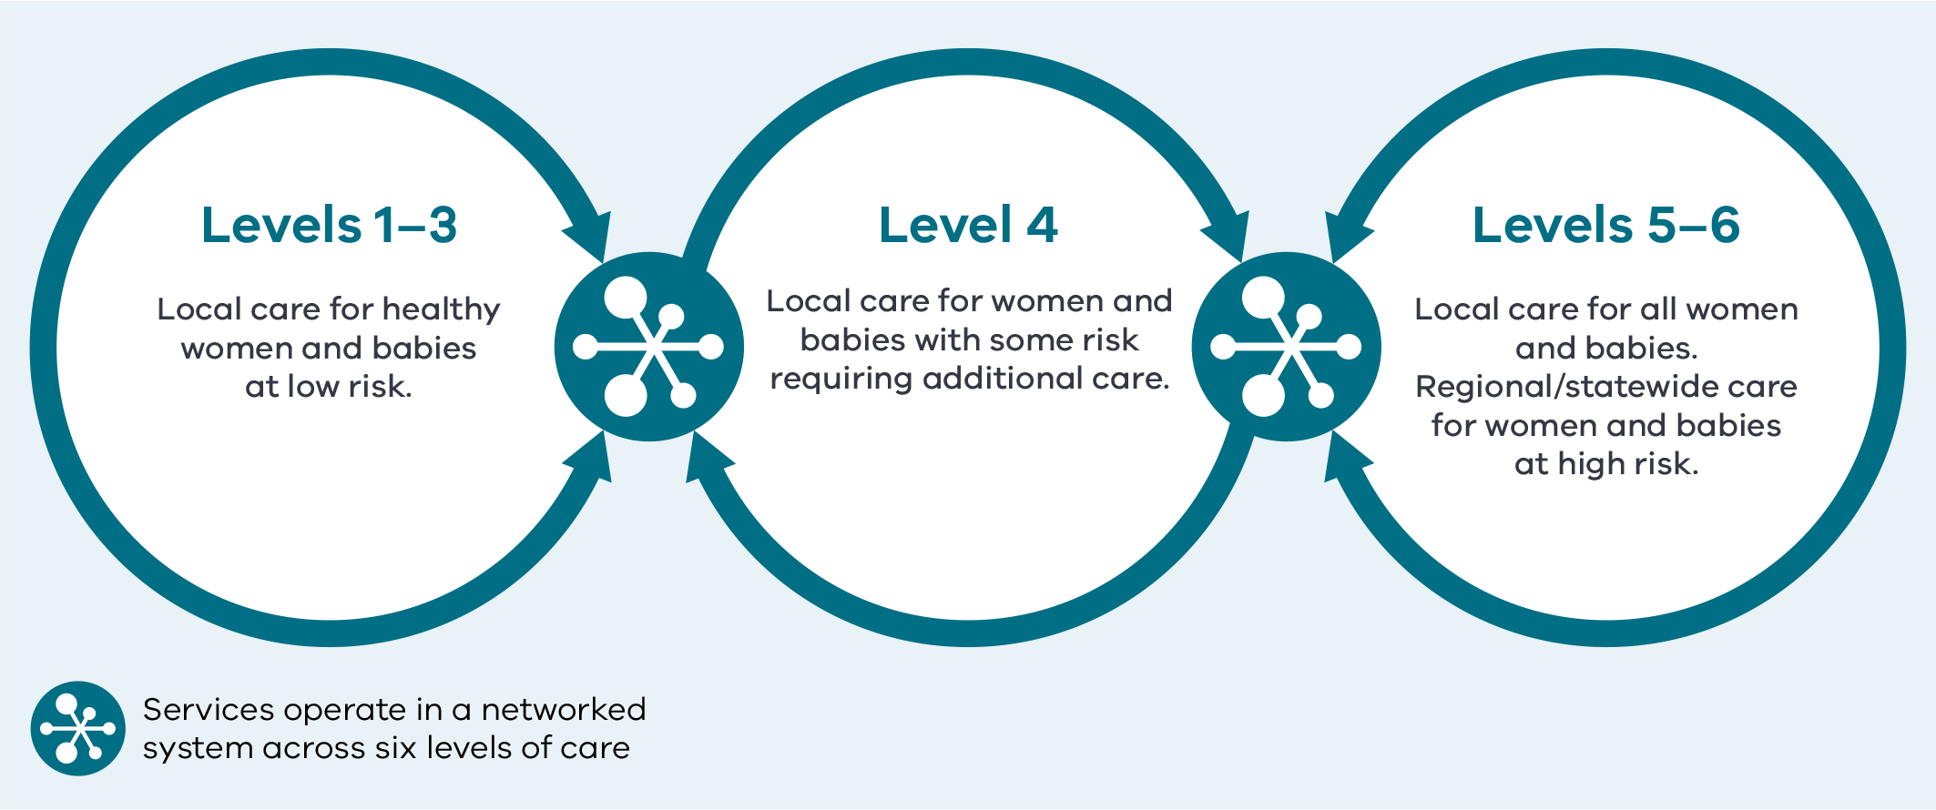
Source: Department of Health 2022, Capability frameworks for Victorian maternity and newborn services, State Government of Victoria, Melbourne.

Informing quality improvement activities
Data and observations in this report can guide, inform and help you prioritise local audits and improvement activities.
Individual health services are encouraged to:
- further identify areas to implement improvement programs and measure the impact by sharing and discussing this report with:
  - consumer advisory committees
  - clinicians, managers, executive and health service boards
  - quality and safety and mortality and morbidity committees.
- engage women, families and consumers with opportunities for improvement. Involving consumers will strengthen the improvement practice and approach across health services.

Observations on the data

Indicators | Observations
1a: Induction of labour in standard primiparae | The statewide rate for 2022 was 17.3%, which is higher than the previous year’s rate which was 15.0%. Of note, the rate was 13.9% in 2020.  Like previous years, the rate in 2022 of standard primiparae having an induction of labour in public hospitals was lower compared with private hospitals (12.4% and 24.0%, respectively).  There remains considerable variation in hospital rates for this indicator, from zero to 40.0% (Figure 4, Figure 5, Figure 6 and Table 2). While this indicator attempts to account for different patient populations, each health service should consider its rate in relation to others of a similar capability level and reflect on their own practice for improvement.
1bi and 1bii: Caesarean section in primiparae | The statewide rate of primiparae who gave birth by caesarean section (Indicator 1bi: Robson group 1) was 19.6%. This rate is higher than in 2021 (18.3%). The rate was lower across public hospitals (18.2%) than private hospitals (26.1%).  The statewide rate of primiparae who gave birth by caesarean section following induction of labour (Indicator 1bii: Modified Robson group 2) was 32.6% and has remained steady compared with 2021 (32.4%). The rate across public hospitals was comparable to private hospitals (33.6% and 29.7%, respectively).
1ci and 1cii: Perineal tears in primiparae | The statewide rate of third and fourth-degree perineal tears in unassisted vaginal births (Indicator 1ci) was 3.5%, a slight decrease from the previous year’s rate of 4.0%. The rate was higher in public hospitals (4.2%) compared with private hospitals (0.4%). Refer to Table 5 for year‑on‑year rates.  The statewide rate of third and fourth-degree tears in assisted vaginal births (Indicator 1cii) was 4.5%, slightly lower compared with the previous year’s rate of 5.0%. The rate was higher in public hospitals (5.2%) compared with private hospitals (2.8%). Refer to Table 6 for year-on-year rates.  The bar graphs and funnel plots (Figure 13 and Figure 14 (Indicator 1ci) and Figure 16 and Figure 17 (Indicator 1cii) show that there is considerable variation (zero to 10.7%) between hospitals across the state and within maternity capability levels in the rate of third-and fourth-degree perineal tears in both assisted and unassisted vaginal births. Similar observations were made among private hospitals.
1di and 1dii: Episiotomies in primiparae | The statewide rate of episiotomy in unassisted vaginal births (Indicator 1di) decreased from 26.6% in 2021 to 24.7% in 2022 (Figure 19, Figure 20 and Figure 21). The rate was lower in public hospitals (24.7%) than private hospitals (26.7%).  The statewide rate of episiotomy in assisted vaginal births (Indicator 1dii) was 85.8% in 2022. The rate was higher in public hospitals than private hospitals at 90.9 and 72.2%, respectively (Figure 22, Figure 23 and Table 8).  Figure 19 and Figure 20 (Indicator 1di) and Figure 22 and Figure 23 (Indicator 1dii) show that compared with 2021, there is large variation between hospitals and capability levels in the rate of primiparae who received an episiotomy during unassisted vaginal births across the state.  There is less inter-hospital variation for the rate of primiparae who received an episiotomy during assisted vaginal births in 2022.
2: Term babies without congenital anomalies who required additional care | The statewide public hospital rate of term babies without congenital anomalies who required additional care in 2022–23 was 11.7%, a slight increase from 11.0% in 2021–22.  Figure 25 and Figure 26 show variation between hospitals in rates of babies without congenital anomalies who required additional care, ranging from zero to 22.2%.  Level 6 and Level 5 hospitals providing care for high-risk pregnancies and high-risk babies are expected to have higher rates of babies requiring additional care. There are a variety of models of care across health services, and some hospitals may keep mothers and babies together on postnatal wards for management and treatment, while others provide that care in a neonatal unit, for example phototherapy for jaundice.
3a and 3b: Severe fetal growth restriction | The statewide rate of singleton babies with severe fetal growth restriction (FGR) who were born at 40 or more weeks’ gestation (Indicator 3a) in 2022 was higher at 22.0% compared with 20.0% in 2021 (Figure 27 and Figure 28). It is worth noting that previously the rate for this indicator in public hospitals had been steadily decreasing over the past 5 years (Table 10 and Figure 29). There had also been a significant reduction in the rate in private hospitals over this period, from 30.0% in 2018 to 17.7% in 2022.  The rate remains higher in public hospitals (22.7%) compared with private hospitals (17.7%) for a second consecutive year.  Indicator 3b is being reported for its second year. The statewide rate of singleton babies actively delivered for FGR before 39 weeks but who were above the 25th centile was slightly less at 17.6% in 2022 compared with 18.2% in 2021 (Figure 30, Figure 31 and Table 11). The rate was lower in public hospitals at 16.8%, while the rate in private hospitals was 20.0%. This balance measure is to monitor unwarranted early delivery of healthy babies. An additional balance measure is the increasing rate of induction of labour in standard primiparae (Indicator 1a).  Babies may be suspected to be small on measurement and serial review of the fundal height or on ultrasound estimation of fetal weight. However, while used for screening, these tests are not always accurate, and some babies are induced for FGR when they are not as small as suspected. Balancing measure (Indicator 3b) has been introduced to monitor this.
4a and 4b: Vaginal birth after primary caesarean section | The proportion of women planning a vaginal birth after caesarean section (VBAC) (Indicator 4a) was 21.5% in 2022, the same as the previous year. (Figure 34). This is following a steady reduction observed since 2018 (Table 12). Women in public hospitals were more likely to plan a VBAC (26.5%) compared with women in private hospitals (9.8%). There was wide variation across the hospitals and capability levels (Figure 33 and Figure 34).  The proportion of women who achieved a planned VBAC (Indicator 4b) decreased in 2022 to 53.4% from 54.3% in 2021. The proportion who achieved a planned VBAC decreased in both public hospitals (53.1% in 2022 compared with 54.1% in 2021) and private hospitals (50.4% in 2022 compared with 52.6% in 2021) (Table 13). The proportion who achieved a VBAC showed variation across the state (from 27.3% to 75%) (Figure 36 and Figure 37).
6a and 6b: Readmissions during the postnatal period | In 2022, the statewide rate of unplanned maternal readmissions within 28 days of discharge (Indicator 6a) was 2.3%, a slight increase from the previous year’s rate of 2.0% (Figure 41, Figure 42, Figure 43 and Table 14).  As in previous years, the rate was higher in public hospitals at 2.5% compared with private hospitals at 1.4% which may reflect an average longer length of stay in private hospitals during the birth admission.  The public hospital statewide average rate of unplanned newborn readmissions within 28 days of discharge (Indicator 6b) has remained steady at 4.9% in 2022 following the slight increase noticed during and after the COVID-19 pandemic (Figure 44, Figure 45 and Table 15).  It is worth noting that health services may be reporting readmission differently due to different policies around domiciliary or hospital-in-the-home care.
7: Smoking cessation | The statewide proportion of women who smoked in the first 20 weeks of their pregnancy but did not smoke in the last 20 weeks of their pregnancy increased in 2022 to 33.8% from 31.4% in 2021 (Table 16), reflecting a positive rate of change. The smoking cessation rate for public hospitals continued to be lower compared with private hospitals (33.1% and 57.1%, respectively), although private hospital cessation rates also decreased from 2020 (64.0%).  The smoking cessation rate between individual hospitals ranged from 8.3% to 97.1% (Figure 47). Also note some outliers as shown in Figure 48. The smoking cessation rates for hospitals in capability level 2 and 3 are, in general, lower than higher capability levels and private hospitals. These hospitals should review their smoking cessation programs.
8a, 8b and 8c: Breastfeeding in hospital | The statewide rate of women with term babies who initiated breastfeeding (Indicator 8a) in 2022 was 94.9% (Figure 50, Figure 51 and Table 17). Although rates have remained steady since 2018, this is the lowest it has been for five years (Figure 52).  The proportion of term breastfed babies who received infant formula in hospital was 30.7% (Indicator 8b). The rate varied between hospitals including those providing a similar level of care (Figure 53, Figure 54 and Table 18). Overall, public hospitals had a lower rate of infant formula use compared with private hospitals (27.3% and 42.6%, respectively).  The statewide rate of final feed exclusively from the breast for term breastfed babies (Indicator 8c) decreased in 2022 to 72.6%. This is the lowest rate in several years (Figure 56, Figure 57 and Table 19). The individual hospital rates varied from 44.3% to 95.7% in 2022.
9: First antenatal visit | The overall proportion of women who had their first antenatal visit recorded as occurring before 12 weeks’ gestation slightly decreased to 75.4% in 2022 from 76.5% in 2021 (Table 20). The rate varied between public and private hospitals (72.3% and 86.3%, respectively). The overall statewide rate has steadily increased since 2018 when the rate was reported at 59.5% (Figure 61 and Table 20).  The data reported to the VPDC for this measure has limitations. Some health services may not include early antenatal visits to a general practitioner that include referral for antenatal investigations and others do include these visits. Some may include visits for reasons other than pregnancy care. Given this, hospitals should review their data collection processes to the VPDC reporting guideline <https://www.health.vic.gov.au/quality-safety-service/victorian-perinatal-data-collection> to ensure an accurate capture of care provided in the community.
10: Low Apgar score | In 2022, a 5-minute Apgar score less than 7 was reported for 1.3% of singleton, term babies across the state. This was a similar rate to the previous 2 years. The rate for public hospitals is higher compared to private hospitals (1.4% and 1.0%, respectively).  The rate varied between individual hospitals, from zero to 6.9% (Figure 62 and Figure 63); however, overall statewide rates continued to remain stable over time (Table 21).
11a and 11b: Women’s experiences of care | In 2022, 67.7% of women who completed the survey across public hospitals responded that they felt involved, as much as they wanted to be, in decisions about their care compared with 71.2% in 2021 (Figure 65). The funnel plot in Figure 66 shows variation across hospitals.  In 2022, the proportion of women who felt they were given active support and encouragement to feed their baby the way they wanted to (Indicator 11b) across public hospitals was 84.6% compared with 87.2% in 2021 (Figure 68). The funnel plot shows variation in this indicator (Figure 69).  Greater variation in the observed data for indicators 11a and 11b may be ascribed to voluntary data collection practices of the VHES, meaning data are not always collected for every Victorian birth.  The data for these indicators is limited, as only a small proportion of women who birthed in the public hospital system are sent the survey and variation in response rate is seen as the survey is voluntary. This report includes only those health services with more than 10 responses over the time period. Data should be interpreted with caution and used in conjunction with additional feedback provided directly to the health service.
12a and 12b: Maternal vaccination | In 2022, 83.5% of women were vaccinated for pertussis during pregnancy (Indicator 12a). This was a slight increase from 2021 where 81.4% of women received vaccination for pertussis. The rate varied between public and private hospitals, with 89.7% and 63.5%, respectively. There was significant variation between individual hospitals, ranging from 5.7 to 100.0% (Figure 71, Figure 72 and Table 24). The wide variation may indicate the data are captured inaccurately in some hospitals, particularly in private hospitals, and doesn’t necessarily indicate that vaccination rates in those hospitals are low.  The rate for influenza was again lower in 2022 with only 73.0% of women receiving vaccination for influenza during their pregnancy (Indicator 12b). This was a slight decline from 2021 (73.7%) and rates remain lower than 2020 where 81.8% of women received vaccination for influenza. The rate was similar between public and private hospitals, at 72.7 and 75.4%, respectively. There was variation between individual hospitals, ranging from 56.5% to 92.9% (Figure 74, Figure 75 and Table 25).  The lower rates for influenza vaccine may be an ongoing effect of COVID-19 with women prioritising COVID-19 vaccine over influenza as the virus spread through the community from late 2021.
13: Women who had a severe postpartum haemorrhage within 24 hours of giving birth | In 2022, 2.5% of women had a severe primary PPH. This was a slight increase from the previous year’s rate of 2.3%. The rate for public hospitals was higher compared with private hospitals (2.9% and 1.2%, respectively). Figure 77 and Figure 78 show variation between individual hospitals. Some health services look after women with conditions that are at higher risk of bleeding – for example, placenta previa or placenta accreta – and this may account for the higher rate at certain health services. Table 26 compares rates of women with severe PPH across private and public hospitals.

Where we are getting better
- Rates of third and fourth-degree perineal tears during unassisted vaginal births in primiparae and the rate of third and fourth-degree perineal tears during assisted vaginal births in primiparae has decreased.
- The rate of babies with a birthweight above the 25th centile actively delivered for fetal growth restriction before 39 weeks’ gestation (Indicator 3b) has decreased.
- Rates of smoking cessation (Indicator 7) have increased.
- Rates of maternal pertussis vaccination (Indicator 12a) have increased.

Where we can improve
The following outcomes suggest the need for health services to comprehensively review their practices and then implement and monitor programs to improve performance.
- Rates of induction of labour in standard primiparae has continued to increase over the previous few years.
- Rates of caesarean section in Robson group 1 has increased.
- Rates of induction of labour or prelabour caesarean section for severe fetal growth restriction in babies before 40 weeks’ gestation (Indicator 3a) have further increased.
- The proportion of women who achieved a planned VBAC (Indicator 4b) has slightly decreased.
- Rates of unplanned maternal readmissions within 28 days of discharge (Indicator 6a) has slightly increased.
- Rates of neonatal readmission (Indicator 6b) have increased.
- The statewide rate of women with term babies who initiated breastfeeding (Indicator 8a) has slightly decreased for the first time in five years.
- The rate of term breastfed babies who received infant formula in hospital (Indicator 8b) has slightly increased.
- The statewide rate of final feed exclusively from the breast for term breastfed babies (Indicator 8c) has slightly decreased in 2022. This is the lowest rate in several years.
- The overall proportion of women who had their first antenatal visit recorded as occurring before 12 weeks’ gestation (Indicator 9) has slightly decreased.
- Rates of maternal influenza vaccination (Indicator 12b) rates has further reduced. In 2022, this may have still been impacted by COVID-19.
- Rates of postpartum haemorrhage (Indicator 13) have slightly increased but may be explained by the PPH collaborative and health service focus on quantified blood loss rather than estimates.
Table 1 summarises results in statewide public and private maternity hospital rates.

Table 1. Summary of statewide public and private maternity hospital rates
Indicator | Statewide 2021 | Statewide 2022 | Statewide public | Statewide private | Least favourable quartile | Most favourable quartile
1a Rate of induction of labour in standard primiparae | 15.0% | 17.3% | 12.4% | 24.0% | 22.7% | 8.4%
1bi Rate of caesarean section in Robson group 1 | 18.3% | 19.6% | 18.2% | 26.1% | 26.6% | 17.2%
1bii Rate of caesarean section in modified Robson group 2 | 32.4% | 32.6% | 33.6% | 29.7% | 39.9% | 29.9%
1ci Rate of third and fourth-degree perineal tears during unassisted vaginal births in primiparae | 4.0% | 3.5% | 4.2% | 0.4% | 3.9% | 0.0%
1cii Rate of third and fourth-degree perineal tears during assisted vaginal births in primiparae | 5.0% | 4.5% | 5.2% | 2.8% | 5.6% | 2.0%
1di Rate of primiparae who received an episiotomy during unassisted vaginal births | 26.6% | 24.7% | 24.7% | 26.7% | 27.7% | 18.2%
1dii Rate of primiparae who received an episiotomy during assisted vaginal births | 86.5% | 85.8% | 90.9% | 72.2% | 75.8% | 92.3%
2 Rate of term babies without congenital anomalies who required additional care*† | N/A | N/A | 11.7% | N/A | 12.9% | 8.5%
3a Rate of severe fetal growth restriction in a singleton pregnancy undelivered by 40 weeks | 20.0% | 22.0% | 22.7% | 17.7% | 26.0% | 12.7%
3b Rate of babies with a birthweight above the 25th centile actively delivered for fetal growth restriction before 39 weeks’ gestation | 18.2% | 17.6% | 16.8% | 20.0% | 21.8% | 12.0%
4a Rate of women who planned a vaginal birth after a primary caesarean section | 21.5% | 21.5% | 26.5% | 9.8% | 13.2% | 30.6%
4b Rate of women who achieved a planned vaginal birth after a primary caesarean section | 54.3% | 53.4% | 53.1% | 50.4% | 47.2% | 59.3%
5 Five-year gestation standardised perinatal mortality ratio (GSPMR) for babies born at ≥ 32 weeks | 1.0 | 1.0 | N/A | N/A | N/A | N/A
6a Rate of maternal readmissions during the postnatal period† | 2.0% | 2.3% | 2.5% | 1.4% | 2.8% | 1.5%
6b Rate of newborn readmissions during the postnatal period*† | N/A | N/A | 4.9% | N/A | 5.0% | 2.9%
7 Rate of smoking cessation during pregnancy | 31.4% | 33.8% | 33.1% | 57.1% | 24.8% | 44.6%
8a Rate of breastfeeding initiation for babies born at ≥ 37 weeks’ gestation | 95.5% | 94.9% | 94.9% | 94.7% | 92.9% | 95.8%
8b Rate of use of infant formula in hospital by breastfed babies born at ≥ 37 weeks’ gestation | 30.0% | 30.7% | 27.3% | 42.6% | 35.4% | 17.2%
8c Rate of final feed being taken directly from the breast by breastfed babies born at ≥ 37 weeks’ gestation | 74.2% | 72.6% | 75.4% | 62.8% | 68.8% | 85.8%
9 Rate of women attending their first antenatal visit prior to 12 weeks’ gestation | 76.5% | 75.4% | 72.3% | 86.3% | 71.6% | 88.2%
10 Rate of term babies without congenital anomalies with an Apgar score < 7 at 5 minutes | 1.2% | 1.3% | 1.4% | 1.0% | 1.7% | 0.8%
11a Rate of women who felt involved as much as they wanted to be in making decisions about their care* | N/A | N/A | 67.7% | N/A | N/A | N/A
11b Rate of women who felt that staff gave them active support and encouragement to feed their baby in the way they wanted to* | N/A | N/A | 84.6% | N/A | N/A | N/A
12a Rate of women vaccinated for pertussis during pregnancy | 81.4% | 83.5% | 89.7% | 63.5% | 89.0% | 95.0%
12b Rate of women vaccinated for influenza during pregnancy | 73.7% | 73.0% | 72.7% | 75.4% | 67.0% | 81.4%
13 Rate of women with severe postpartum haemorrhage | 2.3% | 2.5% | 2.9% | 1.2% | 3.4% | 1.5%
Notes: Quartiles are calculated for statewide public and private health services combined, unless stated otherwise.
* Result includes public hospitals only.
† Results shown are for 2022–23 FY as they are sourced from the VAED.
^ Results include hospitals that meet thresholds only.
N/A – not applicable

1a: Induction of labour in standard primiparae
Figure 4. Indicator 1a: Rate of induction of labour in standard primiparae, 2022
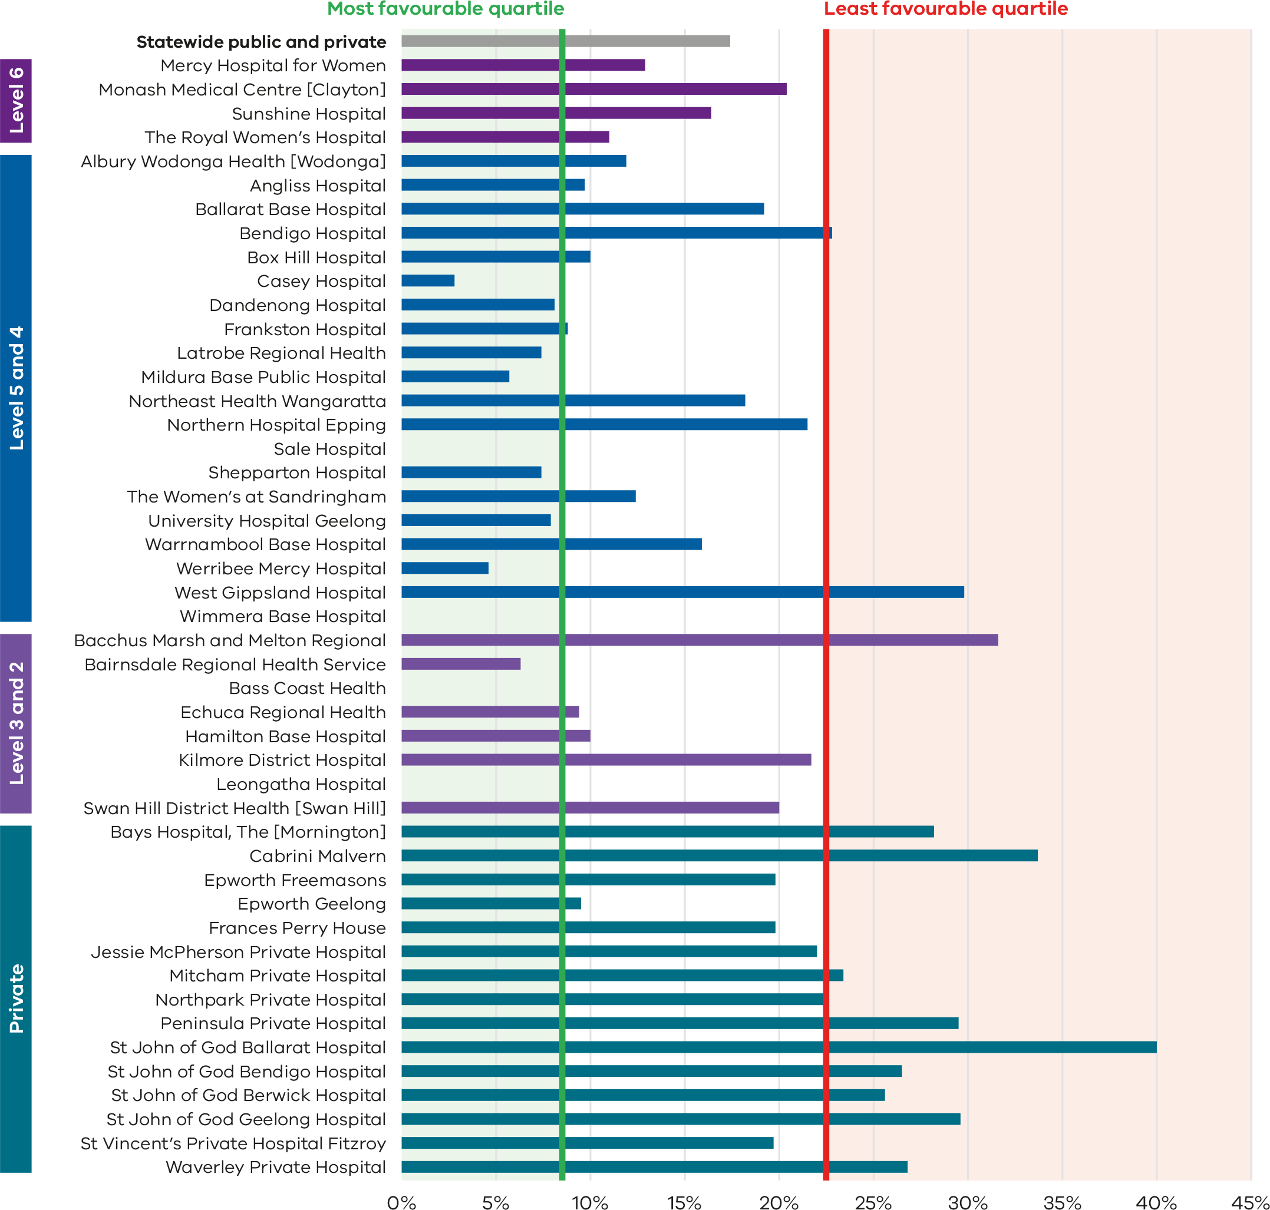

Figure 5. Funnel plot of rate of induction of labour in standard primiparae, 2022
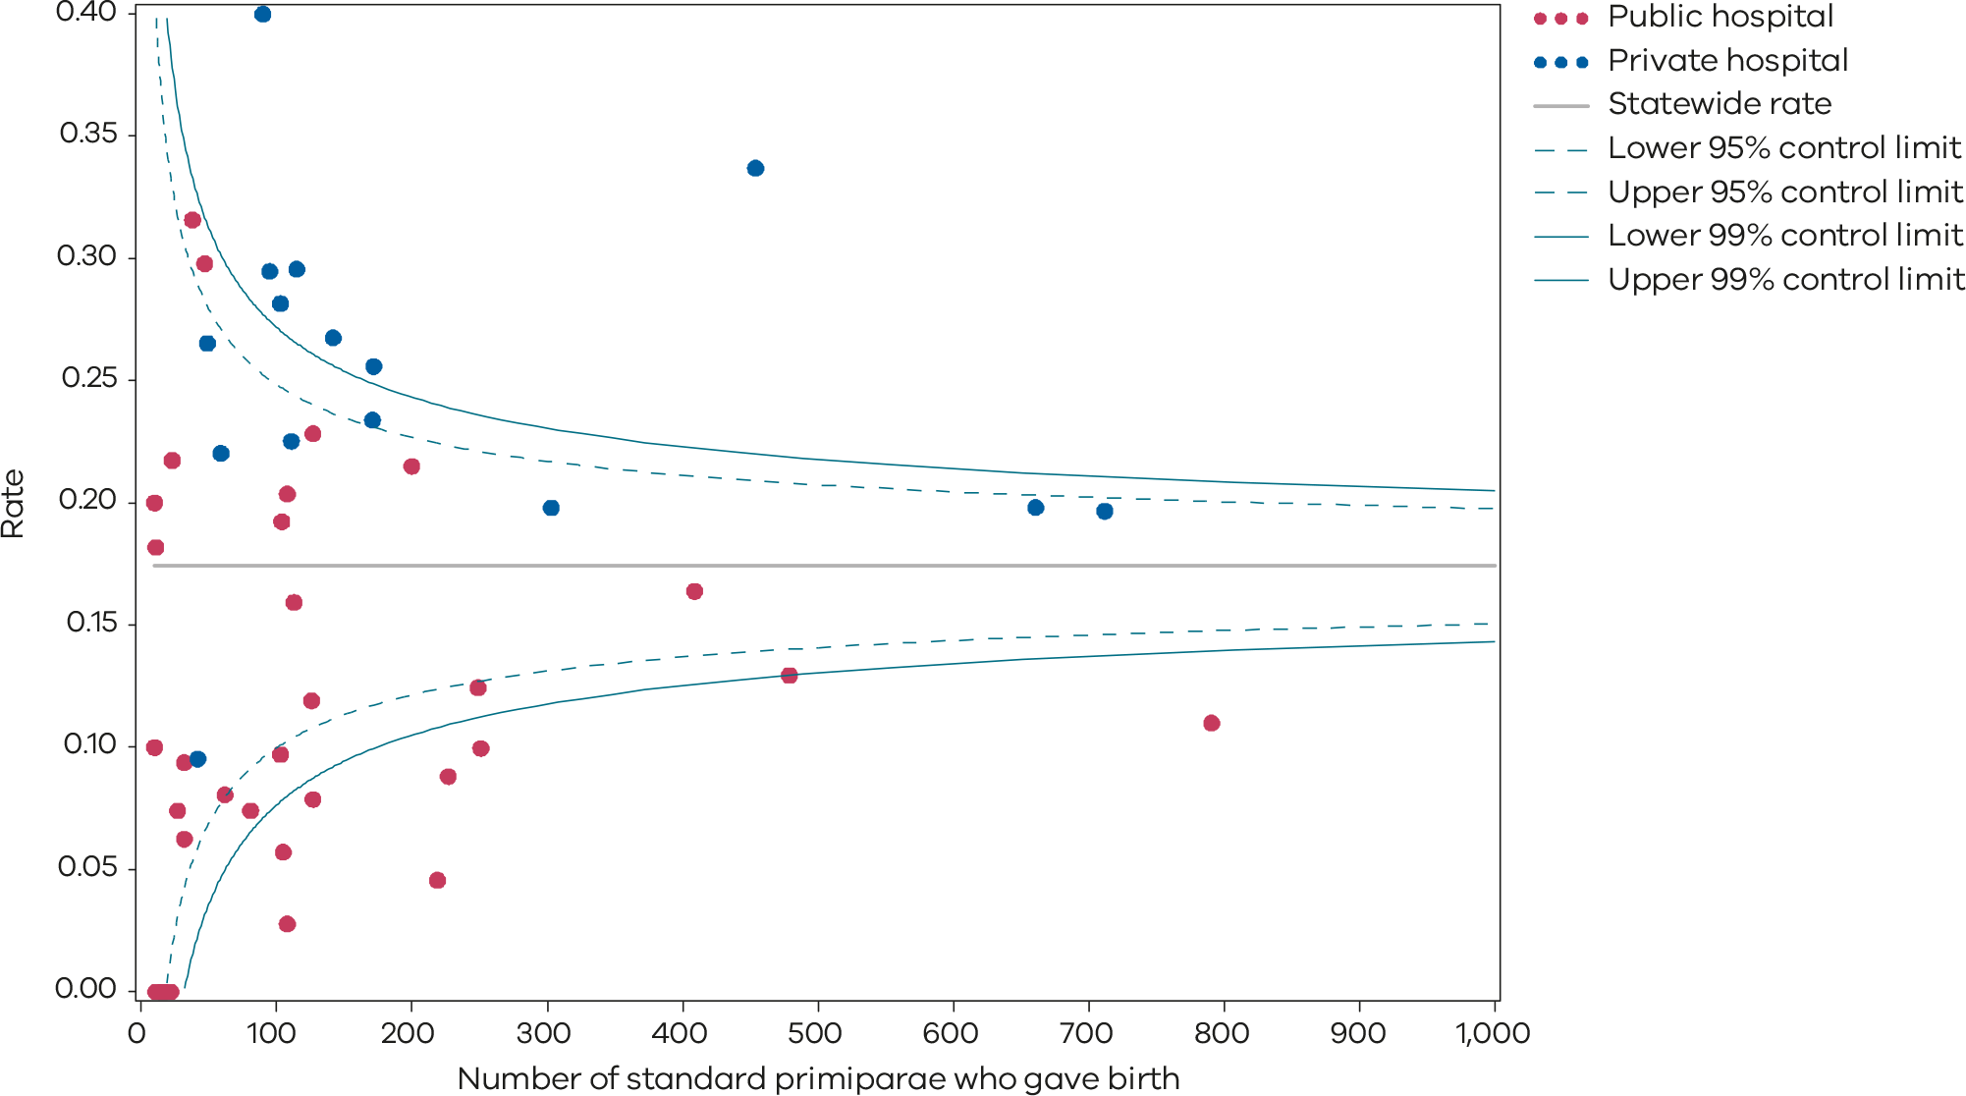
Please refer to the guide on how to interpret funnel plots.
Table 2. Rate of induction of labour in standard primiparae, 2018–2022
 | 2018 | 2019 | 2020 | 2021 | 2022
Public | 9.4% | 11.8% | 8.1% | 11.0% | 12.4%
Private | 21.1% | 26.5% | 23.7% | 21.7% | 24.0%
Statewide | 13.6% | 17.3% | 13.9% | 15.0% | 17.3%
Figure 6. Time trend of Indicator 1a, 2018–2022
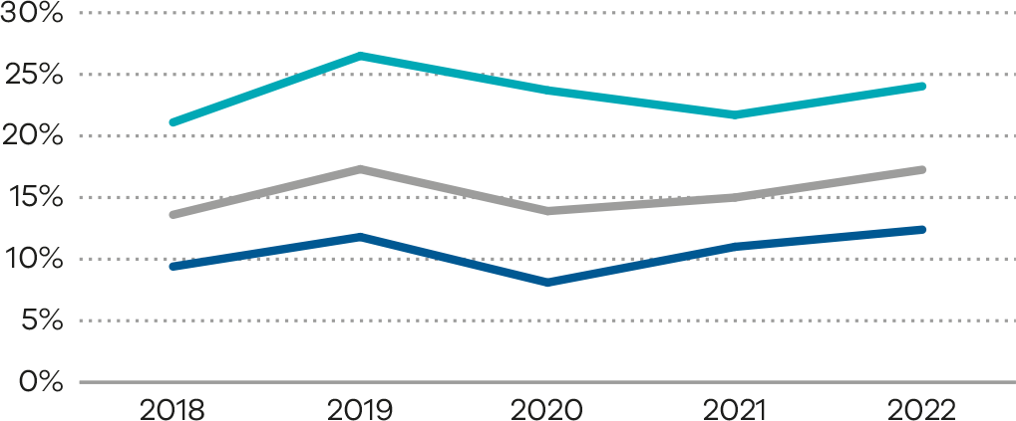

Numerator/denominator
Indicator | Numerator | Denominator
Indicator 1a: Rate of induction of labour in standard primiparae | The number of standard primiparae who give birth undergoing induction of labour | The number of standard primiparae
Note: Sixty-four ICD-10-AM codes were added to the exclusion list because they were not considered to be a clinical indication for induction of labour. This needs to be taken into consideration when comparing rates of induction in 2022 Indicator 1a with previous years. See page 10 for details.

1bi and 1bii: Caesarean section in primiparae

Figure 7. Indicator 1bi: Rate of caesarean section in Robson group 1, 2022
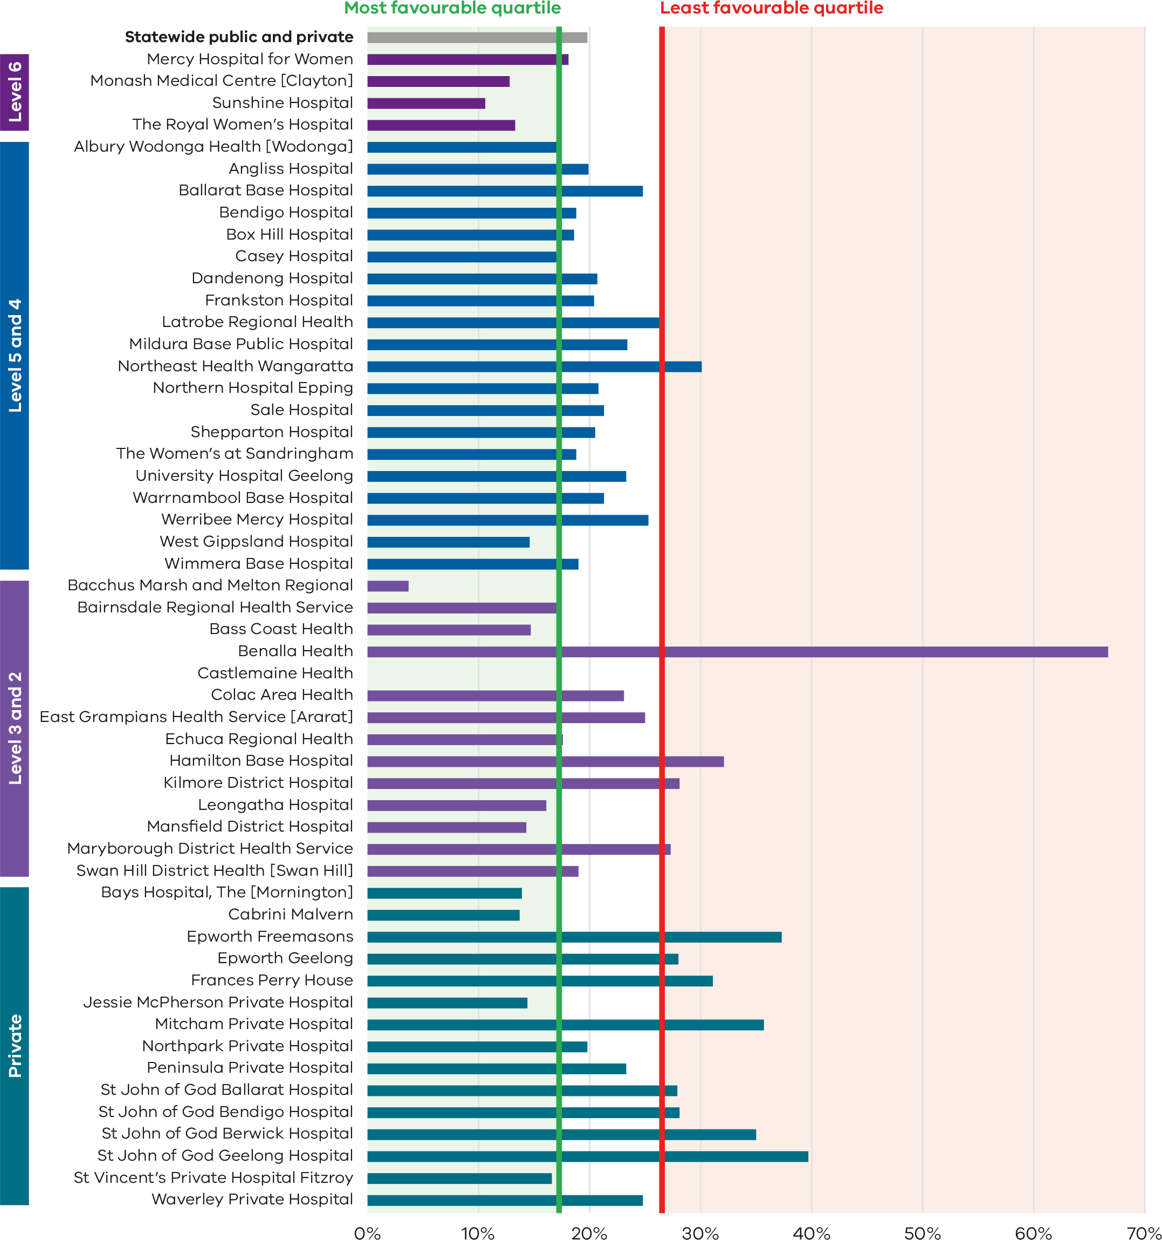
Figure 8. Funnel plot of the rate of caesarean section in Robson group 1, 2022
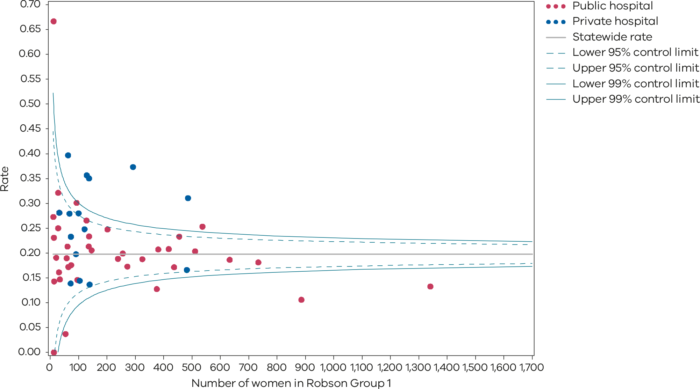
Please refer to the guide on how to interpret funnel plots.
Table 3. Rate of caesarean section in Robson group 1, 2018–2022
 | 2018 | 2019 | 2020 | 2021 | 2022
Public | 15.3% | 16.9% | 17.0% | 17.2% | 18.2%
Private | 21.8% | 22.0% | 24.2% | 23.5% | 26.1%
Statewide | 16.7% | 18.0% | 18.3% | 18.3% | 19.6%
Figure 9. Time trend of Indicator 1bi, 2018–2022
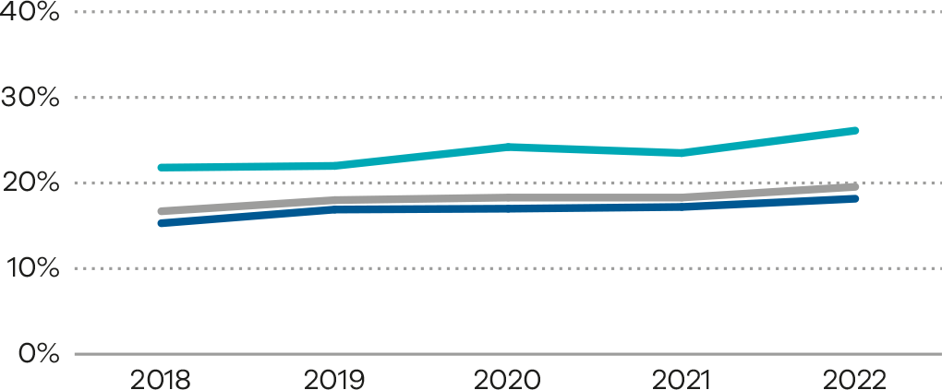
Figure 10. Indicator 1bii: Rate of caesarean section in modified Robson group 2, 2022
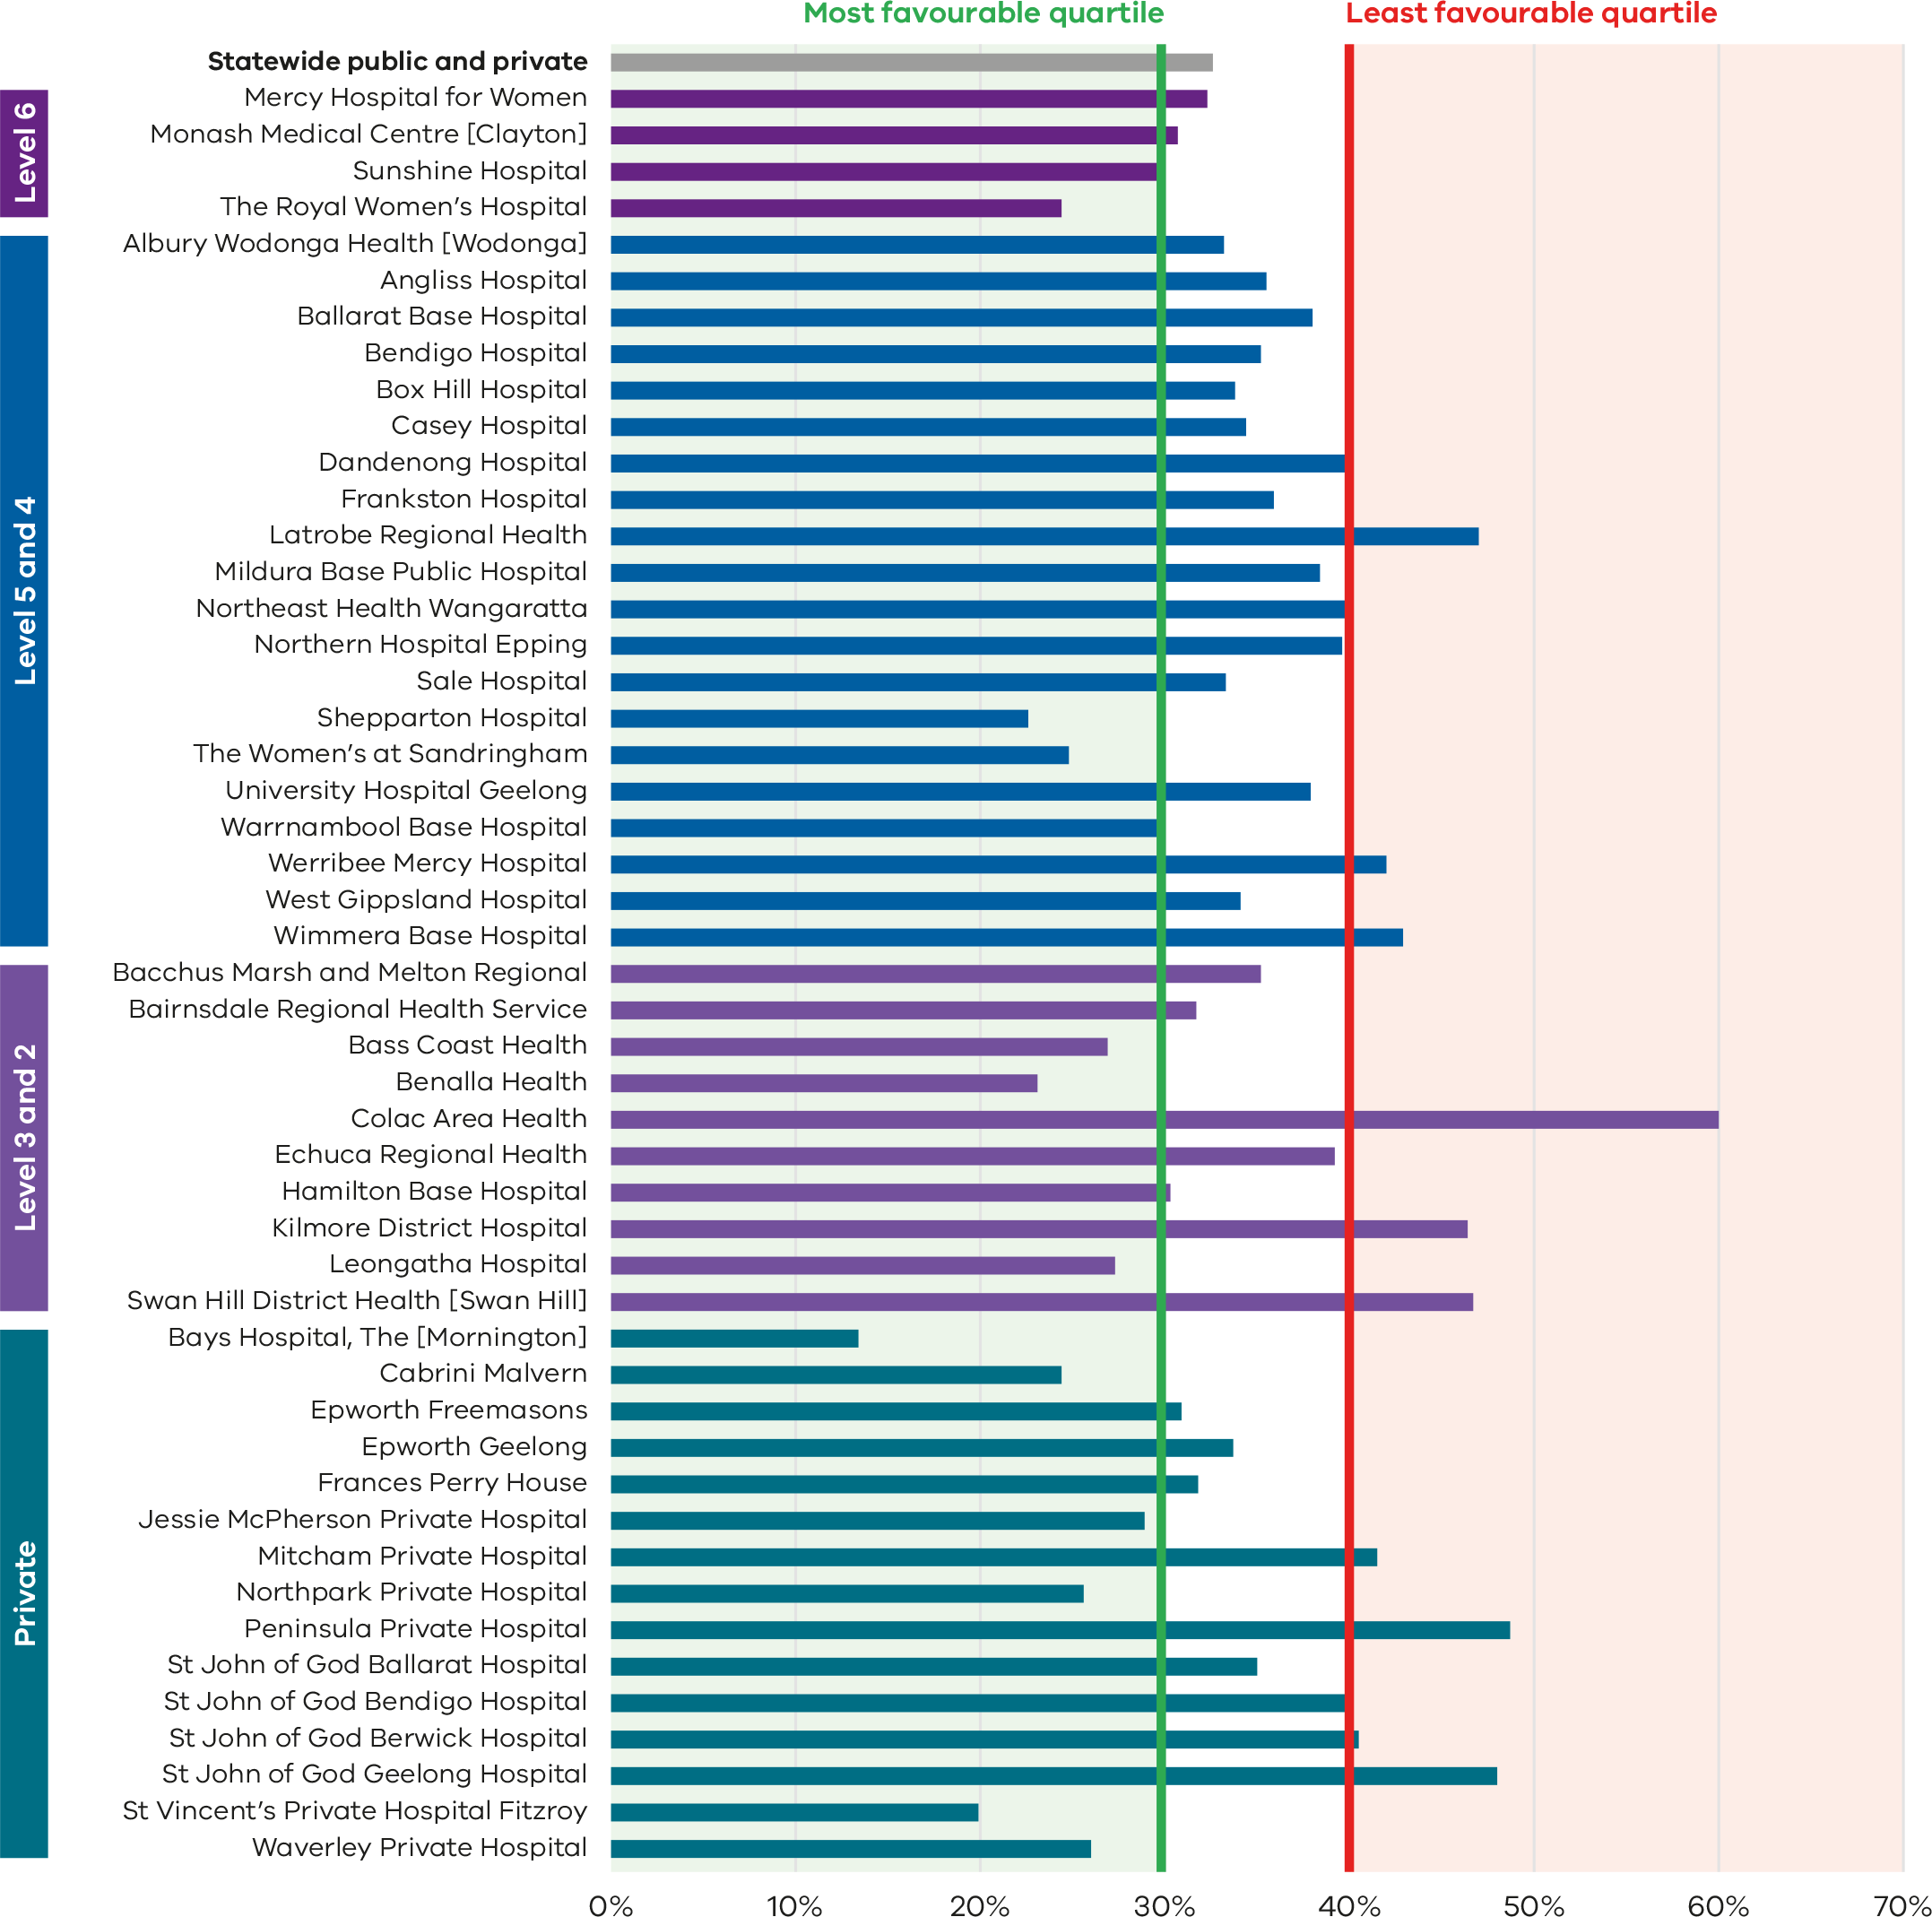

Figure 11. Funnel plot of the rate of caesarean section in modified Robson group 2, 2022
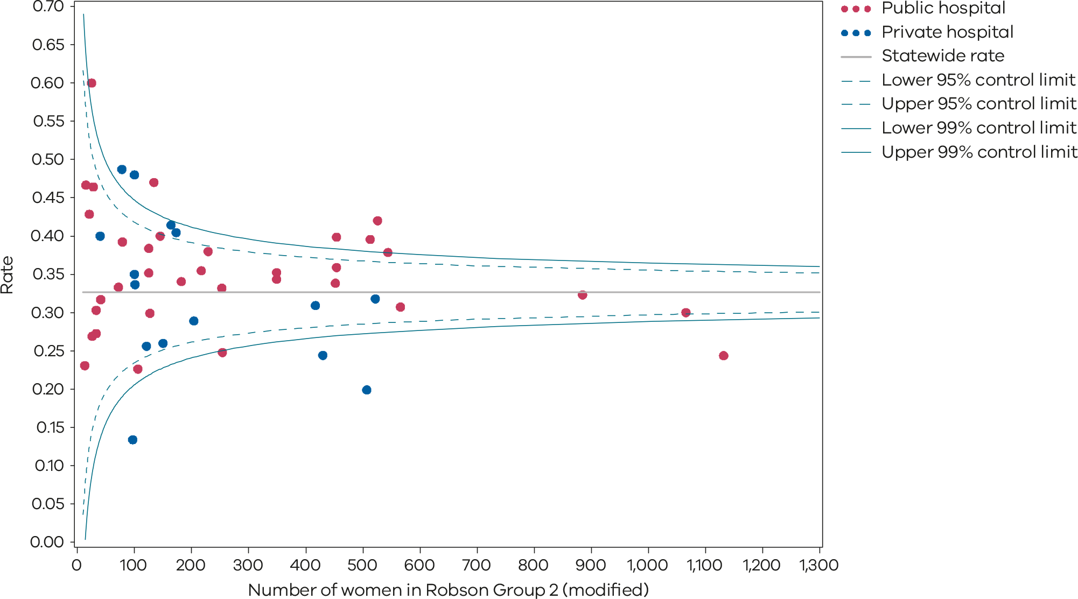
Please refer to the guide on how to interpret funnel plots.
Table 4. Rate of caesarean section in modified Robson group 2, 2018–2022
 | 2018 | 2019 | 2020 | 2021 | 2022
Public | 30.2% | 31.2% | 32.2% | 32.4% | 33.6%
Private | 31.9% | 33.2% | 32.6% | 32.6% | 29.7%
Statewide | 30.6% | 31.6% | 32.3% | 32.4% | 32.6%
Figure 12. Time trend of Indicator 1bii, 2018–2022
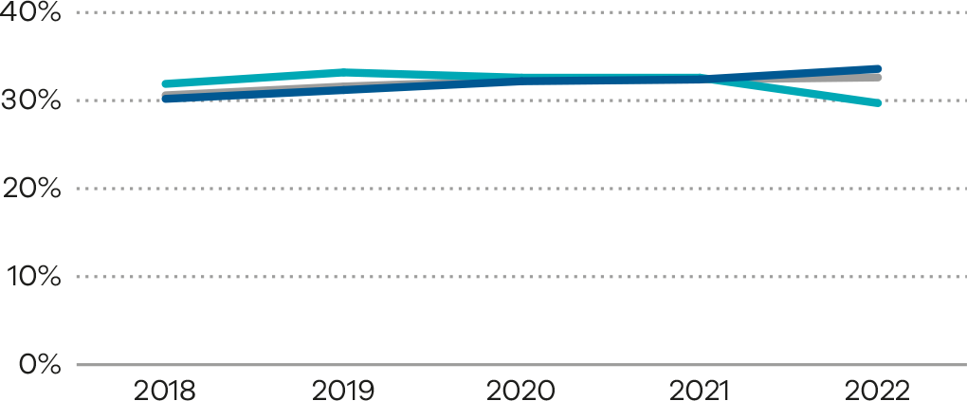
Numerator/denominator
Indicator | Numerator | Denominator
Indicator 1bi: Rate of caesarean section in Robson group 1 | The number of women giving birth for the first time, with spontaneous onset of labour and a singleton, cephalic-presenting baby born at 37 or more weeks by caesarean section | The number of women giving birth for the first time, with spontaneous onset of labour and a singleton, cephalic-presenting baby born at 37 or more weeks
Indicator 1bii: Rate of caesarean section in modified Robson group 2 | The number of women giving birth for the first time, with induced labour (excluding pre‑labour caesarean) and a singleton, cephalic-presenting baby born at 37 or more weeks by caesarean section | The number of women giving birth for the first time, with induced labour (excluding pre-labour caesarean) and a singleton, cephalic-presenting baby born at 37 or more weeks

1ci and 1cii: Perineal tears in primiparae

Figure 13. Indicator 1ci: Rate of third- and fourth-degree perineal tears during unassisted vaginal births in primiparae, 2022
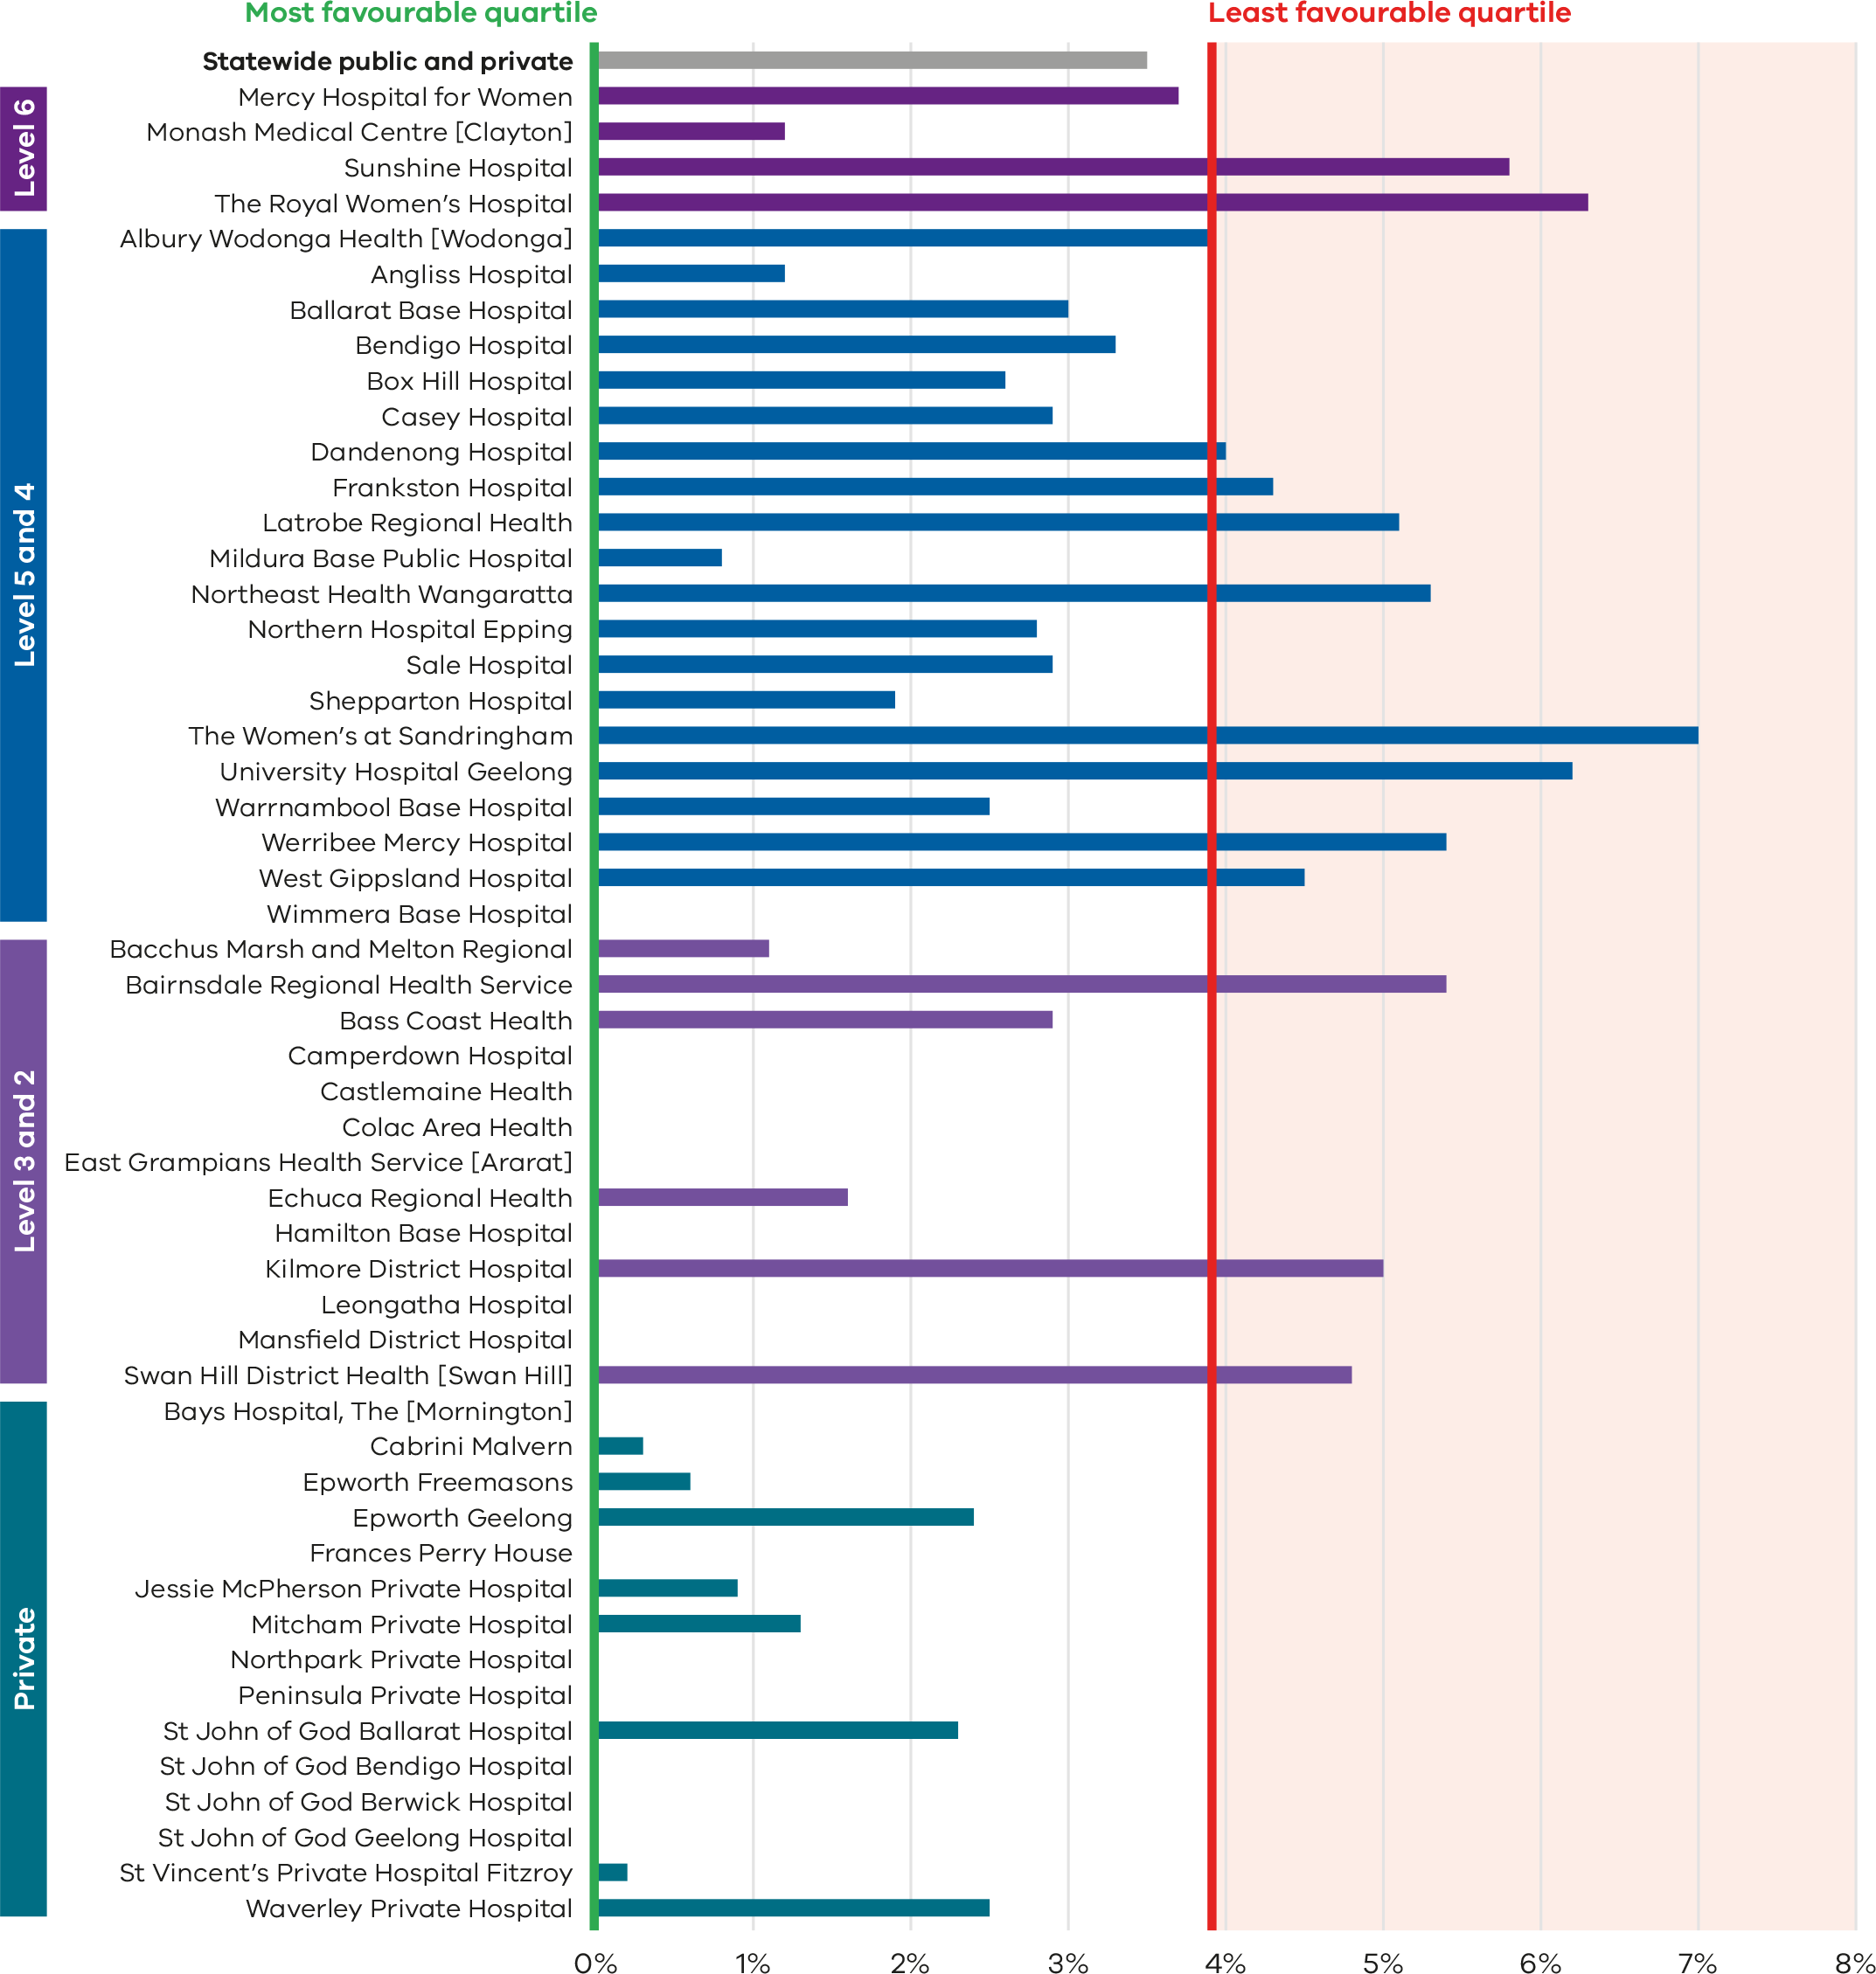
Figure 14. Funnel plot of the rate of third- and fourth-degree perineal tears during unassisted vaginal births in primiparae, 2022
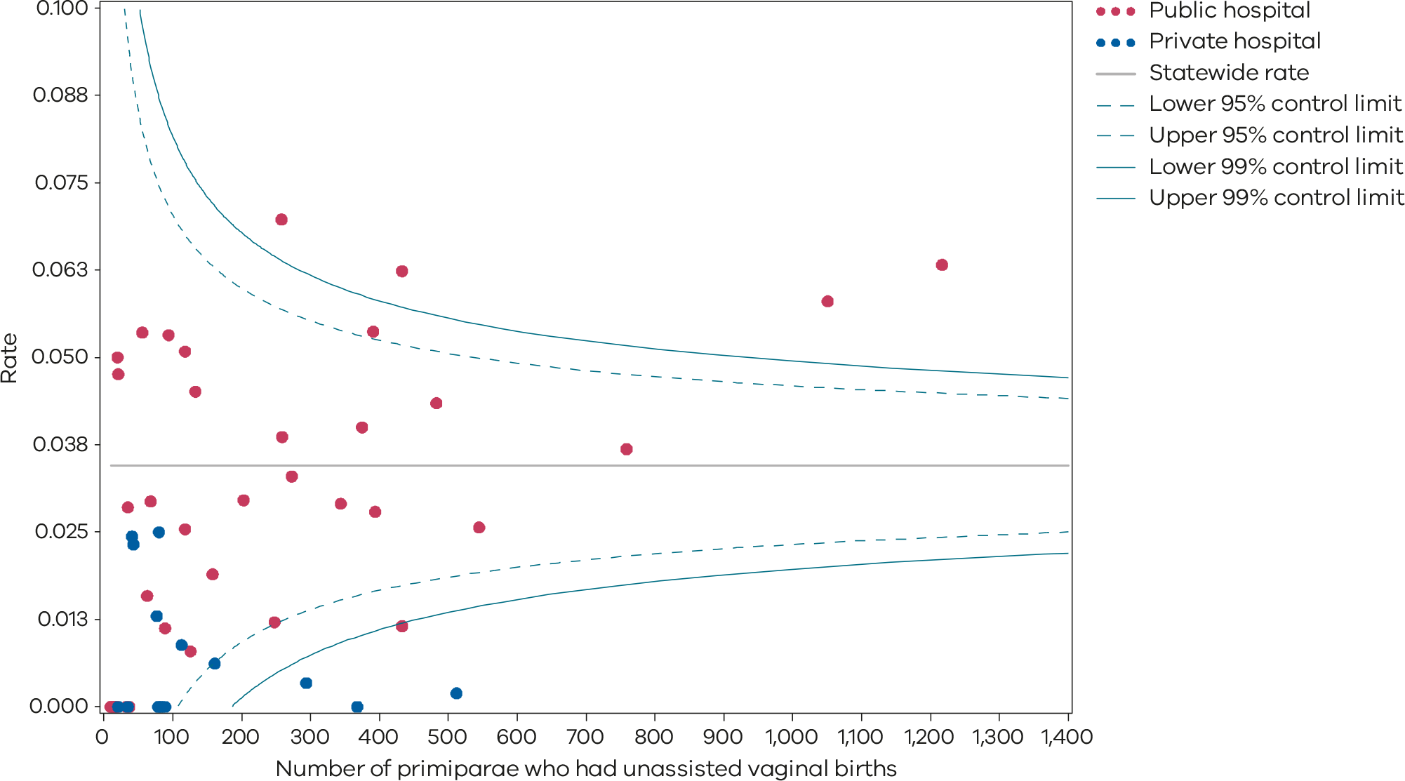
Please refer to the guide on how to interpret funnel plots.
Table 5. Rate of third- and fourth-degree perineal tears during unassisted vaginal births, 2018–2022
 | 2018 | 2019 | 2020 | 2021 | 2022
Public | 4.4% | 4.7% | 4.3% | 4.6% | 4.2%
Private | 1.0% | 1.4% | 0.8% | 1.1% | 0.4%
Statewide | 3.8% | 4.2% | 3.7% | 4.0% | 3.5%
Figure 15. Time trend of Indicator 1ci, 2018–2022
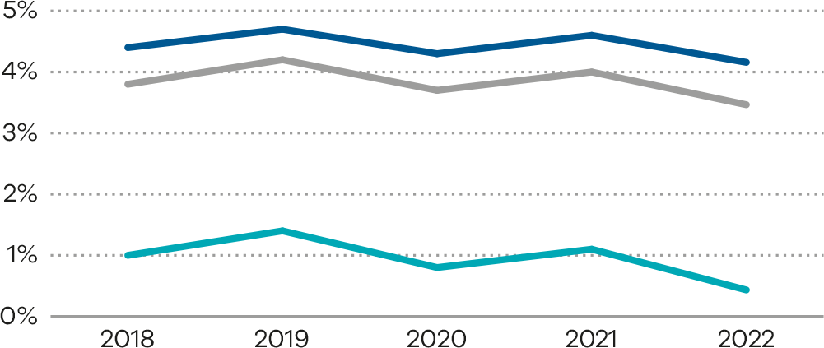
Figure 16. Indicator 1cii: Rate of third- and fourth-degree perineal tears during assisted vaginal births in primiparae, 2022
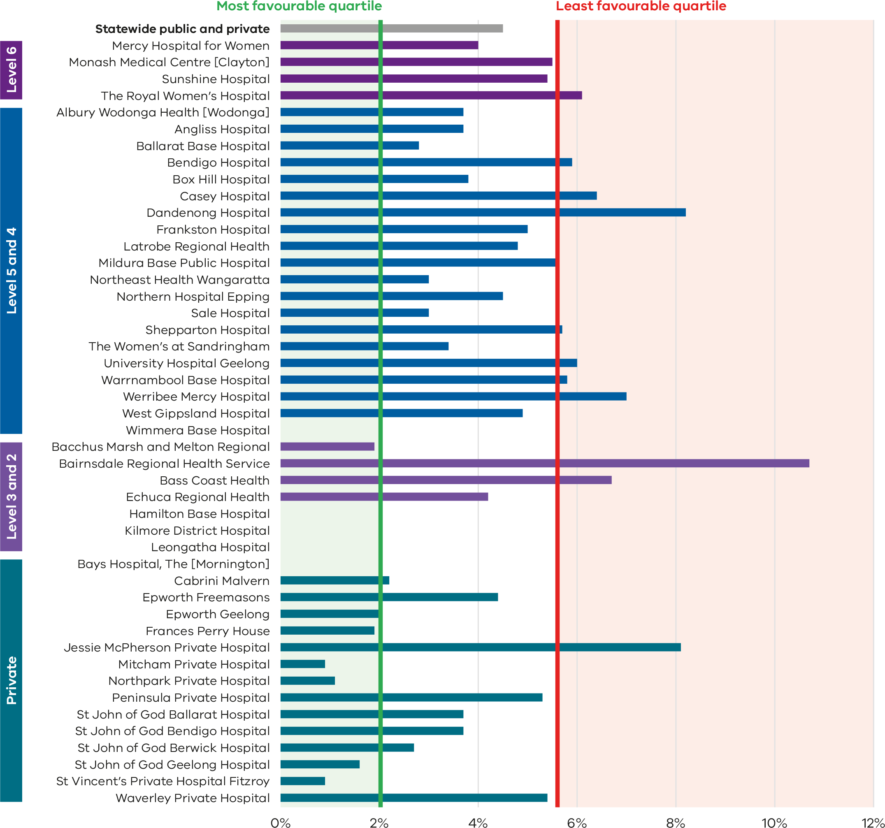
Figure 17. Funnel plot of the rate of third- and fourth-degree perineal tears during assisted vaginal births in primiparae, 2022
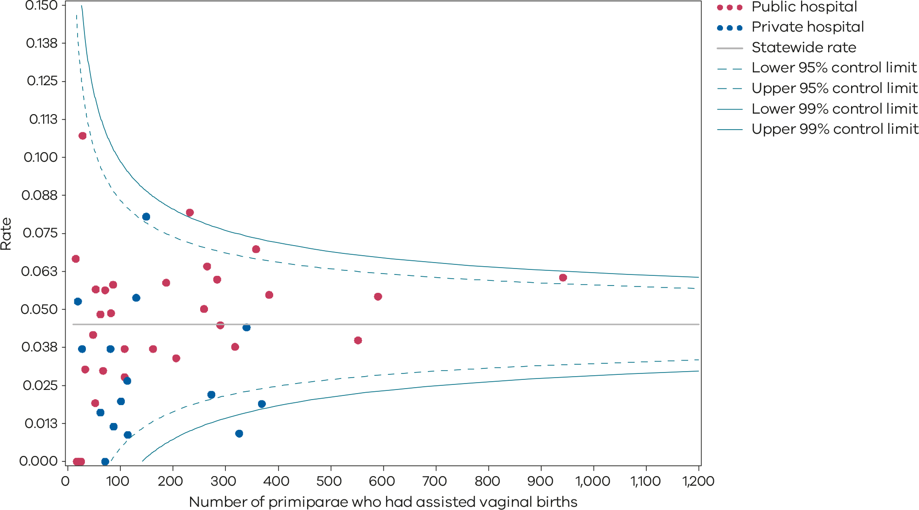
Please refer to the guide on how to interpret funnel plots.
Table 6. Rate of third- and fourth-degree perineal tears during assisted vaginal births, 2018–2022
 | 2018 | 2019 | 2020 | 2021 | 2022
Public | 6.0% | 6.5% | 6.4% | 5.8% | 5.2%
Private | 2.4% | 2.8% | 2.6% | 2.7% | 2.8%
Statewide | 5.0% | 5.6% | 5.4% | 5.0% | 4.5%
Figure 18. Time trend of Indicator 1cii, 2018–2022
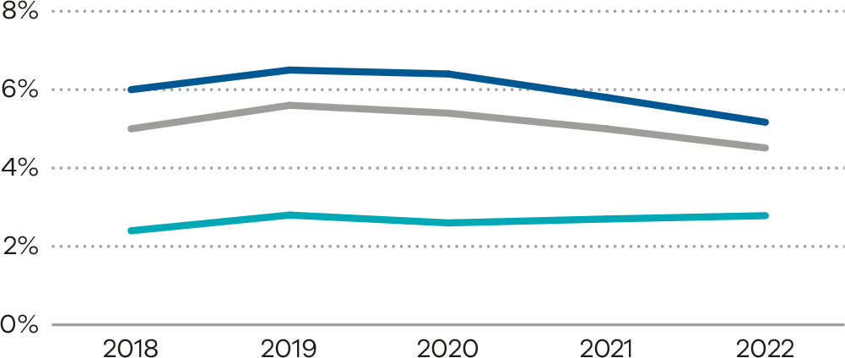
Numerator/denominator
Indicator | Numerator | Denominator
Indicator 1ci: Rate of third- or fourth-degree perineal tears during unassisted vaginal births in primiparae | The number of primiparae who had a third- or fourth-degree perineal laceration during an unassisted vaginal birth | The number of primiparae who had an unassisted vaginal birth
Indicator 1cii: Rate of third- or fourth-degree perineal tears during assisted vaginal births in primiparae | The number of primiparae who had a third- or fourth-degree perineal laceration during an assisted (instrumental) vaginal birth | The number of primiparae who had an assisted vaginal birth

1di and 1dii: Episiotomies in primiparae
Figure 19. Indicator 1di: Rate of primiparae who received an episiotomy during unassisted vaginal births, 2022
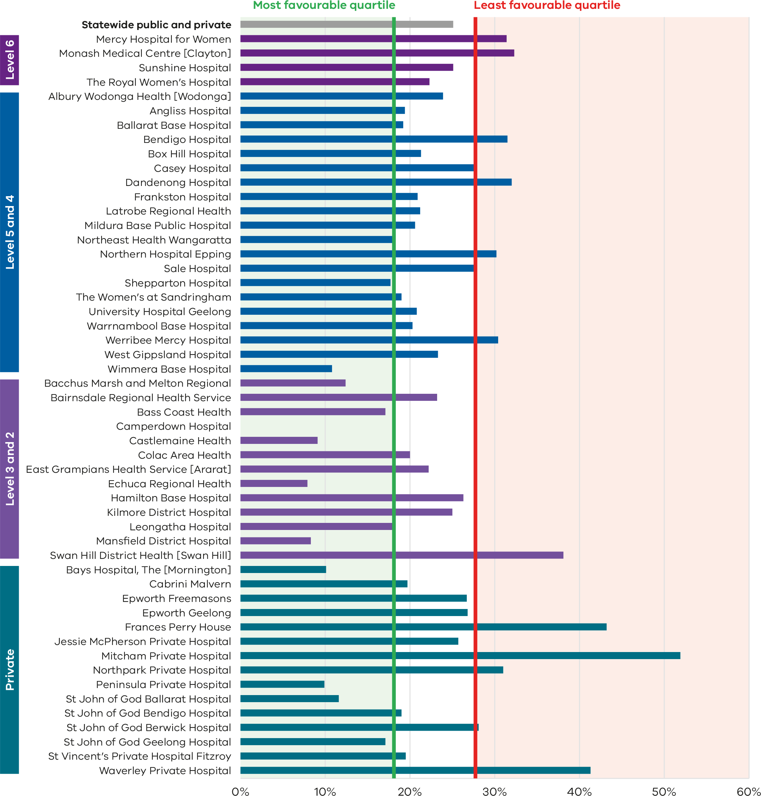
Figure 20. Funnel plot of the rate of primiparae who received an episiotomy during unassisted vaginal births, 2022
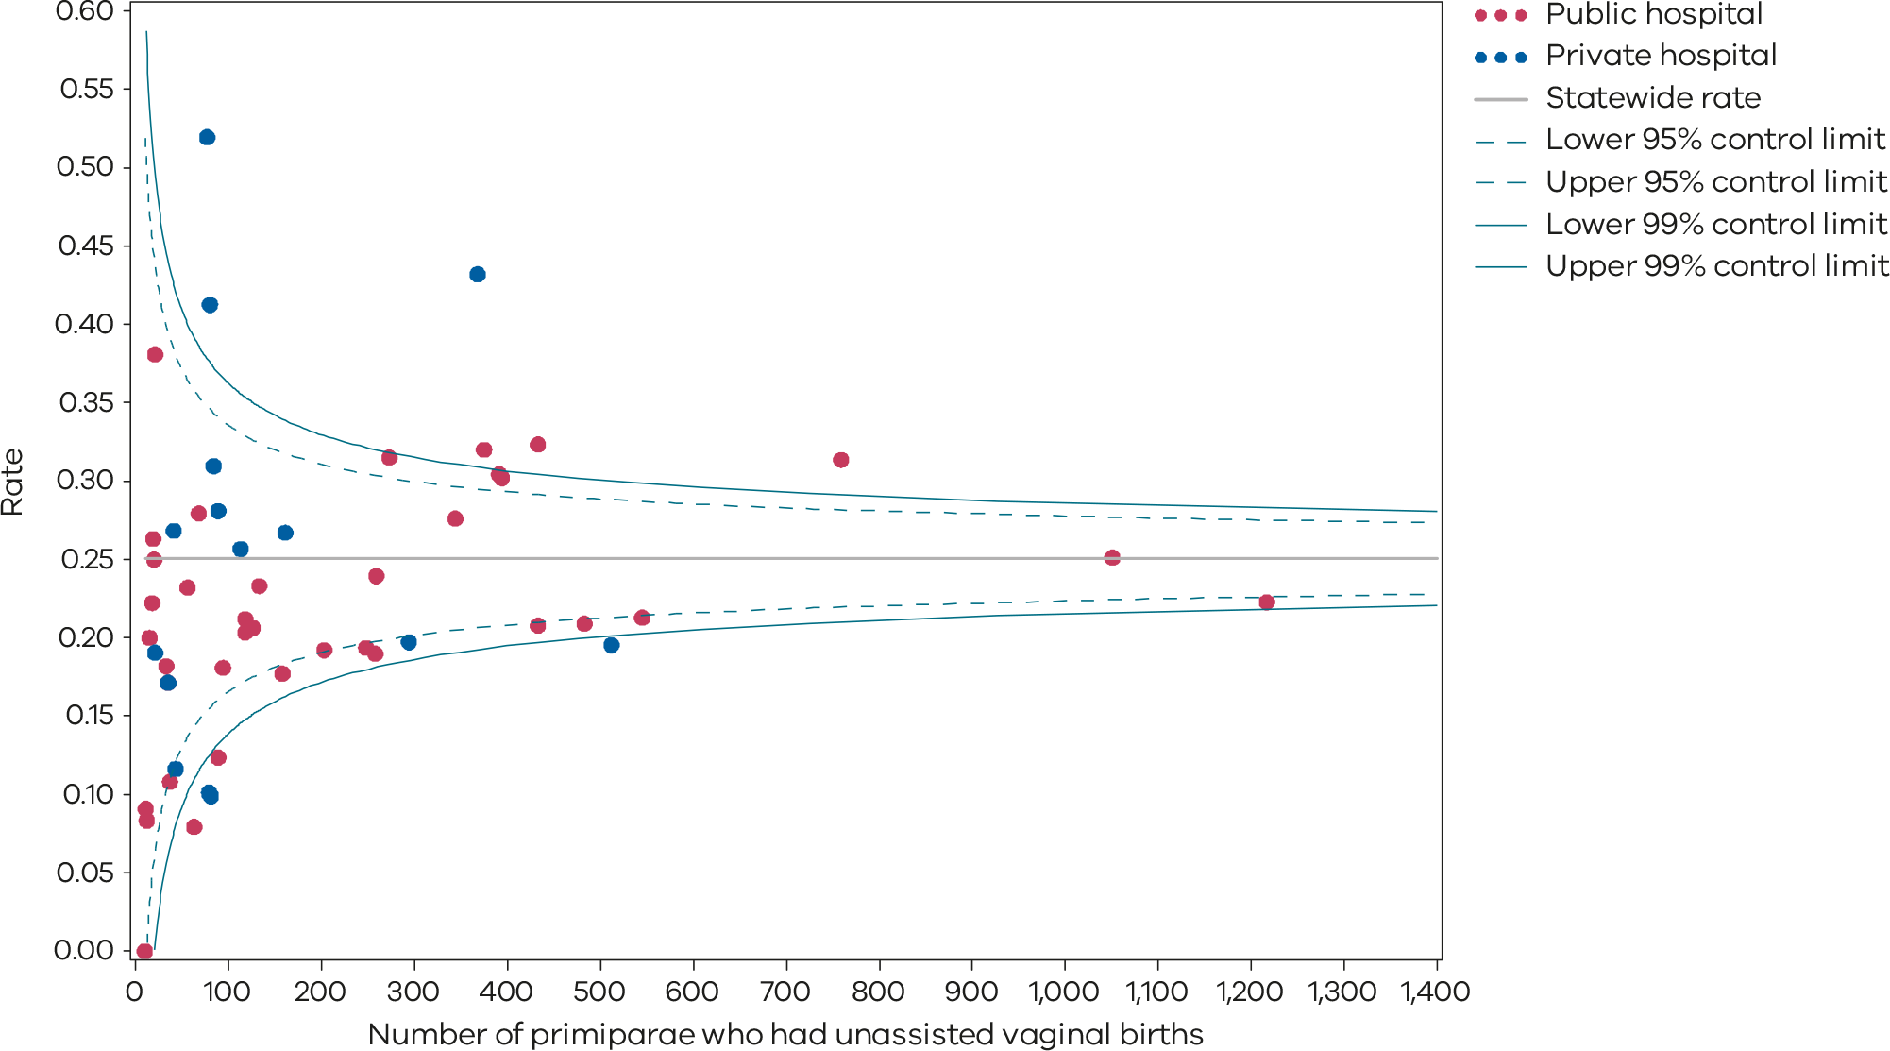
Please refer to the guide on how to interpret funnel plots.
Table 7. Rate of primiparae who received an episiotomy during an unassisted vaginal birth, 2018–2022
 | 2018 | 2019 | 2020 | 2021 | 2022
Public | 25.3% | 26.9% | 27.3% | 26.2% | 24.7%
Private | 33.9% | 32.7% | 30.4% | 30.3% | 26.7%
Statewide | 26.5% | 27.7% | 27.5% | 26.6% | 24.7%
Figure 21. Time trend of Indicator 1di, 2018–2022
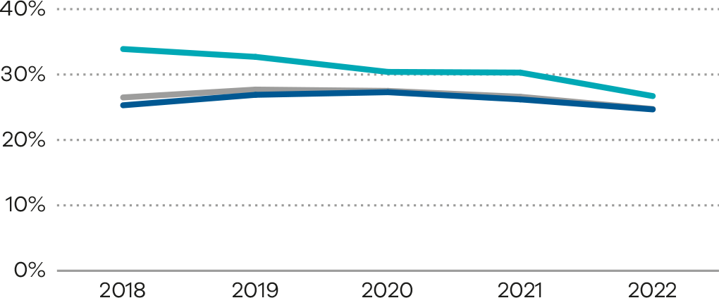
Figure 22. Indicator 1dii: Rate of primiparae who received an episiotomy during assisted vaginal births, 2022
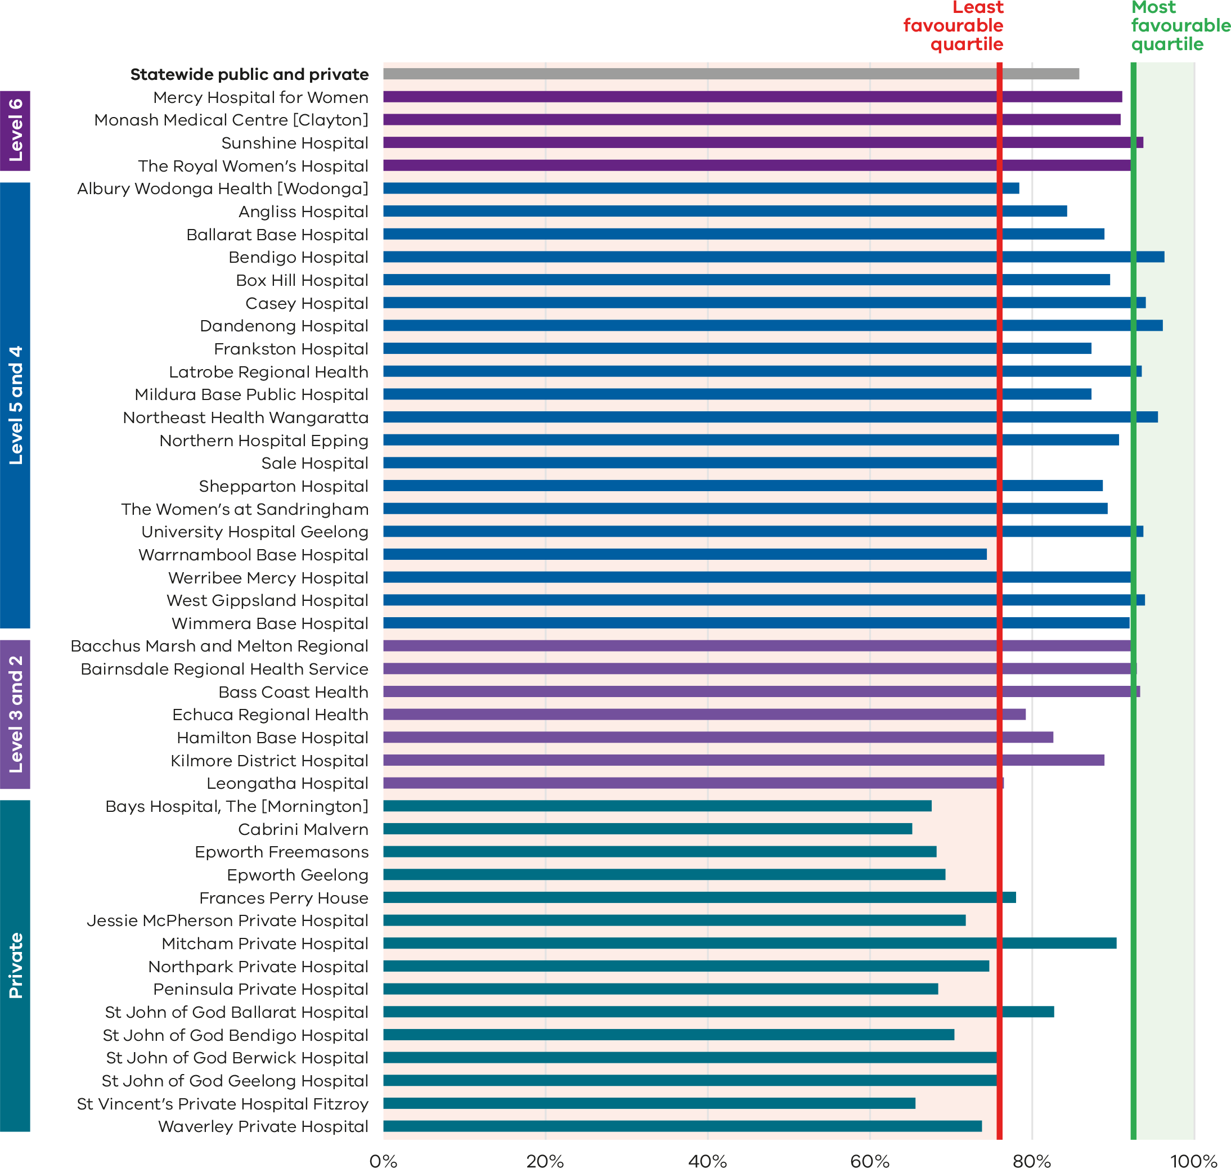

Figure 23. Funnel plot of the rate of primiparae who received an episiotomy during assisted vaginal births, 2022
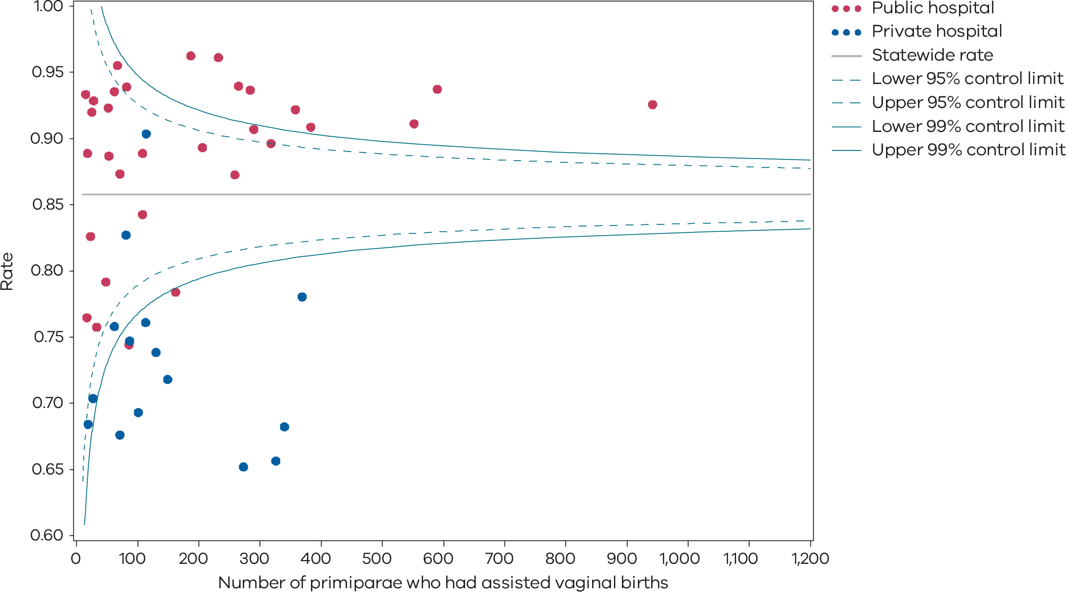
Please refer to the guide on how to interpret funnel plots.
Table 8. Rate of primiparae who received an episiotomy during an assisted vaginal birth, 2018–2022
 | 2018 | 2019 | 2020 | 2021 | 2022
Public | 87.0% | 88.7% | 90.8% | 91.2% | 90.9%
Private | 72.3% | 70.6% | 73.2% | 73.1% | 72.2%
Statewide | 83.1% | 84.0% | 86.4% | 86.5% | 85.8%
Figure 24. Time trend of Indicator 1dii, 2018–2022
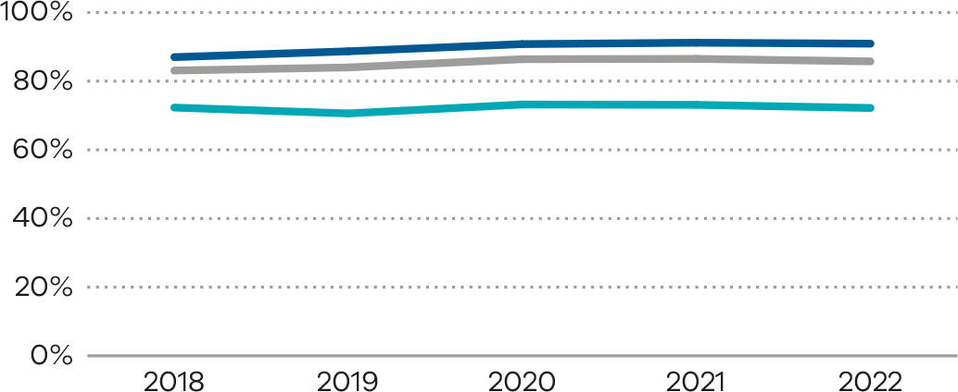
Numerator/denominator
Indicator | Numerator | Denominator
Indicator 1di: Rate of primiparae who received an episiotomy during unassisted vaginal births | The number of primiparae who had an episiotomy during an unassisted vaginal birth | The number of primiparae who had an unassisted vaginal birth
Indicator 1dii: Rate of primiparae who received an episiotomy during assisted vaginal births | The number of primiparae who had an episiotomy during an assisted vaginal birth | The number of primiparae who had an assisted (instrumental) vaginal birth

2: Term babies without congenital anomalies who required additional care
Figure 25. Indicator 2: Rate of term babies without congenital anomalies who required additional care, 2022–23
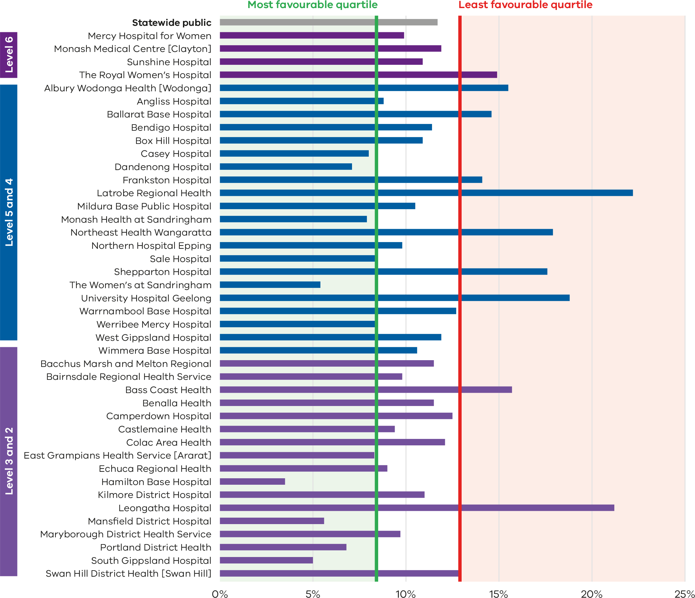
Note 1: Reporting of unqualified babies admissions to the VAED for private hospitals is optional. It is therefore not possible to establish an accurate denominator (that includes public and private hospitals) for this indicator. As such, only public hospitals are included in the results.
Note 2: A result of 0% indicates that a health service met the reporting criteria of 10 or more inborn term babies without congenital anomalies; however, none of these babies required additional care.

Figure 26. Funnel plot of the rate of term babies without congenital anomalies who required additional care, 2022–23
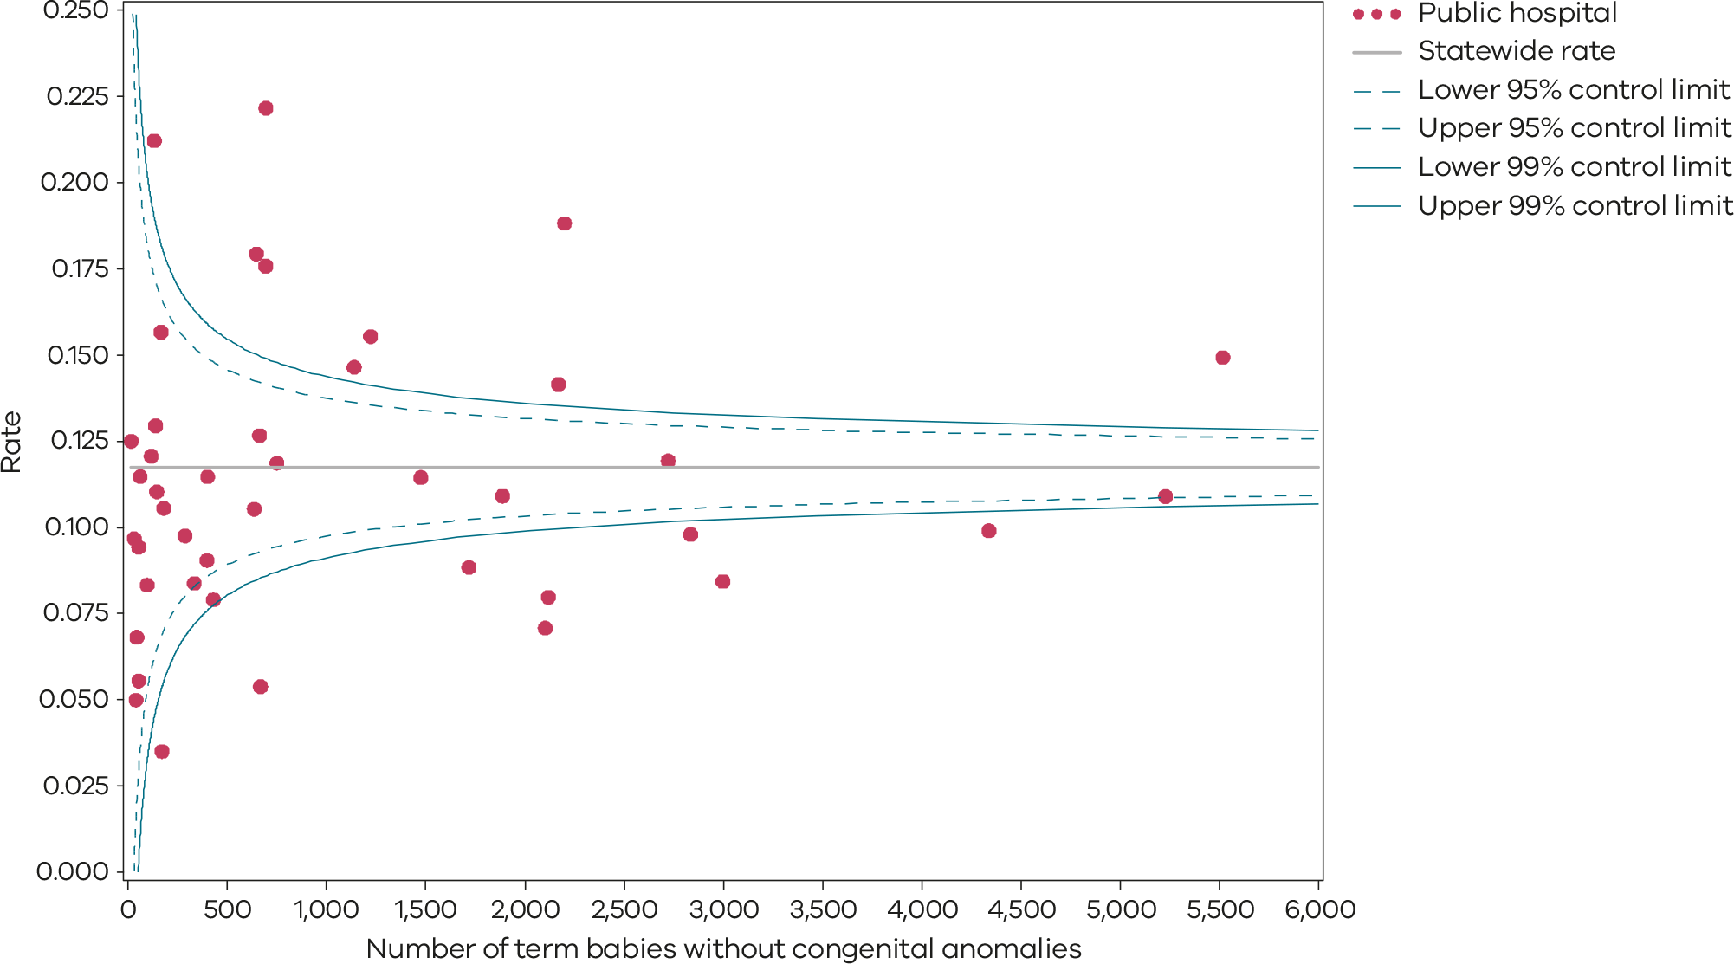
Please refer to the guide on how to interpret funnel plots.
Table 9. Rate of term babies without congenital anomalies who required additional care, by financial year, 2018–19 to 2022–23
 | 2018–19 | 2019–20 | 2020–21* | 2021–22* | 2021–23*
Public | 9.2% | 8.1% | 11.7% | 11.0% | 11.7%
Note there has been a change in the data derivation for this indicator in 2020–21 and 2021–22, reflecting the higher rates for the past 2 years compared with previous years (Table 9).
Numerator/denominator
Indicator | Numerator | Denominator
Indicator 2: Rate of term babies without congenital anomalies who required additional care | The number of tertiary-born (‘inborn’) term babies without congenital anomalies grouped to VIC-DRG P68A, P68B, P68C, P06A, P06B, P60A and P60B | The number of tertiary-born (‘inborn’) term babies without congenital anomalies grouped to VIC-DRG P68A, P68B, P68C, P68D, P06A, P06B, P60A and P60B
Regrouping of some babies initially grouped to P60A and P60B occurred prior to 2019–20. There has been a change to the reporting method and regrouping did not occur for the PSPI report for 2022–23, 2021–22 and 2020–21. This may mean that there is an overestimation of the rate of babies requiring additional care because some healthy babies are transferred for other reasons.

3a and 3b: Severe fetal growth restriction

Figure 27. Indicator 3a: Rate of severe fetal growth restriction in a singleton pregnancy undelivered by 40 weeks, 2022
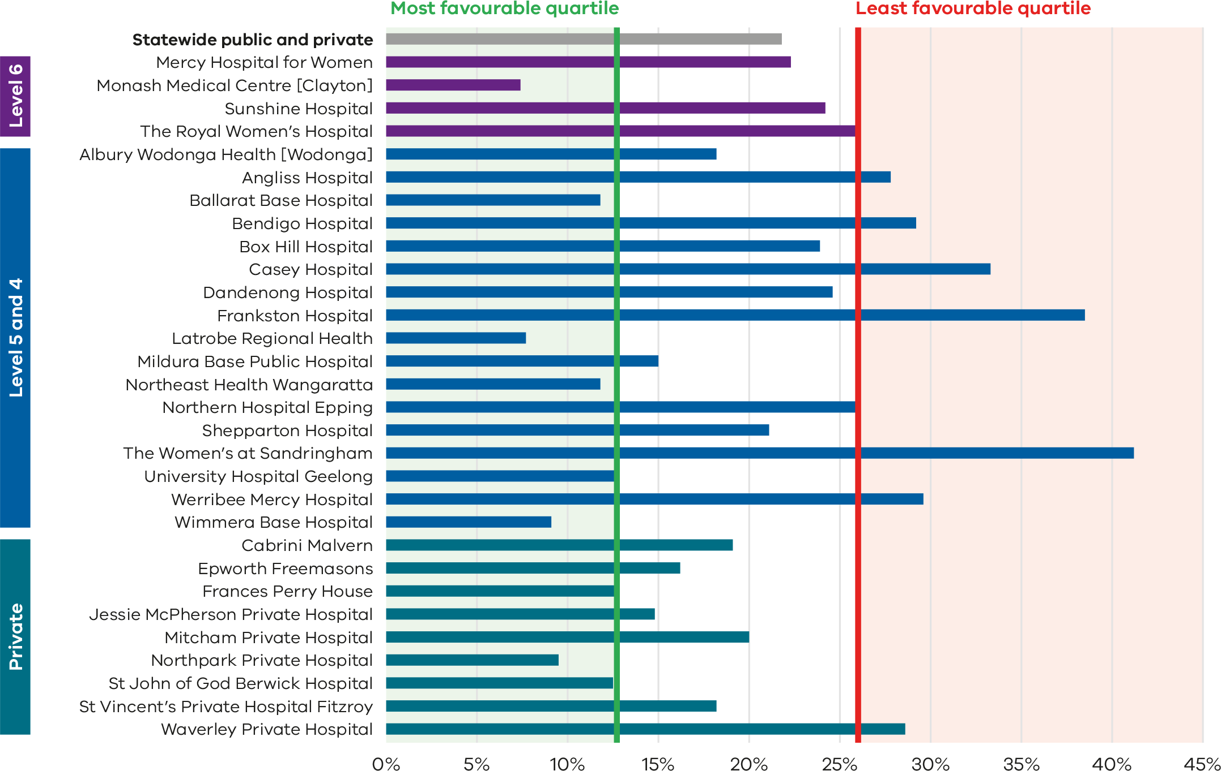

Figure 28. Funnel plot of the rate of severe fetal growth restriction in a singleton pregnancy undelivered by 40 weeks, 2022
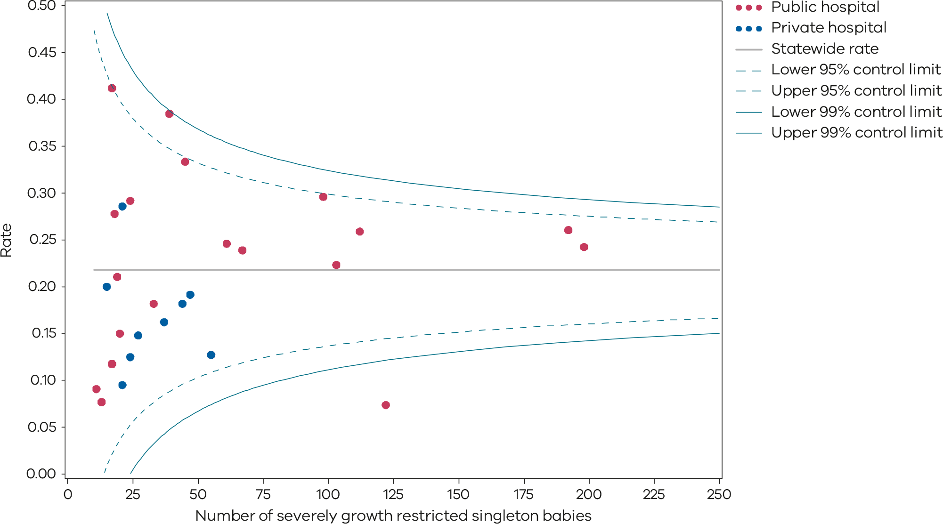
Please refer to the guide on how to interpret funnel plots.
Table 10. Rate of severe fetal growth restriction in a singleton pregnancy undelivered by 40 weeks, 2018–2022
 | 2018 | 2019 | 2020 | 2021 | 2022
Public | 23.0% | 22.1% | 20.5% | 20.6% | 22.7%
Private | 30.2% | 26.4% | 21.3% | 17.5% | 17.7%
Statewide | 24.3% | 23.0% | 20.8% | 20.0% | 22.0%
Figure 29. Time trend of Indicator 3a, 2018–2022
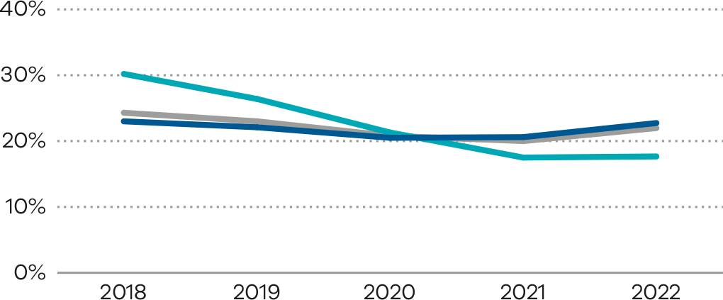
Figure 30. Indicator 3b: Rate of babies with a birthweight above the 25th centile actively delivered for fetal growth restriction before 39 weeks’ gestation (FGR balance measure), 2022
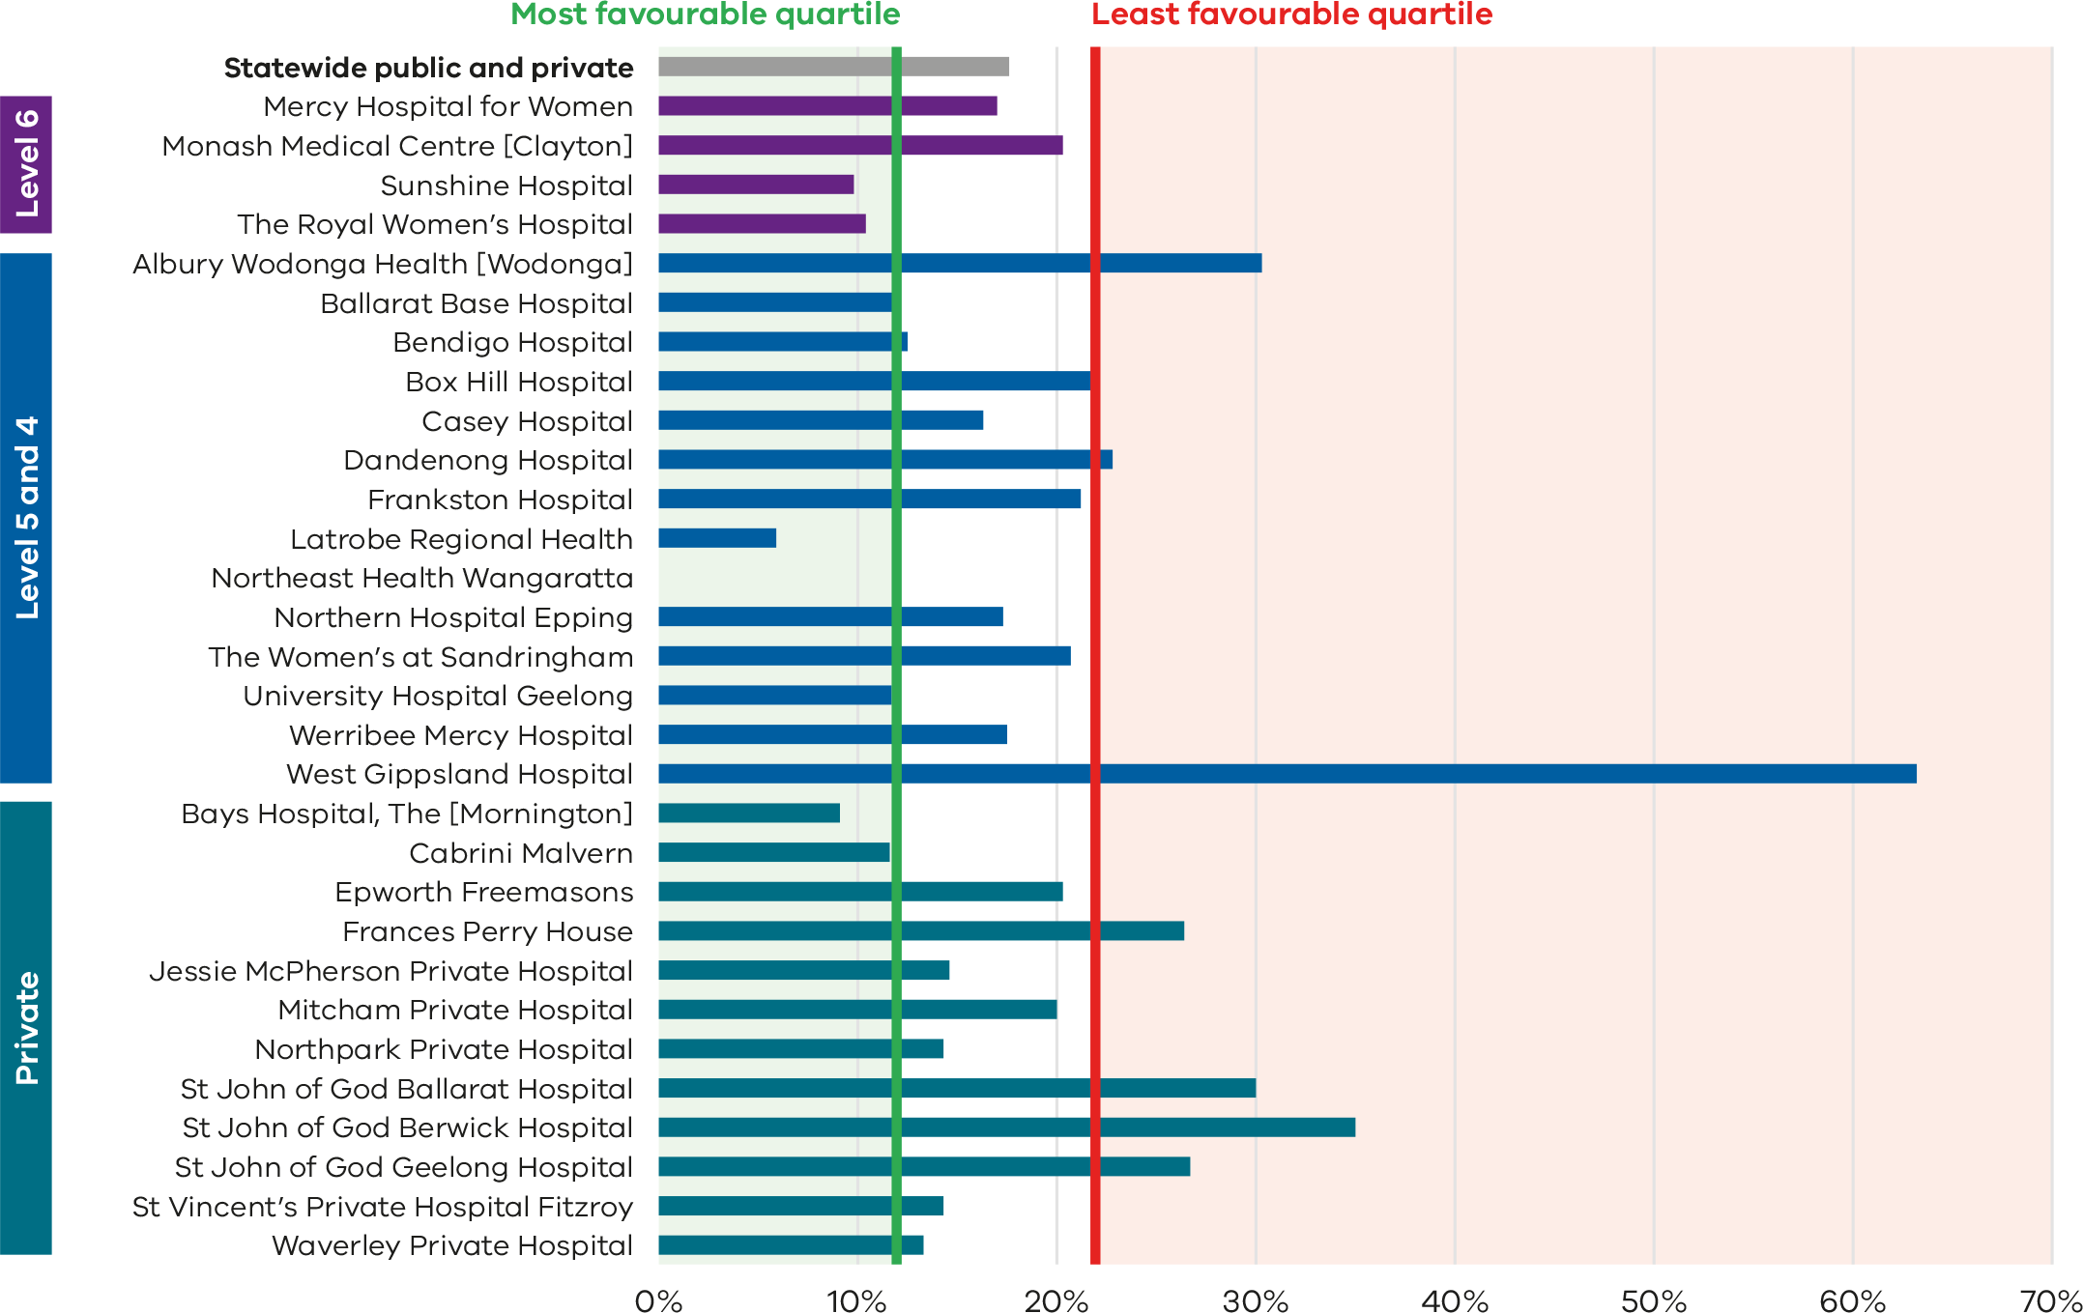

Figure 31. Funnel plot of rate of babies with a birthweight above the 25th centile actively delivered for fetal growth restriction before 39 weeks’ gestation (FGR balance measure), 2022
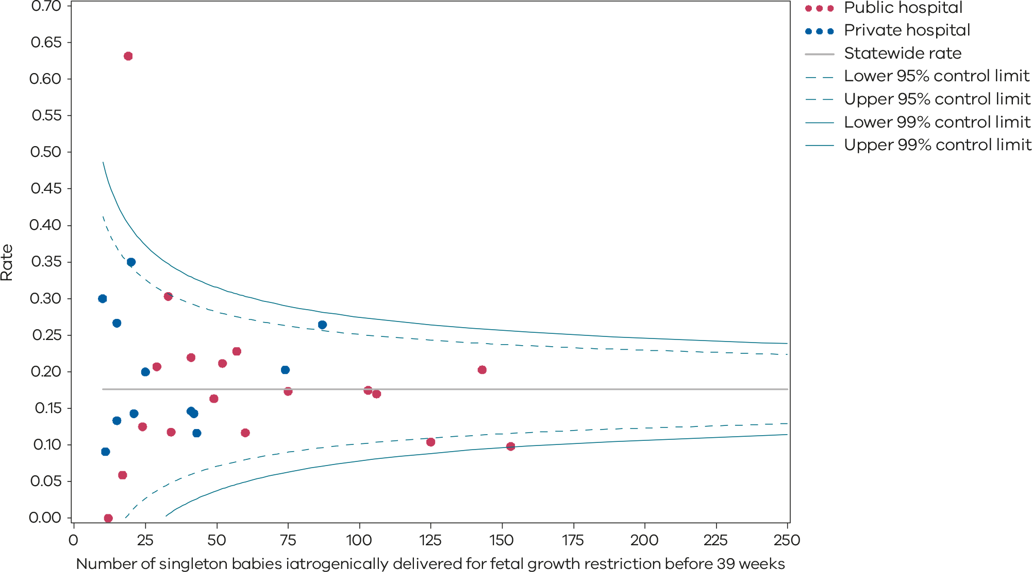
Please refer to the guide on how to interpret funnel plots.
Table 11. Rate of babies with a birthweight above the 25th centile actively delivered for fetal growth restriction before 39 weeks’ gestation (FGR balance measure), 2021–2022
 | 2021 | 2022
Public | 16.8% | 16.8%
Private | 22.1% | 20.0%
Statewide | 18.2% | 17.6%
Figure 32. Time trend of Indicator 3b, 2021–2022
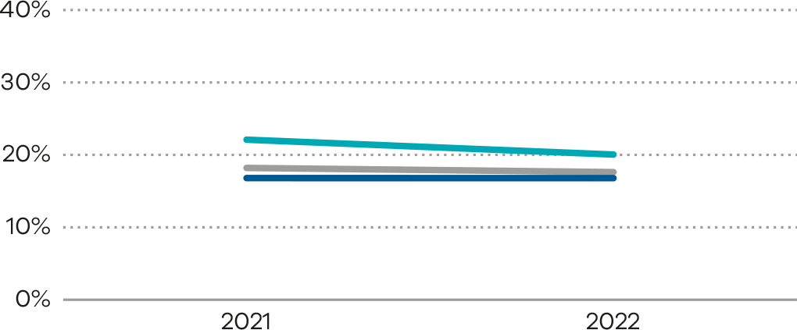
Numerator/denominator
Indicator | Numerator | Denominator
Indicator 3a: Rate of severe fetal growth restriction in a singleton pregnancy undelivered by 40 weeks | Birth at 40 or more weeks’ gestation of a singleton baby with severe FGR | Singleton births (live and stillborn) with severe FGR born at and beyond 32 weeks’ gestation
Indicator 3b: Rate of babies with a birthweight above the 25th centile actively delivered for fetal growth restriction before 39 weeks’ gestation | Singleton births iatrogenically delivered for FGR before 39 weeks’ gestation whose birthweight was above the 25th centile | Singleton births iatrogenically delivered for FGR before 39 weeks’ gestation
For indicator 3a, a baby is considered to be severely growth-restricted when their birthweight is below the third centile for gestation, sex and plurality. It is calculated based on the Australian Institute of Health and Welfare’s national birthweight percentiles by sex and gestation, 2004 to 2013 tables (refer to Tables 26 and 27). For example, if a male singleton baby weighing 1,600 grams is born at 35 weeks, it falls below the third centile for gestation, sex and plurality. The baby is then considered severely growth restricted (Indicator 3a).
For indicator 3b, a baby is considered to be normally growing if their birthweight was above the 25th centile for gestation, sex and plurality. It is calculated based on the Australian Institute of Health and Welfare’s national birthweight percentiles by sex and gestation, 2004 to 2013 tables (refer to Tables 26 and 27).

4a and 4b: Vaginal birth after primary caesarean section
Figure 33. Indicator 4a: Rate of women who planned a vaginal birth after a primary caesarean section, 2022
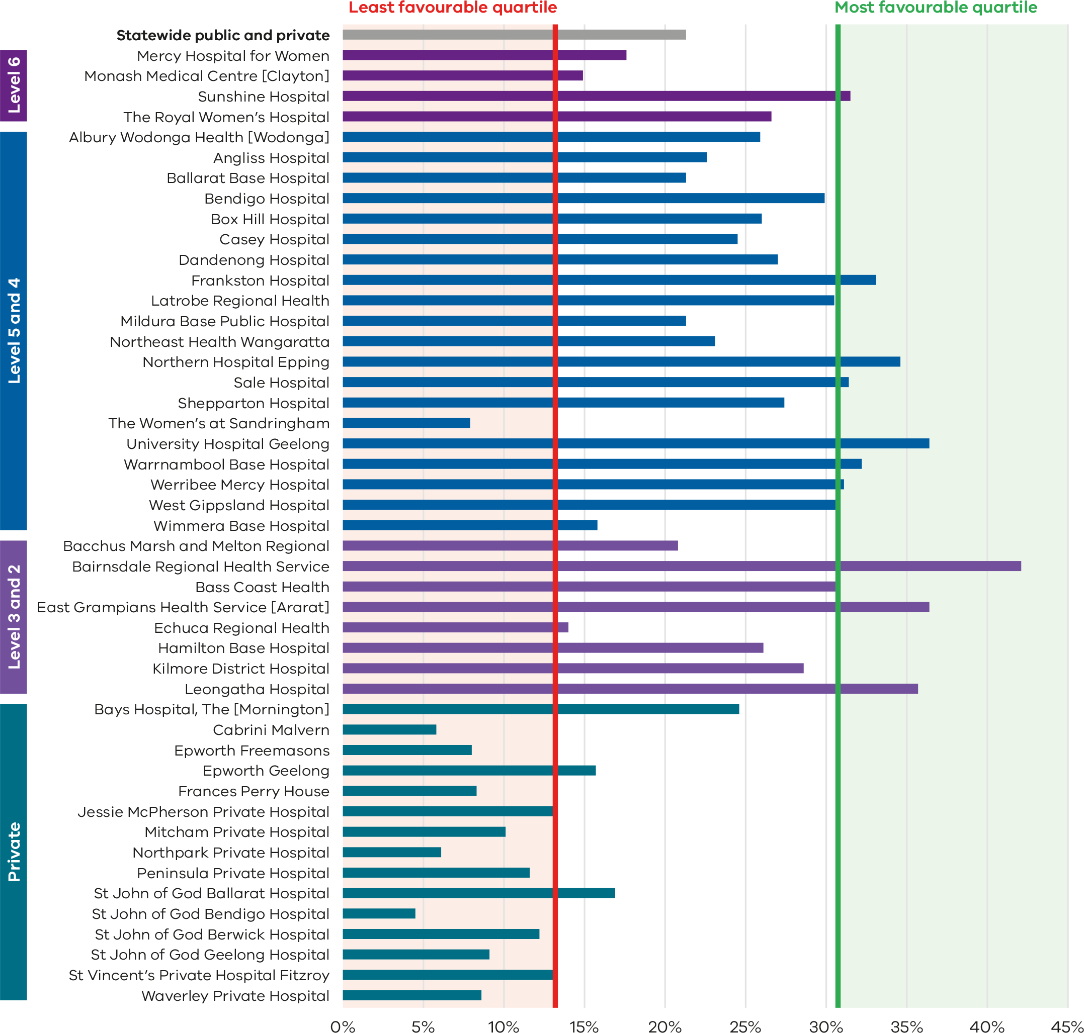

Figure 34. Funnel plot of the rate of women who planned a vaginal birth after a primary caesarean section, 2022
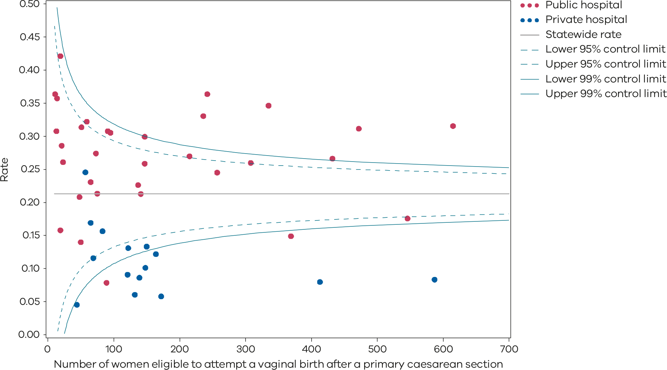
Please refer to the guide on how to interpret funnel plots.
Table 12. Rate of women who planned a vaginal birth after a primary caesarean section,
2018–2022
 | 2018 | 2019 | 2020 | 2021 | 2022
Public | 27.1% | 26.3% | 27.8% | 26.0% | 26.5%
Private | 14.7% | 13.2% | 11.2% | 11.3% | 9.8%
Statewide | 23.4% | 22.3% | 22.9% | 21.5% | 21.5%
Figure 35. Time trend of Indicator 4a, 2018–2022
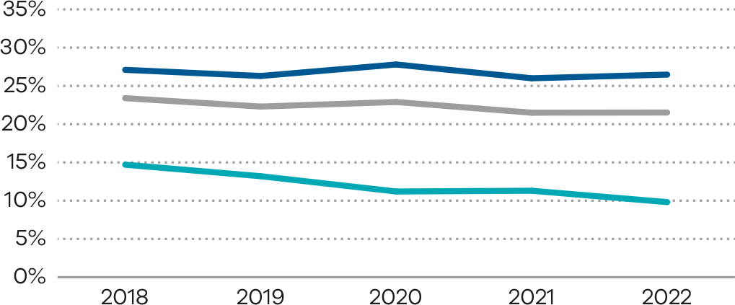
Figure 36. Indicator 4b: Rate of women who achieved a planned vaginal birth after a primary caesarean section, 2022
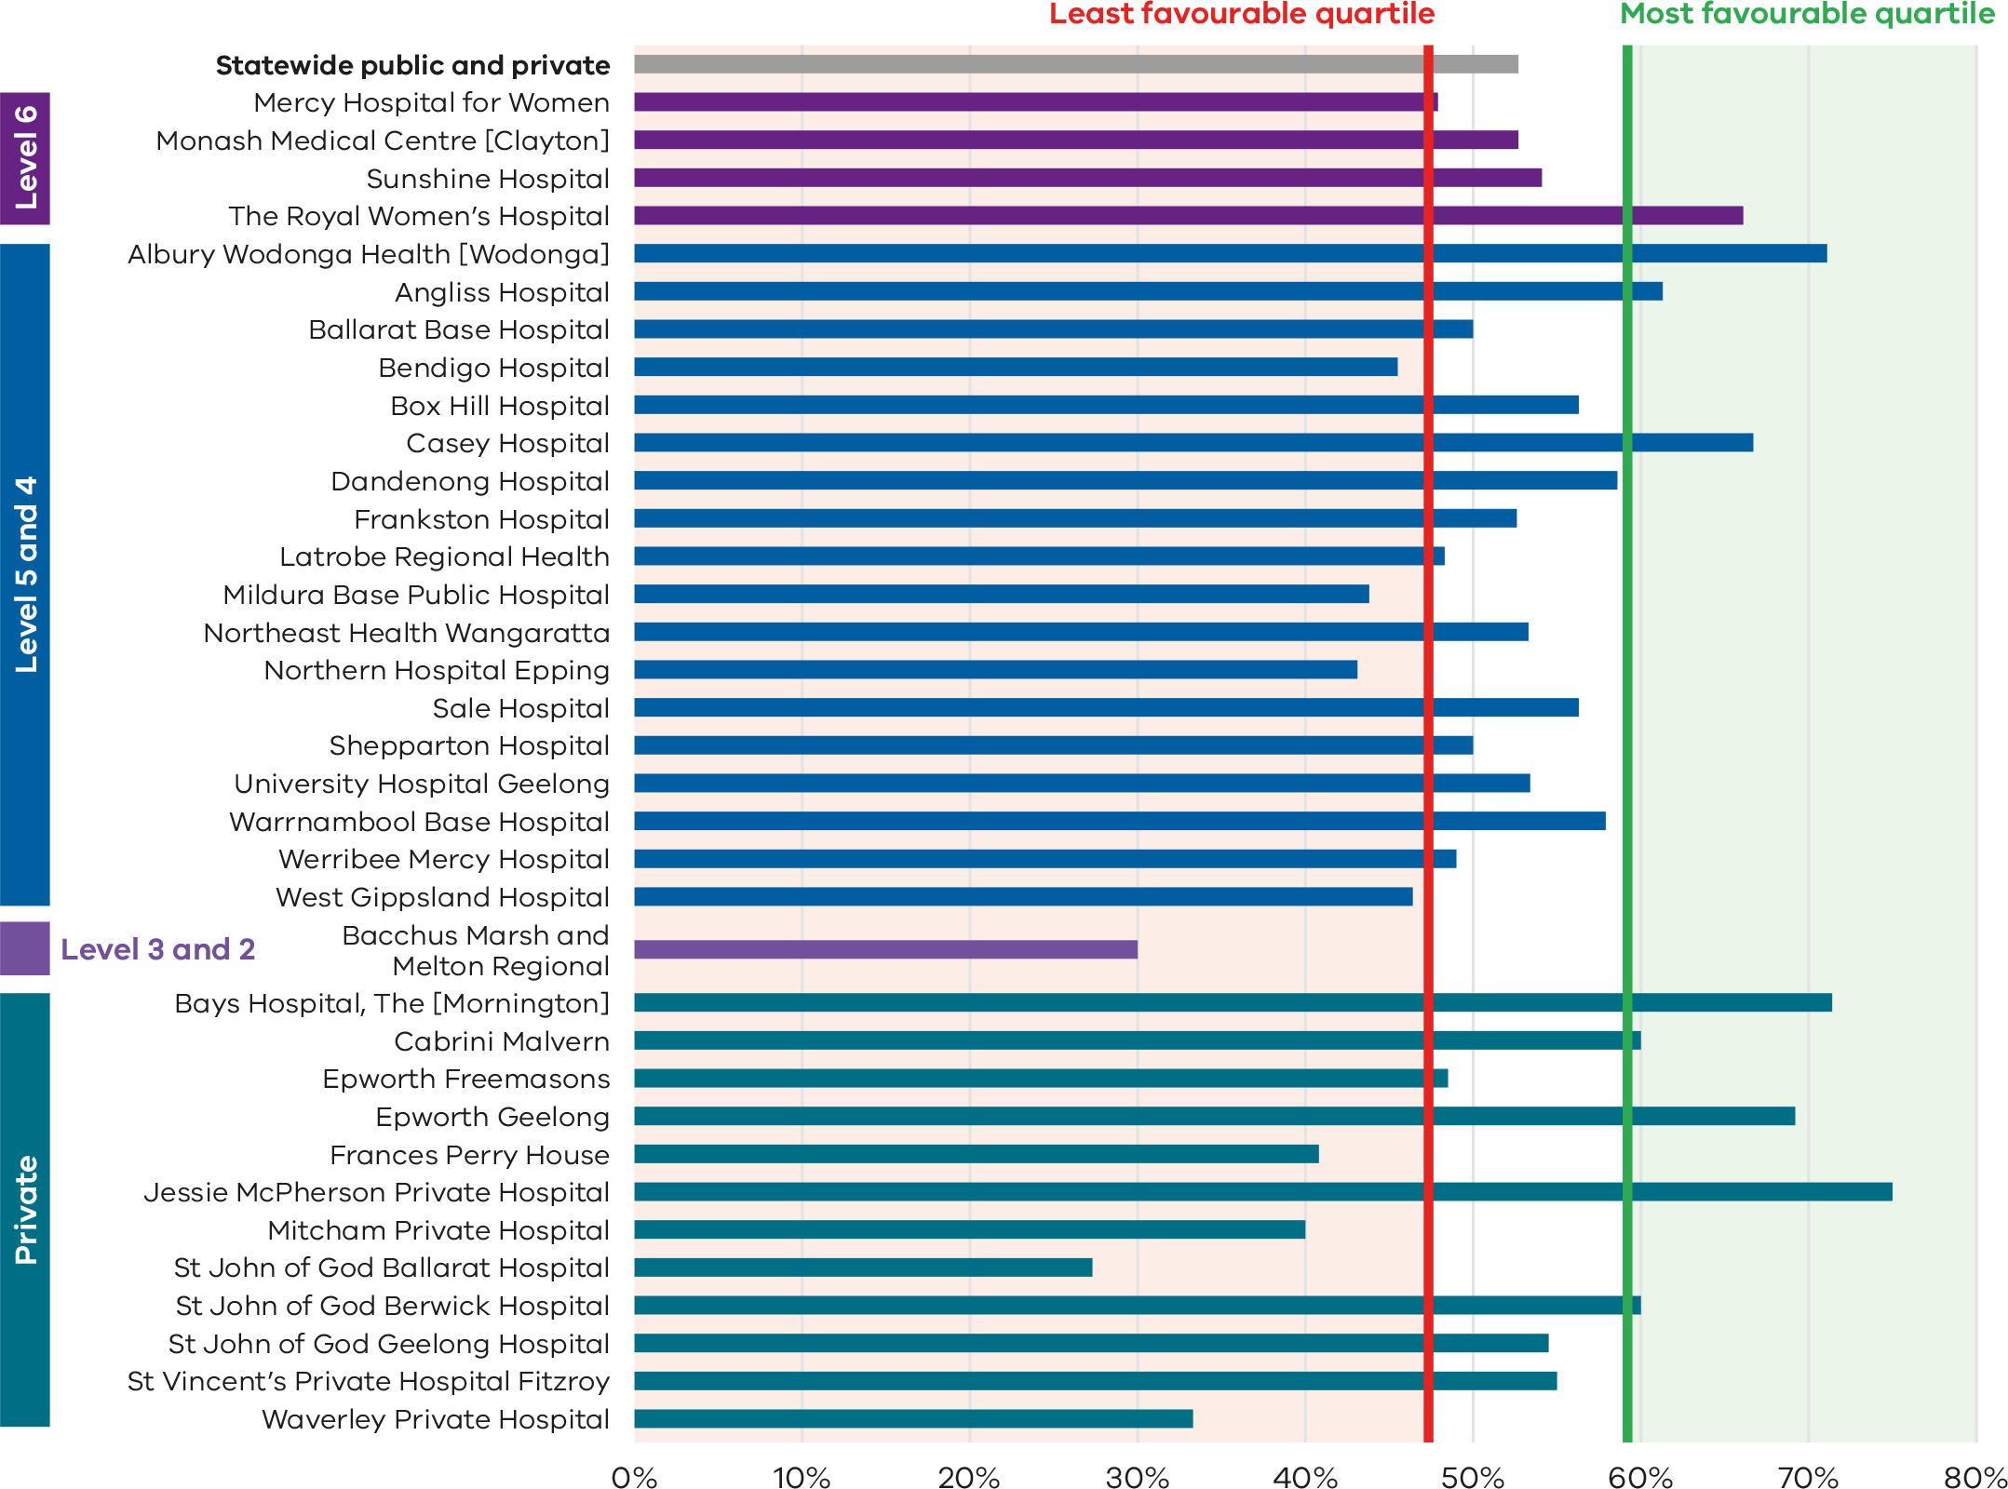

Figure 37. Funnel plot of the rate of women who achieved a planned vaginal birth after a primary caesarean section, 2022
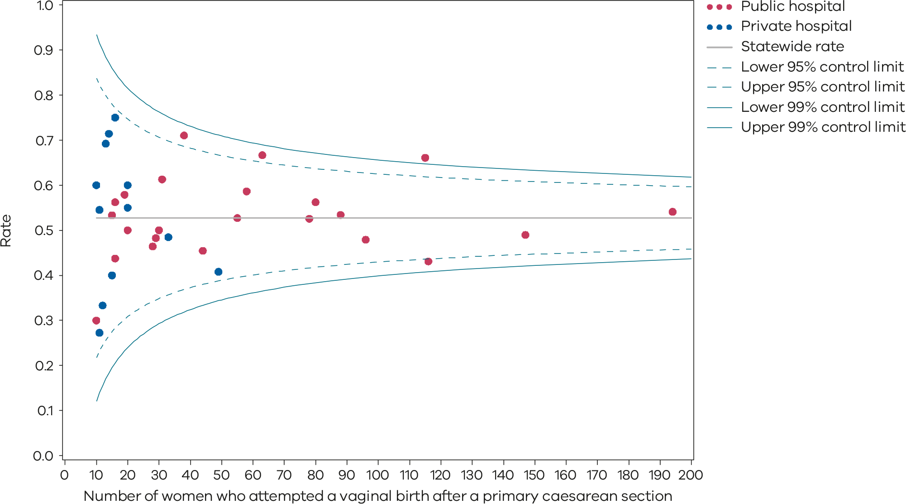
Please refer to the guide on how to interpret funnel plots.
Table 13. Rate of women who achieved a planned vaginal birth after a primary caesarean section, 2018–2022
 | 2018 | 2019 | 2020 | 2021 | 2022
Public | 55.0% | 54.1% | 52.5% | 54.1% | 53.1%
Private | 46.9% | 48.1% | 48.8% | 52.6% | 50.4%
Statewide | 53.5% | 53.2% | 52.2% | 54.3% | 53.4%
Figure 38. Time trend of Indicator 4b, 2018–2022
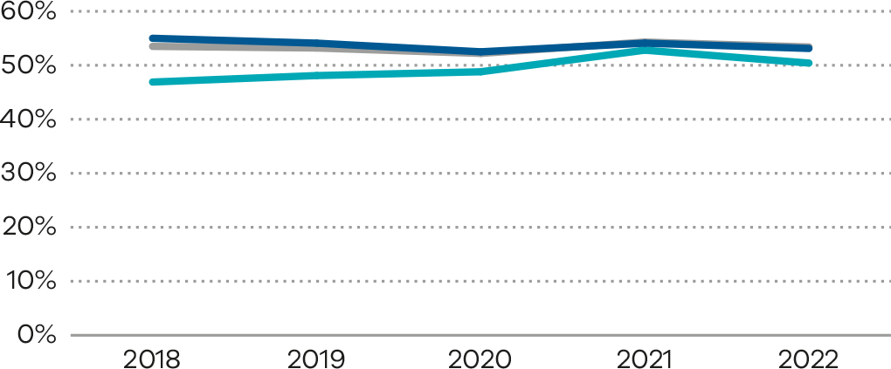
Numerator/denominator
Indicator | Numerator | Denominator
Indicator 4a: Rate of women who planned a vaginal birth after a primary caesarean section | The number of women (second time mothers) with a singleton. term pregnancy) whose previous birth was by caesarean section and who enter labour with a plan for a vaginal birth | The number of women (second time mothers) with a singleton term pregnancy) whose previous birth was by caesarean section
Indicator 4b: Rate of women who achieved a planned vaginal birth after a primary caesarean section | The number of women (second time mothers) with a singleton, term pregnancy) whose previous birth was by caesarean and who enter labour with a plan for a vaginal birth and who achieve a vaginal birth | The number of women (second time mothers) with a singleton term pregnancy) whose previous birth was by caesarean and who enter labour with a plan for a vaginal birth

5: Five-year gestation standardised perinatal mortality ratio
Figure 39. Five-year gestation standardised perinatal mortality rate, 2018–2022
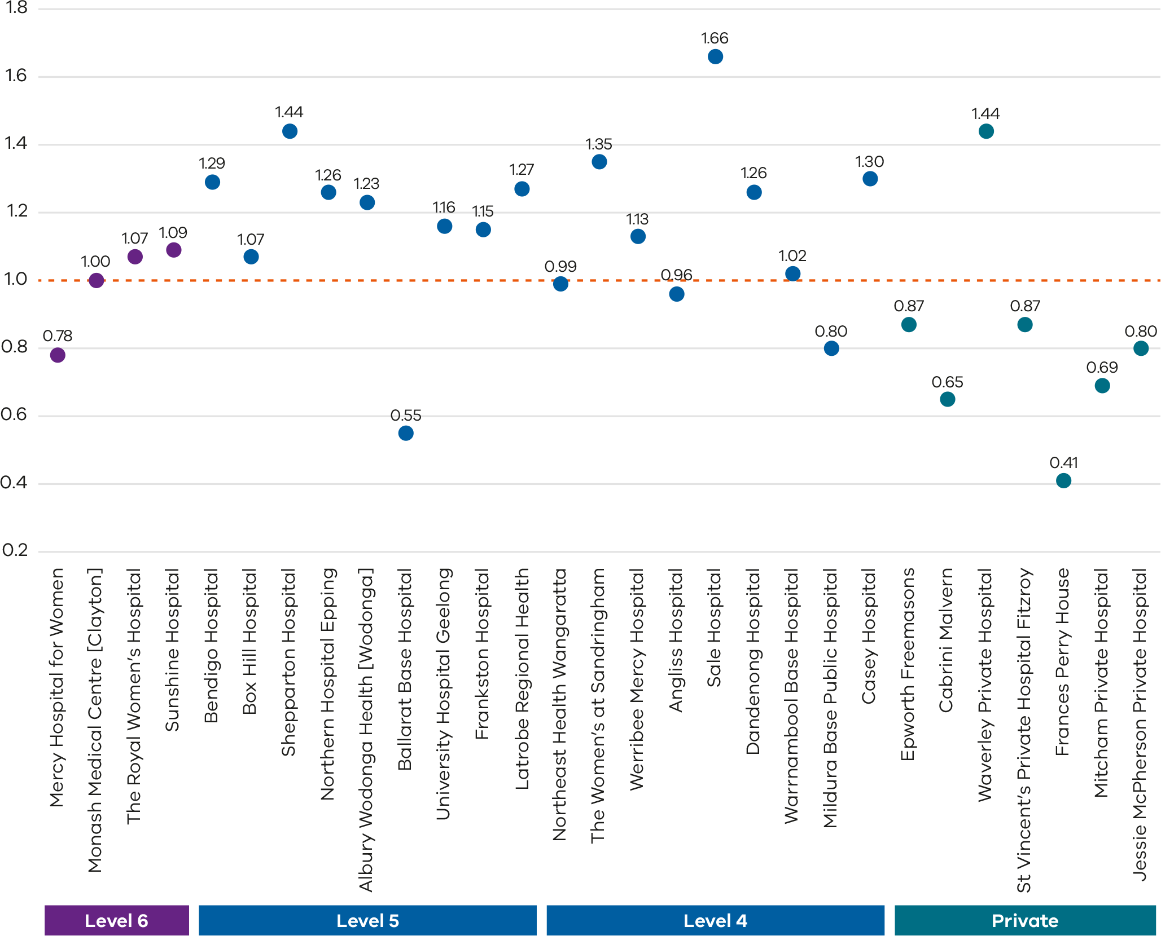
Only health services with at least 5 deaths during the 5-year reference period are included in this plot.
The GSPMRs for individual health services are given in Appendix 3: Overview of results.

Figure 40. Funnel plot of 5-year GSPMR compared with the statewide public rate 2018–2022
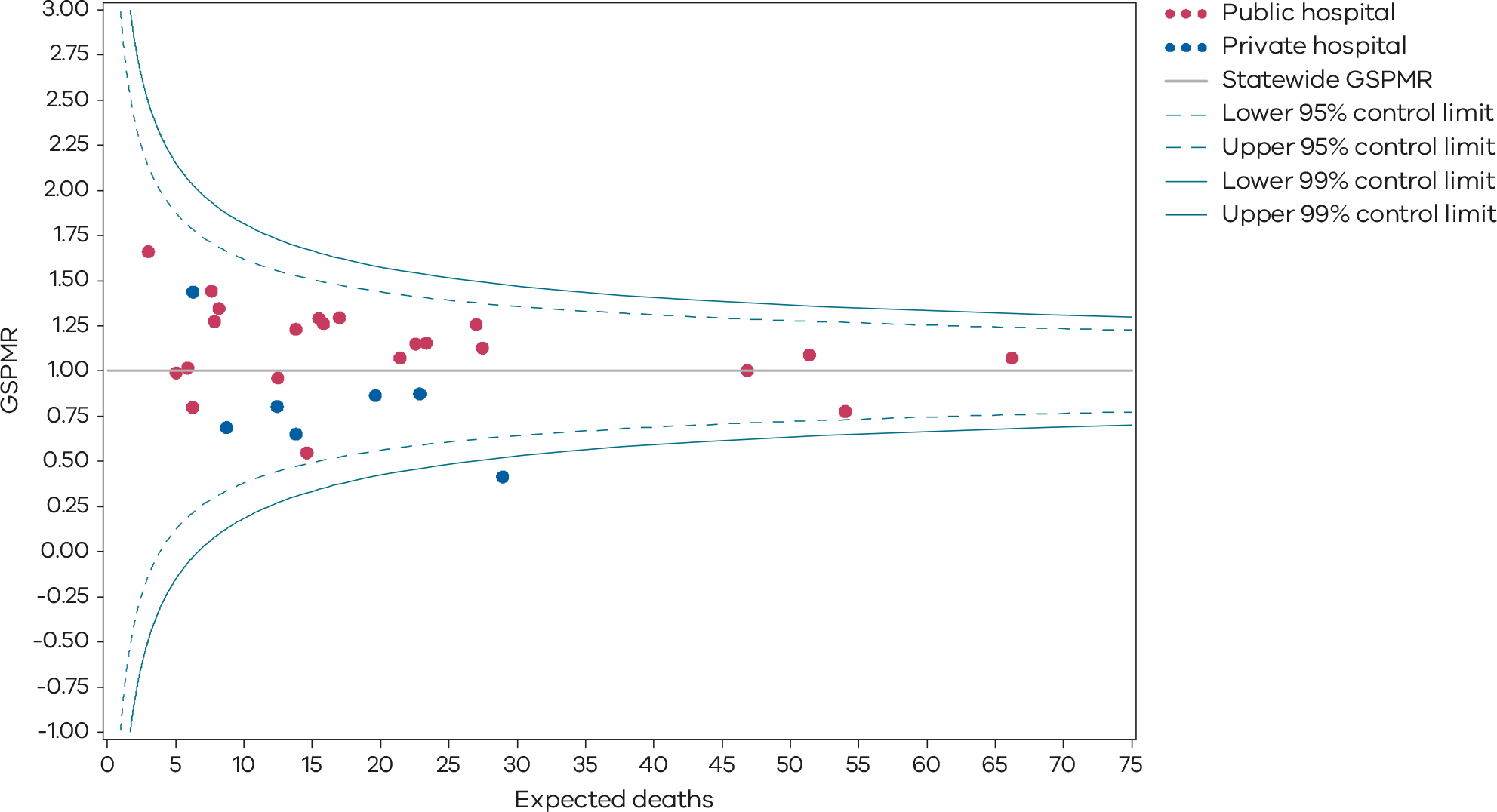
Only health services with at least 5 deaths during the 5-year reference period are included in the funnel plot.
The GSPMRs for individual health services are given in Appendix 3: Overview of results.

Definition and data source

Definition
The GSPMR is standardised according to the gestational age-specific perinatal mortality rates of the total population in Victorian hospitals. The standardisation does not adjust for inter-hospital transfers, and deaths are ascribed to the birth hospital regardless of the timing of the death in relation to the transfer.
The data in this report:
- is calculated from 5 years of pooled data between 2018 and 2022
- is standardised using gestational age
- excludes births earlier than 32 weeks, 0 days
- excludes birthweights less than 150 grams regardless of gestation
- excludes all deaths due to congenital anomalies and all terminations of pregnancy.
These exclusions provide a more sensitive indicator to reflect the quality of care.
The GSPMR is presented with data for individual public and private hospitals being shown in relation to the statewide hospital perinatal mortality rate for each week of gestation as the standard or reference population.

Data source: Victorian Perinatal Data Collection
Data for this indicator are sourced from the VPDC for the calendar year from 1 January 2018 to 31 December 2022.
Observed/expected
Indicator | Observed | Expected
Indicator 5: Perinatal mortality ratio for babies born at 32 or more weeks (gestation standardised, excluding all terminations of pregnancy and deaths due to congenital anomalies) using 5 years’ pooled data in Victorian public and private hospitals (32 weeks or more GSMPR) | Observed perinatal deaths from 32 weeks, 0 days (by weeks’ gestation at birth) | Expected perinatal deaths from 32 weeks, 0 days (by weeks’ gestation at birth)

6a and 6b: Readmissions during the postnatal period
Figure 41. Indicator 6a: Rate of maternal readmissions during the postnatal period, 2022–23
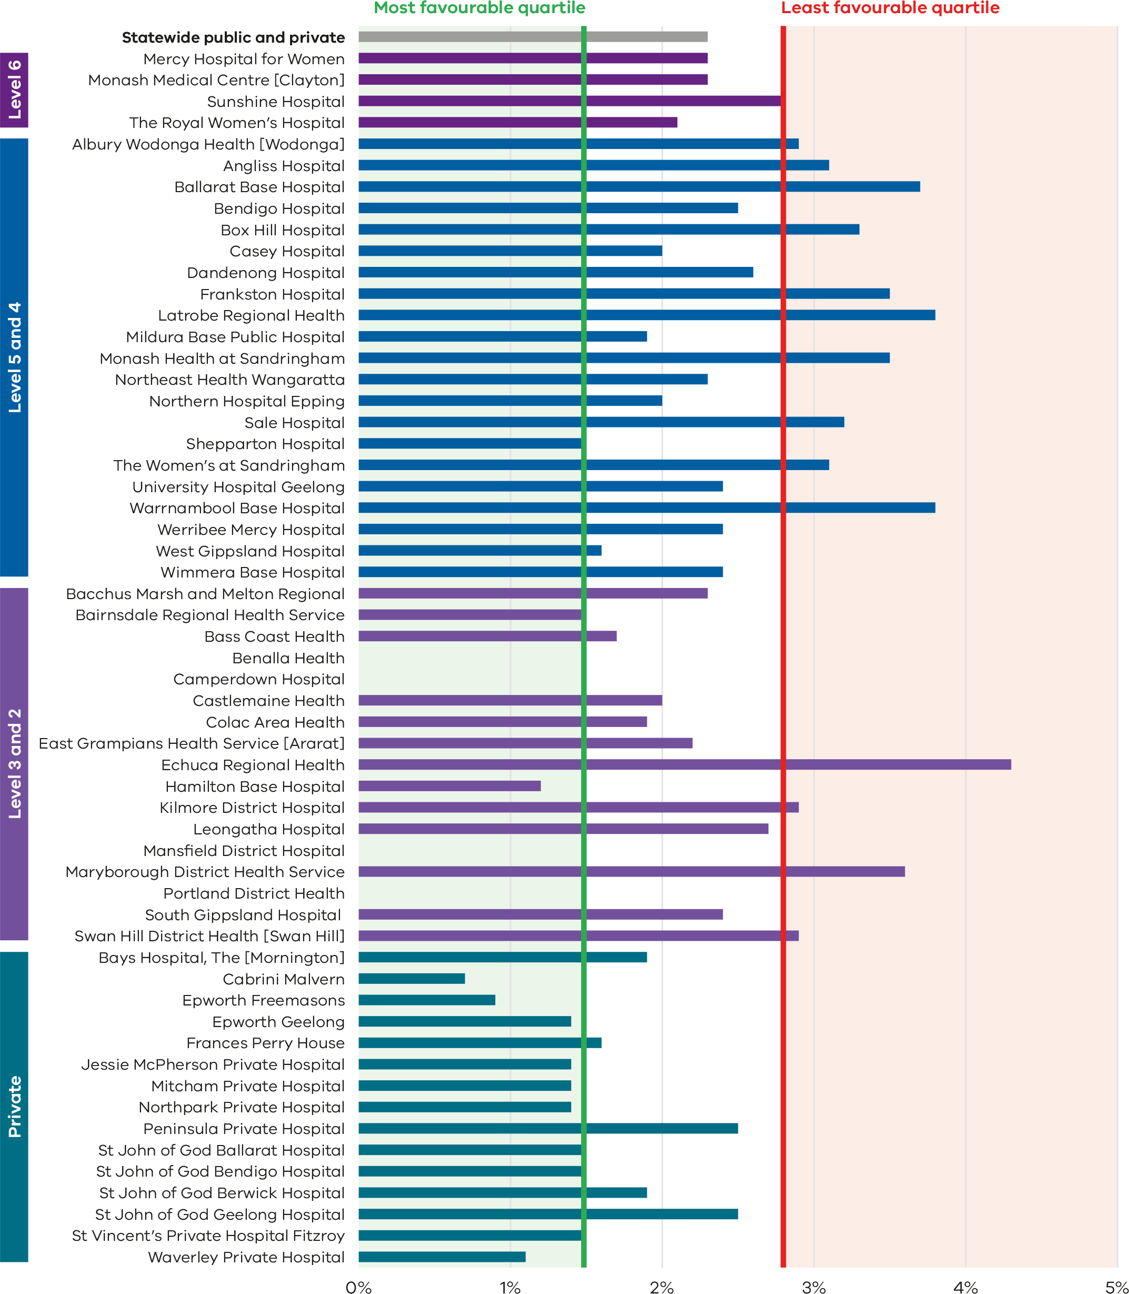
Figure 42. Funnel plot of maternal readmissions during the postnatal period, 2022–23
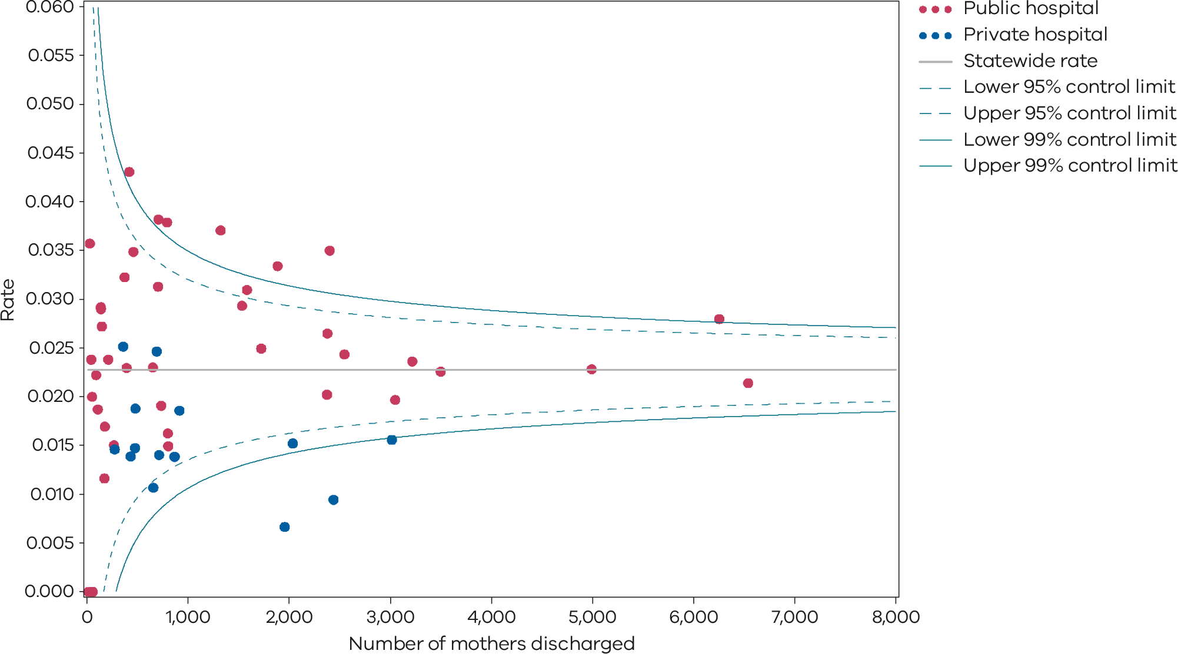
Please refer to the guide on how to interpret funnel plots.
Table 14. Rate of maternal readmissions during the postnatal period, by financial year 2018–19 to 2022–23
 | 2018–19 | 2019–20 | 2020–21 | 2021–22 | 2022–23
Public | 2.7% | 2.4% | 2.5% | 2.2% | 2.5%
Private | 2.0% | 1.7% | 1.7% | 1.3% | 1.4%
Statewide | 2.6% | 2.3% | 2.3% | 2.0% | 2.3%
Figure 43. Time trend of Indicator 6a, 2018–2022
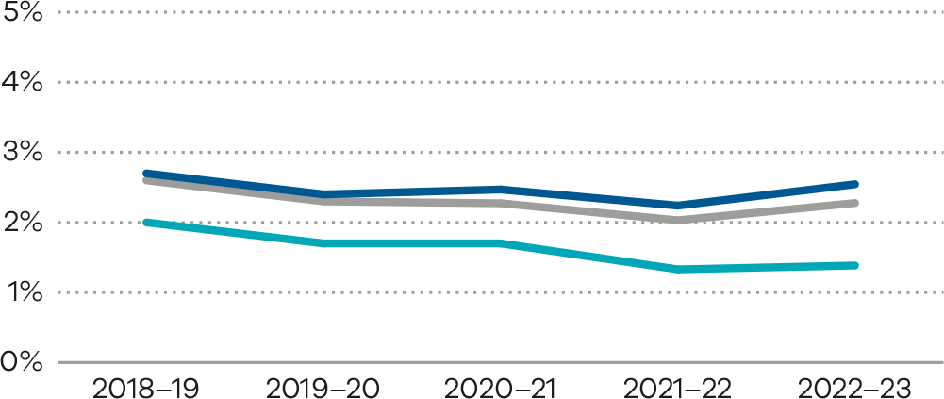
Figure 44. Indicator 6b: Rate of newborn readmissions during the postnatal period, 2022–23
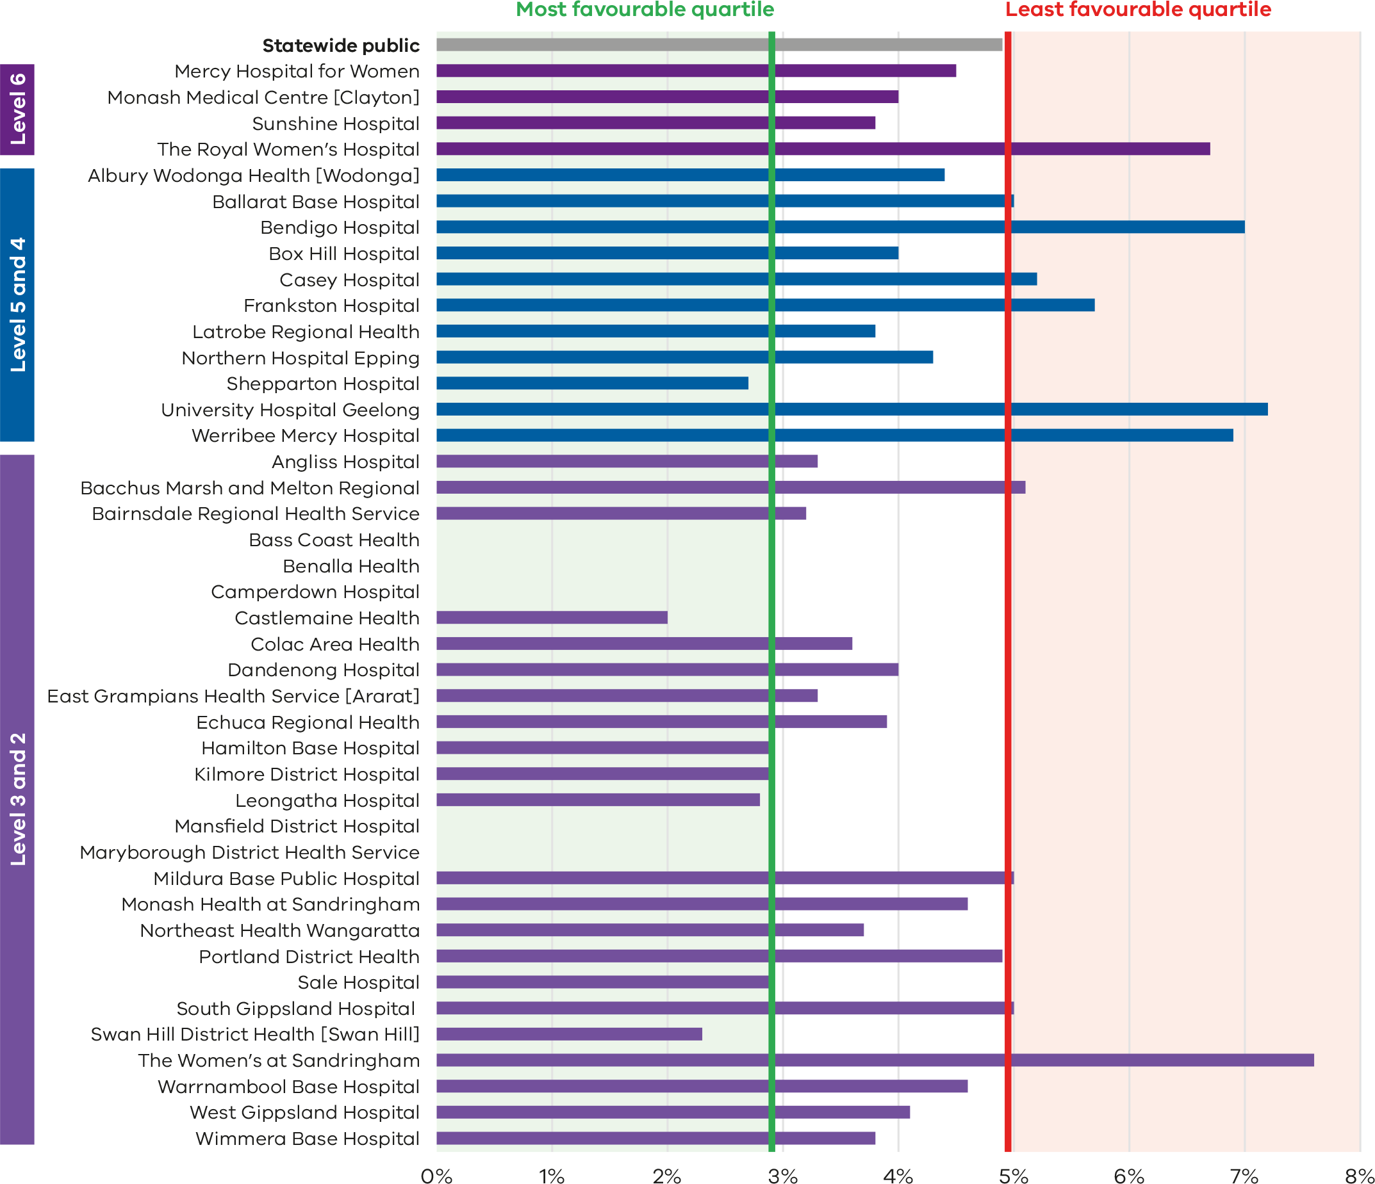
Note: Reporting of unqualified neonate admissions to the VAED for private hospitals is optional. It is therefore not possible to establish an accurate denominator (that includes public and private hospitals) for this indicator. As such, only public hospitals are included in the results.
Figure 45. Funnel plot of newborn readmissions during the postnatal period, 2022–23
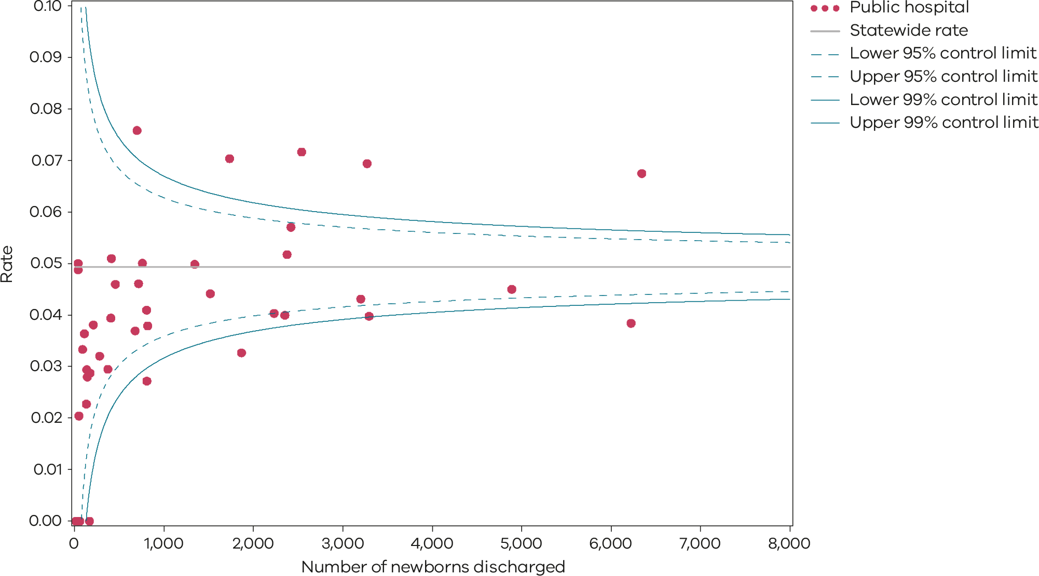
Please refer to the guide on how to interpret funnel plots.
Table 15. Rate of newborn readmissions during the postnatal period, by financial year 2018–19 to 2022–23
 | 2018–19 | 2019–20 | 2020–21 | 2021–22 | 2022–23
Public | 4.1% | 4.1% | 4.9% | 4.9% | 4.9%
Figure 46. Time trend of Indicator 6b, 2018-2022
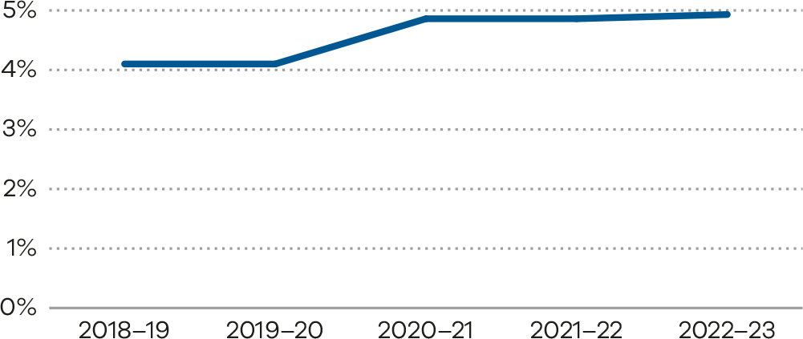
Numerator/denominator
Indicator | Numerator | Denominator
Indicator 6a: Readmission of a mother within 28 days of discharge from a birthing episode admission in a Victorian public or private hospital | The number of women readmitted to any health service within 28 days with a potentially preventable readmission diagnosis code | The total number of birth episodes at a health service
Indicator 6b: Readmission of a newborn within 28 days of discharge from a birthing episode admission in a Victorian public hospital | The number of babies readmitted to any health service with a potentially preventable readmissions diagnosis code within 28 days of birth | The number of babies provided with admitted postnatal care prior to discharge

7: Smoking cessation
Figure 47. Indicator 7: Rate of smoking cessation during pregnancy, 2022
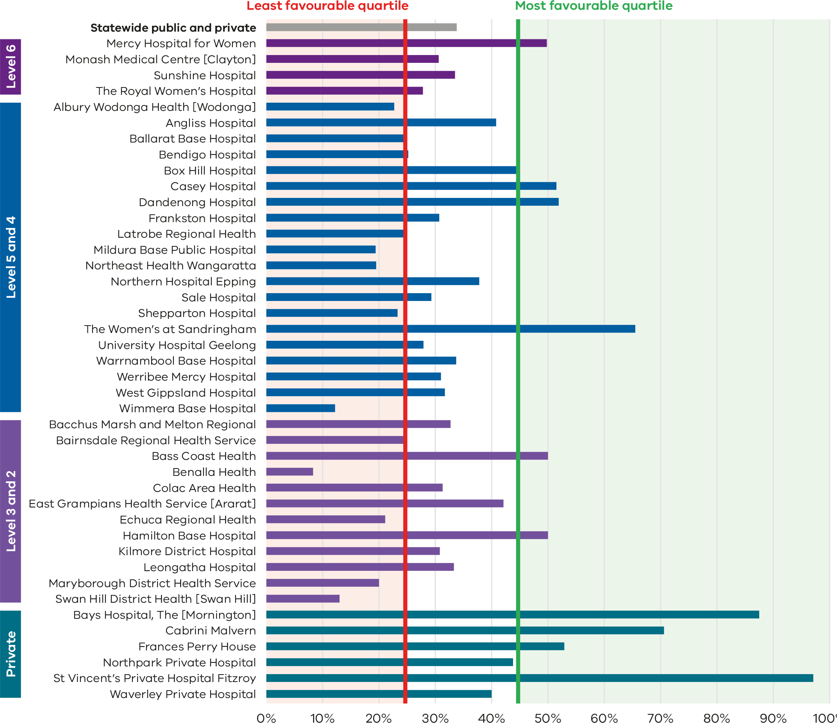

Figure 48. Funnel plot of the rate of smoking cessation during pregnancy, 2022
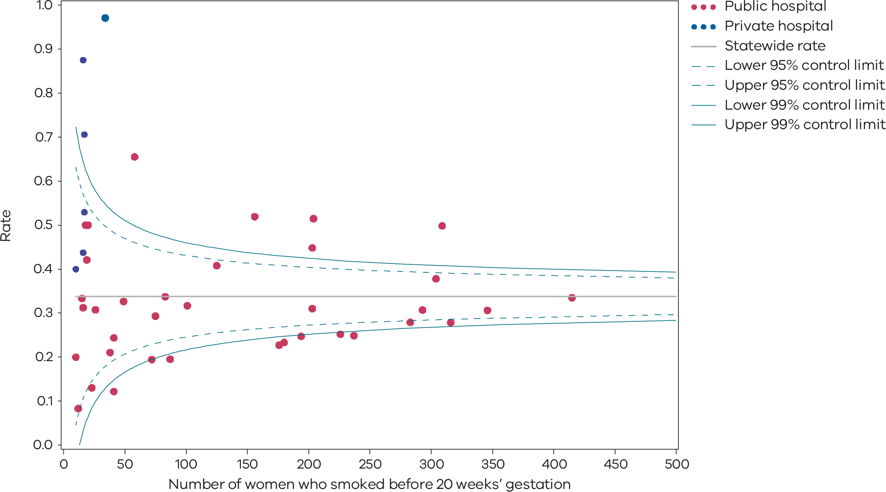
Please refer to the guide on how to interpret funnel plots.
Table 16. Rate of smoking cessation during pregnancy, 2018–2022
 | 2018 | 2019 | 2020 | 2021 | 2022
Public | 26.6% | 26.8% | 32.6% | 30.5% | 33.1%
Private | 60.3% | 59.3% | 64.0% | 57.3% | 57.1%
Statewide | 28.0% | 28.0% | 33.5% | 31.4% | 33.8%
Figure 49. Time trend of Indicator 7, 2018–2022
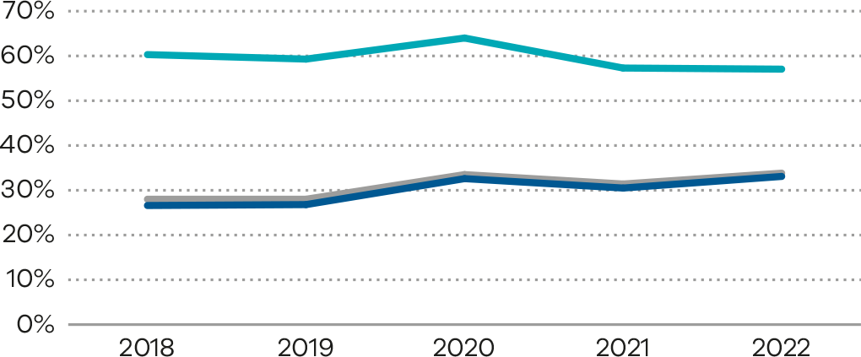
Numerator/denominator
Indicator | Numerator | Denominator
Indicator 7: Rate of smoking cessation during pregnancy | The number of women who were reported as having not smoked at or after 20 weeks’ gestation among those who smoked before 20 weeks | The number of women who smoked before 20 weeks’ gestation

8a, 8b and 8c: Breastfeeding in hospital
Figure 50. Indicator 8a: Rate of breastfeeding initiation by women who gave birth at ≥ 37 weeks’ gestation, 2022
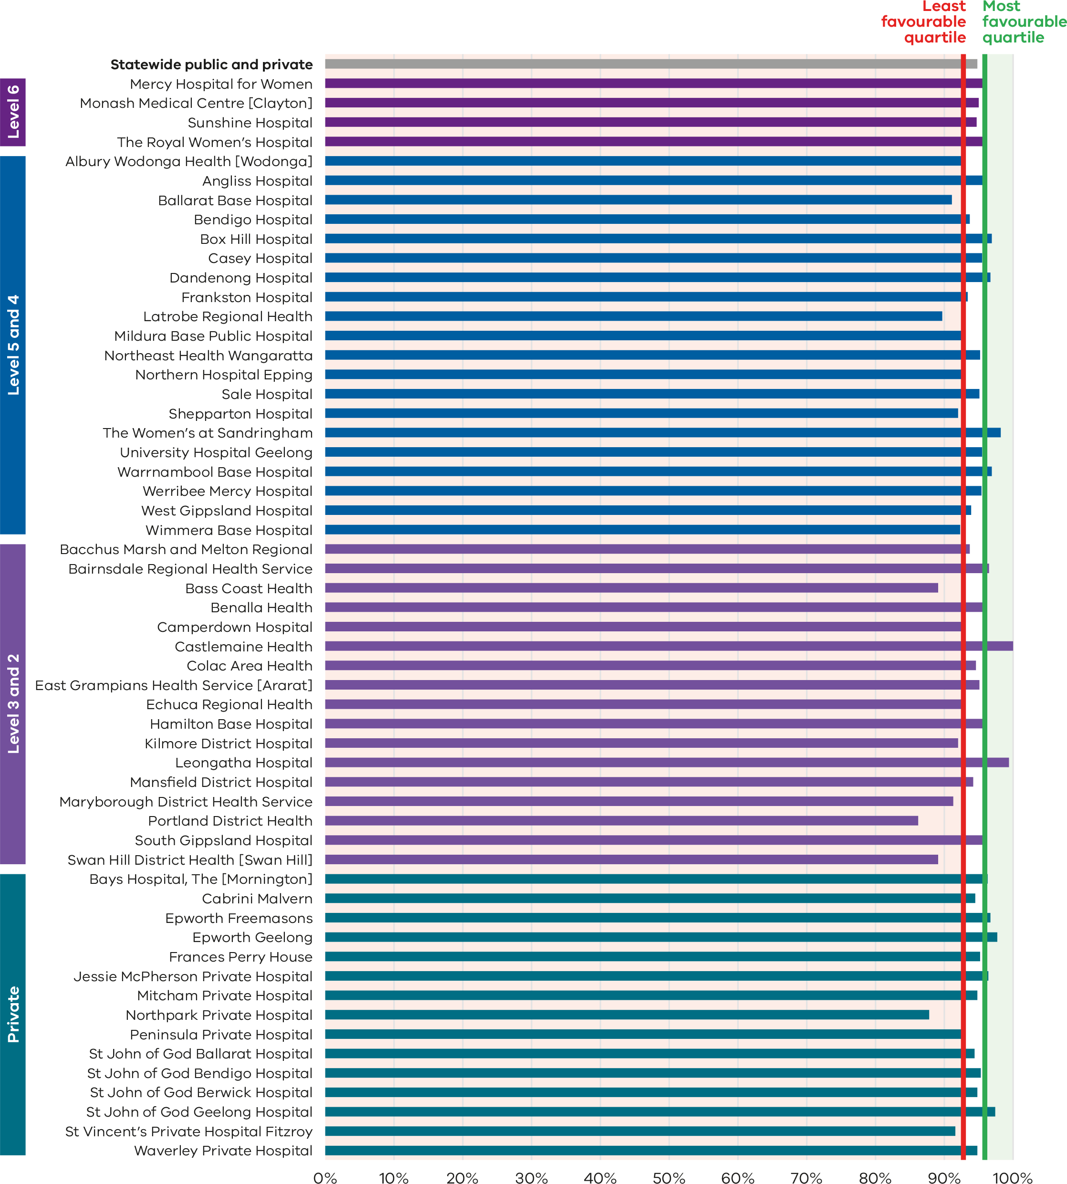
Figure 51. Funnel plot of the rate of breastfeeding initiation by women who gave birth at ≥ 37 weeks’ gestation, 2022
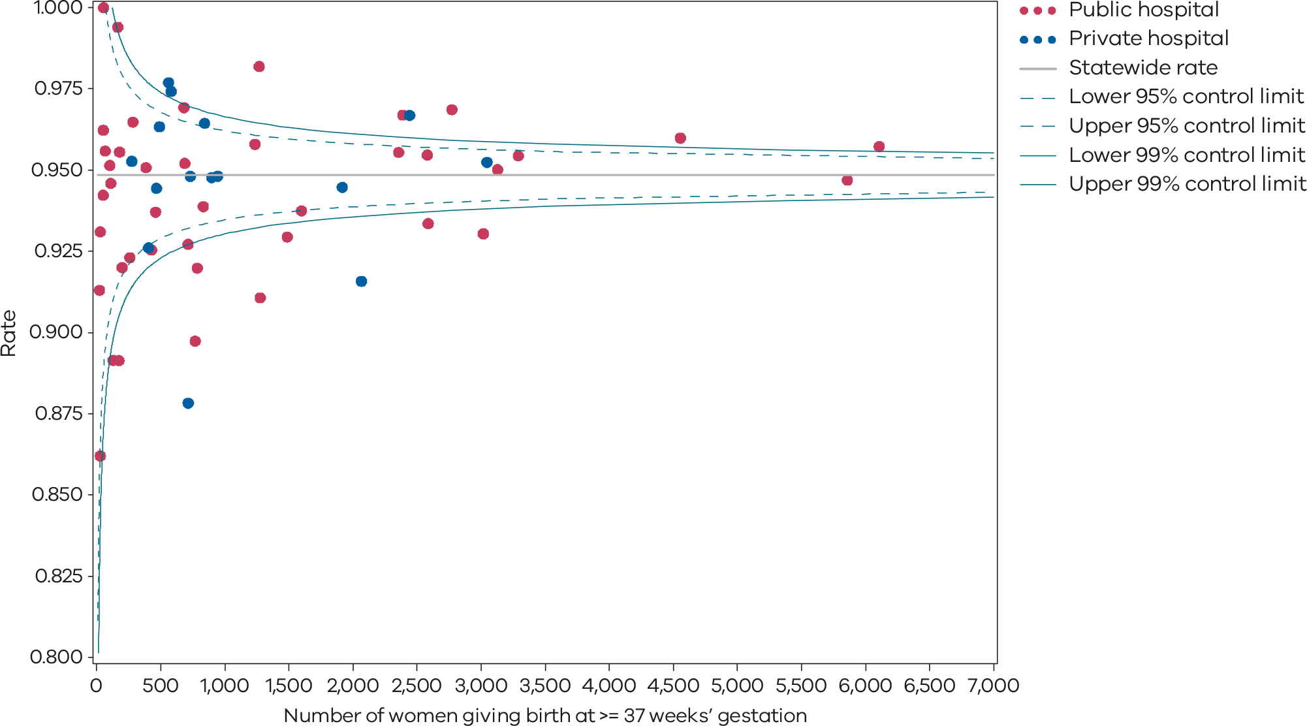
Please refer to the guide on how to interpret funnel plots.
Table 17. Rate of breastfeeding initiation for babies born at ≥ 37 weeks’ gestation, 2018–2022
 | 2018 | 2019 | 2020 | 2021 | 2022
Public | 95.4% | 95.6% | 95.4% | 95.4% | 94.9%
Private | 96.7% | 97.0% | 95.9% | 95.8% | 94.7%
Statewide | 95.7% | 95.9% | 95.6% | 95.5% | 94.9%
Figure 52. Time trend of indicator 8a, 2018–2022
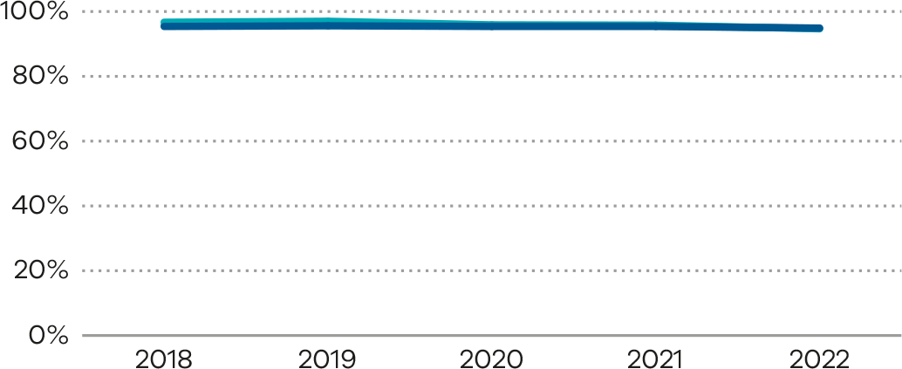
Figure 53. Indicator 8b: Rate of use of infant formula in hospital in breastfed babies born at ≥ 37 weeks’ gestation, 2022
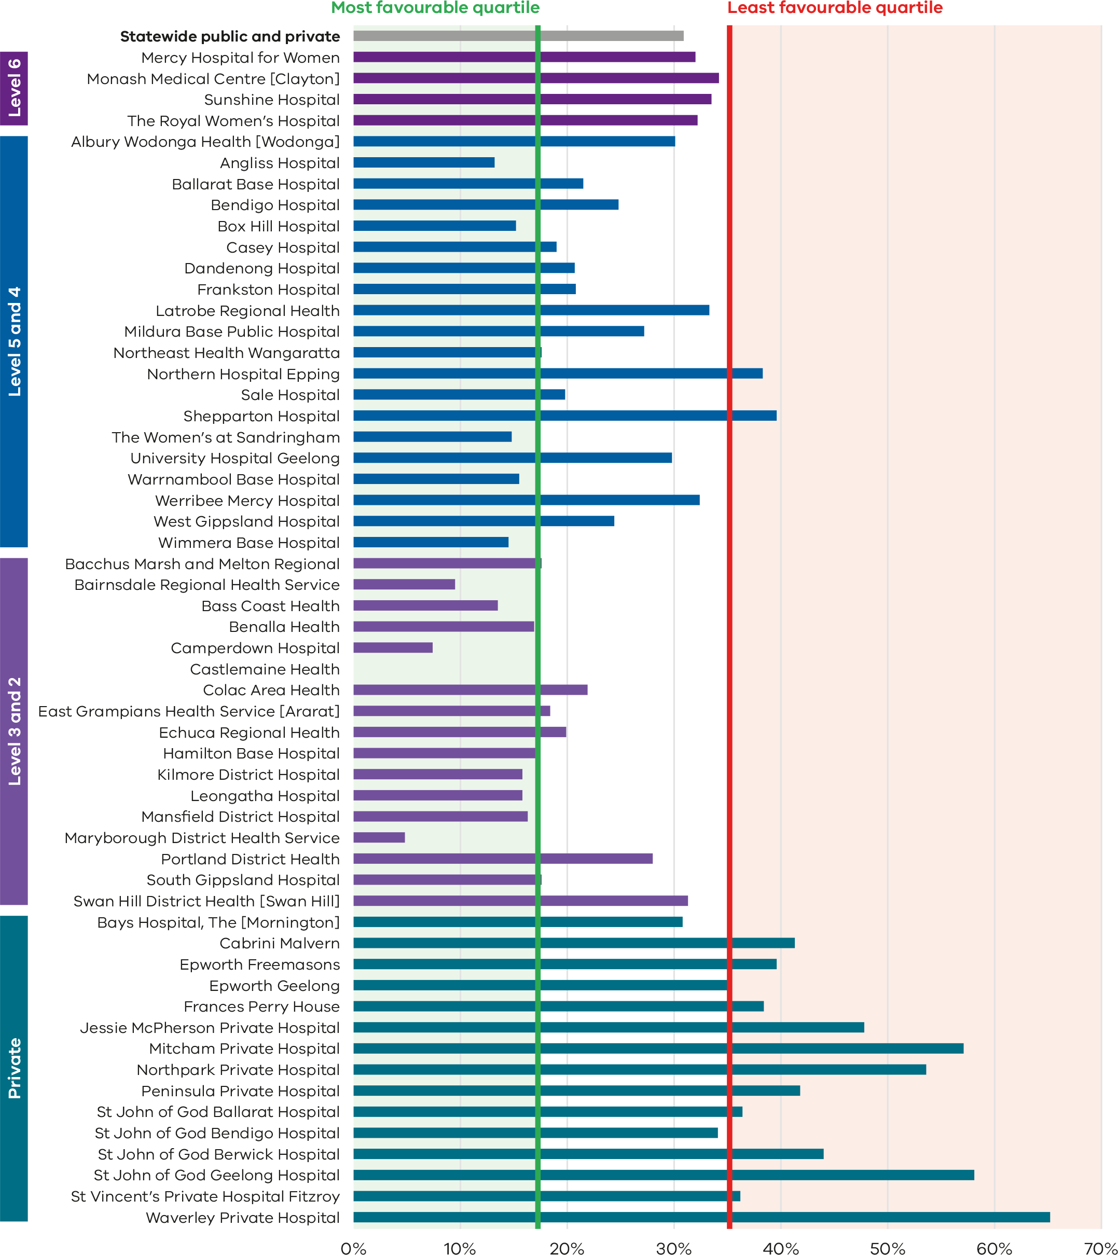
Figure 54. Funnel plot of the rate of use of infant formula in hospital in breastfed babies born at ≥ 37 weeks’ gestation, 2022
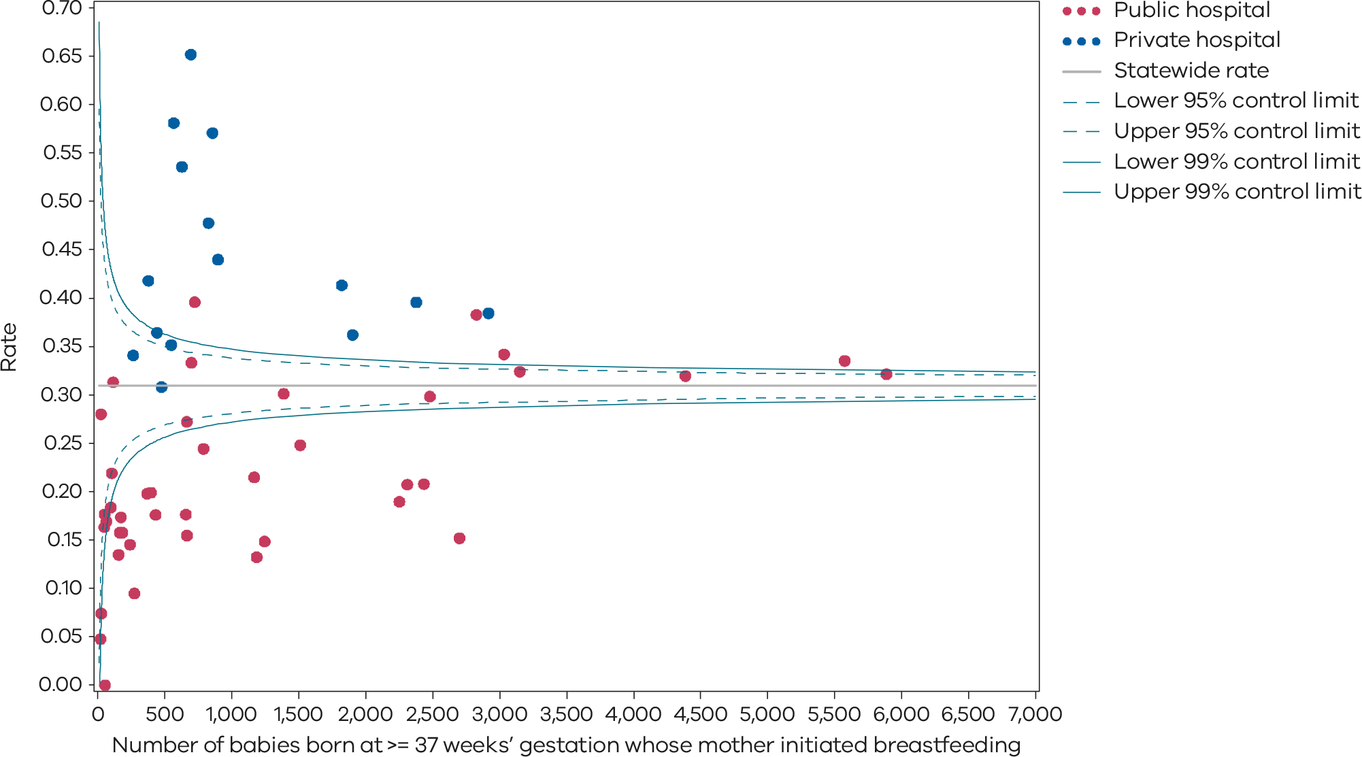
Please refer to the guide on how to interpret funnel plots.
Table 18. Rate of use of infant formula in hospital by breastfed babies born at ≥ 37 weeks’ gestation, 2018–2022
 | 2018 | 2019 | 2020 | 2021 | 2022
Public | 27.0% | 27.6% | 27.8% | 26.7% | 27.3%
Private | 37.8% | 38.5% | 40.5% | 42.0% | 42.6%
Statewide | 29.4% | 30.0% | 30.5% | 30.0% | 30.7%
Figure 55. Time trend of Indicator 8b, 2018–2022
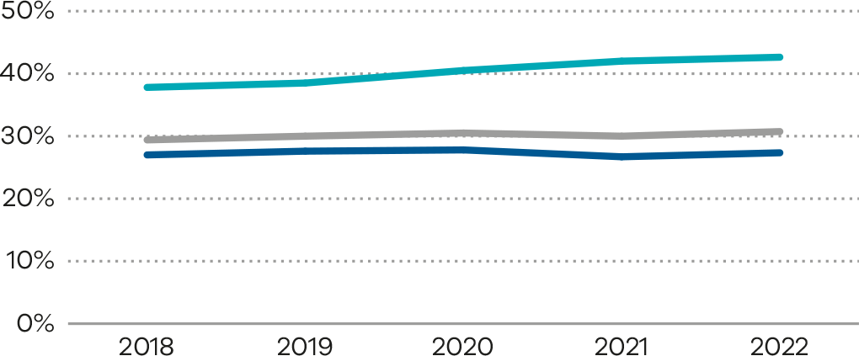
Figure 56. Indicator 8c: Rate of final feed being taken directly from the breast by breastfed babies born at ≥ 37 weeks’ gestation, 2022
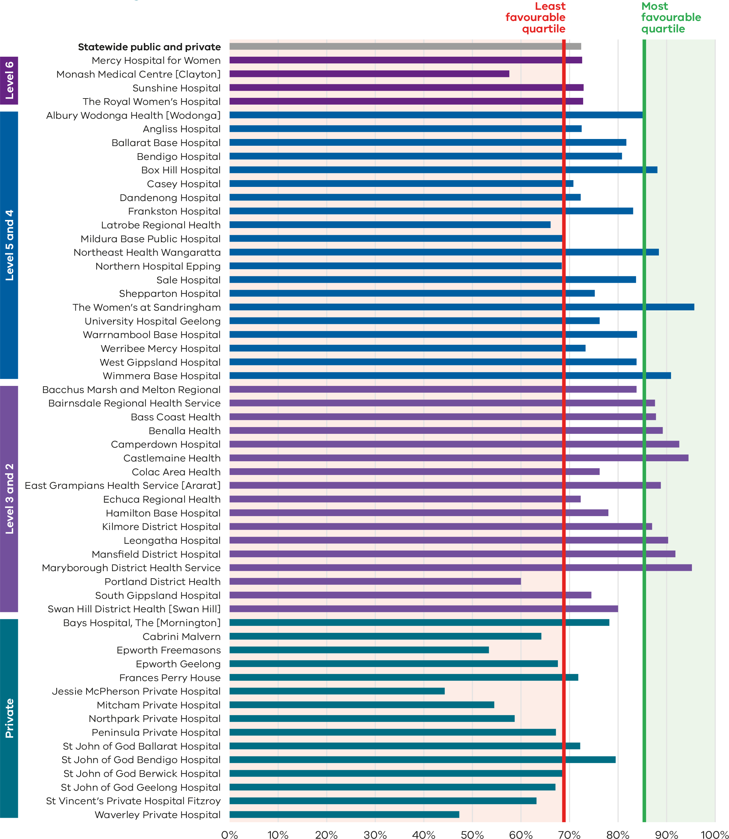
Figure 57. Funnel plot of the rate of final feed being taken directly from the breast by breastfed babies born at ≥ 37 weeks’ gestation, 2022
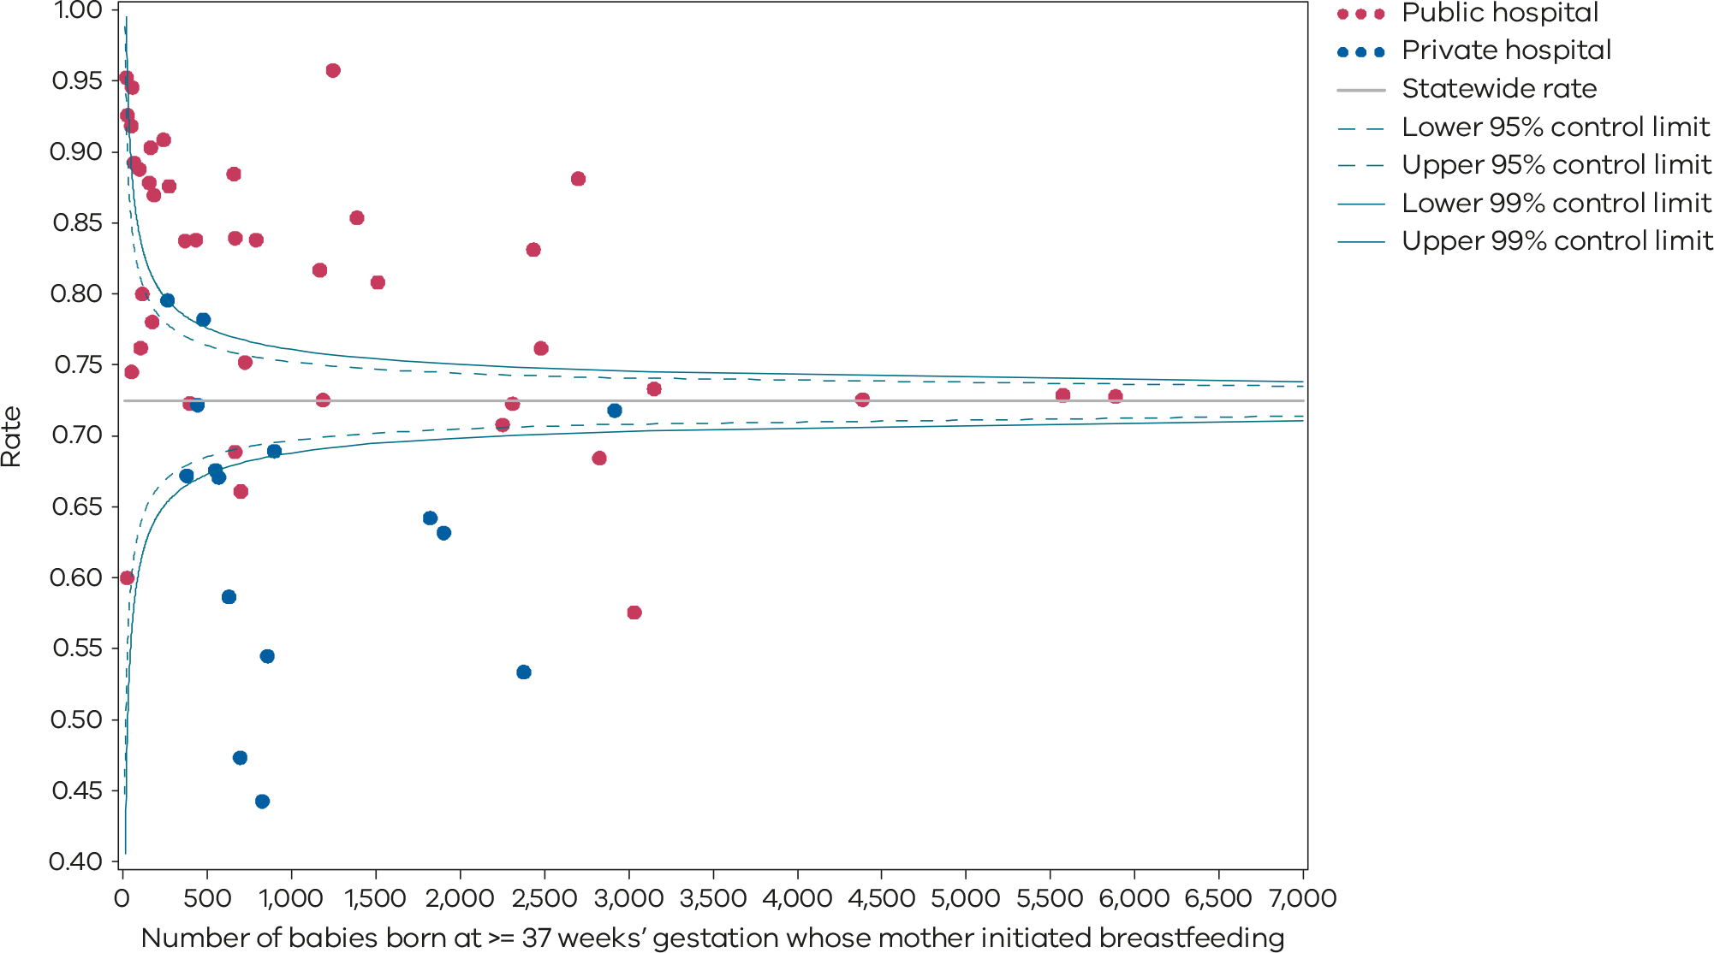
Please refer to the guide on how to interpret funnel plots.
Table 19. Rate of final feed being taken directly from the breast by breastfed babies born at ≥ 37 weeks’ gestation, 2018–2022
 | 2018 | 2019 | 2020 | 2021 | 2022
Public | 75.3% | 74.9% | 75.0% | 76.6% | 75.4%
Private | 69.6% | 68.1% | 65.8% | 65.4% | 62.8%
Statewide | 74.1% | 73.4% | 73.1% | 74.2% | 72.6%
Figure 58. Time trend of Indicator 8c, 2018–2022
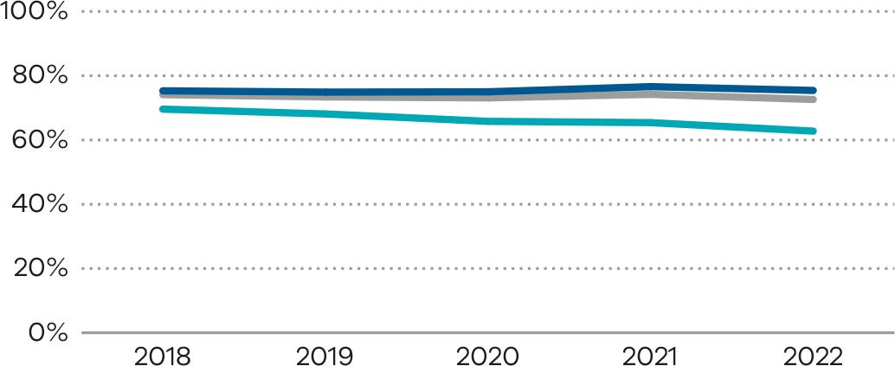
Numerator/denominator
Indicator | Numerator | Denominator
Indicator 8a: Rate of breastfeeding initiation for babies born at ≥ 37 weeks’ gestation | The number of women giving birth to a liveborn baby at 37 or more weeks’ gestation attempting to breastfeed at least once (regardless of the success of the attempt) | The number of women giving birth to a liveborn baby at 37 or more weeks’ gestation
Indicator 8b: Rate of use of infant formula in hospital by breastfed babies born at ≥ 37 weeks’ gestation | The number of liveborn babies born at 37 or more weeks’ gestation who received infant formula in hospital whose mother initiated breastfeeding | The number of liveborn babies born at 37 or more weeks’ gestation whose mother initiated breastfeeding
Indicator 8c: Rate of final feed being taken directly from the breast by breastfed babies born at ≥ 37 weeks’ gestation | The number of liveborn babies born at 37 or more weeks’ gestation whose mother initiated breastfeeding and who fed directly and entirely from the breast at the last feed before discharge | The number of liveborn babies born at 37 or more weeks’ gestation whose mother initiated breastfeeding

9: First antenatal visit
Figure 59. Indicator 9: Rate of women attending their first antenatal visit prior to 12 weeks’ gestation, 2022
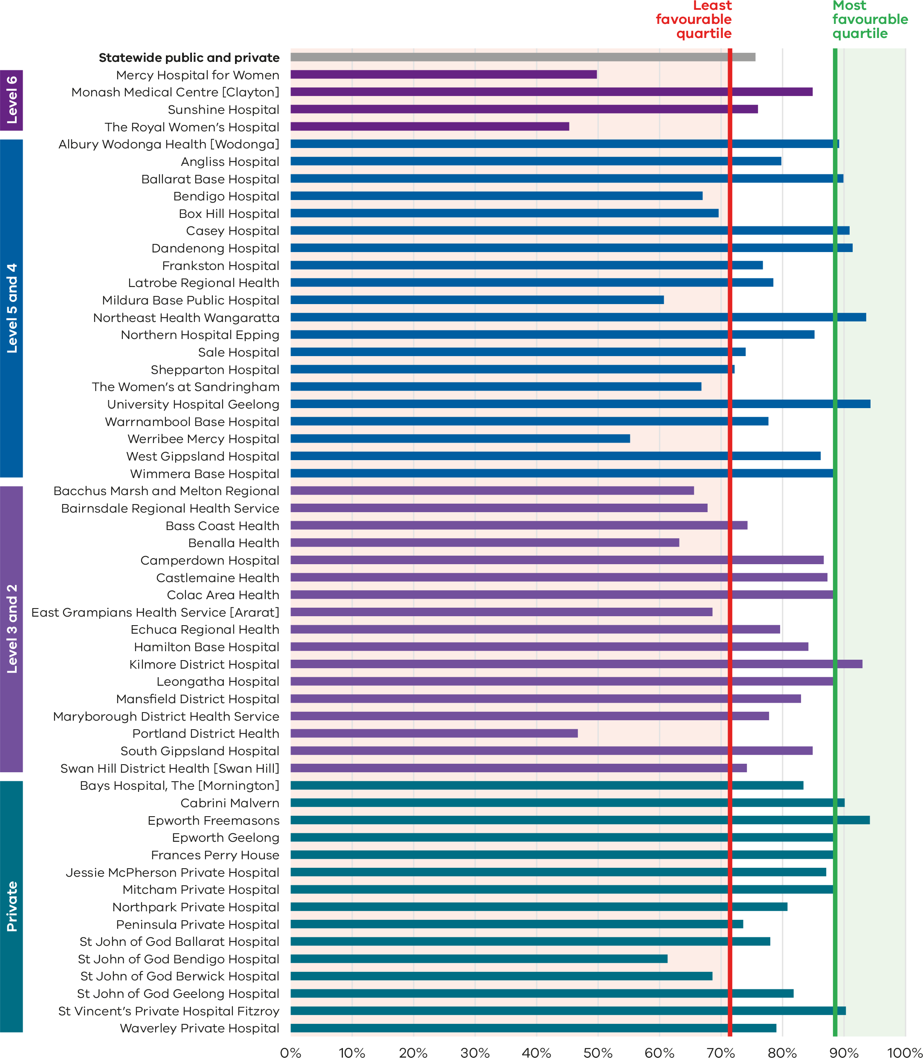
Figure 60. Funnel plot the rate of women attending their first antenatal visit prior to 12 weeks’ gestation, 2022
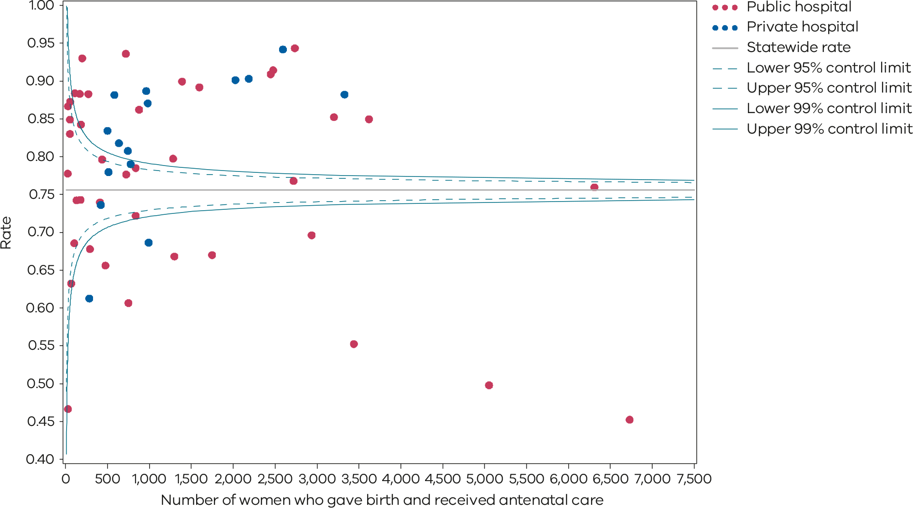
Please refer to the guide on how to interpret funnel plots.
Table 20. Rate of women attending their first antenatal visit prior to 12 weeks’ gestation, 2018–2022
 | 2018 | 2019 | 2020 | 2021 | 2022
Public | 51.5% | 59.9% | 70.1% | 73.4% | 72.3%
Private | 87.1% | 86.8% | 86.5% | 87.6% | 86.3%
Statewide | 59.5% | 65.9% | 73.6% | 76.5% | 75.4%
Figure 61. Time trend of Indicator 9, 2018–2022
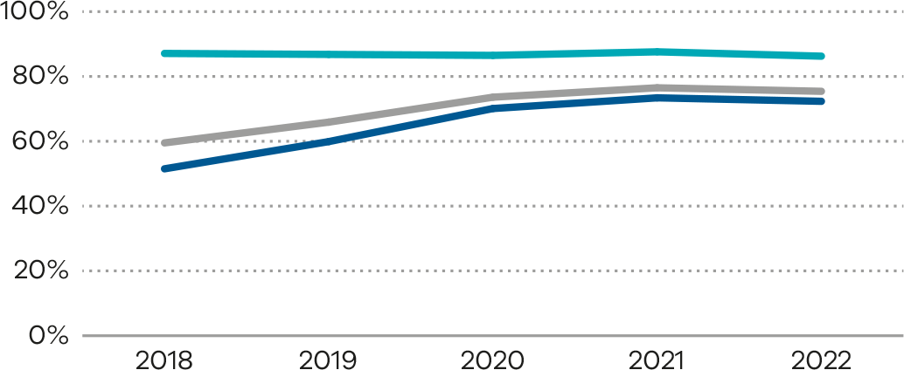
Numerator/denominator
Indicator | Numerator | Denominator
Indicator 9: Rate of women attending their first antenatal visit prior to 12 weeks’ gestation | The number of women who received antenatal care prior to 12 weeks’ gestation with a maternity care provider (including care in the community by general practitioners) and who birthed at the health service | The number of women who gave birth and received antenatal care

10: Low Apgar score
Figure 62. Indicator 10: Rate of term tertiary-born (inborn) babies without congenital anomalies with an Apgar score < 7 at 5 minutes, 2022
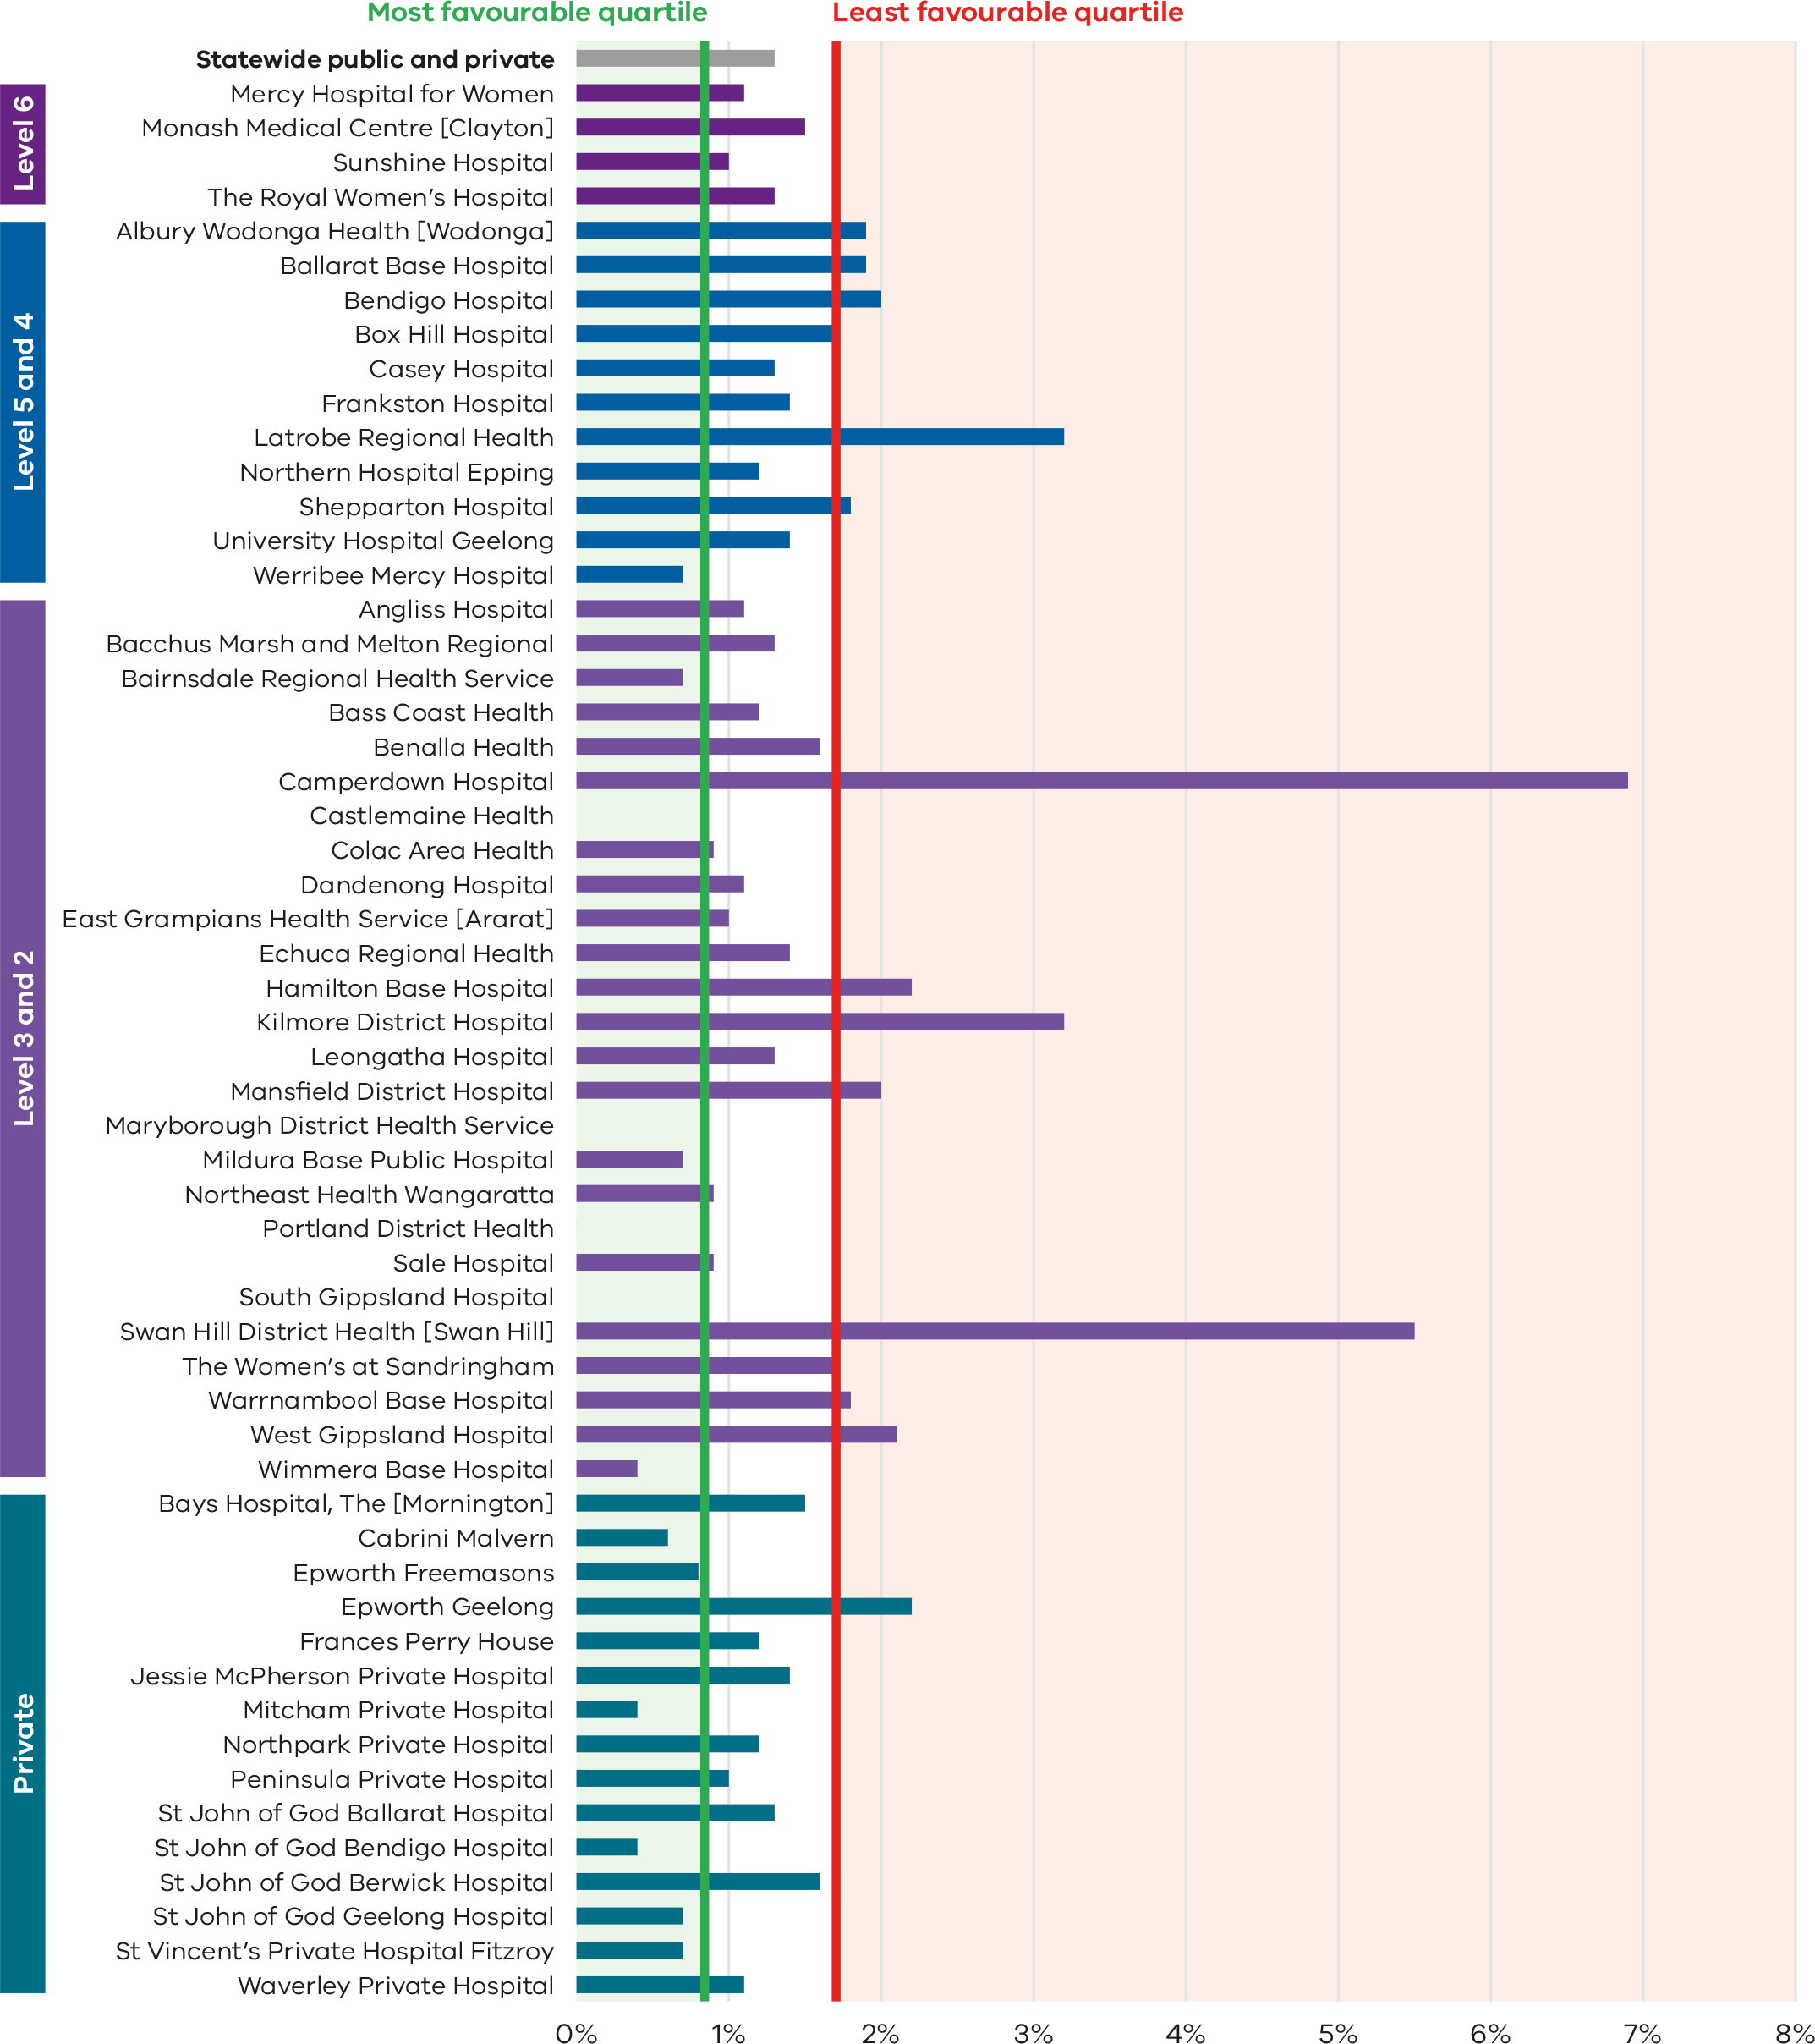
Figure 63. Funnel plot of the rate of term tertiary-born (inborn) babies without congenital anomalies with an Apgar score < 7 at 5 minutes, 2022
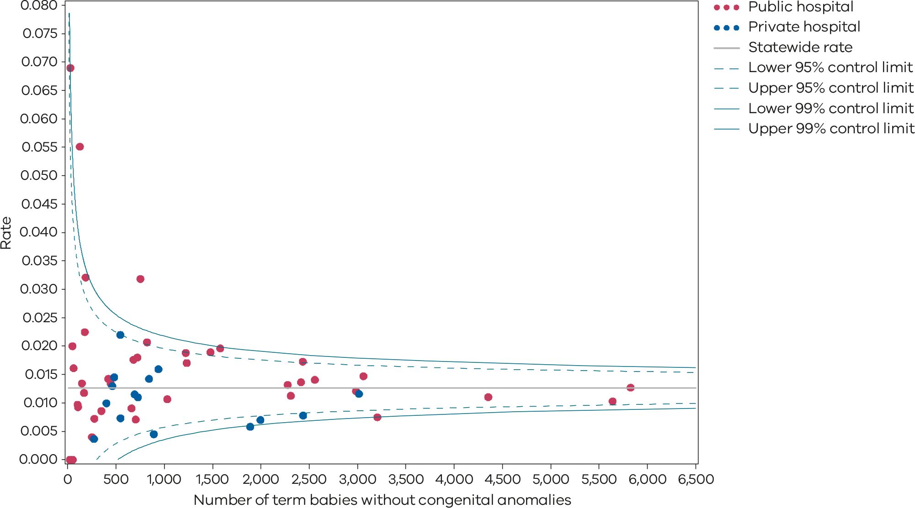
Please refer to the guide on how to interpret funnel plots.
Table 21. Rate of term inborn babies without congenital anomalies with an Apgar score < 7 at 5 minutes, 2018–2022
 | 2018 | 2019 | 2020 | 2021 | 2022
Public | 1.3% | 1.3% | 1.3% | 1.3% | 1.4%
Private | 1.1% | 1.0% | 0.8% | 0.9% | 1.0%
Statewide | 1.3% | 1.3% | 1.2% | 1.2% | 1.3%
Figure 64. Time trend of Indicator 10, 2018–2022
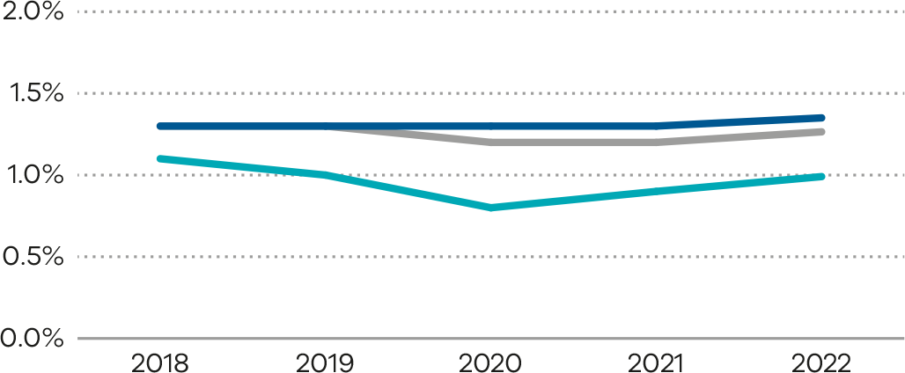
Numerator/denominator
Indicator | Numerator | Denominator
Indicator 10: Rate of term babies without congenital anomalies with an Apgar score < 7 at 5 minutes | The number of inborn, liveborn babies, 37 or more weeks’ gestation without congenital anomalies with an Apgar score less than 7 at 5 minutes | The number of inborn, liveborn babies, 37 or more weeks’ gestation without congenital anomalies

11a and 11b: Women’s experiences of care

Figure 65. Indicator 11a: Rate of women who felt involved as much as they wanted to be in making decisions about their care, 2022
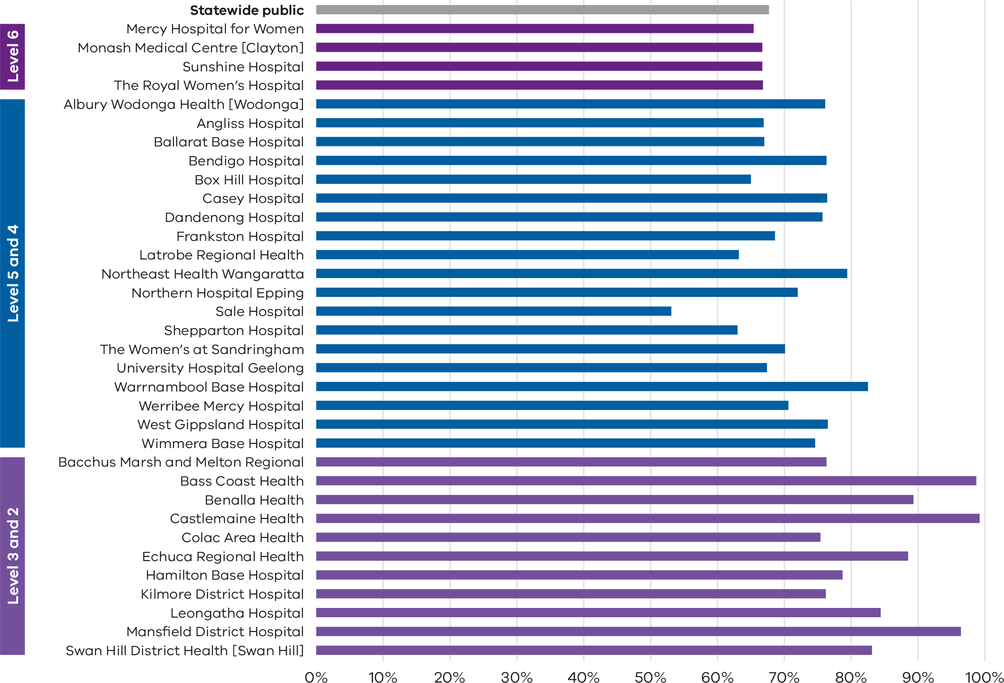
Note: No quartiles are presented for Indicator 11 since the measure is calculated from survey data and a different method of determining least and most favourable outcomes was applied (tested for significant difference compared with the rate for public hospitals).
The VHES only collects data from public hospitals and reports only on services with more than 10 responses in a year. As such, this indicator is only reported for public health services and not all services meet the criteria for reporting in this indicator.

Figure 66. Funnel plot of the rate of women who felt involved as much as they wanted to be in decisions about their care, 2022
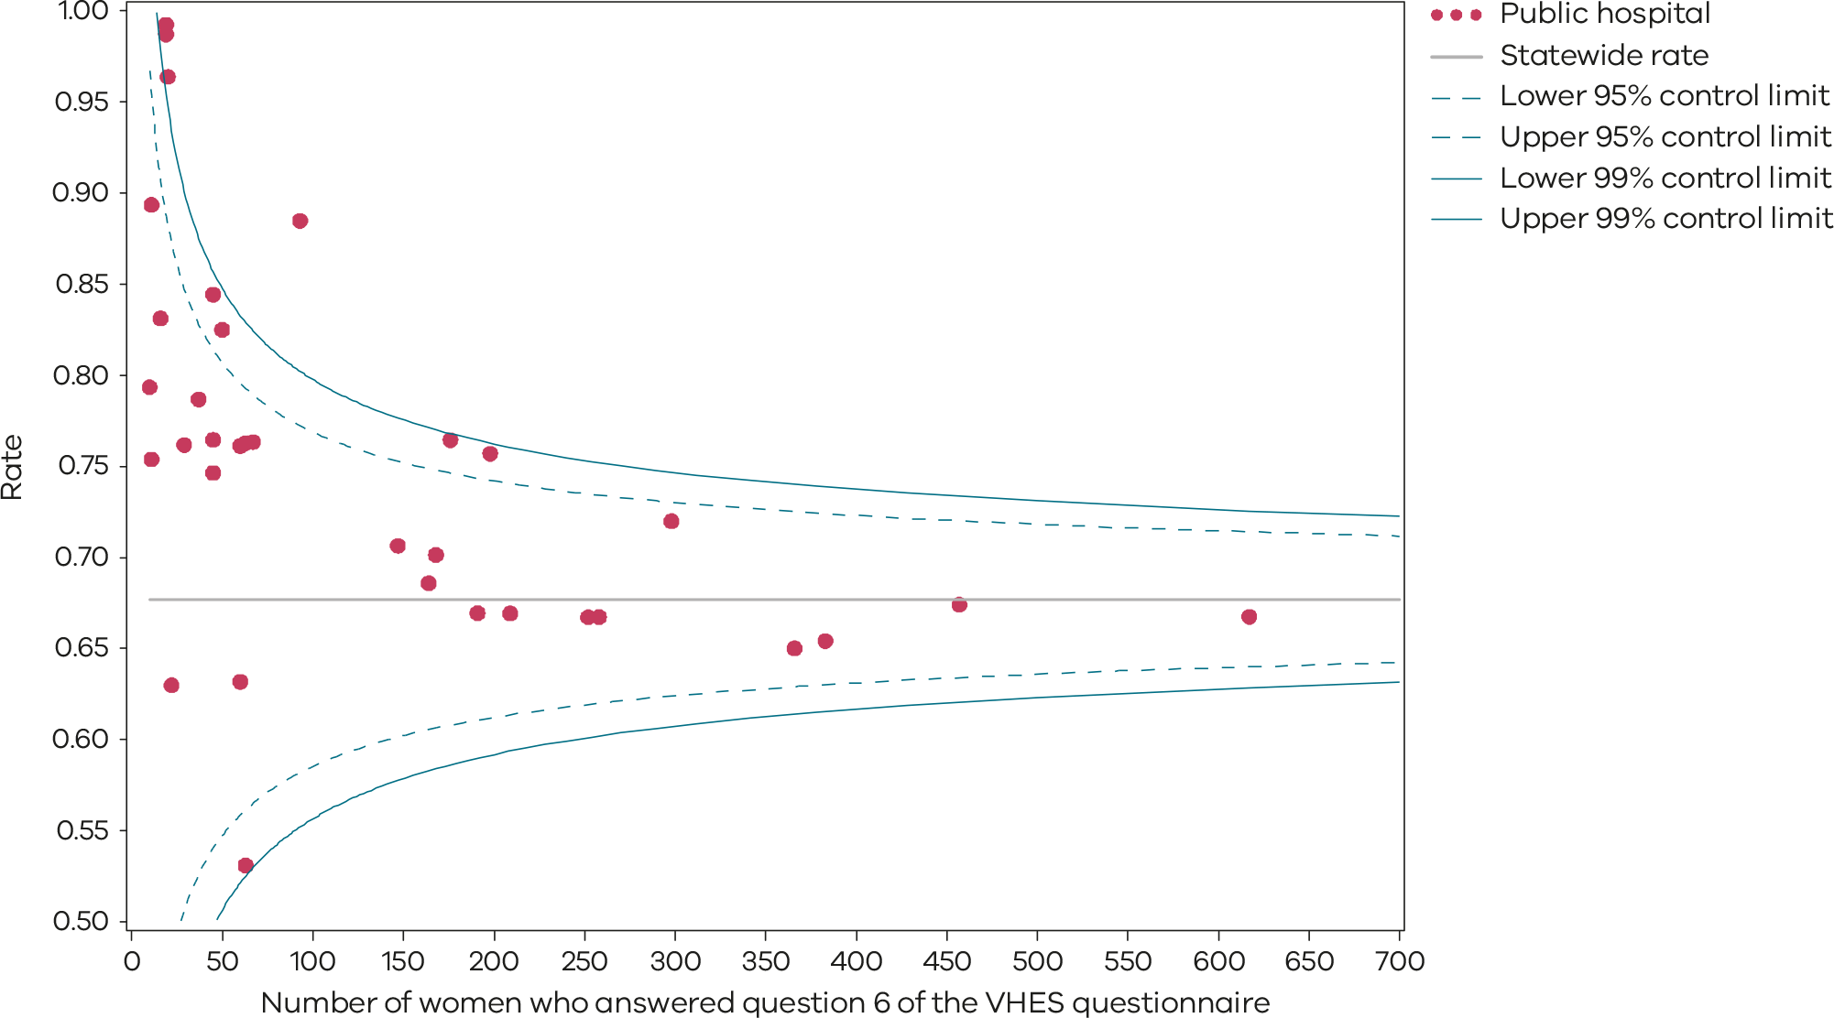
Please refer to the guide on how to interpret funnel plots.
Table 22. Rate of women who felt involved as much as they wanted to be in making decisions about their care, 2021–2022
 | 2021 | 2022
Public | 71.2% | 67.7%
Figure 67. Time trend of Indicator 11a, 2021–2022
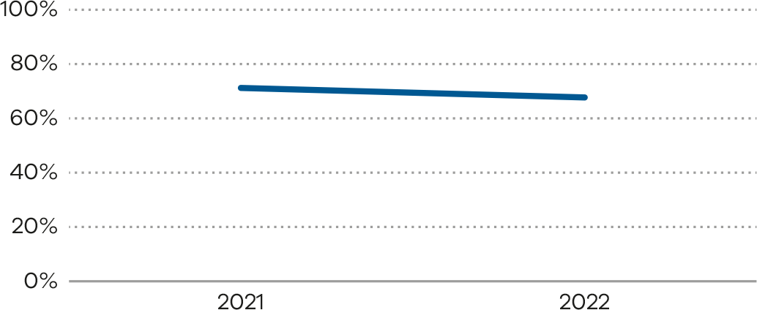
Figure 68. Indicator 11b: Rate of women who felt that staff gave them active support and encouragement to feed their baby in the way they wanted to, 2022
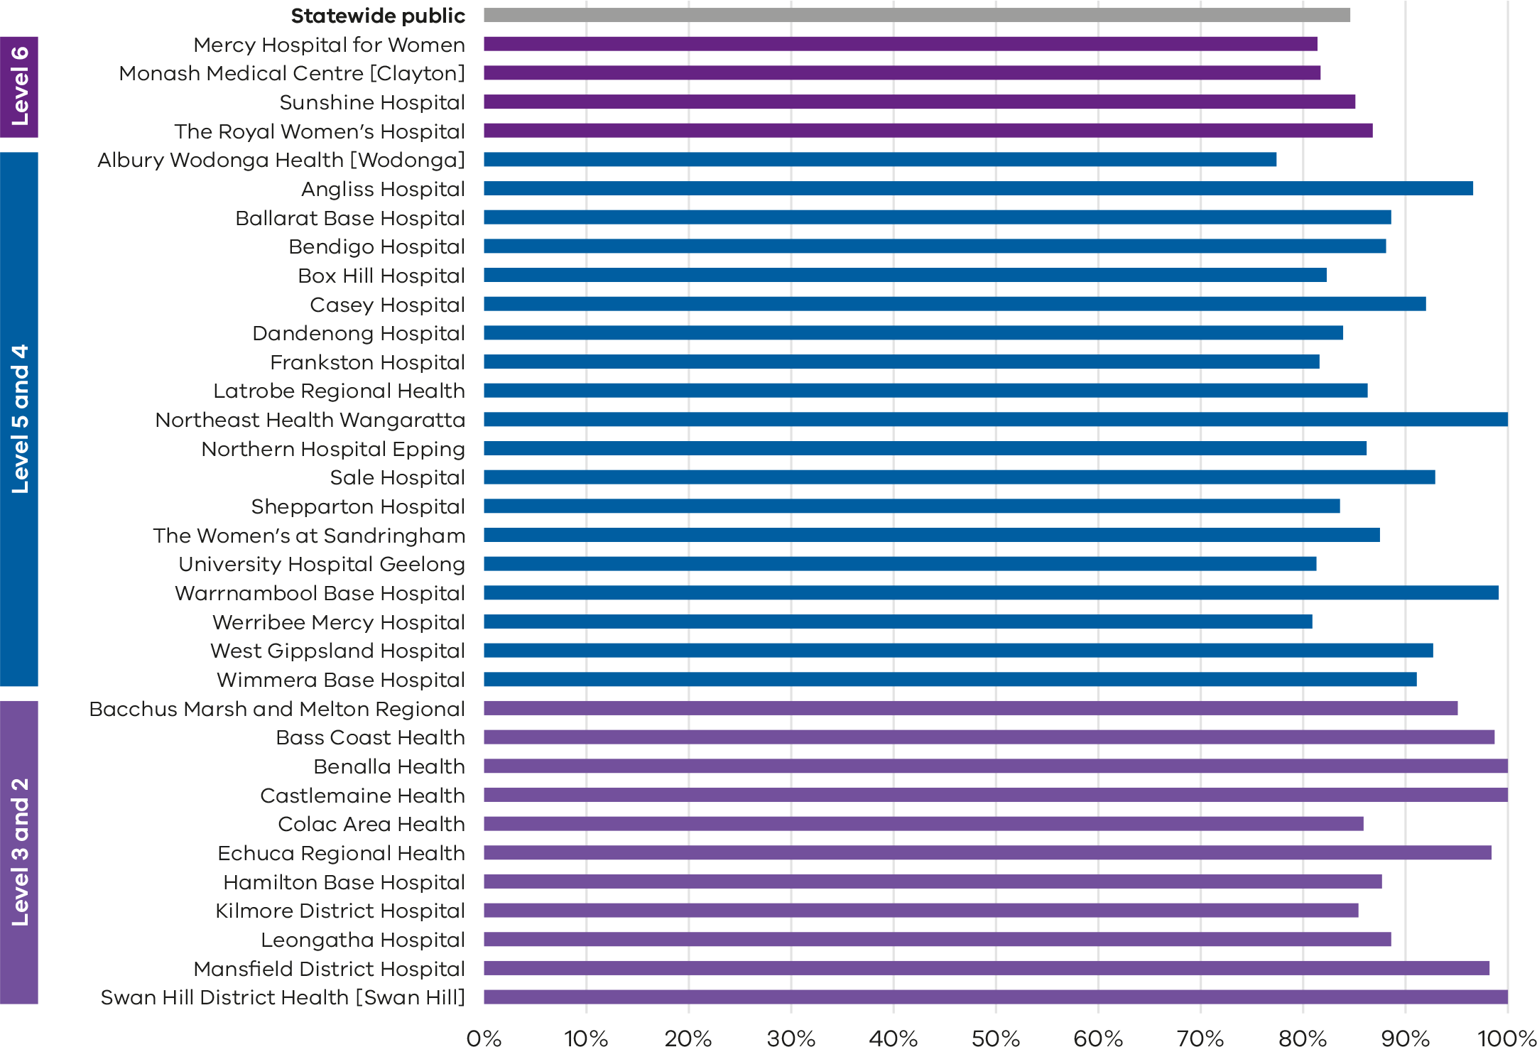
Note: No quartiles are presented for Indicator 11 since the measure is calculated from survey data and a different method of determining least and most favourable outcomes was applied (i.e., tested for significant difference compared with the rate for public hospitals).
The VHES only collects data from public hospitals and reports only on services with more than 10 responses in a year. As such, this indicator is only reported for public health services and not all services meet the criteria for reporting in this indicator.

Figure 69. Funnel plot of the rate of women who felt that staff gave them active support and encouragement to feed their baby in the way they wanted to, 2022
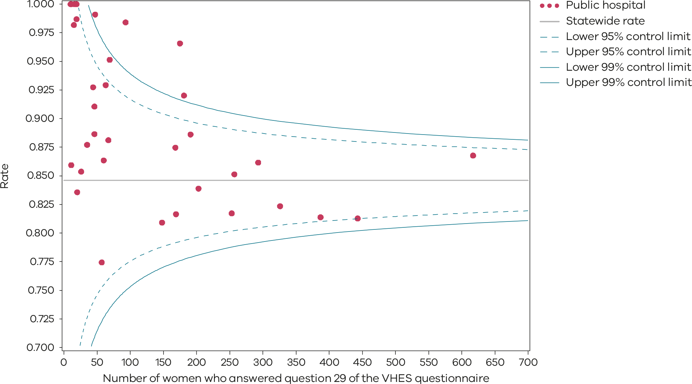
Please refer to the guide on how to interpret funnel plots.
Table 23. Rate of women who felt that staff gave them active support and encouragement to feed their baby in the way they wanted to, 2021–2022
 | 2021 | 2022
Public | 87.2% | 84.6%
Figure 70. Time trend of Indicator 11b, 2021–2022
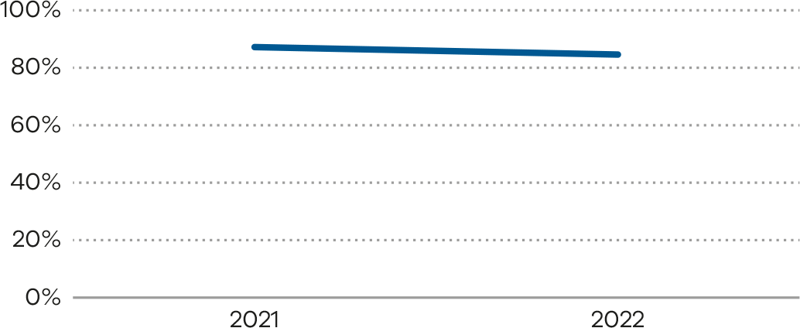
Numerator/denominator
Indicator | Numerator | Denominator
Indicator 11a: Rate of women who reported that they felt involved as much as they wanted to be in making decisions about their care | The number of women who answered ‘yes, definitely’ to question 6 of the VHES maternity questionnaire | The number of women who answered question 6 of the VHES maternity questionnaire
Indicator 11b: Rate of women who felt that staff gave them active support and encouragement to feed their baby in the way they wanted to | The number of women who answered ‘yes, definitely’ to question 29 of the VHES maternity questionnaire | The number of women who answered question 29 of the VHES maternity questionnaire

12a and 12b: Maternal vaccination
Figure 71. Indicator 12a: Rate of women vaccinated for pertussis during pregnancy, 2022
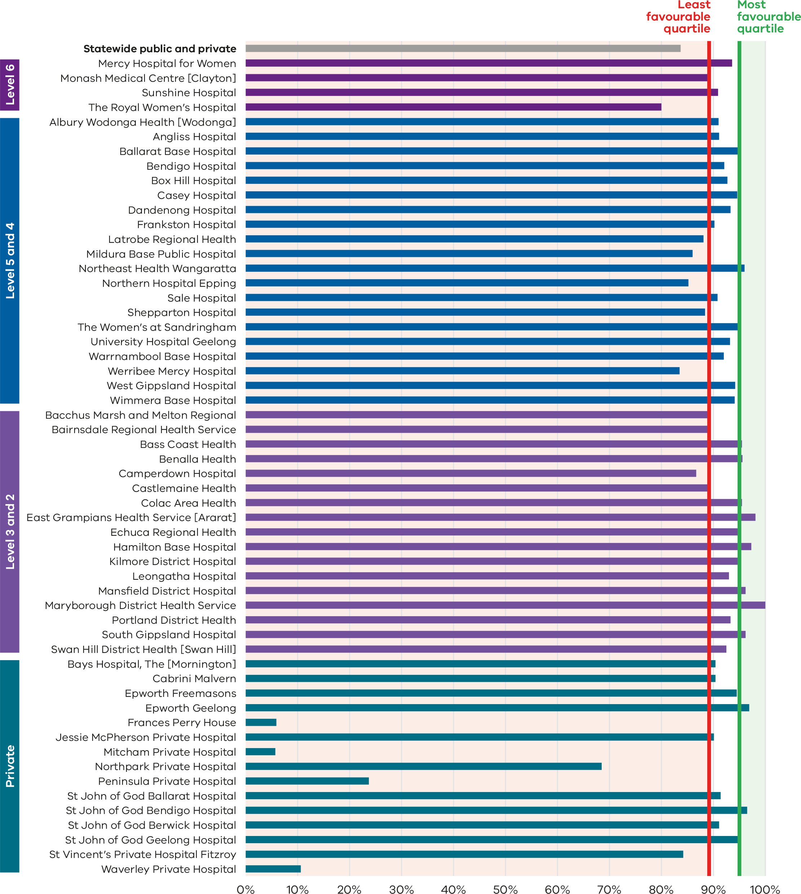
Figure 72. Funnel plot of the rate of women vaccinated for pertussis during pregnancy, 2022
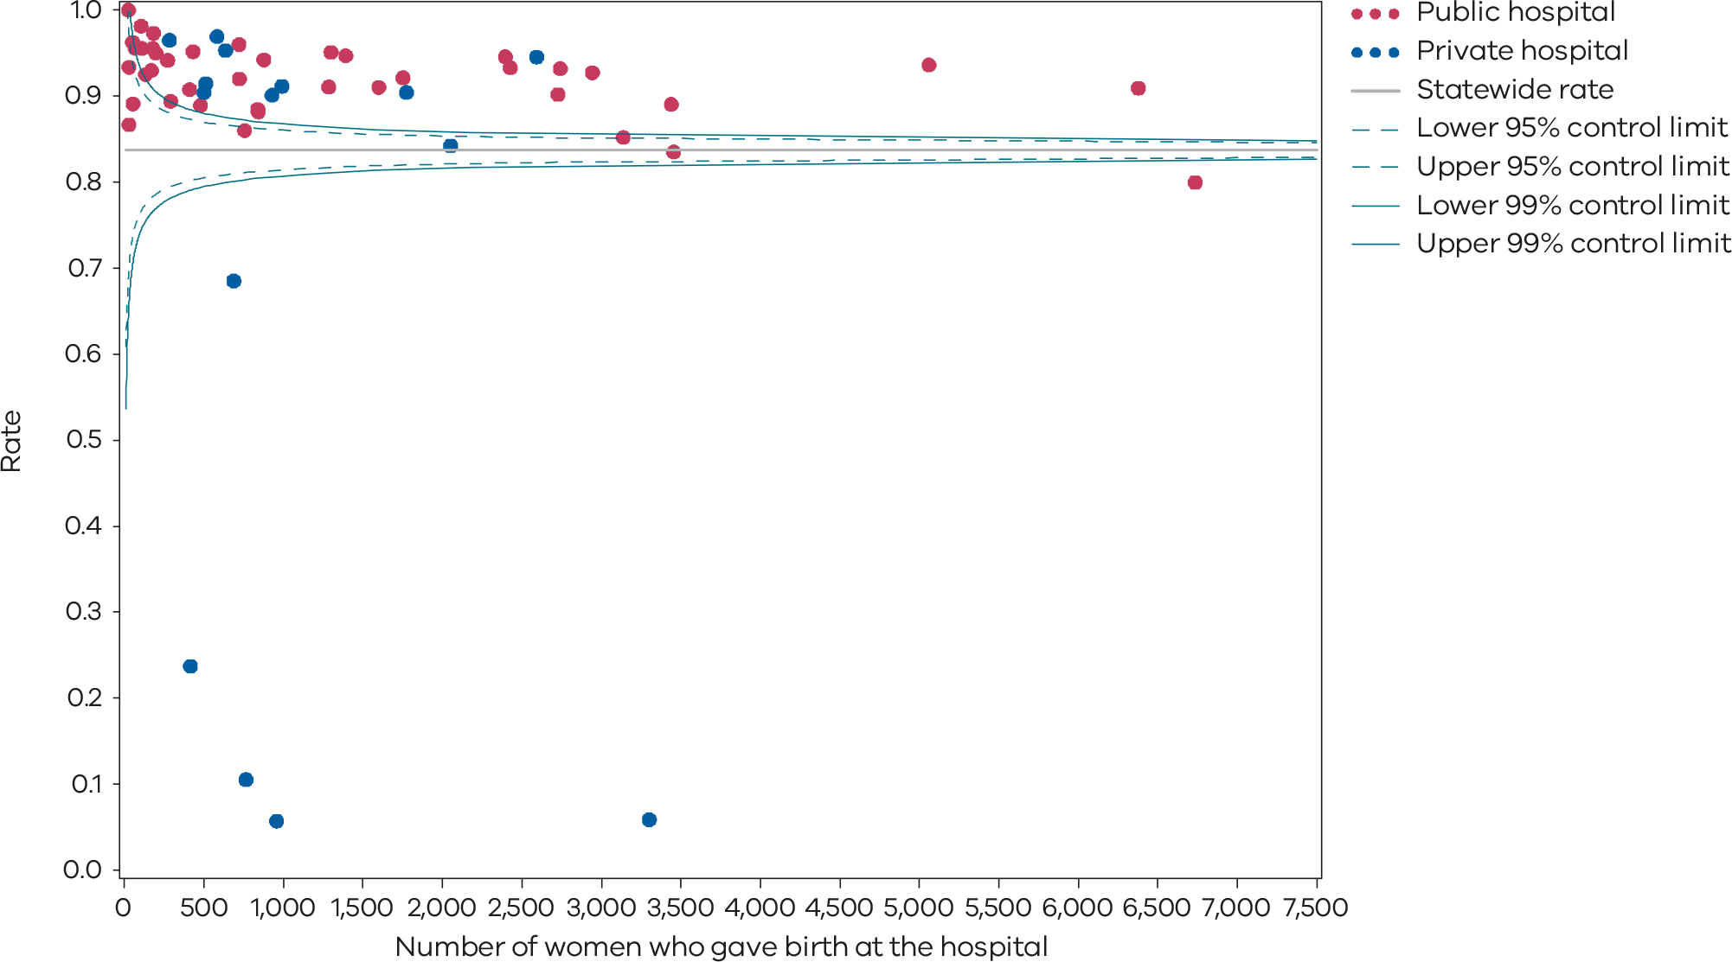
Please refer to the guide on how to interpret funnel plots.
Table 24. Rate of women vaccinated for pertussis during pregnancy, 2018–2022
 | 2018 | 2019 | 2020 | 2021 | 2022
Public | 88.2% | 91.5% | 91.1% | 87.3% | 89.7%
Private | 60.4% | 57.7% | 60.7% | 62.4% | 63.5%
Statewide | 81.8% | 83.8% | 84.3% | 81.4% | 83.5%
Figure 73. Time trend of Indicator 12a, 2018–2022
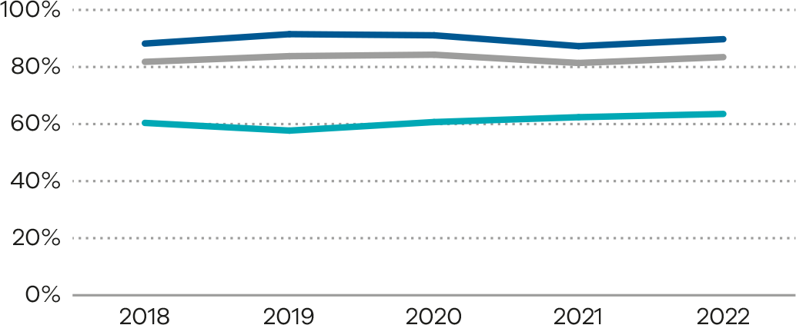
Figure 74. Indicator 12b: Rate of women vaccinated for influenza during pregnancy, 2022
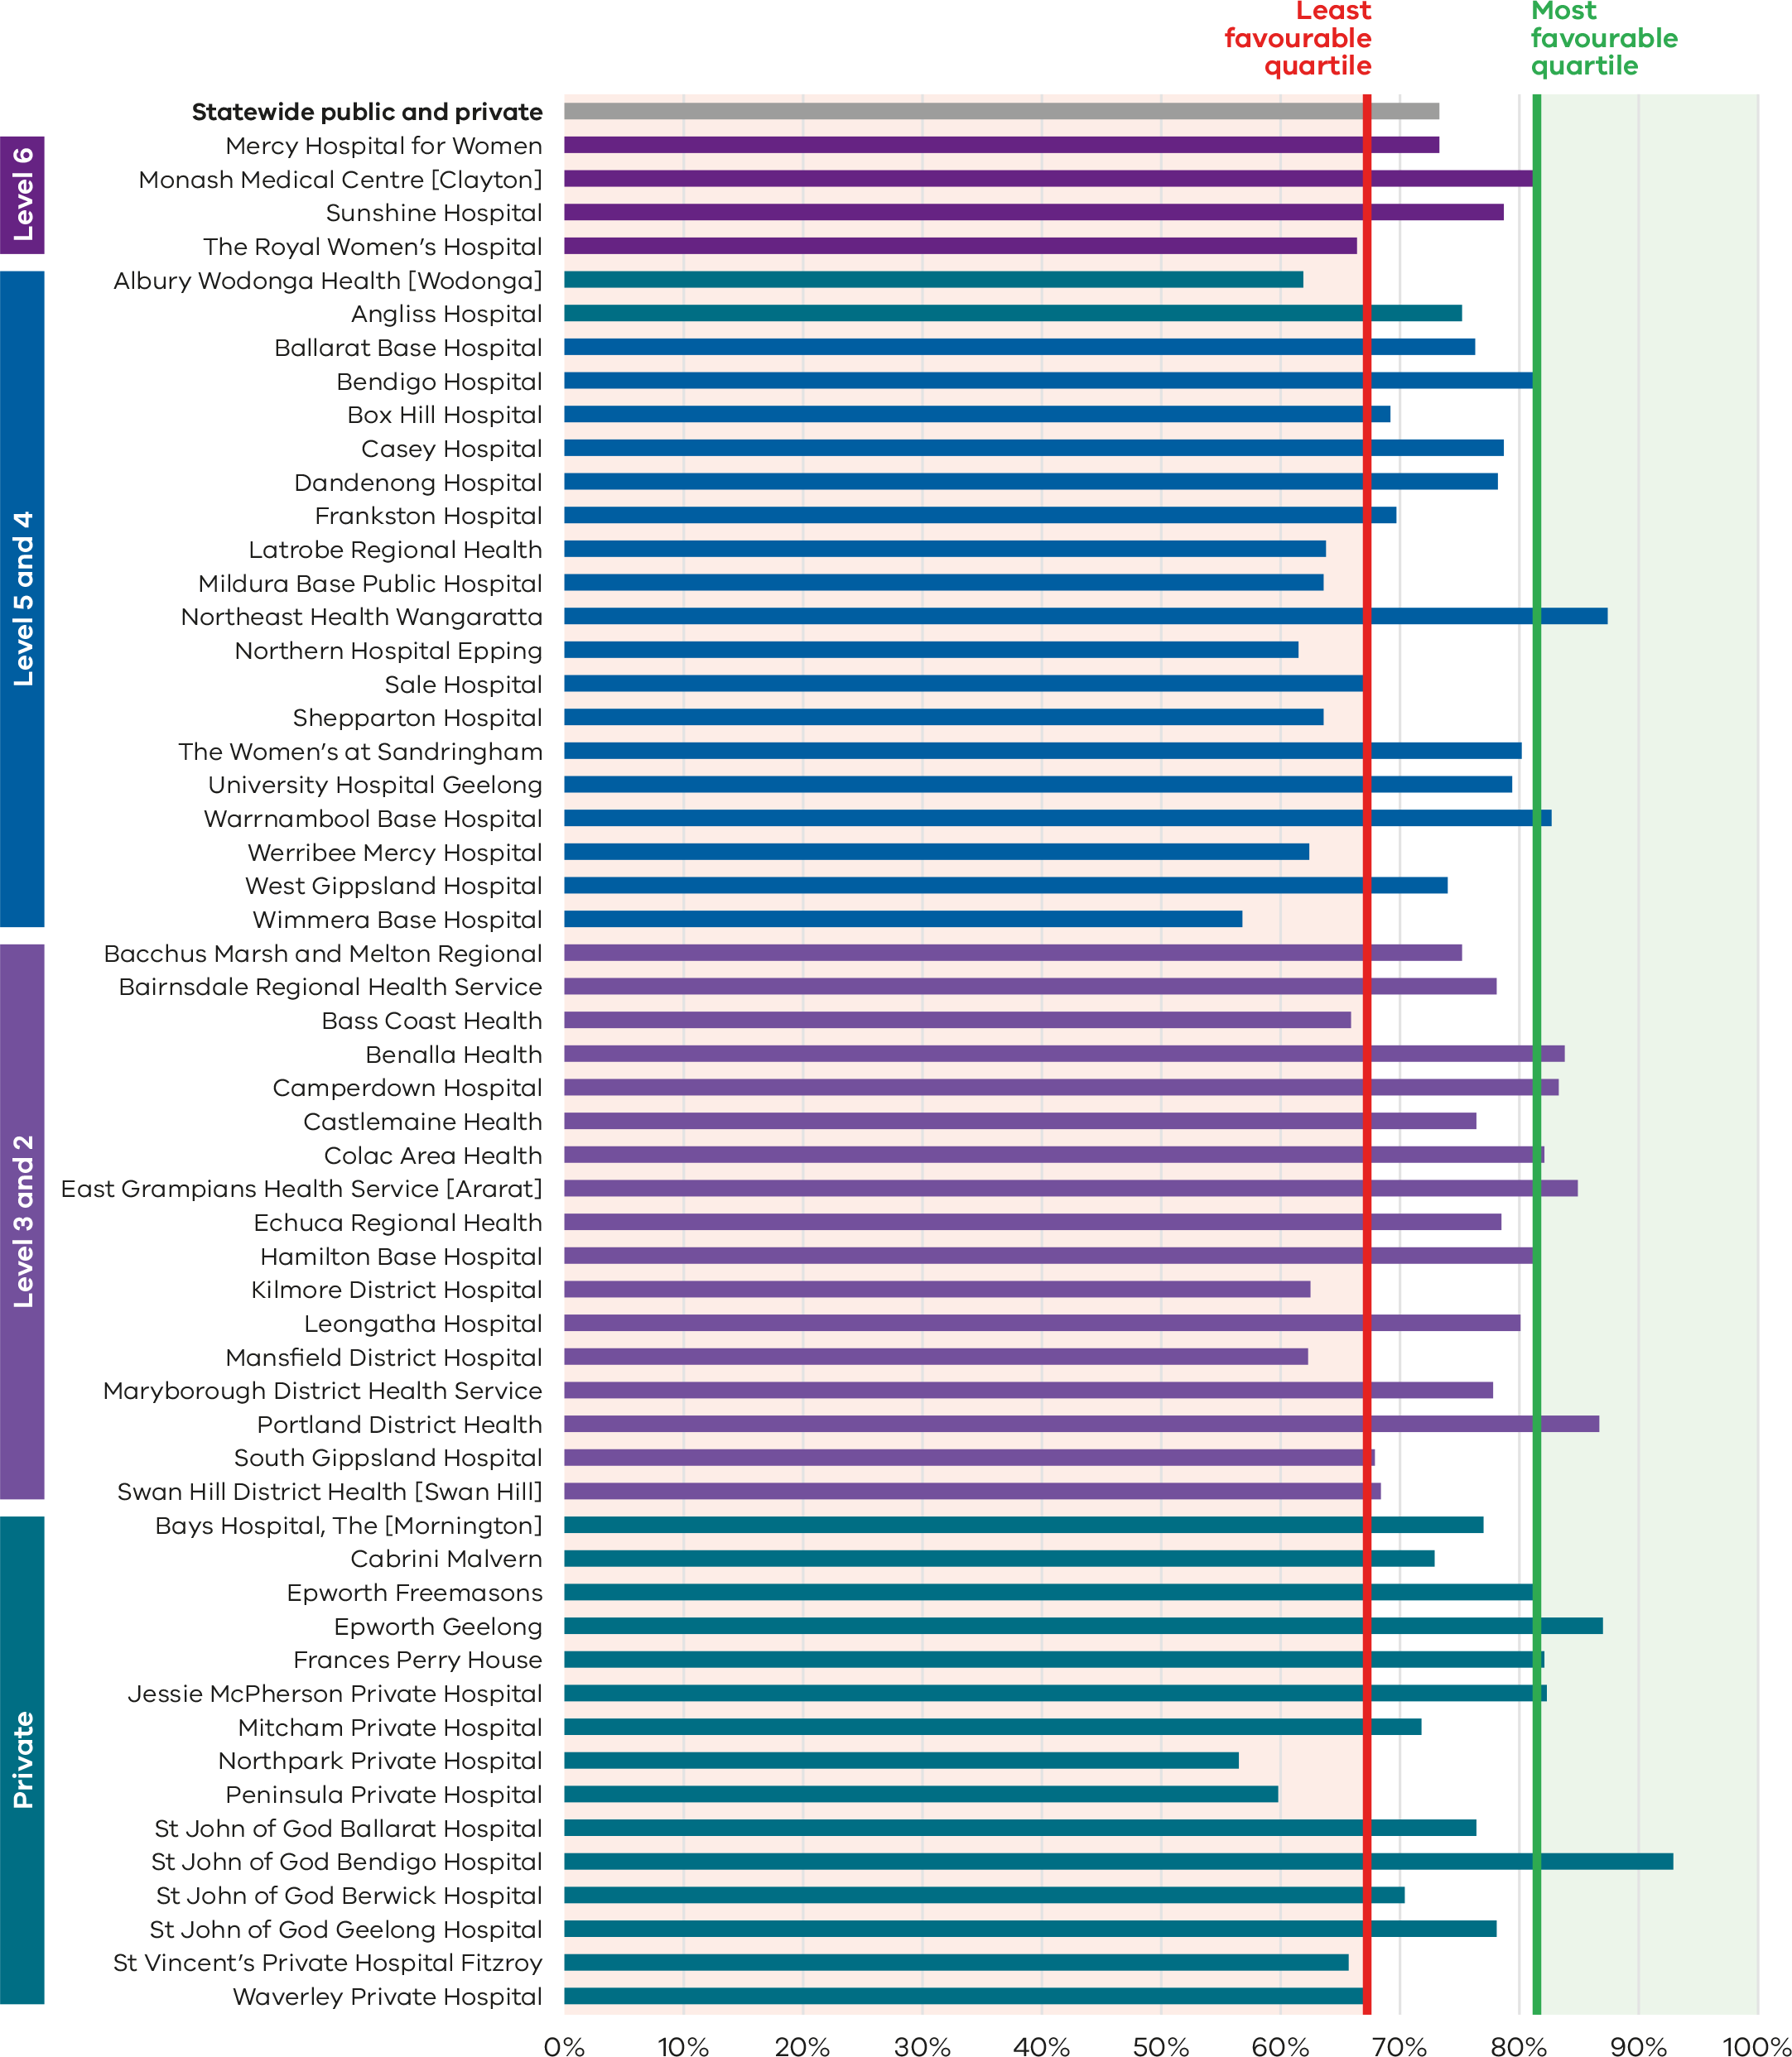
Figure 75. Funnel plot of the rate of women vaccinated for influenza during pregnancy, 2022
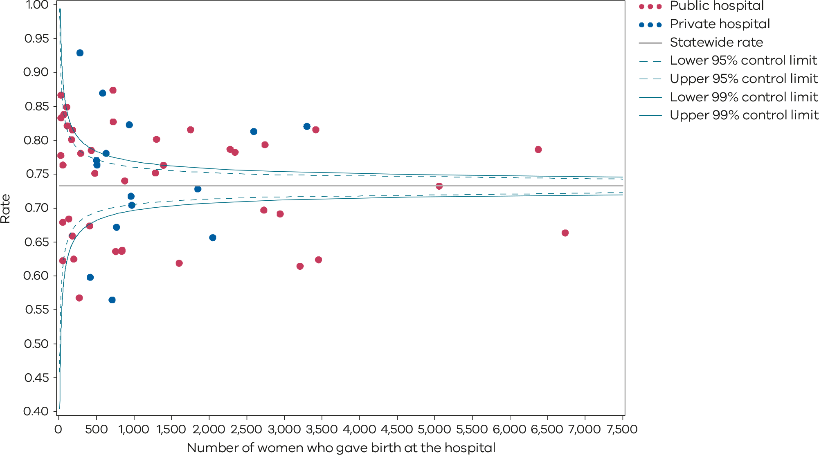
Please refer to the guide on how to interpret funnel plots.
Table 25. Rate of women vaccinated for influenza during pregnancy, 2018–2022
 | 2018 | 2019 | 2020 | 2021 | 2022
Public | 67.8% | 75.8% | 82.3% | 73.7% | 72.7%
Private | 65.0% | 70.9% | 80.7% | 74.7% | 75.4%
Statewide | 67.1% | 74.6% | 81.8% | 73.7% | 73.0%
Figure 76. Time trend of Indicator 12b, 2018–2022
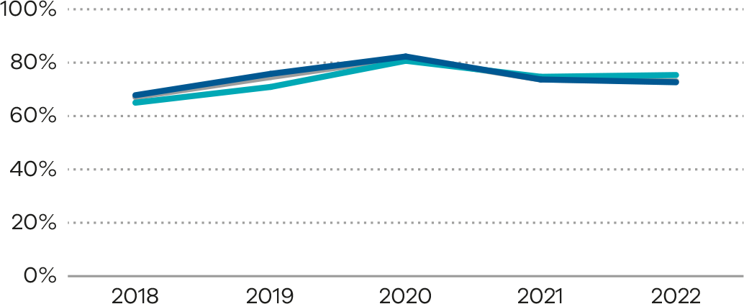
Numerator/denominator
Indicator | Numerator | Denominator
Indicator 12a: The rate of women vaccinated for pertussis during pregnancy | The number of women who received a pertussis vaccine at any point during pregnancy | The number of women who gave birth in Victoria
Indicator 12b: The rate of women vaccinated for influenza during pregnancy | The number of women who received an influenza vaccine at any point during pregnancy | The number of women who gave birth in Victoria

13: Women who had a severe postpartum haemorrhage within 24 hours of giving birth
Figure 77. Indicator 13: Rate of women with severe postpartum haemorrhage, 2022
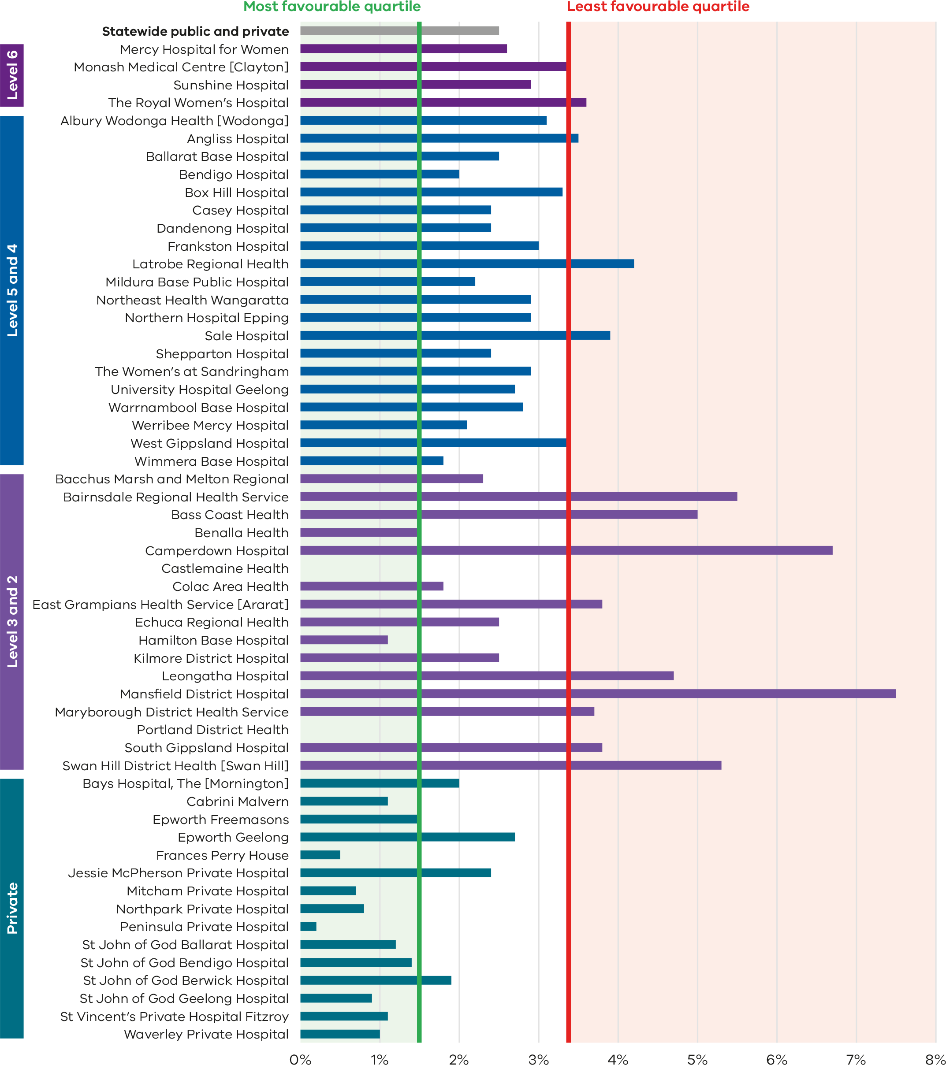
Figure 78. Funnel plot of the rate of women with severe postpartum haemorrhage, 2022
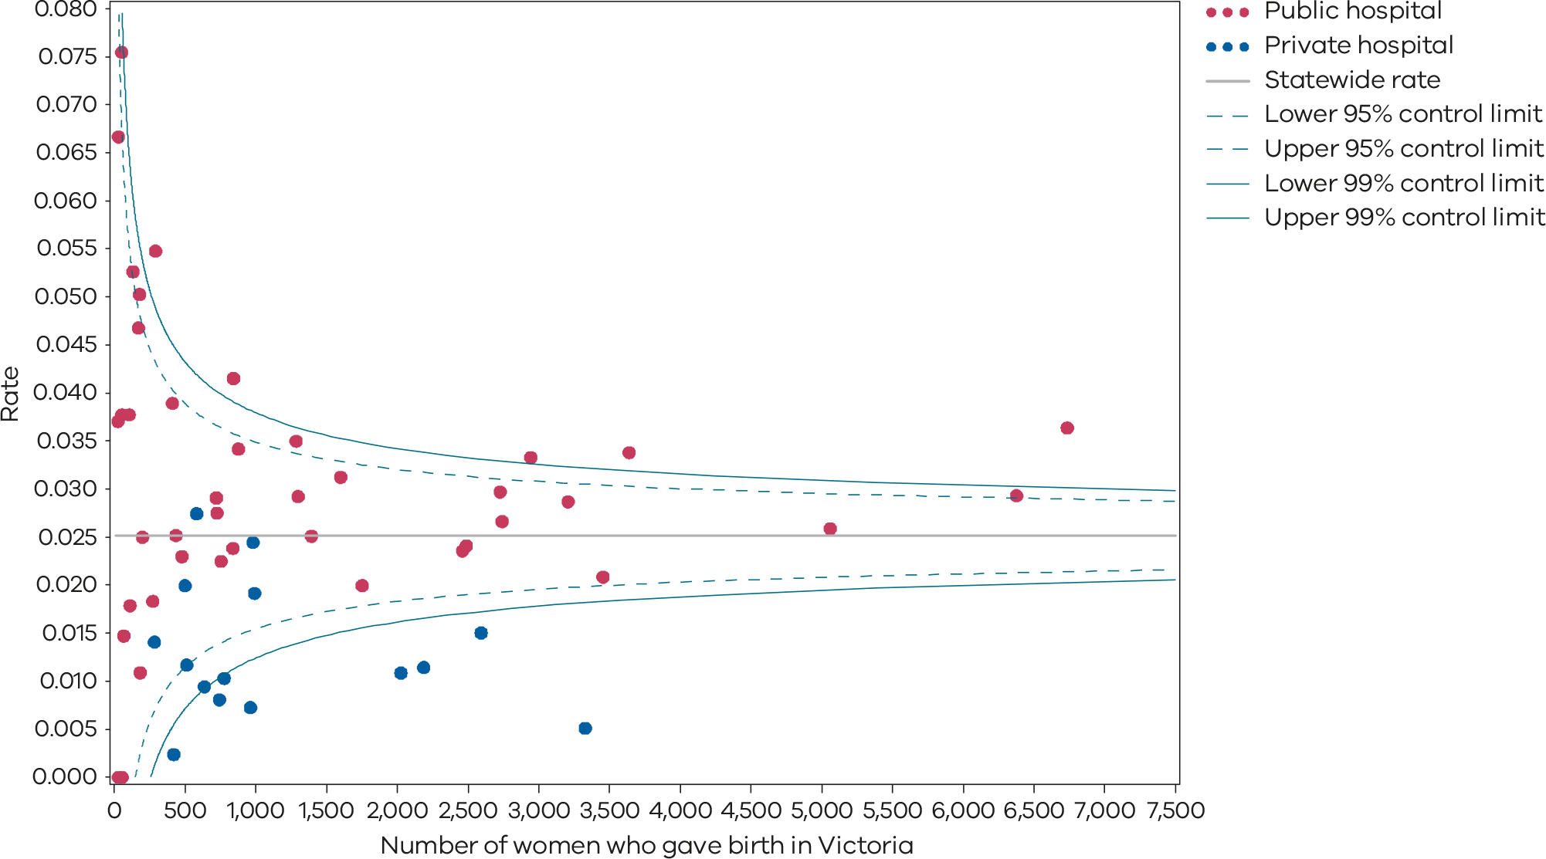
Please refer to the guide on how to interpret funnel plots.
Table 26. Rate of women with severe postpartum haemorrhage, 2018–2022
 | 2018 | 2019 | 2020 | 2021 | 2022
Public | 2.5% | 2.9% | 3.0% | 2.7% | 2.9%
Private | 1.0% | 0.9% | 1.1% | 1.1% | 1.2%
Statewide | 2.2% | 2.4% | 2.6% | 2.3% | 2.5%
Figure 79. Time trend of Indicator 13, 2018–2022
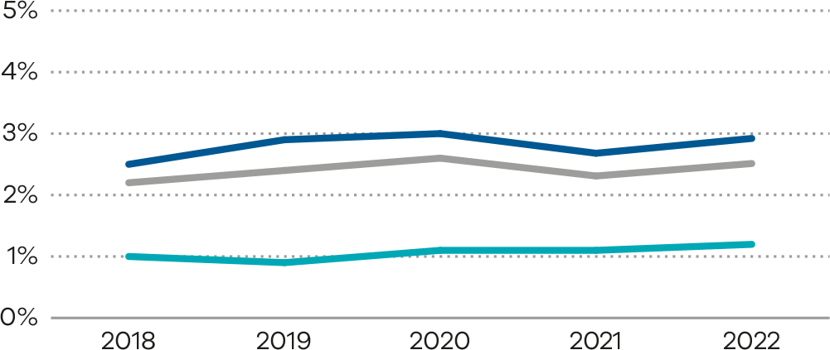
Numerator/denominator
Indicator | Numerator | Denominator
Indicator 13: The rate of women with severe postpartum haemorrhage | The number of women with blood loss of at least 1,500 mL | The number of women who gave birth in Victoria

Appendix 1: Data sources and reporting rules
Safer Care Victoria, eHealth and the Department of Health manage the health data collections used for this report:
- Victorian Perinatal Data Collection: Victorian public and private health services are required to submit specific data to the Consultative Council on Obstetric and Paediatric Mortality and Morbidity.
- Victorian Healthcare Experience Survey collects data for public health services only.
Victorian Admitted Episodes Dataset: Victorian public and private health services are required to submit specific hospital admissions data.
More information on the data sources and the business rules for each indicator can be found under each indicator.
When interpreting the data in this report, it is important to note the following:
- The indicator specifications were reviewed for the 2022 report to ensure inclusion and exclusion criteria were contemporaneous and aligned with current ICD-10-AM classifications of diseases in pregnancy. For Indicator 1a (Induction of labour in standard primiparae), seven ICD-10-AM codes were removed from the exclusion list as they were considered to be a valid clinical indication for an induction of labour. Sixty-four ICD-10-AM codes were added to the exclusion list because they were not considered to be a clinical indication for induction of labour. This needs to be taken into consideration when comparing rates of induction in 2022 Indicator 1a with previous years. Apart from Indicator 5, data is only reported when a health service has had a minimum of 10 occasions for an event (denominator). For example, a hospital that has had fewer than 10 standard primiparae give birth in 2022 (denominator) will not be included in the results for Indicator 1a.
- Due to small numbers, data from smaller health services are subject to wide variation and should be interpreted with caution.
- Private patients admitted to a public health service are reported in the results for the relevant public health service.
- Outcomes for public health services are presented in order of clustered maternity service capability (and newborn service capability for Indicators 6b and 10) and then by the number of women who gave birth at each health service in 2022 (in descending order so hospitals with more births in each capability level appear first).
- Although the statewide rates provided for each indicator are a suitable measure for comparing health services, they do not necessarily represent the optimal rate.
- The indicators in this report do not adjust for maternal characteristics such as obesity, mental health conditions, chronic illnesses, socioeconomic status or IVF pregnancies. Health services should consider individual patient profiles when reviewing their data.
- Some of the variation between hospitals may reflect incomplete reporting. To ensure the accuracy of indicators, health services should make sure they have accurate capture and reporting of diagnostic and treatment codes.

Appendix 2: Total women and babies in Victorian maternity services 2022
Table 27. Total number of women and babies, by maternity service of birth, 2022
Health service | Hospital campus | Maternal capability level of service* | Number of women | Number of babies
The Royal Women’s Hospital | The Royal Women’s Hospital | 6 | 6,736 | 6,901
Western Health | Sunshine Hospital | 6 | 6,378 | 6,483
Mercy Hospitals Victoria Ltd | Mercy Hospital for Women | 6 | 5,061 | 5,163
Monash Health | Monash Medical Centre [Clayton] | 6 | 3,639 | 3,811
Northern Health | Northern Hospital Epping | 5 | 3,209 | 3,250
Eastern Health | Box Hill Hospital | 5 | 2,944 | 2,986
Barwon Health | University Hospital Geelong | 5 | 2,742 | 2,783
Peninsula Health | Frankston Hospital | 5 | 2,728 | 2,769
Bendigo Health Care Group | Bendigo Hospital | 5 | 1,753 | 1,789
Albury Wodonga Health | Albury Wodonga Health [Wodonga] | 5 | 1,601 | 1,616
Grampians Health Ballarat | Ballarat Base Hospital | 5 | 1,394 | 1,416
Latrobe Regional Hospital | Latrobe Regional Hospital | 5 | 843 | 855
Goulburn Valley Health | Shepparton Hospital | 5 | 839 | 844
Mercy Hospitals Victoria Ltd | Werribee Mercy Hospital | 4 | 3,455 | 3,472
Monash Health | Dandenong Hospital | 4 | 2,489 | 2,489
Monash Health | Casey Hospital | 4 | 2,462 | 2,463
The Royal Women’s Hospital | The Women’s at Sandringham | 4 | 1,300 | 1,300
Eastern Health | Angliss Hospital | 4 | 1,286 | 1,295
West Gippsland Healthcare Group | West Gippsland Hospital | 4 | 878 | 895
Mildura Base Hospital | Mildura Base Public Hospital | 4 | 756 | 761
South West Healthcare | Warrnambool Base Hospital | 4 | 727 | 741
Northeast Health Wangaratta | Northeast Health Wangaratta | 4 | 722 | 727
Central Gippsland Health Service | Sale Hospital | 4 | 411 | 413
Grampians Health – Wimmera Health Care Group | Wimmera Base Hospital | 4 | 273 | 275
Western Health BM&M | Bacchus Marsh and Melton Regional | 3 | 479 | 479
Echuca Regional Health | Echuca Regional Health | 3 | 437 | 437
Bairnsdale Regional Health Service | Bairnsdale Regional Health Service | 3 | 292 | 292
Kilmore District Health | Kilmore District Health | 3 | 200 | 200
Western District Health Service | Hamilton Base Hospital | 3 | 184 | 185
Bass Coast Health | Bass Coast Health | 3 | 179 | 180
Gippsland Southern Health Service | Leongatha Hospital | 3 | 171 | 171
Swan Hill District Health | Swan Hill District Health [Swan Hill] | 3 | 133 | 135
Colac Area Health | Colac Area Health | 3 | 112 | 112
East Grampians Health Service | East Grampians Health Service [Ararat] | 3 | 106 | 106
Benalla Health | Benalla Health | 3 | 68 | 68
Mansfield District Hospital | Mansfield District Hospital | 3 | 53 | 53
South Gippsland Hospital | South Gippsland Hospital | 3 | 53 | 53
South West Healthcare | Camperdown Hospital | 3 | 30 | 30
Dhelkaya Health – Castlemaine | Castlemaine Health | 2 | 55 | 55
Portland District Health | Portland District Health | 2 | 30 | 30
Maryborough District Health Service | Maryborough District Health Service [Maryborough] | 2 | 27 | 27
Non-maternity public hospitalsª |  | N/A | 7 | 7
Ramsay Health Care | Frances Perry House | Private | 3,329 | 3,396
Epworth HealthCare | Epworth Freemasons | Private | 2,594 | 2,638
St Vincent’s Private Hospital Melbourne Limited | St Vincent’s Private Hospital Fitzroy | Private | 2,187 | 2,220
Cabrini Health Limited | Cabrini Malvern | Private | 2,027 | 2,052
Jessie McPherson Private Hospital | Jessie McPherson Private Hospital | Private | 981 | 1019
St John of God Health Care Inc. | St John of God Berwick Hospital | Private | 992 | 999
Ramsay Health Care | Mitcham Private Hospital | Private | 963 | 978
Ramsay Health Care | Waverley Private Hospital | Private | 777 | 783
Healthscope | Northpark Private Hospital | Private | 744 | 748
St John of God Health Care Inc. | St John of God Geelong Hospital | Private | 637 | 643
Epworth HealthCare | Epworth Geelong | Private | 583 | 588
St John of God Health Care Inc. | St John of God Ballarat Hospital | Private | 513 | 517
The Bays Hospital Group Inc. | Bays Hospital, The [Mornington] | Private | 501 | 505
Ramsay Health Care | Peninsula Private Hospital | Private | 421 | 425
St John of God Health Care Inc. | St John of God Bendigo Hospital | Private | 284 | 289
Total public |  | N/A | 57,235 | 58,110
Total private |  | N/A | 17,533 | 17,800
Private home births |  | N/A | 445 | 445
Freebirths^{b} |  | N/A | 1 | 1
Statewide total |  | N/A | 75,221 | 76,363
Notes: Excludes babies born ≤ 20 weeks’ gestation, all terminations of pregnancy and birthweight ≤ 150 g. Babies born before arrival are counted at the hospital the mother and baby are subsequently transported to.
* Capability service as at 2022–23
a Includes the Royal Melbourne Hospital (women: n = 3; births: n = 3), Austin Hospital (women: n = 3; births: n = 3) and Kyabram District Health Service (women: n = 1; births: n = 1)
b Freebirth is a birth where the woman intends to birth and does birth without medical or midwifery assistance.

Appendix 3: Overview of results

Table 28. Overview of indicator results, 2022
Hospital campus | Mat capability level | Number of births (babies, 2021) | Indicator 1a | Indicator 1bi | Indicator 1bii | Indicator 1ci | Indicator 1cii | Indicator 1di | Indicator 1dii | Indicator 2 | Indicator 3a | Indicator 3b | Indicator 4a | Indicator 4b | Indicator 5* | Indicator 6a | Indicator 6b | Indicator 7 | Indicator 8a | Indicator 8b | Indicator 8c | Indicator 9 | Indicator 10 | Indicator 11a* | Indicator 11b* | Indicator 12a | Indicator 12b | Indicator 13 | Indicators in most favourable | Indicators in least favourable
Statewide | – | 76,363 | 17.3% | 19.6% | 32.6% | 3.5% | 4.5% | 24.7% | 85.8% | NA | 22.0% | 17.6% | 21.5% | 53.4% | NA | 2.3% | NA | 33.8% | 94.9% | 30.7% | 72.6% | 75.4% | 1.3% | NA | NA | 83.5% | 73.0% | 2.5% | - | -
Public hospitals | – | 58,110 | 12.4% | 18.2% | 33.6% | 4.2% | 5.2% | 24.7% | 90.9% | 11.7% | 22.7% | 16.8% | 26.5% | 53.1% | NA | 2.5% | 4.9% | 33.1% | 94.9% | 27.3% | 75.4% | 72.3% | 1.4% | 67.7% | 84.6% | 89.7% | 72.7% | 2.9% | - | -
Private hospitals | – | 17,800 | 24.0% | 26.1% | 29.7% | 0.4% | 2.8% | 26.7% | 72.2% | NA | 17.7% | 20.0% | 9.8% | 50.4% | NA | 1.4% | NA | 57.1% | 94.7% | 42.6% | 62.8% | 86.3% | 1.0% | NA | NA | 63.5% | 75.4% | 1.2% | - | -
Least favourable quartile | – | – | 22.7% | 26.6% | 39.9% | 3.9% | 5.6% | 27.7% | 75.8% | 12.9% | 26.0% | 21.8% | 13.2% | 47.2% | NA | 2.8% | 5.0% | 24.8% | 92.9% | 35.4% | 68.8% | 71.6% | 1.7% | NA | NA | 89.0% | 67.0% | 3.4% | - | -
Most favourable quartile | – | – | 8.4% | 17.2% | 29.9% | 0.0% | 2.0% | 18.2% | 92.3% | 8.5% | 12.7% | 11.9% | 30.6% | 59.3% | NA | 1.5% | 2.9% | 44.6% | 95.8% | 17.2% | 85.8% | 88.2% | 0.8% | NA | NA | 95.0% | 81.4% | 1.5% | - | -
The Royal Women’s Hospital | 6 | 6,901 | 11.0% | 13.3% | 24.4% | 6.3% | 6.1% | 22.3% | 92.6% | 14.9% | 26.0% | 10.4% | 26.6% | 66.1% | 1.07 | 2.1% | 6.7% | 27.8% | 95.7% | 32.2% | 72.8% | 45.3% | 1.3% | 66.8% | 86.8% | 80.0% | 66.4% | 3.6% | 5 | 9
Sunshine Hospital | 6 | 6,483 | 16.4% | 10.6% | 30.0% | 5.8% | 5.4% | 25.1% | 93.7% | 10.9% | 24.2% | 9.8% | 31.5% | 54.1% | 1.09 | 2.8% | 3.8% | 33.5% | 94.7% | 33.5% | 72.9% | 76.0% | 1.0% | 66.7% | 85.1% | 90.9% | 78.7% | 2.9% | 4 | 1
Mercy Hospital for Women | 6 | 5,163 | 12.9% | 18.1% | 32.3% | 3.7% | 4.0% | 31.4% | 91.1% | 9.9% | 22.3% | 17.0% | 17.6% | 47.9% | 0.78 | 2.3% | 4.5% | 49.8% | 96.0% | 32.0% | 72.6% | 49.8% | 1.1% | 65.4% | 81.4% | 93.6% | 73.3% | 2.6% | 2 | 2
Monash Medical Centre [Clayton] | 6 | 3,811 | 20.4% | 12.8% | 30.7% | 1.2% | 5.5% | 32.3% | 90.9% | 11.9% | 7.4% | 20.3% | 14.9% | 52.7% | 1.0 | 2.3% | 4.0% | 30.6% | 95.0% | 34.2% | 57.6% | 84.9% | 1.5% | 66.7% | 81.7% | 89.0% | 81.6% | 3.4% | 3 | 2
Northern Hospital Epping | 5 | 3,250 | 21.5% | 20.8% | 39.6% | 2.8% | 4.5% | 30.2% | 90.7% | 9.8% | 25.9% | 17.3% | 34.6% | 43.1% | 1.26 | 2.0% | 4.3% | 37.8% | 93.0% | 38.3% | 68.4% | 85.2% | 1.2% | 72.0% | 86.2% | 85.2% | 61.5% | 2.9% | 1 | 6
Box Hill Hospital | 5 | 2,986 | 10.0% | 18.6% | 33.8% | 2.6% | 3.8% | 21.3% | 89.6% | 10.9% | 23.9% | 22.0% | 26.0% | 56.3% | 1.07 | 3.3% | 4.0% | 44.8% | 96.9% | 15.2% | 88.1% | 69.6% | 1.7% | 65.0% | 82.3% | 92.7% | 69.2% | 3.3% | 4 | 4
University Hospital Geelong | 5 | 2,783 | 7.9% | 23.3% | 37.9% | 6.2% | 6.0% | 20.8% | 93.7% | 18.8% | 12.7% | 11.7% | 36.4% | 53.4% | 1.16 | 2.4% | 7.2% | 27.9% | 95.5% | 29.8% | 76.2% | 94.3% | 1.4% | 67.4% | 81.3% | 93.2% | 79.4% | 2.7% | 6 | 4
Frankston Hospital | 5 | 2,769 | 8.8% | 20.4% | 35.9% | 4.3% | 5.0% | 20.9% | 87.3% | 14.1% | 38.5% | 21.2% | 33.1% | 52.6% | 1.15 | 3.5% | 5.7% | 30.7% | 93.4% | 20.8% | 83.1% | 76.8% | 1.4% | 68.6% | 81.6% | 90.2% | 69.7% | 3.0% | 1 | 5
Bendigo Hospital | 5 | 1,789 | 22.8% | 18.8% | 35.2% | 3.3% | 5.9% | 31.5% | 96.3% | 11.4% | 29.2% | 12.5% | 29.9% | 45.5% | 1.29 | 2.5% | 7.0% | 25.2% | 93.7% | 24.8% | 80.8% | 67.0% | 2.0% | 76.3% | 88.1% | 92.1% | 81.6% | 2.0% | 2 | 8
Albury Wodonga Health [Wodonga] | 5 | 1,616 | 11.9% | 17.3% | 33.2% | 3.9% | 3.7% | 23.9% | 78.4% | 15.5% | 18.2% | 30.3% | 25.9% | 71.1% | 1.23 | 2.9% | 4.4% | 22.7% | 92.9% | 30.1% | 85.4% | 89.2% | 1.9% | 76.1% | 77.4% | 91.0% | 61.9% | 3.1% | 2 | 6
Ballarat Base Hospital | 5 | 1,416 | 19.2% | 24.8% | 38.0% | 3.0% | 2.8% | 19.2% | 88.9% | 14.6% | 11.8% | 11.8% | 21.3% | 50.0% | 0.55 | 3.7% | 5.0% | 24.9% | 91.1% | 21.5% | 81.7% | 89.9% | 1.9% | 67.0% | 88.6% | 94.7% | 76.3% | 2.5% | 3 | 5
Latrobe Regional Hospital | 5 | 855 | 7.4% | 26.6% | 47.0% | 5.1% | 4.8% | 21.2% | 93.5% | 22.2% | 7.7% | 5.9% | 30.5% | 48.3% | 1.27 | 3.8% | 3.8% | 24.7% | 89.7% | 33.3% | 66.1% | 78.5% | 3.2% | 63.2% | 86.3% | 88.1% | 63.8% | 4.2% | 4 | 11
Shepparton Hospital | 5 | 844 | 7.4% | 20.5% | 22.6% | 1.9% | 5.7% | 17.7% | 88.7% | 17.6% | 21.1% | NA | 27.4% | 50.0% | 1.44 | 1.5% | 2.7% | 23.3% | 92.0% | 39.6% | 75.2% | 72.2% | 1.8% | 63.0% | 83.6% | 88.4% | 63.6% | 2.4% | 5 | 8
Werribee Mercy Hospital | 4 | 3,472 | 4.6% | 25.3% | 42.0% | 5.4% | 7.0% | 30.4% | 92.2% | 8.4% | 29.6% | 17.5% | 31.1% | 49.0% | 1.13 | 2.4% | 6.9% | 31.0% | 95.4% | 32.4% | 73.3% | 55.2% | 0.7% | 70.6% | 80.9% | 83.5% | 62.4% | 2.1% | 4 | 9
Dandenong Hospital | 4 | 2,489 | 8.1% | 20.7% | 39.9% | 4.0% | 8.2% | 32.0% | 96.1% | 7.1% | 24.6% | 22.8% | 27.0% | 58.6% | 1.26 | 2.6% | 4.0% | 51.9% | 96.7% | 20.7% | 72.3% | 91.4% | 1.1% | 75.7% | 83.9% | 93.3% | 78.2% | 2.4% | 6 | 4
Casey Hospital | 4 | 2,463 | 2.8% | 17.2% | 34.4% | 2.9% | 6.4% | 27.6% | 94.0% | 8.0% | 33.3% | 16.3% | 24.5% | 66.7% | 1.3 | 2.0% | 5.2% | 51.5% | 95.5% | 19.0% | 70.8% | 90.9% | 1.3% | 76.4% | 92.0% | 94.6% | 78.7% | 2.4% | 8 | 3
The Women’s at Sandringham | 4 | 1,300 | 12.4% | 18.8% | 24.8% | 7.0% | 3.4% | 19.0% | 89.3% | 5.4% | 41.2% | 20.7% | 7.9% | NA | 1.35 | 3.1% | 7.6% | 65.5% | 98.2% | 14.8% | 95.7% | 66.8% | 1.7% | 70.1% | 87.5% | 95.1% | 80.2% | 2.9% | 7 | 6
Angliss Hospital | 4 | 1,295 | 9.7% | 19.9% | 35.5% | 1.2% | 3.7% | 19.4% | 84.3% | 8.8% | 27.8% | NA | 22.6% | 61.3% | 0.96 | 3.1% | 3.3% | 40.8% | 95.8% | 13.2% | 72.5% | 79.8% | 1.1% | 66.9% | 96.6% | 91.1% | 75.2% | 3.5% | 3 | 3
West Gippsland Hospital | 4 | 895 | 29.8% | 14.6% | 34.1% | 4.5% | 4.9% | 23.3% | 93.9% | 11.9% | NA | 63.2% | 30.8% | 46.4% | NA | 1.6% | 4.1% | 31.7% | 93.9% | 24.4% | 83.8% | 86.2% | 2.1% | 76.5% | 92.7% | 94.2% | 74.0% | 3.4% | 3 | 6
Mildura Base Public Hospital | 4 | 761 | 5.7% | 23.4% | 38.4% | 0.8% | 5.6% | 20.6% | 87.3% | 10.5% | 15.0% | NA | 21.3% | 43.8% | 0.8 | 1.9% | 5.0% | 19.4% | 92.7% | 27.2% | 68.9% | 60.7% | 0.7% | NA | NA | 86.0% | 63.6% | 2.2% | 2 | 8
Warrnambool Base Hospital | 4 | 741 | 15.9% | 21.3% | 29.9% | 2.5% | 5.8% | 20.3% | 74.4% | 12.7% | NA | NA | 32.2% | 57.9% | 1.02 | 3.8% | 4.6% | 33.7% | 96.9% | 15.5% | 83.9% | 77.7% | 1.8% | 82.5% | 99.1% | 92.0% | 82.7% | 2.8% | 6 | 4
Northeast Health Wangaratta | 4 | 727 | 18.2% | 30.1% | 40.0% | 5.3% | 3.0% | 18.1% | 95.5% | 17.9% | 11.8% | 0.0% | 23.1% | 53.3% | 0.99 | 2.3% | 3.7% | 19.5% | 95.2% | 17.6% | 88.4% | 93.6% | 0.9% | 79.4% | 100.0% | 96.0% | 87.4% | 2.9% | 8 | 5
Sale Hospital | 4 | 413 | 0.0% | 21.3% | 33.3% | 2.9% | 3.0% | 27.9% | 75.8% | 8.4% | NA | NA | 31.4% | 56.3% | 1.66 | 3.2% | 2.9% | 29.3% | 95.1% | 19.8% | 83.7% | 74.0% | 0.9% | 53.1% | 92.9% | 90.8% | 67.4% | 3.9% | 3 | 4
Wimmera Base Hospital | 4 | 275 | 0.0% | 19.0% | 42.9% | 0.0% | 0.0% | 10.8% | 92.0% | 10.6% | 9.1% | NA | 15.8% | NA | NA | 2.4% | 3.8% | 12.2% | 92.3% | 14.5% | 90.9% | 88.3% | 0.4% | 74.6% | 91.1% | 94.1% | 56.8% | 1.8% | 9 | 4
Monash Health at Sandringham | 4 | 0 | NA | NA | NA | NA | NA | NA | NA | 7.9% | NA | NA | NA | NA | NA | 3.5% | 4.6% | NA | NA | NA | NA | NA | NA | NA | NA | NA | NA | NA | 1 | 1
Bacchus Marsh and Melton Regional | 3 | 479 | 31.6% | 3.7% | 35.2% | 1.1% | 1.9% | 12.4% | 92.3% | 11.5% | NA | NA | 20.8% | 30.0% | NA | 2.3% | 5.1% | 32.7% | 93.7% | 17.6% | 83.8% | 65.6% | 1.3% | 76.3% | 95.1% | 88.9% | 75.2% | 2.3% | 4 | 5
Echuca Regional Hospital | 3 | 437 | 9.4% | 17.6% | 39.2% | 1.6% | 4.2% | 7.9% | 79.2% | 9.0% | NA | NA | 14.0% | NA | NA | 4.3% | 3.9% | 21.1% | 92.5% | 19.9% | 72.3% | 79.6% | 1.4% | 88.5% | 98.4% | 95.1% | 78.5% | 2.5% | 4 | 3
Bairnsdale Regional Health Service | 3 | 292 | 6.3% | 17.2% | 31.7% | 5.4% | 10.7% | 23.2% | 92.9% | 9.8% | NA | NA | 42.1% | NA | NA | 1.5% | 3.2% | 24.4% | 96.5% | 9.5% | 87.6% | 67.8% | 0.7% | NA | NA | 89.4% | 78.1% | 5.5% | 7 | 5
Kilmore District Health | 3 | 200 | 21.7% | 28.1% | 46.4% | 5.0% | 0.0% | 25.0% | 88.9% | 11.0% | NA | NA | 28.6% | NA | NA | 2.9% | 2.9% | 30.8% | 92.0% | 15.8% | 87.0% | 93.0% | 3.2% | 76.2% | 85.4% | 95.0% | 62.5% | 2.5% | 5 | 7
Hamilton Base Hospital | 3 | 185 | 10.0% | 32.1% | 30.3% | 0.0% | 0.0% | 26.3% | 82.6% | 3.5% | NA | NA | 26.1% | NA | NA | 1.2% | 2.9% | 50.0% | 95.6% | 17.3% | 78.0% | 84.2% | 2.2% | 78.7% | 87.7% | 97.3% | 81.5% | 1.1% | 9 | 2
Bass Coast Health | 3 | 180 | 0.0% | 14.7% | 26.9% | 2.9% | 6.7% | 17.1% | 93.3% | 15.7% | NA | NA | 30.8% | NA | NA | 1.7% | 0.0% | 50.0% | 89.1% | 13.5% | 87.8% | 74.3% | 1.2% | 98.7% | 98.7% | 95.5% | 65.9% | 5.0% | 12 | 5
Leongatha Hospital | 3 | 171 | 0.0% | 16.1% | 27.3% | 0.0% | 0.0% | 18.2% | 76.5% | 21.2% | NA | NA | 35.7% | NA | NA | 2.7% | 2.8% | 33.3% | 99.4% | 15.8% | 90.3% | 88.3% | 1.3% | 84.4% | 88.6% | 93.0% | 80.1% | 4.7% | 11 | 2
Swan Hill District Health [Swan Hill] | 3 | 135 | 20.0% | 19.0% | 46.7% | 4.8% | NA | 38.1% | NA | 12.9% | NA | NA | NA | NA | NA | 2.9% | 2.3% | 13.0% | 89.1% | 31.3% | 80.0% | 74.2% | 5.5% | 83.1% | 100.0% | 92.5% | 68.4% | 5.3% | 1 | 9
Colac Area Hospital | 3 | 112 | NA | 23.1% | 60.0% | 0.0% | NA | 20.0% | NA | 12.1% | NA | NA | NA | NA | NA | 1.9% | 3.6% | 31.3% | 94.6% | 21.9% | 76.2% | 88.4% | 0.9% | 75.4% | 85.9% | 95.5% | 82.1% | 1.8% | 4 | 1
East Grampians Health Service [Ararat] | 3 | 106 | NA | 25.0% | NA | 0.0% | NA | 22.2% | NA | 8.3% | NA | NA | 36.4% | NA | NA | 2.2% | 3.3% | 42.1% | 95.1% | 18.4% | 88.8% | 68.6% | 1.0% | NA | NA | 98.1% | 84.9% | 3.8% | 6 | 2
Benalla Health | 3 | 68 | NA | 66.7% | 23.1% | NA | NA | NA | NA | 11.5% | NA | NA | NA | NA | NA | 0.0% | 0.0% | 8.3% | 95.6% | 16.9% | 89.2% | 63.2% | 1.6% | 89.3% | 100.0% | 95.6% | 83.8% | 1.5% | 8 | 3
Mansfield District Hospital | 3 | 53 | NA | 14.3% | NA | 0.0% | NA | 8.3% | NA | 5.6% | NA | NA | NA | NA | NA | 0.0% | 0.0% | NA | 94.2% | 16.3% | 91.8% | 83.0% | 2.0% | 96.4% | 98.2% | 96.2% | 62.3% | 7.5% | 10 | 3
South Gippsland Hospital | 3 | 53 | NA | NA | NA | NA | NA | NA | NA | 5.0% | NA | NA | NA | NA | NA | 2.4% | 5.0% | NA | 96.2% | 17.6% | 74.5% | 84.9% | 0.0% | NA | NA | 96.2% | 67.9% | 3.8% | 4 | 2
Camperdown Hospital | 3 | 30 | NA | NA | NA | 0.0% | NA | 0.0% | NA | 12.5% | NA | NA | NA | NA | NA | 0.0% | 0.0% | NA | 93.1% | 7.4% | 92.6% | 86.7% | 6.9% | NA | NA | 86.7% | 83.3% | 6.7% | 7 | 3
Castlemaine Health | 2 | 55 | NA | 0.0% | NA | 0.0% | NA | 9.1% | NA | 9.4% | NA | NA | NA | NA | NA | 2.0% | 2.0% | NA | 100.0% | 0.0% | 94.5% | 87.3% | 0.0% | 99.2% | 100.0% | 89.1% | 76.4% | 0.0% | 10 | 0
Portland District Hospital | 2 | 30 | NA | NA | NA | NA | NA | NA | NA | 6.8% | NA | NA | NA | NA | NA | 0.0% | 4.9% | NA | 86.2% | 28.0% | 60.0% | 46.7% | 0.0% | NA | NA | 93.3% | 86.7% | 0.0% | 5 | 3
Maryborough District Health Service [Maryborough] | 2 | 27 | NA | 27.3% | NA | NA | NA | NA | NA | 9.7% | NA | NA | NA | NA | NA | 3.6% | 0.0% | 20.0% | 91.3% | 4.8% | 95.2% | 77.8% | 0.0% | NA | NA | 100.0% | 77.8% | 3.7% | 5 | 5
Frances Perry House | P | 3396 | 19.8% | 31.1% | 31.8% | 0.0% | 1.9% | 43.2% | 78.0% | NA | 12.7% | 26.4% | 8.3% | 40.8% | 0.41 | 1.6% | NA | 52.9% | 95.2% | 38.4% | 71.8% | 88.2% | 1.2% | NA | NA | 5.9% | 82.1% | 0.5% | 6 | 7
Epworth Freemasons | P | 2638 | 19.8% | 37.3% | 30.9% | 0.6% | 4.4% | 26.7% | 68.2% | NA | 16.2% | 20.3% | 8.0% | 48.5% | 0.87 | 0.9% | NA | NA | 96.7% | 39.6% | 53.4% | 94.2% | 0.8% | NA | NA | 94.5% | 81.3% | 1.5% | 4 | 5
St Vincent’s Private Hospital Fitzroy | P | 2220 | 19.7% | 16.6% | 19.9% | 0.2% | 0.9% | 19.5% | 65.6% | NA | 18.2% | 14.3% | 13.3% | 55.0% | 0.87 | 1.5% | NA | 97.1% | 91.6% | 36.2% | 63.2% | 90.3% | 0.7% | NA | NA | 84.2% | 65.7% | 1.1% | 7 | 6
Cabrini Malvern | P | 2052 | 33.7% | 13.7% | 24.4% | 0.3% | 2.2% | 19.7% | 65.2% | NA | 19.1% | 11.6% | 5.8% | 60.0% | 0.65 | 0.7% | NA | 70.6% | 94.5% | 41.3% | 64.2% | 90.1% | 0.6% | NA | NA | 90.4% | 72.9% | 1.1% | 9 | 5
Jessie McPherson Private Hospital | P | 1019 | 22.0% | 14.4% | 28.9% | 0.9% | 8.1% | 25.7% | 71.8% | NA | 14.8% | 14.6% | 13.1% | 75.0% | 0.80 | 1.4% | NA | NA | 96.4% | 47.8% | 44.3% | 87.1% | 1.4% | NA | NA | 90.1% | 82.3% | 2.4% | 6 | 5
St John of God Berwick Hospital | P | 999 | 25.6% | 35.0% | 40.5% | 0.0% | 2.7% | 28.1% | 76.1% | NA | 12.5% | 35.0% | 12.2% | 60.0% | NA | 1.9% | NA | NA | 94.8% | 44.0% | 68.9% | 68.6% | 1.6% | NA | NA | 91.1% | 70.4% | 1.9% | 3 | 8
Mitcham Private Hospital | P | 978 | 23.4% | 35.7% | 41.5% | 1.3% | 0.9% | 51.9% | 90.4% | NA | 20.0% | 20.0% | 10.1% | 40.0% | 0.69 | 1.4% | NA | NA | 94.8% | 57.1% | 54.5% | 88.7% | 0.4% | NA | NA | 5.7% | 71.8% | 0.7% | 5 | 9
Waverley Private Hospital | P | 783 | 26.8% | 24.8% | 26.0% | 2.5% | 5.4% | 41.3% | 73.8% | NA | 28.6% | 13.3% | 8.6% | 33.3% | 1.44 | 1.1% | NA | 40.0% | 94.8% | 65.2% | 47.3% | 79.0% | 1.1% | NA | NA | 10.6% | 67.2% | 1.0% | 3 | 9
Northpark Private Hospital | P | 748 | 22.5% | 19.8% | 25.6% | 0.0% | 1.1% | 31.0% | 74.7% | NA | 9.5% | 14.3% | 6.1% | NA | NA | 1.4% | NA | 43.8% | 87.8% | 53.6% | 58.7% | 80.8% | 1.2% | NA | NA | 68.5% | 56.5% | 0.8% | 6 | 8
St John of God Geelong Hospital | P | 643 | 29.6% | 39.7% | 48.0% | 0.0% | 1.6% | 17.1% | 75.8% | NA | NA | 26.7% | 9.1% | 54.5% | NA | 2.5% | NA | NA | 97.4% | 58.1% | 67.1% | 81.8% | 0.7% | NA | NA | 95.3% | 78.1% | 0.9% | 7 | 7
Epworth Geelong | P | 588 | 9.5% | 28.0% | 33.7% | 2.4% | 2.0% | 26.8% | 69.3% | NA | NA | NA | 15.7% | 69.2% | NA | 1.4% | NA | NA | 97.7% | 35.2% | 67.6% | 88.2% | 2.2% | NA | NA | 96.9% | 87.0% | 2.7% | 6 | 4
St John of God Ballarat Hospital | P | 517 | 40.0% | 27.9% | 35.0% | 2.3% | 3.7% | 11.6% | 82.7% | NA | NA | 30.0% | 16.9% | 27.3% | NA | 1.5% | NA | NA | 94.4% | 36.4% | 72.2% | 78.0% | 1.3% | NA | NA | 91.4% | 76.4% | 1.2% | 3 | 5
Bays Hospital, The [Mornington] | P | 505 | 28.2% | 13.9% | 13.4% | 0.0% | 0.0% | 10.1% | 67.6% | NA | NA | 9.1% | 24.6% | 71.4% | NA | 1.9% | NA | 87.5% | 96.3% | 30.8% | 78.2% | 83.4% | 1.5% | NA | NA | 90.4% | 77.0% | 2.0% | 9 | 2
Peninsula Private Hospital | P | 425 | 29.5% | 23.3% | 48.7% | 0.0% | 5.3% | 9.9% | 68.4% | NA | NA | NA | 11.6% | NA | NA | 2.5% | NA | NA | 92.6% | 41.8% | 67.2% | 73.6% | 1.0% | NA | NA | 23.7% | 59.8% | 0.2% | 3 | 9
St John of God Bendigo Hospital | P | 289 | 26.5% | 28.1% | 40.0% | 0.0% | 3.7% | 19.0% | 70.4% | NA | NA | NA | 4.5% | NA | NA | 1.5% | NA | NA | 95.3% | 34.1% | 79.5% | 61.3% | 0.4% | NA | NA | 96.5% | 92.9% | 1.4% | 6 | 6
* For these indicators, funnel plots were used to determine most favourable and least favourable outcomes. For indicators 11a and 11b, the most favourable are hospitals with a rate less than the lower 95% control limit and least favourable are hospitals with a rate more than the upper 95% control limit.
Most favourable outcomes are shown in green; least favourable quartiles are shown in orange.
NA indicates the service did not meet the threshold for public reporting for that indicator or that the indicator is not relevant to the service; all numbers presented are percentages except for Indicator 5 results, which are a ratio.
P indicates private hospitals.

Acknowledgements
This report was produced by Safer Care Victoria and the Governance Secretariat, Operations Branch and Safety Intelligence, Safety Insights Program.
Member | Role | Affiliations
Dr Jake Valentine | Senior Project Officer | Safety Intelligence  Safer Care Victoria
Melissah Burnett | Principal Project Officer | Governance Secretariat  Safer Care Victoria
Selina Takanashi | Senior Project Officer | Safety Intelligence  Safer Care Victoria
Hope Deng | Manager | Safety Intelligence  Safer Care Victoria
Simone Pike | Manager | Maternity and Newborn Improvement Team  Safer Care Victoria
Dr Penny Sheehan | Clinical Lead | Maternity and Newborn Improvement Team  Safer Care Victoria
Bronwyn Hogan | Consumer Lead | Maternity and Newborn Improvement Team  Safer Care Victoria
Michelle Hawke | Manager | Governance Secretariat  Safer Care Victoria
A/Professor Rosemarie Boland | Senior Project Officer | Governance Secretariat  Safer Care Victoria
Professor Mark Umstad | Chair | Consultative Council on Obstetric and Paediatric Mortality and Morbidity
Rebecca Van Wollingen | Executive Director | Operations Branch  Safer Care Victoria

Further reading
Boatin A, Cullinane F, Torloni M, Betrán A. 2018. Audit and feedback using the Robson classification to reduce caesarean section rates: a systematic review. BJOG: An International Journal of Obstetrics & Gynaecology. 125(1):36–42.
Department of Health, State Government of Victoria. Caesarean section [Internet] Australia: Better Health Channel, 2022. Available from: https://www.betterhealth.vic.gov.au/health/healthyliving/caesarean-section
Gavine A, Shinwell SC, Buchanan P, Farre A, Wade A, Lynn F, Marshall J, Cumming SE, Dare S, McFadden A. Support for healthy breastfeeding mothers with healthy term babies. Cochrane Database of Systematic Reviews. 2022(10).
Grobman WA, Rice MM, Reddy UM, Tita AT, Silver RM, Mallett G, Hill K, Thom EA, El-Sayed YY, Perez-Delboy A, Rouse DJ. Labor induction versus expectant management in low-risk nulliparous women. New England Journal of Medicine. 2018 Aug 9;379(6):513–523.
Hong J, Atkinson J, Mitchell AR, Tong S, Walker SP, Middleton A, Lindquist A, Hastie R, 2023. Comparison of maternal labor-related complications and neonatal outcomes following elective induction of labor at 39 weeks of gestation vs expectant management: a systematic Review and Meta-analysis. JAMA Network Open, 6(5), e2313162-e2313162.
Department of Health. Maternity Capability Framework for Victorian Maternity and Newborn Services,2022. Available from: https://www.health.vic.gov.au/patient-care/maternity-and-newborn-care-in-victoria.
Red Nose. National Scientific Advisory Group (Young J). Information Statement: Breastfeeding and the risk of sudden unexpected death in infancy. Melbourne: National SIDS Council of Australia, 2014. Available from: https://rednose.org.au/article/breastfeeding-and-the-risk-of-sudden-unexpected-death-in-infancy
Royal Australian and New Zealand College of Obstetricians and Gynaecologists (RANZCOG). Birth after previous caesarean section – Best Practice Statement. 2019. Available from: https://ranzcog.edu.au/wp-content/uploads/2022/05/Birth-after-previous-caesarean-section.pdf
Stillbirth Centre of Research Excellence. Timing of birth, 2023. Available from: https://stillbirthcre.org.au/parents/safer-baby/timing-of-birth/
World Health Organization. Health Topics – Breastfeeding recommendations. World Health Organization, 2023. Available from: https://www.who.int/health-topics/breastfeeding

Useful online resources

Victorian Department of Health
- Victorian Government, Department of Health. Capability frameworks for Victorian maternity and newborn services. Melbourne: State Government of Victoria. 2022.
<https://www.health.vic.gov.au/patient-care/capability-frameworks-for-maternity-and-newborn-care-in-victoria>
- Department of Health, State Government of Victoria. Healthcare decision-making – options, benefits and risks. Australia: Better Health Channel. 2018.
<https://www.betterhealth.vic.gov.au/health/servicesandsupport/healthcare-decision-making-options-benefits-and-risks>
- Victorian Government, Department of Health. Victorian Perinatal Data Collection. Melbourne: State Government of Victoria. 2023.
<https://www.health.vic.gov.au/quality-safety-service/victorian-perinatal-data-collection>

Safer Care Victoria
- Safer Care Victoria.
<https://safercare.vic.gov.au>
- Safer Care Victoria. COVID-19 communique. Consultative Council of Obstetric and Paediatric Morbidity and Mortality. 2023.
<https://www.safercare.vic.gov.au/sites/default/files/2023-09/Final%20CCOPMM%20COVID%20communique.pdf>
- Safer Care Victoria. Maternity and Newborn Learning Health Network. 2023.
<https://www.safercare.vic.gov.au/best-practice-improvement/learning-health-networks/maternity-newborn-lhn>

Breastfeeding
- Australian Breastfeeding Association.
<https://www.breastfeeding.asn.au/>
- BFHI Australia. Baby Friendly Health Initiative.
<https://bfhi.org.au/>

Immunisation
- Australian Government. Australian Immunisation Handbook. Pertussis (whooping cough). 2023.
<https://immunisationhandbook.health.gov.au/vaccine-preventable-diseases/pertussis-whooping-cough>
- Australian Government. Australian Immunisation Handbook. Influenza (flu). 2023.
<https://immunisationhandbook.health.gov.au/contents/vaccine-preventable-diseases/influenza-flu>
- Australian Government. Immunisation for pregnancy. 2025.
<https://www.health.gov.au/topics/immunisation/when-to-get-vaccinated/immunisation-for-pregnancy>
- Australian Government. Immunisation. 2023.
<https://www.health.gov.au/topics/immunisation>
- Australian Government. Immunisation for pregnancy. 2023.
<https://www.health.gov.au/topics/immunisation/when-to-get-vaccinated/immunisation-for-pregnancy>
- Victorian Government, Department of Health. Immunisation. 2023.
<https://www.health.vic.gov.au/public-health/immunisation>
- Sharing Knowledge About Immunisation (SKAI). Pregnancy and newborn vaccinations. 2023.
<https://skai.org.au/pregnancy-and-newborn/resources/factsheets>

Perineal tears
- Safer Care Victoria. Better births for women collaborative. 2023.
<https://www.safercare.vic.gov.au/improvement/projects/mbc/better-births>
- Safer Care Victoria. Perineal protection project – audit tool. 2021.
<https://www.bettersafercare.vic.gov.au/improvement/projects/mbc/perineal-protection>
- Australian Commission on Safety and Quality in Health Care. Third and Fourth Degree Perineal Tears Clinical Care Standard. 2021.
<https://www.safetyandquality.gov.au/standards/clinical-care-standards/third-and-fourth-degree-perineal-tears-clinical-care-standard>
- Women’s Healthcare Australasia. The How to Guide: WHA CEC Perineal Protection Bundle. 2019.
<https://women.wcha.asn.au/wp-content/uploads/sites/3/2022/04/wha_national_collaborative_how_to_guide_21.1.20.pdf>

Postpartum haemorrhage
- Safer Care Victoria. Postpartum Haemorrhage Collaborative. 2022.
<https://www.safercare.vic.gov.au/100000lives/projects/postpartum-haemorrhage-collaborative>
- Safer Care Victoria. Clinical guidance: maternity. Postpartum haemorrhage (PPH) – prevention, assessment and management. 2018.
<https://www.safercare.vic.gov.au/clinical-guidance/maternity/postpartum-haemorrhage-pph-prevention-assessment-and-management>

Smoking cessation
- Quit Victoria.
<https://www.quit.org.au>
- iSISTAQUIT
<https://isistaquit.org.au>
- Stillbirth Centre of Research Excellence. The Safer Baby Bundle. Smoking Cessation.
<https://stillbirthcre.org.au/about-us/our-work/the-safer-baby-bundle/smoking-cessation/>

Stillbirth
- Safer Care Victoria. Safer baby collaborative. 2022.
<https://www.safercare.vic.gov.au/best-practice-improvement/improvement-projects/mothers-babies-children/safer-baby-collaborative>
- Stillbirth Centre of Research Excellence. The Safer Baby Bundle. Fetal Growth Restriction (FGR) Care Pathway for singleton pregnancies. 2023.
<https://learn.stillbirthcre.org.au/wp-content/uploads/2023/05/FGR-Management-Pathway_v3.0.pdf>
- Stillbirth Centre of Research Excellence. Safer Baby in Pregnancy. Timing of Birth.
<https://stillbirthcre.org.au/parents/safer-baby/timing-of-birth/>
- Stillbirth Centre of Research Excellence. Safer Baby Bundle eLearning module. 2023.
<https://learn.stillbirthcre.org.au>

Newborn resuscitation
- Australian Resuscitation Council. Neonatal resuscitation guidelines. 2023.
<https://www.anzcor.org>
- Victorian Newborn Resuscitation Project. 2023.
<https://www.neoresus.org.au>

Australian Institute of Health and Welfare
- Australian Institute of Health and Welfare. Australia’s mothers and babies. Canberra: Australian Institute of Health and Welfare. 2023.
<https://www.aihw.gov.au/reports/mothers-babies/australias-mothers-babies>

Centre for Epidemiology and Evidence
- Centre for Epidemiology and Evidence. New South Wales Mothers and Babies 2021. NSW Government: Centre for Epidemiology and Evidence. 2023.
<https://www.health.nsw.gov.au/hsnsw/Pages/mothers-and-babies-2021.aspx>



