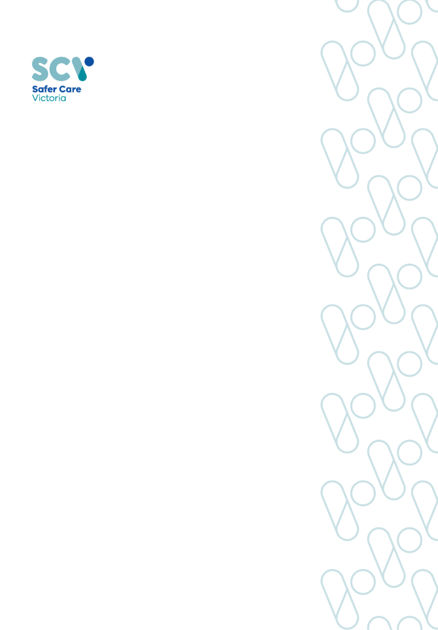
August 2025

Victorian Maternal and Child Health Clinical Practice Guidelines
Nipple pain and damage

OFFICIAL

To receive this publication in an accessible format email Safer Care Victoria <info@safercare.vic.gov.au>

Authorised and published by the Victorian Government, 1 Treasury Place, Melbourne.
© State of Victoria, Australia, Safer Care Victoria, month year

ISBN 978-1-76131-987-7 (pdf/online/MS word)
Available at the Safer Care Victoria website <https://www.safercare.vic.gov.au>



Contents
1
Key Messages / Red flags 4
Abbreviations 4
Definitions and abbreviations 4
Background 4
Common Causes 5
Assessment 5
Management 6
When to seek medical assessment/advice 8
Information for health professionals 8
Information for families 8
References 9

Nipple pain and damage

Key Messages / Red flags
- Nipple pain and damage is one of the most common reasons for weaning.
- Most women experience some nipple tenderness during the first week of breastfeeding
- Pain that is severe, persistent or occurs between feeds, should be investigated.
- Nipple pain and damage can increase the risk of mastitis, infant formula supplementation and
maternal anxiety.
- Nipple damage ranges from mild inflammation, small blisters, grazes, compression stripes,
cracks and fissures.
- Other signs of nipple pathology include yellow crust, flaky or plaque on skin, shiny skin,
pustules or blanching.
- Rest the nipple and feed with expressed breast milk. (EBM)

Abbreviations
EBM: Expressed Breast Milk
GP: General Practitioner

Definitions and abbreviations
- Bleb/white spot: A white spot on the nipple can be painful. It may also be called a blocked nipple pore, bleb, or a milk blister. It is usually about the size of a pinhead or a bit larger. It may be white, pink, or yellow in colour and the skin around the spot may be red and inflamed.
- Engorgement: A term used when the breast is extremely hard, swollen and tender. The nipple may be stretched and flattened, affecting the flow of milk. Attachment to the breast may become more difficult for the baby.
- Latch: Latch refers to how the baby fastens onto the breast while breastfeeding. A good latch promotes high milk flow and minimizes nipple discomfort for the mother.
- Nipple vasospasm: The nipple constricts, often undergoing three colour changes – from white to blue to red and the pain is often immediately after or in between feeds.
- Positioning: How the baby is held at the breast to facilitate feeding.

Background
- Many new mothers experience transient nipple pain or discomfort in the first few days after birth. This is often due to incorrect attachment of the baby to the breast.¹
- The nipple becomes compressed between the baby’s tongue and the roof of their mouth, causing trauma. This appears as redness, swelling or grazing of the nipple.
- Pain typically peaks in the first week postpartum and often improves by days 7–10, although some women experience persistent discomfort.¹
- Pain that is severe, persistent, or occurs between feeds should be investigated.
- Nipple pain is the most common reason for early cessation of breastfeeding.1

Common Causes
- Incorrect latch - attaching and positioning to the breast. (most common cause of nipple pain and trauma)
- Engorgement - when the breast is extremely hard, swollen, and tender, and the nipple may be stretched and flattened affecting the flow of milk and attachment to the breast may become more difficult for the baby.
- Infant disorganised sucking action, high, arched, or flattened palate, tongue tie, strong sucking vacuum.
- Infection – often bacterial or candida or herpes simplex.
- Bleb/white spot- It may also be called a blocked nipple pore, or a milk blister.
- Nipple variations such as flatness, inversion or retraction
- Inappropriate use of a breast pump – shield may be too small - incorrect placement or suction too high.
- Hormonal sensitivity – during ovulation, menstruation, or a new pregnancy
- Nipple vasospasm - Occurs typically following breastfeeds. It may happen because of the cold and similar symptoms are experienced in the fingers and toes when it's very cold.²

Assessment
- Take a history, ensure a partnership approach and sensitive communication.
- Description of pain - where, onset, type, when pain occurs and associated factors.
- Include use of breast pumps or other aids such as nipple shields, creams, dressings etc.
- A hepatitis C positive mother must discard breast milk if her nipples are cracked or bleeding but cannot pass Hepatitis C to her baby via breastmilk if nipples are intact.³
- A mother with hepatitis B can breastfeed her baby safely if the baby has received their immunoglobulin with the first 12 hrs of birth.³
- Assess breasts and nipples, looking for:
  - signs of trauma such as inflammation, small blisters, grazes, cracks or fissures
  - exudate or yellow crust
  - plaques or flaky skin
  - shiny skin
  - pustules
  - blanching
- Assess the baby, looking for:
  - birth history, including gestation
  - general health including weight gain
  - oral examination including tongue tie, thrush
  - observe a full breastfeed if possible, noting
  - frequency and duration
  - feeding positions
  - latch
  - any formula or bottle use.

Management
General management
- Reassure the mother that this is a short-term problem and provide vital support.
- Discuss and support with positioning and attachment.
- If engorged, soften the areola prior to attachment and treat associated engorgement.
- Offer the baby the least sore nipple first.
- Try different positions or try infant-led attachment.
- Apply EBM to the nipple area after a feed. EBM is equal to or more beneficial than applying nipple ointments that contain purified lanolin.
- Avoid the use of soaps, shampoos, or non-medically prescribed ointments on nipples.
- If breast pads are being used, avoid plastic-backed pads and replace damp pads frequently.
- Breastfeed on demand unless severe pain continues, or damage is worsening, despite management.
- Provide education to the parents about signs and symptoms of mastitis and how to avoid it.

Signs and symptoms of mastitis
- Red, hot, firm and painful skin on the breast, which can appear to be shiny and tight with red streaks
- A lump or wedge-shapes are on some or all the breast
- General flu-like symptoms including:
  - lethargy
  - headaches
  - muscle aches
  - nausea
  - tachycardia (fast heart rate)
  - anxiety
  - fevers above 38.5°C.
- There is little evidence to support the use of nipple shields for managing nipple pain without first correcting the cause. Shields may exacerbate the problem and cause early weaning.
- If the pain does not improve with general measures, a review is recommended to determine the underlying cause. This may involve consultation with an MCH Nurse, Lactation Consultant, Breastfeeding Service, or GP, as appropriate.

When the nipples are too sore to feed
- Advise rest and teach the mother how to express milk manually from the affected breast until the pain subsides. This can be for a few feeds for a period of several days, from either one or both breasts.
- If using a breast pump, ensure the pump shield is central over the nipple and has a sufficient diameter, with suction pressures comfortable for the mother. Express enough to drain breast well to prevent engorgement or breast inflammation/mastitis.
- If the baby needs to be taken temporarily off the breast, feed EBM via cup, spoon or dropper. If poor attachment is the underlying cause, avoid using bottles and teats, particularly for very young infants.

Nipple Infections
- Cracks or fissures on the nipple may allow bacterial entry and can present as nipple redness, weeping, crusting lesions or pustules. This may delay the sore nipple healing and can increase the risk of developing breast inflammation and mastitis
- A medical review will be required for diagnosis and treatment.

Nipple Vasospasm
- The nipple constricts, causing often a three colour changes from white (vasoconstriction) to blue (cyanosis) to red. (rapid blood reflow) The pain is often immediately after or in between feeds.
- Nipple vasospasm is often an unrecognised cause of nipple pain.
- May be associated with incorrect positioning and attachment.
- Can be exacerbated by cold temperatures, as well as nicotine or caffeine intake.

To manage nipple vasospasm:
  - keep warm, wear layered clothing, breastfeed in a warm space.
  - avoid airing nipples after feeds.
  - use warm packs or nipple warmers after and between feeds to maintain circulation.
  - cutting back on nicotine and caffeine can also help, as both may worsen vasospasm by constricting blood vessels.
  - dietary supplementation with magnesium and fish oil may also be helpful.²
  - advise the mother to see a GP if the pain persists.

Bleb / White Spot
- A bleb or white spot may also be referred to as a blocked nipple pore, or a milk blister.
- A white spot on the nipple can be painful.
- It is usually about the size of a pinhead or a bit larger.
- It may be white, pink, or yellow in colour and the skin around the spot may be red and inflamed.
- The cause is not known but it is thought to happen when the opening of a milk duct becomes inflamed and closes, which stops the milk flowing.
- Sometimes the baby can clear these during a feed, if they are feeding well.

To manage a bleb or White Spot:
  - avoid damage to the nipple and do not pick or scrape the spot.
  - be gentle with the nipple to avoid creating more damage.
  - continue to breastfeed, as it may take time to clear completely.
  - try different breastfeeding positions.
  - if it is too painful to breastfeed, try hand expressing to get the milk flowing.
  - a cool pack may help in between feeds.
  - soaking the nipple in warm water before feeding / expressing, may help to soften the spot.

When to seek medical assessment/advice
General
- Advise the mother to seek medical attention if:
  - the mother feels worse and is very unwell
  - there has been no improvement in 12-24 hours.
- Review with the Universal Maternal and Child Health nurse and / or lactation service, as appropriate.
- Consider contacting the Victorian Virtual Emergency Department for support after hours, or if unable to access local GP.

When to Seek Medical Assessment - White Spot
- If the white spot does not clear or becomes very painful, advise the mother to see medical attention.
- An ointment or cream may be prescribed to reduce inflammation.

When to Seek Medical Assessment – Nipple infections
- Refer to a GP for medication, treatment and diagnosis.
- If the mother feels unwell or the breast is red, they should see a doctor as soon as possible and when making the appointment, report that it is possibly mastitis.

When to Seek Medical Assessment – Nipple vasospasm
- See a GP if pain persists, despite management strategies.

Information for health professionals
- Royal Women’s Hospital, Breastfeeding Problems:https://www.thewomens.org.au/health-information/breastfeeding/breastfeeding-problems
- Royal Women’s Hospital, Clinical Guidelines: https://www.thewomens.org.au/health-professionals/clinical-resources/clinical-guidelines-gps
- RWH, Infant feeding – nipple and breast pain in lactation – Guideline https://app.prompt.org.au/download/191945?code=e2a62332-6de8-41fb-92de-710ae7f1ca09
- Safer Care Victoria, Neonatal eHandbook: https://www.safercare.vic.gov.au/best-practice-improvement/clinical-guidance/neonatal/breastfeeding-for-neonates
- Australian Breastfeeding Association: https://www.breastfeeding.asn.au/resources/why-are-my-nipples-sore

Information for families
- Better Health Channel – Breastfeeding – mastitis and other nipple and breast problems
https://www.betterhealth.vic.gov.au/health/healthyliving/breastfeeding-mastitis-and-other-nipple-and-breast-problems
- Raising Children Network – Breastfeeding challenges – sore nipples and nipple infections
https://raisingchildren.net.au/newborns/breastfeeding-bottle-feeding/breastfeeding-challenges/sore-nipples-infection
- RCH Kids Health Information Fact sheets, Breastfeeding
https://www.rch.org.au/kidsinfo/fact_sheets/Breastfeeding/
- Australian Breastfeeding Association: https://www.breastfeeding.asn.au/resources/positioning
- Australian Breastfeeding Association: https://www.breastfeeding.asn.au/resources/attachment

References
- Australian Breastfeeding Association. Why are my nipples sore? [Internet]. Melbourne: Australian Breastfeeding Association; 2023 [cited 2025 Aug 20]. Available from: https://www.breastfeeding.asn.au/resources/why-are-my-nipples-sore
- The Royal Women's Hospital. Nipple vasospasm [Internet]. Melbourne: The Royal Women's Hospital; [cited 2025 Aug 20]. Available from: https://www.thewomens.org.au/health-information/breastfeeding/breastfeeding-problems
- Department of Education and Early Childhood Development. Victorian breastfeeding guidelines [Internet]. Melbourne: State Government of Victoria; 2014 [cited 2025 Aug 20]. p. 32. Available from: https://www.education.vic.gov.au/Documents/childhood/professionals/health/brestfeedguidelines14.pdf
- The Royal Women's Hospital. Breastfeeding problems [Internet]. Melbourne: The Royal Women's Hospital; [cited 2025 Aug 20]. Available from: https://www.thewomens.org.au/health-information/breastfeeding/breastfeeding-problems
- The Royal Women's Hospital. Infant feeding – Nipple and breast pain in lactation – Guideline [Internet]. Melbourne: The Royal Women's Hospital; [cited 2025 Aug 20]. Available from: https://www.thewomens.org.au/health-professionals/clinical-resources/clinical-guidelines-gps

