Clinical Practice Point
Think dissection: Improving the care of patients with aortic dissection

Last updated: 12 August 2026

To receive this publication in an accessible format email Safer Care Victoria <info@safercare.vic.gov.au>
Authorised and published by the Victorian Government, 1 Treasury Place, Melbourne.
© State of Victoria, Australia, Safer Care Victoria, August 2026.
ISBN/ISSN
Available at the Safer Care Victoria website <https://www.safercare.vic.gov.au>

Contents
Summary and key considerations 2
Consideration 1 2
Consideration 2 2
Consideration 3 2
Consideration 4 2
Consideration 5 2
Consideration 6 3
Consideration 7 3
Consideration 8 3
Acknowledgements 4
First Nations acknowledgement 4
Contributions and recognition 4
Introduction 5
What is aortic dissection? 5
Background 5
Aim 5
State insights 6
Safer Care Victoria and Coroners Court of Victoria 6
Coroners Prevention Unit 6
Adult Retrieval Victoria 9
Databases 11
Victorian Admitted Episode Database 11
Victorian Audit of Surgical Mortality 13
Multi-specialty perspective reports 15
Aortic dissection in pregnant women: Consultative Council on Obstetric and Paediatric Mortality and Morbidity’s perspective 15
Aortic dissection in older adults: geriatric medicine’s perspective 17
Aortic dissection: emergency medicine’s perspective 19
Appendix 21
Aortic dissection grouped by ICD-11 codes 21
Aortic dissection grouped by year and sex 22
References 25

Summary and key considerations
Aortic dissection is a preventable harm needing urgent, coordinated statewide action.

Missed or delayed diagnosis of this life-threatening condition is not an isolated clinical failure, it is a system problem. Growing concerns have emerged within the healthcare system regarding adverse outcomes resulting from missed or delayed diagnosis of aortic dissection (AD). This paper examines AD cases across Victoria using data from multiple agencies, synthesising evidence-based practices and consideration for medical specialties and healthcare organisations.
The themes can be distilled as follows:
- AD rarely presents with textbook features, with presentations varying significantly depending on the location and extent of dissection.
- Health services have often not reconsidered the differential diagnosis when symptoms persisted, progressed or were consistent with conditions mimicking AD.
- Cognitive bias and clinician assumptions about patients have often superseded objective clinical findings.
- Inadequate history-taking and critical clinical information has been lost across care transitions.

Consideration 1
Health services are encouraged to strengthen clinical education and diagnostic reasoning approaches in local governance structures and training programs to help clinicians better recognise and manage AD. This includes navigating diagnostic uncertainty, reducing premature diagnostic closure and implementing approaches to identify and address cognitive biases that may override objective clinical findings.

Consideration 2
Health services are encouraged to review and strengthen care transitions and clinical handover processes across all care settings, ensuring critical information is consistently communicated and acted on.

Consideration 3
Health services are encouraged to make documentation of differential diagnoses a mandatory part of clinical assessment and practices. Clinical leads should reinforce this through regular local audit and case review processes, particularly for high-acuity and diagnostically complex presentations.

Consideration 4
A senior clinician should review cases before discharge where feasible. This will help prevent premature diagnostic closure in patients without a clear diagnosis after initial assessment, including those who have ruled out acute coronary syndrome or pulmonary embolism.

Consideration 5
A coordinated approach across the cardiac hospitals should be explored to support timely transfer of patients with AD. This should consider health service infrastructure and workforce capability.

Consideration 6
Receiving centres should ensure access to a senior cardiothoracic surgeon and appropriate endovascular support to enable timely and effective intervention.

Consideration 7
Missed or delayed diagnoses of AD, including those that led to in-hospital mortality, should be treated as sentinel events. These cases should undergo a structured review through the health service’s morbidity and mortality processes to support organisational learning and ongoing system improvement.

Consideration 8
Fostering a blame-free reporting culture is critical. This supports staff to report delays, near-misses and diagnostic challenges. It also allows organisations to identify opportunities for improvement and drive sustainable change.

Safer Care Victoria will factor these considerations into our work and continue our close partnership with the Department of Health, aligning our efforts with the department’s priorities while responding to emerging strategic directions.

Acknowledgements

First Nations acknowledgement
Safer Care Victoria acknowledges the strength, power and resilience of First Nations people as members of the world’s oldest living culture. We recognise Aboriginal people as Australia’s First Nations people and honour the richness and diversity of all Traditional Owners across Victoria. We pay our deepest respects to ancestors, Elders and leaders, past and present, whose strength and fortitude have paved the way for future generations.

Contributions and recognition
We acknowledge eHealth for their support in providing access to the Victorian Admitted Episodes Dataset, which supported the data analysis presented in this report.
We also acknowledge the invaluable contributions of Professor Andrew Wilson PSM, Professor David Watters AM OBE, Professor Mark Umstad AM, Professor Anne-Maree Kelly, Dr Kate Gregorevic, Associate Professor Philip McCahy, Dr Visopiano Sanyu, Lucy Wong, Kylie Dyson, Ryan Hon, the Coroners Court of Victoria and, in particular, Dr Michaela Mee and Dr David Eddey from the Coroners Prevention Unit.

Introduction

What is aortic dissection?
Aortic dissection (AD) is a rare and serious cardiovascular emergency characterised by a tear in the inner layer of the aorta. Such a tear allows blood to flow between the layers of the aortic wall. This condition can rapidly progress to life-threatening complications. Prompt recognition and intervention are essential for patient survival.

Background
Since 2018, several deaths linked to missed or delayed diagnoses of AD have been reported to Coroners Court of Victoria and to Safer Care Victoria. This highlights ongoing challenges in recognising and managing this life-threatening condition.

Aim
This paper aims to provide a comprehensive understanding of AD epidemiology at the state and national levels. Building on these findings, we will outline evidence-based approaches for recognising and managing AD in diverse patient groups.

State insights

Safer Care Victoria and Coroners Court of Victoria
Analysis of sentinel events and coronial investigations in AD cases reveals concerning patterns. Patients presenting to an emergency department (ED) were discharged after alternative diagnoses were excluded, only to be found unresponsive at home or to re-present after the opportunity for effective intervention had passed. In most cases, AD had not been considered. Five critical and recurring themes contributing to missed or delayed diagnosis are identified below. These issues persist despite previous coronial recommendations, indicating that current approaches to preventing these deaths are insufficient.
- Over-reliance on ‘classic’ presentations: Clinicians consistently dismissed AD as a diagnosis when widely recognised ‘classic’ signs and symptoms such as chest pain, interscapular back pain, differential upper limb blood pressures, and low blood pressure are absent.
- Premature diagnosis and overly narrow use of chest pain pathways: When clinicians identified plausible life-threatening diagnoses, particularly acute coronary syndrome supported by electrocardiogram (ECG) changes and elevated cardiac biomarkers, they did not consider or exclude AD with further investigations.
- Failure to investigate or re-evaluate persistent or progressive symptoms: When initial investigations do not confirm a working diagnosis, and particularly when severe symptoms persist despite treatment and across multiple reviews, clinicians failed to reconsider alternative life-threatening diagnoses or to escalate to senior clinicians.
- Cognitive biases and assumptions about patient behaviour: Personal assumptions about patients, particularly those with a history of substance use, superseded objective clinical assessment. For example, one patient was labelled as drug-seeking, and in another case symptoms were attributed to withdrawal, while legitimate pain and concerning clinical findings were dismissed. These biases operate despite objective evidence of significant pathology, including abnormal investigations and persistent severe symptoms.
- Inadequate history-taking and communication deficiencies: Critical information is not sought during clinical assessment. Specific characteristics of pain, particularly its onset, severity, location, radiation and nature, are frequently inadequate. Even when key red flag features were documented in one setting, this information was lost during transitions of care.

Coroners Prevention Unit
The Coroners Prevention Unit conducted an audit of deaths reported to the Coroners Court from 2021 to 2023 that were subsequently determined to be due to AD (Table 1).

Table 1: Coroners Court referrals with death due to AD
 | 2021 | 2022 | 2023 | Total
Type of AD
(via autopsy/computed tomography)
Type A | 34 | 45 | 45 | 124
Type B | 0 | 0 | 0 | 0
Location of death
At home/nursing home/other community location/with Ambulance Victoria/shortly post-ED arrival pre-medical assessment | 31 | 36 | 33 | 100
At ED post-starting medical assessment | 0 | 2 | 5 | 7
At theatre/intensive care unit/ward/coronary care unit | 3 | 7 | 7 | 17
Median age | 70 | 68 | 64 | 66
Age range (years) | 33–93 | 26–93 | 29–89 | 26–93
Sex (%)
Female | 53 | 38 | 44 | 44
Prior medical care (last one month) | 7 | 12 | 16 | 35
No prior medical care | 27 | 33 | 29 | 89

Overall, all 124 cases involved Type A thoracic AD, with a median age of 66 years (range 26–93). Thirty-five of these cases had medical care in the month prior. Of these 35 cases, 22 were seen via ED and/or a general practitioner, and one was seen by a general practitioner only. The Coroners Prevention Unit analysed 12 ED episodes based on referrals and available results. In all presentations, chest pain was present (4 also with back pain), and all underwent a standard chest pain workup including ECG, troponins and chest x-ray. Most presentations involved atypical features or ‘confounders’ that could have pointed towards alternative life-threatening diagnoses. Features included pleuritic chest pain, diarrhoea and vomiting, pericarditis changes on ECG, bradycardia or raised non-dynamic troponins.
Of these 12 episodes, only one had AD documented as a differential diagnosis; 4 had no differential diagnosis documented at all. While red flags were present in 11 of the 12 episodes, it is difficult in hindsight to conclude these were ‘ignored’ because recognising red flags depends on AD being actively considered as a differential in the first place. Collectively, these cases highlight the diagnostic complexity of AD, which frequently presents atypically in emergency settings.

Clinical practice point
CT angiography should be performed without hesitation whenever AD is a possibility.

Key considerations
- Health services are encouraged to strengthen clinical education and diagnostic reasoning approaches in local governance structures and training programs to help clinicians better recognise and manage AD. This includes navigating diagnostic uncertainty, reducing premature diagnostic closure and implementing approaches to identify and address cognitive biases that may override objective clinical findings.
- Health services are encouraged to review and strengthen care transitions and clinical handover processes across all care settings, ensuring critical information is consistently communicated and acted on.
- Health services are encouraged to make documentation of differential diagnoses a mandatory part of clinical assessment and practices. Clinical leads should reinforce this through regular local audit and case review processes, particularly for high-acuity and diagnostically complex presentations.
- A senior clinician should review cases before discharge where feasible. This will help prevent premature diagnostic closure in patients without a clear diagnosis after initial assessment, including those who have ruled out acute coronary syndrome or pulmonary embolism.

Adult Retrieval Victoria
Over the 13-month period from June 2024 to July 2025, Adult Retrieval Victoria transported 12 AD patients between hospitals for management, a process where time is critical (Table 2).
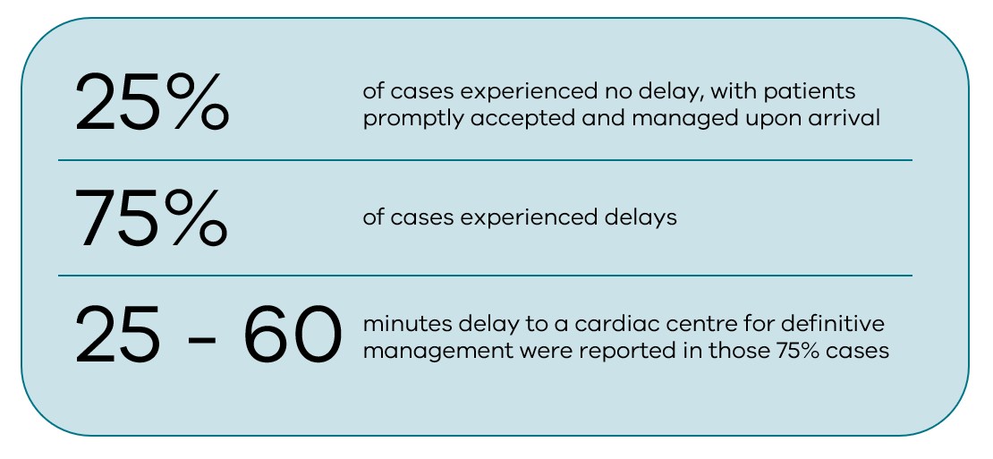
Table 2: Patients transported by Adult Retrieval Victoria between hospitals for AD management, June 2024 to July 2025
Hospital of presentation, transport method | Cardiac hospital in Melbourne | AD category | Issues and delays
A, MICA | 01 | Type A tamponade | 54 calls, sent to three separate hospitals (hospital 02, hospital 03, then hospital 01)  Transport delay
B, MICA | 02 | Thoracic aortic ulcer, Tamponade | Multiple calls to cardiac hospital 01, hospital 02 and hospital 03  Transport delay
C, ARV crew | 02 | Type A tamponade with persistent hypotension | Multiple calls  Transport delay
C, ARV crew | 03 | Type A | No delay
C, ARV crew | 02 | Type A | Transport delay
D, MICA | 04 | Type A with aortic regurgitation | Transport delay  Patient deteriorated en route
E, HEMS | 02 | Type A | Six centres contacted  Transport delay
C, MICA | 01 | Type A | Multiple calls  Transport delay
F, MICA | 05 | Type A | Three hospitals called  Transport delay
E, MICA | 05 | Type A | Three hospitals called, road crew availability issue  Transport delay
G, HEMS | 05 | Type A and B | No delay  CT with helipad required
H, ARV | 02 | Type A tamponade | No delay
ARV = Adult Retrieval Victoria; HEMS = Helicopter Emergency Medical Service; MICA = Mobile Intensive Care Ambulance

Findings
Cases needing Australian Resuscitation Council, Mobile Intensive Care Ambulance or Helicopter Emergency Medical Service retrieval experienced notable delays. These delays were compounded by difficulties in identifying and securing an appropriate centre willing and able to accept the patient for management.

Key considerations
- A coordinated approach across the cardiac hospitals should be explored to support timely transfer of patients with AD. This should consider health service infrastructure and workforce capability.
- Receiving centres should ensure access to a senior cardiothoracic surgeon and appropriate endovascular support to enable timely and effective intervention.

Databases

Victorian Admitted Episode Database
To help understand the number of people diagnosed with AD, we sought data from the Victorian Admitted Episode Dataset covering the 2020–21 to 2024–25 financial years. We analysed non-elective admission and 4 specific International Classification of Diseases (ICD)-11 codes for AD: I71.00 (unspecified site), I71.01 (thoracic aorta), I71.02 (abdominal aorta) and I71.03 (thoracoabdominal aorta) (Table 3).
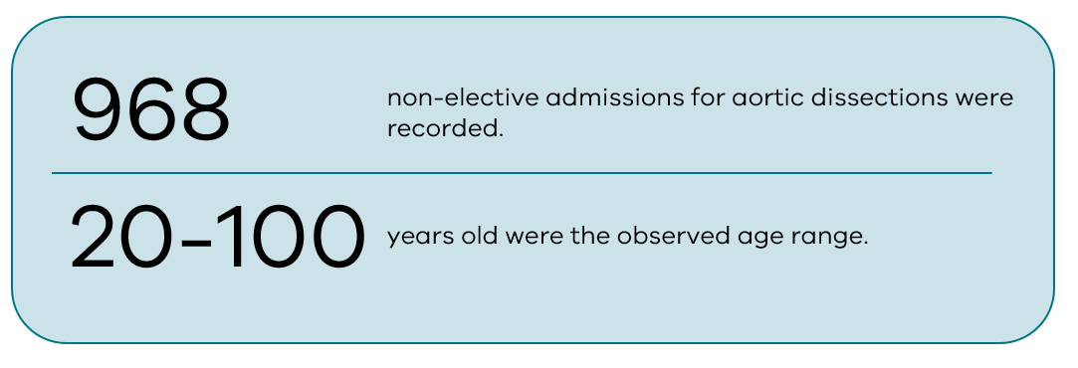
Table 3: Total mortality cases and rates across 4 ICD-11 codes, 2020–21 to 2024–25
ICD-11 code | Cases identified | Death | Mortality rate
I71.00 | 164 | 35 | 21%
I71.01 | 544 | 80 | 15%
I71.02 | 127 | 17 | 13%
I71.03 | 133 | 21 | 16%
Total | 968 | 153 | 16%

Findings
- AD cases recorded in Victoria have shown a steady upward trend over the past 5 financial years, rising from 154 cases in 2020–21 to 231 cases in 2024–25 (Appendix, Figure 1).
- Patients ranged in age from 20 to 100 years at the time of diagnosis, showing that AD can affect people across the entire adult lifespan.
- I71.01 was diagnosed more frequently than the other subtypes, indicating that thoracic involvement represents the main form of AD in Victoria (Appendix, Figure 6).
- Males were typically diagnosed with AD around a decade earlier than females (Appendix, Figure 7).
- The total mortality rate was about 16%, with 153 deaths reported during this period (Table 3).
- Among female patients, AD at an unspecified site (I71.00) and thoracic aorta (I71.01) were the most frequently diagnosed subtypes (Appendix, Figure 8).
- Among male patients, thoracic aorta (I71.01) was the main diagnosis (Appendix, Figure 9).
- Comparing across sexes, AD at an unspecified site (I71.00) was more prevalent in women than men (Appendix, Figure 9), whereas thoracic aorta (I71.01), abdominal (I71.02) and thoracoabdominal (I71.03) were all more frequently diagnosed in men than women (Appendix, Figures 8 and 9).
- The mortality rates seen in Australia and Victoria are consistent with contemporary outcomes reported by large registries in the United States, Germany and Europe more broadly.¹

Victorian Audit of Surgical Mortality
Our 2024–25 annual report noted 8 reports of deaths from AD to the Victorian Audit of Surgical Mortality (VASM) (Table 4). A death qualifies for VASM reporting when the patient underwent surgery or was under the care of a surgeon. Under the VASM process, the responsible surgeon or their representative completes a case form, which is then reviewed by an independent peer assessor. A subset of cases, about 5–10%, undergoes a further second-level assessment that involves a detailed review of the clinical notes.
VASM peer review findings are categorised into either no issues or clinical management issues. Clinical management issues are broken down into 3 areas: issues for consideration, issues of concern and adverse events. Adverse events refer to instances where a patient has experienced harm as a result of a procedure or the management of its complications. One issue for consideration and one issue of concern were identified. No adverse events have been reported (Table 4).

Findings
Table 4: Findings of the 8 deaths from the reported AD, 2024–25
Age/sex | AD presentation and category | Treatment | CMI | Date/Cause of death
73  female | TF from home;  Type A; CPR | Aortic repair  Bronchoscope for clots | Issue of concern: ICU care and tracheostomy bleed due to extended respiratory support | D26 respiratory failure and tracheostomy
85  female | No TF;  acute aortic syndrome with conservative management for 2 months | Aortic repair due to ongoing chest pain reported by the patient | Issue for consideration: decision to operate | D4 CVA
48  male | TF;  Type B: Gut and lower limb ischaemia | TEVAR,  laparotomy x 3 | None | D10 MOF, ICH
64  male | Type A | < 2 hours to repair operatively, no delay to surgery | None | D4 CVA
71  male | TF;  subacute Type A  Type B abdominal AD with 6 weeks of medical management | 6 weeks AA replacement and elephant trunk  stent to DA | None | D7 CVA, palliated
47  male | TF;  Type A | Complex aortic repair surgery | None | D10 pericardial effusion, MOF
49  male | TF with no delay;  obtunded on arrival | Repair Bentall procedure, frozen elephant trunk procedure, CABG | None | D0 bleed in operating theatre. Withdrawn
50  male | TF;  Type A | Aortic repair  D1 right hemicolectomy, unplanned return to theatre multiple times | None | D34 acute kidney injury, liver, MOF, gastrointestinal haemorrhage
47  male | TF;  Type A | Aortic arch and AA replacement, reimplant of innominate artery, left common carotid artery, left subclavian artery and elephant trunk | None | D11 CVA. Palliated due to electroencephalography encephalopathy
AA = ascending aorta; AAA = abdominal aortic aneurysm; CABG = coronary artery bypass graft; CMI = clinical management issue; CVA = cerebral vascular accident; DA = descending aorta; D1–34 = day of death post-operatively; ICH = intra-cranial haemorrhage; MOF = multi-organ failure; TEVAR = thoracic endovascular aortic repair; TF = transfer prior to treatment

These deaths highlight the inherent complexity of the surgical procedures required to manage AD. They also show the difficulties in maintaining adequate circulation to vital organs, along with the wide spectrum of potential complications that may arise.
Surgeons are expected to submit cases to VASM as a meaningful contribution to continuous quality improvement in surgical care, particularly for high-risk conditions such as AD. This helps identify systemic gaps in clinical decision-making, operative management and post-procedural care. It informs the need for targeted education, updated protocols and strengthened governance to reduce preventable harm.

Multi-specialty perspective reports
This section incorporates clinical expertise and insights from obstetrics, geriatric medicine and emergency medicine. It provides a comprehensive understanding of how AD presents and is managed across diverse patient populations and clinical settings.

Aortic dissection in pregnant women: Consultative Council on Obstetric and Paediatric Mortality and Morbidity’s perspective

Incidence of pregnancy-associated aortic dissection²
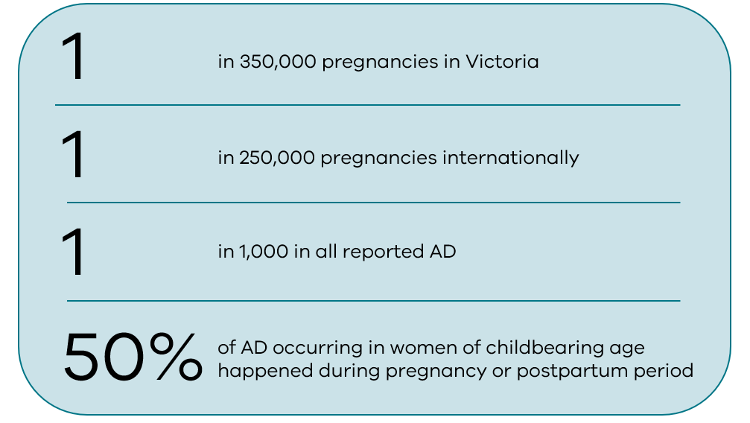
Diagnosing AD in pregnancy is challenging. Cardinal symptoms including chest pain, back pain and syncope are common complaints during normal pregnancy and may be attributed to pregnancy-related physiological changes.³ This symptom overlap can lead to diagnostic delays with potentially catastrophic consequences.
Half of pregnancy-associated AD cases occur in women with underlying genetic aortopathies such as Marfan’s syndrome, Loeys-Dietz syndrome, vascular Ehlers-Danlos syndrome, Turner syndrome and other hereditary connective disorders.³ Their risk of AD can be estimated by measuring the degree of aortic root dilation.⁴ However, it is important to note that in Ehlers-Danlos syndrome, aortic root dilatation does not reliably predict rupture risk. Individualised clinical assessment and management strategies are needed for these patients.

Clinical practice points
- Women diagnosed with underlying genetic aortopathies need specialised pre-conception counselling and risk assessment through expert maternal-fetal medicine consultation, including comprehensive cardiac imaging before pregnancy.
- When AD is suspected in a pregnant patient, proceed immediately with CT angiography. The radiation exposure to the fetus is extremely low and the benefits of accurate and timely diagnosis far outweigh the minimal fetal radiation risk.
- When aortic root diameter exceeds a threshold of between 40 and 45 mm, current clinical guidelines recommend prophylactic aortic root replacement before pregnancy.

In the critical scenario of AD presenting with maternal cardiac arrest after 24 weeks’ gestation, immediate resuscitative hysterotomy or emergency caesarean section should be performed, ideally within 4 minutes of cardiac arrest. This intervention is crucial not only for potential fetal survival but also to significantly improve the success rate of maternal cardiopulmonary resuscitation by relieving aortocaval compression and improving venous return, thereby optimising maternal resuscitation efforts.

Aortic dissection in older adults: geriatric medicine’s perspective
Abdominal aortic aneurysm (AAA) becomes increasingly prevalent with advancing age. Its clinical significance is reflected in the high mortality rate of 60–70% associated with AAA rupture. This highlights the critical need for early detection and timely intervention.
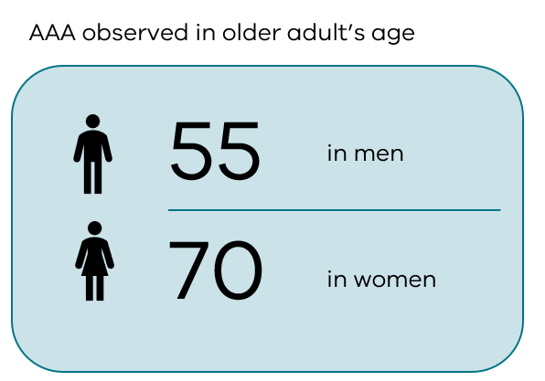 | 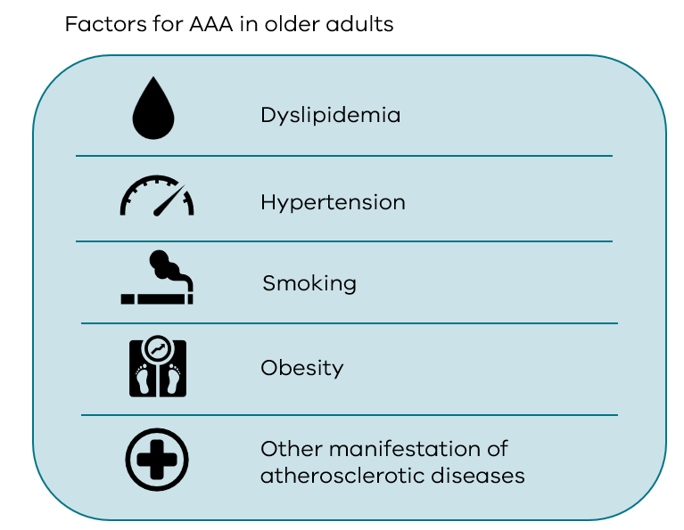
The risk factors for AAA are common to many conditions, including cardiac atherosclerosis and chronic kidney disease. This may limit a patient’s capacity to withstand the haemodynamic instability and organ hypoperfusion that accompany acute dissection. The presence of underlying vascular pathology adds another layer of complexity, with atherosclerosis representing the most prevalent risk factor for descending thoracic aortic aneurysm in older adults.
Frail older adults with multimorbidity face greater risks of complications and death during surgery for dissection. However, data from the International Registry of Acute Aortic Dissection has shown that many patients aged 70 or older, and even those in their 80s, can still benefit significantly from surgical intervention.* This suggests that clinicians should engage in shared decision-making with patients about operative risk before proceeding.

Clinical practice points
- Prompt diagnosis is essential to enable timely, individualised management that carefully weighs the potential benefits and risks of intervention. This challenges assumptions about surgical futility in advanced age.⁵
- Many of the cases of AD will not meet criteria for coroner referral because they are known and natural causes of death. But it is still important that these deaths are reviewed as part of in-hospital morbidity and mortality processes to ensure any lessons are used to improve care.

* The data may be subject to selection bias because the surgical candidates likely represent a healthier subgroup of the broader older adult population with AD.

Key considerations
Missed or delayed diagnoses of AD, including those that led to in-hospital mortality, should be treated as sentinel events. These cases should undergo a structured review through the health service’s morbidity and mortality processes to support organisational learning and ongoing system improvement.
Fostering a blame-free reporting culture is critical. This supports staff to report delays, near-misses and diagnostic challenges. It also allows organisations to identify opportunities for improvement and drive sustainable change.

Aortic dissection: emergency medicine’s perspective
While AD is rare,^{6–9} missed AD regularly appears in coronial investigations and civil claims for medical negligence.
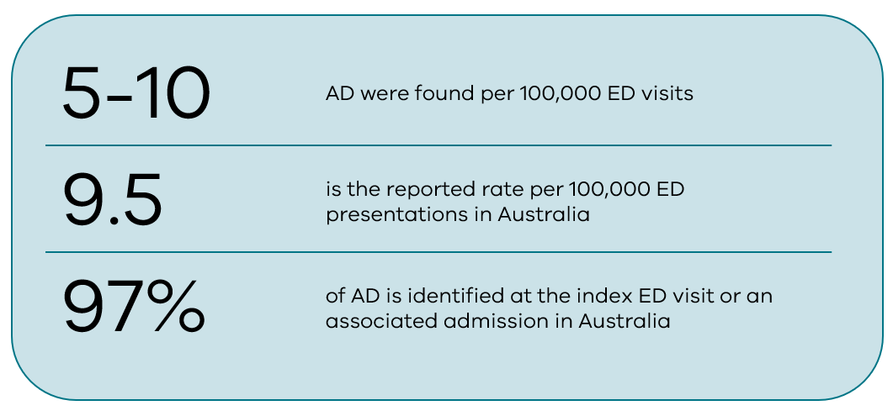
Apart from its atypical presentation, diagnostic overlap with other conditions (such as pulmonary embolism and reductive use of chest pain pathways), other factors make timely diagnosis of AD in the ED particularly difficult:
- Inadequate sensitivity of chest X-ray: The width of the mediastinum on chest X-ray helps rule out AD. However, at least 20% of patients with AD have normal mediastinal width, and widened mediastinum is more commonly seen in elderly patients without dissection. This limits the utility of this finding.
- Unvalidated risk stratification tool: The Aortic Dissection Detection Risk Score (ADDRS) and associated clinical pathway could improve diagnostic accuracy for AD. However, the tool was not developed using widely accepted methods for creating clinical decision rules, and it depends on clinicians already having a suspicion of AD.¹⁰ Also, since lack of initial clinical suspicion represents the most common barrier to timely diagnosis, the real-world utility of this scoring system is limited.
- Unvalidated double rule-out CT protocol: Double rule-out CT protocols evaluate both pulmonary embolism and AD simultaneously, but this approach has not yet been validated in clinical studies.¹¹
- D-dimer screening: Increased use of the ADDRS pathway incorporating D-dimer testing (with CT aortography performed if D-dimer ≥ 500 ng/mL) could reduce missed AD. However, this approach carries a false-negative rate of 1–2%, and CT aortography itself carries risks of severe allergic reactions (including death) and significant morbidity.¹²
- Point-of-care-ultrasound: Whilst an AD may sometimes be identified via bedside ultrasound examinations, they cannot rule it out. A CT aortogram is needed if an AD remains a potential diagnosis.

Clinical practice points
Risk-benefit modelling reveals that for every 100,000 emergency patients without a clear-cut chest pain diagnosis managed according to the ADDRS-D-dimer pathway, about 2 cases of AD would be identified. However, this would be at the cost of 40,000 CT aortograms, around 40 serious adverse reactions to contrast medium, and about 53 additional lifetime cancers.¹⁰ This strategy would also consume substantial radiological resources and could potentially delay imaging for patients with other serious time-sensitive conditions such as acute stroke.
While the desire to identify every case of AD is understandable, the evidence shows that widespread implementation of the ADDRS-D-dimer pathway without applying clinical judgement would cause more harm than benefit. Therefore, clinical judgement and selective, targeted investigation are better tools in diagnosing AD than over algorithmic testing in isolation.

Future direction
Work is underway on research to better diagnose AD. This includes research on novel biomarkers and on AI, both to enhance radiological detection of AD and as part of multi-modality models incorporating radiology, ECG and biomarkers.¹³

Appendix

Aortic dissection grouped by ICD-11 codes
Statistical process control (SPC) charts were created to track all aortic dissection (AD) cases irrespective of their ICD-11 classification. The analysis shows a significant shift between March 2023 and October 2023, with 6 consecutive points above the system average (Figure 1). This notable rise suggests potential influences from post-pandemic factors affecting patient presentations and healthcare use patterns.
Figure 1: SPC for total AD regardless of their ICD-11 codes
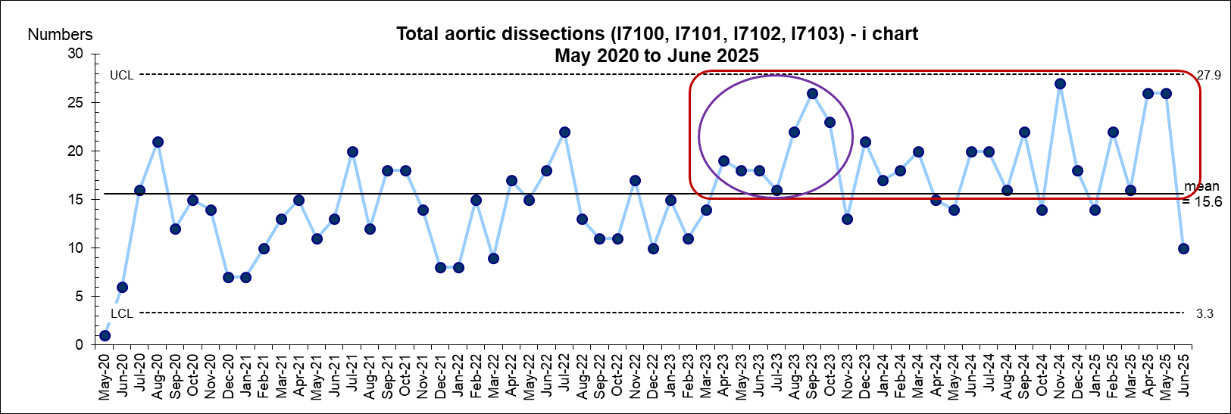
Individual SPC charts were developed for each of the 4 codes. Overall, I71.00 and I71.02 exhibit consistent and stable trends (Figures 2 and 3). Conversely, I71.01 shows 2 separate shifts above the system average from July 2023 to December 2023 and from November 2024 to April 2025 (Figure 4). Similarly, this may be attributed to post-pandemic factors affecting patient presentations and healthcare use. While I71.03 displays 2 separate shifts: the first occurring from January 2024 to June 2024, and the second from October 2024 to March 2025 (Figure 5), more data points are needed to determine whether these shifts are sustained and to identify their underlying causes.
Figure 2: SPC for total AD for I71.00, May 2020 to June 2025
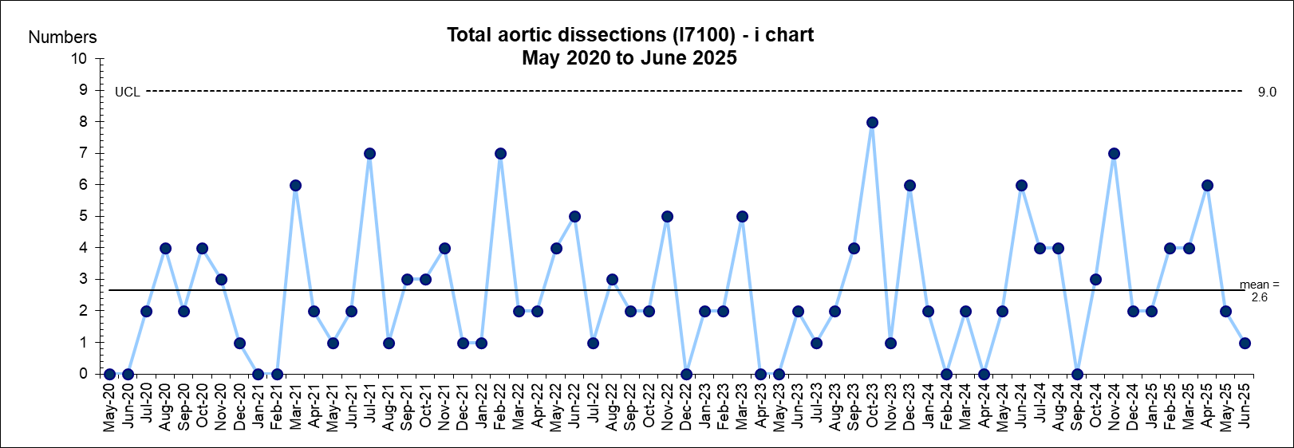
Figure 3: SPC for total AD for I71.02, May 2020 to June 2025
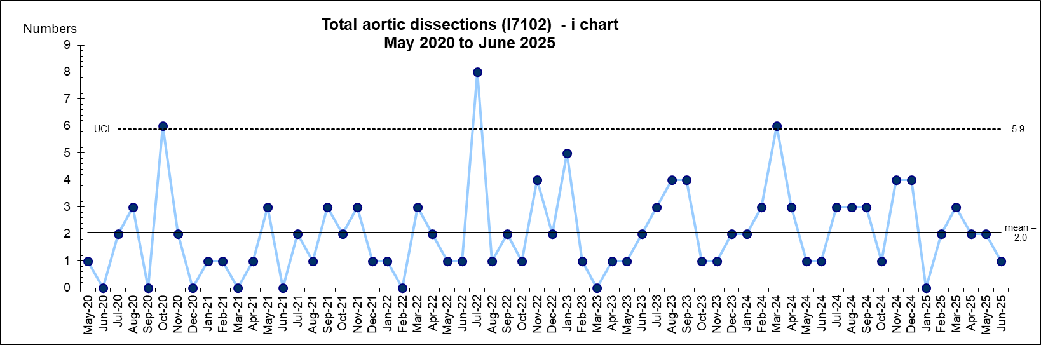
Figure 4: SPC for total AD for I71.01, May 2020 to June 2025
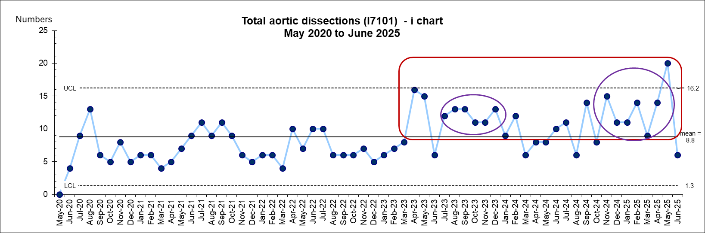
Figure 5: SPC for total AD for I71.03, May 2020 to June 2025
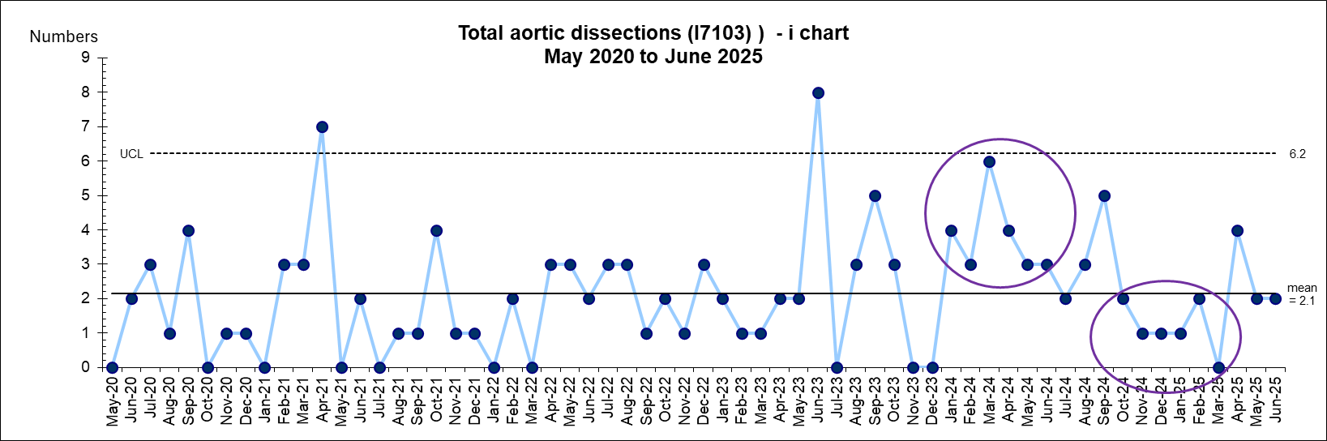

Aortic dissection grouped by year and sex
When 5-year annual data (excluding elective admissions) was examined across the 4 ICD-11 codes, I71.01 was diagnosed more frequently than the other subtypes. This indicates that thoracic involvement is the main form of AD in Victoria (Figure 6).
Figure 6: Yearly total AD by ICD-11 codes, May 2020 to June 2025
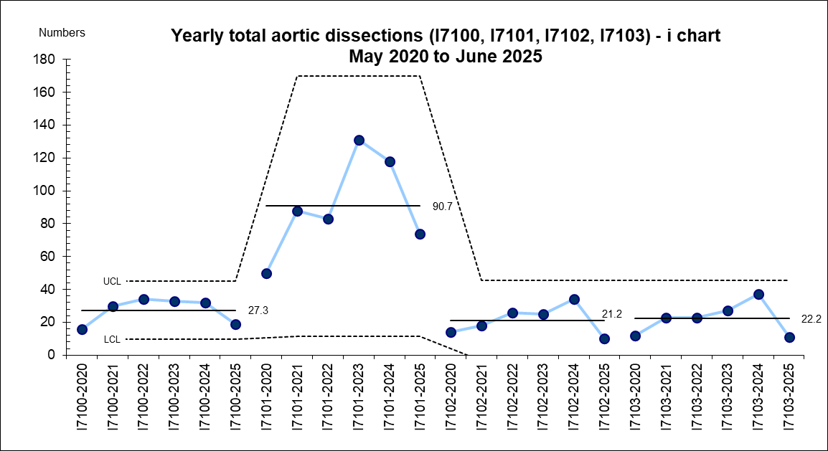
Analysis of the sex profile for total AD cases, regardless of ICD-11 code, reveals that men were diagnosed with AD significantly more often than women. This highlights a male predominance in the overall incidence of this condition, noting that women are more likely to present with atypical features (Figure 7).
Figure 7: Total AD by gender, May 2020 to June 2025
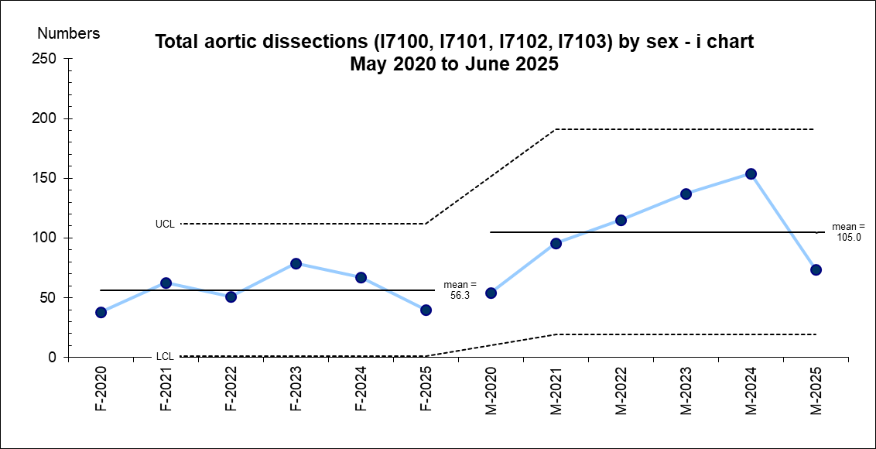
F = female, M = male
When ICD-11 codes were analysed by sex, distinct patterns emerged. Among female patients, I71.00 and I71.01 were the most frequently diagnosed subtypes (Figure 8). Conversely, among male patients, I71.01 was the main diagnosis relative to the other subtypes (Figure 9). Comparing across sexes, AD at an unspecified site (I71.00) was more prevalent in women than men, whereas thoracic aorta (I71.01), abdominal (I71.02) and thoracoabdominal (I71.03) were all more frequently diagnosed in men than women.
Figure 8: Female total AD by ICD-11 codes, May 2020 to June 2025
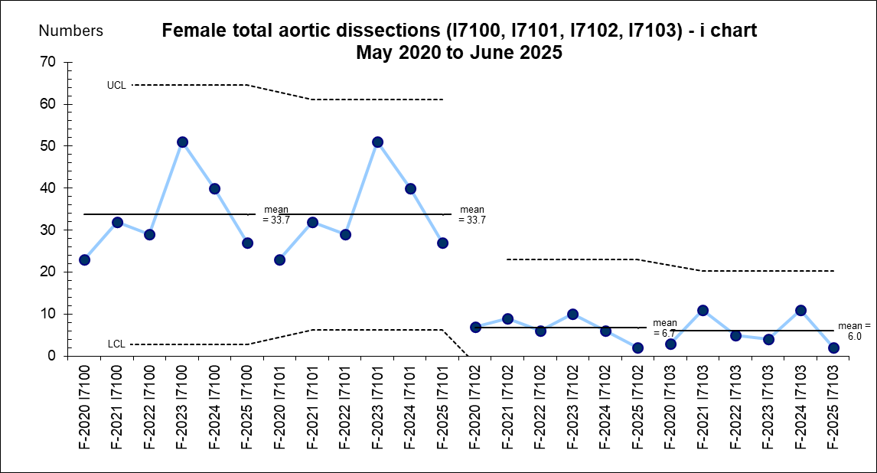
F = female
Figure 9: Male total AD by ICD-11 codes, May 2020 to June 2025
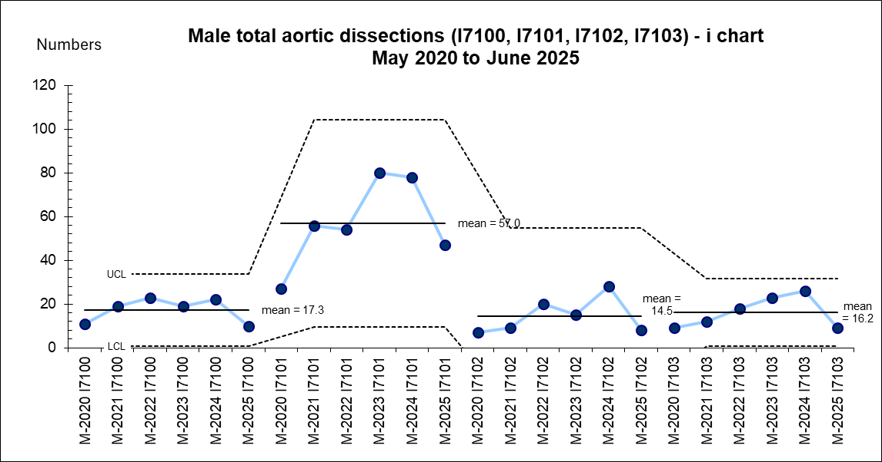

M = male

References
1. Trimarchi S, Mandigers TJ, Bissacco D, et al. (2024) ‘Twenty-five years of observations from the International Registry of Acute Aortic Dissection (IRAD) and its impact on the cardiovascular scientific community’, The Journal of Thoracic and Cardiovascular Surgery, 168(4):977-89.
2. Thalmann M, Sodeck GH, Domanovits H, et al. (2011) Acute type A aortic dissection and pregnancy: a population-based study. European Journal of Cardio-thoracic Surgery, 39(6):e159-63.
3. Russo M, Boehler-Tatman M, Albright C, et al. (2022) ‘Aortic dissection in pregnancy and the postpartum period. Seminars in Vascular Surgery, 35(1):60–8.
4. Kim SY, Wolfe DS, Taub CC (2018) ‘Cardiovascular outcomes of pregnancy in Marfan’s syndrome patients: a literature review’, Congenital Heart Disease, 13(2):203–9.
5. Dakour-Aridi H, Yin K, Hussain F, et al. (2021) ‘Outcomes of intact thoracic endovascular aortic repair in octogenarians’, Journal of Vascular Surgery, 74(3):882–92.
6. Dinh MM, Bein KJ, Delaney J, et al. (2020) ‘Incidence and outcomes of aortic dissection for emergency departments in New South Wales, Australia 2017-2018: a data linkage study’, Emergency Medicine Australasia, 32:599–603.
7. Wundram M, Falk V, Eulert-Grehn JJ, et al. (2020) ‘Incidence of acute Type A aortic dissection in emergency departments’, Scientific Reports, 10:7434.
8. Rogers AM, Hermann LK, Booher AM, et al. (2011) ‘Sensitivity of the aortic dissection detection risk score, a novel guideline-based tool for identification of acute aortic dissection at initial presentation: results from the international registry of acute aortic dissection’, Circulation, 123:2213–8.
9. Alter SM, Eskin B, Allegra JR (2015) ‘Diagnosis of aortic dissection in emergency department patients is rare’, The Western Journal of Emergency Medicine, 16: 629–31.
10. Stiell IG, Wells GA (1999) ‘Methodologic standards for the development of clinical decision rules in emergency medicine’, Annals of Emergency Medicine, 33: 437–7.
11. Gartly R, Kalgaonkar S, Isles C (2023) ‘Aortic dissection masquerading as pulmonary embolism: a case series’, Journal of Medical Case Reports and Case Series, 4(01).
12. Nazerian P, Mueller C, Soeiro AM, et al. (2018) ‘Diagnostic accuracy of the aortic dissection detection risk score plus D-dimer for acute aortic syndromes: the ADvISED prospective multicenter study’, Circulation, 137: 250–8.
13. Lo EMK, Chen S, Wong RHL (2025) ‘Artificial intelligence-driven diagnosis of acute thoracic aortic dissection: integrating imaging, biomarkers, and clinical workflows-a narrative review’, Annals of Translational Medicine, 13(4):45.

